Data Structures and Graph Theory I
Chapter 4 List, Stack, Queue

1. What is list and operations of list?
Answer
A list is a sequential data structure. It differs from the stack and queue data structure in that additions and removals can be made at any position in the list.
- Position (a first element in the list, a second element, and so on.).
- Finite, ordered sequence of data items known as elements (not sorted by value).
- The list ADT do not depend on the elemental data type (used for lists of integers, lists of characters, lists of payroll records, lists of lists, ……)
- Empty (List contains no elements)
- Length of the list (The number of elements currently stored)
- Head (The beginning of the list)
- Tail (The end of the list)
Relationship between the value of an element and its position in the list sorted lists and unsorted lists. There are some operations of list:
Add : adds a new node
Set : update the contents of a node
Remove : removes a node
IsEmpty : reports whether the list is empty
IsFull : reports whether the list is full
Initialize : creates/initializes the list
Data storage must now contain both item and pointer to next item. These are called ‘nodes. This can be made dynamic. Dynamic memory allocation allows a program to allocate memory at runtime. Much more efficient for insertion and deletion
2. Describe about the array-based list implementation using the list ADT with examples.
Answer
There are two standard approaches to implement lists-
- the array-based list
- the linked list
Implement List ADT: Using Array
In Array-based List Implementation, A List Inherits from abstract class List Class A List’s portion contains the data members for the array-based list.
- Allocated at some fixed size
- “=defaultsize” (the parameter is optional)
- Data members
- listArray: the array which holds the list elements
- maxSize: maximum permitted size
- listSize: actual hold value (number of list items)
- Curr: current position
Store list elements in contiguous cells of the array. Inserting or removing elements at the tail of the list is easy (append operation).
- To insert an element at the head of the list, all elements currently in the list must shift one position toward the tail to make room
- To insert at position i within a list of n elements, then n−i elements must shift toward the tail
- To remove an element from the head of the list, all remaining elements must shift toward the head by one position
- To remove the element at position i, n- i -1 elements must shift toward the head.
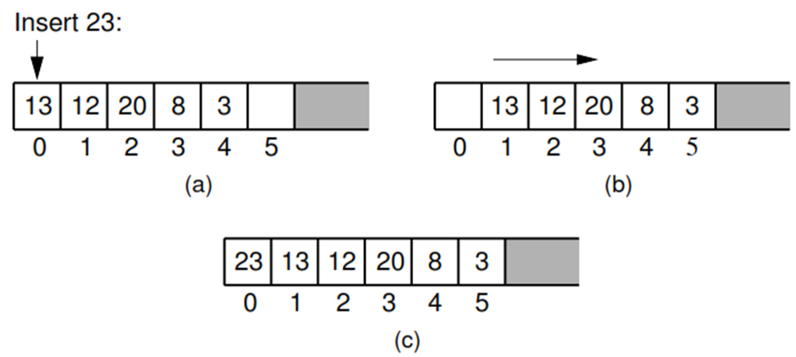
Figure: Inserting an element at the head of an array-based list requires shifting all existing elements in the array by one position toward the tail. (a) A list containing ﬁve elements before inserting an element with value 23. (b) The list after shifting all existing elements one position to the right. (c) The list after 23 has been inserted in array position 0. Shading indicates the unused part of the array.

3. Describe about the linked-list implementation with their processes.
Answer
The linked list use of pointers and dynamic memory allocation. Allow elements to be non-contiguous in memory. Order the elements by associating each with its neighbor(s) through pointers. It made up of a series of objects called nodes of the list.
There are some of Linked List Node Implementation:
- Link class
- Element field (to store the element value)
- Next field (to store a pointer to the next node on the list)
- NULL (points nowhere, i.e; for the last list node’s next field)
- head (point to the list’s first node)
- tail (point to the last link of the list)
- curr (point to the current element)
- Singly linked list or one-way list
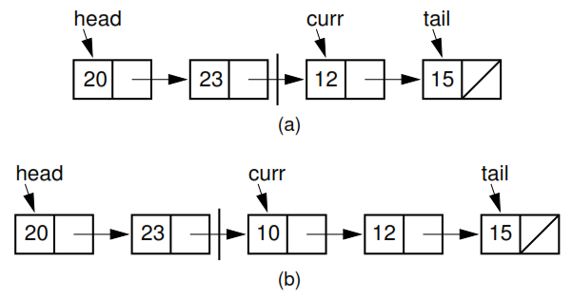

Figure: Illustration of a faulty linked-list implementation where curr points directly to the current node.
(a) Linked list prior to inserting element with value 10.
(b) Desired effect of inserting element with value 10.

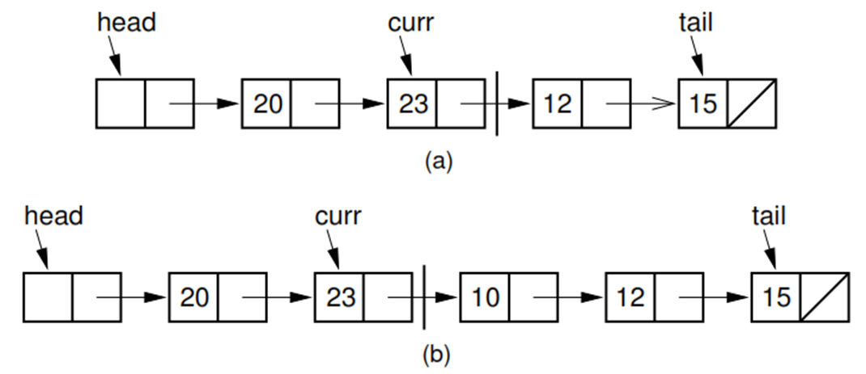
Fig: Insertion using a header node, with curr pointing one node head of the current element.
(a) Linked list before insertion. The current node contains 12.
(b) Linked list after inserting the node containing 10.

4. Describe about the linked list operation with example.
Answer
Linked List insertion process
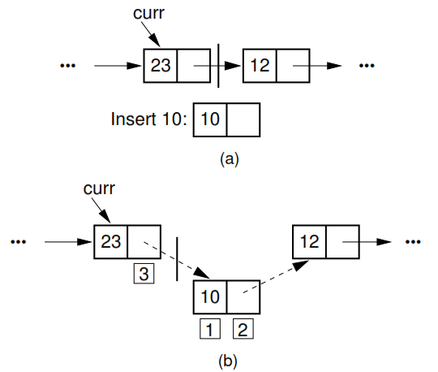
The linked list insertion process. (a) The linked list before insertion. (b) The linked list after insertion.
1. marks the element ﬁeld of the new link node.
2. marks the next ﬁeld of the new link node, which is set to point to what used to be the current node (the node with value 12).
3. marks the next ﬁeld of the node preceding the current position. It used to point to the node containing 12; now it points to the new node containing 10.
Linked Liset removal process
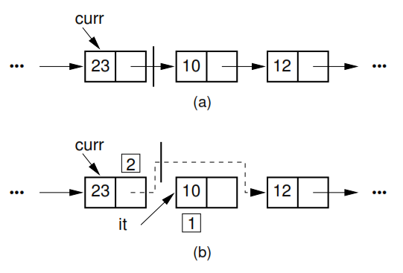
The linked list removal process. The linked list before removing the node with value 10. (b) The linked list after removal.
1. marks the list node being removed. it is set to point to the element.
2. marks the next ﬁeld of the preceding list node, which is set to point to the node following the one being deleted.

5. Describe about the operation of Doubly Linked Lists.
Answer
Insertion for Doubly Linked Lists
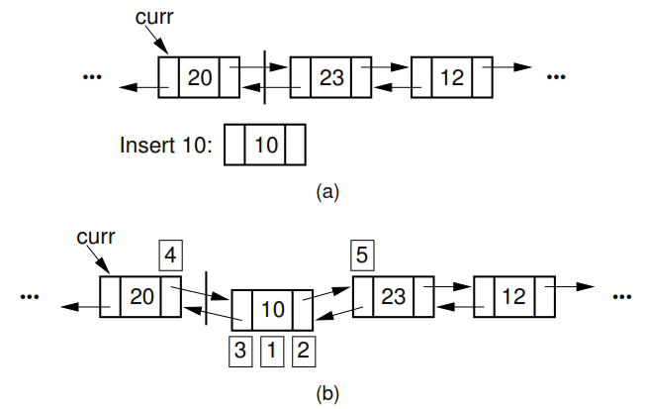
Insertion for doubly linked lists. The labels 1, 2, and 3 correspond to assignments done by the linked list node constructor. 4 marks the assignment to curr->next. 5 marks the assignment to the prev pointer of the node following the newly inserted node.
Doubly Linked List Removal
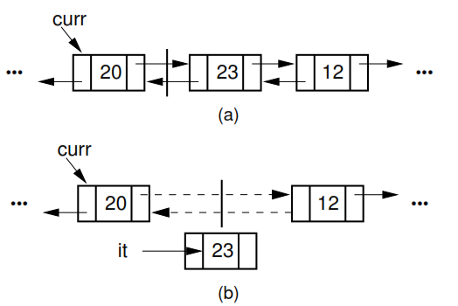
Doubly linked list removal. Element it stores the element of the node being removed. Then the nodes to either side have their pointers adjusted.

6. What is stack and describe with their function?
Answer
A stack is a sequence of items (list-like structure) that are accessible at only one end of the sequence. It is called a last-in-first-out (LIFO) collection. This mean that the last thing we added (pushed) is the first thing that gets pulled (popped) off. The accessible element of the stack is called the top element. In programming terms, putting an item on top of the stack is called "push" and removing an item is called "pop".
The two approaches: array-based and linked stacks. There are basically three operations that can be performed on stacks. They are (1) inserting an item into a stack (push). (2) deleting an item from the stack (pop). (3) displaying the contents of the stack(pip).
Push () function - push() function is used to insert an element at the top of the stack. The element is added to the stack container and the size of the stack is increased by 1.
pop() function - pop() function is used to remove an element from the top of the stack(newest element in the stack). The element is removed to the stack container and the size of the stack is decreased by 1.

7. What are the operations of stack and how to implement the stack?
Answer
The operations work as follows:
- A pointer called TOP is used to keep track of the top element in the stack.
- When initializing the stack, we set its value to -1 so that we can check if the stack is empty by comparing TOP == -1.
- On pushing an element, we increase the value of TOP and place the new element in the position pointed to by TOP.
- On popping an element, we return the element pointed to by TOP and reduce its value.
- Before pushing, we check if stack is already full
- Before popping, we check if stack is already empty
Although stack is a simple data structure to implement, it is very powerful. The most common uses of a stack are:
To reverse a word - Put all the letters in a stack and pop them out. Because of LIFO order of stack, you will get the letters in reverse order.
In programming - In the case of parentheses when a left parenthesis is encountered it is pushed on the stack
and when a right parenthesis is encountered its matching left parenthesis is popped from the stack. If the stack has no left parenthesis, that means the parentheses don’t match, there is an extra right parenthesis.
In browsers - The back button in a browser saves all the urls you have visited previously in a stack. Each time you visit a new page, it is added on top of the stack. When you press the back button, the current URL is removed from the stack and the previous url is accessed.

8. Describe about the array-based stack implementation.
Answer
Stack's capacity is limited to a certain value and overfilling the stack will cause an error. In spite of capacity limitation, array-based implementation is widely applied in practice. In a number of cases, required stack capacity is known in advance and allocated space exactly satisfies the requirements of a particular task.
Advantages: best performance
Disadvantage: fixed size
Basic implementation: initially empty array, field to record where the next data gets placed into if array is full, push() returns false. otherwise adds it into the correct spot if array is empty, pop() returns null. otherwise removes the next item in the stack.

9. Describe about the Linked stack implementation with examples.
Answer
The major problem with the stack implemented using array is, it works only for fixed number of data values. That means the amount of data must be specified at the beginning of the implementation itself. Stack implemented using array is not suitable, when we don't know the size of data which we are going to use.
One disadvantage of using an array to implement a stack is the wasted space---most of the time most of the array is unused. The stack implemented using linked list can work for unlimited number of values. That means, stack implemented using linked list works for variable size of data. So, there is no need to fix the size at the beginning of the implementation. The Stack implemented using linked list can organize as many data values as we want.
In linked list implementation of a stack, every new element is inserted as 'top' element. That means every newly inserted element is pointed by 'top'. Whenever we want to remove an element from the stack, simply remove the node which is pointed by 'top' by moving 'top' to its next node in the list. The next field of the first element must be always NULL.
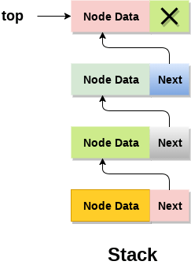
10. What are Queue specifications and operations on ADT?
Answer
Like the stack, the queue is a list-like structure that provides restricted access to its elements. Queue elements may only be inserted at the back and removed from the front.A queue is a useful data structure in programming. It is similar to the ticket queue outside a cinema hall, where the first person entering the queue is the first person who gets the ticket.
Queue follows the First In First Out (FIFO) rule - the item that goes in first is the item that comes out first too. In programming terms, putting an item in the queue is called an "enqueue" and removing an item from the queue is called "dequeue". Two implementations for queues: the array-based queue and the linked queue.
A queue is an object or more specifically an abstract data structure (ADT) that allows the following operations:
- Enqueue: Add element to end of queue
- Dequeue: Remove element from front of queue
- IsEmpty: Check if queue is empty
- IsFull: Check if queue is full
- Peek: Get the value of the front of queue without removing it
A queue is like a line of people waiting for a bank teller. The queue has a front and a rear. New people must enter the queue at the rear. This is usually called an enqueue operation. When an item is taken from the queue, it always comes from the front. This is usually called a dequeue operation.
11. What is the implementation of Queue data structure?
Answer
Initially the head (FRONT) and the tail (REAR) of the queue points at the first index of the array (starting the index of array from 0). As we add elements to the queue, the tail keeps on moving ahead, always pointing to the position where the next element will be inserted, while the head remains at the first index.
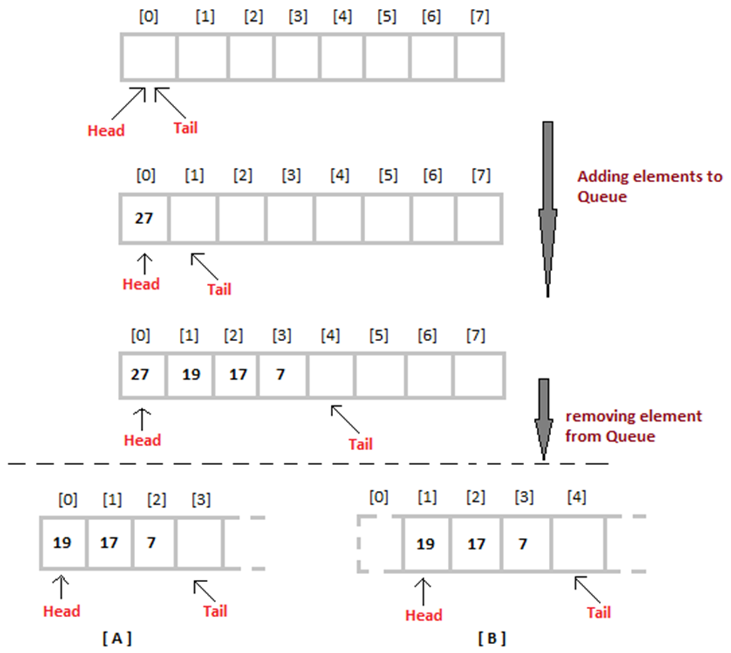
12. What is the operation work of queue and how to implement the queue?
Answer
Queue operations work as follows:
- Two pointers called FRONT and REAR are used to keep track of the first and last elements in the queue.
- When initializing the queue, we set the value of FRONT and REAR to -1.
- On enqueuing an element, we increase the value of REAR index and place the new element in the position pointed to by REAR.
- On dequeuing an element, we return the value pointed to by FRONT and increase the FRONT index.
- Before enqueuing, we check if queue is already full.
- Before dequeuing, we check if queue is already empty.
- When enqueuing the first element, we set the value of FRONT to 0.
- When dequeuing the last element, we reset the values of FRONT and REAR to -1 (initial state).
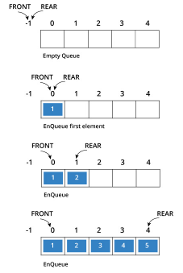
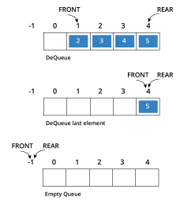
A queue can be implemented with an array, as shown here. For example, this queue contains the integers 4 (at the front), 8 and 6 (at the rear).
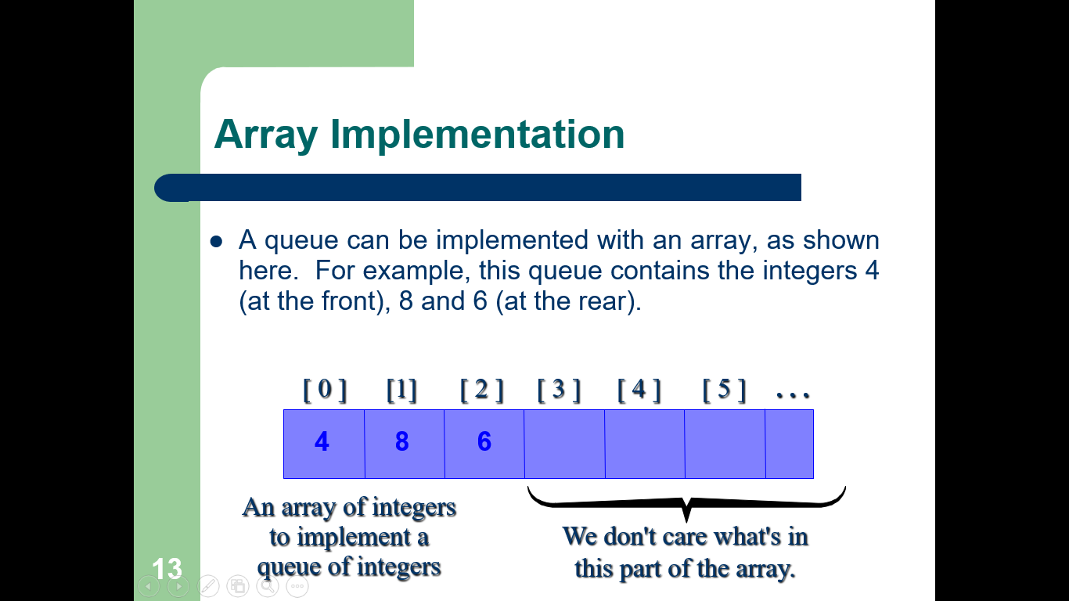
The easiest implementation also keeps track of the number of items in the queue and the index of the first element (at the front of the queue), the last element (at the rear).
When an element leaves the queue, size is decremented, and first changes, too. Here are the algorithms of dequeue operation.
- Check if the queue is empty or not.
- If the queue is empty, then print underflow error and exit the program.
- If the queue is not empty, then print the element at the head and increment the head.
When an element enters the queue, size is incremented, and last changes, too. Here are the algorithms of enqueue operation.
- Check if the queue is full or not.
- If the queue is full, then print overflow error and exit the program.
- If the queue is not full, then increment the tail and add the element.

13. What is the implementation of queue?
Answer
The queue is easy to implement. But it has a limited capacity with a fixed array or must use a dynamic array for an unbounded capacity. A queue can also be implemented with a linked list with both a head and a tail pointer. The head_ptr points to the front of the list and the tail_ptr points to the rear of the list.

14. What are the key differences between stack and queue?
Answer
Stack follows LIFO mechanism on the other hand Queue follows FIFO mechanism to add and remove elements. In a stack, the same end is used to insert and delete the elements. On the contrary, two different ends are used in the queue to insert and delete the elements.
As Stack have only one open end that is the reason for using only one pointer to refer to the top of the stack. But queue uses two pointers to refer front and the rear end of the queue. Stack performs two operations known as push and pop while in Queue its known as enqueue and dequeue.
Stack implementation is easier whereas Queue implementation is tricky. Queue has variants like circular queue, priority queue, doubly ended queue, etc. In contrast, stack does not have variants.

