Team “Evo1ution”

WRO Future Engineer Report

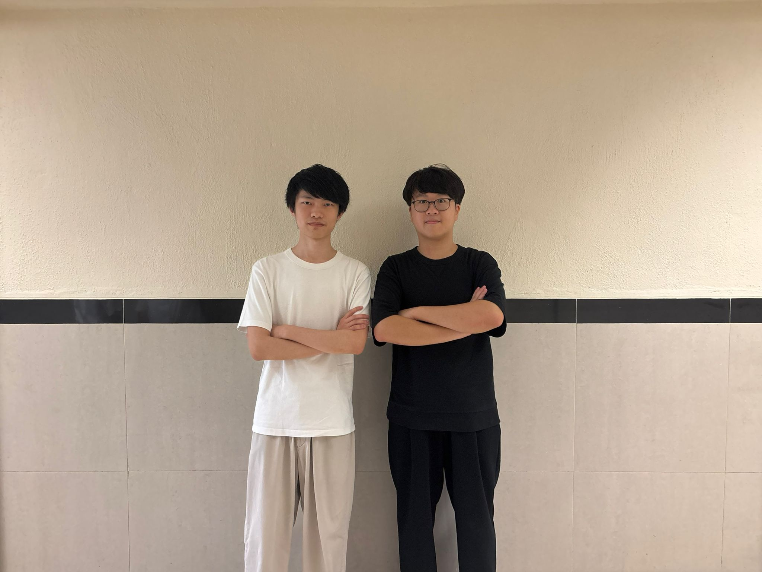

Team name:
Evo1ution
Participants:
Rex, Tak Chun Sin
Marco, Lam Marco
Kyle, Ka Hei Cheung
Coach:
Elwin, Ka Yau Li
Supporter:
Harold, Yat Long Cheung
Donald, Kam Pan Tong
Harrison, Kwok Ho Tsang

Sponsors:
 |  |  | 

Table of Contents
Table of Contents 2
About Us 3
Members' Introductions and Thoughts 3
1. Choice of Electromechanical Components 6
2. Mobility Management 8
2.1. Overview 8
2.2. Mechanical Differential 9
2.3. Ackermann Steering 10
2.4. Chassis Design 11
2.4.1 Centre of Mass Consideration 12
2.4.2 Weight Control 13
2.5. The Front-Wheel Drive (FWD) 13
2.5.1 Decision and Benefits using FWD 13
2.5.2 Kinematic Analysis: Overcoming Understeer 13
2.6. Independent Rear Stub Axle Assembly 14
3. Power and Sense Management 15
3.1. Power consumption of electrical components 15
3.2. Voltage Converter (YB-MPP01-V1.0) 15
3.3. Power Source (Enhanced 18650 batteries) 15
3.4. Camera (Pi Camera Module 3 Wide) 16
3.5. Motor with encoder (BM50 with encoder) 16
3.6. Steering motor (CZ356 Servo Motor) 18
3.7. Debug Display (Waveshare 1.3” IPS LCD HAT) 18
3.8. Build Of Materials and Wiring Diagrams 19
3.8.1. Build Of Materials 19
3.8.2. Schematic of ESP32-S3 20
3.8.3. Schematic of Waveshare 13” ISP LCD HAT 21
3.8.4. Pictorial Wiring Diagram 21
3.8.5. Schematic Wiring Diagram 22
4. Obstacle Management 23
4.1. Open Challenge (OC1) 23
4.2. Obstacle Challenge (OC2) 25
5. Vehicle Photos 26
6. Team Photos 26
7. Performance Video and GitHub Repository 27
8. References 27
A. Appendix 27
A.1. What we learned 27
A.2. Difference between our robot for the Hong Kong Regional competition and the current robot 28
A.3. How Wheels Affect a Car's Performance? 28
A.4. Difficulties 30

About Us
We are Team Evo1ution. The team name is derived from the word “Evolution,” reflecting our commitment to continuous improvement and our determination to strive for the best. This spirit has guided us since our time in the robotics team during secondary school. We intentionally replaced the letter “l” with the number “1” to symbolise our ambition to achieve first place in the competition.

Our team consists of seven alumni from Po Leung Kuk Tang Yuk Tien College, each of whom previously served as chairperson of the school robotics team and shares a strong interest in robotics. Through years of competitions and training, we have built strong friendships and developed a shared commitment to robotics.

Last year, we participated in the WRO Future Engineers category in both the Hong Kong Regional Round and the International Final in Singapore. We achieved the Regional Championship in Hong Kong and placed 28th in the International Final. This year, we aim to build on that experience and achieve an even better result by making significant improvements to our robot. Unfortunately, two of our previous teammates, Donald and Harrison, are unable to participate due to academic commitments. Therefore, we recruited two new teammates, Kyle and Marco, to join us as we continue working towards victory.

Members' Introductions and Thoughts
Kyle Cheung (Participant) – Age 18


Kyle, a secondary school graduate, is responsible for program development in the PLKTYTC Robotics Team. He achieved first and second place in the 2023 and 2024 WRO Hong Kong RoboSports category. While preparing for the 2026 Robocon Hong Kong Contest, he draws on his strong competition background.

“It is a wonderful change from recognising and chasing the table tennis ball to dodging the pillars. As a rookie of this selection, I learnt to manipulate Raspberry Pi and Esp 32 for the advanced mission, in addition to a camera. The adventure of creating an integrated algorithm is both a torture and a boon at the same time: I mastered the skill of camera data acquisition, but the tuning part took me days and nights.”

Marco Lam (Participant) – Age 19


Marco, an Enrichment Stream in Theoretical Physics student at The Chinese University of Hong Kong, is responsible for developing the main program, conducting module tests, and fine-tuning robot performance across diverse scenarios. Although this is his first robotics competition since primary school, his strong foundation in programming — highlighted by achieving Honourable Mention in the Hong Kong Olympiad in Informatics (2022–
2023) — has proven valuable to the team.

“Initially, I expected the Future Engineer challenges to be relatively straightforward. However, I quickly encountered numerous bugs in the main program that required extensive debugging. Through systematically identifying and resolving these issues, I discovered how interesting and rewarding this kind of challenge can be. These experiences have sharpened my problem-solving skills and deepened my appreciation for iterative testing and robust system development.”

Rex Sin (Participant) – Age 20

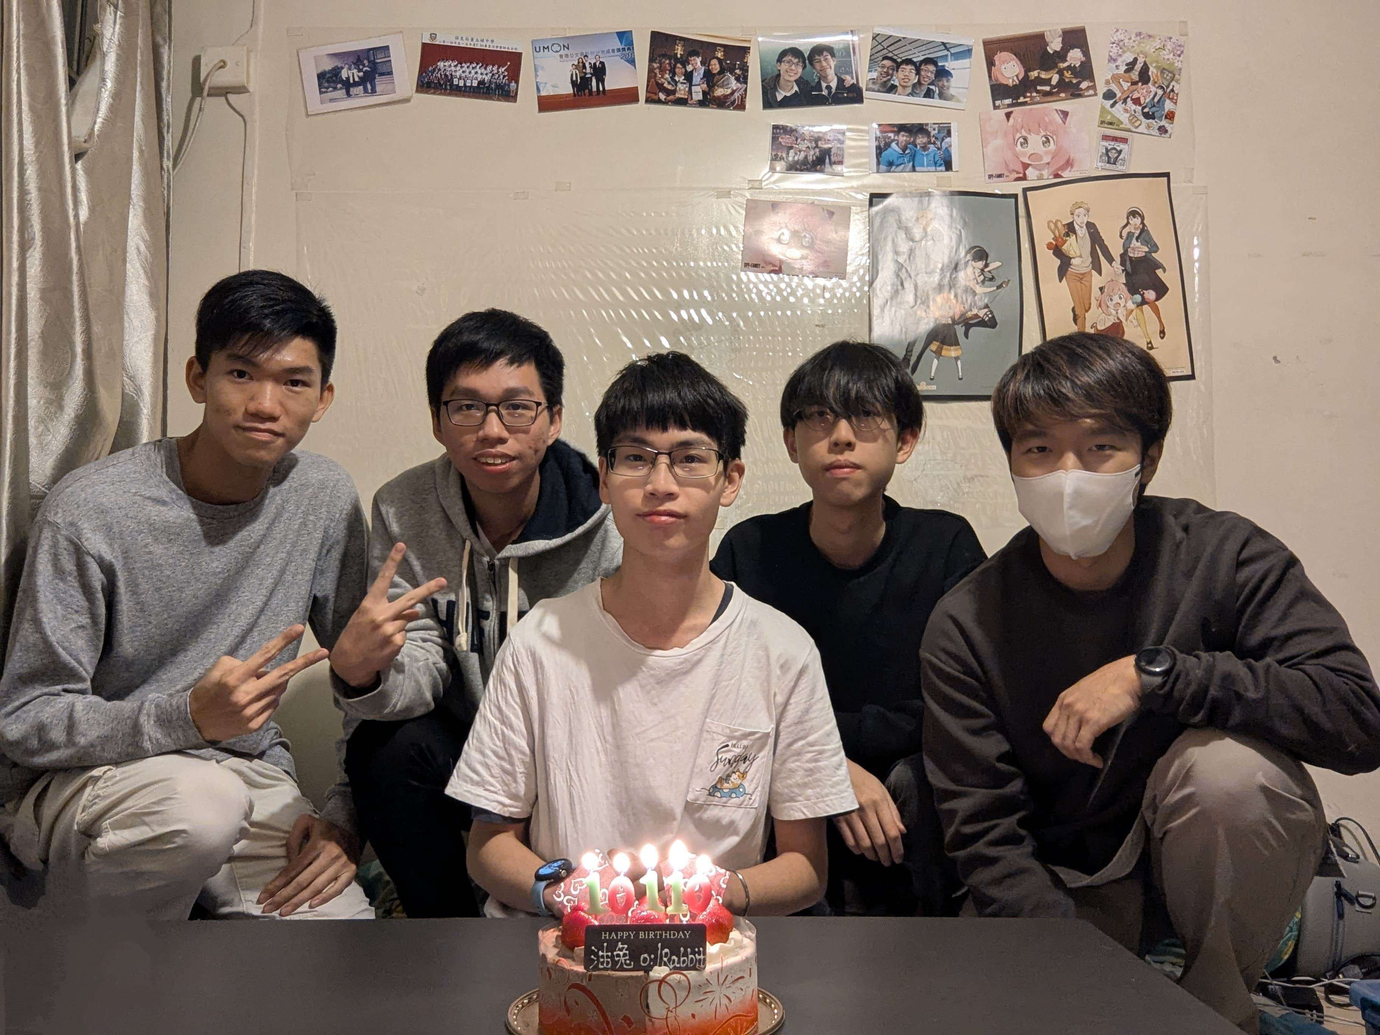
Rex is currently studying Computer Science in Australia but remains fully engaged with the team through video conferencing. He leads strategy design, debugging, and solution development, produces and uploads our YouTube videos, and coordinates the preparation of this report. Having begun his robotics journey at the age of 12, he won the U.S. Robot Parade world championship while representing Hong Kong and has since earned numerous awards in local competitions.

“From the experience of participating in this competition last year, I learnt that it demands not only an optimised mechanical design for navigating obstacles but also a significant programming effort. I am grateful to my teammates for involving me despite my being overseas. My primary contribution has been to ensure our documentation is as polished as possible, so the team can focus on fine-tuning the robot. Researching mechanical features to justify each design choice has deepened my understanding, as I consulted multiple sources and carefully edited this report.”

Elwin Li (Coach) – Age 23

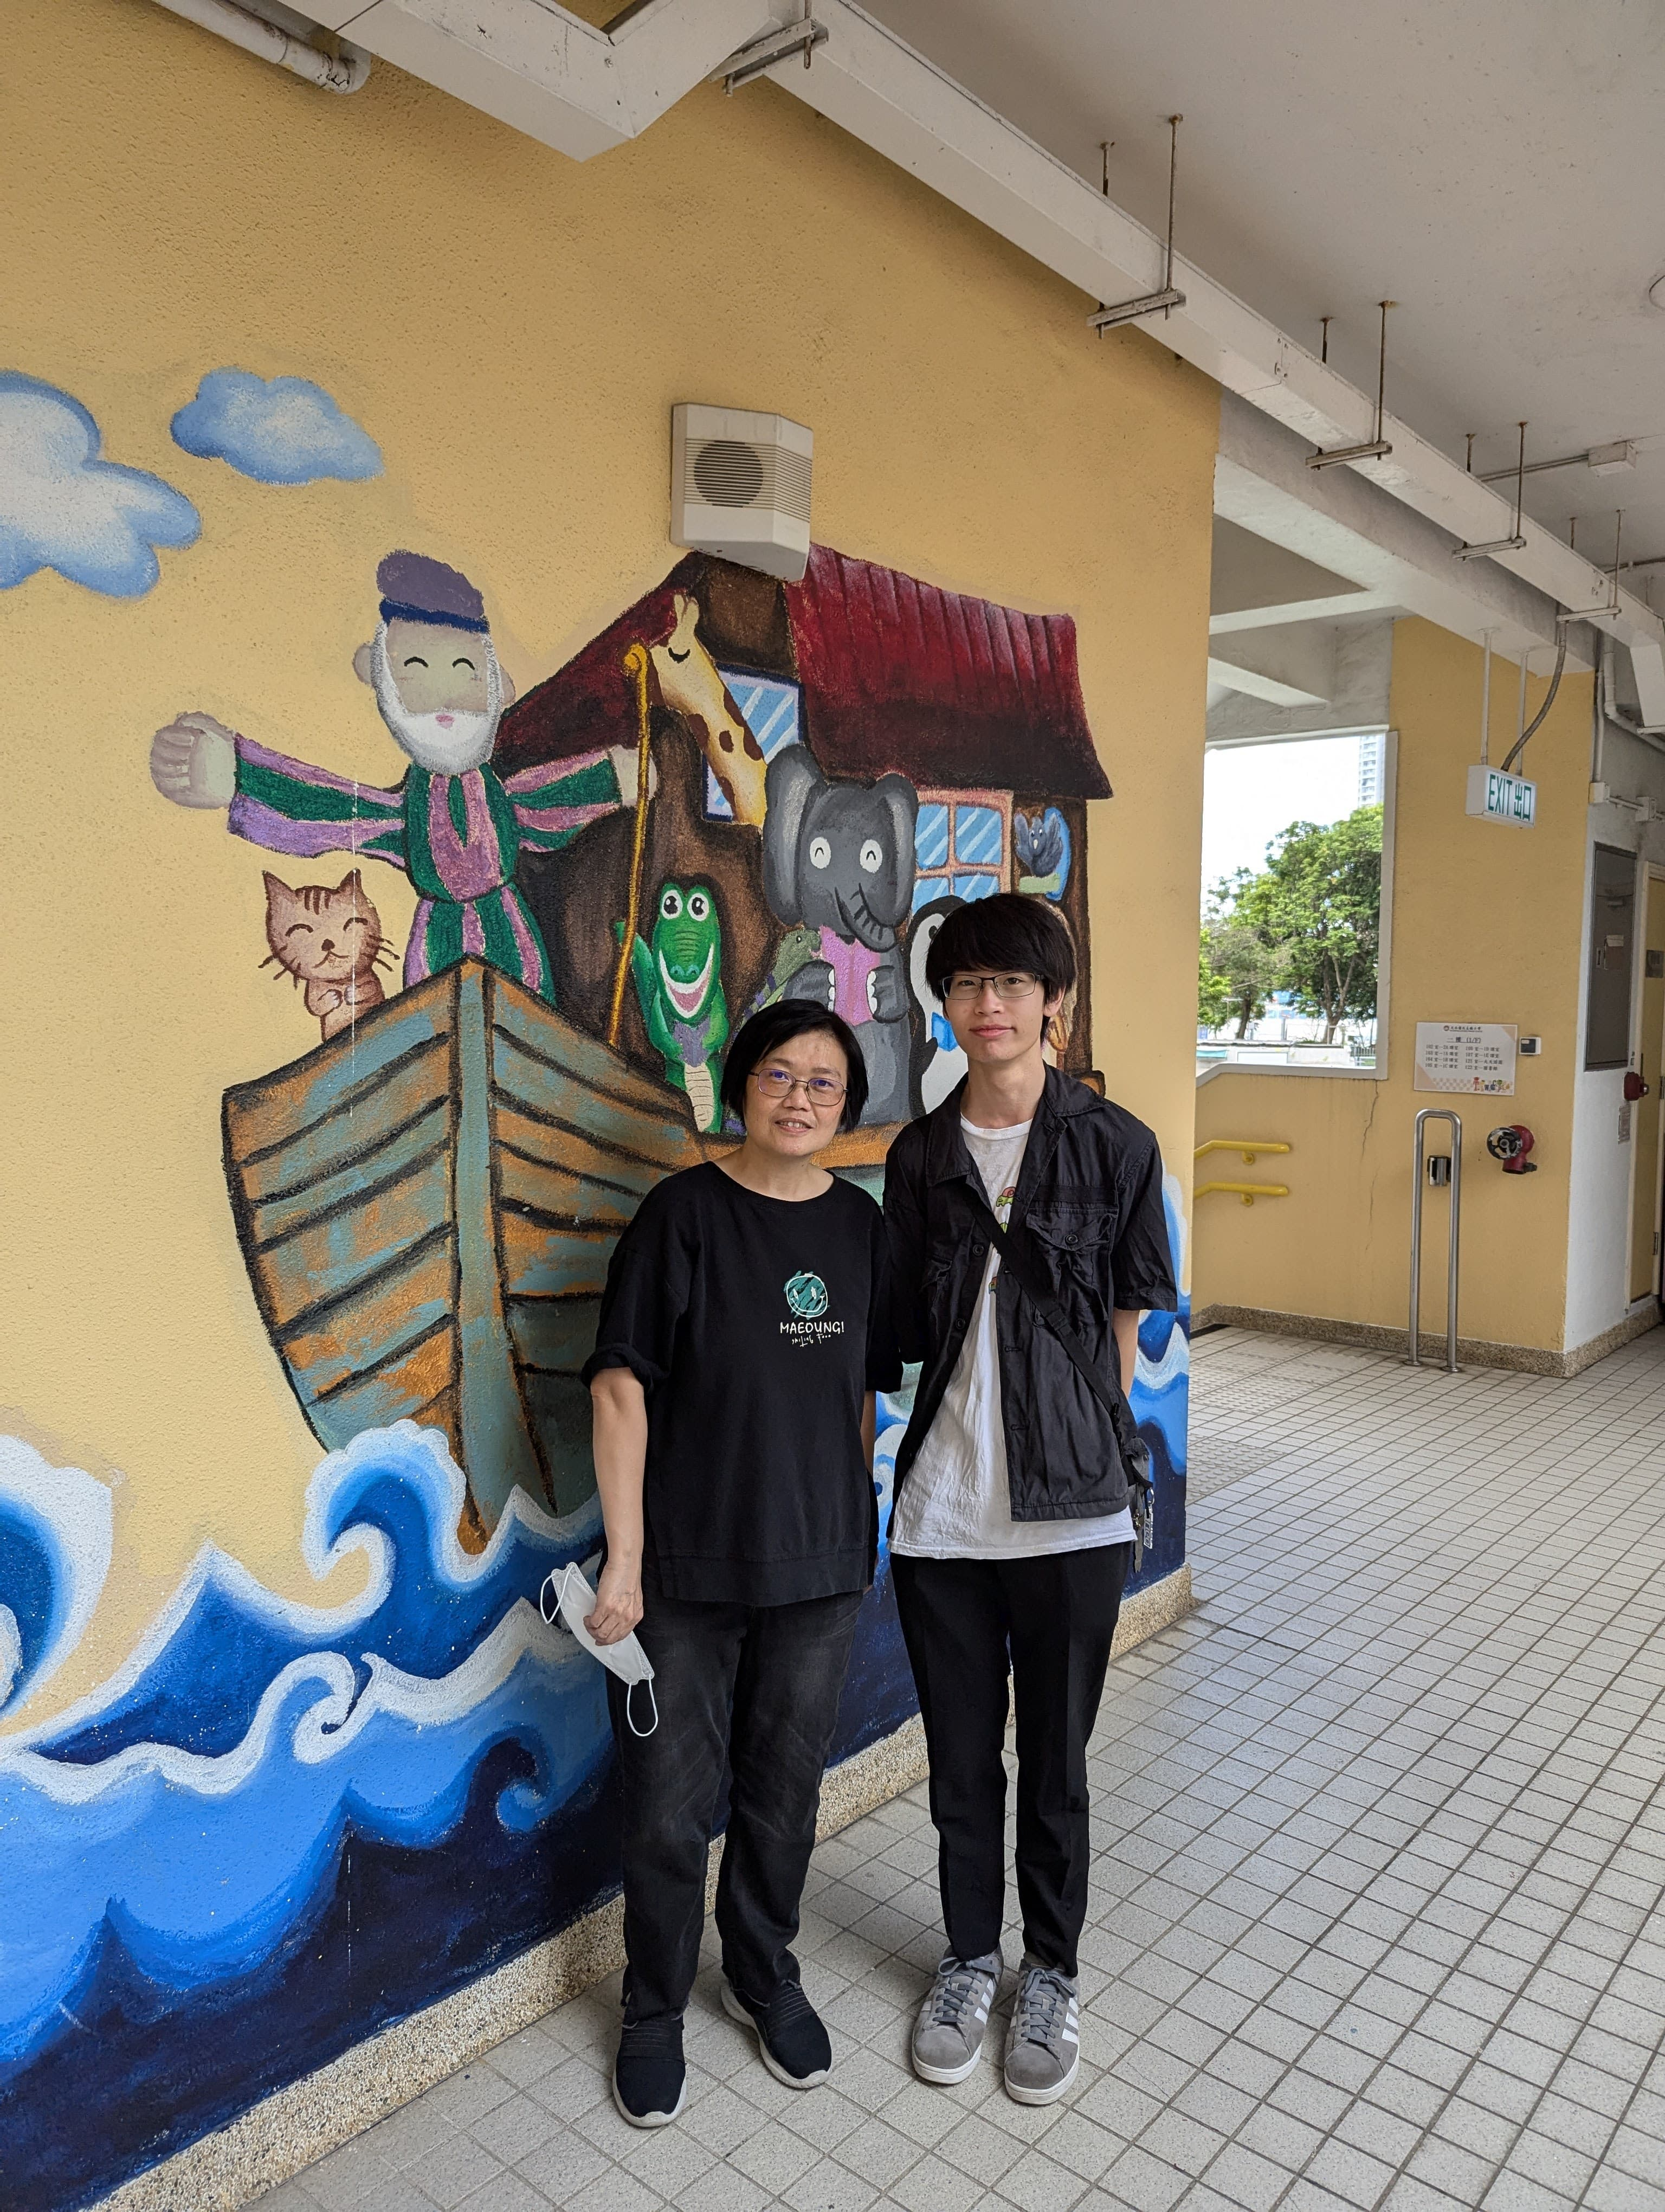
Elwin is an MPhil student in Physics who previously coached the PLKTYTC Robotics Team and the Physics Olympiad class. With expertise in physics, mathematics, and programming, he contributes to university research on gravitational waves. Within our team, he is responsible for meeting planning, goal setting, task allocation, sponsorship coordination, hardware procurement, and, most importantly, programming strategy. Elwin also competed in the 2021 Robocon Hong Kong Contest and served as a judge for the 2024 WRO Hong Kong Future Engineers selection. In addition, he led our team in participating in the 2025 WRO Future Engineers Hong Kong Regional Round and the International Final in Singapore.
“As a former student and coach of Po Leung Kuk Tang Yuk Tien College, I am privileged to mentor this talented new generation through a streamlined yet exceptionally demanding competition. The Open Challenge strengthens core navigation skills, while the Obstacle Challenge requires advanced image processing, adaptability, and the ability to respond to constantly changing conditions. I greatly admire my team’s unwavering dedication. They have invested countless hours in mechanical analysis, control algorithm refinement, and comprehensive subsystem testing. Their intellectual curiosity and collaborative spirit reflect the highest standards of our robotics programme, and I am proud to lead such a capable and committed group. Beyond robotics, we are also close friends who regularly spend time together, play games, and enjoy hotpot gatherings at my home. Their camaraderie brings laughter, warmth, and genuine friendship to every project. I cherish this team not only for their technical excellence, but also for the strong bonds we share.”

Harold Cheung (Mechanical Supporter) – Age 24
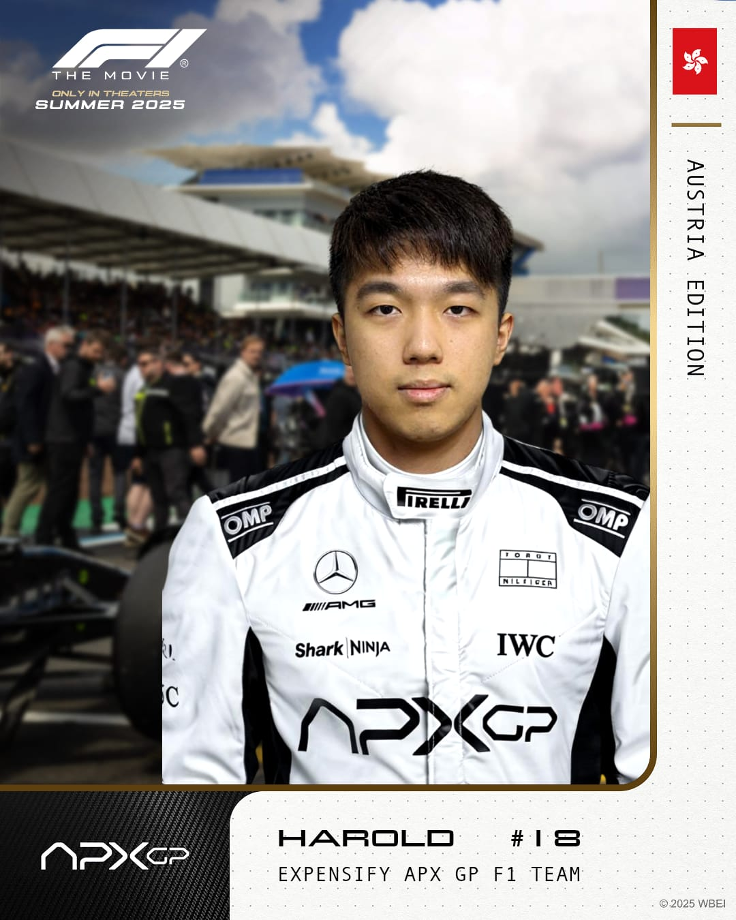
Having graduated with a degree in Aeronautical and Aviation Engineering, Harold is now an educator teaching Design and Technology (D&T) and Computer Literacy at Shun Tak Fraternal Association Cheng Yu Tung Secondary School, where he also manages robotics clubs and develops STEAM curricula. Serving as the team's Technical Supporter, he provides critical guidance on mechanical design. This year, he spearheaded the development of the robot's new Front-Wheel Drive (FWD) system and took charge of 3D printing for rapid prototyping. As a motorsport enthusiast and co-editor of STEM textbooks, Harold excels at drawing inspiration from real-world mechanics and translating those practical physical principles into innovative competitive robotics design.
“I am thrilled to compete once again alongside my juniors. Although I have worked with WRO Hong Kong, my experience has been primarily in RoboMission, so I was not initially familiar with the Future Engineer format. After studying the rules, I realised that we would need a system as advanced as a Tesla. Drawing on my go-kart racing background and many years of local WRO competition, I guided the team in self-driving car design and used this opportunity to teach my juniors key automotive principles and mechanical structures. Even in a supporting role, I have greatly enjoyed this process and hope that my contributions will enhance our overall performance.”

Donald Tong (Supporter) – Age 20

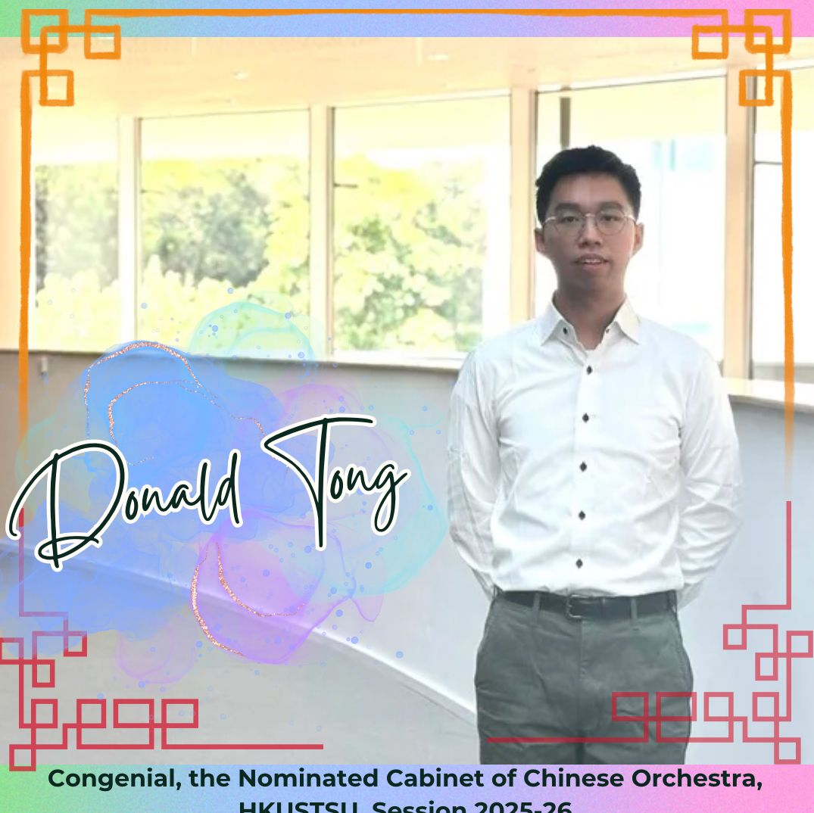
Donald, a Civil and Environmental Engineering student and coach of the PLKTYTC Robotics Team, is responsible for developing core libraries and functions, fine-tuning robot behaviour, and conducting extensive operational tests, including evaluating performance under varied object placements. Together with his teammate Rex Sin, he achieved second place in the 2024 WRO Hong Kong Senior RoboMission selection. He also previously secured second place in the 2019 international Beach Rescue and Salvage Robot competitions.
“This is my second time playing future engineering, but I changed my role to supporter this time. By learning from the failure of last year, I can share my experiences on what we can avoid doing to the participants when they participate in the competition. Also, as a supporter, I learned more skills to provide ideas and instructions on drawing CADs and laser cuts. These experiences must help me gain a lot.”

Harrison Tsang (Supporter) – Age 21


Currently studying Artificial Intelligence: Systems and Technologies, Harrison coaches the PLKTYTC Robotics Team and leads our robot construction and primary program development. While simultaneously preparing for the 2025 Robocon Hong Kong Contest, he draws on his experience as the 2021 WRO Hong Kong Senior RoboMission champion and as a multiple world-title winner in international robotics that same year.
“Having competed as a participant in the past, I would say the Future Engineer challenges do not mirror our previous RoboMission experience. Stepping into a supporter role this time gave me a fresh perspective on the unpredictable nature of sensor and camera performance. For instance, when the team's PiCam misidentified walls, floors, and computers as green during testing, I was able to draw on my past experience to guide them through the troubleshooting process. Helping the team master camera data acquisition techniques from the sidelines gave me a much deeper appreciation for what it means to be an effective, supportive teammate.”

1. Choice of Electromechanical Components
Controller and Sensors
Last year, during the International Final in Singapore, we selected the ESP32-S3 development kit as the main and sole controller for our robot. The ESP32-S3 features a dual-core processor, allowing it to process data from different sensors and the camera while simultaneously controlling the motors. By incorporating FreeRTOS, a real-time operating system, we were able to implement multitasking, enabling the ESP32-S3 to communicate with multiple connected components at the same time. This made it effective for executing several tasks concurrently.
However, we found that the processing power of the ESP32-S3 was insufficient for handling the large amount of data from the camera while maintaining stable communication with other electronic components. Therefore, we decided to use a more powerful controller capable of processing raw camera data more efficiently.
As a result, we have chosen the Raspberry Pi 5 as the main controller for our robot this year. Despite its compact size, the Raspberry Pi 5 provides significantly stronger processing power, supports a dedicated operating system, and is compatible with the Raspberry Pi Camera Module 3 Wide. Since the Pixy 2.1 camera module was not stable enough for us to achieve consistent performance during the Obstacle Challenge and was easily affected by slight changes in ambient lighting, we decided to use the Raspberry Pi Camera Module 3 Wide as our camera module this year. Following the principle that “simplicity is best”, we also decided not to include any distance sensors or inertial measurement units (IMUs). Instead, we will rely solely on the camera module to complete the challenges.
Although the Raspberry Pi 5 is used as the main controller for image processing and decision-making, we decided to keep the ESP32-S3 as a dedicated motor controller for the driving and steering systems. Compared with the Raspberry Pi 5, the ESP32-S3 is more suitable for low-level motor control because it can generate stable PWM signals and communicate directly with motor drivers and servo motors with lower latency.
This separation also allows the Raspberry Pi 5 and ESP32-S3 to focus on different tasks. The Raspberry Pi 5 handles camera input, image processing, and high-level navigation decisions, while the ESP32-S3 receives control commands and translates them into precise motor actions. This improves the overall stability of the system and reduces the processing load on the Raspberry Pi 5.
In addition, the ESP32-S3 is easier to program for direct hardware control, especially for tasks such as speed control, steering control, and real-time response to motor commands. By using the ESP32-S3 as a dedicated motor controller, we can achieve a more reliable and organised control architecture for the robot.
Driving system (Motor)
For the driving system, we selected the BM50 brushless motor with an integrated encoder. Although the motor is compact in size, it provides a strong balance of high rotational speed, sufficient torque, stable operation, and precise controllability, making it highly suitable for the WRO Future Engineers challenges.
One of the main reasons we chose this motor is its built-in encoder, which allows us to monitor the motor’s rotation accurately in real time. This enables more precise speed control and helps the robot maintain consistent movement during both the Open Challenge and the Obstacle Challenge. Since the robot needs to travel smoothly, adjust its speed when turning, and respond reliably to visual input from the camera, accurate motor feedback is essential for stable autonomous driving. The BM50 motor only requires a 12V power supply, making it compatible with our robot’s electrical system without requiring a complex power setup. It has a maximum rotational speed of (4450 ± 445) RPM, a stall torque of 60mN·m, and a maximum torque of 423mN·m. This gives us a wide operating range, allowing the robot to move quickly on straight sections while still having enough torque to handle acceleration, turning, and small disturbances during the run.

Another important advantage of this motor is its built-in safety mechanism. If the motor stalls for two seconds due to external forces, it automatically stops to prevent damage. This is especially useful in the WRO environment, where the robot may accidentally hit walls, obstacles, or track boundaries during practices. This protection improves the reliability of our system and reduces the risk of damaging the motor during repeated trial runs.
Therefore, the BM50 brushless motor provides the speed, torque, feedback control, and safety features required for a stable and responsive autonomous robot. Its compact form factor also allows us to design a lighter and more space-efficient driving system, which supports our goal of building a simple, reliable, and high-performance robot for this year’s competition.
Steering
For the steering system, we selected the compact CZ356 servo motor. One of the main reasons for choosing this servo is its small size and LEGO-compatible design, which allow us to mount it directly onto the robot using simple LEGO parts. This makes the steering mechanism easier to assemble, adjust, and maintain during testing.
Since the robot needs to perform accurate and responsive steering in both the Open Challenge and the Obstacle Challenge, a compact servo motor is advantageous because it reduces the overall size and weight of the front steering structure. Its LEGO compatibility also helps us design a cleaner and more modular mechanism, allowing the servo to be securely fixed without requiring complicated custom-made parts.
Debug Display
We selected the Waveshare 1.3” IPS LCD Display HAT with a 240×240 resolution as the display module for the robot. It allows us to show important information, system status, and debugging messages during testing and practice sessions. By displaying real-time data directly on the robot, we can monitor its operation more conveniently without always needing to connect it to an external computer.
The display module also includes three push buttons, which provide a simple way to control the robot during testing. For example, we can start or stop the program with a single button press, making the debugging process faster and more efficient. This is especially useful during repeated trial runs, as it allows us to quickly restart or adjust the robot without changing the code or reconnecting external devices.
Powering Unit
For the power system, we use three enhanced 18650 rechargeable batteries with a higher capacity than standard 18650 cells. Compared with typical 1800mAh batteries, our selected 3200mAh cells provide a longer operating time and help ensure a more stable power supply during practice sessions and throughout the competition day.
Using three 18650 cells allows us to provide approximately 12V to the main power system of the robot, which is suitable for powering the driving motor and other electronic components. However, the Raspberry Pi 5 requires a stable 5V input. Therefore, we use a YB-MPP01-V1.0 power supply expansion board for the Raspberry Pi 5 to step down the voltage from the battery pack to a regulated 5V output. This ensures that the Raspberry Pi 5 can operate reliably without being affected by voltage fluctuations from the main battery system.
A stable power system is important because sudden voltage drops may cause the Raspberry Pi 5 to restart, interrupt the camera processing, or affect communication with the ESP32-S3. By using high-capacity batteries together with a dedicated voltage regulation board, we can improve the reliability of the robot during long testing periods and competition runs.

Further details and specifications of our selected electronic components are provided in Section 3.

2. Mobility Management

2.1. Overview
The mobility and specialised characteristics of a kart make it an ideal prototype for the WRO Future Engineers competition missions. A kart has a simple yet robust chassis, as well as a straightforward steering system, making it a suitable reference model for our robot design. Our supporter, Mr Harold Cheung, who is an amateur go-kart racer, provided detailed photographs of his kart for our reference.
Mr Cheung and our coach, Mr Elwin Li, also invited their friend, Mr Lewis Wong, to explain how a car operates and which factors influence its performance, stability, and handling. Mr Wong is currently a mechanical engineer in Touring Car Racing (TCR) and has extensive experience in race car setup. His explanation helped us better understand the relationship between wheel alignment, steering response, weight distribution, and vehicle stability. Further details are provided in the appendix, “How Wheels Affect a Car’s Performance?”
In addition, Rex and Elwin evaluated an electric go-kart in Australia to compare its performance with that of a conventional petrol-powered model. This comparison allowed us to better understand the differences in acceleration, power delivery, handling, and overall driving behaviour between electric and conventional kart systems. The key mobility-enhancing features we investigated are as follows:
- Mechanical differential
- Ackermann Steering
- Chassis Design:
- Design Overview | - Steering System
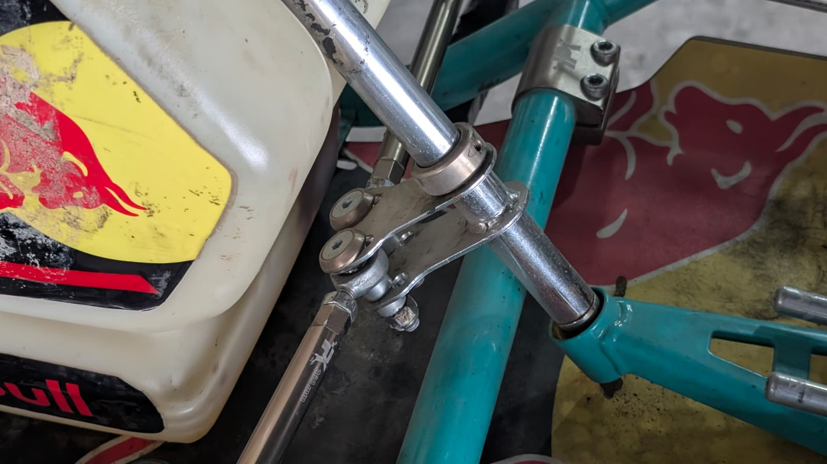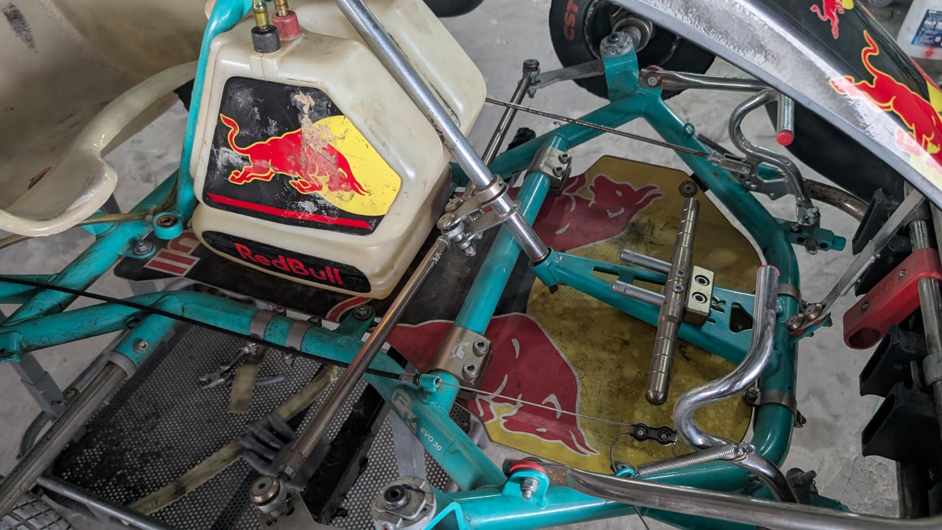
The axle that controls the Ackermann steering system.
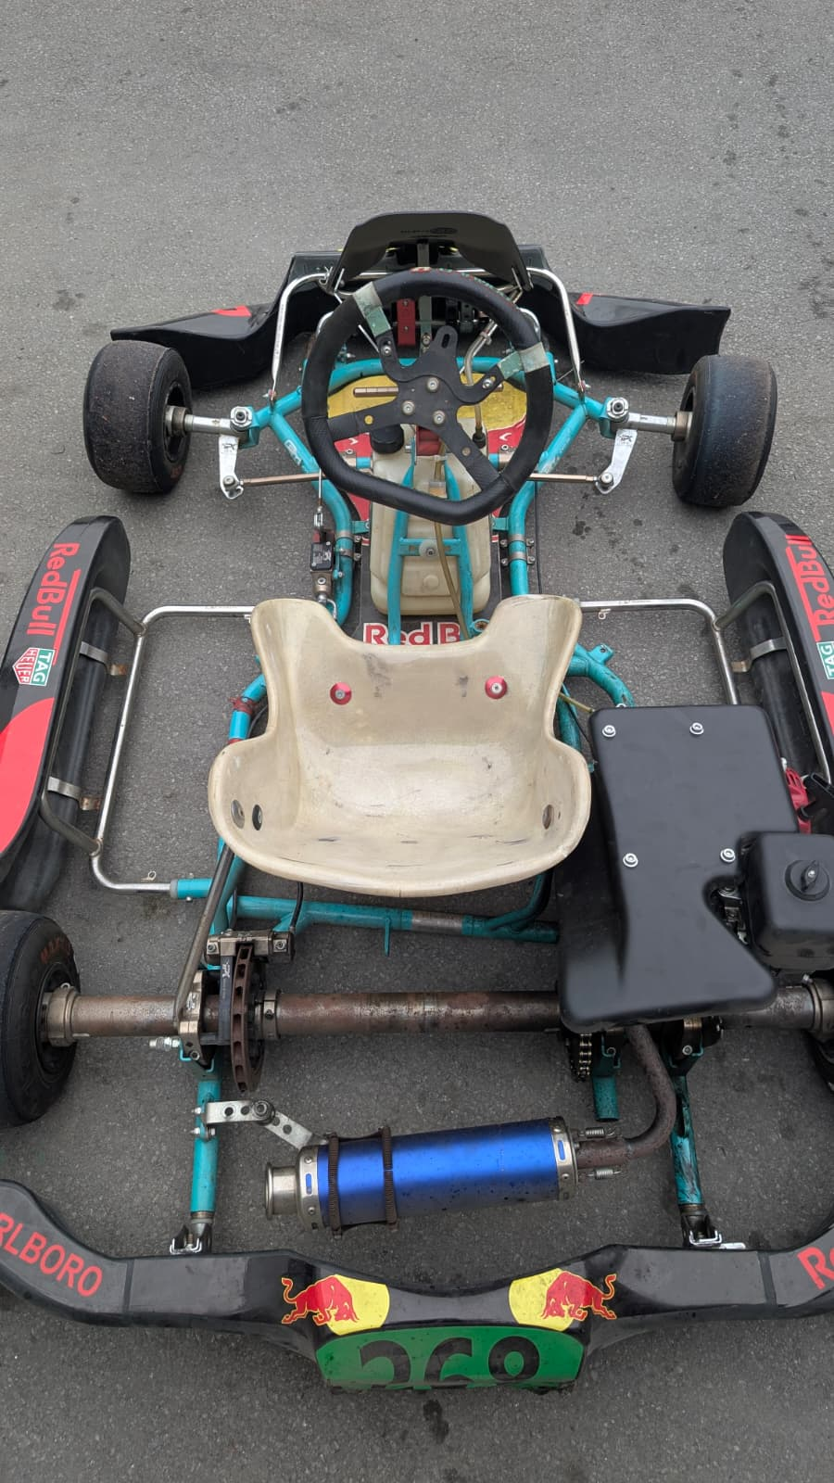
Our reference of Ackermann steering system and the motor (the black box on the left of the seat) that is placed in the middle of the kart.

These design characteristics were applied to the smart car last year and evaluated to determine their effectiveness in the WRO Future Engineers missions. Although the go-kart-inspired rear-wheel-drive (RWD) design last year provided excellent straight-line speed, we observed clear limitations during sharp cornering, particularly when entering and exiting the parking area.
Building on our previous prototype, our team conducted a comprehensive review of the robot’s mobility system. Through testing, we identified two major mechanical issues: understeering during tight turns and structural weakness at the front axle. These problems compromised the robot's turning stability and reduced its reliability during more demanding sections of the challenge.
To address these limitations, we designed a completely state-of-the-art front-wheel-drive (FWD) architecture for the Future Engineers challenges this year. This new system integrates our proven differential mechanism and Ackermann steering geometry into the front driving axle. By moving the driving force to the front wheels, we aim to improve traction, steering response, and control during sharp turns, especially in complex manoeuvres such as navigating around obstacles and entering the parking area.

2.2. Mechanical Differential
Although most vehicles rely on a differential to enable smooth cornering, conventional and electric go-karts typically do not incorporate one. To evaluate the effectiveness of a differential in our robot, we first recorded the differential mechanism of our smart car in slow motion to verify that it functioned correctly. We then measured the right-angle turning radius and turning time with and without the differential installed. Our results showed that incorporating the differential reduced the turning radius by approximately 3cm.

Due to size constraints, we adopted a 20:28 gear ratio from the driving motor to the differential (Fig. 1), which reduced the top speed of the robot by approximately 30%. As shown in Fig. 2, the plotted trajectories, where the dotted lines represent the setup without a differential and the solid lines represent the setup with a differential, demonstrate the effect of wheel-speed variation during turning. Under equal driving torque, the inner wheel must travel a shorter path than the outer wheel. Without a differential, both wheels are forced to rotate at the same speed, causing wheel slip and reducing turning efficiency. By allowing the inner and outer wheels to rotate at different speeds, the differential prevents inner-wheel spin and enables smoother, more stable, and more efficient turning. In addition, the torque is significantly increased by 40%, which enhances the grip when operating at high speed. Table I shows a detailed comparison for different setups.

After comparing the pros and cons when including or excluding a differential, we decided to retain it in the design this year. Since the BM50 motor uses a D-shaft, we created a CAD model and ordered a CNC-machined metallic D-shaft-to-LEGO-axle adaptor to connect the motor reliably with LEGO-compatible components. This adaptor allows us to combine the higher performance of the BM50 motor with the modularity and flexibility of LEGO-based mechanical construction.

Tests \ Setups | W/o differential | 20:28 differential | % difference
Top speed | 4450RPM | 3112RPM | -30.0%
Turning radius | 35cm | 32cm | -8.6%
Toque | 423mN·m | 592mN·m | +40%
Turning performance | Understeer | Smooth | ---
Low-speed control | Worse | Better | ---
Motor load during turning | Higher | Lower (reduced resistance) | ---
Mechanical complexity | Lower | Higher | ---
Gear backlash | No | Yes | ---
Weight | Lower | Higher | ---
Note: Red: Worse, Green: Better
Table I. Performance comparison between configurations with and without a mechanical differential, based on experimental testing and measurements. Green cells indicate the configuration with better performance for a given criterion, while red cells indicate comparatively poorer performance.
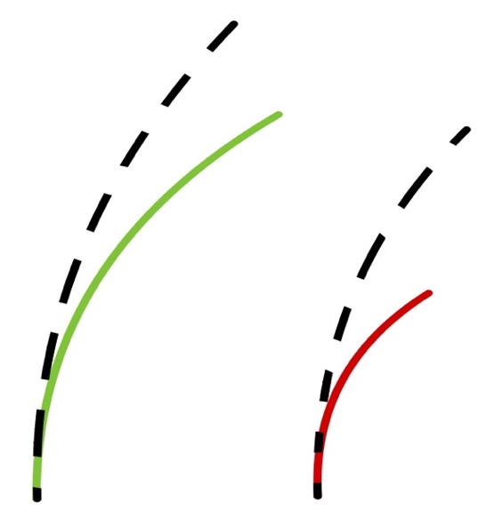

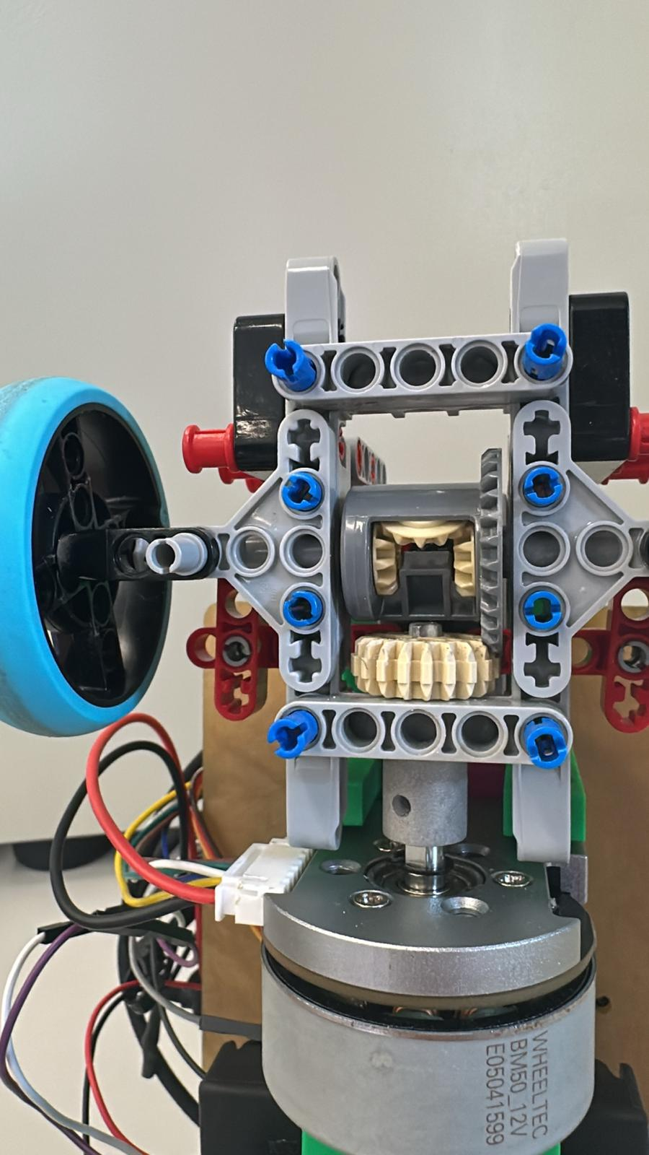
Fig. 1. Mechanical differential of the robot

Fig. 2. Path differences between the inner and outer wheel sets with and without differential.

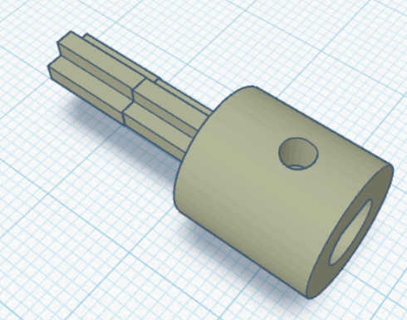
Fig. 3. CAD model of the D-shaft-to-LEGO-axle

2.3. Ackermann Steering
Ackermann steering geometry improves turning performance by ensuring that the inner and outer front wheels are aligned toward a common instantaneous centre of rotation during low-speed manoeuvres. While go-karts typically use steel tubing and adjustable linkages to achieve precise steering geometry, our LEGO-based Ackermann steering system uses a simplified linkage design that still provides measurable improvements in cornering performance, as illustrated in Fig. 4.
In an Ackermann steering system, the inner wheel turns at a sharper angle than the outer wheel. This allows all four wheels to follow concentric paths around a common centre of rotation during a turn. If both front wheels were set to the same steering angle, they would resist each other’s motion, increasing rolling resistance, tyre slip, and energy loss. By combining the Ackermann steering mechanism with our new FWD differential setup, we were able to minimise sliding and improve turning efficiency.

Our Ackermann Steering | Ideal Ackermann Steering
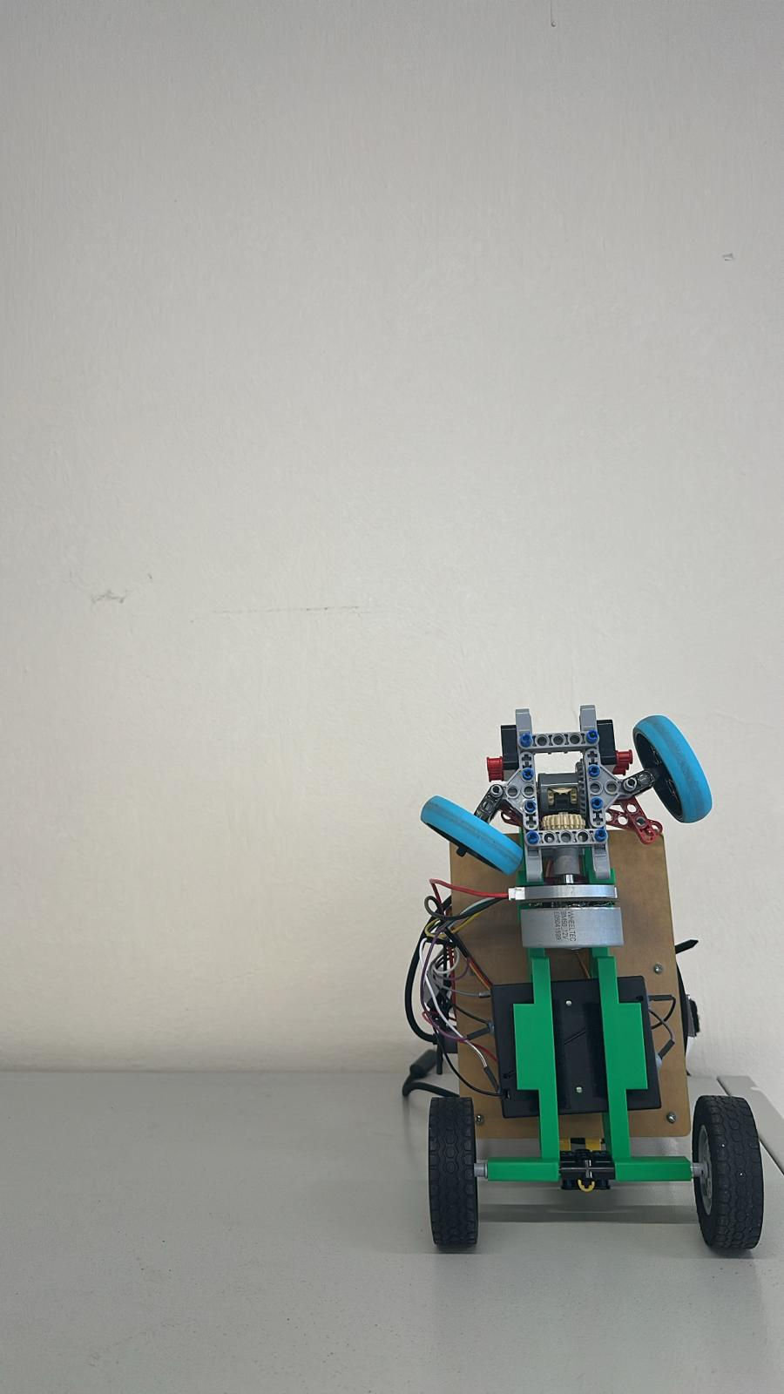  Fig. 4. Ackermann steering applied in our smart car. | 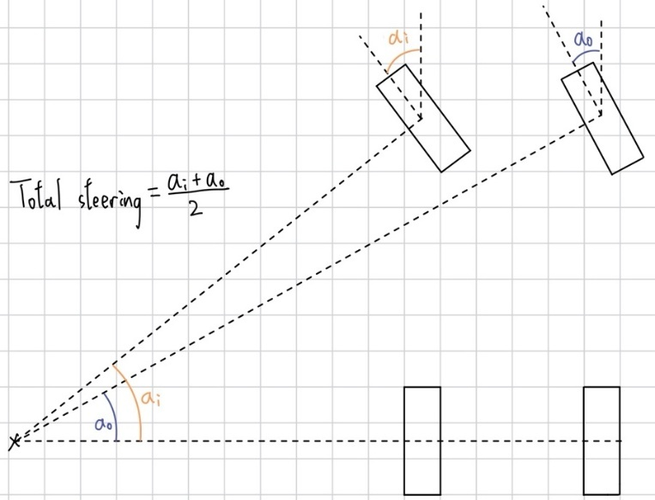  Fig. 5. A sketch showing an ideal Ackermann steering and the final steering angle with this system.

2.4. Chassis Design
A shorter wheelbase improves manoeuvrability and agility by allowing the vehicle to complete tighter turns. Figure 7 compares the turning radii of long- and short-wheelbase configurations, calculated using the maximum inside-wheel steering angle under ideal Ackermann geometry. As shown in the figure, the shorter wheelbase produces a noticeably smaller turning radius.
To observe this effect in real vehicles, we visited an industrial area and compared the turning behaviour of different heavy vehicles. We observed that a standalone Scania tractor unit had a relatively small turning radius, allowing the driver to complete a left turn directly by steering left. In contrast, a Scania tractor hauling a container required a much larger turning space. The driver first steered slightly to the right to create enough clearance before turning left. Although the tractor units were essentially the same, the attached container increased the overall vehicle length and swept path, making tight cornering more difficult in narrow spaces.
Guided by this observation, we reduced the wheelbase of our robot to improve agility and cornering response. At the same time, we placed the heavier components in the lower part of the chassis to maintain a low centre of gravity and improve stability during turns.
Although shortening the chassis can increase the risk of oversteering, our FWD design helps reduce this issue by placing both the driving and steering functions on the same pair of front wheels. Since the front wheels actively pull the robot in the intended direction, the robot can maintain better directional control during turns. This reduces the tendency of the rear section to swing outward, especially when cornering at higher speeds or making sharp manoeuvres.
In addition, the compact chassis improves agility, while the FWD layout helps preserve stability. By combining a shorter wheelbase with careful weight distribution and front-wheel traction, we were able to achieve tighter turns without significantly compromising control.
During a turn, the inside wheel follows a shorter arc than the outside wheel. If both front wheels share the same steering angle, they cannot follow concentric paths, resulting in tyre slip and increased rolling resistance. Ackermann steering addresses this issue by turning the inside wheel at a sharper angle than the outside wheel, aligning all wheels toward a common centre of rotation. This geometry minimises sliding, reduces resistance, and enables smoother cornering. In our tests, implementing Ackermann steering reduced the turning radius of our smart car by approximately 5%.
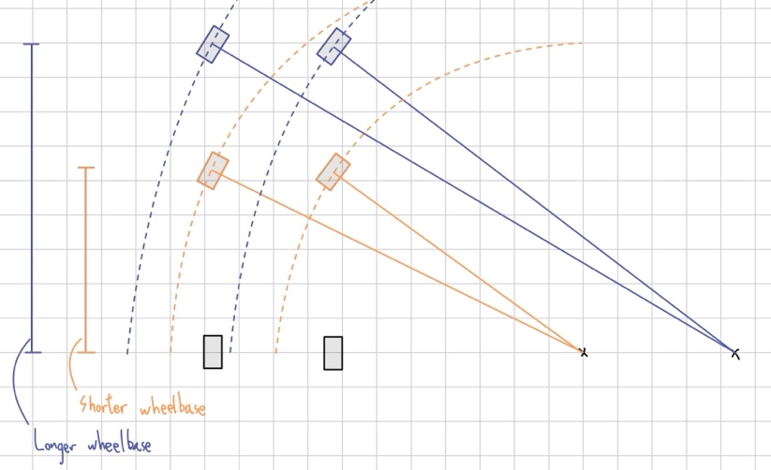
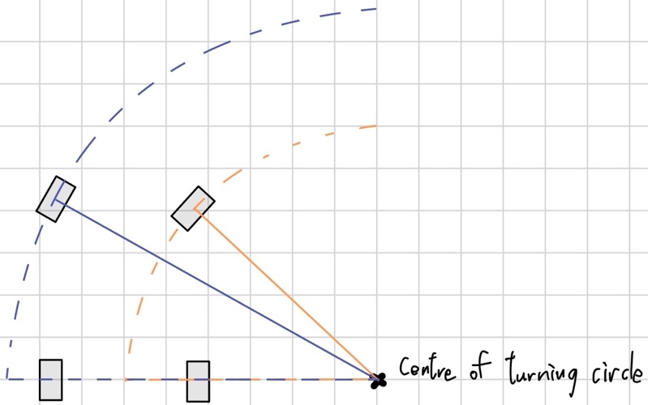
Fig. 7. Turn radius comparison between long (blue front wheels) and short (orange front wheels) wheelbases

Fig. 6. A sketch showing that all the wheels are following concentric paths.

Based on our previous experience, we realised that relying heavily on LEGO elements limited the flexibility of our mechanical design, especially when compared with a fully custom 3D-printed chassis. Although LEGO components are convenient for rapid prototyping and adjustment, they also impose constraints on structural layout, component placement, and overall compactness.
To address these limitations, we first rebuilt the main frame using acrylic plates. This improved the rigidity of the chassis and allowed us to arrange the electronic and mechanical components more flexibly. The acrylic frame also provided a more stable platform for testing different drivetrain and steering configurations.
After further evaluation, we designed a 3D-printed main frame to reduce the overall size of the robot and improve integration between different components. This custom chassis allowed us to create a more compact, lightweight, and purpose-built structure, further enhancing its mobility, stability, and overall performance.

2.4.1 Centre of Mass Consideration
Benefits of a low centre of mass design

Reduced Rollover Risk:  During cornering, lateral acceleration generates an outward rolling moment that is proportional to the height of the centre of mass. Lowering the centre of mass reduces this rolling moment and improves the vehicle’s resistance to rollover. | Impact on Inertia:  A lower centre of mass helps reduce body roll during steering and directional changes. This allows the robot to respond more predictably to steering inputs, especially when making sharp turns or quick corrections.
Increased Stability:  Lowering the center of mass improves overall stability and reduces the robot’s sensitivity to external disturbances, such as uneven surfaces, sudden acceleration, or minor collisions with track boundaries. | Better Cornering:  During cornering, weight shifts toward the outer wheels. A lower centre of mass reduces this weight transfer, allowing the wheels to maintain more consistent contact with the ground. This improves grip and enables faster, smoother, and more controlled turns.

In summary, a low center of mass is essential for stability, safety, and responsive handling. Therefore, we arranged the components of our smart car as close to the chassis as possible and removed nonessential parts. The heaviest components, the battery box and the driving motor, are mounted at chassis level, while only the camera is positioned above the main board. This layout helps reduce rollover risk during high-speed turning, improve cornering stability, and maintain a compact overall structure.

2.4.2 Weight Control
Minimising the mass of the smart car is critical for maximising speed. Proved by the following formula,
$$KE = \frac{1}{2}mv^{2}$$
a lower mass $m$ yields a higher velocity $v$ for a given energy input $KE$. Wheel mass is especially influential because it directly affects rotational inertia and acceleration. We, therefore, selected the lightest available LEGO wheels and rigorously limited component count, constructing the Ackermann linkage with the fewest pieces and installing only essential modules.

2.5. The Front-Wheel Drive (FWD)
The transition from rear-wheel drive (RWD) to front-wheel drive (FWD) was a strategic engineering decision aimed at improving cornering stability and manoeuvrability. A detailed comparison of our experimental results for the RWD and FWD configurations is presented in Table II.

2.5.1 Decision and Benefits using FWD
In our mechanical setup, which uses plastic and rubber components on a competition mat, the RWD configuration tended to push the robot through turns. This made sharp cornering more difficult and increased the risk of understeering or wheel slip. After comparing the advantages and disadvantages of both drivetrain layouts, we decided to implement FWD in our robot this year, despite its greater mechanical complexity compared with an RWD design.

By adopting an FWD system, the front wheels actively pull the robot along the intended trajectory. Since the same pair of wheels is responsible for both steering and driving, the driving force helps guide the robot through the turn rather than resisting the steering motion. This allows the robot to achieve larger effective steering angles while maintaining better traction and directional control.

During testing, this integrated front-end system successfully reduced the turning radius to 25 cm and achieved a consistent cornering time of approximately 1 second. These results demonstrate that the new FWD architecture provides significantly better cornering performance than our previous RWD design.

Tests \ Setups | RWD | FWD
Stability | Understeer during sharp turns | Stable when entering corners
Cornering | Push the car wide when too much power | Easier to control, especially at low speeds
Traction | Poorer when rear traction is lost | Higher as weight shifts forward
Acceleration | Better as weight shifts to the rear | Worse as weight shifts backwards, losing front-wheel traction
Mechanical design | Simpler | More complex
Straight-line speed | Faster but less stable | Stable but slightly slower
Parking | Fast but less precise | Easier to control
Table II. Experimental performance comparison of the rear-wheel-drive and front-wheel-drive configurations. For each criterion, green cells indicate the better-performing configuration, while red cells indicate comparatively poorer performance.

2.5.2 Kinematic Analysis: Overcoming Understeer
To understand the necessity of shifting from rear-wheel drive (RWD) to front-wheel drive (FWD), it is important to analyse the underlying vehicle dynamics, particularly the traction limits and force directions acting on the robot during cornering.

In real-world automotive engineering, FWD vehicles are often more prone to understeer because the front tyres must share their available grip between steering and acceleration. However, our testing showed that the behaviour of our LEGO-based robot was different from that of a full-scale vehicle. The friction coefficient between our wheels and the competition mat is much lower than that of real tyres on asphalt, which significantly changes the balance between driving force, lateral grip, and steering response.

In our previous RWD setup, the rear wheels generated the forward driving force while the front wheels were responsible only for steering. When the front wheels were turned at a large angle, they did not have enough lateral grip to redirect the chassis effectively. As a result, the rear wheels continued to push the robot forward, while the angled front wheels resisted the motion instead of guiding the robot through the turn. This conflict between the rear driving force and the front steering direction caused severe understeer. It also created large lateral forces on the steering knuckles, which contributed to structural failures where the front wheels detached during testing.

The FWD architecture reduces this problem by aligning the driving force more closely with the steering direction. Since the front wheels are responsible for both driving and steering, the force pulling the chassis is directed along the intended path of the turn. Meanwhile, the rear wheels act mainly as free-rolling trailing wheels, reducing the opposing force that previously pushed the robot straight ahead. This improved force alignment reduces understeer, lowers lateral stress on the steering components, and provides more stable cornering performance.

2.6. Independent Rear Stub Axle Assembly
To complement our new front-wheel-drive (FWD) architecture, we completely redesigned the rear wheel assembly. Instead of using a continuous solid axle or adding a rear differential, we implemented an independent rear stub axle system.
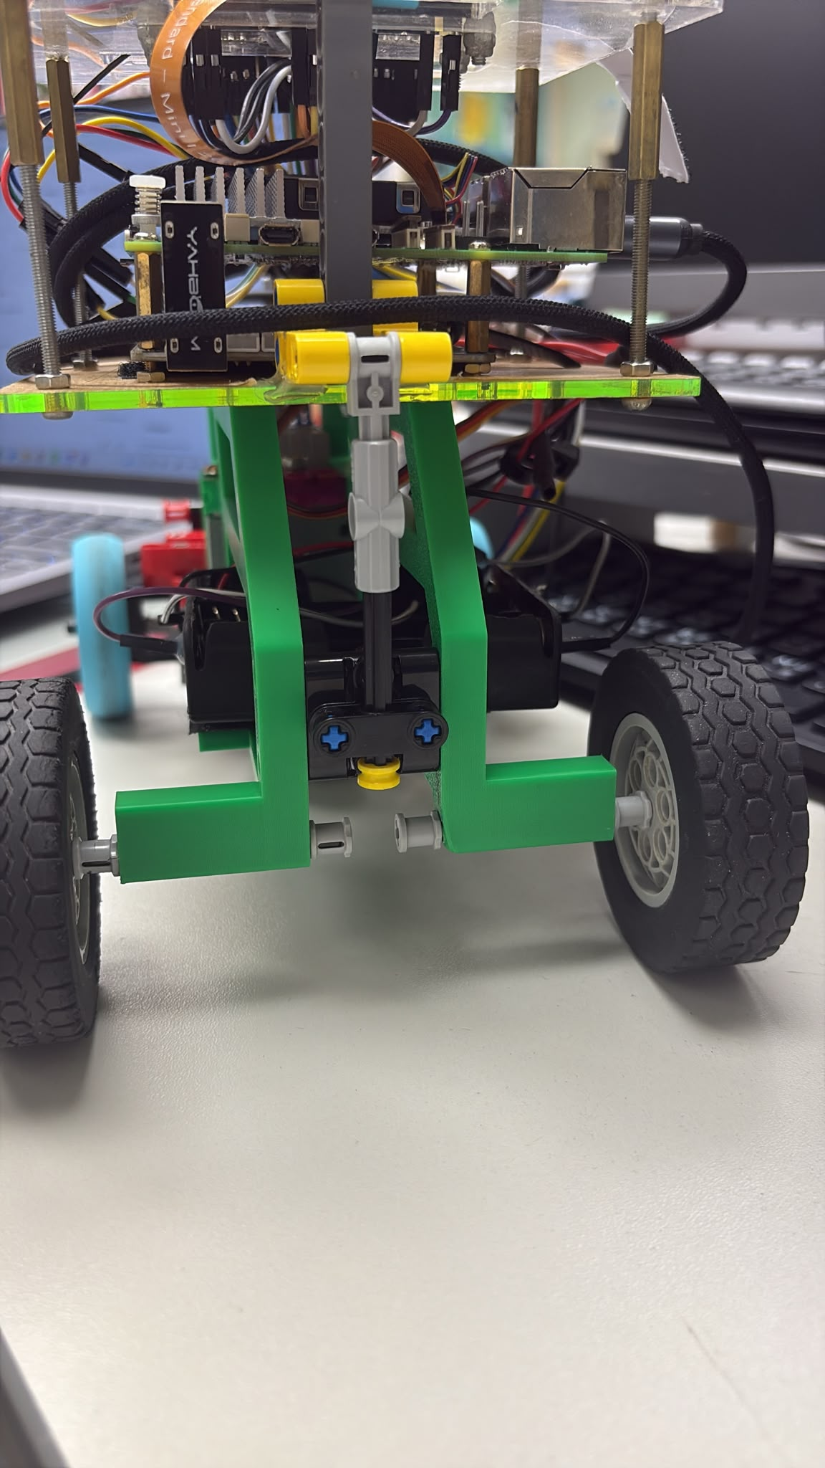
Fig. 8. Independent Rear Stub Axle Assembly

Mechanical Integration:
The rear wheels are mounted on two separate, non-driven stub axles, also known as dead axles. These short independent shafts are inserted directly into a custom-designed 3D-printed support structure, which is rigidly secured to the main chassis. Unlike a conventional solid-axle setup, there is no mechanical linkage or continuous shaft connecting the left and right rear wheels.

Kinematic Advantages:
This design was selected to match the kinematic requirements of our FWD system. Since the front axle is responsible for both propulsion and steering, the rear wheels only function as load-bearing, free-rolling trailing wheels.

During a turning manoeuvre, the outer rear wheel follows a longer arc than the inner rear wheel and therefore needs to rotate at a higher speed. If a solid rear axle were used, both rear wheels would be forced to rotate at the same speed. This would cause one wheel to slip or drag along the competition mat, increasing rolling resistance and reducing cornering efficiency.

By using independent stub axles, the left and right rear wheels are mechanically decoupled. This allows them to rotate at different speeds naturally during cornering, passively accommodating the required wheel-speed difference. As a result, we can avoid using a complex and bulky rear differential while reducing overall weight, mechanical friction, and energy loss. This design supports smoother and more efficient cornering, which is especially important for sharp turns and parking manoeuvres in the WRO Future Engineers missions.

3. Power and Sense Management

3.1. Power consumption of electrical components
Table III shows the power requirements for all the electronic components of the robot.

 | Current (A) | Voltage (V) | Power (W)
ESP32-S3 | ~ 0.06 | 5 | ~ 0.3
BM50 motor with encoder | < 0.65 | 12 | < 7.8
Raspberry Pi 5 | < 3 | 5 | ~ 15
Pi Camera module 3 wide | ~ 0.2 | 3.3 | ~ 0.65
LCD HAT | ~ 0.04 | 3.3 | ~ 0.132
CZ356 | ~ 0.55 | 5 | < 2.75
Table III. Summary of the power requirements for the electronic components used in the robot.

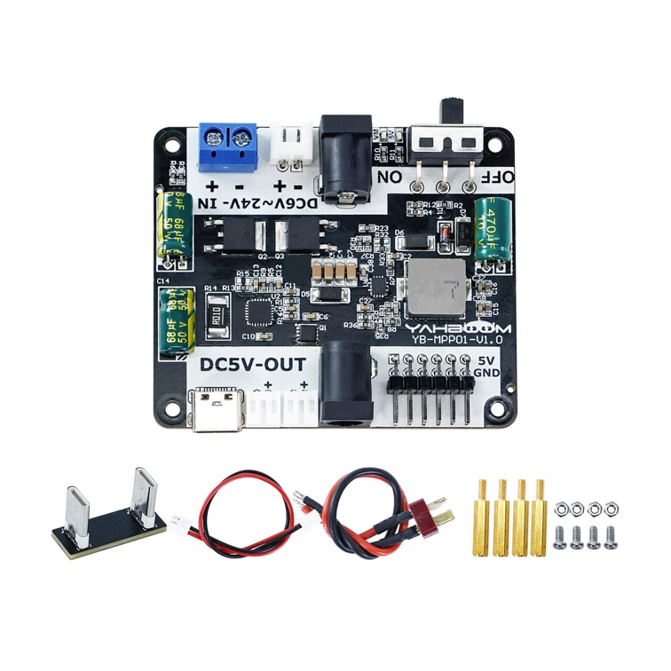
3.2. Voltage Converter (YB-MPP01-V1.0)
The YB-MPP01-V1.0 is a buck converter designed for the Raspberry Pi 5. Its function is to step down the input voltage from the main battery source to a lower and stable output voltage suitable for the Raspberry Pi.

Since the robot must operate independently during the challenges, it is not possible to power the Raspberry Pi using a 5 V power adapter connected to a wall socket. Therefore, a voltage converter is required to convert the battery voltage into a stable 5 V supply for the Raspberry Pi. By using the YB-MPP01-V1.0 power supply expansion board, we can ensure that the Raspberry Pi 5 receives a reliable power input while the robot remains fully mobile during testing and competition runs. The minimum efficiency of this board is approximately 80%.

3.3. Power Source (Enhanced 18650 batteries)
Drawing on our previous WRO RoboMission experience, we recognised that robot performance can be sensitive to battery condition and voltage stability. Therefore, we selected batteries with a higher capacity and a more stable voltage output under load than standard zinc–carbon batteries.
18650 alkaline zinc battery is the best choice for our robot. Using the data from Table III, we can estimate the capacity of electricity required for operating one hour at maximum power:
The total maximum power required from the power source is given by
$15+ 2.75+0.132=22.3525 W$.
Since the minimum efficiency of the YB-MPP01-V1.0 buck converter board is 80%, the power required directly from the power source, including the BM50 motor, which is directly connected to the power source, is
$\frac{22.3525}{80\%}+7.8=30.1525 W$.
Assume the maximum output voltage of the power source is 12V; the capacity of the power source required for operating one hour at maximum power is
$\frac{30.1525}{12} 1 1000=2512.7 mAh$.
Compared with our original 1500mAh batteries, each of the enhanced 3200 mAh cells provide an additional 1700mAh of capacity. This allows the robot to operate for longer periods between charges, giving us more continuous testing time during practice and improving reliability throughout the competition day.
Based on our calculated power requirement, the robot requires approximately 2512.7 mAh of capacity for operation. Since the three 18650 batteries are connected in series, the total voltage increases to approximately 11.1 V nominal, or 12.6 V when fully charged, while the battery-pack capacity remains 3200 mAh. Therefore, the selected battery pack provides sufficient capacity for the required operating time, with an additional safety margin of approximately 687.3 mAh.
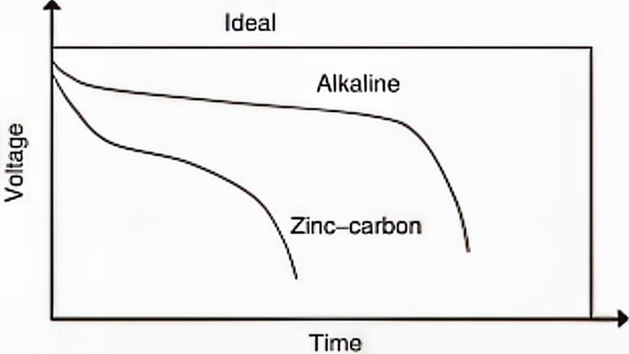
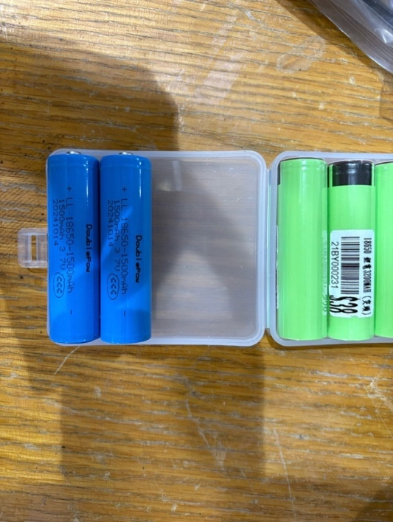
Figure 9 compares the discharge curves of the two battery types. The alkaline zinc battery shows a noticeably flatter voltage profile, indicating smaller voltage fluctuations over time. Based on this comparison, we chose rechargeable 18650 alkaline zinc batteries instead of conventional zinc–carbon cells because they provide better voltage stability and are more environmentally friendly due to their reusability.
Fig. 9. Ideal and actual discharge curves of primary zinc batteries (Alkaline Zinc cell and Zinc-carbon cell) (Huot, 2009)
Fig. 10. Batteries used for our smart car. Left (blue): 1500 mAh. Right (green): 3200 mAh.

3.4. Camera (Pi Camera Module 3 Wide)
Before construction, we researched competitor strategies and identified two main obstacle-detection methods: close-range colour sensing and camera-based vision. A camera-based system allows the robot to detect multiple obstacles simultaneously and recognise the track layout from a greater distance. This enables earlier decision-making and faster responses during both the Open Challenge and the Obstacle Challenge. Therefore, we adopted a vision-based approach for the robot this year.
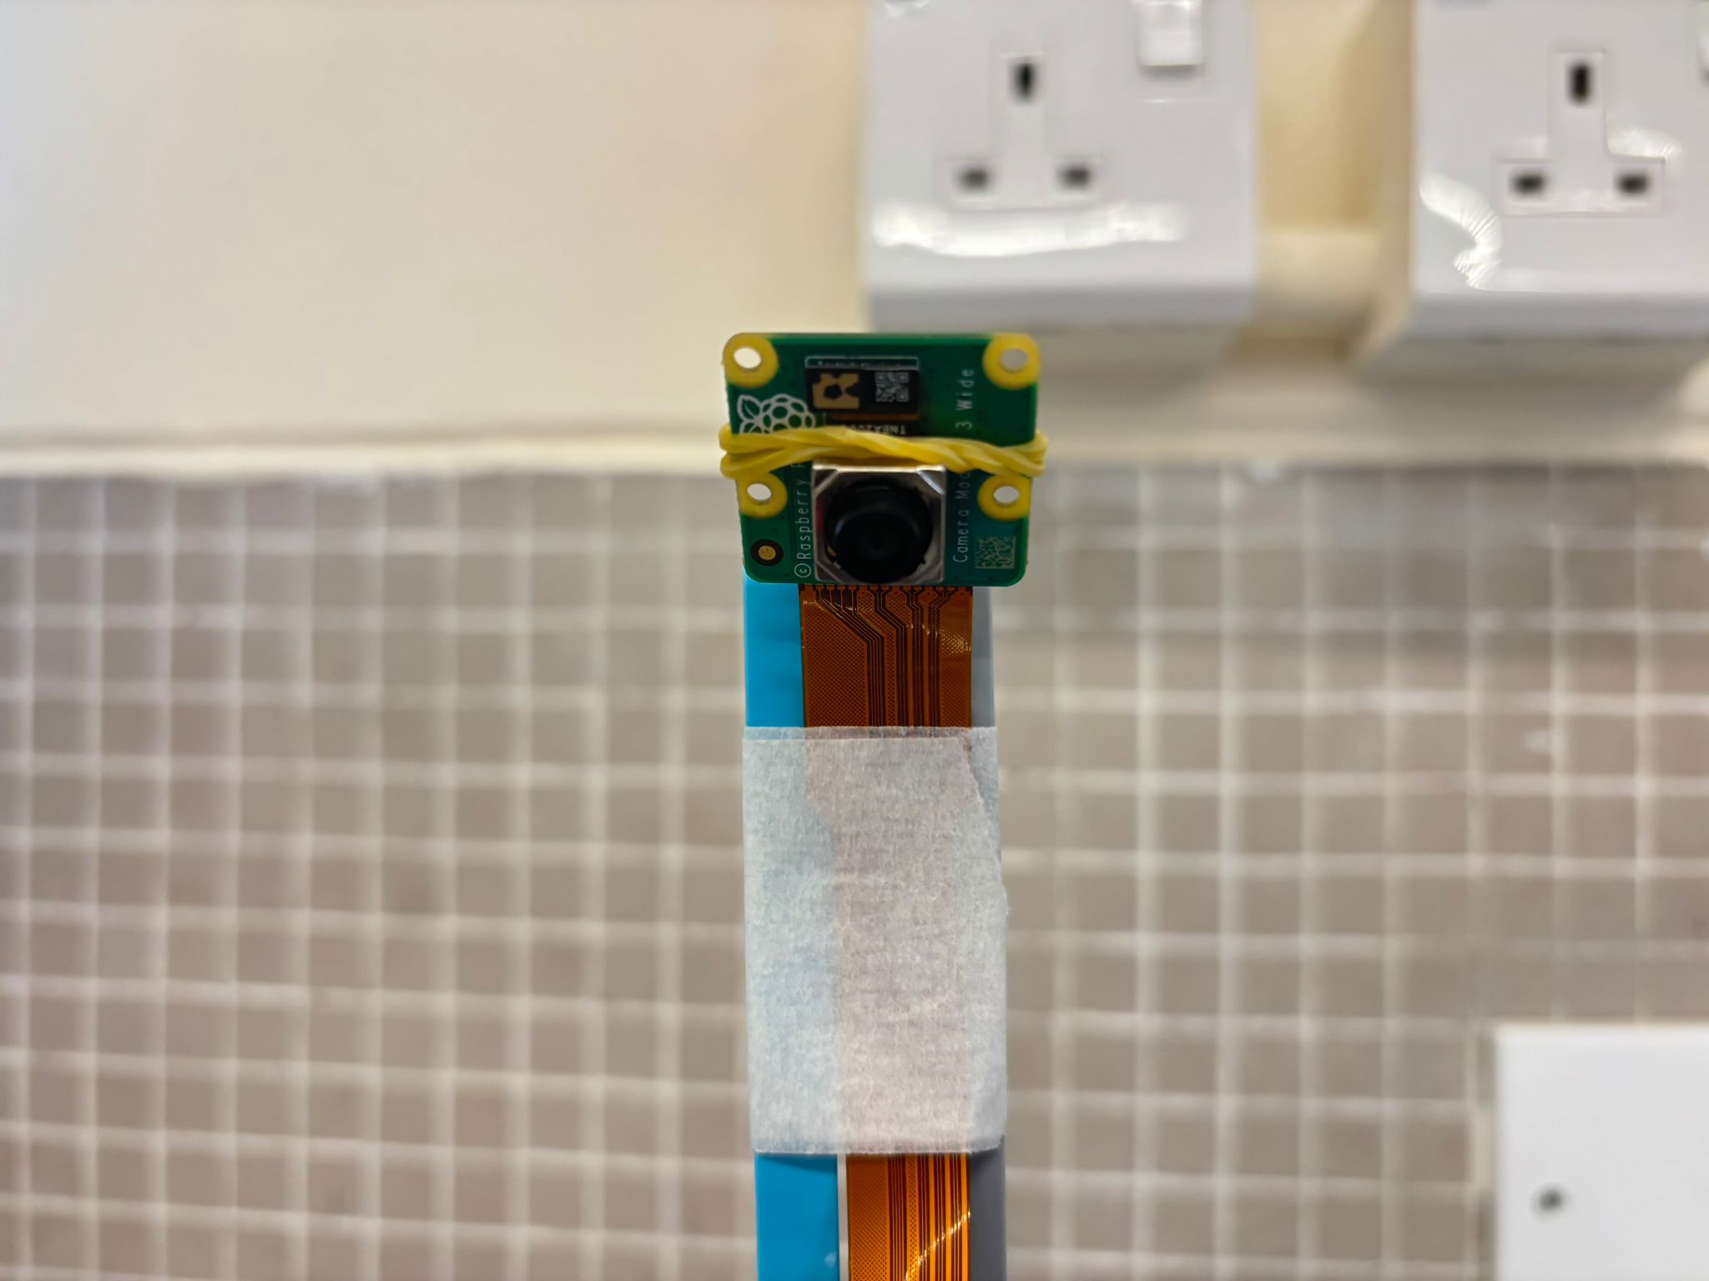Fig. 11. The Pi Camera module 3 wide we used for the Obstacle Challenge.
Previously, we used the Pixy 2.1 camera module. However, through testing, we found that its performance was not sufficiently stable across different environments, especially when lighting conditions changed. As a result, we switched to the Raspberry Pi Camera Module 3 Wide. This camera can capture images at up to 12 megapixels and provides a wide field of view, allowing the robot to detect obstacles, track boundaries, and road features at greater distances with improved accuracy and consistency.

3.5. Motor with encoder (BM50 with encoder)
While preparing for the previous competition, we learned about the BATTLEACE robot competition, where participating robots use compact motors capable of delivering high speed and high power output. This inspired us to search for a fast and powerful motor with an integrated encoder that could be used in our robot car.
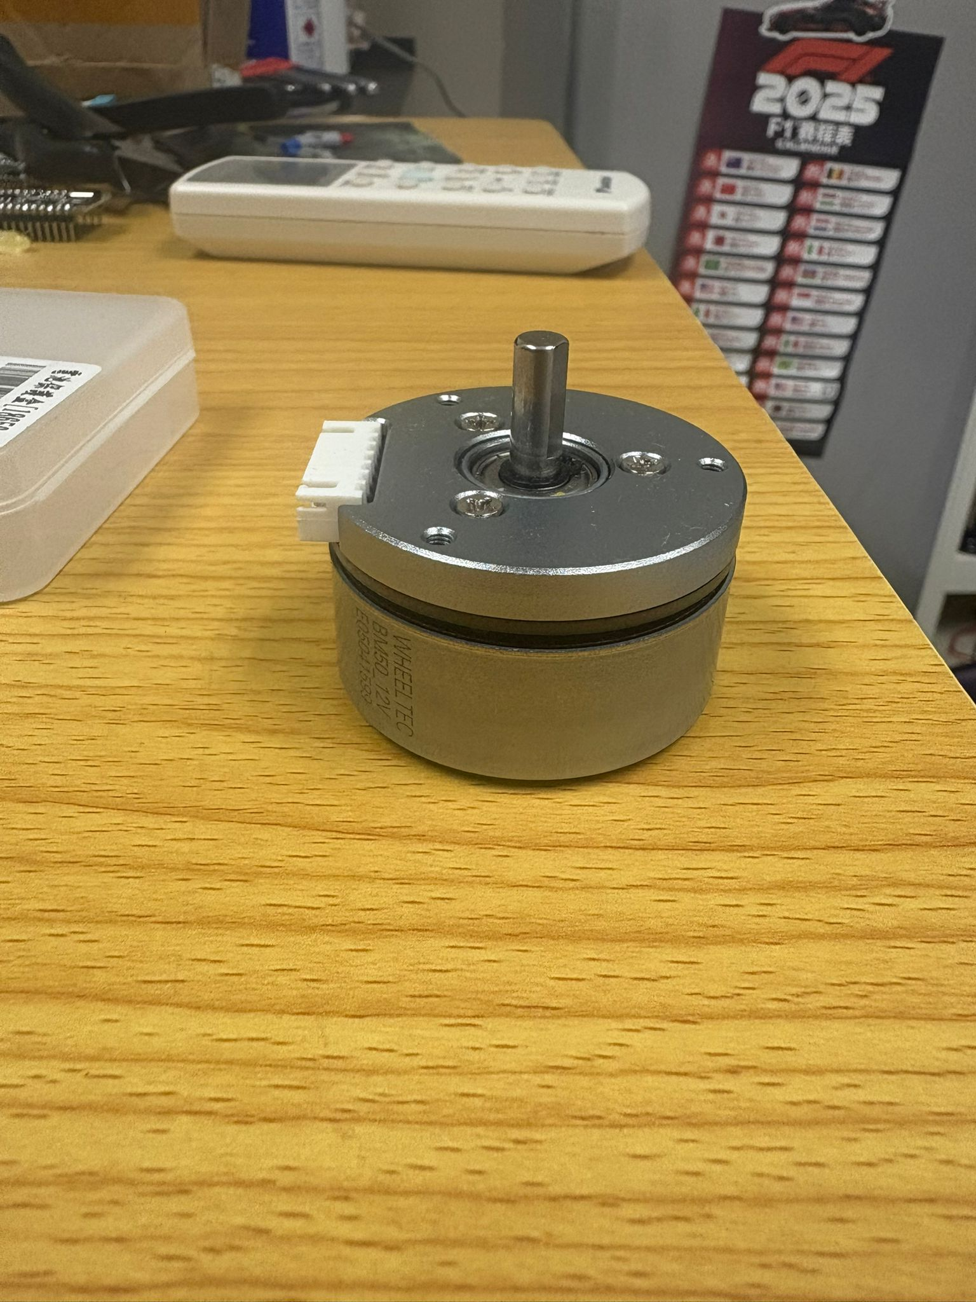Fig. 12. The encoder motor we used.
After comparison and testing, we selected the BM50 motor. During testing, we found that applying only approximately 14% of the BM50 motor’s power produced a speed similar to that of our previous motor operating at full power. A more detailed comparison is provided in Table IV. Based on this significant performance improvement, we decided to replace the previous motor with the BM50.
With this upgrade, our robot was able to complete the Open Challenge in just 19 seconds while using only 50% of the BM50 motor’s power. This demonstrates that the BM50 provides a substantial speed reserve, allowing us to achieve faster performance while still maintaining room for further speed adjustment and control optimisation.
Motors | Motor Voltage (V) | No load current (A) | Rated load current (A) | Stall current (A) | Rated speed (RPM) | Stall torque  (N ⋅ m)
BM50 | 12 | 0.65 | 2.6 | 16 | 4450 | 0.423
MATRIX TT Encoder Motor | 6 | 0.47 | 1.31 | 3.4 | 163 | 0.08
LEGO EV3 Large Motor | 7.4 | 0.07 | 0.5 | 1.8 | 170 | 0.21
LEGO SPIKE Prime Large Motor | 7.2 | 0.135 | 0.43 | 1.4 | 175 | 0.25
Table IV. Comparative summary of the BM50 motor and other commonly used motors, based on key specifications, performance characteristics, and suitability for the robot’s driving system.

From Table IV, we can see that BM50 outperforms all other commonly used motors. Here, we also proved that it is the optimal motor for our robot to participate in the Future Engineers challenges:
Below is a table of the basic information of our robot:
Weight: | 0.95kg | Front-wheel radius: | 0.028m | Differential gear ratio: | 20:28
Targeted acceleration: | 0.6m/s² | Rolling coefficient: | 0.02 | Differential efficiency: | 70%
Table V. Basic specifications of our robot.

From Table V, we can then calculate the torque required for the motor we used. The force required for the robot to achieve the given targeted acceleration is given by
$0.95 0.6=0.57$N.
Thus, the torque required is
$0.57 0.028=0.01596$Nm.
However, the wheels also experience rolling friction between them and the ground. The additional torque required to overcome the friction is given by
$0.95 9.81 0.02 0.028 2=0.01043784$Nm,
where the total torque on the wheels is
$0.01043784+0.01596= 0.02639784$Nm.

Since the wheels are connected to a mechanical differential, the gear ratio and the efficiency of the differential should also be considered. Therefore, the torque required from the motor is
$\frac{0.02639784}{\frac{28}{20} 0.7}= 0.02693657143Nm<0.423Nm$.
Therefore, the BM50 is a suitable motor with sufficient torque to drive the robot.
The encoder integrated with the BM50 motor measures the travel distance of the robot by recording the rotation angle of the motor. By converting the encoder readings into wheel rotation and travelled distance, the robot can control its movement more accurately and repeatably.
For example, during the Obstacle Challenge, the robot reverses by a fixed distance after completing each lap. This is achieved by resetting the encoder count and using the encoder feedback to control the backward motion until the required distance is reached.
Since the Raspberry Pi 5 requires a stable 5 V supply, the YB-MPP01-V1.0 buck converter is incorporated into the power system to step down the battery voltage to a suitable level for the Raspberry Pi. The BM50 motor, which operates at 12 V, is powered separately through the motor drive circuit.

3.6. Steering motor (CZ356 Servo Motor)
We selected the CZ356 servo motor for the steering system not only because of its compact size, but also because of its LEGO-compatible design. This compatibility allows the servo motor to be mounted easily onto our robot using simple LEGO attachments and structural parts, reducing the need for complex custom-made brackets. As a result, the steering mechanism can be assembled, adjusted, and repaired more conveniently during testing and competition.
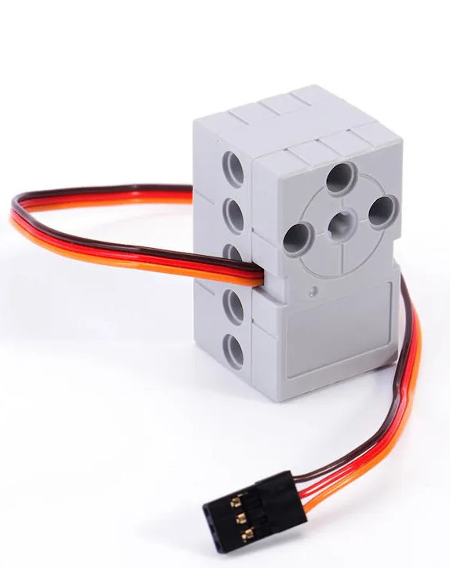
Fig. 14. The CZ356 servo motor.
The small size of the CZ356 servo motor is also important because our steering system is located at the front of the robot, where space is limited due to the integration of the front-wheel-drive mechanism, differential, and Ackermann steering linkage. A compact servo helps us keep the front assembly lightweight and organised, which improves the overall balance of the robot and reduces unnecessary load on the steering structure.
Since our robot is lightweight, only a moderate amount of torque is required to rotate the front steering linkage. The CZ356 servo motor provides a torque of 0.16 N·m while operating under a 5 V power supply, which is sufficient for our steering mechanism. This allows the robot to achieve stable and responsive steering without using a larger and heavier servo motor.
In addition, using a 5 V servo motor simplifies the electrical design, as it can be powered from the regulated low-voltage supply used by other control components. Overall, the CZ356 servo motor provides a suitable balance of size, torque, ease of installation, LEGO compatibility, and electrical simplicity, making it an appropriate choice for the steering system of our robot.

3.7. Debug Display (Waveshare 1.3” IPS LCD HAT)
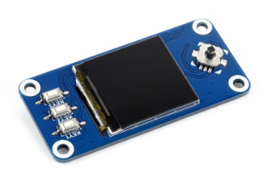
Fig. 15. The monitor we used.
During testing and calibration, a debug display is essential for monitoring the robot’s internal status in real time. We selected the Waveshare 1.3-inch IPS LCD HAT because it provides a compact but clear display that can be mounted directly onto the robot without occupying much space. Its 240 × 240 resolution is sufficient for showing key information such as program status, camera detection results, motor speed, steering angle, battery voltage, lap count, and error messages.
This display is particularly useful during practice sessions because it allows us to check whether the robot is operating correctly without connecting an external monitor or computer. For example, when tuning the vision algorithm, the display can show whether obstacles, track boundaries, or colour regions are being detected correctly. When testing the driving system, it can also show encoder readings, selected speed settings, or whether the robot is currently in start, stop, calibration, or running mode.
In addition, the HAT includes three push buttons, which provide a simple physical interface for controlling the robot. These buttons can be programmed to start or stop the robot, switch between testing modes, reset values, or trigger calibration procedures. This makes repeated testing more efficient, as we can control the robot directly from the onboard interface instead of modifying the program or reconnecting to the Raspberry Pi each time.

3.8. Build Of Materials and Wiring Diagrams

3.8.1. Build Of Materials
Label | Quantity | Name
BT1 | 3 | 18650
M1 | 1 | BM50
M2 | 1 | Motor_Servo
Module1 | 1 | Raspberry Pi 5
U1 | 1 | ESP32-S3-DevKitC
U2 | 1 | Pi Cam 3
U6 | 1 | BM50 Motor Driver Encoder
U8 | 1 | YB-MPP01-V1.0
U9 | 1 | ST7789 HAT

3.8.2. Schematic of ESP32-S3
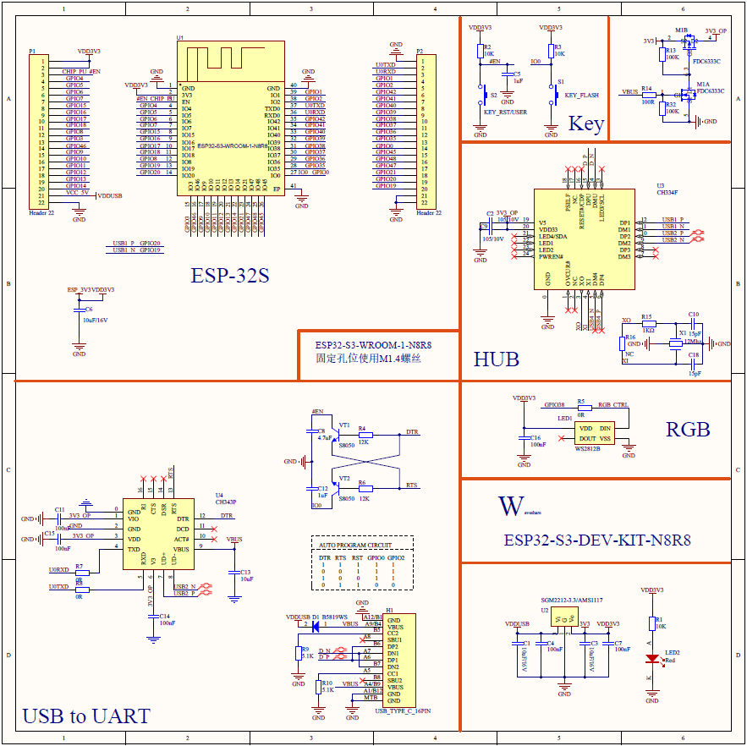

3.8.3. Schematic of Waveshare 13” ISP LCD HAT
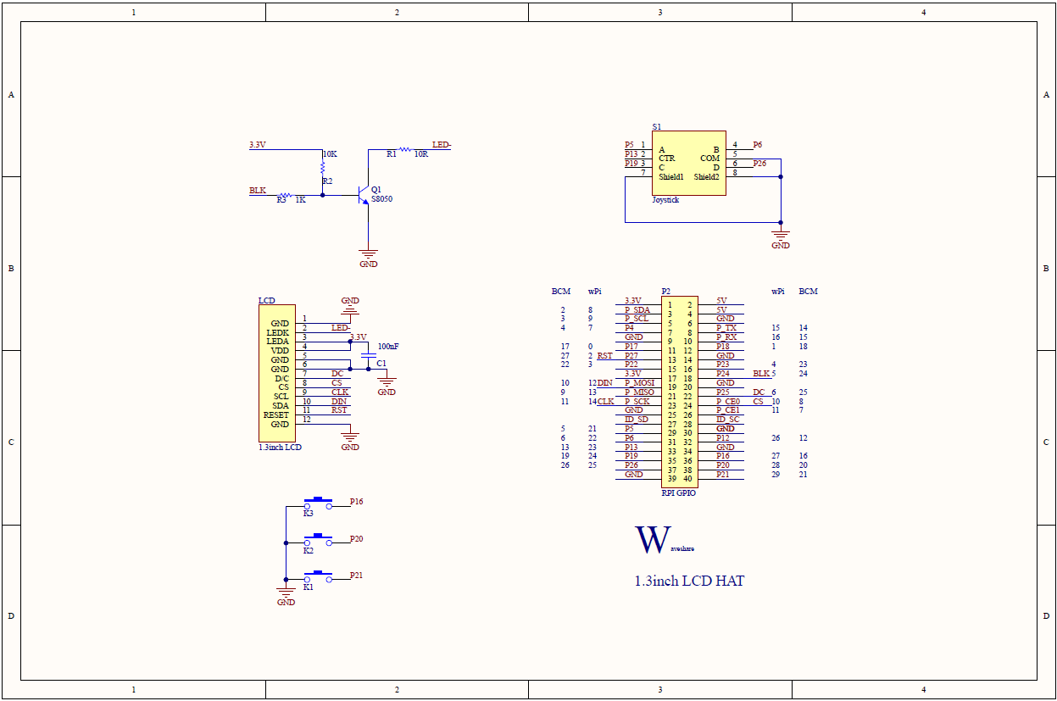

3.8.4. Pictorial Wiring Diagram
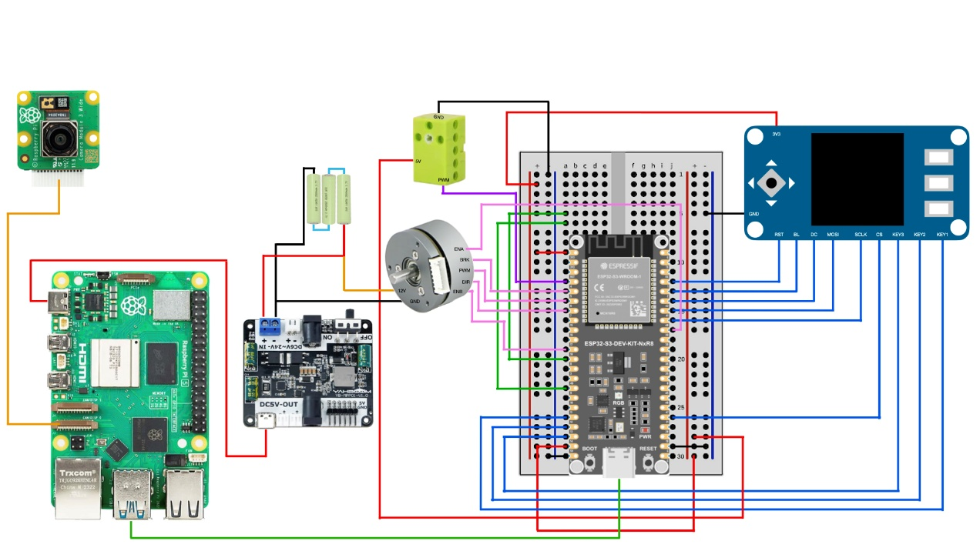

3.8.5. Schematic Wiring Diagram
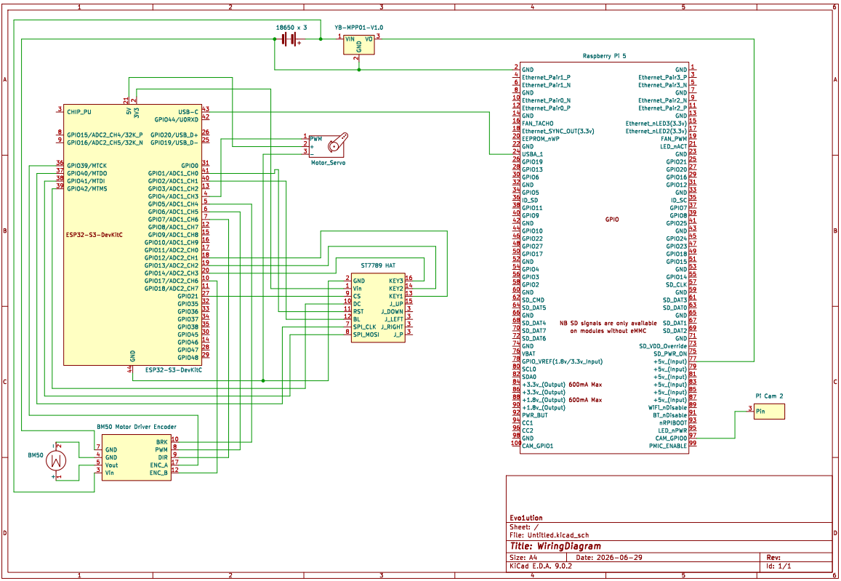

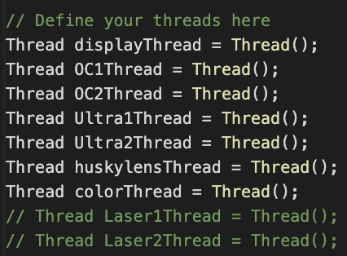
4. Obstacle Management
**Fig. 15.** Example of our program code showing how threads are created to manage multiple tasks concurrently.
To minimise workload and conserve computing resources during multitasking, we use the ThreadController library to manage task execution efficiently. Instead of creating a large number of threads, we only create the essential ones required for key functions. This reduces unnecessary context-switching overhead and helps maintain stable real-time performance.
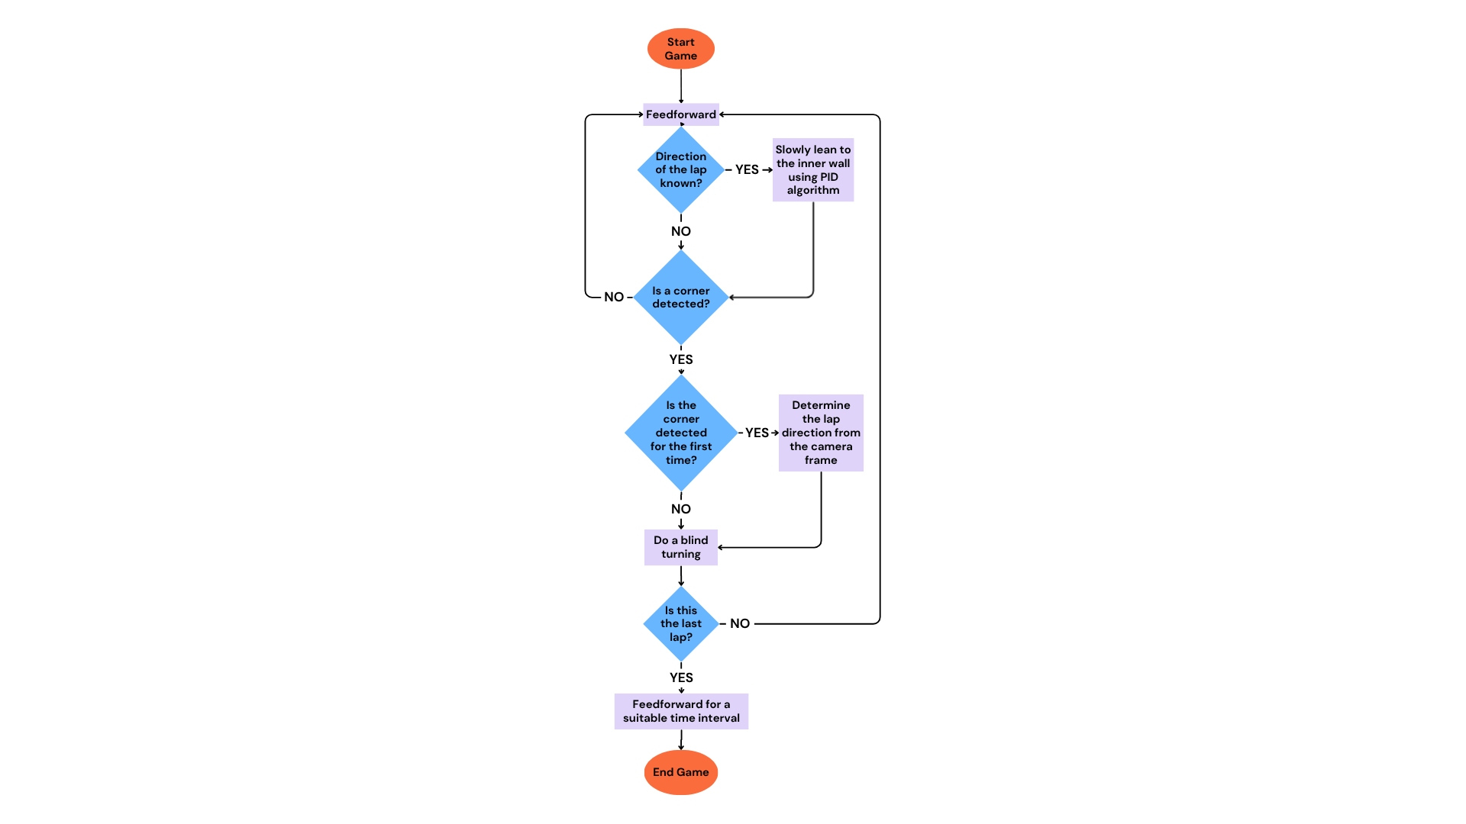
Fig. 19. Flow chart of our program for the Open Challenge
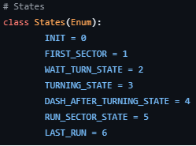
Fig. 18. Example of our program code showing the operating states used in the robot’s state machine.
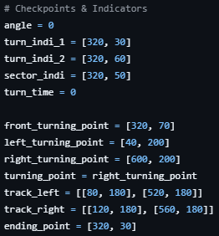
Fig. 17. Example of our program code showing how checkpoints are used to track the robot’s progress and control its behaviour during the challenge.
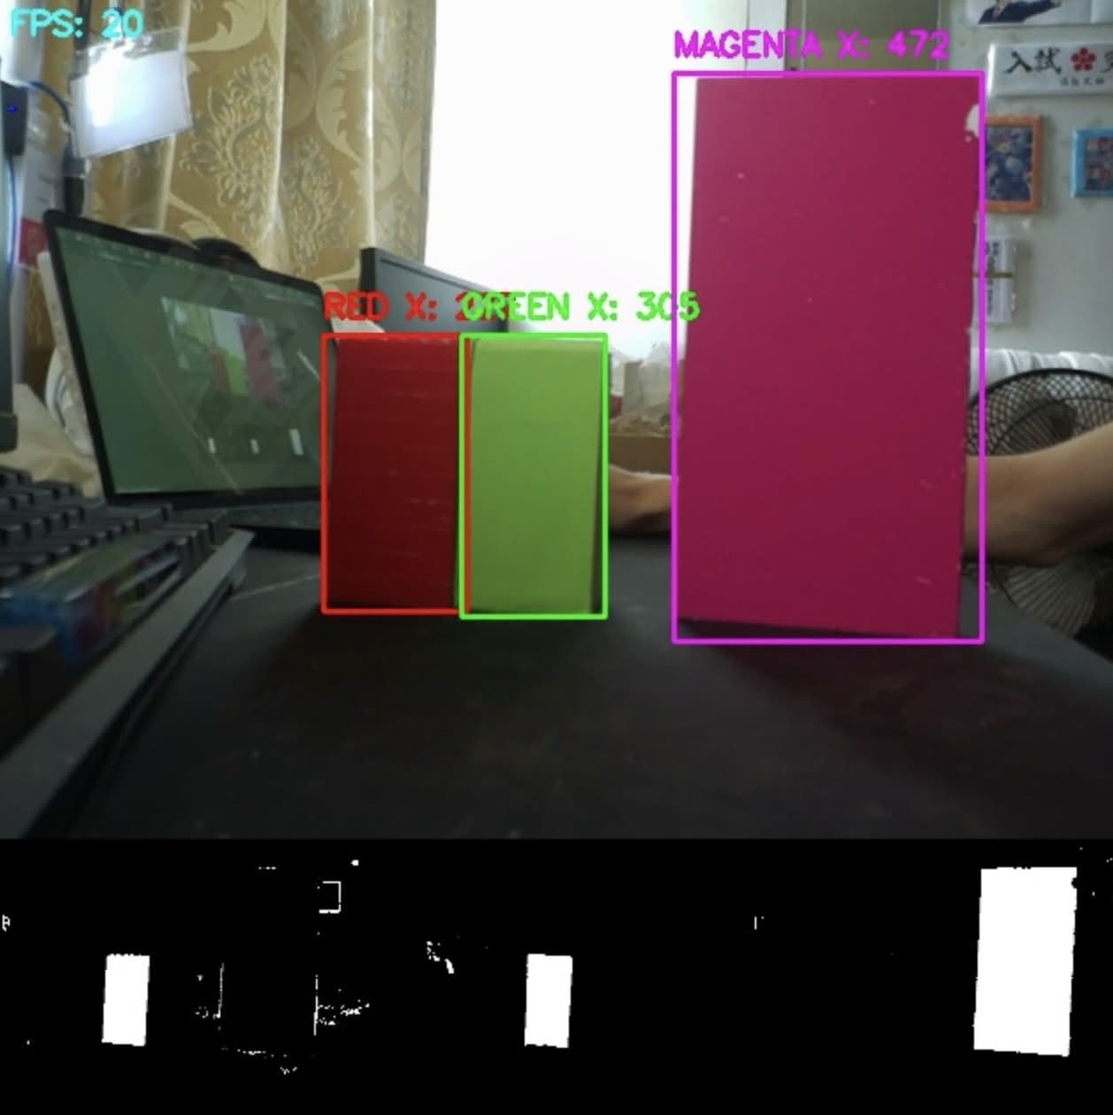
Fig. 16. Results of the image-processing filters used to detect and highlight key visual features, including track boundaries, obstacles, and the parking area.

As mentioned above, the Raspberry Pi is responsible for analysing camera feedback. After receiving images from the camera, the Raspberry Pi applies different image-processing filters to identify and highlight important features, including the track, obstacles, and the parking lot. Based on the processed image data, the Raspberry Pi then checks whether specific conditions are fulfilled and determines the current state of the vehicle.

After the vehicle state has been determined, the Raspberry Pi sends the corresponding control command to the ESP32-S3. The ESP32-S3 then controls the driving motor and steering servo according to the received command. This division of tasks allows the Raspberry Pi to focus on image processing and high-level decision-making, while the ESP32-S3 handles low-level motor control more efficiently.

4.1. Open Challenge (OC1)
In OC1, the only unknown parameter is the lap direction, which can be either clockwise or anticlockwise. Using camera feedback, the robot initially travels straight until the visual indicators marked on the camera frame detect the track condition required to determine the direction of the challenge. After the first turn has been completed, the robot follows the inner wall with the aid of a PID algorithm. This allows it to maintain a suitable distance from the wall while continuing to move forward stably. After completing 12 turns, corresponding to three laps, the robot stops in the end-of-game sector.
Figure 20 shows the indicators marked on the camera frame. The Left Turning Point (LTP), Right Turning Point (RTP), and Front Point (FP) are used to determine whether a turn is available. The Anticlockwise Indicator (AI) and Clockwise Indicator (CI) are used to determine the direction of the challenge. When the robot is in a position where it should continue moving straight, the FP lies inside the white track, while the LTP and RTP lie outside the white track.
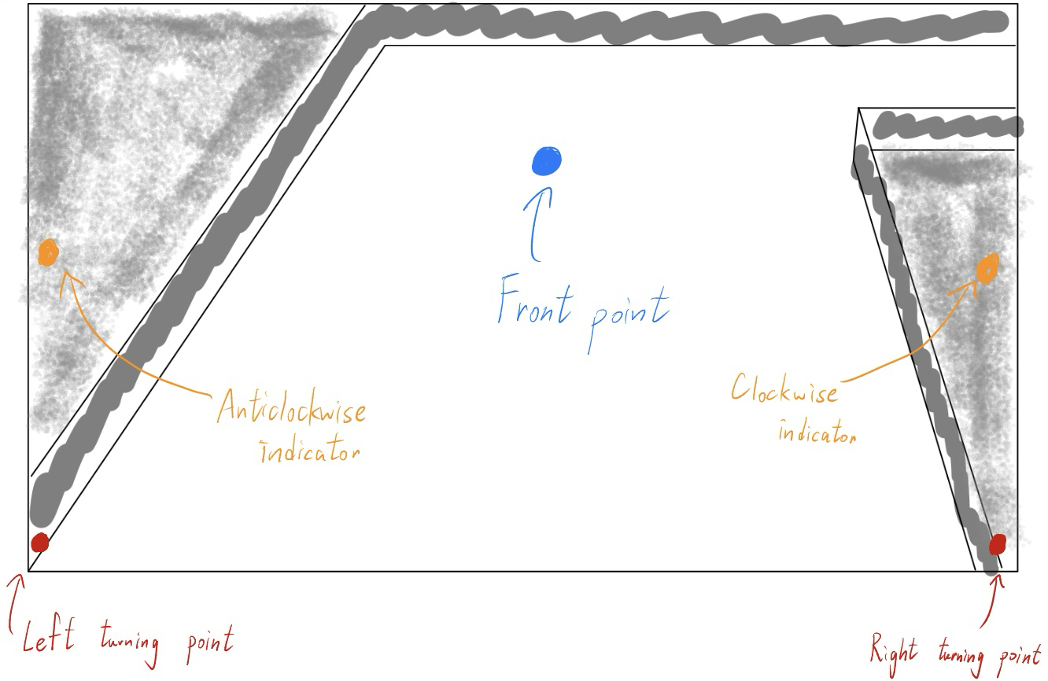
Fig. 20. Diagram illustrating the definition of the indicators and the locations at which they are marked.
The robot identifies a turnable corner when the FP lies outside the track and one of the turning points, either the LTP or RTP, lies inside the white track. At the same time, one of the direction indicators also lies inside the track, allowing the robot to determine whether it should turn clockwise or anticlockwise, as illustrated in Figure 21.
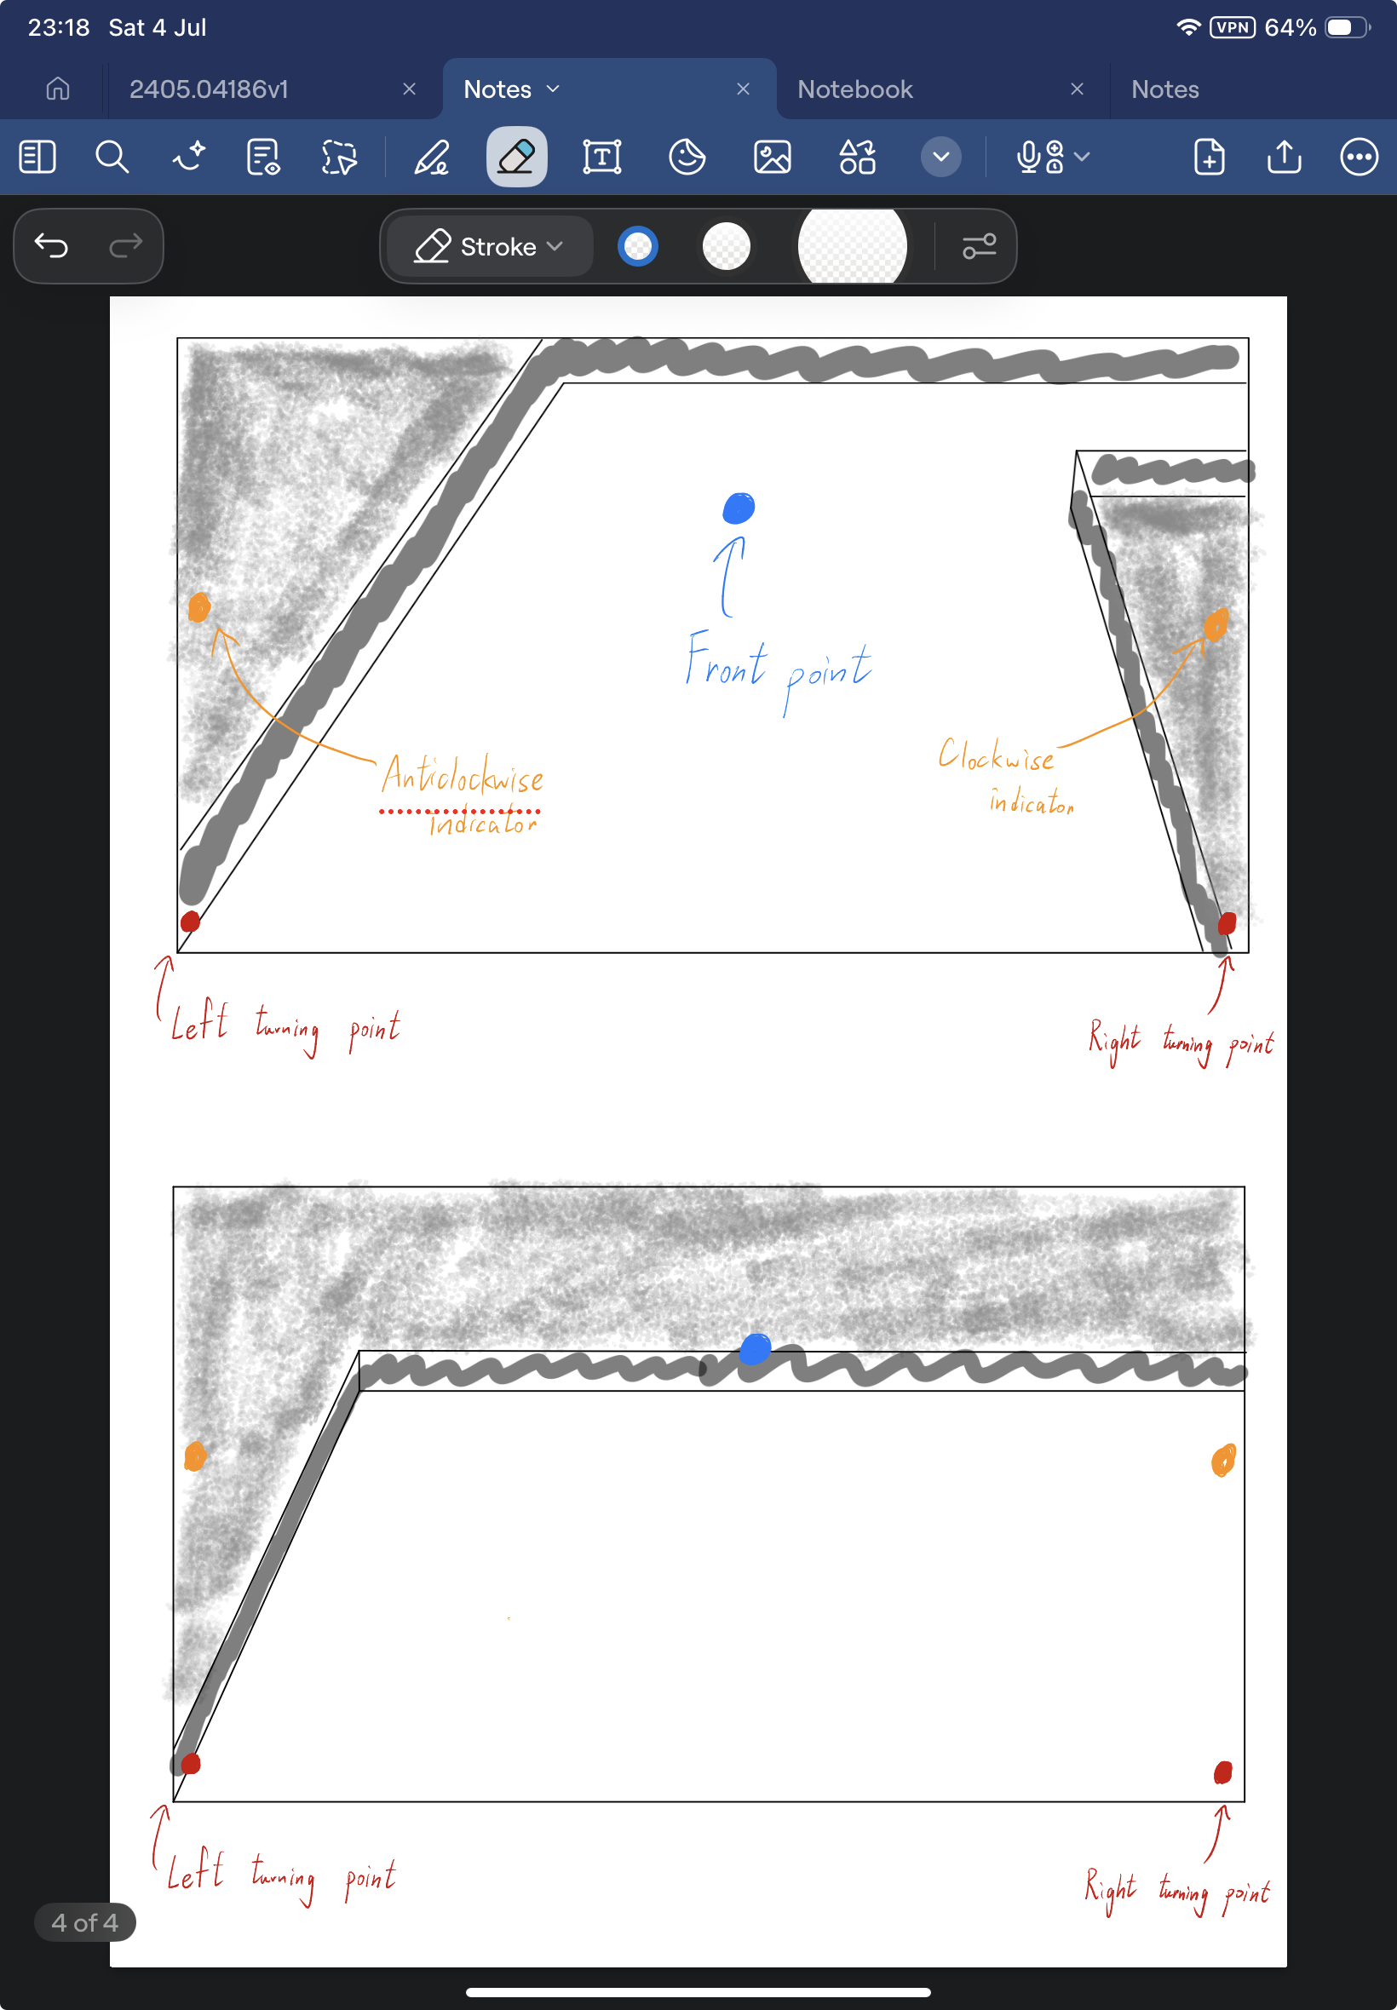
Fig. 21. Diagram illustrating the condition under which the robot determines that a turn is available.
Once a turn is detected, the robot performs a blind turn using a preset timer. The turning duration is intentionally set to be slightly shorter than the time required to complete the full turn. After this partial turn, the robot calculates its distance from the inner wall and uses the PID algorithm to gradually move closer to it. A conservative PID setting is used to prevent the robot from crashing into the inner wall. The purpose of following the inner wall is to shorten the travelling distance and reduce the total time required to complete the challenge.
Using the same logic, the robot records the number of completed turns until it reaches 12 turns, which corresponds to three full laps. It then moves forward for a fixed time interval and stops within the starting sector.
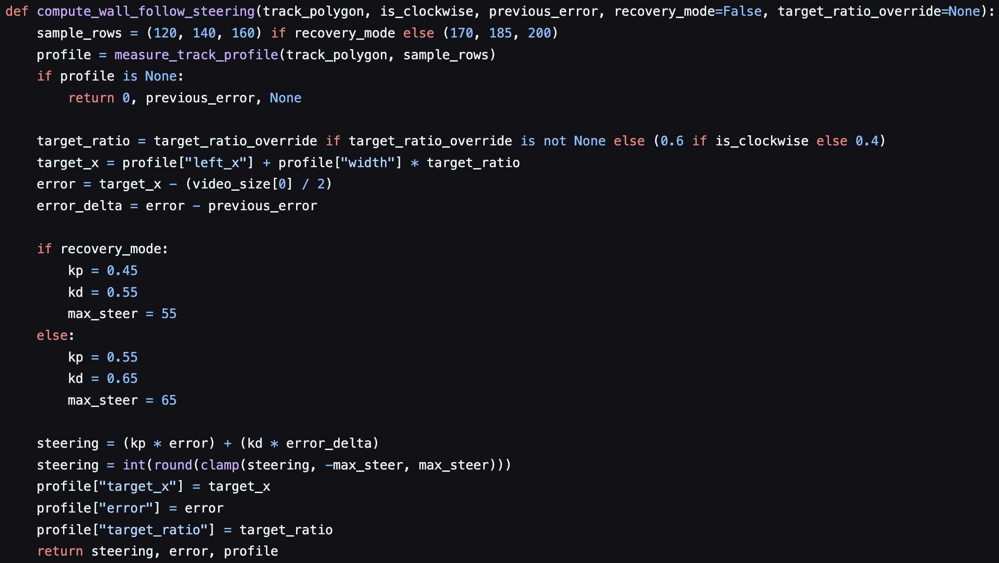
Fig. 22. Code segment showing how the robot uses a PID algorithm to lean toward the inner wall. The program first measures the relative distance from the inner wall, then calculates the steering correction based on the distance error and the change in error, using the preset (k_{p}) and (k_{d}) values. A maximum steering limit is also applied to prevent excessive correction.

4.2. Obstacle Challenge (OC2)
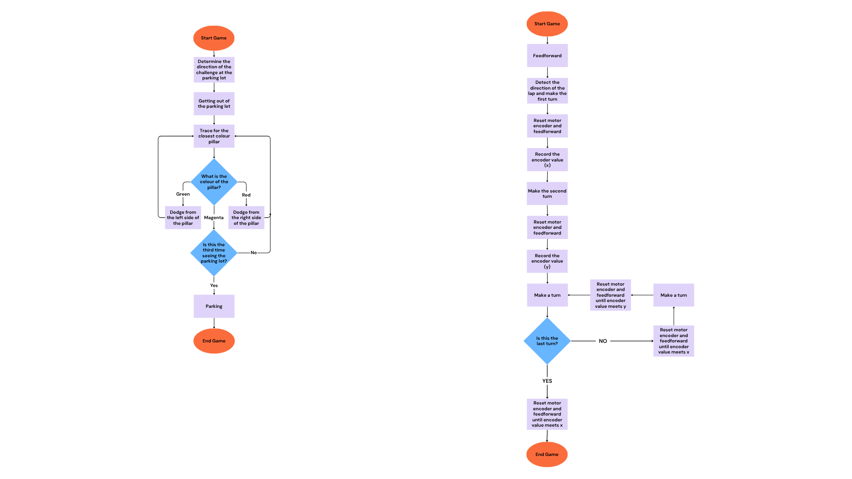
Fig. 23. Flow chart of our program for the Obstacle Challenge.
In OC2, the lap direction is easier to determine because the robot starts inside the parking lot. By analysing the camera image at the beginning of the run, the robot can identify whether the challenge direction is clockwise or anticlockwise. While exiting the parking lot, the robot continuously checks for coloured obstacles. If an obstacle is detected, it performs an avoidance manoeuvre and then proceeds forward until it detects the inner barrier. It then reverses by a fixed distance to obtain a wider field of view and assess whether an obstacle is present immediately after the corner.
Our control logic for OC2 is based on detecting and responding to the closest coloured obstacle visible to the camera. When an obstacle is detected, the robot determines the correct side from which to avoid it according to the obstacle colour, using the steering formula introduced in the following paragraph. Since the robot already knows the direction of the challenge, if no coloured obstacle is detected but a dead end is identified ahead, the robot turns in the correct direction of the track: left for anticlockwise and right for clockwise.
The robot also records the number of times it detects the magenta parking lot. Once this count reaches three, indicating that the robot has completed the required number of laps, it executes the parking function and performs the parallel parking manoeuvre.
To maintain a suitable distance from each obstacle, we developed formulas to calculate the desired avoidance path, as shown in Figure 24. When an obstacle is detected, the coordinates of its midpoint are recorded. The robot then selects the appropriate formula according to the obstacle colour and calculates the required steering percentage. For example, if the midpoint of a red obstacle is located at (100, 100), the calculated steering percentage is (-140%). Since the steering output is limited to the valid control range, this value is capped at (-100%), causing the robot to steer left and avoid the obstacle from the correct side.
When no obstacle is detected, the robot continues moving forward using the stable wall-following strategy developed for OC1. This process is repeated sector by sector until the robot completes the third lap. After that, it returns to the parking lot and executes the final parking manoeuvre.
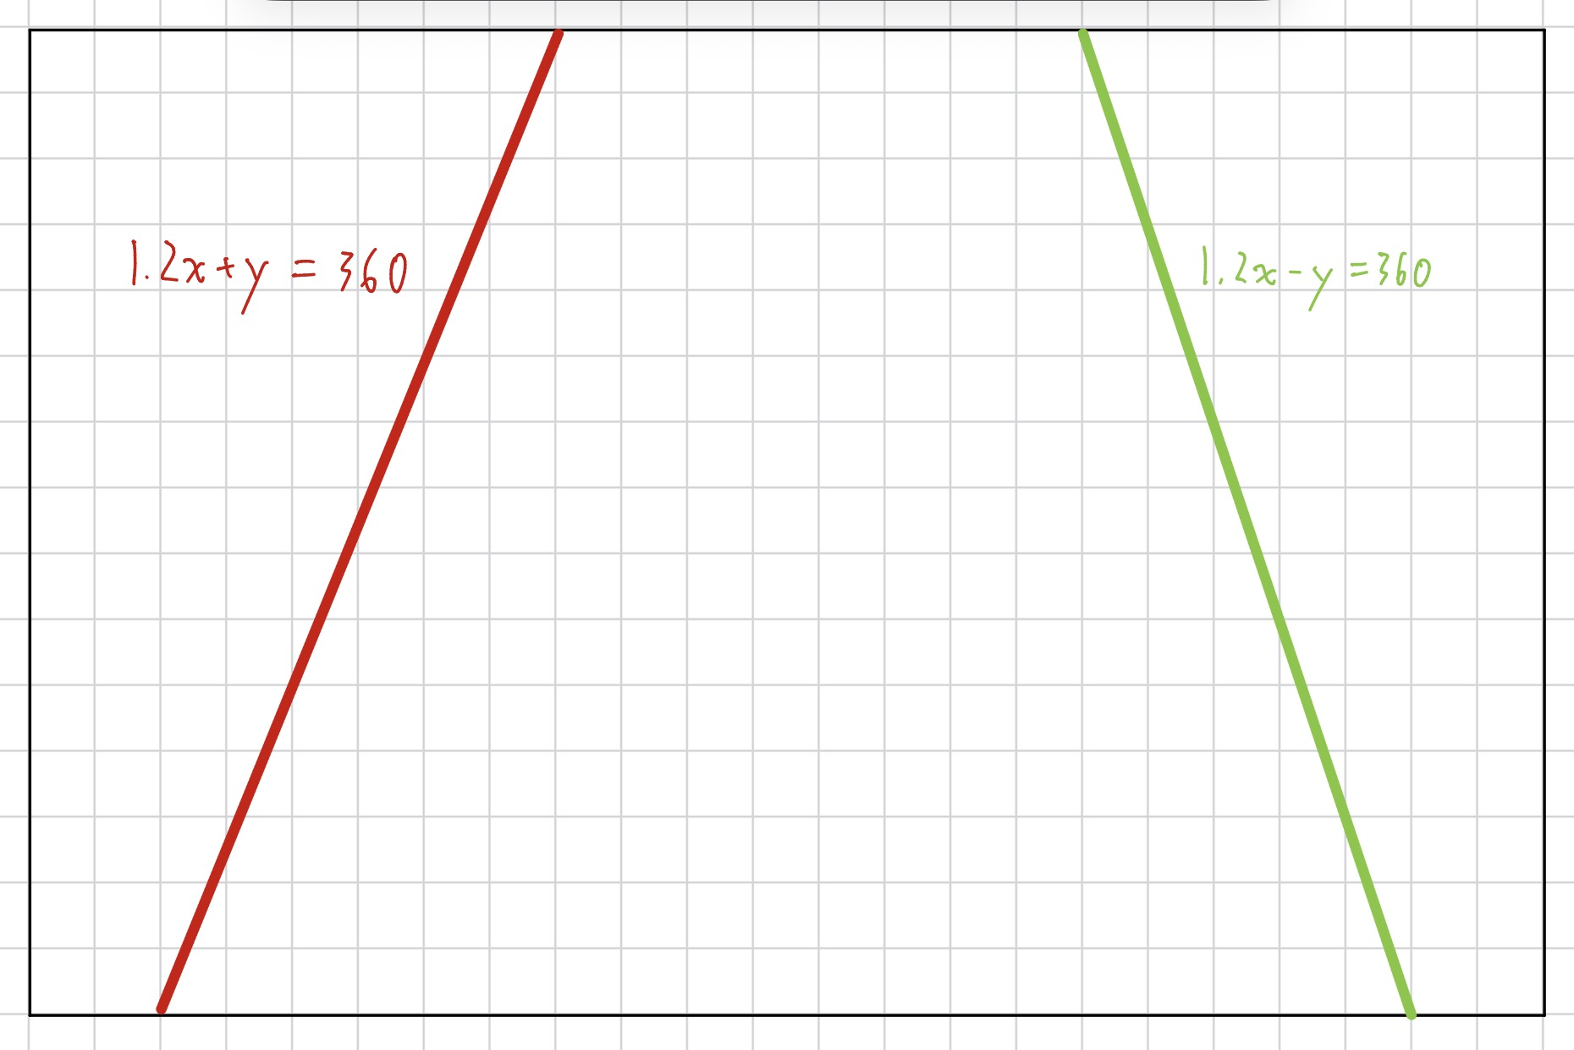
Fig. 24. The formulas of the ideal track for the green and red obstacles.

5. Vehicle Photos
Top View | Front View | Back View |  | Bottom View
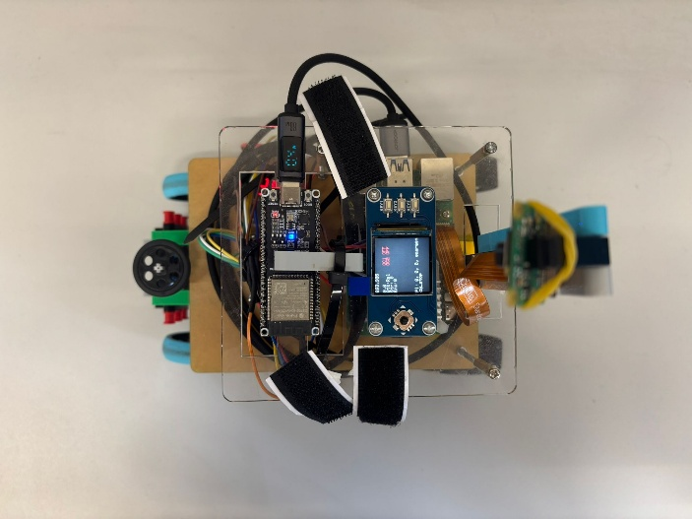 | 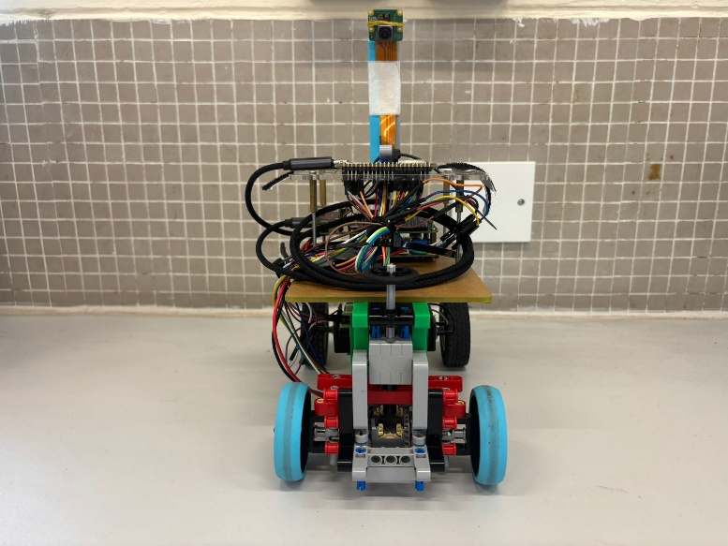 | 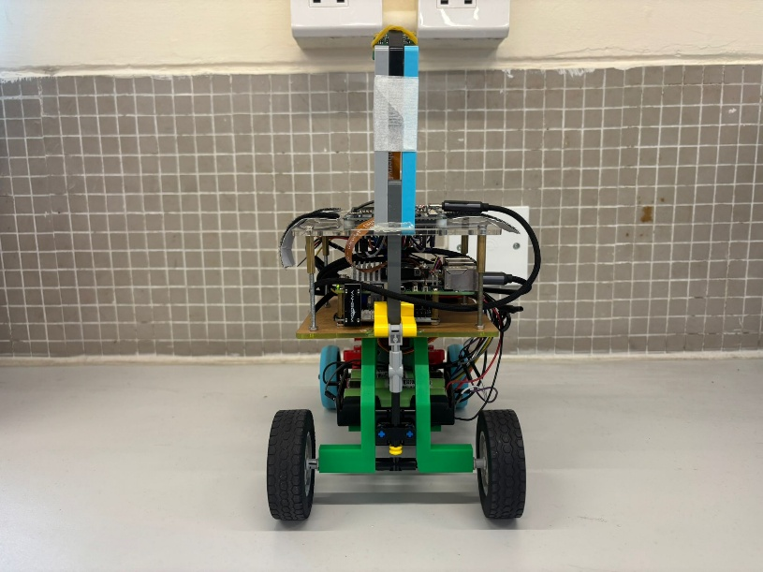 |  | 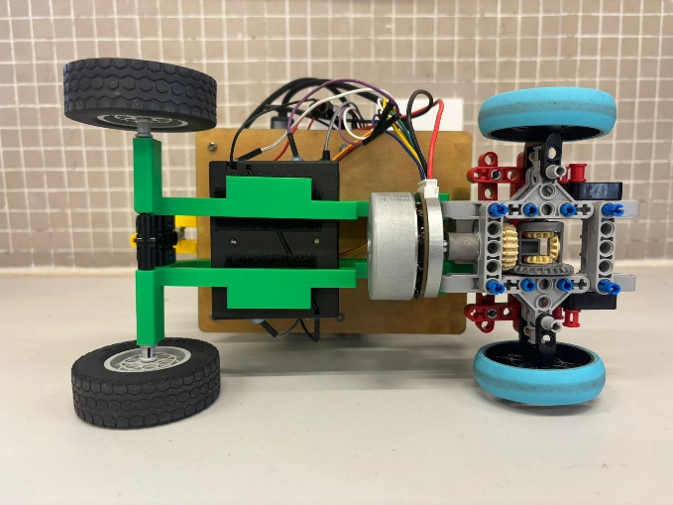
Side View (Left) |  |  | Side View (Right)
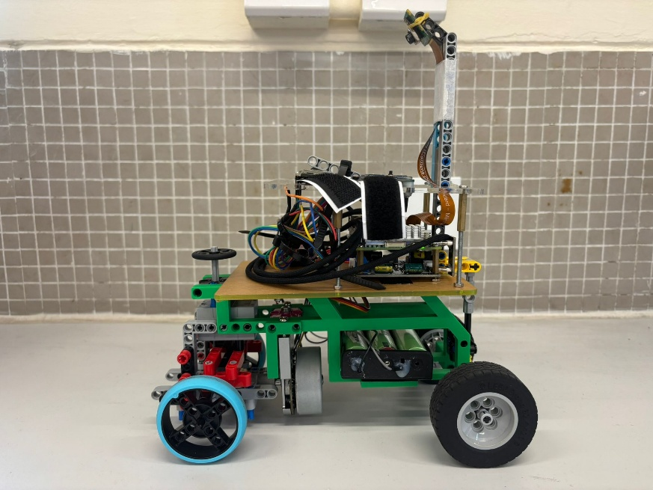 |  |  | 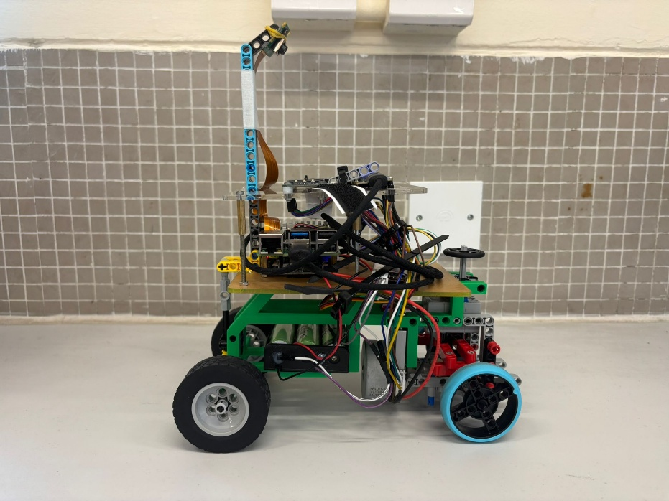

6. Team Photos
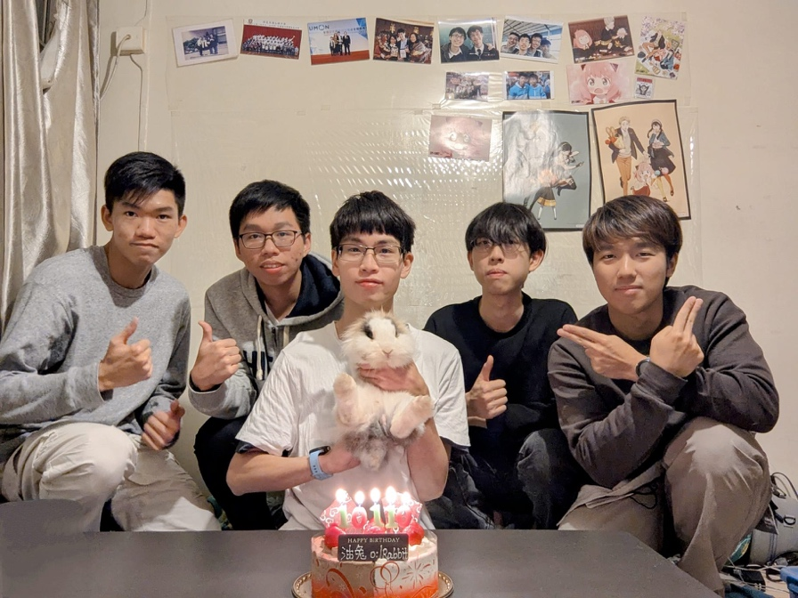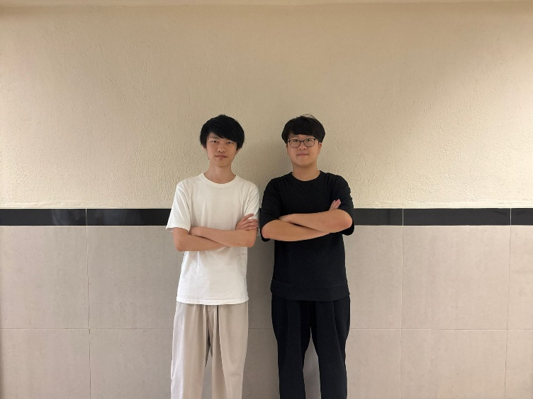
Fig. 25. Pictures of our team. Left: The team celebrate for the birthday of their coach, Mr Li. Right: The new team members.

7. Performance Video and GitHub Repository
Scan the QR code for our practice videos!

Open Challenge  Performance Video | Obstacle Challenge  Performance Video | Our GitHub Repository  Latest working branch: Gen-1.0
 |  | 

8. References
Huot, J.-Y. (2009). Zinc. In Encyclopedia of Electrochemical Power Sources (pp. 883–892). Amsterdam: Elsevier.

A. Appendix

A.1. What we learned
In addition to studying real-world vehicles, we consulted a professional race car engineer, Mr Lewis Wong, and incorporated the following key insights:
- Slip-angle optimisation is unnecessary for a robot of this scale, and the incremental benefit of Ackermann steering is limited; nonetheless, we implemented a simple LEGO-based Ackermann mechanism for demonstration and modest performance gains.
- A differential is highly beneficial, as it significantly smooths low-speed turning despite a slight reduction in straight-line speed.
- A shorter wheelbase improves turning agility and overall manoeuvrability.
- A wider front track than rear track during cornering enhances smoothness, although we did not implement this due to chassis-width constraints.
- Lightweight wheels increase top speed more effectively than reducing overall vehicle mass.
- Smaller wheel diameters further improve manoeuvrability.
- A low centre of mass is critical for stability.
- An onboard gyro is essential for precise heading estimation and reliable lap counting.
- Storing pillar colours in an array upon first detection enables faster decision-making on subsequent passes.
- Reducing camera resolution, where image quality remains sufficient, increases frame rate and improves responsiveness.

A.2. Difference between our robot for the Hong Kong Regional competition and the current robot
 | Old design | Current design
Photo | 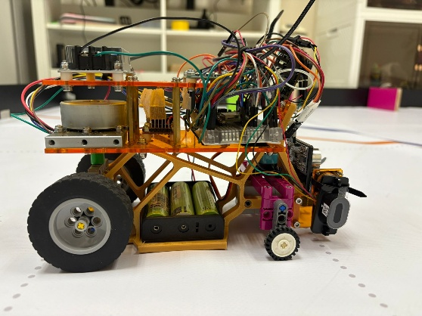 | 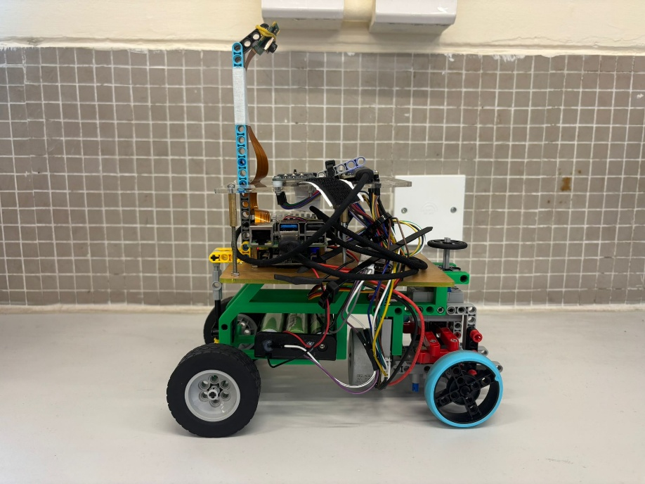
Major chassis materials | Self-designed 3D-printed components and acrylic plates | Self-designed 3D-printed components and acrylic plates
Driving motor & encoder | BM50 brushless motor with encoder | BM50 brushless motor with encoder
Servo motor | CZ356 | CZ356
Camera | Camera (PixyCam2.1) | Raspberry Pi Camera Module 3 wide
Time of Flight sensor (ToF) | STP-23L
IMU | ICM-20948
Controller | ESP32 | ESP32, Raspberry Pi
Advantages | - Easier algorithm design | - Simpler connection of electronic components
Disadvantages | - Unstable performance | - Difficult to design the algorithm to identify the state using camera feedback only

A.3. How Wheels Affect a Car's Performance?
After discussing with Lewis and conducting further research, we identified numerous factors that influence a car’s performance. We begin with the wheels.
Wheels
Toe-in and toe-out: Toe-in occurs when the front edges of the wheels are closer together than the rear edges, improving straight-line stability. Toe-out is the opposite, with the front edges farther apart than the rear. As we aim to use simple mechanisms and structures, and we expect toe settings to have only a minor effect at our scale, we chose not to implement adjustable toe on the robot.
Camber (positive and negative): Positive camber means the top of the wheel tilts away from the vehicle, which can enhance stability at high speeds and on rough surfaces. Negative camber means the top of the wheel tilts toward the vehicle, improving grip and handling in corners because the outside tyre maintains a larger contact patch with the ground. Most real vehicles, not just race cars, use some degree of negative camber. Initially, we did not intend to incorporate camber for the same “simplicity” reasons. However, because LEGO parts are slightly elastic, our structure unintentionally introduced a small negative camber. We have not quantified the difference between zero and negative camber on our robot, but we have observed no adverse effects and therefore kept the current configuration.
Tyre size and configuration: Using an F1 car as a conceptual reference, and given that our drive motor provides high torque and strong acceleration in a rear-wheel-drive layout, we selected larger and wider rear tyres. The increased contact patch improves traction and helps prevent wheelspin during acceleration. For the front wheels, we chose smaller, narrower tyres, as they are primarily responsible for steering. A smaller contact patch and lower tyre mass enhance steering responsiveness and reduce the load on the steering motor. In practice, the available front-wheel grip is sufficient to prevent understeer during cornering.
Wheelbase: As discussed earlier, a shorter wheelbase reduces the turning radius and improves agility. However, if the wheelbase is too short, the car becomes prone to understeer and can actually corner worse. Our goal was, therefore, to find an optimal compromise between a compact wheelbase and acceptable understeer characteristics.
Wheel weight: Lewis emphasised that wheel mass is critical. Theoretically, adding 10 g to each wheel has a greater impact on performance than adding 40 g to the car body, because rotating mass is more influential than static mass. In our case, we are not building a full-scale race car, and typical LEGO wheel weights are relatively small. As a result, using a 30 g wheel instead of an 8 g wheel is unlikely to be a decisive factor in our competition performance unless the wheel weight becomes extremely large (on the order of 200 g per wheel).

Track width: Track width is the distance between the centrelines of the wheels on the same axle. A wider track width improves lateral stability and allows higher cornering speeds and cornering stiffness. However, we chose not to maximise the track width (20 cm) on our robot. Some corners on the field are quite narrow, and a wider track would increase the likelihood of hitting the walls or colour blocks. A very wide track would also be disadvantageous when manoeuvring in the parking lot.
Steering geometry and maximum steering angle: Real cars employ Ackermann steering geometry, where the inner front wheel turns more than the outer one in a corner, reducing tyre scrub and improving grip. Although it is difficult to implement a perfect Ackermann system using LEGO parts, we designed a simplified version inspired by kart steering. This solution is lightweight and provides a modest but meaningful performance benefit. We also needed to select an appropriate maximum steering angle. An excessively large steering angle can induce apparent understeer and significantly reduce cornering speed, making the car feel as if it lacks power in turns. Ultimately, we chose a moderate steering angle that allows the robot to clear all corners on the field without excessive understeer.
Tyre material and surface grip: In full-scale motorsport, when track and weather conditions are favourable, engineers fit slick tyres (without tread) that soften at high temperatures to maximise grip. For our robot, the WRO field surface is relatively smooth, so using softer tyres with a defined tread pattern helps increase friction and reduce wheelspin during acceleration. If the front wheels were made of a much harder material, understeer could occur due to insufficient grip. In practice, we did not systematically test different tyre compounds, as we preferred to allocate more time to other aspects of robot design and programming.
Other Performance Factors
Beyond wheel characteristics, several additional factors significantly affect performance, including overall weight, centre of gravity, and aerodynamics.
We actively reduced the robot’s mass by using 3D-printed components for the chassis and main structure, allowing us to remove redundant parts and minimise LEGO usage. We also positioned the heaviest component—the batteries and battery box (167 g total)—as low as possible in the chassis to lower the centre of gravity and improve stability.
By contrast, we chose not to consider aerodynamic effects in our design. The robot’s speed is relatively low, so aerodynamic drag is effectively negligible. We do not expect race outcomes to hinge on differences as small as 0.01 seconds, and thus prioritised mechanical design and control algorithms over aerodynamic optimisation.

A.4. Difficulties
During the Hong Kong regional selection and practice period, we encountered a number of challenges. Below, we describe the main difficulties and how we addressed them.
Practice venue
The WRO Future Engineer field measures approximately 3 m × 3 m. In Hong Kong, space is limited: we could not keep a full-size field set up at home. Fortunately, our alma mater is willing to let us share the field with their team. Although we can only work within the school's operating hours, it is the best venue we can find so far.
Time constraints
We are highly motivated to achieve a strong result at this competition. However, all team members are full-time university students, so our availability is limited. In practice, we can only train on weekends. Even then, family commitments and social gatherings sometimes further reduce our training time.
Our coach is an MPhil student who must balance coursework, research, and departmental responsibilities. Our supporter is a full-time teacher who is only available on weekends. Consequently, our preparation required careful scheduling, efficient use of limited training hours, and strong commitment from every member of the team.

