SELENIUM WEBDRIVER
ASSIGNMENT 5 REPORT
The HTML Web Table Extractor
Prepared by: Oishi Das
B.Tech Computer Science & Engineering
Technology: Python + Selenium WebDriver
Execution Status: Successfully Completed

1. Assignment Objective
The objective of this assignment is to automate extraction of information from a multi-column HTML data table using Selenium WebDriver. The automation must iterate through the table rows and columns, locate a particular row by matching a name, and retrieve the corresponding value from the Price or Status column.
2. Application Under Test
Website | Rahul Shetty Academy – Upload/Download Test
URL | https://rahulshettyacademy.com/upload-download-test/
Automation Tool | Selenium WebDriver
Programming Language | Python
Browser | Google Chrome
Target Record | Mango
Required Field | Price
Retrieved Value | 299
3. Table Structure
The web page contains a multi-column data table with the following columns:
- S No
- Fruit Name
- Color
- Price
- Season
The target row used for the extraction was the row whose Fruit Name is "Mango". The corresponding Price value was retrieved as 299.
4. Automation Workflow
- Launch Google Chrome using Selenium WebDriver.
- Open the Rahul Shetty Academy upload/download test page.
- Locate the HTML table.
- Identify the table rows and inspect their cells.
- Compare the Fruit Name value in each row with the target name "Mango".
- When the matching row is found, identify the Price column in that row.
- Retrieve the Price value from the matching row.
- Display the extracted result in the terminal and provide visual execution evidence.
- Save screenshots automatically for submission evidence.
5. Selenium Concepts Demonstrated
- WebDriver browser automation
- Element location using Selenium locators
- Table row and column traversal
- Text extraction from web elements
- Conditional matching of a target row
- Retrieval of a related cell value
- Automatic screenshot capture
- Execution verification through terminal output
6. Target Data Extraction
The automation searched the table for the target fruit name:
Target Name: Mango
Retrieved Price: 299
7. Evidence of the Web Table
The following evidence shows the multi-column table used during execution. The table contains Mango and its associated Price value of 299.

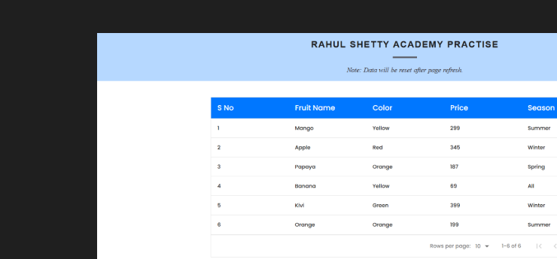
Figure 1. HTML data table used for Assignment 5
8. Expected Execution Result
Verification | Result
Target row located | PASS
Target name | Mango
Price column retrieved | PASS
Retrieved price | 299
Screenshot evidence | Generated automatically
9. Project Structure
Selenium_Assignment_5_6/
└── Assignment_5_HTML_Web_Table_Extractor/
├── assignment_5.py
└── screenshots/
├── assignment_5_01_table_page.png
└── assignment_5_02_target_row_found.png
10. Result and Conclusion
The HTML Web Table Extractor assignment was completed successfully. Selenium WebDriver accessed the multi-column table, located the row containing the target name "Mango", and retrieved the corresponding Price value of 299. The execution also produced automatic screenshot evidence. This demonstrates practical use of Selenium for reading structured tabular web data and extracting a related value from a dynamically rendered table.
11. Learning Outcome
- Understanding how HTML tables are represented as rows and cells.
- Using Selenium to locate and inspect tabular web elements.
- Matching a target record based on text content.
- Extracting a value from the same row after a successful match.
- Using screenshots as automated evidence of Selenium execution.

