SELENIUM WEBDRIVER
ASSIGNMENT 6 REPORT
Windows, Tabs, and Iframes
Prepared by: Oishi Das
B.Tech Computer Science & Engineering
Technology: Python + Selenium WebDriver
Execution Status: Successfully Completed
1. Assignment Objective
The objective of this assignment is to demonstrate Selenium WebDriver's ability to work with embedded iframes and browser windows. The automation accesses content inside an iframe, returns to the main document, opens a new browser window, obtains its window handle and title, closes the new window, and finally returns to the original browser window.
2. Application Under Test
Website | The Internet – Herokuapp Selenium Practice Site
iFrame Page | https://the-internet.herokuapp.com/iframe
Multiple Windows Page | https://the-internet.herokuapp.com/windows
Automation Tool | Selenium WebDriver
Programming Language | Python
Browser | Google Chrome
iFrame Content | TinyMCE editor
New Window Title | New Window
3. Assignment Requirements
- Open a page containing an embedded iframe.
- Use driver.switch_to.frame() to switch into the iframe.
- Interact with an element inside the iframe.
- Return to the main document.
- Open a new browser window.
- Use driver.window_handles to obtain the available window handles.
- Switch Selenium context to the new window.
- Retrieve the title of the new window.
- Close the new window.
- Switch back to the original browser window.
4. Automation Workflow
- Open the Herokuapp iFrame page.
- Locate the TinyMCE iframe using its frame identifier.
- Switch Selenium execution context into the iframe.
- Access the TinyMCE editor and enter test content.
- Capture an automatic screenshot of the iframe interaction.
- Use driver.switch_to.default_content() to return to the main page.
- Open the Herokuapp Multiple Windows page.
- Click the 'Click Here' link to open a new browser window.
- Retrieve driver.window_handles and identify the newly opened handle.
- Switch to the new window using driver.switch_to.window().
- Read the new window title.
- Capture a screenshot of the new window.
- Close the new window using driver.close().
- Switch back to the original window.
- Display the final assignment result and save the final screenshot.
5. Selenium Concepts Demonstrated
- driver.switch_to.frame()
- driver.switch_to.default_content()
- driver.window_handles
- driver.switch_to.window()
- driver.title
- driver.close()
- Explicit waits using WebDriverWait
- Automatic screenshot capture
6. iFrame Interaction
The automation opened the Herokuapp iFrame page and switched into the embedded TinyMCE editor. Text was entered into the editor using Selenium, demonstrating that Selenium was operating inside the iframe rather than on the parent document.
Iframe interaction result: SUCCESS
7. Window Handling
After completing the iframe operation, the automation opened the Multiple Windows page and clicked the 'Click Here' link. Selenium detected two window handles, switched to the newly created window, and retrieved its title as 'New Window'. The new window was then closed and Selenium returned to the original window.
Window Operation | Result
New window opened | SUCCESS
Window handles retrieved | SUCCESS
Switched to new window | SUCCESS
New window title | New Window
New window closed | SUCCESS
Returned to original window | SUCCESS
8. Execution Evidence
The successful execution produced automatic screenshots and the terminal confirmed completion of every required operation. The VS Code execution evidence below shows the generated screenshot files together with the successful terminal result.

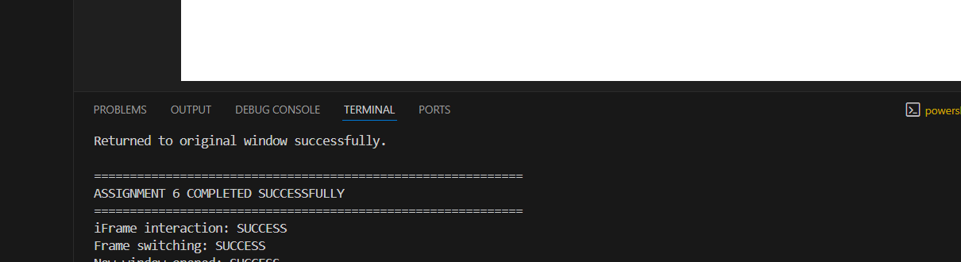
Figure 1. Successful Assignment 6 execution and screenshot evidence
9. Screenshot Evidence Produced
- assignment_6_01_iframe_page.png
- assignment_6_02_inside_iframe.png
- assignment_6_03_iframe_completed.png
- assignment_6_04_windows_page.png
- assignment_6_05_new_window.png
- assignment_6_06_final_result.png
10. Project Structure
Selenium_Assignment_5_6/
└── Assignment_6_Windows_Tabs_Iframes/
├── assignment_6.py
└── screenshots/
├── assignment_6_01_iframe_page.png
├── assignment_6_02_inside_iframe.png
├── assignment_6_03_iframe_completed.png
├── assignment_6_04_windows_page.png
├── assignment_6_05_new_window.png
└── assignment_6_06_final_result.png
11. Final Execution Result
The Assignment 6 automation completed successfully. The iframe was accessed and interacted with, Selenium successfully switched between the main document and iframe, a new browser window was opened and identified using window handles, its title was retrieved as 'New Window', the new window was closed, and control was restored to the original window. Automatic screenshots were generated throughout the execution.
ASSIGNMENT 6 COMPLETED SUCCESSFULLY
12. Conclusion
This assignment demonstrates practical Selenium WebDriver techniques for handling multiple browsing contexts. It shows how an automation script can enter and leave an iframe safely and manage multiple browser windows through window handles. The successful execution and generated screenshots provide evidence that all requested operations were completed.
13. Learning Outcome
- Understanding why Selenium requires an explicit context switch for iframe content.
- Using frame switching to interact with elements inside an embedded document.
- Understanding browser window handles and their role in multi-window automation.
- Switching between browser contexts using Selenium WebDriver.
- Retrieving and verifying a browser window title.
- Closing a secondary window while preserving the original window.
- Using explicit waits and screenshots to improve automation reliability and evidence.

