SELENIUM AUTOMATION – ASSIGNMENT 7
Page Object Model (POM) Restructure
Submitted by: Oishi Das
B.Tech Computer Science Engineering

1. Objective
The objective of Assignment 7 was to restructure the previously completed Selenium automation work using the Page Object Model (POM) design pattern. The implementation separates page locators and UI interaction methods from test assertions and verification logic.

2. Assignment Requirements
- Create separate Page Object classes for the application areas being automated.
- Keep locators and UI interaction methods inside the Page Object classes.
- Keep test assertions separate from the Page Object classes.
- Use the Page Objects from pytest test cases.
- Execute the tests successfully and capture execution evidence.

3. Project Structure
selenium_assign
└── Assignment_7_POM_Restructure
├── pages
│ ├── __init__.py
│ ├── table_page.py
│ ├── iframe_page.py
│ └── windows_page.py
├── screenshots
│ ├── assignment_7_01_table_test.png
│ ├── assignment_7_02_iframe_page.png
│ ├── assignment_7_03_inside_iframe.png
│ ├── assignment_7_04_new_window.png
│ └── assignment_7_05_final_result.png
├── test_data
│ └── table.html
├── tests
│ ├── __init__.py
│ ├── test_table.py
│ └── test_windows_iframe.py
├── conftest.py
├── pytest.ini
└── requirements.txt

4. Page Object Model Implementation

4.1 TablePage
TablePage contains the table-page locator definitions and methods required to open the HTML table, retrieve its rows, and obtain a value from a specified row and column. No test assertion is placed inside this Page Object.

4.2 IFramePage
IFramePage contains the iframe locator and methods for opening the page, switching into the iframe, entering text into the editor, and returning to the main document.

4.3 WindowsPage
WindowsPage contains the locator and UI methods for opening the Multiple Windows page, retrieving window handles, switching between windows, reading the title, and closing the current window.

5. Test Design
The test files contain the verification logic. The table test verifies that the table contains data and that Mango has a Price of 299. The iframe/window test verifies iframe interaction, new-window creation, the title of the new window, closing the new window, and returning to the original window.

6. Test Environment
Component | Value
Operating System | Windows 11
Python | 3.14.7
Pytest | 9.1.1
Selenium | Installed through requirements.txt
Browser | Google Chrome
Test Runner | pytest

7. Test Execution
The complete Assignment 7 suite was executed from the Assignment_7_POM_Restructure directory using:
pytest -v
FINAL RESULT: 2 PASSED
Execution completed successfully with both collected tests passing.
Test | Result
test_mango_price | PASSED
test_iframe_and_window_handling | PASSED

8. Functional Verification
- Mango was located successfully in the HTML table.
- Mango Price was retrieved as 299.
- The price assertion passed.
- The iframe page was opened successfully.
- Text was entered inside the iframe editor.
- A new browser window was opened successfully.
- The new window title was verified as 'New Window'.
- The new window was closed successfully.
- Control was returned to the original window.
- All required test assertions passed.

9. Screenshot Evidence
The automated execution generated the following screenshots in the screenshots folder:
- assignment_7_01_table_test.png – HTML table test evidence
- assignment_7_02_iframe_page.png – iframe page before interaction
- assignment_7_03_inside_iframe.png – iframe interaction evidence
- assignment_7_04_new_window.png – new-window evidence
- assignment_7_05_final_result.png – final window-handling evidence

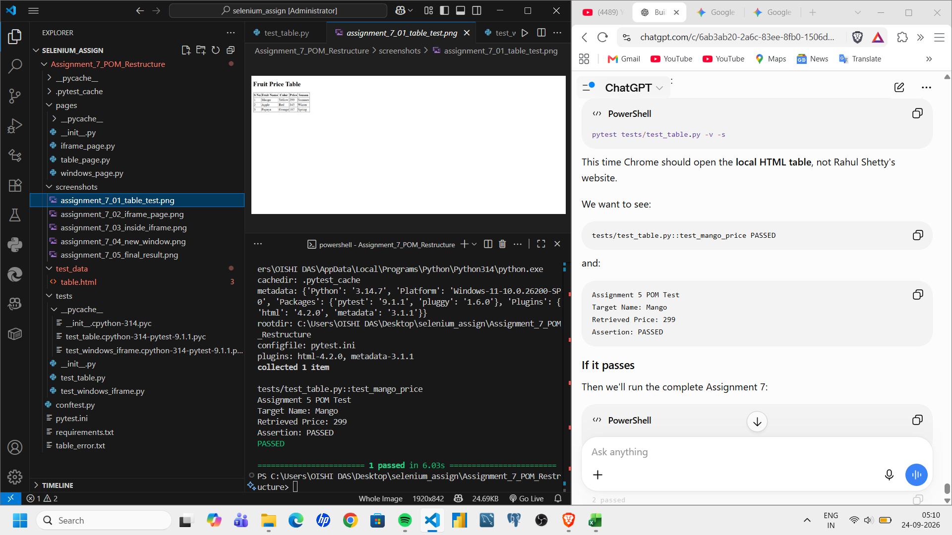
Execution evidence showing the local table test passing and the generated table screenshot.

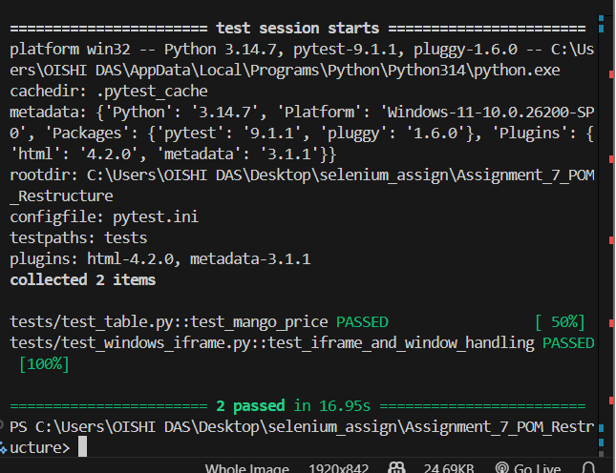
Final pytest execution evidence showing both Assignment 7 tests passed.

10. POM Architecture Summary
Test Layer
↓
Uses Page Objects
↓
Page Object Layer
├── Locators
└── UI interaction methods
↓
Browser / Web Page
Assertions remain in the Test Layer.

11. Learning Outcomes
- Understood the purpose of the Page Object Model design pattern.
- Separated page-specific locators from test verification.
- Used reusable page methods from pytest tests.
- Handled iframe switching and multiple browser windows through Page Objects.
- Used pytest assertions to verify expected results.
- Organized Selenium automation into a maintainable project structure.

12. Conclusion
Assignment 7 was completed successfully using a Page Object Model architecture. The table, iframe, and multiple-window functionality was separated into dedicated Page Objects, while assertions remained in the test layer. The complete pytest suite executed successfully with 2 tests passed and 0 tests failed.

