Week 1 Task
Data Cleaning and Preliminary Analysis with R
Dataset: Titanic Passenger Survival Dataset
Prepared By | Oishi Das
Program | Data Analytics Internship — Week 1
Tool Used | R (v4.3.3) — RStudio / Rscript
Dataset Source | Public dataset (Kaggle / open GitHub mirror), 891 records, 12 variables
Date | August 2026

Table of Contents

1. Dataset Overview
For this task, the Titanic passenger dataset was selected. It is a well-known, publicly available dataset (originally distributed via Kaggle's "Titanic: Machine Learning from Disaster" competition) that records demographic and travel details of 891 passengers aboard the RMS Titanic, along with whether each passenger survived the sinking. The dataset was chosen because it satisfies all the complexity requirements for this exercise: it contains missing values across multiple columns, a healthy mix of numerical and categorical variables, and known outliers in at least one continuous field (Fare).

1.1 Why This Dataset
- Missing data: three columns (Age, Cabin, Embarked) contain missing values with different missingness patterns and severities, requiring different cleaning strategies.
- Mixed variable types: numerical (Age, Fare, SibSp, Parch) and categorical (Sex, Embarked, Pclass, Survived) fields co-exist, allowing both statistical and encoding techniques to be demonstrated.
- Real-world relevance: it mirrors the kind of messy, mixed-type data an analyst encounters in industry (customer/demographic records with partial fields).
- Outliers: the Fare column has a strong right skew with genuine outliers (first-class suite fares), useful for demonstrating IQR-based outlier detection.

1.2 Data Dictionary
Column | Type | Description
PassengerId | Numeric (ID) | Unique passenger identifier
Survived | Categorical (0/1) | Survival outcome (0 = No, 1 = Yes) — target variable
Pclass | Categorical (1/2/3) | Ticket/passenger class (proxy for socio-economic status)
Name | Text | Passenger full name (incl. title)
Sex | Categorical | male / female
Age | Numeric | Age in years (fractional for infants)
SibSp | Numeric | Number of siblings/spouses aboard
Parch | Numeric | Number of parents/children aboard
Ticket | Text | Ticket number
Fare | Numeric | Passenger fare (£)
Cabin | Categorical | Cabin number (mostly missing)
Embarked | Categorical | Port of embarkation (C/Q/S)

1.3 Initial Structure Check
The dataset was loaded into R with read.csv() and inspected using str() and dim() to confirm 891 observations across 12 variables before any cleaning was applied.
titanic <- read.csv("titanic.csv", stringsAsFactors = FALSE,
na.strings = c("", "NA"))
dim(titanic)
str(titanic)
Dimensions of dataset:
[1] 891 12

Structure of dataset:
'data.frame': 891 obs. of 12 variables:
$ PassengerId: int 1 2 3 4 5 ...
$ Survived : int 0 1 1 1 0 ...
$ Pclass : int 3 1 3 1 3 ...
$ Name : chr "Braund, Mr. Owen Harris" ...
$ Sex : chr "male" "female" "female" ...
$ Age : num 22 38 26 35 35 NA ...
$ SibSp : int 1 1 0 1 0 ...
$ Parch : int 0 0 0 0 0 ...
$ Ticket : chr "A/5 21171" "PC 17599" ...
$ Fare : num 7.25 71.28 7.92 53.1 8.05 ...
$ Cabin : chr NA "C85" NA "C123" ...
$ Embarked : chr "S" "C" "S" "S" ...

2. Data Cleaning Process

2.1 Missing Value Analysis
Missing values were quantified for every column using is.na() combined with sapply(), producing both raw counts and percentages. This revealed three affected columns with very different severities, which determined the imputation strategy for each.
na_counts <- sapply(titanic, function(x) sum(is.na(x)))
na_pct <- round(100 * na_counts / nrow(titanic), 2)
Column | Missing Count | Missing %
Cabin | 687 | 77.10%
Age | 177 | 19.87%
Embarked | 2 | 0.22%
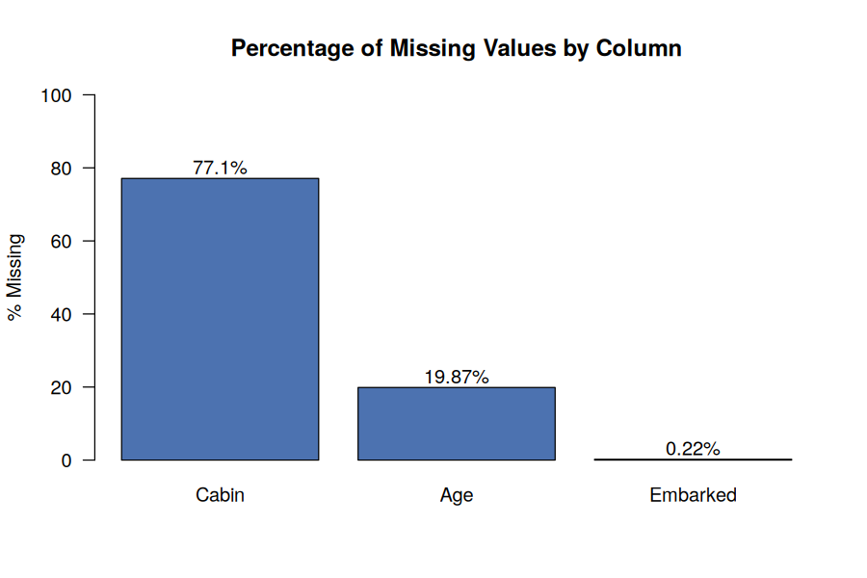
Figure 1. Percentage of missing values by column.

2.2 Handling Missing Values
- Cabin (77.1% missing): too sparse to impute meaningfully. Instead of dropping all cabin information, a binary flag HasCabin (1 = cabin recorded, 0 = missing) was engineered to preserve the signal that cabin data tends to be recorded for higher-fare passengers, then the raw Cabin column was dropped.
- Age (19.87% missing): imputed using the median Age within each Pclass × Sex subgroup, rather than a single global median. This respects the fact that age distributions differ meaningfully by class and gender (e.g., 3rd-class passengers skew younger).
- Embarked (0.22% missing, 2 rows): imputed with the mode (most frequent port, "S" = Southampton), since the count is negligible and a simple mode fill introduces virtually no bias.
# Age: group-wise median imputation
age_medians <- clean %>%
group_by(Pclass, Sex) %>%
summarise(med_age = median(Age, na.rm = TRUE), .groups = "drop")

clean <- clean %>%
left_join(age_medians, by = c("Pclass", "Sex")) %>%
mutate(Age = ifelse(is.na(Age), med_age, Age)) %>%
select(-med_age)

# Embarked: mode imputation
mode_embarked <- names(sort(table(clean$Embarked), decreasing = TRUE))[1]
clean$Embarked[is.na(clean$Embarked)] <- mode_embarked
Age missing before imputation: 177
# Median age by Pclass x Sex
Pclass Sex med_age
1 female 35
1 male 40
2 female 28
2 male 30
3 female 21.5
3 male 25
Age missing after imputation: 0

Mode of Embarked: S

Remaining missing values after cleaning:
Survived Pclass Sex Age SibSp Parch Fare Embarked HasCabin
0 0 0 0 0 0 0 0 0
After this stage, non-informative identifier and free-text columns (PassengerId, Name, Ticket) were also dropped since they do not contribute to numerical/statistical analysis in their raw form.

2.3 Outlier Detection
Outliers were identified using the standard IQR (interquartile range) rule: any value below Q1 − 1.5×IQR or above Q3 + 1.5×IQR is flagged. This was applied to the two key continuous variables, Fare and Age.
detect_outliers_iqr <- function(x) {
q1 <- quantile(x, 0.25, na.rm = TRUE)
q3 <- quantile(x, 0.75, na.rm = TRUE)
iqr <- q3 - q1
lower <- q1 - 1.5 * iqr
upper <- q3 + 1.5 * iqr
list(lower = lower, upper = upper,
n_outliers = sum(x < lower | x > upper))
}
fare_out <- detect_outliers_iqr(clean$Fare)
age_out <- detect_outliers_iqr(clean$Age)
Fare outlier bounds: [ -26.72 , 65.63 ]
Fare outliers detected: 116 out of 891

Age outlier bounds: [ -0.25 , 57.75 ]
Age outliers detected: 33 out of 891
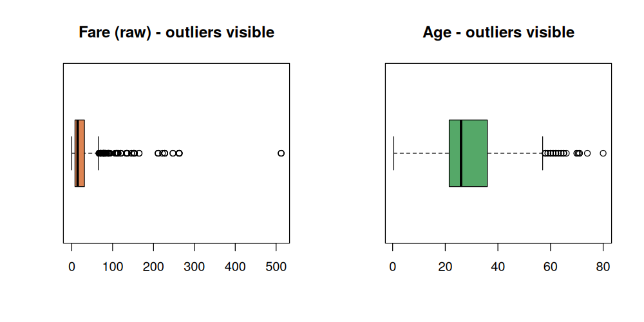
Figure 2. Boxplots of Fare and Age showing outlier spread before treatment.
Rather than deleting the 116 rows flagged on Fare (which would discard over 13% of the data and bias the sample toward lower-fare, lower-class passengers), outliers were capped (Winsorized) at the upper IQR bound. This preserves all records while limiting the influence of extreme values on downstream statistics such as means and correlations. Age outliers were left uncapped, since 33 elderly passengers (up to 80 years) are plausible, valid data points rather than data-entry errors.
clean$Fare_capped <- ifelse(clean$Fare > fare_out$upper,
fare_out$upper, clean$Fare)
Fare summary before capping:
Min. 1st Qu. Median Mean 3rd Qu. Max.
0.00 7.91 14.45 32.20 31.00 512.33
Fare summary after capping:
Min. 1st Qu. Median Mean 3rd Qu. Max.
0.00 7.91 14.45 24.05 31.00 65.63

2.4 Normalization / Scaling
Two scaling approaches were applied to the continuous variables (Age and the outlier-capped Fare) to make them comparable and model-ready: min-max normalization (rescaling to a 0–1 range) and z-score standardization (mean 0, standard deviation 1). Both are retained as separate columns so either can be used depending on downstream needs (min-max suits distance-based methods; z-scores suit methods sensitive to variance, such as PCA or regression).
min_max_norm <- function(x) (x - min(x)) / (max(x) - min(x))

clean$Age_norm <- min_max_norm(clean$Age)
clean$Fare_norm <- min_max_norm(clean$Fare_capped)
clean$Age_z <- as.numeric(scale(clean$Age))
clean$Fare_z <- as.numeric(scale(clean$Fare_capped))
Age - original range: [ 0.42 , 80 ]
Age_norm (min-max) range: [ 0 , 1 ]
Age_z (z-score) mean/sd: [ 0 , 1 ]

Fare - original range: [ 0 , 65.63 ]
Fare_norm (min-max) range: [ 0 , 1 ]

2.5 Encoding Categorical Variables
Two encoding techniques were used depending on the cardinality of the categorical field:
- Label encoding for the binary Sex field (male = 1, female = 0) — appropriate since there are only two categories and no ordinal relationship is implied by a single 0/1 column.
- One-hot encoding for the three-level Embarked field (Embarked_C, Embarked_Q, Embarked_S as separate 0/1 indicator columns) — necessary because label-encoding three unordered categories as 1/2/3 would falsely imply an order/magnitude relationship between ports.
- Pclass was converted to an ordered factor (1st/2nd/3rd) for readability in visualizations, and Survived was mapped to a labeled factor (No/Yes) for clearer plotting and cross-tabulation.
clean$Sex_encoded <- ifelse(clean$Sex == "male", 1, 0)

clean$Embarked_C <- as.integer(clean$Embarked == "C")
clean$Embarked_Q <- as.integer(clean$Embarked == "Q")
clean$Embarked_S <- as.integer(clean$Embarked == "S")

clean$Pclass <- factor(clean$Pclass, levels = c(1,2,3),
labels = c("1st","2nd","3rd"))
Sex encoding check:
0 1
female 314 0
male 0 577

Embarked one-hot encoding check (C / Q / S counts): 168 / 77 / 646
The fully cleaned, imputed, outlier-treated and encoded dataset (19 columns, 891 rows, zero missing values) was exported as titanic_cleaned.csv for downstream analysis.

3. Exploratory Data Analysis

3.1 Descriptive Statistics
summary() was re-run on the cleaned numeric columns to confirm the effect of cleaning and to establish baseline descriptive statistics for the analysis.
summary(clean[, c("Age","Fare","SibSp","Parch")])
Statistic | Age | Fare | SibSp | Parch
Min | 0.42 | 0.00 | 0 | 0
1st Quartile | 21.50 | 7.91 | 0 | 0
Median | 26.00 | 14.45 | 0 | 0
Mean | 29.11 | 32.20 | 0.52 | 0.38
3rd Quartile | 36.00 | 31.00 | 1 | 0
Max | 80.00 | 512.33* | 8 | 6
*Note: the Max shown here reflects the pre-capping Fare for full transparency; the Fare_capped field used in correlation and modelling-ready analysis is bounded at 65.63 as shown in Section 2.3.
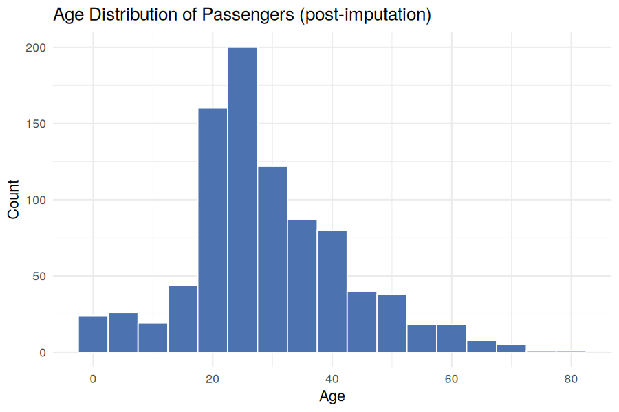
Figure 3. Age distribution after group-wise median imputation.

3.2 Survival Breakdown
Cross-tabulations were computed to understand how survival varied by Sex and Pclass — the two strongest categorical predictors of outcome in this dataset.
Group | Survived: No | Survived: Yes
Overall | 61.6% | 38.4%
Female | 25.8% | 74.2%
Male | 81.1% | 18.9%
1st Class | 37.0% | 63.0%
2nd Class | 52.7% | 47.3%
3rd Class | 75.8% | 24.2%
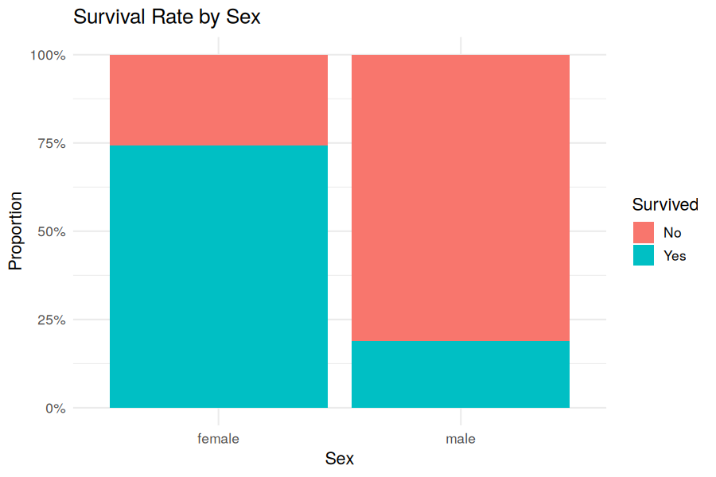
Figure 4. Survival rate by sex — women had roughly 3.9x the survival rate of men.
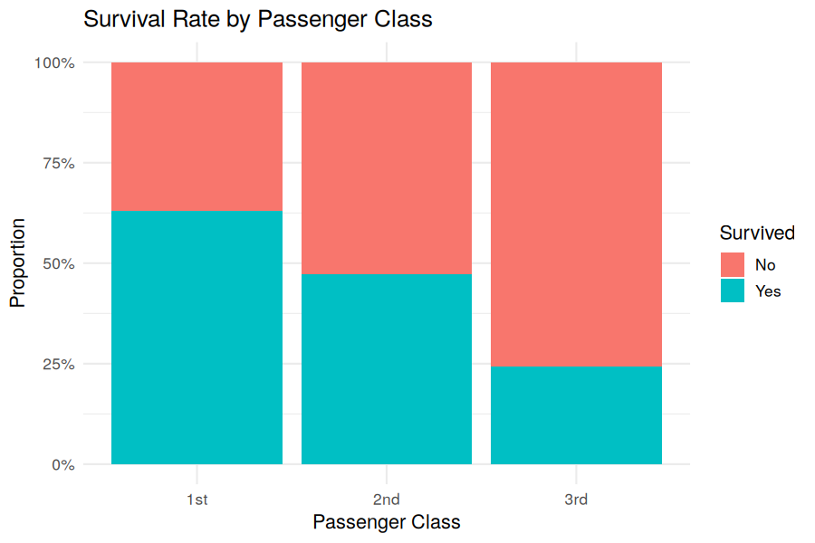
Figure 5. Survival rate by passenger class — a clear socio-economic gradient in survival.

3.3 Relationship Between Fare, Age and Survival
A scatter plot of Age against the capped Fare, coloured by survival outcome, was used to visually check for interaction effects between the two continuous variables and the outcome.
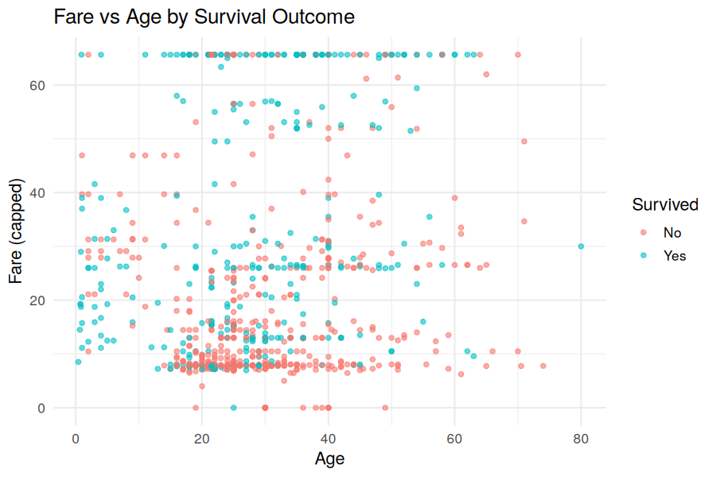
Figure 6. Fare vs Age coloured by survival outcome — higher-fare passengers show visibly higher survival density.

3.4 Correlation Analysis
A Pearson correlation matrix was computed across the key numeric/encoded variables to quantify linear relationships and screen for candidate predictors ahead of any future modelling.
num_vars <- clean[, c("Survived","Age","Fare_capped","SibSp",
"Parch","Sex_encoded")]
corr_mat <- cor(num_vars, use = "complete.obs")
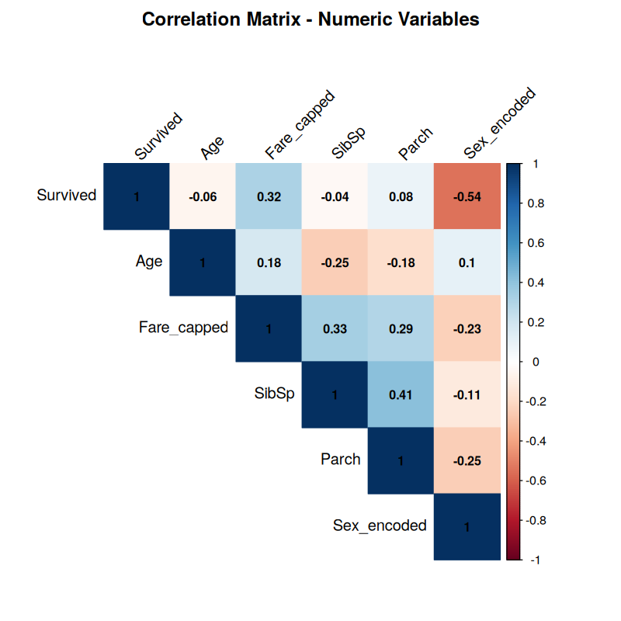
Figure 7. Correlation heatmap across numeric/encoded variables.
Variable Pair | Correlation | Interpretation
Survived ↔ Sex_encoded | -0.54 | Strongest relationship — being male is associated with lower survival
Survived ↔ Fare_capped | +0.32 | Higher fare (proxy for wealth/class) associated with higher survival
SibSp ↔ Parch | +0.41 | Passengers travelling with siblings/spouses also tend to travel with family
Age ↔ SibSp | -0.25 | Younger passengers more likely to be travelling with siblings
Survived ↔ Age | -0.06 | Very weak direct linear relationship with age alone

3.5 Key Insights
- Sex was the single strongest predictor of survival in this dataset (r = -0.54): women survived at 74.2% versus 18.9% for men, consistent with the historical "women and children first" evacuation protocol.
- Socio-economic status (Pclass/Fare) mattered substantially: 1st-class passengers survived at 63.0% versus 24.2% for 3rd-class, and Fare correlated positively with survival (r = +0.32) even after capping outliers.
- Age in isolation was a weak linear predictor of survival (r = -0.06), suggesting its effect is likely non-linear or conditional on other factors (e.g., children specifically, rather than age broadly).
- Family-size variables (SibSp, Parch) were moderately correlated with each other (r = +0.41) but only weakly with survival directly, suggesting a possible non-linear "sweet spot" (small families) rather than a monotonic effect — a good candidate for feature engineering (e.g., a combined FamilySize variable) in a follow-on task.
- Missing data was not random: Cabin-recording strongly overlaps with higher fares/classes, which is why a HasCabin flag was preserved instead of simply deleting the column.

4. Methodology Summary and Conclusion

4.1 Cleaning Pipeline Summary
Step | Technique Used | Rationale
Missing: Cabin | Drop column + binary HasCabin flag | 77% missing — too sparse to impute; flag preserves signal
Missing: Age | Group-wise median (Pclass x Sex) | Age varies systematically by class/gender
Missing: Embarked | Mode imputation | Only 2 rows affected — negligible bias
Outliers: Fare | IQR rule + Winsorized capping | Preserves all rows; limits influence of extreme fares
Outliers: Age | IQR rule, flagged but not capped | Extreme ages are plausible, valid values
Scaling | Min-max + Z-score (Age, Fare) | Prepares variables for distance- or variance-based methods
Encoding: Sex | Label encoding (binary) | Only two categories, no ordinality implied
Encoding: Embarked | One-hot encoding (3 columns) | Avoids false ordinal relationship across 3 ports

4.2 Conclusion
This task walked through a complete, defensible data cleaning and preliminary EDA pipeline in R on the Titanic dataset: profiling and quantifying missingness, applying context-aware imputation rather than blanket deletion, detecting and treating outliers without discarding data, normalizing continuous variables for downstream modelling, and encoding categorical variables using techniques appropriate to their cardinality. The resulting exploratory analysis surfaced clear, interpretable patterns — sex and passenger class as the dominant survival drivers — that are consistent with the historical record, giving confidence that the cleaning steps preserved the genuine signal in the data rather than distorting it. The cleaned dataset (titanic_cleaned.csv, 891 rows x 19 columns, zero missing values) is now ready for feature engineering and predictive modelling in a subsequent phase.

4.3 Deliverables Produced
- titanic_cleaned.csv — fully cleaned, imputed, outlier-treated and encoded dataset
- analysis.R — complete, reproducible R script covering all cleaning and EDA steps
- 7 visualizations (missingness chart, outlier boxplots, distribution, survival breakdowns, scatter plot, correlation heatmap)
- This report, documenting methodology, code, outputs and insights end-to-end

