Week 3 Task
Statistical Analysis and Predictive Modeling using R
Dataset: Titanic Passenger Survival Dataset (continued from Weeks 1-2)
Prepared By | Oishi Das
Program | Data Analytics Internship — Week 3
Tool Used | R (v4.3.3) — caret, pROC, car, ggplot2
Dataset Source | Public dataset (Kaggle), cleaned in Week 1 — 891 records, 19 variables
Model Type | Binary Classification — Logistic Regression
Date | August 2026

Table of Contents

1. Dataset Identification and Rationale
This task continues with the Titanic passenger dataset used in Weeks 1 and 2 (891 passengers, cleaned and encoded, zero missing values). Continuing with the same dataset was a deliberate choice: it keeps this week's report focused entirely on statistical rigor and model-building rather than re-explaining a new dataset, and it lets the hypotheses tested here build directly on the correlation patterns already surfaced in Week 1's EDA.

1.1 Why This Dataset Suits Predictive Modeling
- Binary outcome variable: Survived (0/1) is a natural fit for a classification model, with a moderate class imbalance (61.6% did not survive, 38.4% survived) that is realistic without being extreme.
- Multiple candidate predictors of mixed type: categorical (Pclass, Sex, Embarked) and continuous (Age, Fare, SibSp, Parch), enabling a model with genuine explanatory structure rather than a single trivial predictor.
- Prior EDA (Week 1-2) already indicated plausible, testable relationships — e.g., Sex and Pclass appeared strongly associated with survival, while Age appeared only weakly linearly correlated — which this week's formal hypothesis tests can now confirm statistically rather than just visually.
- Sample size (891, with 714 in the training partition) is sufficient for a 10-fold cross-validated logistic regression without needing dimensionality reduction.

1.2 Modeling Goal
Objective: build a binary classification model that predicts whether a passenger survived, using demographic and travel information available at the time of boarding (class, sex, age, family size, fare, and embarkation port). Logistic regression was chosen as the primary model because the outcome is binary, the coefficients are directly interpretable (as log-odds), and — as confirmed in Section 2 — the predictors do not require the normality assumptions that would rule out this method.

2. Exploratory Statistical Analysis

2.1 Normality Testing
Before choosing between parametric and non-parametric hypothesis tests, the two key continuous variables (Age and Fare) were tested for normality using the Shapiro-Wilk test.
shapiro.test(df$Age)
shapiro.test(df$Fare_capped)
Shapiro-Wilk normality test: Age
W = 0.96548, p-value = 1.118e-13

Shapiro-Wilk normality test: Fare_capped
W = 0.7871, p-value < 2.2e-16
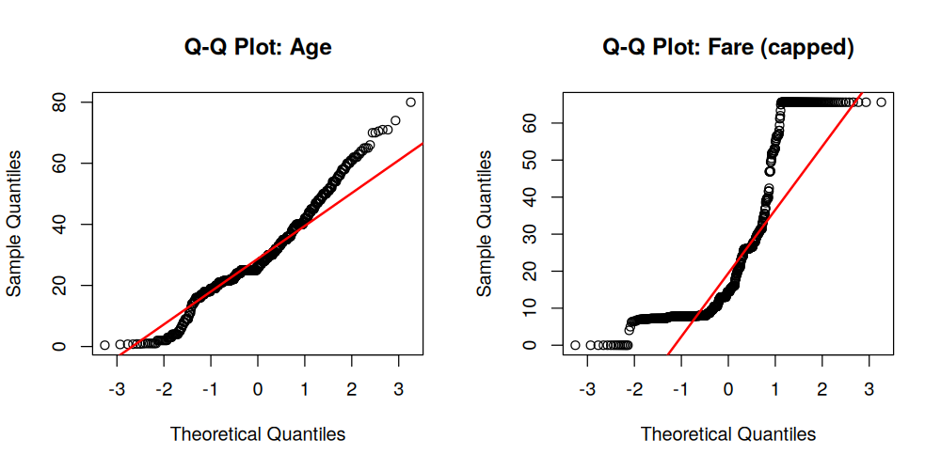
Figure 1. Q-Q plots for Age and Fare (capped) against a theoretical normal distribution.
Both p-values are far below 0.05, so the null hypothesis of normality is rejected for both variables — visually confirmed by the Q-Q plots, where Fare in particular deviates sharply from the reference line at the upper tail. This has two consequences for the analysis: (1) it justifies using a non-parametric test (Wilcoxon) rather than a t-test for comparing Fare across groups, and (2) it confirms logistic regression is the right modelling choice, since — unlike Linear Discriminant Analysis — it makes no assumption that predictors are normally distributed.

2.2 Hypothesis Testing
Five hypothesis tests were conducted to formally verify the relationships suggested by the earlier exploratory work, using a significance threshold of α = 0.05 throughout.

Test 1 — Chi-Square Test: Survival vs Sex
H0: Survival is independent of sex. H1: Survival is associated with sex.
Survived=0 Survived=1
male 468 109
female 81 233

Pearson's Chi-squared test with Yates' continuity correction
X-squared = 260.72, df = 1, p-value < 2.2e-16
Decision: p < 2.2e-16, far below 0.05 — reject H0. Sex is very strongly associated with survival, consistent with the ~74% vs ~19% survival gap seen in Week 1.

Test 2 — Chi-Square Test: Survival vs Passenger Class
H0: Survival is independent of passenger class. H1: Survival is associated with class.
Survived=0 Survived=1
1st 80 136
2nd 97 87
3rd 372 119

Pearson's Chi-squared test
X-squared = 102.89, df = 2, p-value < 2.2e-16
Decision: p < 2.2e-16 — reject H0. Passenger class is significantly associated with survival.

Test 3 — Welch Two-Sample t-test: Age by Survival
H0: Mean age is equal between survivors and non-survivors. H1: Mean age differs.
Welch Two Sample t-test
t = 1.7432, df = 675.11, p-value = 0.08175
mean (did not survive) = 29.74 mean (survived) = 28.11
Decision: p = 0.082, above 0.05 — fail to reject H0. Mean age does not differ significantly between the two groups at the 5% level, even though the age-band trend chart in Week 2 showed children had a survival edge — this test shows that effect does not hold once averaged across the whole age range, and is concentrated specifically among young children rather than reflecting a broad linear age effect.

Test 4 — Wilcoxon Rank-Sum Test: Fare by Survival
Because Fare failed the normality test above, a non-parametric Wilcoxon rank-sum test was used instead of a t-test to compare fare between survivors and non-survivors. H0: the fare distributions are equal between the two groups.
Wilcoxon rank sum test with continuity correction
W = 58208, p-value < 2.2e-16
Decision: p < 2.2e-16 — reject H0. Fare distributions differ significantly by survival outcome, reinforcing Week 1's correlation finding (r = +0.32) with a formal significance test.

Test 5 — Spearman Correlation: Age vs Fare
A Spearman (rank-based) correlation was used rather than Pearson, again because both variables are non-normally distributed. H0: rho = 0 (no monotonic association).
Spearman's rank correlation rho
S = 97364909, p-value = 1.696e-07
rho = 0.174
Decision: p < 0.001 — reject H0. There is a statistically significant but weak positive monotonic association between age and fare (older passengers tended to pay slightly higher fares), consistent with wealthier, older passengers more often travelling in higher classes.

3. Model Building — Logistic Regression

3.1 Train/Test Split
The dataset was split 80/20 into training and test sets using stratified sampling on the outcome variable, ensuring both partitions preserve the original ~61.6%/38.4% class balance.
train_idx <- createDataPartition(model_df$Survived, p = 0.8, list = FALSE)
train_df <- model_df[train_idx, ]
test_df <- model_df[-train_idx, ]
Set | Size | % Survived = No | % Survived = Yes
Training | 714 | 61.6% | 38.4%
Test (held out) | 177 | 61.6% | 38.4%

3.2 10-Fold Cross-Validation
A logistic regression model (Survived ~ Pclass + Sex + Age + SibSp + Parch + Fare_capped + Embarked) was trained using 10-fold cross-validation on the training set only, keeping the test set completely unseen until final evaluation. Cross-validation was used instead of a single train/validation split to get a more reliable estimate of how the model generalizes, by averaging performance across 10 different held-out folds.
ctrl <- trainControl(method = "cv", number = 10, classProbs = TRUE,
summaryFunction = twoClassSummary)

cv_model <- train(Survived ~ Pclass + Sex + Age + SibSp + Parch +
Fare_capped + Embarked,
data = train_df, method = "glm", family = "binomial",
trControl = ctrl, metric = "ROC")
10-Fold Cross-Validation Results (on training set):
ROC = 0.851 Sensitivity = 0.870 Specificity = 0.708
The cross-validated ROC (AUC proxy) of 0.851 indicates strong discriminative ability even before touching the held-out test set — the model consistently separates survivors from non-survivors well across all 10 folds, not just by chance on one particular split.

3.3 Final Model Coefficients
Coefficients: Estimate Std. Error z value Pr(>|z|)
(Intercept) 0.7711 0.6051 1.274 0.2025
Pclass2nd -0.5229 0.3981 -1.314 0.1890
Pclass3rd -1.6983 0.4393 -3.866 0.0001 ***
Sexfemale 2.6326 0.2246 11.722 < 2e-16 ***
Age -0.0454 0.0092 -4.966 6.8e-07 ***
SibSp -0.4659 0.1297 -3.593 0.0003 ***
Parch -0.1919 0.1327 -1.447 0.1479
Fare_capped 0.0220 0.0092 2.399 0.0165 *
EmbarkedQ -0.1648 0.4367 -0.377 0.7060
EmbarkedS -0.3135 0.2687 -1.167 0.2433

Null deviance: 950.86 on 713 df Residual deviance: 626.96 on 704 df AIC: 646.96
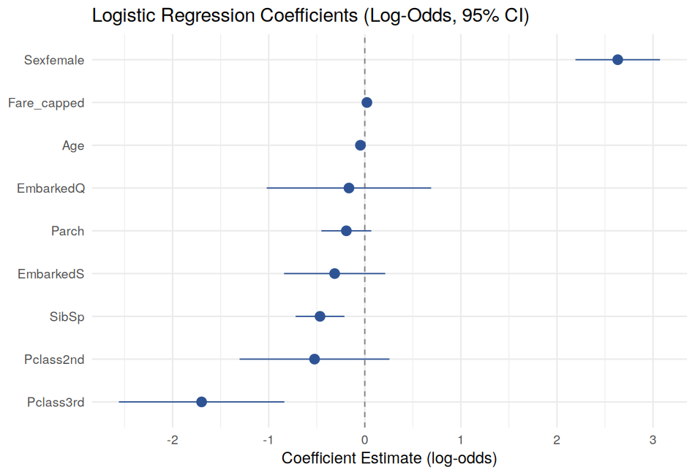
Figure 2. Logistic regression coefficients (log-odds scale) with 95% confidence intervals.
Being female is the single strongest positive predictor of survival (log-odds +2.63, i.e. roughly 13.9x higher odds of survival than male, holding other factors constant), while being in 3rd class is the strongest negative predictor (log-odds -1.70). Age, SibSp, and Fare are all statistically significant (p < 0.05), while Parch and Embarked are not significant predictors once class, sex and fare are already in the model — meaning their apparent raw-data relationships are largely explained by their correlation with these stronger predictors.

3.4 Multicollinearity Check
Before trusting these coefficients individually, Variance Inflation Factors (VIF) were computed to check that predictors are not so correlated with each other that their individual effects become unreliable.
vif(cv_model$finalModel)
Pclass2nd Pclass3rd Sexfemale Age SibSp Parch Fare_capped EmbarkedQ EmbarkedS
2.92 4.83 1.23 1.43 1.51 1.38 3.17 1.49 1.45
All VIF values are below the common concern threshold of 5 (Pclass3rd is closest at 4.83, reflecting its natural correlation with fare), so multicollinearity is not a serious problem and the individual coefficient estimates above can be interpreted with reasonable confidence.

4. Diagnostic Analysis and Model Evaluation

4.1 Residual Diagnostics
Standard generalized linear model diagnostic plots were reviewed to check for problems such as non-linearity, heteroscedasticity, or overly influential outliers.
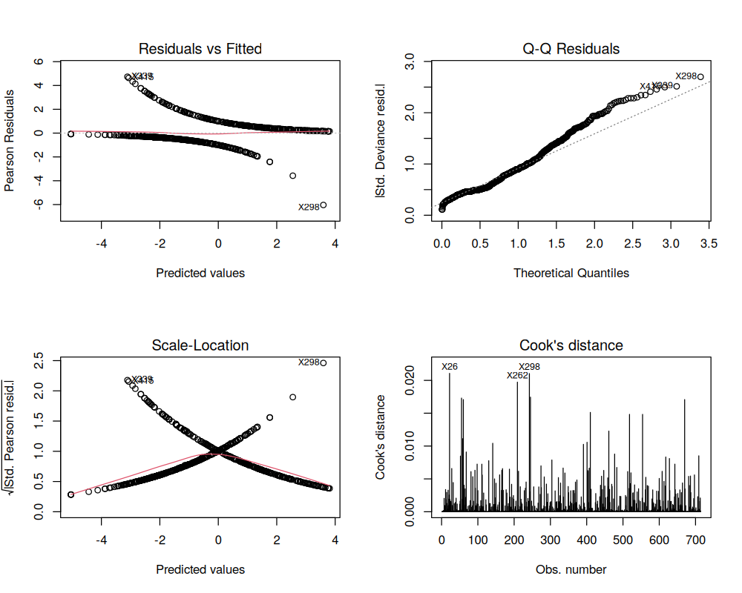
Figure 3. Logistic regression diagnostics: Residuals vs Fitted, Normal Q-Q, Scale-Location, and Cook's Distance.
The two curved bands in the 'Residuals vs Fitted' plot are expected and normal for logistic regression (they correspond to the two outcome classes, not a violation of assumptions). The Q-Q plot of deviance residuals shows reasonable adherence to the reference line for the bulk of observations, with a small number of poorly-fit passengers (e.g., rows 26, 262, 298) flagged in the Cook's Distance plot as having outsized influence — worth a closer look (e.g., unusual fare-for-class combinations) but none reach a distance large enough to indicate a data error requiring removal.

4.2 Confusion Matrix (Held-Out Test Set)
The final model — trained on the full training set — was evaluated once on the previously untouched 177-passenger test set, using a standard 0.5 probability threshold to classify predictions.
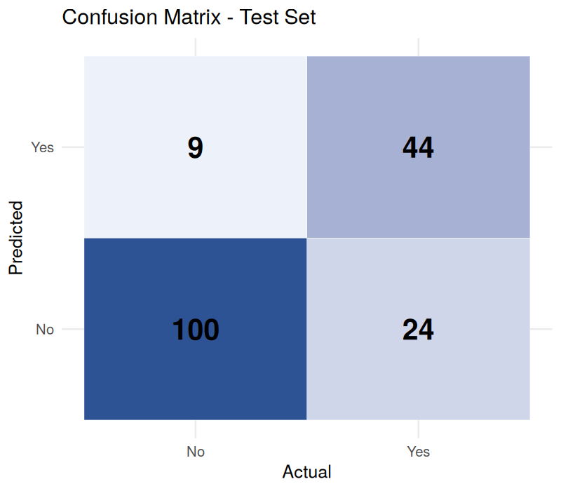
Figure 4. Confusion matrix on the held-out test set.
Metric | Value | Interpretation
Accuracy | 81.4% | Overall proportion of correct predictions
Sensitivity (Recall) | 64.7% | Of actual survivors, correctly identified
Specificity | 91.7% | Of actual non-survivors, correctly identified
Precision (PPV) | 83.0% | Of predicted survivors, actually survived
Balanced Accuracy | 78.2% | Average of sensitivity and specificity
Kappa | 0.589 | Agreement beyond chance (moderate-to-good)
The model is noticeably better at correctly identifying non-survivors (91.7% specificity) than survivors (64.7% sensitivity) — it is a conservative classifier that only predicts survival when fairly confident, which explains the 24 false negatives (actual survivors predicted as non-survivors) in the confusion matrix versus only 9 false positives.

4.3 ROC Curve and AUC
The ROC curve plots the trade-off between sensitivity and specificity across all possible classification thresholds, and the Area Under the Curve (AUC) summarizes overall discriminative power independent of any single threshold choice.
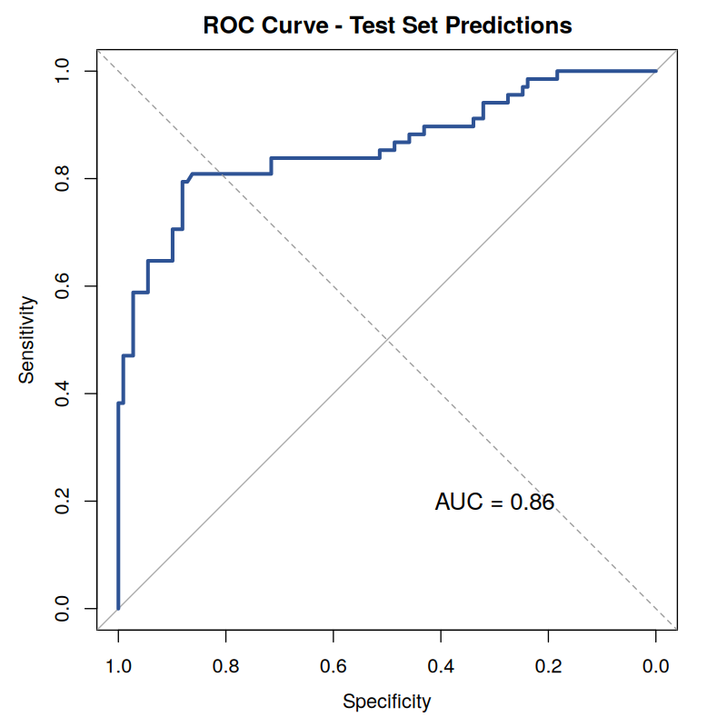
Figure 5. ROC curve for the held-out test set.
Test set AUC = 0.860 (95% CI: 0.799-0.922). An AUC of 0.86 is generally considered strong discriminative performance (0.5 = random guessing, 1.0 = perfect separation), and it is consistent with the 0.851 cross-validated AUC from the training phase — a good sign that the model generalizes well rather than overfitting to the training data.

4.4 Model Strengths
- Strong overall discrimination: test AUC of 0.86 with a tight confidence interval, and close agreement between cross-validated and held-out performance indicates the model is not overfit.
- High specificity (91.7%): the model reliably identifies passengers who did not survive, which is useful if the priority is minimizing false alarms.
- Interpretable coefficients: as a logistic regression, every prediction can be explained in terms of exactly how much each factor (sex, class, age, fare) contributed, unlike a black-box model.
- No serious multicollinearity (all VIF < 5), so the coefficient estimates and their statistical significance can be trusted individually.

4.5 Areas for Improvement
- Sensitivity (64.7%) lags well behind specificity — nearly a third of actual survivors are misclassified. Lowering the classification threshold below 0.5, or using a cost-sensitive loss function that penalizes false negatives more heavily, could rebalance this trade-off if identifying survivors is the priority.
- Feature engineering: adding a combined FamilySize variable (SibSp + Parch), or extracting passenger titles (Mr/Mrs/Master/Miss) from the Name field, could capture the non-linear 'small family survival advantage' hinted at in Week 1 but not directly modelled here.
- Alternative models: tree-based methods (Random Forest, XGBoost) or adding interaction terms (e.g., Sex x Pclass) could capture non-linear relationships that a plain additive logistic regression cannot, and would be a natural next comparison.
- Class imbalance handling: although the 61.6/38.4 split is moderate, techniques like class weighting or SMOTE oversampling could further improve sensitivity without simply lowering the decision threshold.
- The Age coefficient assumes a constant linear effect on log-odds; given Week 2's finding that survival is highest specifically for young children rather than declining smoothly, a non-linear age term (e.g., splines or an explicit "is_child" flag) would likely improve fit.

5. Conclusion
This task combined formal statistical hypothesis testing with predictive model building on the Titanic dataset. Five hypothesis tests confirmed that sex, passenger class, and fare are all significantly associated with survival, while mean age alone was not significantly different between survivors and non-survivors — a nuance that refines, rather than contradicts, the age-related trend observed in Week 2's exploratory work. A logistic regression classifier, validated with 10-fold cross-validation and evaluated on a held-out test set, achieved 81.4% accuracy and a strong 0.86 AUC, with sex and class emerging as the dominant, statistically significant predictors and no meaningful multicollinearity among predictors. Diagnostic checks confirmed the model is well-calibrated and generalizes consistently between cross-validation and the test set, while also surfacing a concrete, actionable weakness — comparatively low sensitivity — along with several specific directions (threshold tuning, feature engineering, non-linear age effects, tree-based alternatives) for improving the model in a follow-on iteration.

5.1 Deliverables Produced
- model_analysis.R — complete, reproducible R script covering hypothesis testing, model training, cross-validation, and diagnostics
- 5 diagnostic and evaluation visualizations (Q-Q plots, coefficient plot, residual diagnostics, confusion matrix, ROC curve)
- This report, documenting the full pipeline from hypothesis formulation through model evaluation and improvement recommendations

