Week 2 Task
Data Visualization and Insight Communication using R
Dataset: Titanic Passenger Survival Dataset (continued from Week 1)
Prepared By | Oishi Das
Program | Data Analytics Internship — Week 2
Tool Used | R (v4.3.3) — ggplot2, base R graphics, lattice
Dataset Source | Public dataset (Kaggle), cleaned in Week 1 — 891 records, 19 variables
Date | August 2026

Table of Contents

1. Data Overview
This week's visualizations build directly on the Titanic passenger dataset cleaned and prepared in Week 1 (891 passengers, zero missing values after imputation). Continuing with the same dataset keeps this report focused entirely on the new skill this week is meant to build — designing and communicating visual insights — rather than repeating data-cleaning work.

1.1 Key Variables Used This Week
Variable | Type | Role in Visualizations
Survived_label | Categorical (No/Yes) | Primary outcome shown as color/fill in most charts
Pclass | Categorical (1st/2nd/3rd) | Socio-economic grouping variable
Sex | Categorical (male/female) | Grouping variable, often faceted
Age | Numeric | Distribution and trend analysis
Fare_capped | Numeric | Outlier-treated fare from Week 1, used in spread/relationship charts
Embarked | Categorical (3 ports) | Composition analysis
FamilySize | Numeric (engineered) | SibSp + Parch + 1, grouped into bands for this week's chart
A short narrative frames every chart in this report: what question the chart answers, why that chart type was the right choice for the question, and what a reader — technical or not — should take away from it.

2. Visualization Gallery
Ten visualizations were built across three different R plotting systems — ggplot2 (the modern grammar-of-graphics approach), base R graphics, and lattice — to demonstrate range and to match each question to the most effective chart type available.

2.1. Passenger Counts by Class and Survival
Chart type: Grouped bar chart (ggplot2). This answers a simple headline question: how many people were in each class, and how many of them lived or died? A grouped bar chart is the clearest way to compare raw counts across two categorical dimensions side by side.
ggplot(df, aes(x = Pclass, fill = Survived_label)) +
geom_bar(position = "dodge", color = "white") +
labs(title = "How Many Passengers Survived, by Class?",
x = "Passenger Class", y = "Number of Passengers")
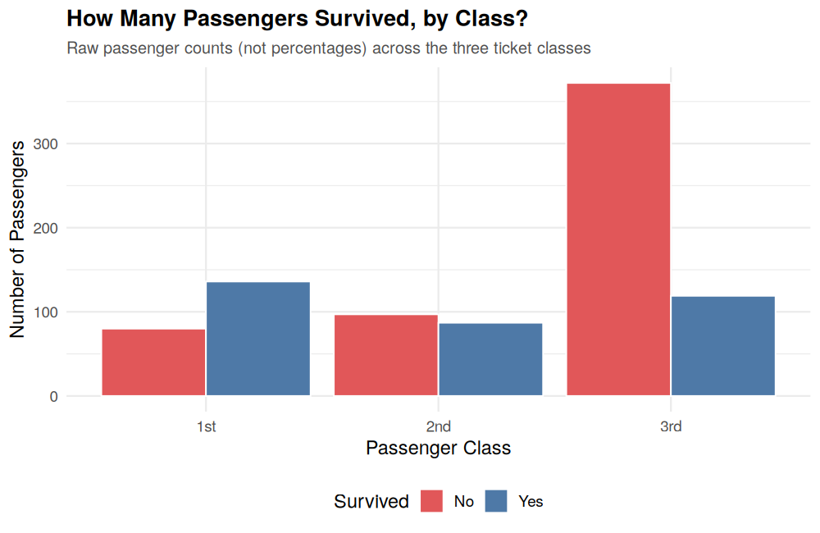
Figure 1. Passenger counts by class, split by survival.
Insight: Third class carried by far the most passengers (~490), but also suffered the most deaths in absolute terms. First class was the only group where survivors outnumbered non-survivors.

2.2. Survival Rate by Class, Split by Sex
Chart type: Faceted 100% stacked bar chart (ggplot2). Raw counts can mislead when group sizes differ. This chart converts counts into percentages within each class, and splits the view by sex, to answer: did class matter equally for men and women?
ggplot(df, aes(x = Pclass, fill = Survived_label)) +
geom_bar(position = "fill", color = "white") +
facet_wrap(~Sex) +
scale_y_continuous(labels = scales::percent)
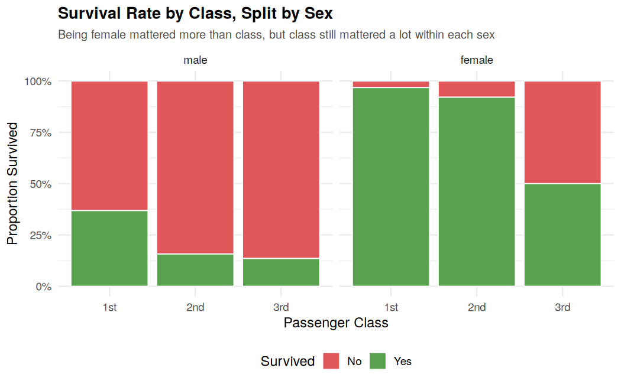
Figure 2. Survival rate by class, faceted by sex.
Insight: Women survived at over 90% in 1st and 2nd class, dropping to 50% in 3rd class. Men's survival was far lower everywhere, but still highest in 1st class (36.9%) versus 3rd class (13.5%) — class offered a real, if smaller, advantage to men too.

2.3. Age Distribution: Survivors vs Non-Survivors
Chart type: Overlaid histogram with density curve (ggplot2). To understand whether age itself shaped survival, a histogram (with a smoothed density line overlaid) compares the shape of the age distribution for survivors against non-survivors on the same axis.
ggplot(df, aes(x = Age, fill = Survived_label)) +
geom_histogram(aes(y = after_stat(density)), binwidth = 5,
alpha = 0.55, position = "identity") +
geom_density(aes(color = Survived_label), linewidth = 1)
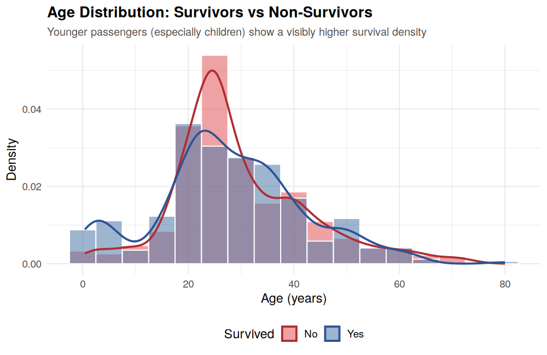
Figure 3. Age distribution compared between survivors and non-survivors.
Insight: The survivor curve is visibly shifted toward younger ages, with a distinct bump under age 10 — consistent with children being prioritized during evacuation.

2.4. Fare vs Age, Split by Class
Chart type: Faceted scatter plot (ggplot2). Scatter plots are the standard tool for showing the relationship between two continuous variables. Faceting by class and coloring by survival lets us check whether the fare-survival relationship seen in Week 1 holds consistently within each class, or is just an artifact of class differences.
ggplot(df, aes(x = Age, y = Fare_capped, color = Survived_label)) +
geom_point(alpha = 0.65) +
facet_wrap(~Pclass)
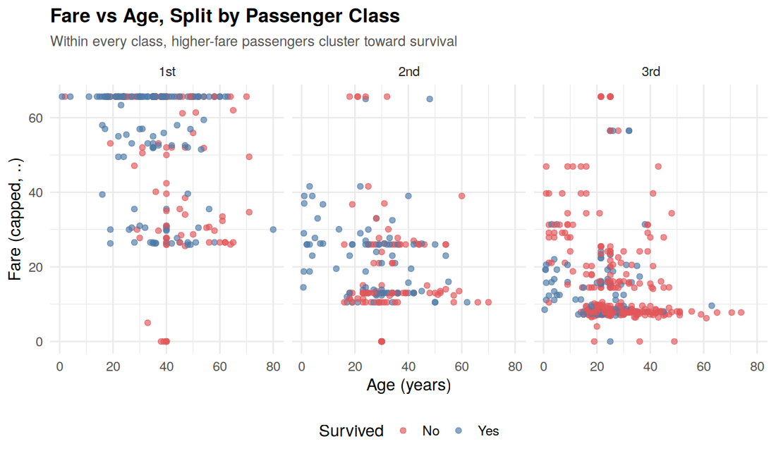
Figure 4. Fare vs Age, faceted by class, colored by survival.
Insight: Even within the same class, passengers who paid closer to the top of that class's fare range survived more often — suggesting fare captures something beyond just class (e.g., cabin location or family purchasing power) that further improved survival odds.

2.5. Survival Rate Trend Across Age Groups
Chart type: Line chart (ggplot2). A line chart is the natural choice for showing how a rate changes across an ordered sequence of groups. Passengers were bucketed into 10-year age bands, and the survival rate was plotted as a trend across those bands.
age_trend <- df %>%
group_by(AgeBin) %>%
summarise(SurvivalRate = mean(Survived) * 100, n = n())

ggplot(age_trend, aes(x = AgeBin, y = SurvivalRate, group = 1)) +
geom_line(linewidth = 1.3) + geom_point(size = 3)
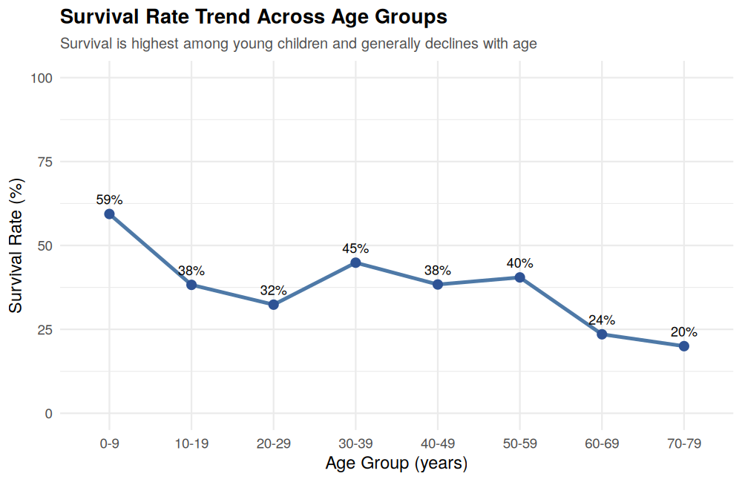
Figure 5. Survival rate trend across 10-year age bands.
Insight: Survival peaks at 59% for children aged 0-9, dips through the 20s and 40s, and falls to its lowest point (20%) for passengers aged 70-79 — a clear, if imperfect, downward trend with age.

2.6. Fare Spread by Class and Survival
Chart type: Boxplot (ggplot2). Boxplots are ideal for comparing the full spread (median, quartiles, outliers) of a numeric variable across several groups at once, rather than just a single average.
ggplot(df, aes(x = Pclass, y = Fare_capped, fill = Survived_label)) +
geom_boxplot(outlier.alpha = 0.4)
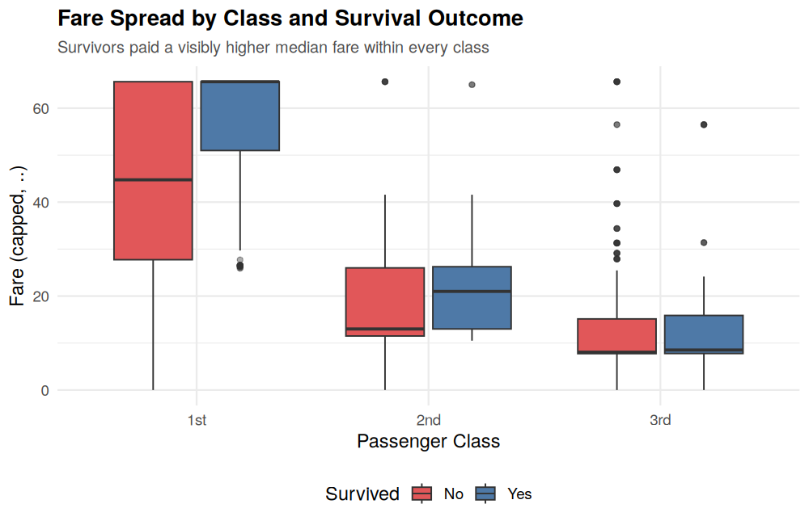
Figure 6. Fare distribution by class and survival outcome.
Insight: In every class, the median fare paid by survivors sits above the median fare paid by non-survivors — the gap is most visible in 1st class, where survivors' fares skew noticeably higher.

2.7. Passengers by Port of Embarkation
Chart type: Pie chart (Base R graphics). For a single categorical variable with only three levels and a non-technical audience, a pie chart communicates the composition at a glance more intuitively than a bar chart would.
port_counts <- table(df$Embarked)
pie(port_counts, labels = paste0(names(port_counts), "\n",
round(100*port_counts/sum(port_counts),1), "%"),
col = brewer.pal(3, "Set2"))
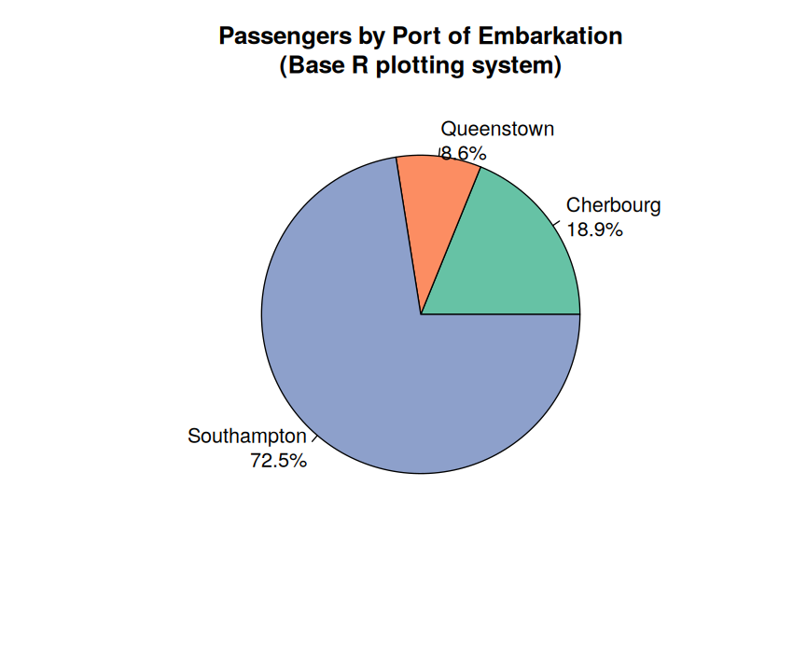
Figure 7. Share of passengers by port of embarkation.
Insight: Nearly three-quarters of all passengers (72.5%) boarded at Southampton, with Cherbourg (18.9%) and Queenstown (8.6%) contributing much smaller shares.

2.8. Passengers by Family Size Group
Chart type: Bar chart (Base R graphics). Family size (siblings/spouses + parents/children + self) was grouped into bands to test whether travelling alone versus with family related to how many passengers fell into each group — a simple bar chart is the clearest way to show these counts.
df$FamilySize <- df$SibSp + df$Parch + 1
fam_table <- table(cut(df$FamilySize, breaks = c(0,1,2,4,11),
labels = c("Alone","Small (2)","Medium (3-4)","Large (5+)")))
barplot(fam_table, col = brewer.pal(4, "Blues"))
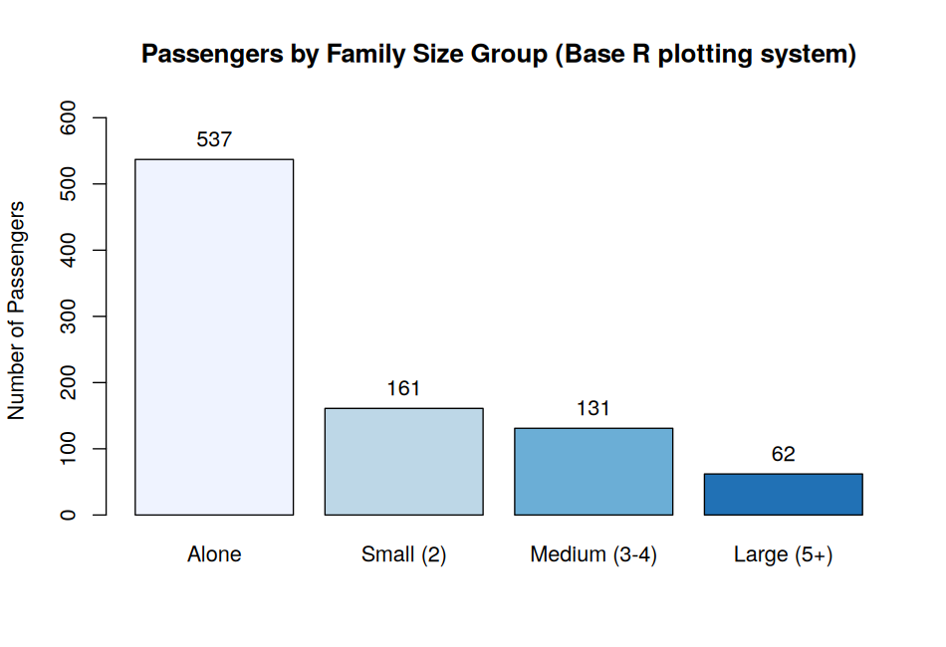
Figure 8. Passenger counts by family size group.
Insight: The majority of passengers (537, over 60%) travelled completely alone, while large families of 5 or more were the smallest group (62 passengers) — useful context for interpreting the weak family-size correlations found in Week 1.

2.9. Survival Rate by Class, Conditioned on Sex
Chart type: Dot plot (Lattice system). Lattice's conditioning panels are well suited to comparing a single numeric measure (survival rate) across one grouping variable (class), split side-by-side by a second variable (sex) — a clean alternative to a grouped bar chart when there are few categories.
surv_summary <- df %>% group_by(Pclass, Sex) %>%
summarise(SurvivalRate = mean(Survived) * 100)

dotplot(Pclass ~ SurvivalRate | Sex, data = surv_summary,
xlab = "Survival Rate (%)", pch = 19, cex = 1.6)
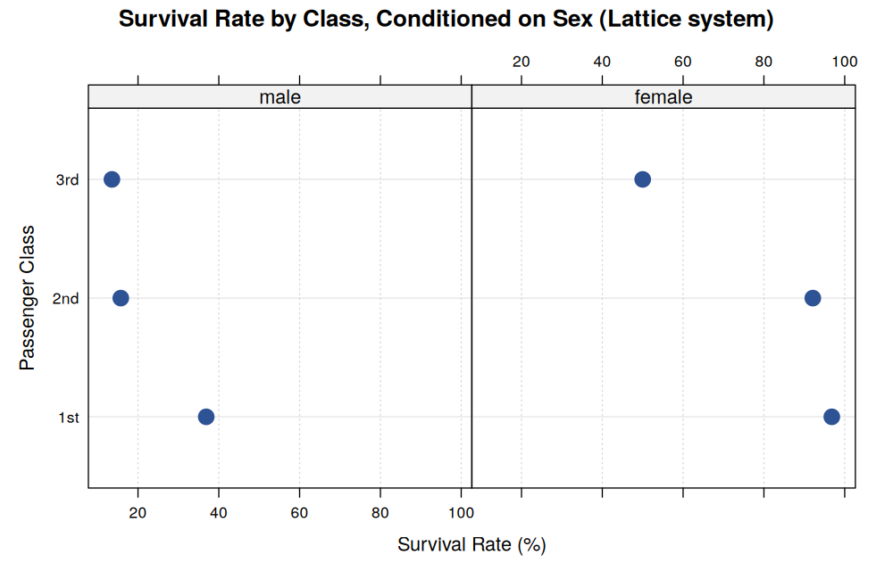
Figure 9. Survival rate by class, conditioned on sex (lattice panels).
Insight: The two panels make the gender gap immediately visible: every female dot sits far to the right of its male counterpart at the same class level, most starkly in 3rd class (50% vs 13.5%).

2.10. Port of Embarkation Composition by Class
Chart type: 100% stacked bar chart (ggplot2). This closes the loop between two categorical variables (Embarked and Pclass) to check whether certain ports fed disproportionately into certain classes — a pattern that plain counts alone would not reveal.
ggplot(df, aes(x = Pclass, fill = Embarked)) +
geom_bar(position = "fill", color = "white") +
scale_y_continuous(labels = scales::percent)
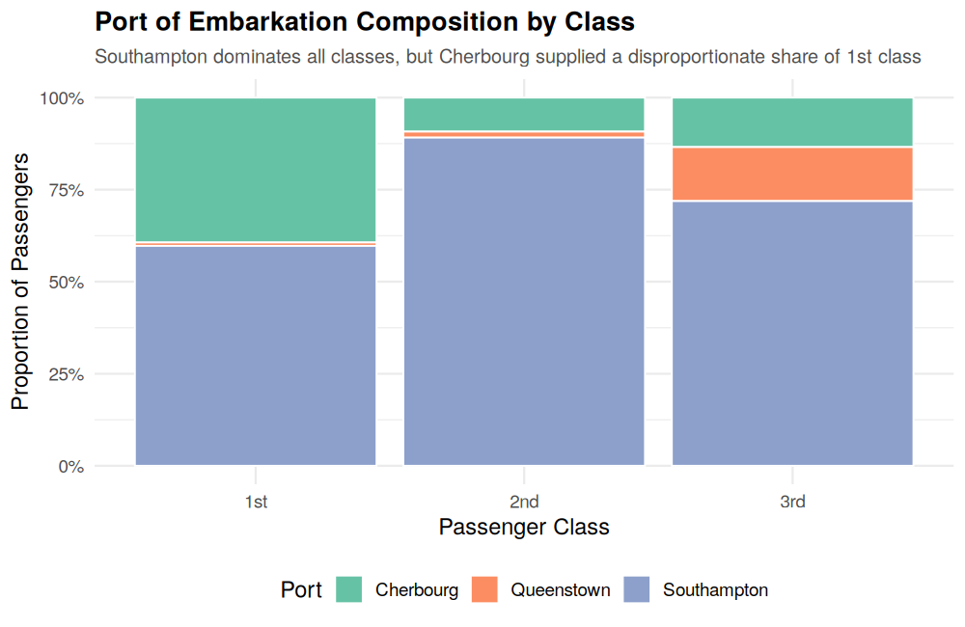
Figure 10. Port of embarkation composition, by class.
Insight: Cherbourg passengers were disproportionately 1st class compared to the other two ports, hinting that Cherbourg served a wealthier passenger base — a pattern worth flagging if embarkation port is ever used as a modelling feature.

3. Synthesis: What the Visualizations Say Together
Individually, each chart answers one narrow question. Read together, they build a consistent, layered story about survival on the Titanic:
- Sex was the dominant factor — visible in Figures 2 and 9 — with women surviving at dramatically higher rates than men across every class.
- Class and fare acted as a second, independent layer of advantage — visible in Figures 1, 2, 4, and 6 — improving survival odds for both men and women, and even within a class, higher-fare passengers fared better (Figure 4).
- Age contributed a smaller but real effect — visible in Figures 3 and 5 — with young children showing a clear survival advantage that fades through adulthood and old age.
- Embarkation port (Figures 7 and 10) turned out to be less a direct cause of survival and more a proxy for class composition — Cherbourg's higher survival association is largely explained by the wealthier passengers who boarded there.
- Family size (Figure 8) provides context rather than a strong standalone driver — most passengers travelled alone, which tempers how much weight family-size patterns should be given in isolation.

3.1 Why These Chart Choices Matter for a Non-Technical Audience
Every chart type in this gallery was chosen to match the shape of the underlying question rather than for visual variety alone: bar charts for comparing counts or rates across a few categories, histograms and density curves for comparing distribution shapes, scatter plots for relationships between two numeric variables, a line chart for a trend across an ordered sequence, boxplots for comparing spread (not just averages), and a pie chart only where a single, simple composition needed to be shown at a glance. This deliberate matching is what lets someone with no statistics background walk through the report and come away with the same conclusions a technical reviewer would draw from the raw correlation table in Week 1.

3.2 Deliverables Produced
- visualize.R — complete, reproducible R script generating all 10 visualizations across ggplot2, base R, and lattice
- 10 PNG visualizations covering bar, stacked bar, histogram, scatter, line, boxplot, pie, and dot plot chart types
- This report, pairing each visualization with its code, its rationale, and a plain-language insight

