Meeting 1 – Thursday October 4th

# In Attendance:

* Aidan Fogarty
* Daniel Perecz
* Eoghan Murphy
* Michael Downling
* Oishin Smith

# Agenda

* Discussed roles.
* Set up Slack.
* Set up Trello Board.
* Showed Hangman Prototype and decided on basic technology we’d be using for the project (node.js and socket.io).

# Planned Tasks:

* Familiarize with requirements
* Look at tutorials on Javascript and jQuery

Meeting 2 – Monday October 8th

# In Attendance:

* Aidan Fogarty
* Daniel Perecz
* Eoghan Murphy
* Michael Downling
* Oishin Smith

# Agenda

* Discussed requirements.
* Decided ambiguities and questions to ask Renaat.

# Planned Tasks:

* Complete requirements specification.
* Research into graphics software that works with socket.io.

Meeting 3 – Friday October 12th

# In Attendance:

* Aidan Fogarty
* Daniel Perecz
* Eoghan Murphy
* Michael Downling
* Oishin Smith

# Agenda

* Played a game of Scrabble.
* Wrote scenarios using Scrabble game as a guide.

# Planned Tasks:

* Create Use Cases from scenarios.

Meeting 4 – Thursday October 18th

# In Attendance:

* Aidan Fogarty
* Daniel Perecz
* Eoghan Murphy
* Michael Downling
* Oishin Smith

# Agenda

* Discussed classes.
* Decided primary class list.

# Planned Tasks:

* Complete CRCs.
* Research and complete Use Case Diagram.

Meeting 5 – Monday October 22nd

# In Attendance:

* Aidan Fogarty
* Daniel Perecz
* Eoghan Murphy
* Michael Downling
* Oishin Smith
* Martin Zaloudek (Only joined the group)

# Agenda

* Tidied up scenarios.
* Did a rough version of the class diagram and the use case diagram.

# Planned Tasks:

* Tidy up CRCs.
* Finish Class Diagram.
* Finish Use Case Diagram.
* Do Structured Walkthrough.

Meeting 5 – Tuesday October 23rd

# In Attendance:

* Aidan Fogarty
* Daniel Perecz
* Eoghan Murphy
* Michael Downling
* Oishin Smith
* Martin Zaloudek

# Agenda

* Redesigned the Client class to be a superclass of Player and MainView.
* Made necessary changes to accommodate this change.

# Planned Tasks:

* Make 2 new use cases that are required.
* Change CRC to reflect class change.

Meeting 6 – Wednesday October 24th

# In Attendance:

* Aidan Fogarty
* Daniel Perecz
* Eoghan Murphy
* Michael Downling
* Oishin Smith
* Martin Zaloudek

# Agenda

* Finished off Class Diagram.
* Worked on Structured Walkthrough.

# Planned Tasks:

* Finish structured walkthrough.
* Gather everything into one document.

Meeting 7 – Thursday October 25th

# In Attendance:

* Aidan Fogarty
* Daniel Perecz
* Eoghan Murphy
* Michael Downling
* Oishin Smith
* Martin Zaloudek

# Agenda

* Read over everything.
* Submitted analysis part of the project.

# Planned Tasks:

* Meet again next Monday to discuss the next section of the project.

Extra Information regarding record keeping

We kept a Trello board to keep track of the status of tasks:

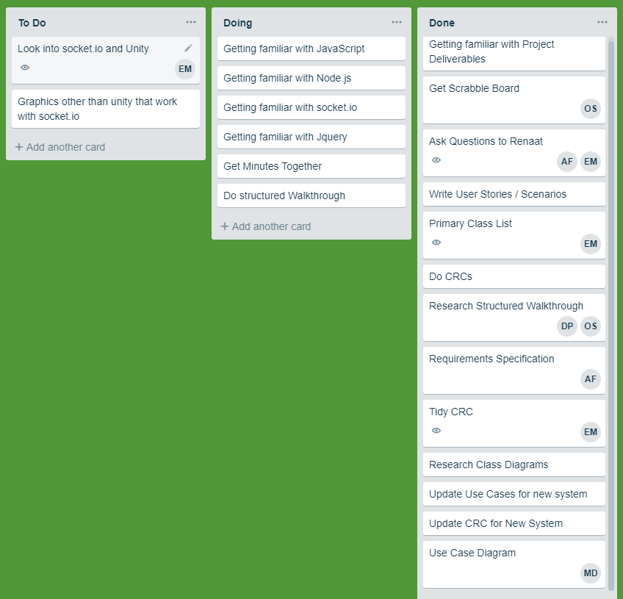

We also had a git repository to make sure all our files were up to date:

