# Preface

Since we are taking a novel approach at recreating a multiplayer Scrabble game, we feel that a short explanation is necessary. The game will (in most cases) be played in the same room. A lobby will be started on a central screen. Players will connect with their phones (or other web capable devices) to this lobby. Players can then make their moves from their devices and everything that happens will be updated on the larger screen (allowing for spectators and a more traditional feel).

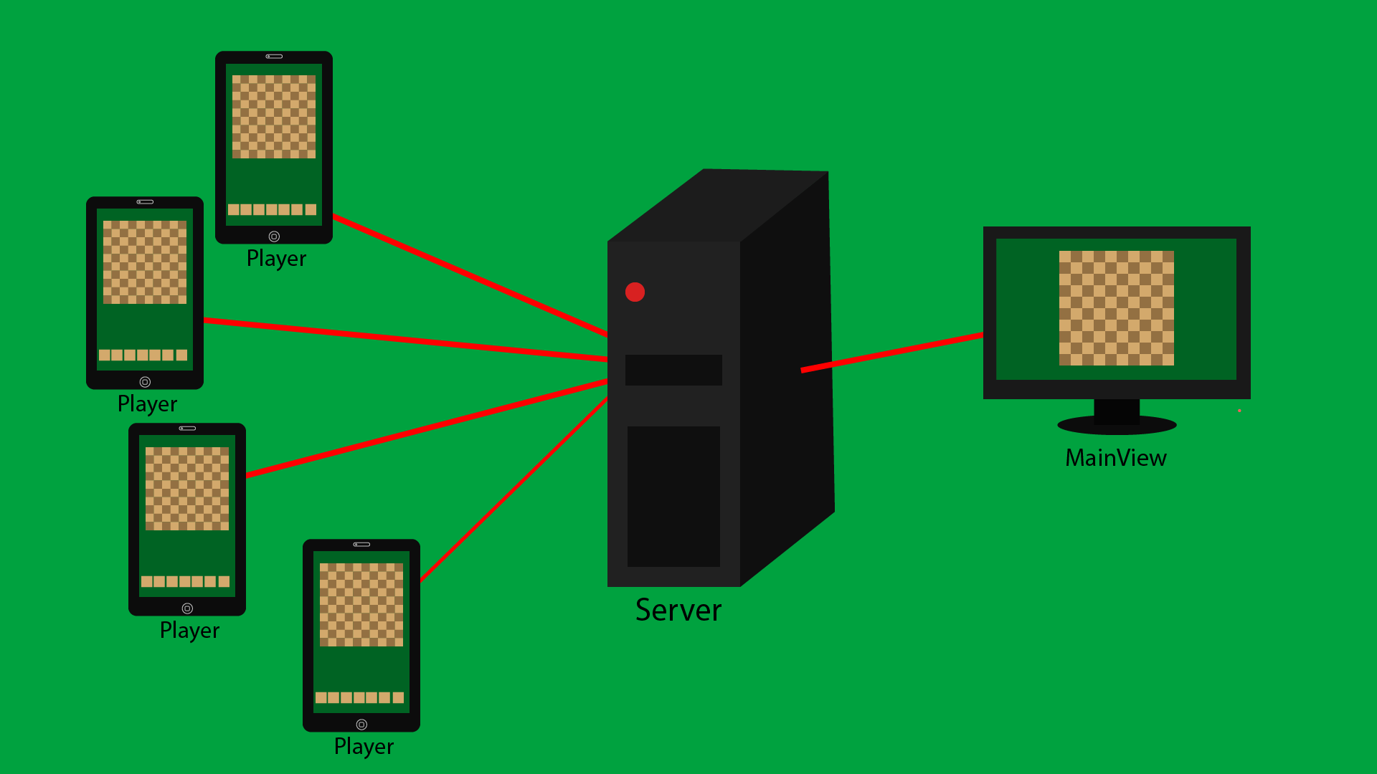An illustration of how the game will work.