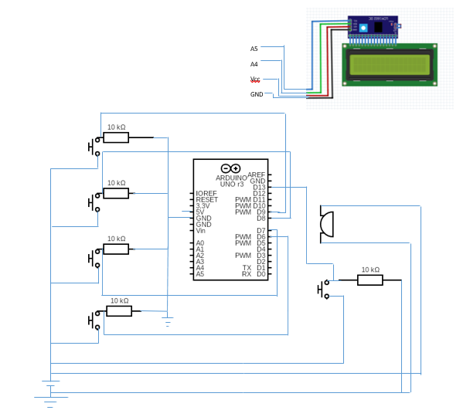
CIRCUIT DIAGRAM

