oisin anderson

A00260168

Databases Assigment

**Concept**

The key concept of my project is that it can be used to store data for a paper sales company. It can store info about the customers and the orders they make, info about the employees and info about the paper that is sold in that business. The information that can be viewed is very informative as you can see the different information in the business and export data to a csv file for handier use. Also there is chart to analyse employees sales performances and how well the paper is selling which could help decide whether paper might not be sold anymore in this business.

**Snapshot Of GUI**

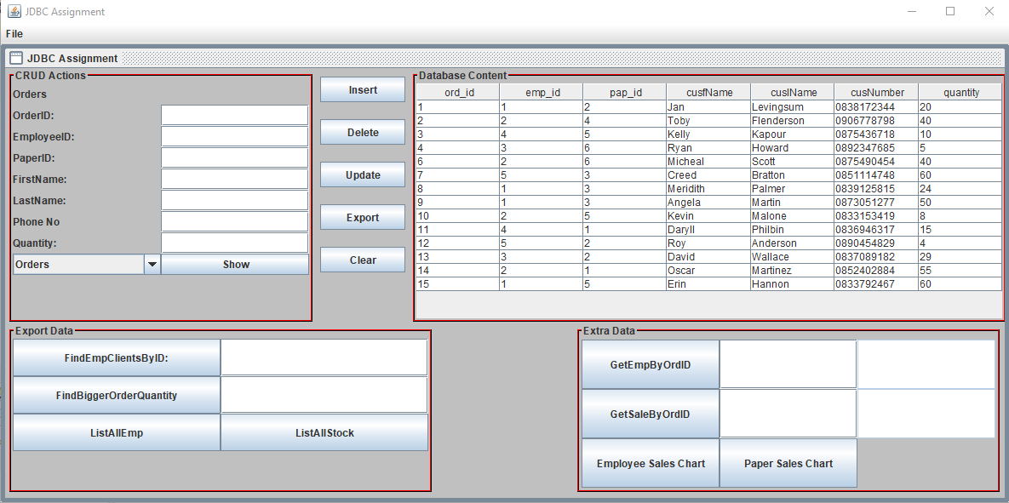

Above is a snapshot of the gui for my project.

**Highlights**

Stored Procedure

I included 2 stored procedures in my project. The first one gets the Employees name from the order id you enter and displays it in a text field. The second one gets the total price of a sale from the order id you enter and displays it in a text field. Both stored procedures have one input and one output. The first one concats the first name and last name of the employee and the second one does a sum by multiplying the quantity of paper sole for that sale by the price of the paper.

Below are 2 screenshots of the code for the Stored procedure

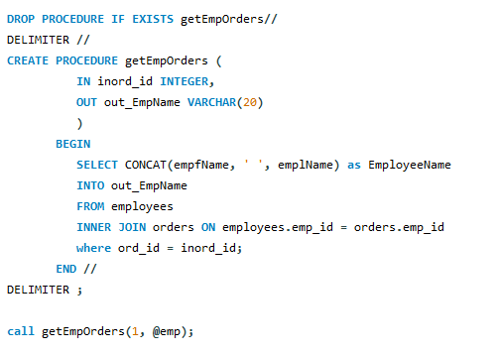

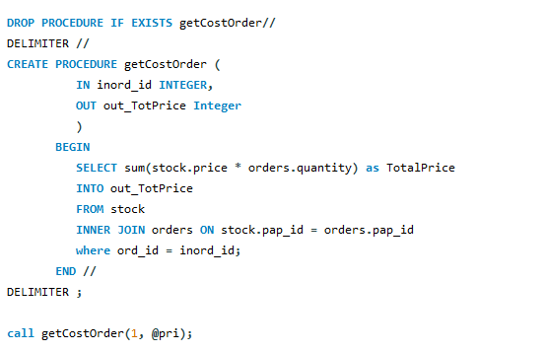

Charts

I decided to include two charts into the project. The first chart returns the employees total sales record on a pie chart while the second one returns the paper sales record on a pie chart. I use inner join statements to link together the separate tables in the database to get all the info required for the database. The Employees sales pie chart was difficult because I had to join all 3 tables to get the correct info.

Below are screenshots of the charts

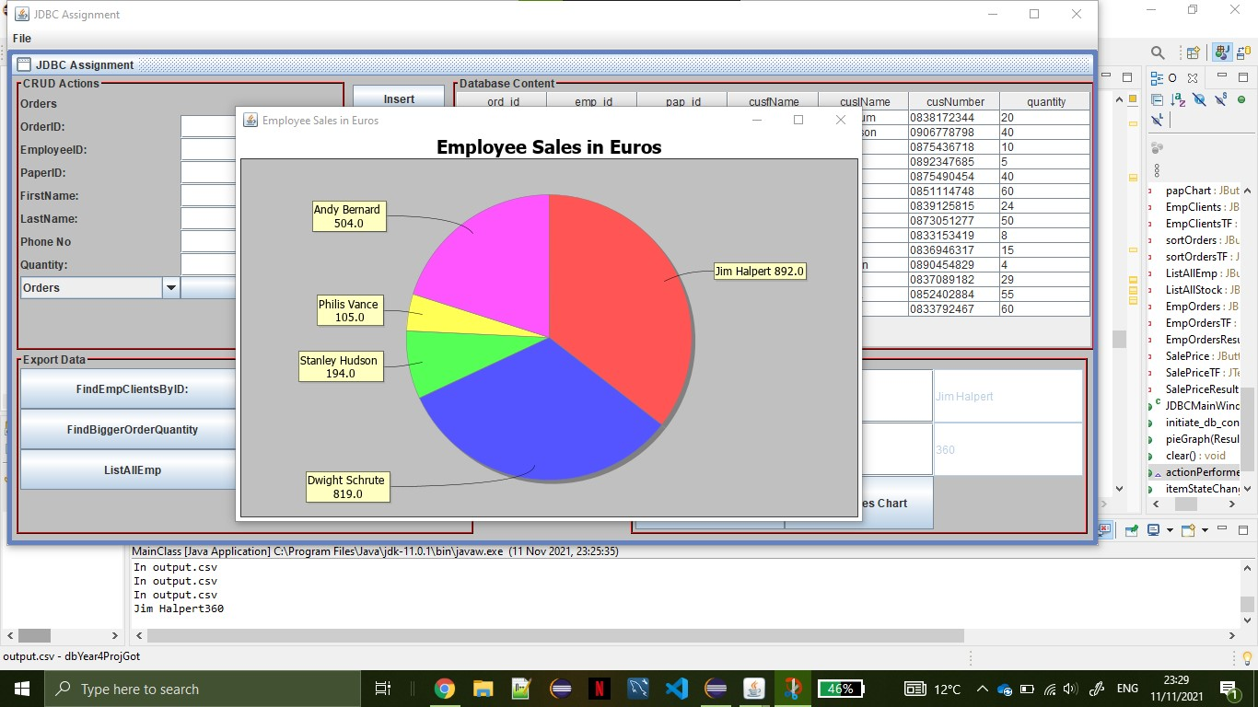

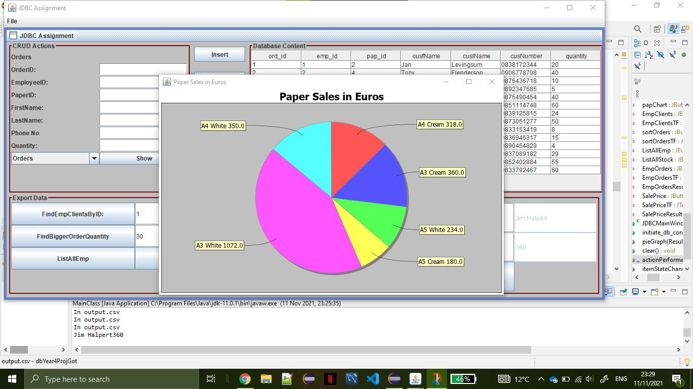

Three Tables

I included 3 database tables in this project. The main table is the orders table as it includes emp_id from the employees table as a foreign id and it includes pap_id ad a foreign key from the stock table.