Show commands:

- sh ip route
- sh ip ospf neighbor
- sh ip protocols
- sh ip ospf int
- sh ip ospf database
- sh ip route ospf
- debug ip ospf adj
Enabling OSPF
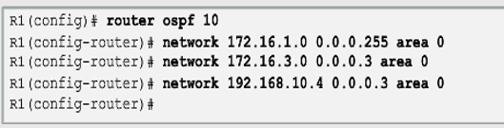
Make a interface passive:
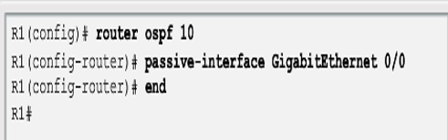
Assigning a Loopback address to an interface
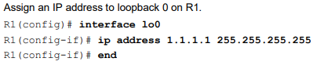
Changing the reference bandwidth

R1(config)# router ospf 1
R1(config-router)# auto-cost reference-bandwidth 10000

