VLSM, Route Aggregation, RIP1, RIP2
Network administrators must anticipate and manage the physical growth of networks. This may require them to buy or lease another floor of a building for new network equipment such as racks, patch panels, switches, and routers. Network designers must choose address schemes that allow for growth. Variable-length subnet mask (VLSM) is used to create efficient and scalable address schemes.
Almost every enterprise must implement an IP address scheme. Many organizations select TCP/IP as the only routed protocol to run on their networks. Unfortunately, the architects of TCP/IP did not predict that the protocol would eventually sustain a global network of information, commerce, and entertainment.
IPv4 offered an address strategy that was scalable for a time before it resulted in an inefficient allocation of addresses. IPv4 may soon be replaced with IP version 6 (IPv6) as the dominant protocol of the Internet. IPv6 has virtually unlimited address space and implementation has begun in some networks. Over the past two decades, engineers have successfully modified IPv4 so that it can survive the exponential growth of the Internet. VLSM is one of the modifications that has helped to bridge the gap between IPv4 and IPv6.
Networks must be scalable since the needs of users evolve. When a network is scalable it is able to grow in a logical, efficient, and cost-effective way. The routing protocol used in a network helps determine the scalability of the network. It is important to choose the routing protocol wisely. Routing Information Protocol version 1 (RIP v1) is suitable for small networks. However, it is not scalable to large networks. RIP version 2 (RIP v2) was developed to overcome these limitations.
What is VLSM?
As IP subnets have grown, administrators have looked for ways to use their address space more efficiently. This page introduces a technique called VLSM. With VLSM, a network administrator can use a long mask on networks with few hosts, and a short mask on subnets with many hosts.
In order to implement VLSM, a network administrator must use a routing protocol that supports it. Cisco routers support VLSM with Open Shortest Path First (OSPF), Integrated IS-IS, Enhanced Interior Gateway Routing Protocol (EIGRP), RIP v2, and static routing.
VLSM allows an organization to use more than one subnet mask within the same network address space. VLSM implementation maximizes address efficiency, and is often referred to as subnetting a subnet.
Classful routing protocols require that a single network use the same subnet mask. As an example, a network with an address of 192.168.187.0 can use just one subnet mask, such as 255.255.255.0.
A routing protocol that allows VLSM gives the network administrator freedom to use different subnet masks for networks within a single autonomous system
Waste of Space
In the past, the first and last subnet were not supposed to be used. The use of the first subnet, which was known as subnet zero, was discouraged because of the confusion that could occur if a network and a subnet had the same address. This also applied to the use of the last subnet, which was known as the all-ones subnet. With the evolution of network technologies and IP address depletion, the use of the first and last subnets have become an acceptable practice in conjunction with VLSM.
In the Figure 1, the Sydney, Brisbane, Perth, and Melbourne remote offices may each have 30 hosts. The team realizes that it has to address the three point-to-point WAN links between Sydney, Brisbane, Perth, and Melbourne. If the team uses the last three subnets for the WAN links, all of the available addresses will be used and there will be no room for growth. The team will also have wasted the 28 host addresses from each subnet to simply address three point-to-point networks. This address scheme would waste one-third of the potential address space.
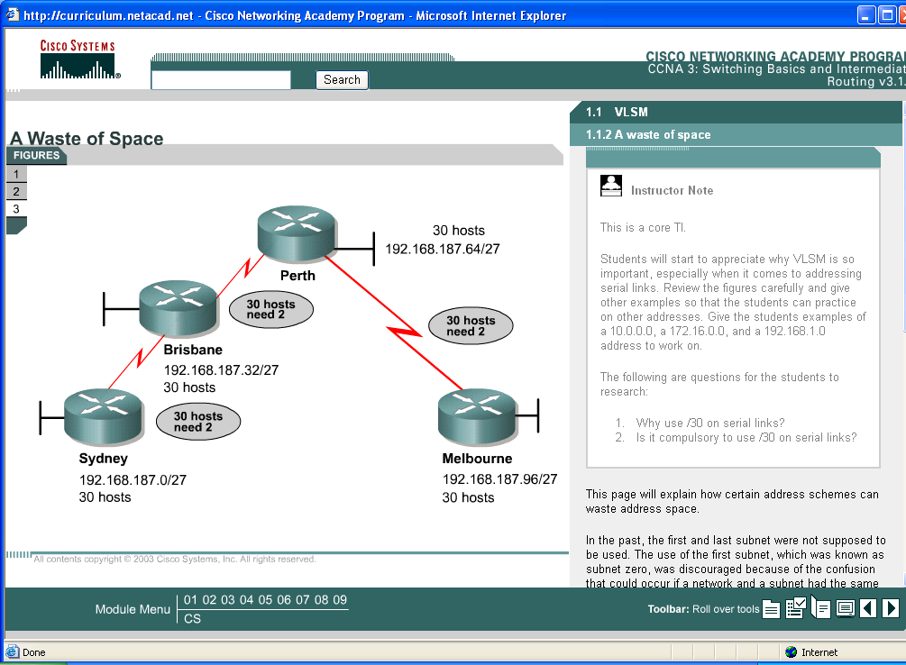

Figure 1
Such an address scheme is fine for a small LAN. However, it is extremely wasteful if point-to-point connections are used.
VLSM helps to manage IP addresses. A subnet mask should satisfy the requirements of a LAN with one subnet mask and the requirements of a point-to-point WAN with another.
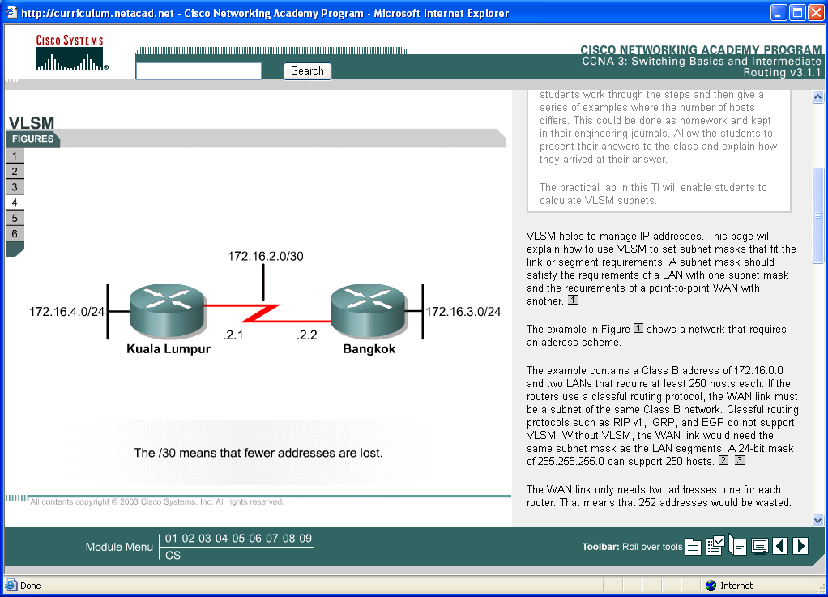
For example, if there was a Class B address of 172.16.0.0 and two LANs that require at least 250 hosts each. If the routers use a classful routing protocol, the WAN link must be a subnet of the same Class B network. Classful routing protocols such as RIP v1, IGRP, and EGP do not support VLSM. Without VLSM, the WAN link would need the same subnet mask as the LAN segments. A 24-bit mask of 255.255.255.0 can support 250 hosts.
The WAN link only needs two addresses, one for each router. That means that 252 addresses would be wasted.
If VLSM was used, a 24-bit mask would still be applied on the LAN segments for the 250 hosts. A 30-bit mask could be used for the WAN link because only two host addresses are needed. The WAN links use subnet addresses with a prefix of /30. This prefix allows for only two host addresses which is just enough for a point-to-point connection between a pair of routers.
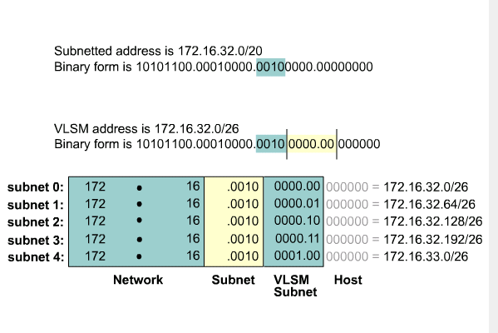
Figure3
To calculate the subnet addresses used on the WAN links, further subnet one of the unused /26 subnets VLSM can be used to subnet an already subnetted address. For example, consider the subnet address 172.16.32.0/20 and a network that needs ten host addresses. With this subnet address, there are 2¹² – 2, or 4094 host addresses, most of which will be wasted. With VLSM it is possible to subnet 172.16.32.0/20 to create more network addresses with fewer hosts per network. When 172.16.32.0/20 is subnetted to 172.16.32.0/26, there is a gain of 2⁶, or 64 subnets. Each subnet can support 2⁶ – 2, or 62 hosts. Use the following steps to apply VLSM to 172.16.32.0/20:
- Write 172.16.32.0 in binary form.
- Draw a vertical line between the 20th and 21st bits, as shown in Figure . The original subnet boundary was /20.
- Draw a vertical line between the 26th and 27th bits, as shown in Figure . The original /20 subnet boundary is extended six bits to the right, which becomes /26.
- Calculate the 64 subnet addresses with the bits between the two vertical lines, from lowest to highest in value.

It is important to remember that only unused subnets can be further subnetted. If any address from a subnet is used, that subnet cannot be further subnetted. Four subnet numbers are used on the LANs. The unused 172.16.33.0/26 subnet is further subnetted for use on the WAN links.
Route Aggregation
When VLSM is used, it is important to keep the subnetwork numbers grouped together in the network to allow for aggregation. For example, networks like 172.16.14.0 and 172.16.15.0 should be near one another so that the routers only carry a route for 172.16.14.0/23.
The use of classless interdomain routing (CIDR) and VLSM prevents address waste and promotes route aggregation, or summarization. Without route summarization, Internet backbone routing would likely have collapsed sometime before 1997.
Figure 4 illustrates how route summarization reduces the burden on upstream routers. This complex hierarchy of variable-sized networks and subnetworks is summarized at various points with a prefix address, until the entire network is advertised as a single aggregate route of 200.199.48.0/20. Route summarization, or supernetting, is only possible if the routers of a network use a classless routing protocol, such as OSPF or EIGRP. Classless routing protocols carry a prefix that consists of a 32-bit IP address and bit mask in the routing updates. In Figure 4, the summary route that eventually reaches the provider contains a 20-bit prefix common to all of the addresses in the organization. That address is 200.199.48.0/22 or 11001000.11000111.0011. For summarization to work, addresses should be carefully assigned in a hierarchical fashion so that summarized addresses will share the same high-order bits.
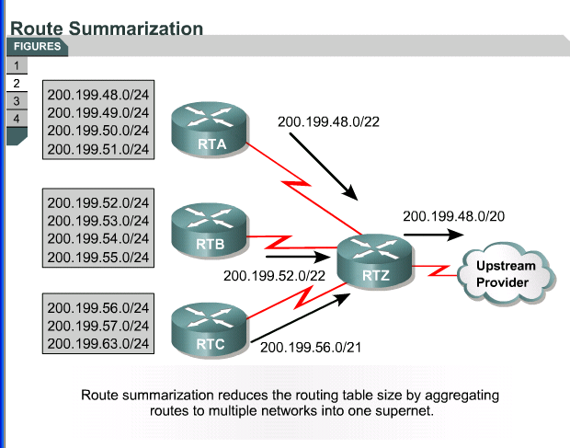
Figure 4
The following are important rules to remember:
- A router must know in detail the subnet numbers attached to it.
- A router does not need to inform other routers about each subnet if the router can send one aggregate route for a set of routes.
- A router that uses aggregate routes has fewer entries in its routing table.
VLSM increases route summarization flexibility because it uses the higher-order bits shared on the left, even if the networks are not contiguous.
RIPv1 RIPv2
The Internet is a collection of autonomous systems (AS). Each AS is generally administered by a single entity. Each AS has a routing technology which can differ from other autonomous systems. The routing protocol used within an AS is referred to as an Interior Gateway Protocol (IGP). A separate protocol used to transfer routing information between autonomous systems is referred to as an Exterior Gateway Protocol (EGP). RIP is designed to work as an IGP in a moderate-sized AS. It is not intended for use in more complex environments.
RIP v1 is considered a classful IGP. RIP v1 is a distance vector protocol that broadcasts the entire routing table to each neighbour router at predetermined intervals. The default interval is 30 seconds. RIP uses hop count as a metric, with 15 as the maximum number of hops.
If the router receives information about a network, and the receiving interface belongs to the same network but is on a different subnet, the router applies the one subnet mask that is configured on the receiving interface:
- For Class A addresses, the default classful mask is 255.0.0.0.
- For Class B addresses, the default classful mask is 255.255.0.0.
- For Class C addresses, the default classful mask is 255.255.255.0.
RIP v1 is a popular routing protocol because virtually all IP routers support it. The popularity of RIP v1 is based on the simplicity and the universal compatibility it demonstrates. RIP v1 is capable of load balancing over as many as six equal-cost paths, with four paths as the default.
RIP v1 has the following limitations:
- It does not send subnet mask information in its updates.
- It sends updates as broadcasts on 255.255.255.255.
- It does not support authentication.
- It is not able to support VLSM or classless interdomain routing (CIDR).
RIPv2
Both versions of RIP share the following features:
- It is a distance vector protocol that uses a hop count metric.
- It uses holddown timers to prevent routing loops – default is 180 seconds.
- It uses split horizon to prevent routing loops.
- It uses 16 hops as a metric for infinite distance.
RIP v2 provides prefix routing, which allows it to send out subnet mask information with the route update. Therefore, RIP v2 supports the use of classless routing in which different subnets within the same network can use different subnet masks, as in VLSM.
RIP v2 provides for authentication in its updates. A set of keys can be used on an interface as an authentication check. RIP v2 allows for a choice of the type of authentication to be used in RIP v2 packets. The choice can be either clear text or Message-Digest 5 (MD5) encryption. Clear text is the default. MD5 can be used to authenticate the source of a routing update. MD5 is typically used to encrypt enable secret passwords and it has no known reversal.
RIP v2 multicasts routing updates using the Class D address 224.0.0.9, which provides for better efficiency.
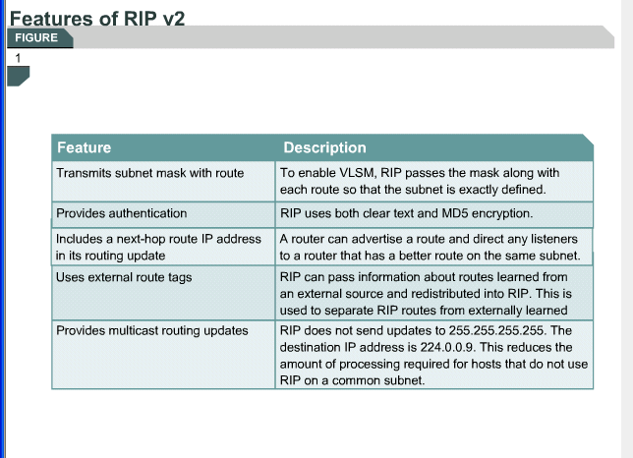
Figure 5
Comparing RIPv1 and RIPv2
RIP uses distance vector algorithms to determine the direction and distance to any link in the internetwork. If there are multiple paths to a destination, RIP selects the path with the least number of hops. However, because hop count is the only routing metric used by RIP, it does not necessarily select the fastest path to a destination.
RIP v1 allows routers to update their routing tables at programmable intervals. The default interval is 30 seconds. The continual sending of routing updates by RIP v1 means that network traffic builds up quickly. To prevent a packet from looping infinitely, RIP allows a maximum hop count of 15. If the destination network is more than 15 routers away, the network is considered unreachable and the packet is dropped. This situation creates a scalability issue when routing in large heterogeneous networks. RIP v1 uses split horizon to prevent loops. This means that RIP v1 advertises routes out an interface only if the routes were not learned from updates entering that interface. It uses holddown timers to prevent routing loops. Holddowns ignore any new information about a subnet indicating a poorer metric for a time equal to the holddown timer.
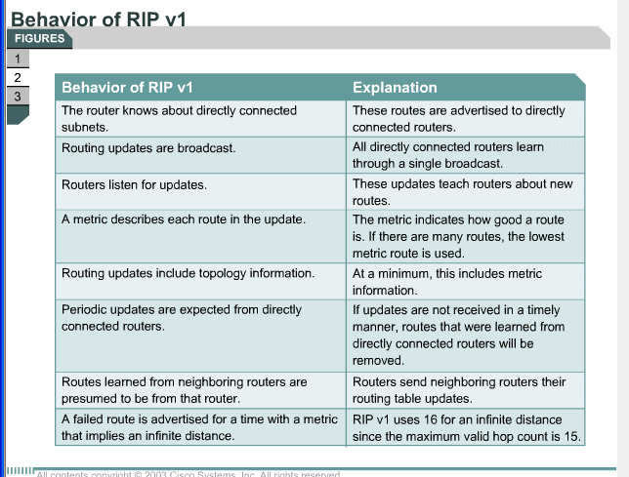

RIP v2 is an improved version of RIP v1. It has many of the same features of RIP v1. RIP v2 is also a distance vector protocol that uses hop count, holddown timers, and split horizon. The TTL field in the IP packet forces the packet to be dropped. When the hop count reaches 15 routers, the network is considered unreachable, and the packet is dropped because the router doesn't have a route to the destination network.
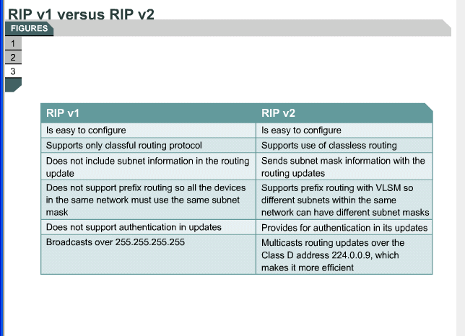

By default, routers learn paths to destinations three different ways:
- Static routes – The system administrator manually defines the static routes as the next hop to a destination. Static routes are useful for security and traffic reduction, as no other route is known.
- Default routes – The system administrator also manually defines default routes as the path to take when there is no known route to the destination. Default routes keep routing tables shorter. When an entry for a destination network does not exist in a routing table, the packet is sent to the default network.
- Dynamic routes – Dynamic routing means that the router learns of paths to destinations by receiving periodic updates from other routers.
Conclusion

Variable-Length Subnet Masks (VLSM), often referred to as "subnetting a subnet", is used to maximize addressing efficiency. It is a feature that allows a single autonomous system to have networks with different subnet masks. The network administrator is able to use a long mask on networks with few hosts, and a short mask on subnets with many hosts.
It is important to design an addressing scheme that allows for growth and does not involve wasting addresses. To apply VLSM to the addressing problem, large subnets are created for addressing LANs. Very small subnets are created for WAN links and other special cases.
VLSM helps to manage IP addresses. VLSM allows for the setting of a subnet mask that suits the link or the segment requirements. A subnet mask should satisfy the requirements of a LAN with one subnet mask and the requirements of a point-to-point WAN with another.

Addresses are assigned in a hierarchical fashion so that summarized addresses will share the same high-order bits. There are specific rules for a router. It must know in detail the subnet numbers attached to it and it does not need to tell other routers about each individual subnet if the router can send an aggregate route for a set of routers. A router using aggregate routes would have fewer entries in its routing tables.
RIP v1 is considered an interior gateway protocol that is classful. RIP v1 is a distance vector protocol that broadcasts its entire routing table to each neighbour router at predetermined intervals. The default interval is 30 seconds. RIP uses hop count as a metric, with 15 as the maximum number of hops.
To enable a dynamic routing protocol, select a routing protocol, such as RIP v2, assign the IP network numbers without specifying the subnet values, and then assign the network or subnet addresses and the appropriate subnet mask to the interfaces.

