VLSM Class B_Practice_1

Part 1
a. Design an IP addressing layout for topology shown.
b. Use VLSM in design.
- Name all routers and end devices as shown in topology.

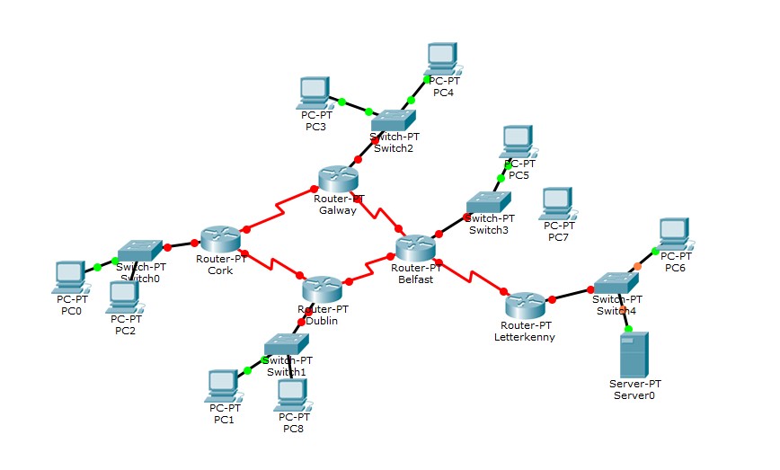

The global network address is 135.30.0.0 /16. Use VLSM so that the addressing requirements listed below can be met.

Requirements:

- The Galway LAN requires 2000 host IP addresses
- The Dublin requires 1800 host IP addresses
- The Belfast requires 3000 host IP addresses
- The Letterkenny requires 500 host IP addresses
- The Cork requires 800 host IP addresses
- The Link from Galway to Cork will require an IP address for each end of the link.
- The Link from Galway to Belfast will require an IP address for each end of the link
- The Link from Cork to Dublin will require an IP address for each end of the link
- The Link from Belfast to Dublin will require an IP address for each end of the link
- The Link from Belfast to Letterkenny will require an IP address for each end of the link

