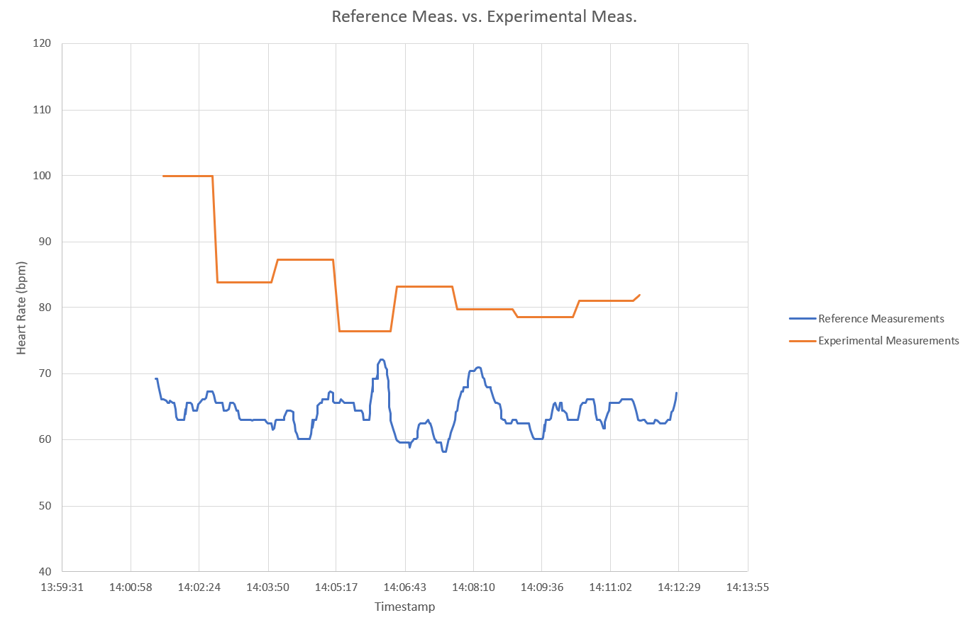

Figure 8: 8-Tap Moving Average Filter – Resolution 0.1Hz

Table 1: 8-Tap Moving Average Filter – Resolution 0.1Hz (Results)



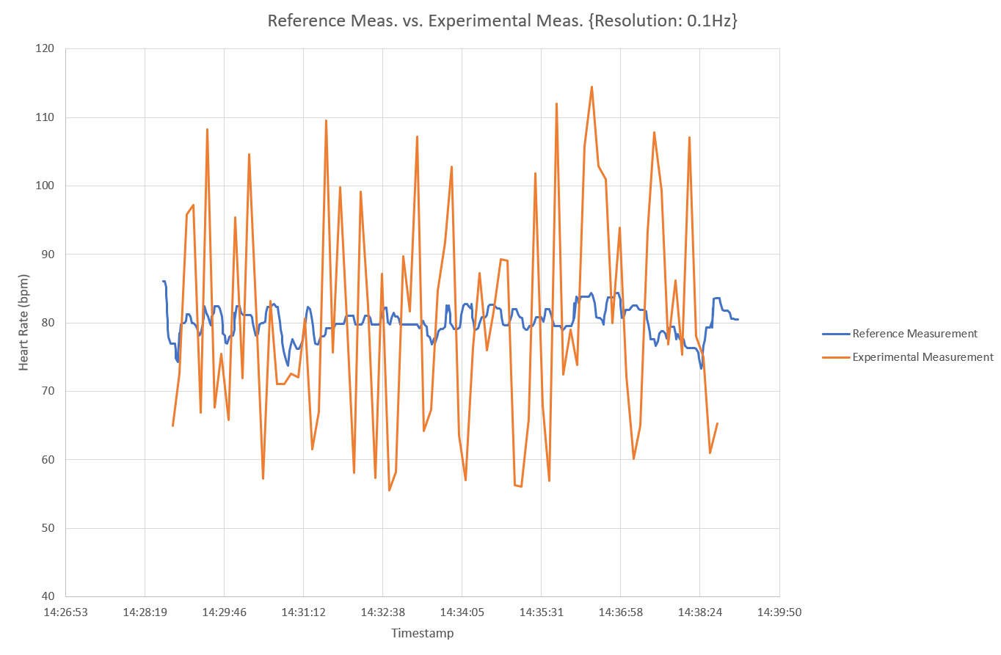

Figure 9: Gaussian Filter – Resolution 0.1Hz

Table 2: Gaussian Filter – Resolution 0.1Hz (Results)



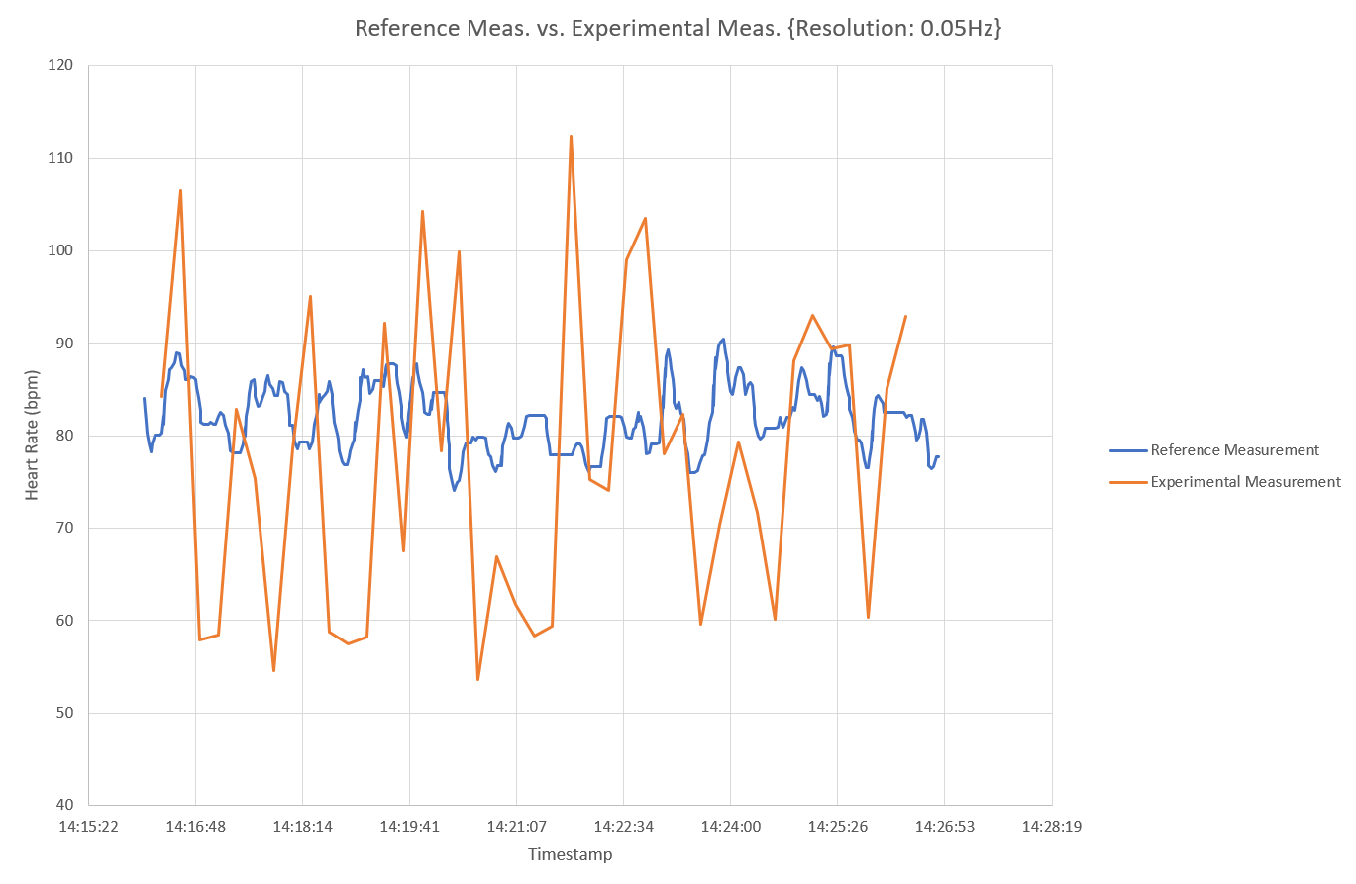

Figure 10: Gaussian Filter – Resolution: 0.05Hz

Table 3: Gaussian Filter – Resolution 0.05Hz (Results)



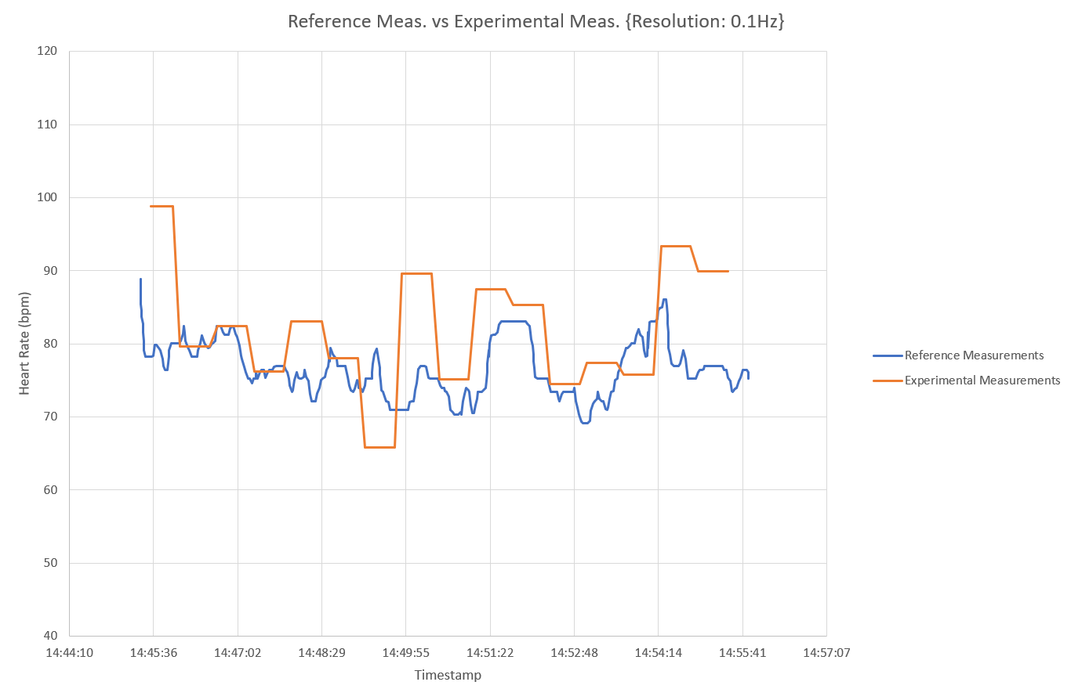

Figure 11: 4-Tap Moving Average Filter – Resolution 0.1Hz

Table 4: 4-Tap Moving Average Filter – Resolution 0.1Hz (Results)



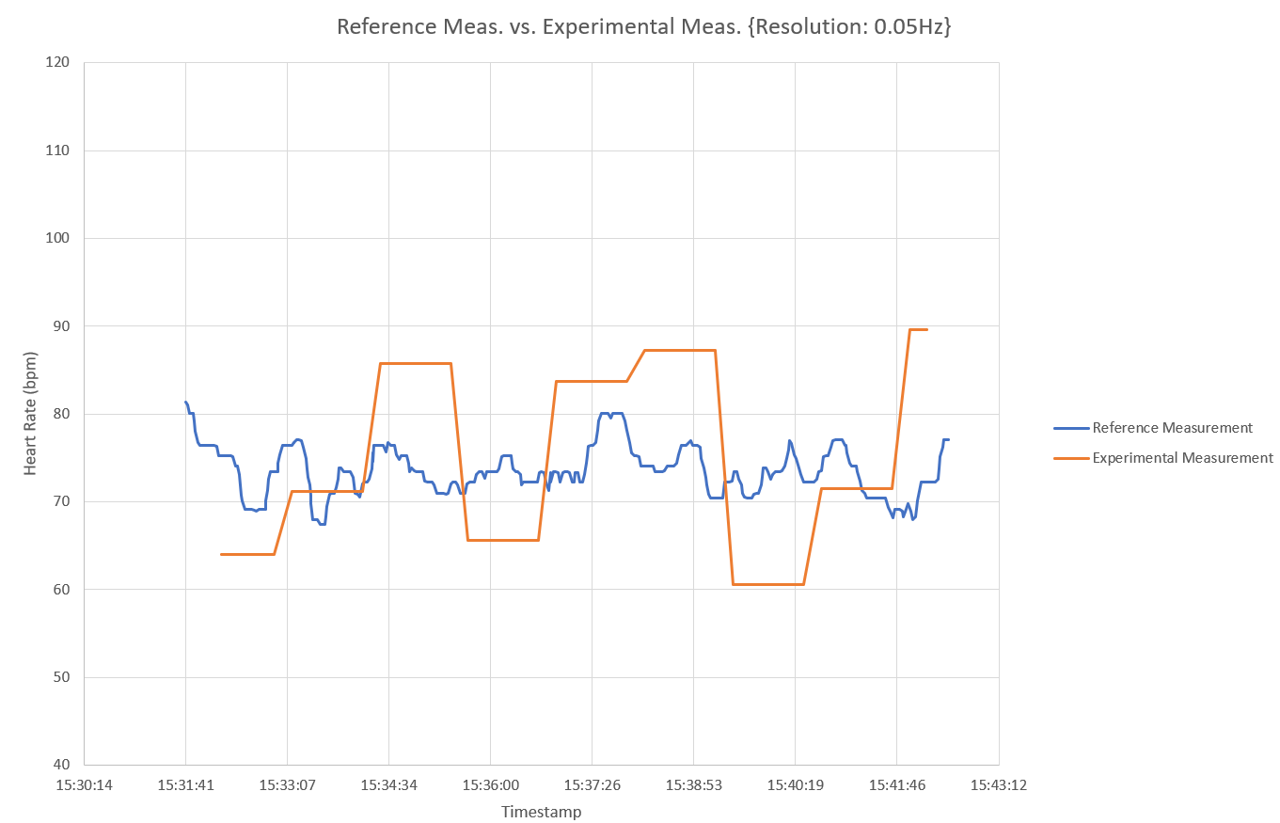

Figure 12: 4-Tap Moving Average Filter – Resolution 0.05Hz

Table 5: 4-Tap Moving Average Filter – Resolution 0.05Hz (Results)



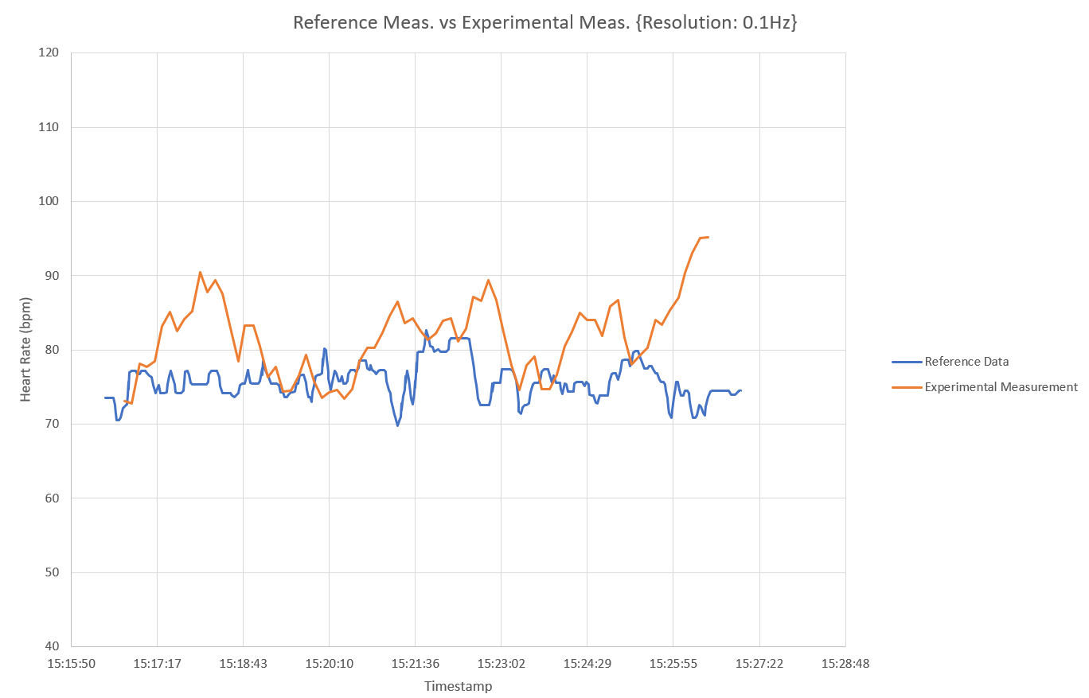

Figure 13: 1-Tap Sliding Window Filter – Resolution 0.1Hz

Table 6: 1-Tap Sliding Window Filter – Resolution 0.1Hz (Results)



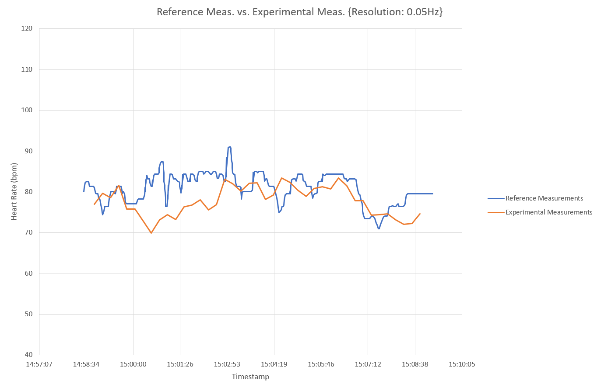

Figure 14: 1-Tap Sliding Window Filter – Resolution 0.05Hz

Table 7: 1-Tap Sliding Window Filter – Resolution 0.05Hz (Results)

