**Data Communication and Networks Lab**

**Experiment 1**

**Name : Ojasa Chitre**

**TE Comps**

**Batch : A**

**Date : 3rd August, 2020**

**Aim: Study of different types of physical layer wired/wireless connections**

Type of Connections :

* Wired Network :
  + "Wired" is the term refers to any physical medium consisting of cables. The cables can be copper wire, twisted pair or fiber optic. Wired network is used to carry different forms of electrical signals from one end to the other. Mostly in wired network one internet connection is being taken using T1 line, cable modem or using any other means. This connection is shared among multiple devices using wired network concept.
* Wireless Network :

"Wireless" is the term refers to medium made of electromagnetic waves (i.e. EM Waves) or infrared waves. All the wireless devices will have antenna or sensors. Typical wireless devices include cellular mobile, wireless sensors, TV remote, satellite disc receiver, laptops with WLAN card etc. Wireless network does not use wires for data or voice communication; it uses radio frequency waves as mentioned above.

Ref 2

What Is the physical layer ?

* In the seven-layer [OSI model](https://en.wikipedia.org/wiki/OSI_model) of [computer networking](https://en.wikipedia.org/wiki/Computer_network), the physical layer or layer 1 is the first and lowest layer.
* The physical layer defines the means of transmitting raw [bits](https://en.wikipedia.org/wiki/Bit) over a physical [data link](https://en.wikipedia.org/wiki/Data_link) connecting network [nodes](https://en.wikipedia.org/wiki/Node_(networking)). The [bitstream](https://en.wikipedia.org/wiki/Bitstream) may be grouped into code words or symbols and converted to a physical [signal](https://en.wikipedia.org/wiki/Signal) that is transmitted over a [transmission medium](https://en.wikipedia.org/wiki/Transmission_medium). The physical layer provides an electrical, mechanical, and procedural interface to the transmission medium. The shapes and properties of the [electrical connectors](https://en.wikipedia.org/wiki/Electrical_connector), the frequencies to broadcast on, the [line code](https://en.wikipedia.org/wiki/Line_code) to use and similar low-level parameters, are specified by the physical layer.

Ref 3

**Wireless Networks :**

**Protocols :**

1. **Wireless Local Area Network (WLAN) technologies** can deliver up to 200 Mbps at distances up to 100 meters. *802.11a/b/g (Wi-Fi)* are widely deployed WLAN examples. Proprietary [MIMO](https://searchmobilecomputing.techtarget.com/definition/MIMO) products and the new 802.11n high-speed WLAN standard are emerging technologies in this category.
2. **Wireless Personal Area Network (WPAN) technologies** are designed to reach only about 10 meters.

802.15.1also known as Bluetooth.

IrDA (Infrared Data Association) and Bluetooth are two common WPAN examples. Emerging technologies in this space include 802.15.4a ([Zigbee](https://internetofthingsagenda.techtarget.com/definition/ZigBee)) and 802.15.3c (UWB).

1. **Wireless Metropolitan Area Network (WMAN) technologies** deliver up to 75 Mbps over wireless "first mile" links that span several kilometers. There have been several iterations of the 802.16 Broadband Wireless Access WMAN standard, certified under the brand WiMAX. Fixed WiMAX is now being complemented by the emerging 802.20 Mobile WiMAX standard.
2. **802.11a/b/g (Wi-Fi) :**

Comparison between versions of 802.11 WLAN protocols.

|  |  |  |  |  |  |  |
| --- | --- | --- | --- | --- | --- | --- |
| Protocol | Frequency  (GHz) | Bandwidth  (MHz) | Stream Data Rate (Mbit/s) | Modulation | Indoor Range | Outdoor Range |
| 802.11 | 2.4 GHz | 22 MHz | 1-2 Mbps | - | 20 m (66 ft) | 100 m (330 ft) |
| 802.11a | 5 GHz | 5/10/20 MHz | As high as 54 Mbps | [OFDM](https://en.wikipedia.org/wiki/Orthogonal_frequency-division_multiplexing) | 35 m  (115ft) | 120m  (390ft) |
| 802.11b | 2.4 GHz | 22 MHz | Up to 11 Mbps | [DSSS](https://en.wikipedia.org/wiki/Direct-sequence_spread_spectrum) | 35 m  (115ft) | 140m  (460ft) |
| 802.11g | 2.4 GHz | 5/10/20 MHz | As high as 54 Mbps | [OFDM](https://en.wikipedia.org/wiki/Orthogonal_frequency-division_multiplexing) | 38m  (125ft) | 140m  (460ft) |
| 802.11n  (It has 4 MIMO streams) | 2.4 / 5 GHz | Up to 40 MHz | Up to 600 Mbps | [MIMO-OFDM](https://en.wikipedia.org/wiki/MIMO-OFDM) | 70m  (230ft) | 250m  (820ft) |

**802.11 topologies :**

1. **Ad Hoc Topology :**

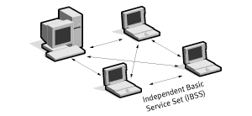

IBSS (Independent Basic service Set) configurations are also referred to as an independent configuration or an ***ad-hoc network***. Logically, an IBSS configuration is analogous to a peer-to-peer office network in which no single node is required to function as a server. IBSS WLANs include a number of nodes or wireless stations that communicate directly with one another on an ad-hoc, peer-to-peer basis. Thus it contains set of wireless stations that communicate directly with one another without using an access point or any connection to a wired network. It is useful for quickly and easily setting up a wireless network at anyplace where a wireless infrastructure does not exist or is not required for services, such as a hotel room, convention center, or airport, or where access to the wired network is barred (such as for consultants at a client site). Generally, IBSS implementations cover a limited area and aren’t connected to any larger network

1. Basic Service Set

BSS consists of at least one access point connected to the wired network infrastructure and a set of wireless end stations. This configuration is called a Basic Service Set (BSS). Thus, BSS configurations rely on an Access Point (AP) that acts as the logical server for a single WLAN cell or channel. Communications between node A and node B actually flow from node A to the AP and then from the AP to node B.

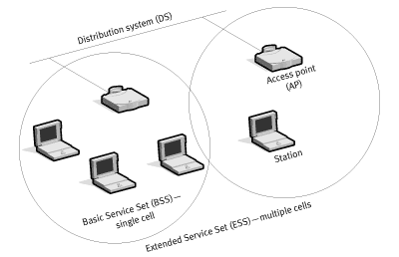

An Extended Service Set (ESS) consists of a series of overlapping BSSs (each containing AP) connected together by means of a Distributed System (DS). Although the DS could be any type of network, it is almost invariably an Ethernet LAN. Mobile nodes can roam between APs and like this seamless campus-wide coverage (CAN) is possible. Since most corporate WLANs require access to the wired LAN for services (file servers, printers, Internet links) they will operate in BSS/ESS topology.

1. **802.15 WPAN:**

**802.15.1 (Bluetooth):**

* The IEEE 802.15.1 standard is the basis for the Bluetooth wireless communication technology. Bluetooth is a low tier, ad hoc, wireless standard for short range communication. It is designed for small and low cost devices with low power consumption.
* The technology operates with three different classes of devices: Class 1, class 2 and class 3 where the range is about 100 meters, 10 meters and 1 meter respectively.
* Wireless LAN operates in the same 2.4 GHz frequency band as Bluetooth, but the two technologies use different signaling methods which should prevent interference.
* Piconet is a basic unit of bluetooth networking. Devices function as master and slave in piconet. There are two configurations viz. one master and one slave or one master and multiple slaves. Master will determine channel and phase.
* Modulation used is π/4 DQPSK and 8DPSK and the data 3 Mbps

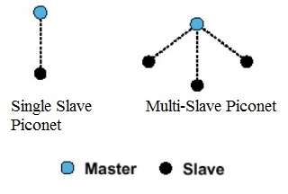

* The bluetooth network consisting of one or more piconets is known as scatternet. The devices in one piconet type may function as master or slave in another piconet type of the same scatternet. This bluetooth network type allows many devices to share the same network area. This will allow efficient use of the bandwidth.

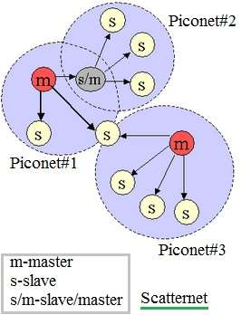

**802.15.4a (ZigBee):**

* Zigbee is an [IEEE 802.15.4](https://en.wikipedia.org/wiki/IEEE_802.15.4)-based [specification](https://en.wikipedia.org/wiki/Specification_(technical_standard)) for a suite of high-level communication protocols used to create [personal area networks](https://en.wikipedia.org/wiki/Personal_area_network) with small, low-power [digital radios](https://en.wikipedia.org/wiki/Digital_radio), such as for [home automation](https://en.wikipedia.org/wiki/Home_automation), medical device data collection, and other low-power low-bandwidth needs, designed for small scale projects which need wireless connection. Hence, Zigbee is a low-power, low data rate, and close proximity (i.e., personal area) [wireless ad hoc network](https://en.wikipedia.org/wiki/Wireless_ad_hoc_network).
* The technology defined by the Zigbee specification is intended to be simpler and less expensive than other [wireless personal area networks](https://en.wikipedia.org/wiki/Wireless_personal_area_network) (WPANs), such as [Bluetooth](https://en.wikipedia.org/wiki/Bluetooth) or more general wireless networking such as [Wi-Fi](https://en.wikipedia.org/wiki/Wi-Fi). Applications include wireless light switches, [home energy monitors](https://en.wikipedia.org/wiki/Home_energy_monitor), traffic management systems, and other consumer and industrial equipment that requires short-range low-rate wireless data transfer.
* Range is typically between 1m-100m. The data rate is up to 250Kbps.

**802.16a (WiMax) (WMAN):**

* WiMAX (Worldwide Interoperability for Microwave Access) is a family of [wireless broadband](https://en.wikipedia.org/wiki/Wireless_broadband) communication standards based on the [IEEE 802.16](https://en.wikipedia.org/wiki/IEEE_802.16) set of standards, which provide multiple physical layer (PHY) and Media Access Control (MAC) options.
* The name "WiMAX" was created by the WiMAX Forum, which was formed in June 2001 to promote conformity and interoperability of the standard, including the definition of predefined system profiles for commercial vendors. The forum describes WiMAX as "a standards-based technology enabling the delivery of [last mile](https://en.wikipedia.org/wiki/Last_mile) [wireless broadband access](https://en.wikipedia.org/wiki/Wireless_broadband_access) as an alternative to [cable](https://en.wikipedia.org/wiki/Cable_modem) and [DSL](https://en.wikipedia.org/wiki/Digital_subscriber_line)". [IEEE 802.16m](https://en.wikipedia.org/wiki/IEEE_802.16m) or WirelessMAN-Advanced was a candidate for the [4G](https://en.wikipedia.org/wiki/4G), in competition with the [LTE Advanced](https://en.wikipedia.org/wiki/LTE_Advanced) standard.
* WiMAX was initially designed to provide 30 to 40 megabit-per-second data rates, with the 2011 update providing up to 1 Gbit/s for fixed stations.
* Modulations are BPSK, QPSK, 16,64 – QAM.

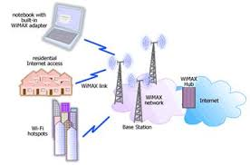

**Wired Networks :**

**Protocols :**

1. Ethernet (802.3)

2. Fast Ethernet (802.3u)

3. Fiber Distribution Data Interface (FDDI)

1. Ethernet (802.3 protocol)

There are a number of versions of IEEE 802.3 protocol. The most popular ones are-

* **IEEE 802.3**: This was the original standard given for 10BASE-5. It used a thick single coaxial cable into which a connection can be tapped by drilling into the cable to the core. Here, 10 is the maximum throughput, i.e. 10 Mbps, BASE denoted use of baseband transmission, and 5 refers to the maximum segment length of 500m.
* **IEEE 802.3a**: This gave the standard for thin coax (10BASE-2), which is a thinner variety where the segments of coaxial cables are connected by BNC connectors. The 2 refers to the maximum segment length of about 200m (185m to be precise).
* **IEEE 802.3i**: This gave the standard for twisted pair (10BASE-T) that uses unshielded twisted pair (UTP) copper wires as physical layer medium. The further variations were given by IEEE 802.3u for 100BASE-TX, 100BASE-T4 and 100BASE-FX.
* **IEEE 802.3i**: This gave the standard for Ethernet over Fiber (10BASE-F) that uses fiber optic cables as medium of transmission.  
  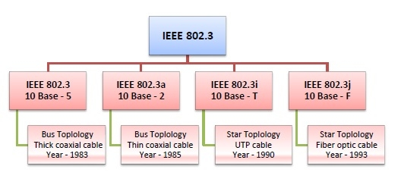

**10BASE2 :**

* The name 10BASE2 is derived from several characteristics of the physical medium. The 10 comes from the transmission speed of 10 [Mbit/s](https://en.wikipedia.org/wiki/Megabit_per_second). The BASE stands for [baseband](https://en.wikipedia.org/wiki/Baseband) signalling, and the 2 for a maximum segment length approaching 200 m (the actual maximum length is 185 m).
* 10 Mbit/s Ethernet uses [Manchester coding](https://en.wikipedia.org/wiki/Manchester_code). A binary zero is indicated by a low-to-high transition in the middle of the bit period and a binary one is indicated by a high-to-low transition in the middle of the bit period. Manchester coding allows the clock to be recovered from the signal. However, the additional transitions associated with it double the signal bandwidth.

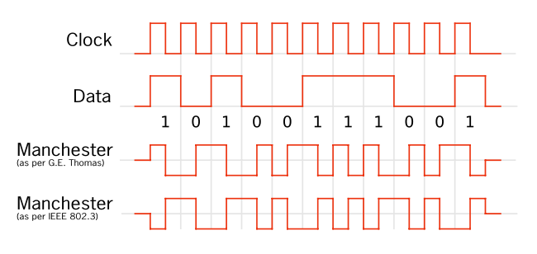

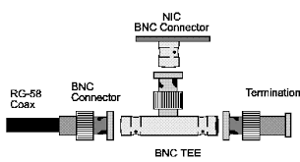

**10BASE5 :**

* 10BASE5 (also known as thick Ethernet or thicknet) was the first commercially available variant of [Ethernet](https://en.wikipedia.org/wiki/Ethernet). The technology was standardized in 1982 as [IEEE 802.3](https://en.wikipedia.org/wiki/IEEE_802.3). 10BASE5 uses a thick and stiff coaxial cable up to 500 meters (1,600 ft) in length. Up to 100 stations can be connected to the cable using [vampire taps](https://en.wikipedia.org/wiki/Vampire_tap) and share a single [collision domain](https://en.wikipedia.org/wiki/Collision_domain) with 10 [Mbit/s](https://en.wikipedia.org/wiki/Megabit_per_second) of [bandwidth](https://en.wikipedia.org/wiki/Bandwidth_(computing)) shared among them.
* A vampire tap (also called a piercing tap) is a device for physically connecting a [station](https://en.wikipedia.org/wiki/Node_(networking)), typically a computer, to a network that uses [10BASE5](https://en.wikipedia.org/wiki/10BASE5) cabling. This device clamps onto and "bites" into the cable (hence the [vampire](https://en.wikipedia.org/wiki/Vampire) name), inserting a probe through a hole drilled using a special tool through the outer shielding to contact the inner conductor, while other spikes bite into the outer conductor.

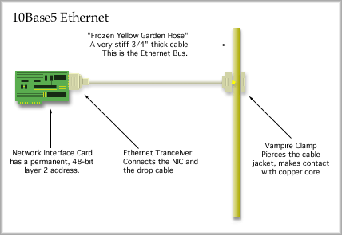

**10BASET :**

* Ethernet over twisted pair technologies use [twisted-pair cables](https://en.wikipedia.org/wiki/Twisted-pair_cable) for the [physical layer](https://en.wikipedia.org/wiki/Physical_layer) of an [Ethernet](https://en.wikipedia.org/wiki/Ethernet) computer network. They are a subset of all [Ethernet physical layers](https://en.wikipedia.org/wiki/Ethernet_physical_layer).
* 10BaseT is the most popular form of 10-Mbps Ethernet, using unshielded twisted-pair (UTP) cabling for connecting stations, and using hubs to form a network. 10BaseT supports a maximum bandwidth of 10 Mbps, but in actual networks, the presence of collisions reduces this to more like 4 to 6 Mbps. 10BaseT is based on the 802.3 specifications.
* 10BaseT networks are wired together in a star topology to a central hub. The UTP cabling used for wiring should be category 3 cabling, category 4 cabling, or category 5 cabling, terminated with RJ-45 connectors.

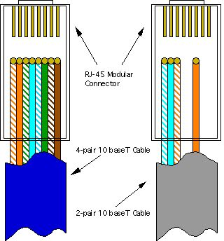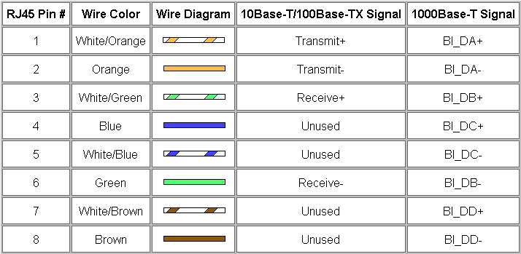

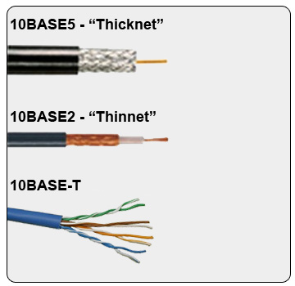

1. Fast Ethernet :

In [computer networking](https://en.wikipedia.org/wiki/Computer_network), Fast Ethernet [physical layers](https://en.wikipedia.org/wiki/Ethernet_physical_layer) carry traffic at the nominal rate of 100 Mbit/s. The [prior Ethernet](https://en.wikipedia.org/wiki/Classic_Ethernet) speed was 10 Mbit/s. Of the Fast Ethernet physical layers, 100BASE-TX is by far the most common.

Fast Ethernet was introduced in 1995 as the IEEE 802.3u standard and remained the fastest version of Ethernet for three years before the introduction of [Gigabit Ethernet](https://en.wikipedia.org/wiki/Gigabit_Ethernet). The acronym GE/FE is sometimes used for devices supporting both standards.

100BASE-TX (100 Mbit/s over two-pair [Cat5](https://en.wikipedia.org/wiki/Category_5_cable) or better cable), 100BASE-T4 (100 Mbit/s over four-pair [Cat3](https://en.wikipedia.org/wiki/Category_3_cable) or better cable, defunct), 100BASE-T2 (100 Mbit/s over two-pair Cat3 or better cable, also defunct).

The segment length for a 100BASE-T cable is limited to 100 metres (328 ft) (the same limit as [10BASE-T](https://en.wikipedia.org/wiki/10BASE-T) and [gigabit Ethernet](https://en.wikipedia.org/wiki/Gigabit_Ethernet)). All are or were standards under [IEEE 802.3](https://en.wikipedia.org/wiki/IEEE_802.3) (approved 1995). Almost all 100BASE-T installations are 100BASE-TX.

**100BASE-TX :**

* 100BASE-TX is the predominant form of Fast Ethernet, and runs over two wire-pairs inside a [category 5](https://en.wikipedia.org/wiki/Category_5_cable) or above cable. Each [network segment](https://en.wikipedia.org/wiki/Network_segment) can have a maximum cabling distance of 100 metres (328 ft). One pair is used for each direction, providing [full-duplex](https://en.wikipedia.org/wiki/Full-duplex) operation with 100 Mbit/s of throughput in each direction.
* When used to build a [local area network](https://en.wikipedia.org/wiki/Local_area_network), the devices on the network (computers, printers etc.) are typically connected to a [hub](https://en.wikipedia.org/wiki/Network_hub) or [switch](https://en.wikipedia.org/wiki/Network_switch), creating a [star network](https://en.wikipedia.org/wiki/Star_network). Alternatively it is possible to connect two devices directly using a [crossover cable](https://en.wikipedia.org/wiki/Ethernet_crossover_cable).

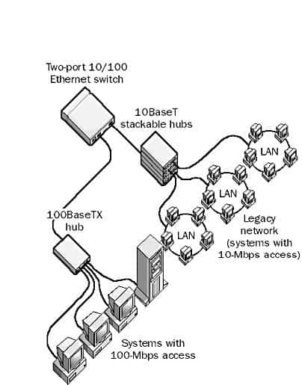

**100BASE-T2 :**

* In 100BASE-T2, standardized in IEEE 802.3y, the data is transmitted over two copper pairs, but these pairs are only required to be category 3 rather than the category 5 required by 100BASE-TX. Data is transmitted and received on both pairs simultaneously thus allowing full-duplex operation. Transmission uses 4 bits per symbol.

**100BASE-T4 :**

* 100BASE-T4 was an early implementation of Fast Ethernet. It requires four twisted copper pairs of [voice grade twisted pair](https://en.wikipedia.org/wiki/Category_3_cable), a lower performing cable compared to [category 5 cable](https://en.wikipedia.org/wiki/Category_5_cable) used by 100BASE-TX. Maximum distance is limited to 100 meters. One pair is reserved for transmit, one for receive, and the remaining two switch direction. The fact that 3 pairs are used to transmit in each direction makes 100BASE-T4 inherently half-duplex.

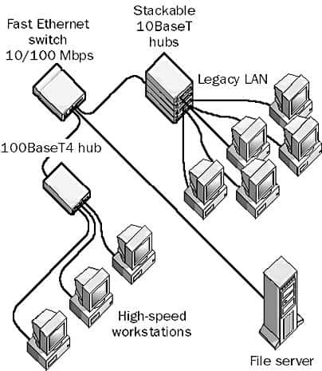

**100BASE-FX :**

* A type of standard for implementing Fast Ethernet networks. 100BaseFX is a version of Fast Ethernet that is often used for wiring campus backbones. 100BaseFX networks are wired together in a star topology using fiber-optic cabling and 100-Mbps fiber-optic hubs or Ethernet switches. The maximum length of any segment of fiber-optic cabling connecting a station (computer) to a hub is 412 meters.

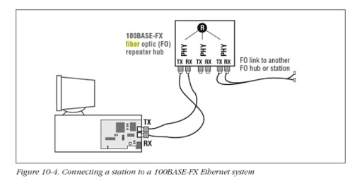

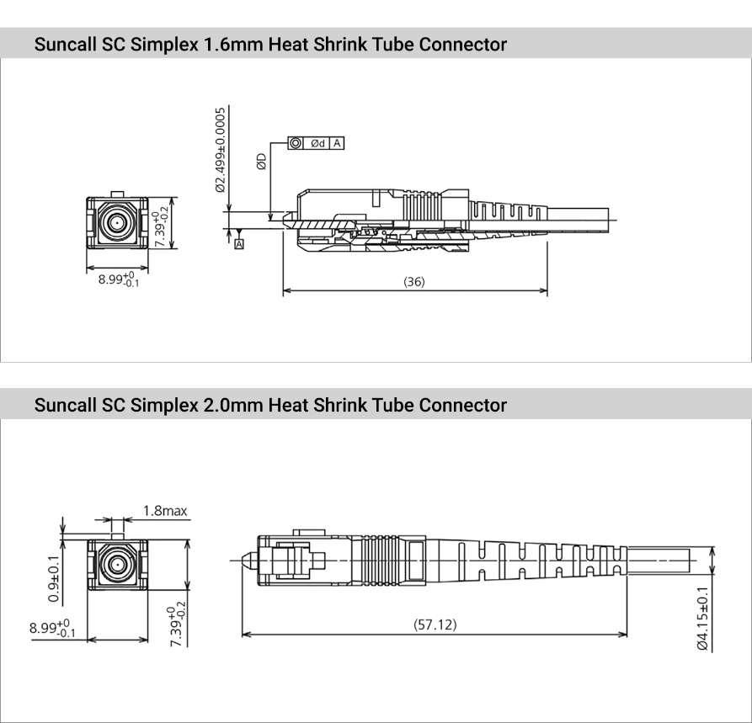

1. FDDI :

Fiber Distributed Data Interface (FDDI) is a standard for [data transmission](https://en.wikipedia.org/wiki/Data_transmission) in a [local area network](https://en.wikipedia.org/wiki/Local_area_network). It uses [optical fiber](https://en.wikipedia.org/wiki/Optical_fiber) as its standard underlying physical medium, although it was also later specified to use [copper](https://en.wikipedia.org/wiki/Copper) cable, in which case it may be called CDDI (Copper Distributed Data Interface), standardized as TP-PMD (Twisted-Pair Physical Medium-Dependent), also referred to as TP-DDI (Twisted-Pair Distributed Data Interface).

FDDI was effectively made obsolete in local networks by [Fast Ethernet](https://en.wikipedia.org/wiki/Fast_Ethernet) which offered the same 100 Mbit/s speeds, but at a much lower cost and, since 1998, by [Gigabit Ethernet](https://en.wikipedia.org/wiki/Gigabit_Ethernet) due to its speed, and even lower cost, and ubiquity.

FDDI provides a 100 [Mbit/s](https://en.wikipedia.org/wiki/Mbit/s) optical standard for [data transmission](https://en.wikipedia.org/wiki/Data_transmission) in [local area network](https://en.wikipedia.org/wiki/Local_area_network) that can extend in range up to 200 kilometers (120 mi). Although FDDI logical topology is a ring-based token network, it did not use the IEEE 802.5 [token ring](https://en.wikipedia.org/wiki/Token_ring) [protocol](https://en.wikipedia.org/wiki/Communications_protocol) as its basis; instead, its protocol was derived from the IEEE 802.4 [token bus](https://en.wikipedia.org/wiki/Token_bus) timed token protocol. In addition to covering large geographical areas, FDDI local area networks can support thousands of users. FDDI offers both a Dual-Attached Station (DAS), counter-rotating token ring topology and a Single-Attached Station (SAS), token bus passing ring topology.

FDDI was considered an attractive campus [backbone network](https://en.wikipedia.org/wiki/Backbone_network) technology in the early to mid-1990s since existing Ethernet networks only offered 10 Mbit/s data rates and token ring networks only offered 4 Mbit/s or 16 Mbit/s rates. Thus it was a relatively high-speed choice of that era.

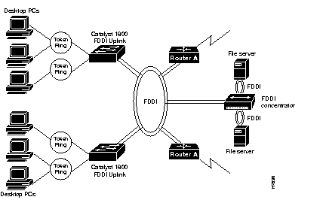

Resources :

1. <https://www.researchgate.net/publication/332319614_A_Survey_on_Wired_and_Wireless_Network>
2. <https://www.rfwireless-world.com/Terminology/wired-network-vs-wireless-network.html>
3. <https://en.wikipedia.org/wiki/Physical_layer>
4. <https://www.webopedia.com/TERM/I/IrDA.html#:~:text=Short%20for%20Infrared%20Data%20Association,to%20another%20without%20any%20cables.>
5. <https://searchnetworking.techtarget.com/tutorial/Wireless-protocols-learning-guide>
6. <https://en.wikipedia.org/wiki/IEEE_802.11>
7. <http://www.cs.uccs.edu/~gsc/pub/master/pjfong/UCCS%20Project/Articles/IE%20802_11%20Network%20Topology.htm>
8. <https://janmagnet.files.wordpress.com/2008/07/comparison-ieee-802-standards.pdf>
9. <https://en.wikipedia.org/wiki/Fast_Ethernet>