**CMSC203 Assignment 0**

Class: CMSC203 CRN XXXX

 Program: Assignment 0

Instructor:

 Summary of Description: (Give a brief description for each Program) A program that requires you to use functions to calculate the volume of a box and the volume of a Sphere.

 Due Date: MM/DD/YYYY

 Integrity Pledge: I pledge that I have completed the programming assignment independently.

 I have not copied the code from a student or any source.

**Complete the following five parts of Assignment 0. Name your file as FirstInitialLastName_Assignment0.docx**

**Part1: Setup GitHub:** Provide the screen shots of your GitHub account with Assignment 0 file is uploaded on GitHub:

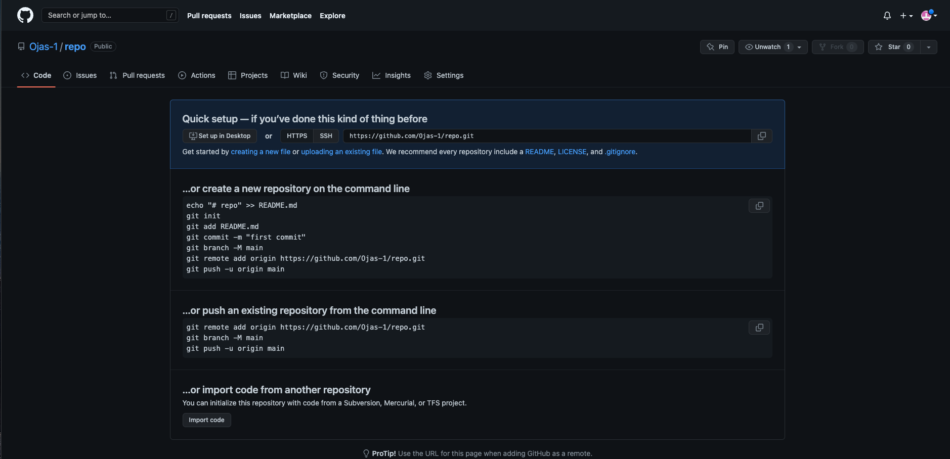

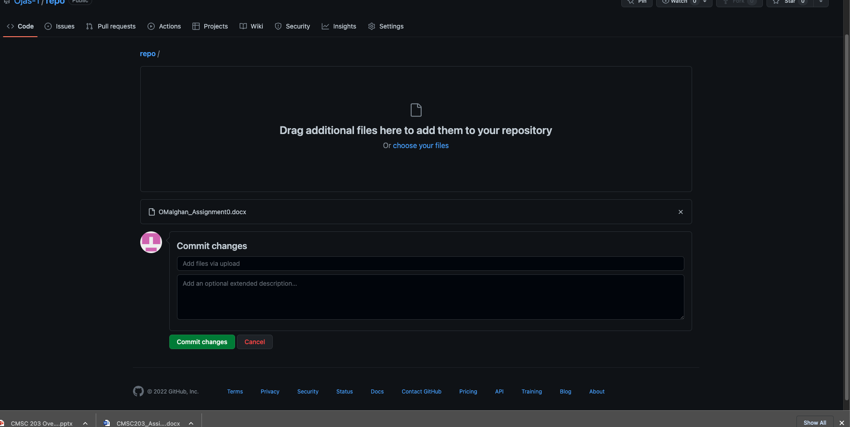

**Part 2 -Install JDK, Test java Application from Command Line**

Provide the screen shots from Step 1 and 2 here:

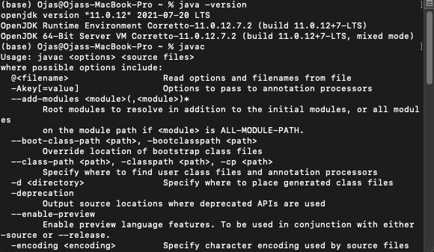

**Part 3 - Install Eclipse, Test Eclipse Java Application**

Provide the screen shots from Step 1 and 2 here:

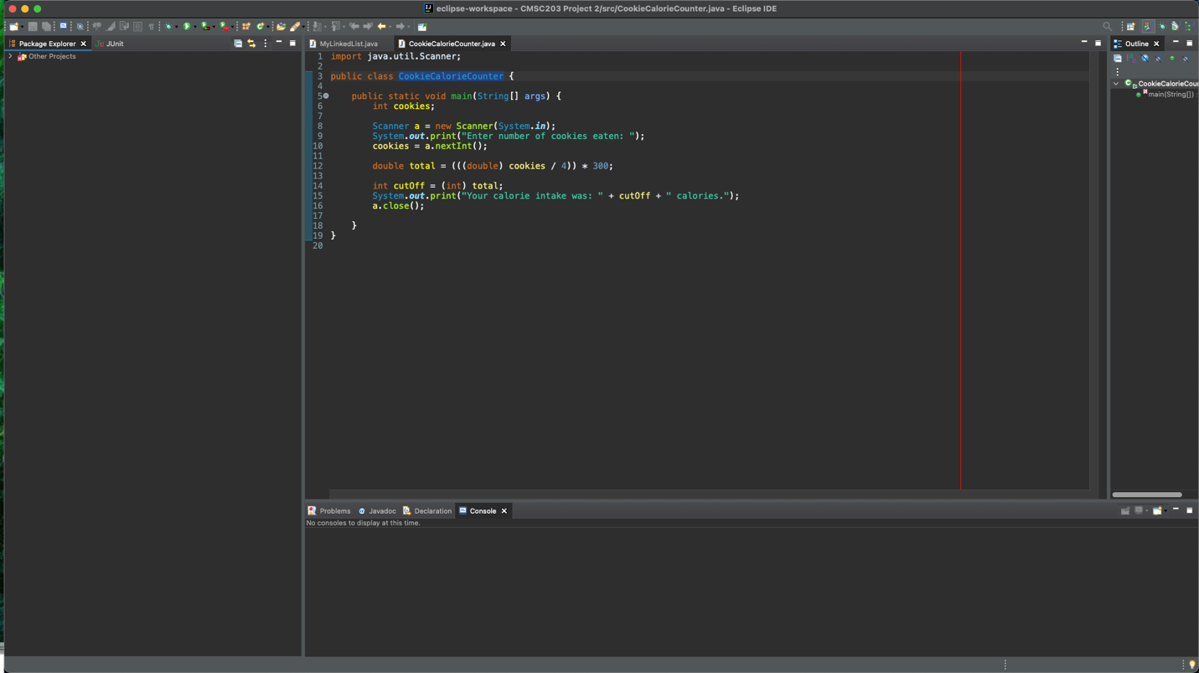

**Part 4 - Install, Setup, Test Junit Program.**

Provide the screen shots showing:

* 1. Eclipse with working JUnit Test example
  2. Project screenshot
  3. Running example screenshot

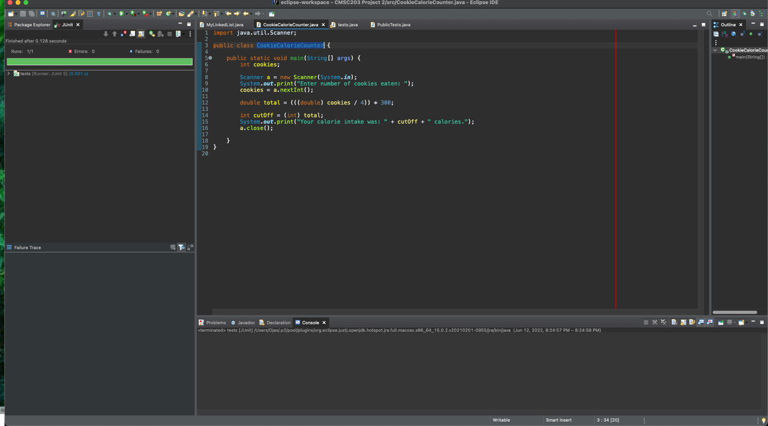

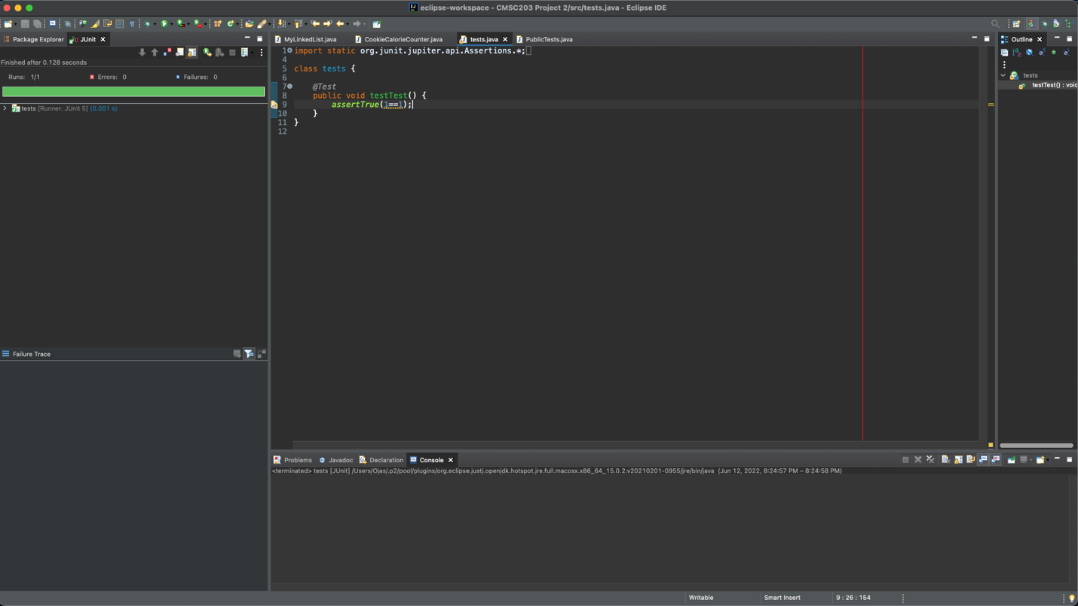

**Part 5 - Install, Setup, and Test JavaFX Application.**

Provide the screen shots showing:

1. JavaFX Project screenshot
2. Running example screenshot
3. Java Source Code File

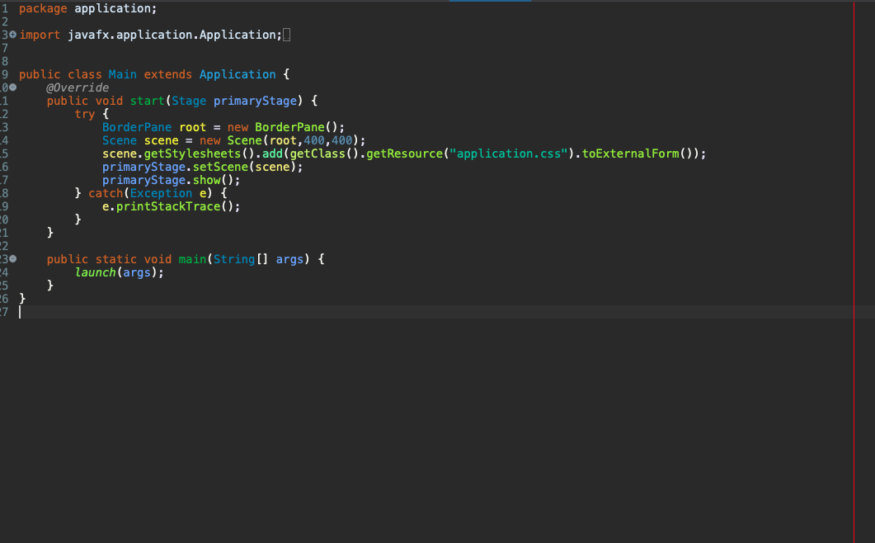

**Lessons Learned** <Provide answers to the questions listed below>**:**

Write about your Learning Experience, highlighting your lessons learned and learning experience from working on this assignment.

What have you learned?

How to sort of use git and java fx

What did you struggle with?

Java fx and creating a window

What parts of this assignment were you successful with, and what parts (if any) were you not successful with?

I do not think my Java FX turned out right.

Provide any additional resources/links/videos you used to while working on this assignment.

[**https://www.youtube.com/watch?v=_7OM-cMYWbQ&ab_channel=BroCode**](https://www.youtube.com/watch?v=_7OM-cMYWbQ&ab_channel=BroCode)

**Check List:** <Provide answers to the column Y/N or N/A >**:**

|  |  |  |  |
| --- | --- | --- | --- |
| **#** |  | **Y/N** | **Comments** |
|  | **Assignment files:** |  |  |
|  | * FirstInitialLastName_Assignment0.docx/pdf | **Yes or No** | **Y** |
|  | * Source java files | **Yes or No** | **N?** |
|  | **Program compiles** | **Yes or No** | **Y** |
|  | **Program runs with desired outputs related to a Test Plan** | **Yes or No** | **Y?** |
|  | **Documentation file: Screenshots of** |  |  |
|  | * Part1: Setup GitHub | **Yes or No** | **Y** |
|  | * Part 2 -Install JDK, Test java Application from Command Line | **Yes or No** | **Y** |
|  | * Part 3 - Install Eclipse, Test Eclipse Java Application | **Yes or No or N/A** | **Y** |
|  | * Part 4 - Install, Setup, Test Junit Program | **Yes or No or N/A** | **Y** |
|  | * Part 5 - Install, Setup, and Test JavaFX Application. | **Yes or No or N/A** | **Y** |
|  | * Lessons Learned | **Yes or No** | **Y** |
|  | * Checklist is completed and included in the Documentation | **Yes or No** | Y |