1. Start a Process.

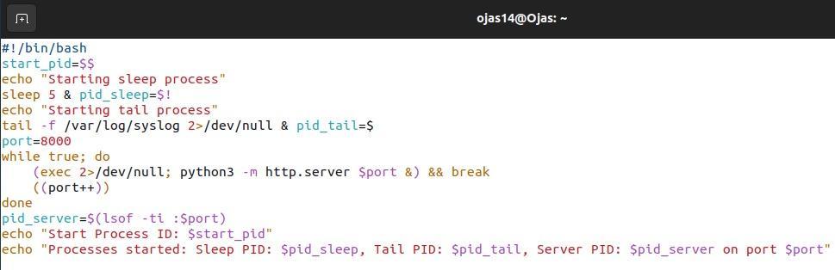

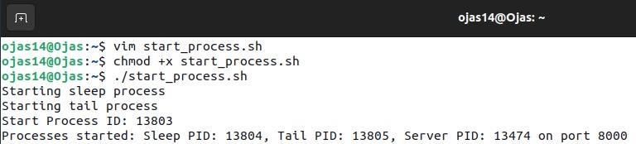

2. Replacing a Process Image.

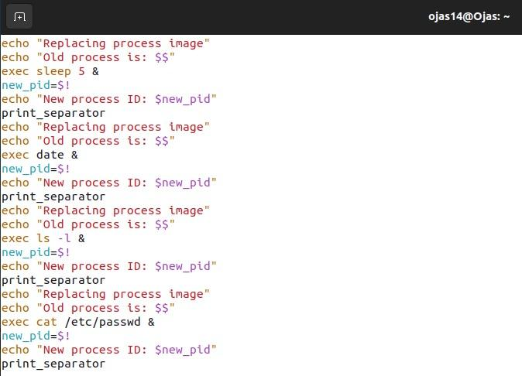

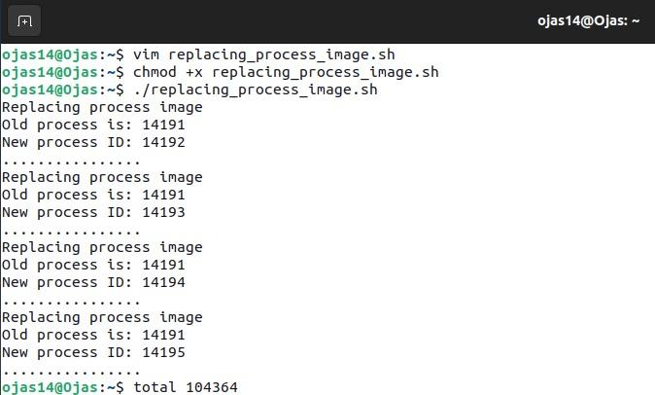

3. Duplicating a Process.

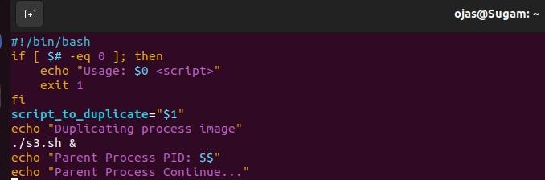

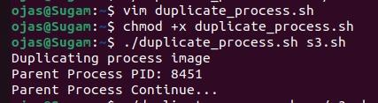

4. Waiting for a Process.

