Jenkins Installation & Multi-Project Build Report
By: S.Ojaskrisshnan – 2023103623- CSE Q

Overview: This document contains the step-by-step installation of Jenkins automation server and complete execution logs for three mandatory project types:
1. Freestyle Project using simple Windows Batch commands
2. Freestyle Project pulling source code from a GitHub repository
3. Maven Java Project executing automated build, test, and JAR packaging

1. Jenkins Installation and Controller Setup
Jenkins LTS (version 2.568.2) was downloaded and started as a standalone WAR service on http://localhost:8080. The controller interface was verified after initial setup.
Figure 1: Jenkins Controller Dashboard UI
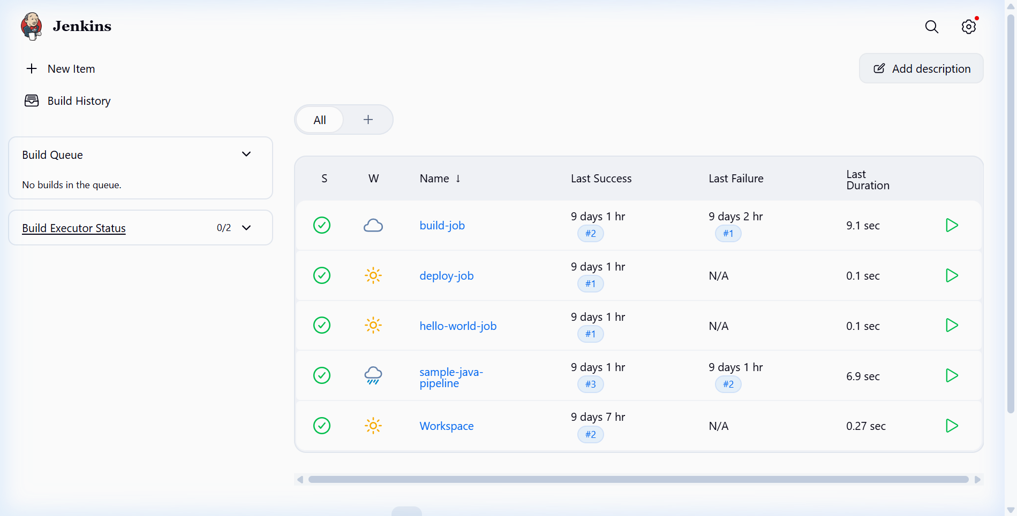

2. Freestyle Project with Simple Commands
A new Freestyle project named Freestyle-Simple-Commands was created. A build step was configured using Windows Batch command syntax to execute basic system information commands.
echo ==============================================
echo Running Simple Command Freestyle Job
echo Hostname: %COMPUTERNAME%
echo Current Date and Time: %DATE% %TIME%
echo ==============================================
dir
Figure 2: Creating Freestyle Project
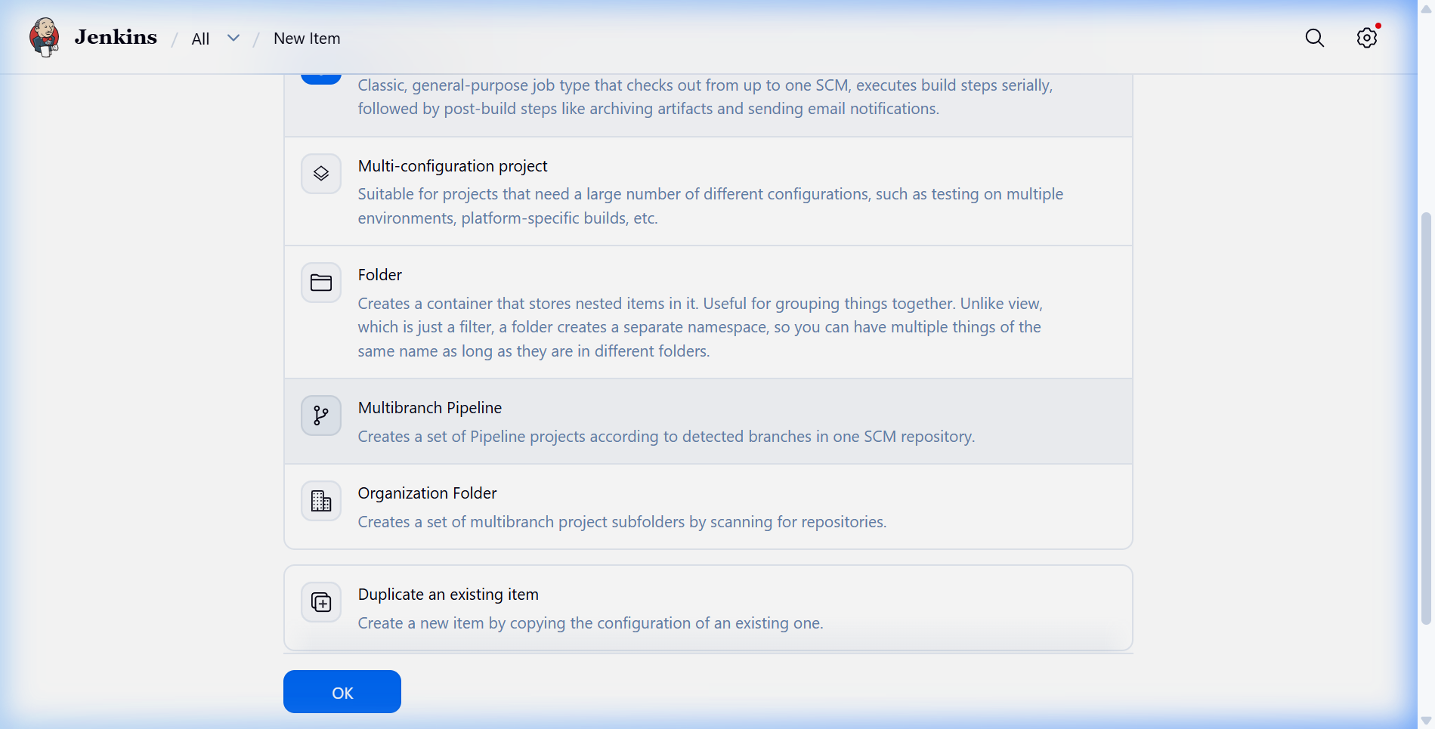
Figure 3: Configuring Batch Build Steps
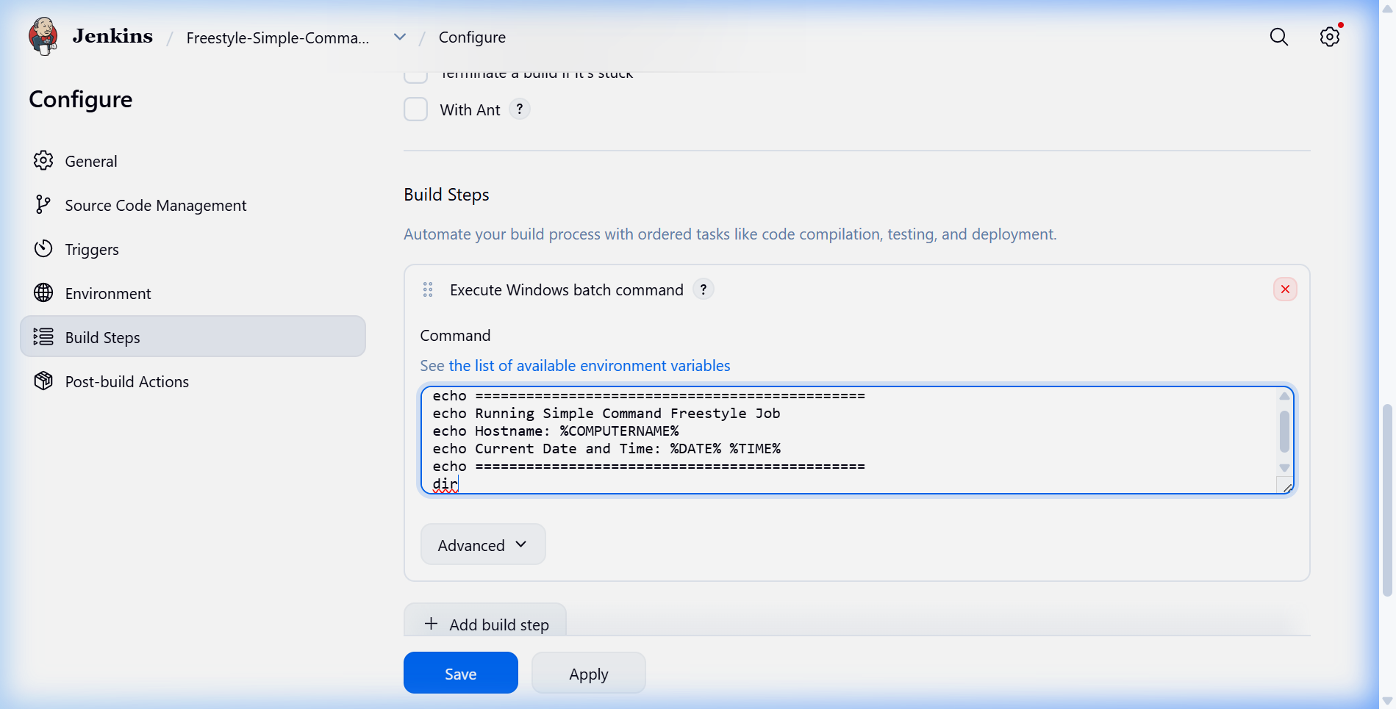
Figure 4: Execution Console Output (SUCCESS)
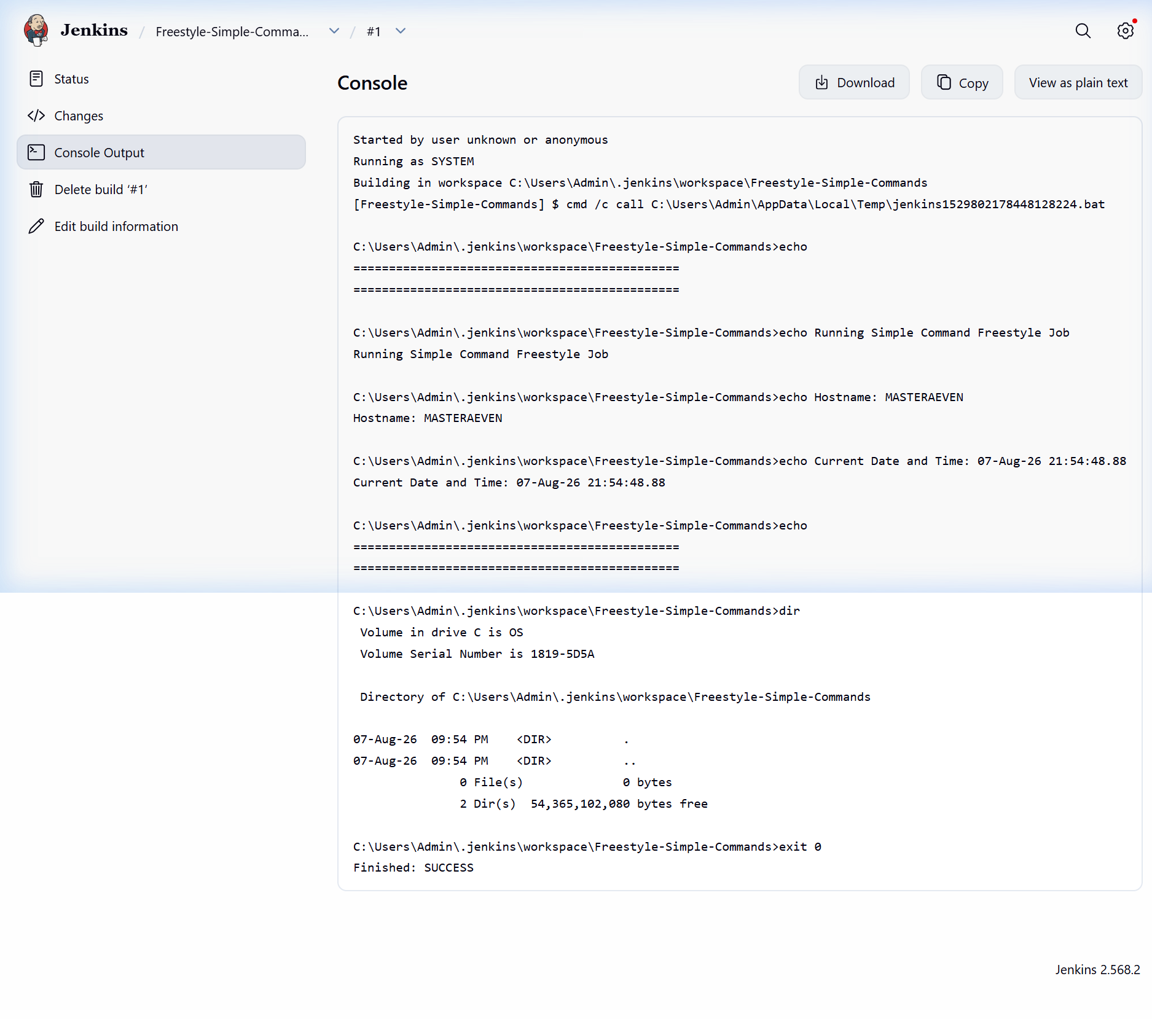

3. Build Project from GitHub
A project named Build-From-GitHub was configured with Git Source Code Management. The repository URL https://github.com/jenkins-docs/simple-java-maven-app.git was cloned automatically during build execution.
Figure 5: Git Clone and SCM Checkout Console Output
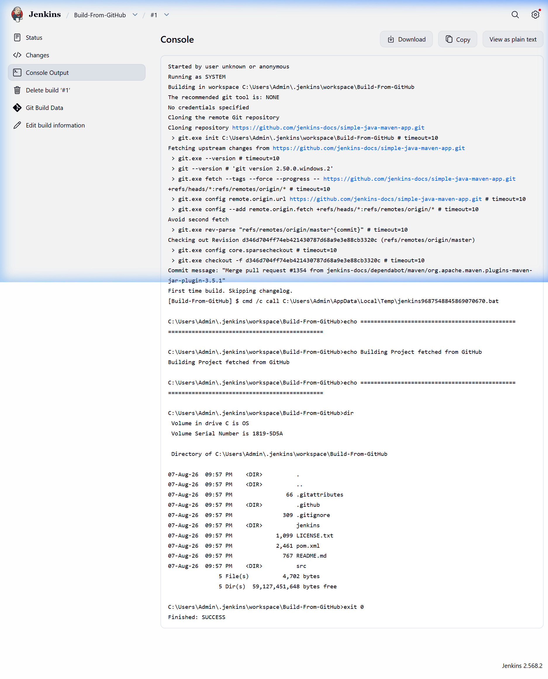

4. Build Maven Project
First, Apache Maven 3.9.9 was registered under Manage Jenkins -> Tools. Then a project named Build-Maven-Project was created with top-level Maven targets clean package. Jenkins successfully compiled the Java source files, executed JUnit unit tests, and generated the output JAR package.
Figure 6: Global Tool Configuration for Apache Maven 3.9.9
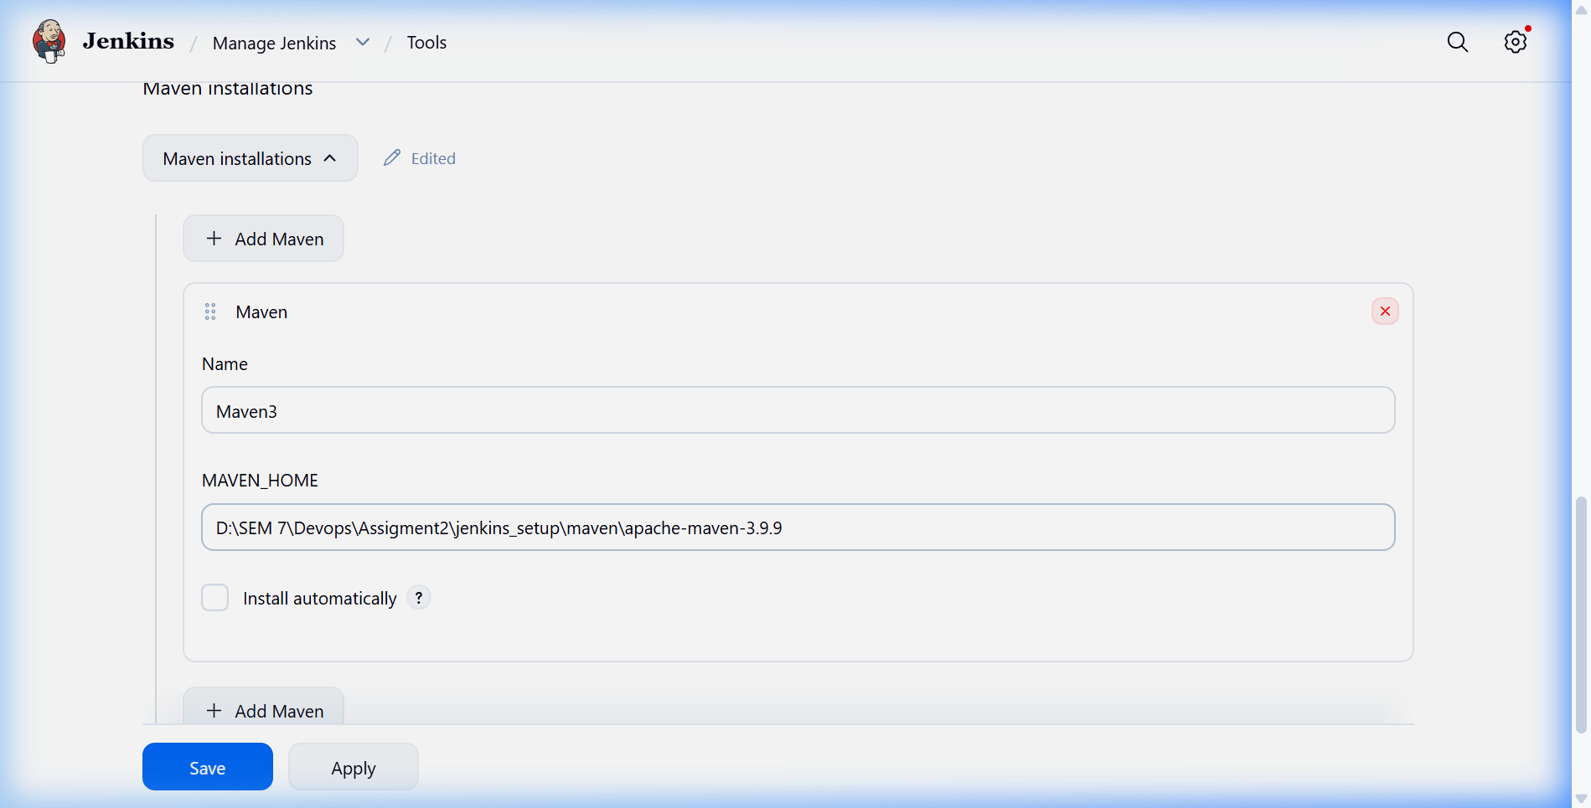
Figure 7: Maven Build Success Console Output (JAR Generated)
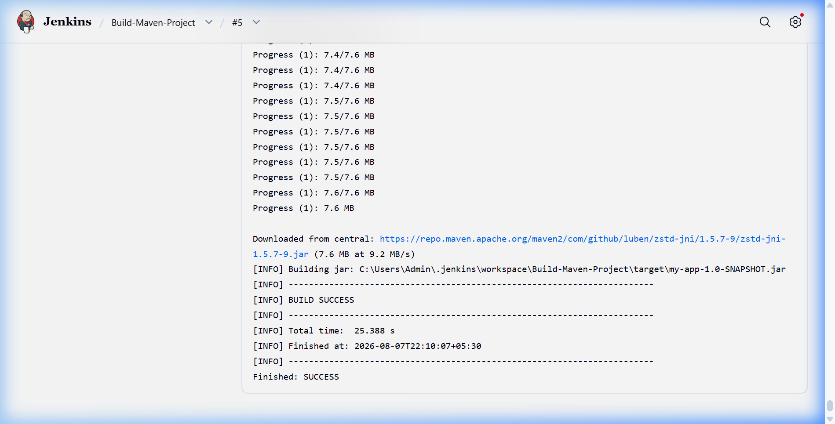

5. Summary of Completed Deliverables
Task | Job Name | Source / Build Steps | Status
Freestyle Simple Commands | Freestyle-Simple-Commands | Batch Script (%COMPUTERNAME%, dir) | Finished: SUCCESS
Build from GitHub | Build-From-GitHub | Git SCM Checkout | Finished: SUCCESS
Build Maven Project | Build-Maven-Project | Maven Goals: clean package | BUILD SUCCESS

