Exercise 1: Control Structures

Scenario 1: The bank wants to apply a discount to loan interest rates for customers above 60 years old.
  - Question: Write a PL/SQL block that loops through all customers, checks their age, and if they are above 60, apply a 1% discount to their current loan interest rates.

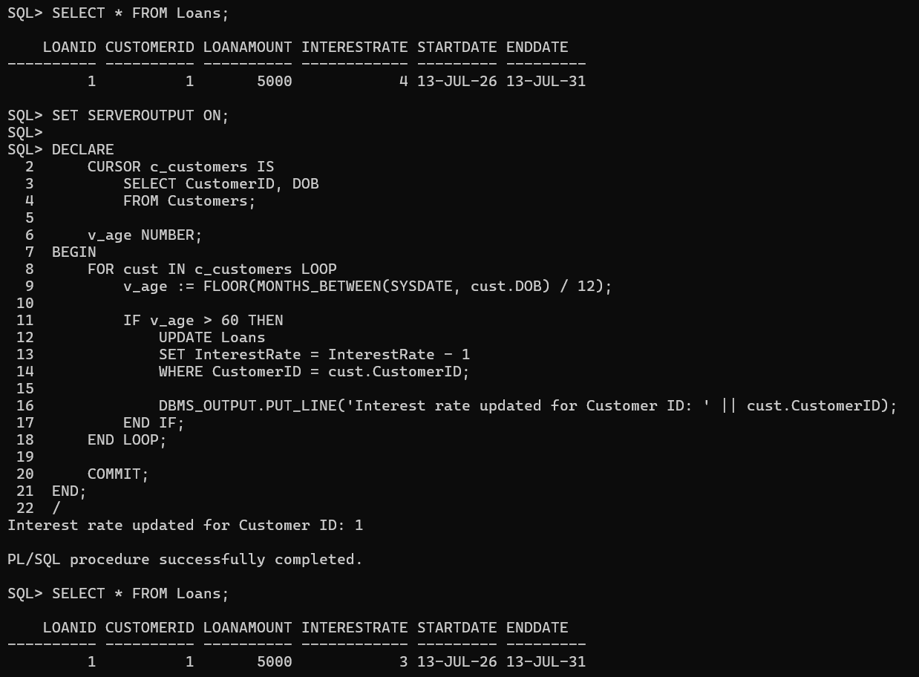

Scenario 2: A customer can be promoted to VIP status based on their balance.
  - Question: Write a PL/SQL block that iterates through all customers and sets a flag IsVIP to TRUE for those with a balance over $10,000.
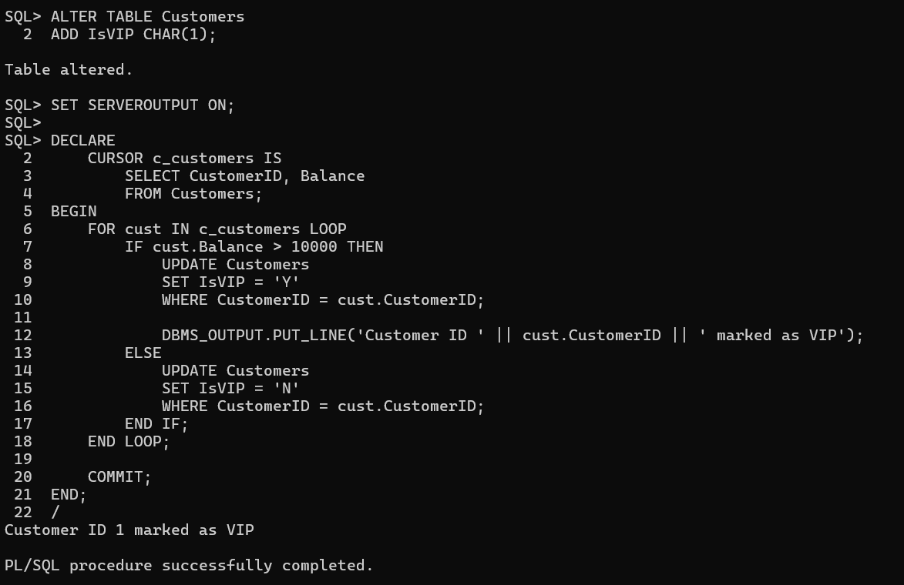
Scenario 3: The bank wants to send reminders to customers whose loans are due within the next 30 days.
  - Question: Write a PL/SQL block that fetches all loans due in the next 30 days and prints a reminder message for each customer.
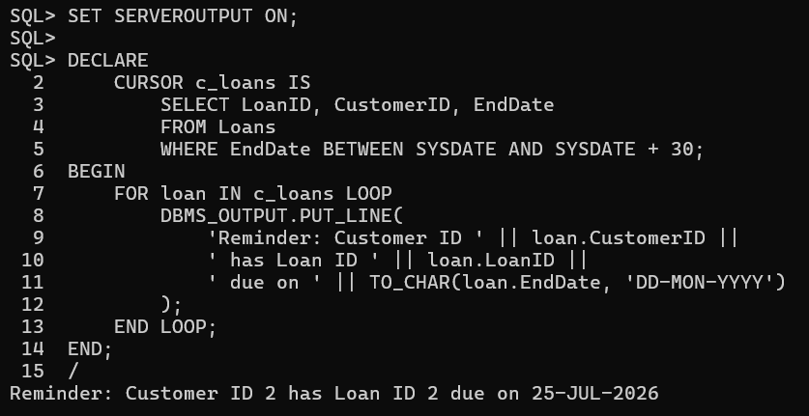

Exercise 2: Error Handling
Scenario 1: Handle exceptions during fund transfers between accounts.
  - Question: Write a stored procedure SafeTransferFunds that transfers funds between two accounts. Ensure that if any error occurs (e.g., insufficient funds), an appropriate error message is logged and the transaction is rolled back.
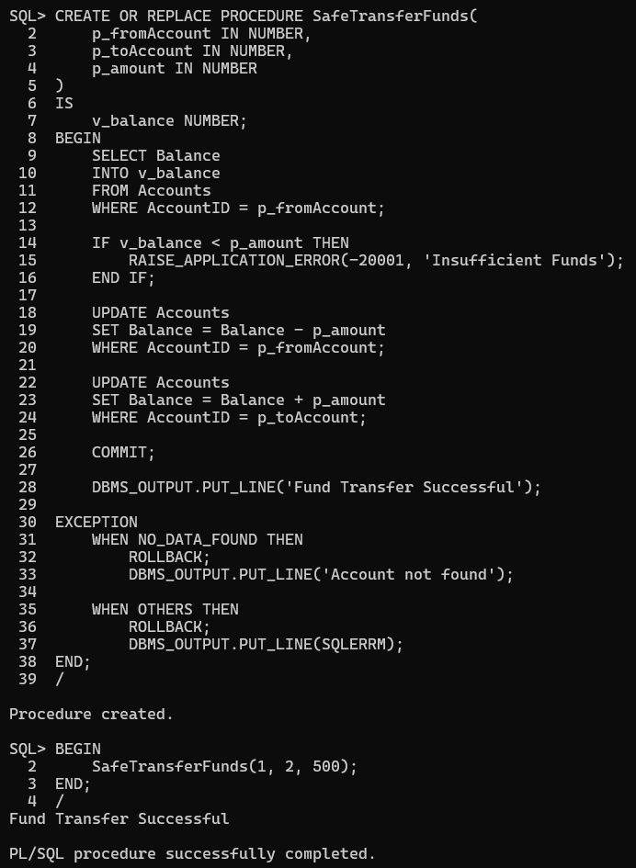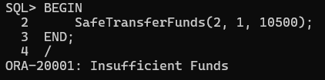

Scenario 2: Manage errors when updating employee salaries.
  - Question: Write a stored procedure UpdateSalary that increases the salary of an employee by a given percentage. If the employee ID does not exist, handle the exception and log an error message.
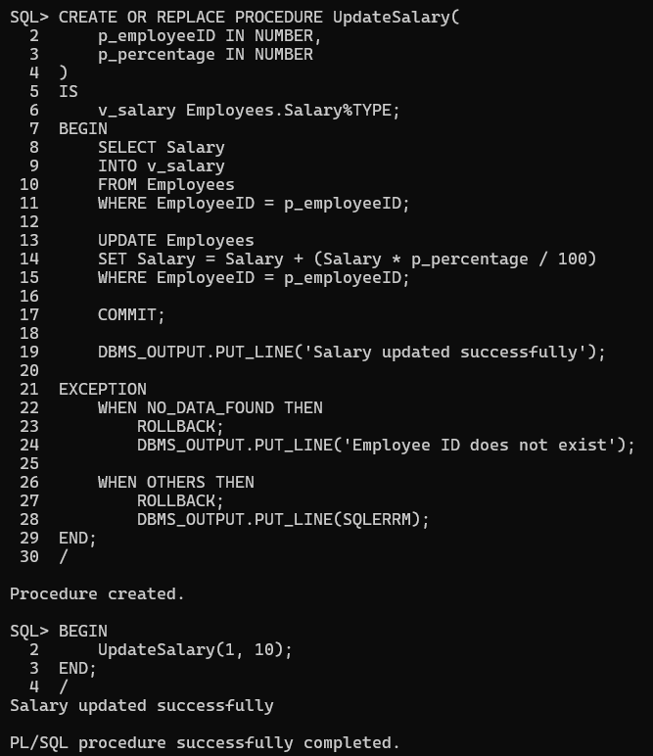

Scenario 3: Ensure data integrity when adding a new customer.
  - Question: Write a stored procedure AddNewCustomer that inserts a new customer into the Customers table. If a customer with the same ID already exists, handle the exception by logging an error and preventing the insertion.
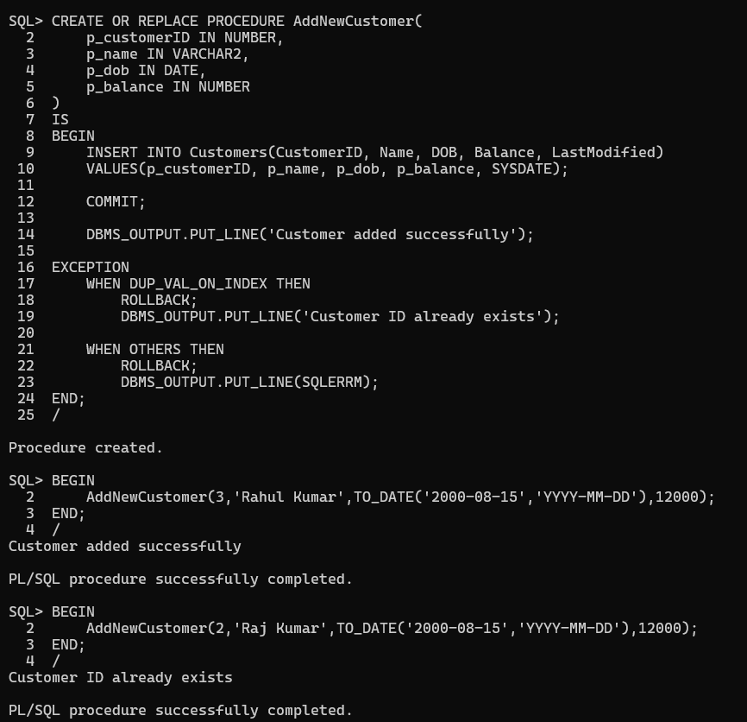

Exercise 3: Stored Procedures

Scenario 1: The bank needs to process monthly interest for all savings accounts.
  - Question: Write a stored procedure ProcessMonthlyInterest that calculates and updates the balance of all savings accounts by applying an interest rate of 1% to the current balance.
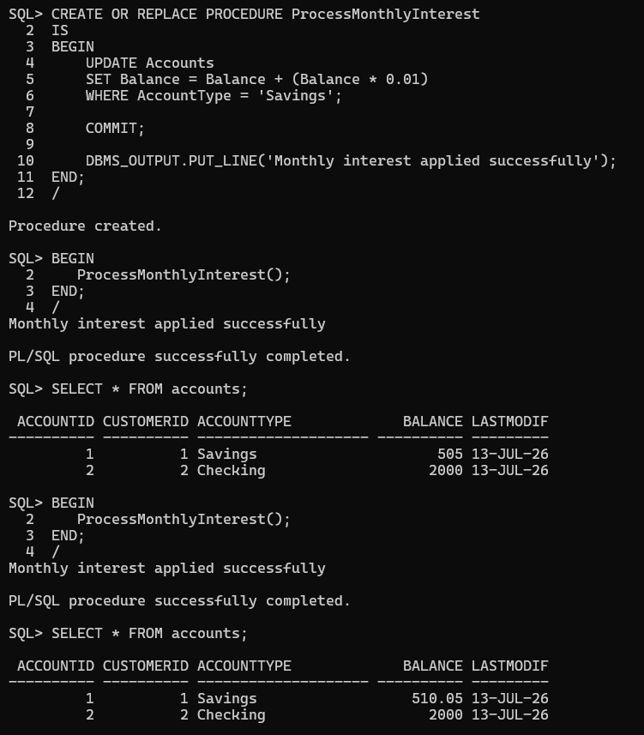

Scenario 2: The bank wants to implement a bonus scheme for employees based on their performance.
  - Question: Write a stored procedure UpdateEmployeeBonus that updates the salary of employees in a given department by adding a bonus percentage passed as a parameter.
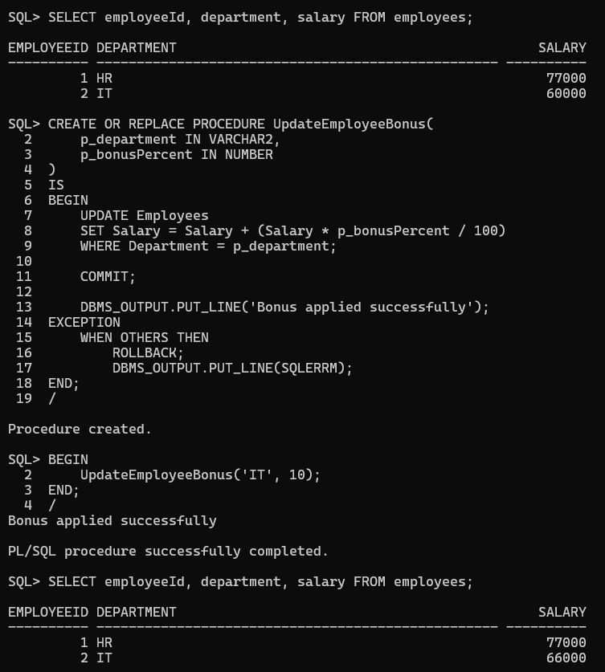
Scenario 3: Customers should be able to transfer funds between their accounts.
  - Question: Write a stored procedure TransferFunds that transfers a specified amount from one account to another, checking that the source account has sufficient balance before making the transfer.
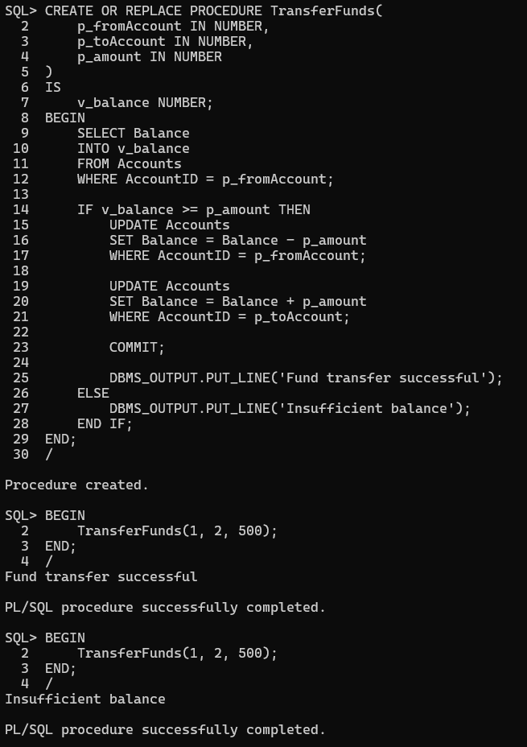

Exercise 4: Functions

Scenario 1: Calculate the age of customers for eligibility checks.
  - Question: Write a function CalculateAge that takes a customer's date of birth as input and returns their age in years.
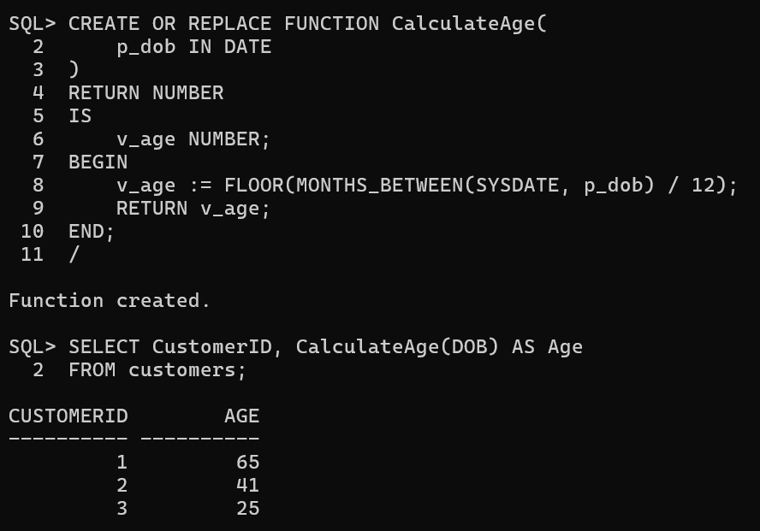
Scenario 2: The bank needs to compute the monthly installment for a loan.
  - Question: Write a function CalculateMonthlyInstallment that takes the loan amount, interest rate, and loan duration in years as input and returns the monthly installment amount.
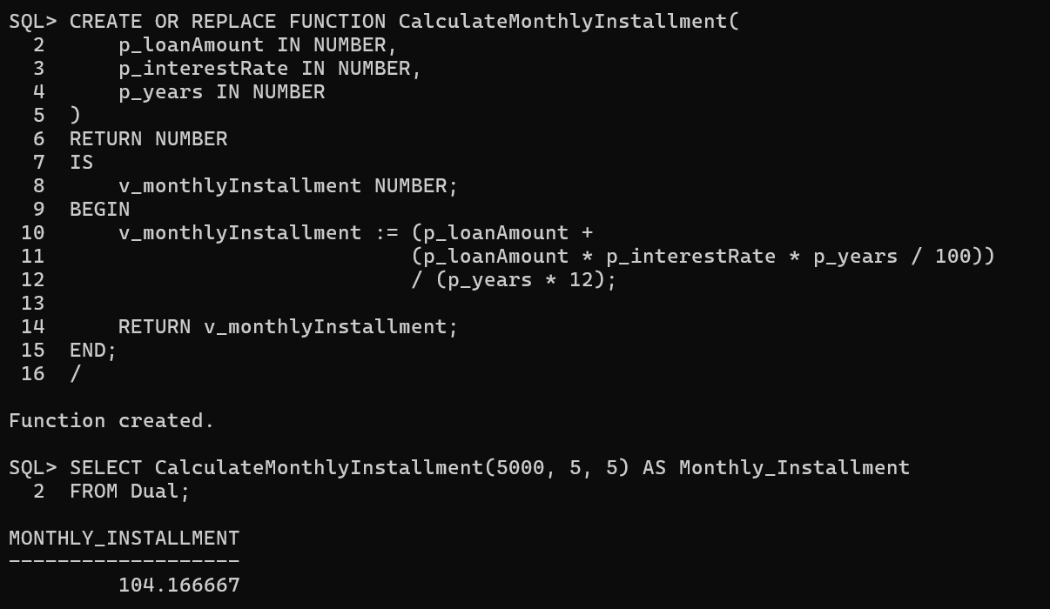
Scenario 3: Check if a customer has sufficient balance before making a transaction.
  - Question: Write a function HasSufficientBalance that takes an account ID and an amount as input and returns a boolean indicating whether the account has at least the specified amount.
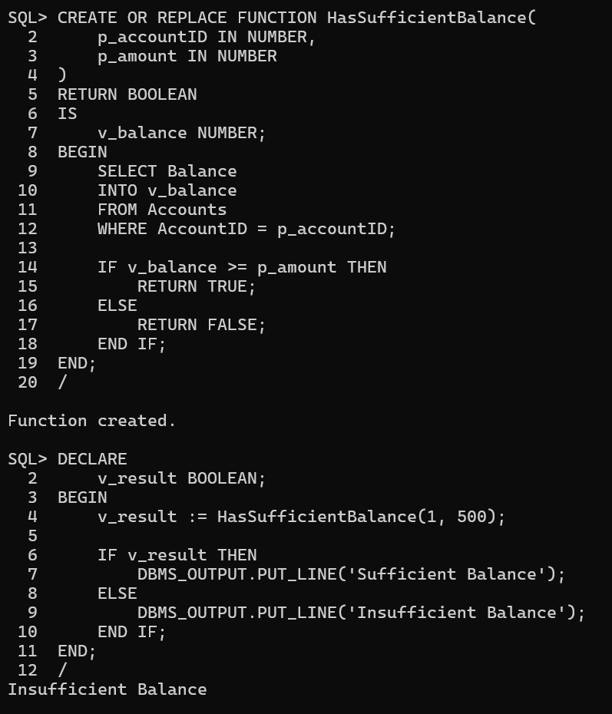

Exercise 5: Triggers

Scenario 1: Automatically update the last modified date when a customer's record is updated.
  - Question: Write a trigger UpdateCustomerLastModified that updates the LastModified column of the Customers table to the current date whenever a customer's record is updated.
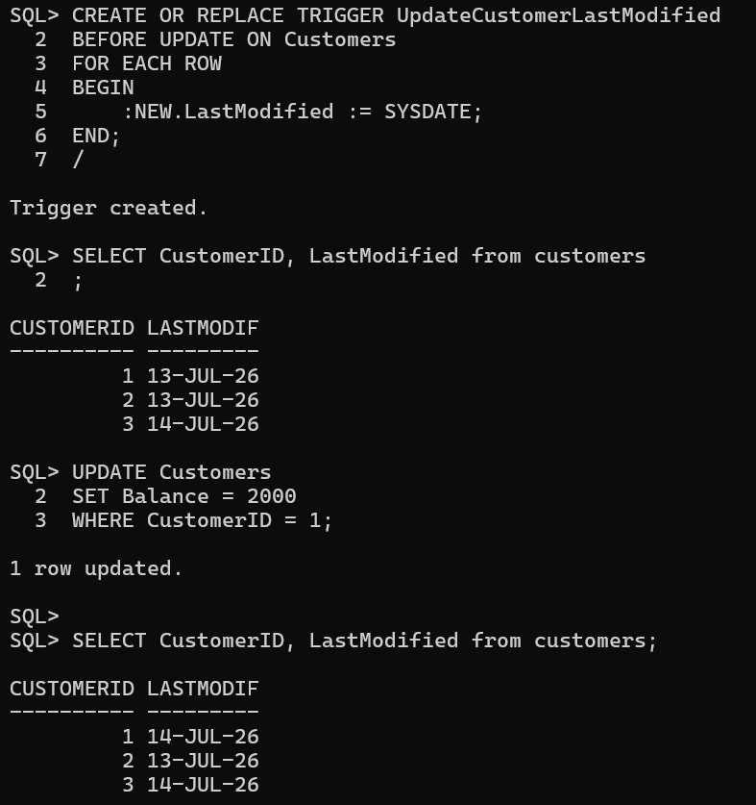

Scenario 2: Maintain an audit log for all transactions.
  - Question: Write a trigger LogTransaction that inserts a record into an AuditLog table whenever a transaction is inserted into the Transactions table.
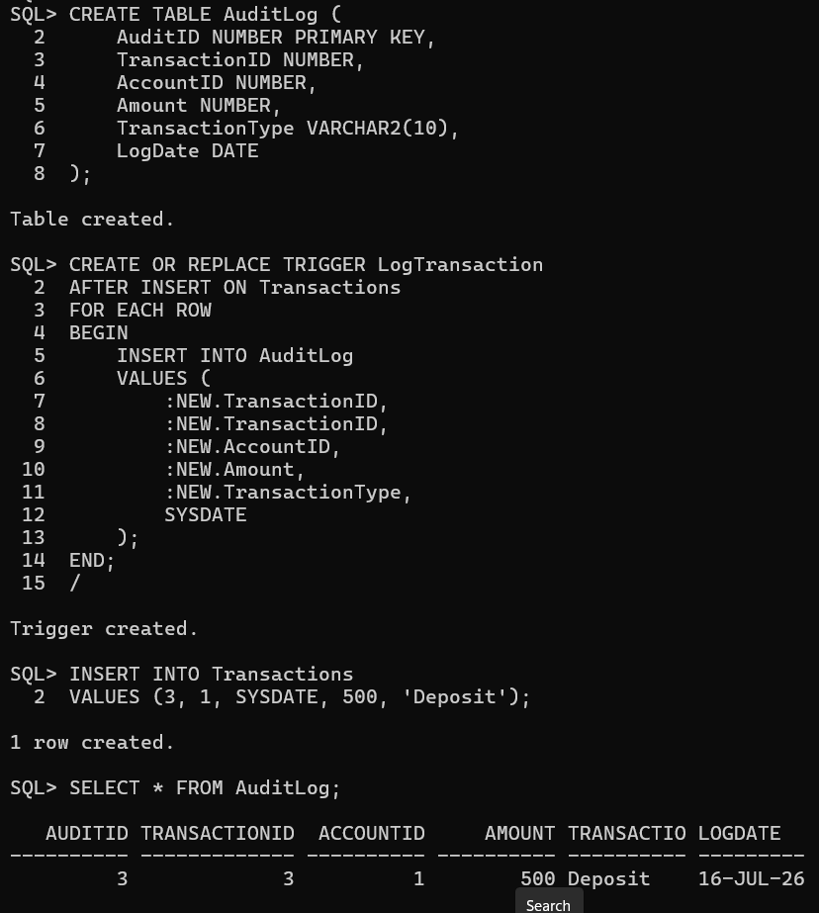

Scenario 3: Enforce business rules on deposits and withdrawals.
  - Question: Write a trigger CheckTransactionRules that ensures withdrawals do not exceed the balance and deposits are positive before inserting a record into the Transactions table.
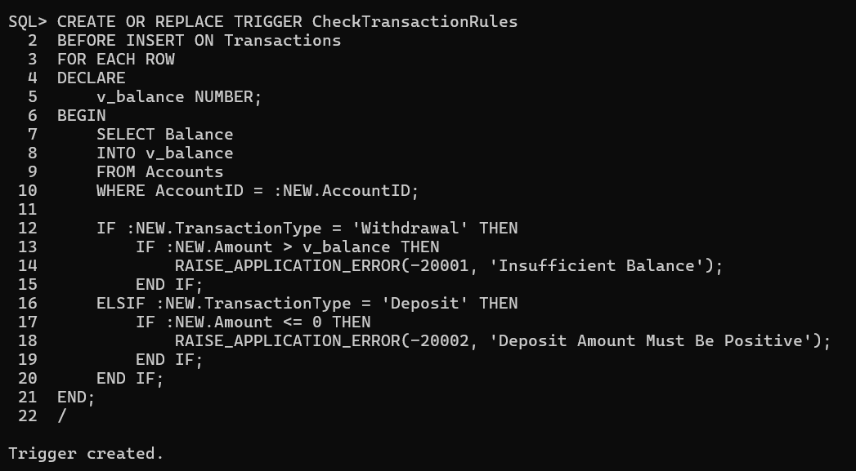

Exercise 6: Cursors

Scenario 1: Generate monthly statements for all customers.
  - Question: Write a PL/SQL block using an explicit cursor GenerateMonthlyStatements that retrieves all transactions for the current month and prints a statement for each customer.
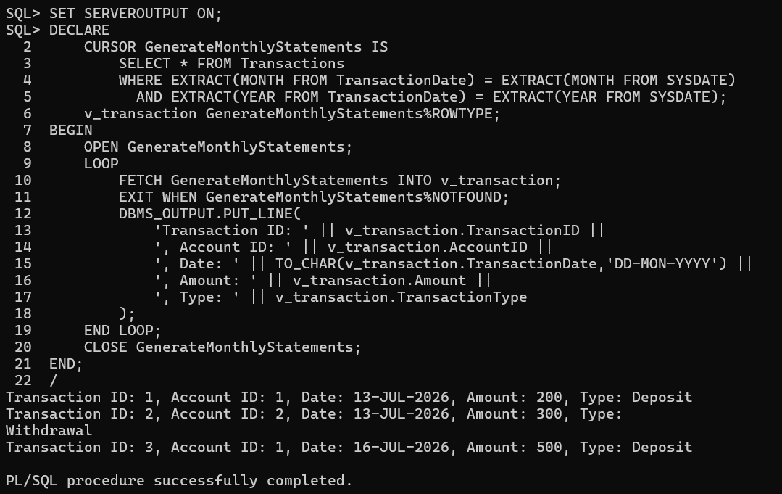
Scenario 2: Apply annual fee to all accounts.
  - Question: Write a PL/SQL block using an explicit cursor ApplyAnnualFee that deducts an annual maintenance fee from the balance of all accounts.
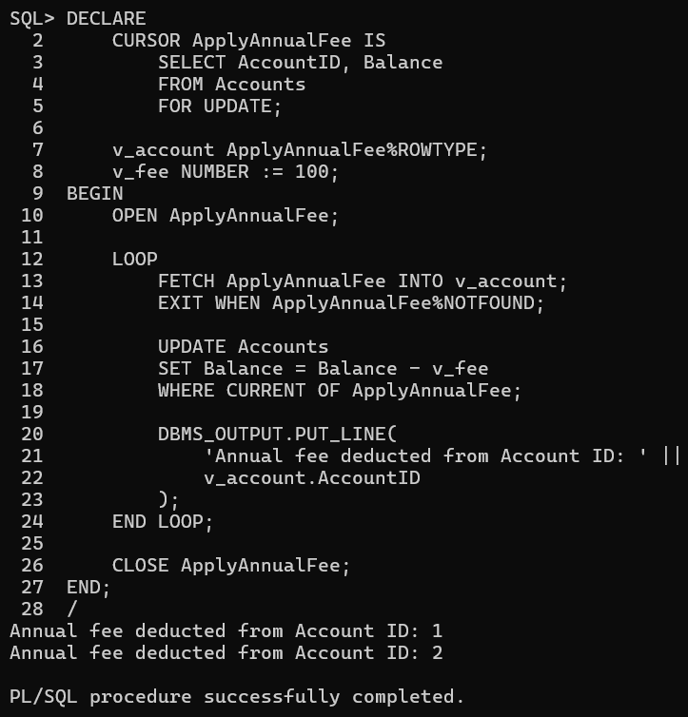
Scenario 3: Update the interest rate for all loans based on a new policy.
  - Question: Write a PL/SQL block using an explicit cursor UpdateLoanInterestRates that fetches all loans and updates their interest rates based on the new policy.
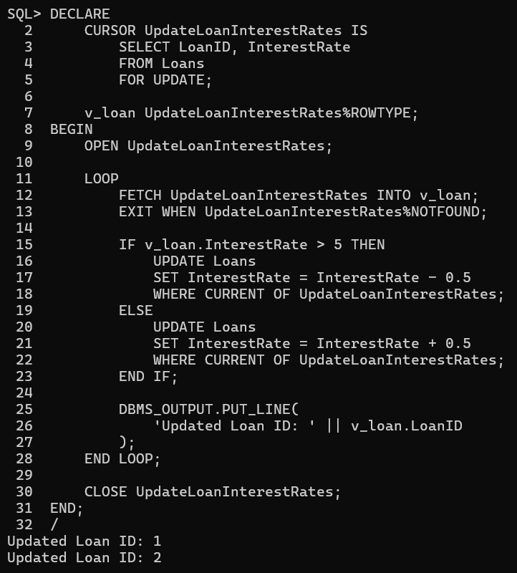\

Exercise 7: Packages

Scenario 1: Group all customer-related procedures and functions into a package.
  - Question: Create a package CustomerManagement with procedures for adding a new customer, updating customer details, and a function to get customer balance.
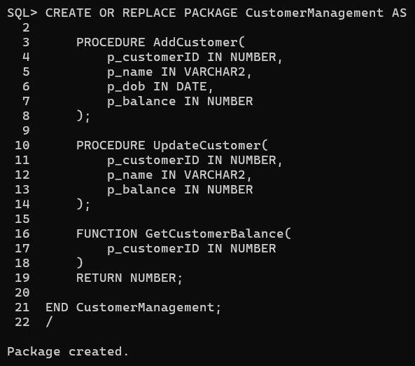

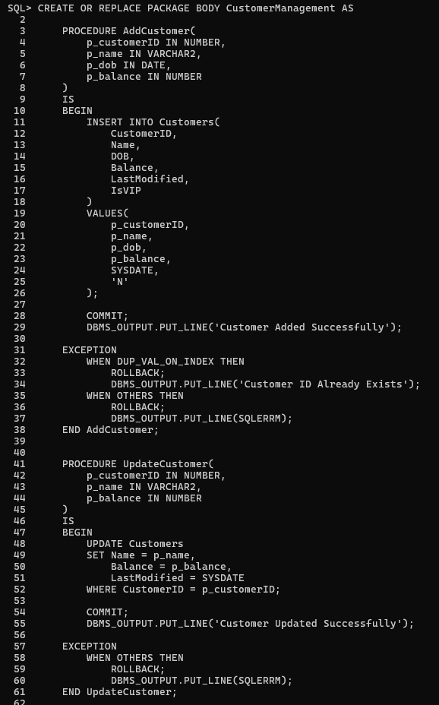
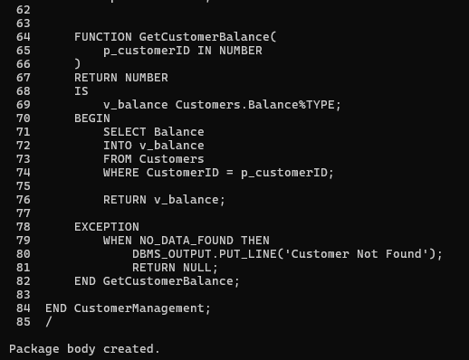
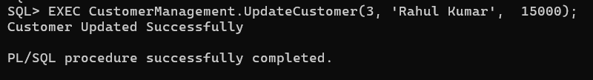

Scenario 2: Create a package to manage employee data.
  - Question: Write a package EmployeeManagement with procedures to hire new employees, update employee details, and a function to calculate annual salary.
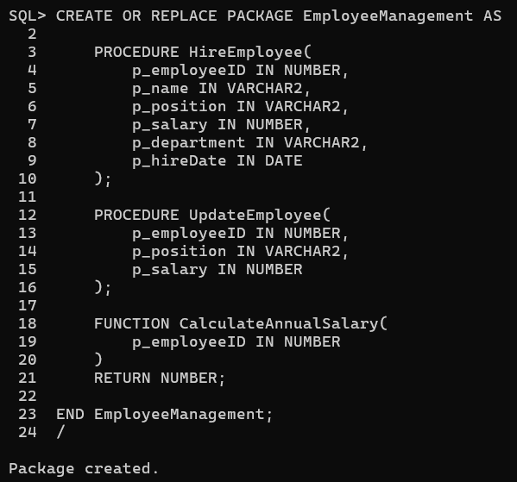
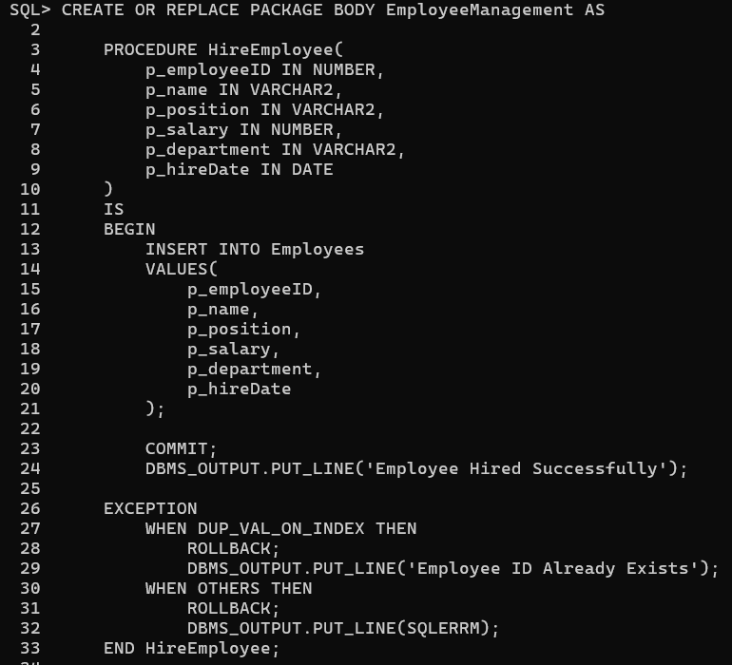
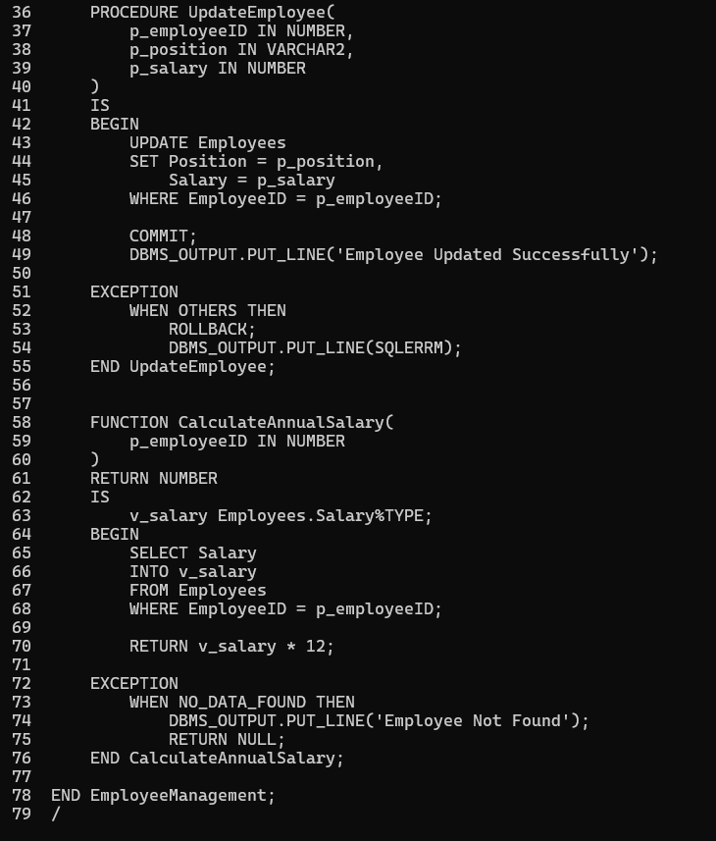
Scenario 3: Group all account-related operations into a package.
  - Question: Create a package AccountOperations with procedures for opening a new account, closing an account, and a function to get the total balance of a customer across all accounts.
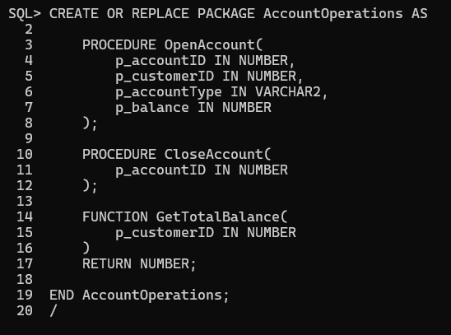
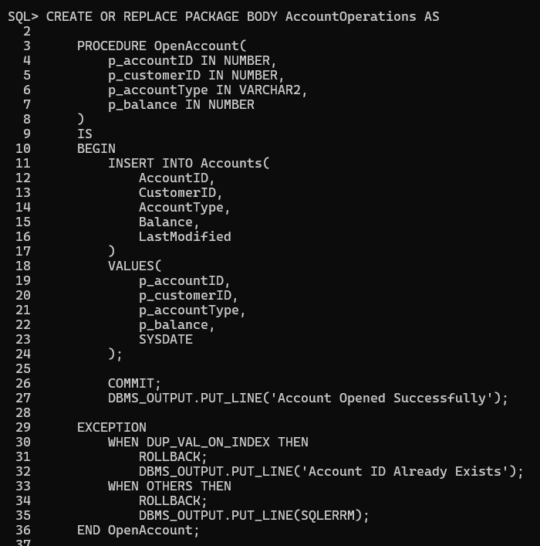
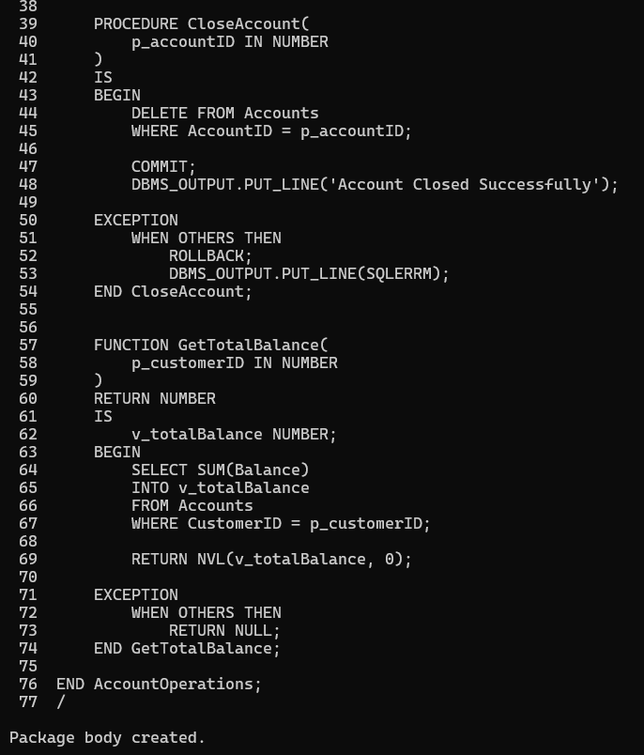

Schema to be Created

CREATE TABLE Customers (
CustomerID NUMBER PRIMARY KEY,
Name VARCHAR2(100),
DOB DATE,
Balance NUMBER,
LastModified DATE
);

CREATE TABLE Accounts (
AccountID NUMBER PRIMARY KEY,
CustomerID NUMBER,
AccountType VARCHAR2(20),
Balance NUMBER,
LastModified DATE,
FOREIGN KEY (CustomerID) REFERENCES Customers(CustomerID)
);

CREATE TABLE Transactions (
TransactionID NUMBER PRIMARY KEY,
AccountID NUMBER,
TransactionDate DATE,
Amount NUMBER,
TransactionType VARCHAR2(10),
FOREIGN KEY (AccountID) REFERENCES Accounts(AccountID)
);

CREATE TABLE Loans (
LoanID NUMBER PRIMARY KEY,
CustomerID NUMBER,
LoanAmount NUMBER,
InterestRate NUMBER,
StartDate DATE,
EndDate DATE,
FOREIGN KEY (CustomerID) REFERENCES Customers(CustomerID)
);

CREATE TABLE Employees (
EmployeeID NUMBER PRIMARY KEY,
Name VARCHAR2(100),
Position VARCHAR2(50),
Salary NUMBER,
Department VARCHAR2(50),
HireDate DATE
);

Example Scripts for Sample Data Insertion

INSERT INTO Customers (CustomerID, Name, DOB, Balance, LastModified)
VALUES (1, 'John Doe', TO_DATE('1985-05-15', 'YYYY-MM-DD'), 1000, SYSDATE);

INSERT INTO Customers (CustomerID, Name, DOB, Balance, LastModified)
VALUES (2, 'Jane Smith', TO_DATE('1990-07-20', 'YYYY-MM-DD'), 1500, SYSDATE);

INSERT INTO Accounts (AccountID, CustomerID, AccountType, Balance, LastModified)
VALUES (1, 1, 'Savings', 1000, SYSDATE);

INSERT INTO Accounts (AccountID, CustomerID, AccountType, Balance, LastModified)
VALUES (2, 2, 'Checking', 1500, SYSDATE);

INSERT INTO Transactions (TransactionID, AccountID, TransactionDate, Amount, TransactionType)
VALUES (1, 1, SYSDATE, 200, 'Deposit');

INSERT INTO Transactions (TransactionID, AccountID, TransactionDate, Amount, TransactionType)
VALUES (2, 2, SYSDATE, 300, 'Withdrawal');

INSERT INTO Loans (LoanID, CustomerID, LoanAmount, InterestRate, StartDate, EndDate)
VALUES (1, 1, 5000, 5, SYSDATE, ADD_MONTHS(SYSDATE, 60));

INSERT INTO Employees (EmployeeID, Name, Position, Salary, Department, HireDate)
VALUES (1, 'Alice Johnson', 'Manager', 70000, 'HR', TO_DATE('2015-06-15', 'YYYY-MM-DD'));

INSERT INTO Employees (EmployeeID, Name, Position, Salary, Department, HireDate)
VALUES (2, 'Bob Brown', 'Developer', 60000, 'IT', TO_DATE('2017-03-20', 'YYYY-MM-DD'));

