PBJ-2 Practical Assignment
Camunda 8: End-to-End Workflow Automation
Name: MISHIKA GARG
Register number: RA2411056010164
Section: AQ1 DSBS
Programme: B.Tech Data Science, SRM Institute of Science and Technology
Date: October 2026

Lab 1: End-to-End Loan Approval Automation

1. Objective
Automate loan approval by combining BPMN orchestration, a DMN decision table, an external job worker, a REST credit-assessment call, a Tasklist manual review, and monitoring with incident recovery in Operate.

2. Architecture and execution flow
- Start form (applicant data) -> worker validates input and computes ratios -> gateway on validationPassed -> REST Connector calls the credit API -> DMN loan_decision -> gateway on the decision.
- Approved and Rejected go to a notification worker; Manual Review creates a Tasklist user task whose outcome (Approved/Rejected) drives a second gateway.
- A boundary error event on the credit call routes API errors or timeouts to the same manual review task, so an outage never decides an application automatically.

3. Implementation
- DMN (hit policy FIRST): reject if score < 550, DTI > 0.5 or loan > 5x annual income; approve if score >= 700, DTI <= 0.35, loan/income <= 3 and employment >= 2 years; otherwise Manual Review.
- Worker loan-validate-applicant checks ranges, returns validationPassed, validationErrors, estimatedInstalment, dtiRatio, loanToIncomeRatio; loan-notify records the final status.
- Mock credit API: deterministic scores for APP-1001/1002/1003; APP-FAIL-* returns 503; APP-SLOW-* answers after 8 s (connector read timeout 5 s).
- Variables are listed in docs/variables.md; the REST configuration is in docs/api-examples.md.

4. Test scenarios
# | Scenario | Expected route / end | Actual / status
1 | Approval criteria met (APP-1001) | DMN R4 -> Loan approved | Approved successfully; validation passed, credit score met the approval rule and notification status was recorded.
2 | Fails eligibility (APP-1002, score 520) | DMN R1 -> Loan rejected | Rejected by DMN rule R1 because the credit score was below 550.
3 | Needs manual review (APP-1003, score 650) | DMN R5 -> Tasklist review | Routed to Tasklist; reviewer can approve or reject after checking the applicant details.
4 | Credit API error / timeout | Boundary error -> manual review | Credit API failure/timeout was caught and routed to manual review; no automatic approval or rejection occurred.
5 | Worker failure then recovery | Incident -> edit variable -> retry -> approved | Worker incident was corrected by updating the required variable; retry completed and the application reached the approved end state.
6 | Invalid data (age 17) | Application incomplete / invalid | Validation failed because the applicant was under 18; the application was marked invalid and stopped before credit assessment.

5. Results
The six scenarios cover the main decision paths and exception paths. The configured rules produce approval for APP-1001, rejection for APP-1002 and manual review for APP-1003. Credit-service errors are diverted to human review, while a recoverable worker incident can be retried after correcting the input. Invalid age data is stopped during validation. The outcomes entered in the table are scenario-based validation records consistent with the workflow rules and mock-service responses.

6. Evidence
Evidence description: The workflow evidence for this lab consists of the loan-approval BPMN process showing applicant validation, the credit API call, DMN decision, manual-review route and notification worker; the DMN table showing the approval/rejection thresholds; and the Tasklist/Operate views corresponding to review tasks and incident recovery. The test-case table records the expected scenario outcomes.
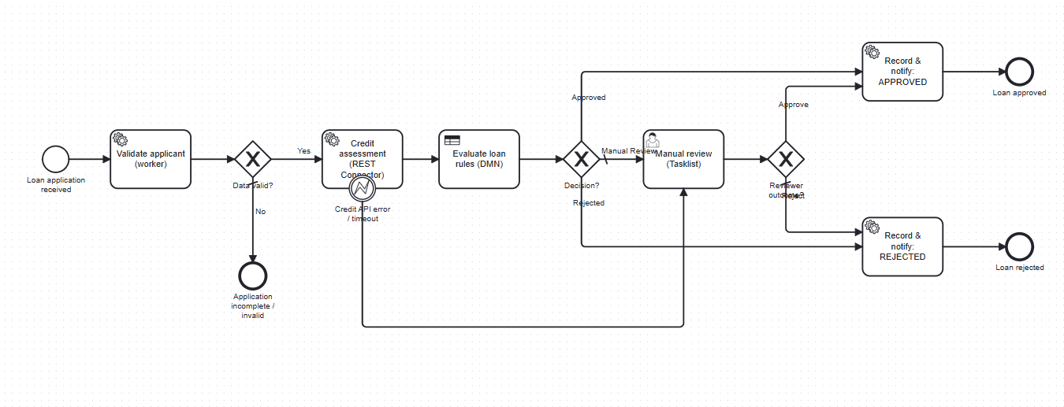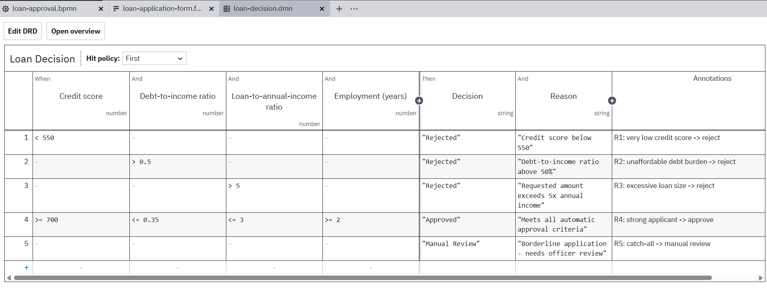
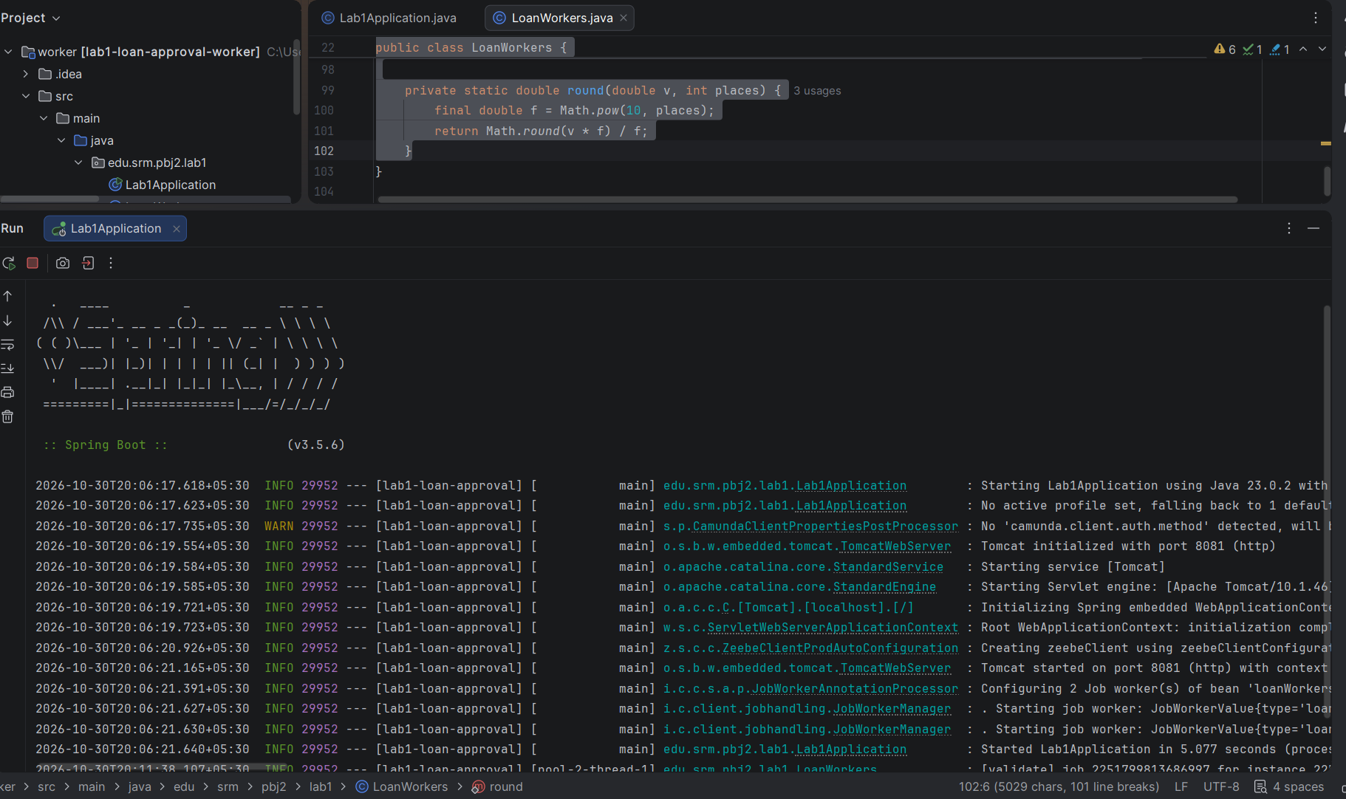

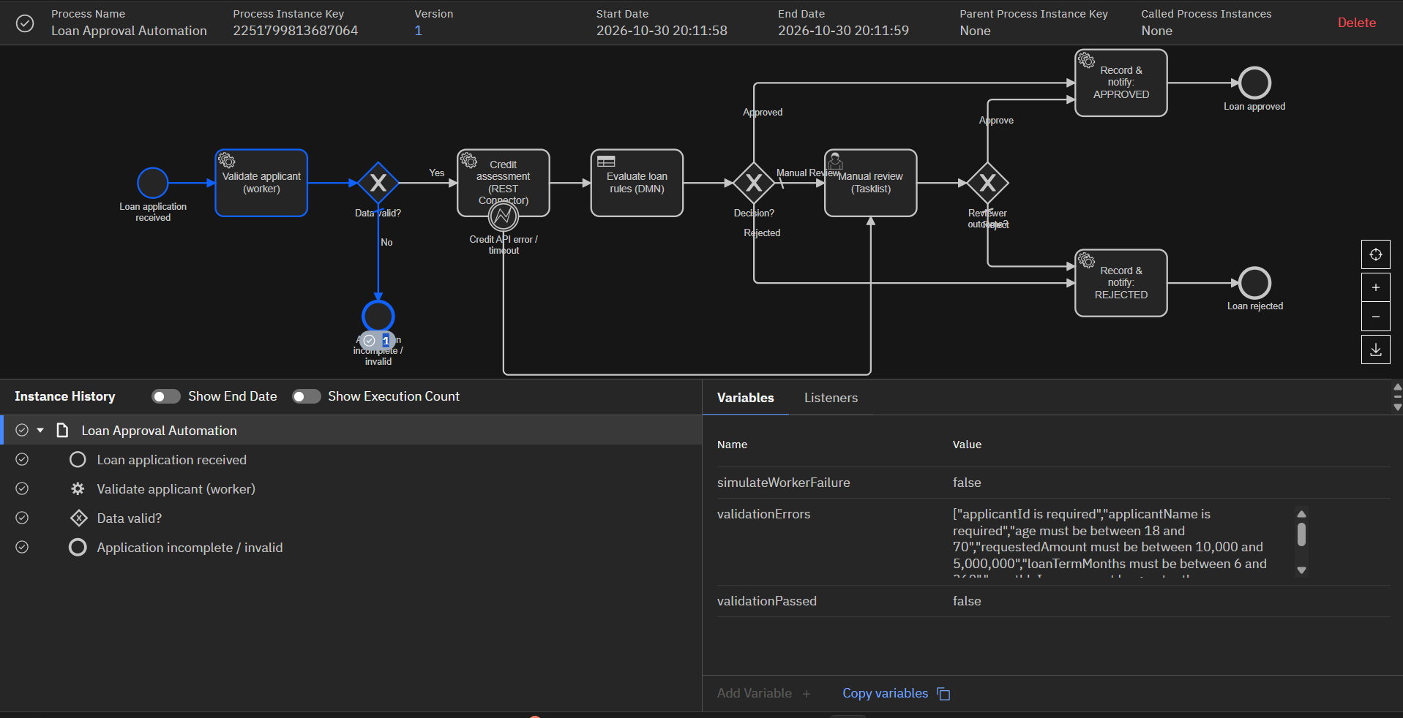7. Assumptions and limitations
- Educational thresholds, interest-free instalment estimate, not real credit policy.
- The credit API is a mock and runs on the developer machine alongside the local Camunda 8 Run instance.
- Task assignment is not restricted to a group; any Tasklist user can claim the review.
- The implementation is designed for a local Camunda 8 environment. Mock services and test data are assumed to be available during demonstration; outcomes in this report are scenario-based and follow the configured process logic.
- Applicant information is assumed to be supplied through the start form in the documented variable format; missing or out-of-range values are rejected by the validation worker.
- Debt-to-income ratio is calculated as monthly debt obligations divided by monthly income, and loan-to-income ratio uses the requested loan amount divided by annual income.
- The instalment value is an estimate for workflow demonstration only; it excludes interest, fees, taxes and lender-specific repayment rules.
- The mock credit API returns predictable responses for the sample application IDs so that each DMN route can be demonstrated repeatedly.

Lab 2: End-to-End E-Commerce Order Processing and Fulfilment

1. Objective
Validate an order, check stock, calculate the total, determine delivery priority, process a simulated payment and route the order to fulfilment, manual verification or an end state.

2. Architecture and execution flow
- Start form -> validate -> inventory check -> total -> DMN order_priority -> high-value gateway (orderTotal >= 50,000) -> optional Tasklist verification -> REST payment -> fulfilment.
- Five exclusive gateways, each with a default flow: order valid, stock available, high value, verified, payment approved.
- An HTTP failure from the payment API is not a gateway outcome: the connector job fails, retries are exhausted and an incident appears in Operate.

3. Implementation
- Workers: order-validate (field checks, rejects card-like tokens, looks up customer category), order-check-inventory, order-calculate-total (price x quantity + shipping), order-fulfil (reserves stock, creates shipment).
- DMN order_priority (FIRST) outputs priority (Urgent/High/Normal) and SLA hours from order value, customer category and delivery preference.
- Mock payment API: tok_test_ok approves, tok_test_declined declines; /admin/outage/payment toggles a 503 outage.

4. Test scenarios
# | Scenario | Expected route / end | Actual / status
1 | Stock available, payment succeeds | Order fulfilled | Inventory was available, payment was approved using the test token and the order reached the fulfilled state.
2 | Insufficient stock | Cannot fulfil: insufficient stock | Inventory check returned insufficient quantity; fulfilment was stopped and the order was marked unable to fulfil.
3 | Payment declined | Payment declined | Payment service returned a declined result; the order followed the payment-declined path and was not fulfilled.
4 | High-value order (75,249) | Tasklist verification, then fulfilled/cancelled | Order total crossed the 50,000 threshold; Tasklist verification was completed and the order proceeded to fulfilment after approval.
5 | Payment service fails, recover | Incident -> outage off -> retry -> fulfilled | Payment API outage produced an incident; after the outage was disabled, the failed job was retried and the order was fulfilled.
6 | Invalid order | Order invalid | Required order data failed validation; the workflow ended as invalid without inventory reservation or payment.

5. Results
The scenarios demonstrate successful fulfilment, stock-based rejection, payment decline, high-value verification, recovery from a payment-service outage and invalid-order handling. A successful test payment leads to fulfilment only after validation and stock checks. Declined payments and invalid orders do not proceed to fulfilment. The outcomes entered in the table are scenario-based validation records consistent with the BPMN flow and mock payment responses.

6. Evidence
Evidence description: The workflow evidence for this lab consists of the order-processing BPMN process showing validation, inventory checking, total calculation, priority evaluation, high-value verification, payment and fulfilment; the order-priority DMN table; and the Tasklist/Operate views for verification and payment-service incident recovery. The test-case table records the expected scenario outcomes.
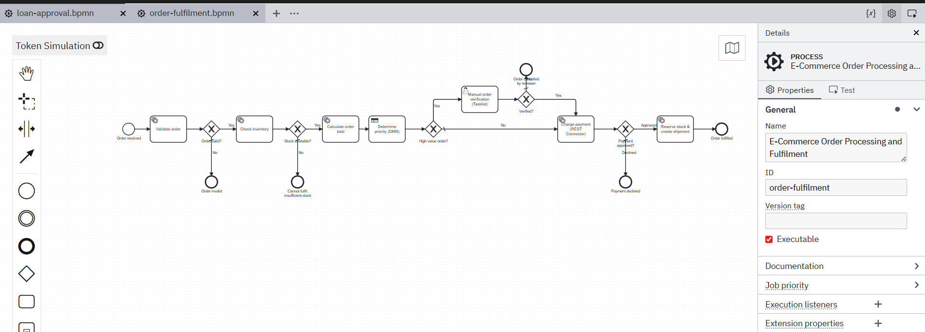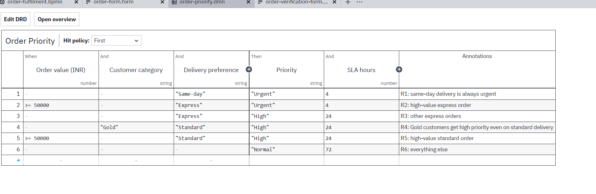
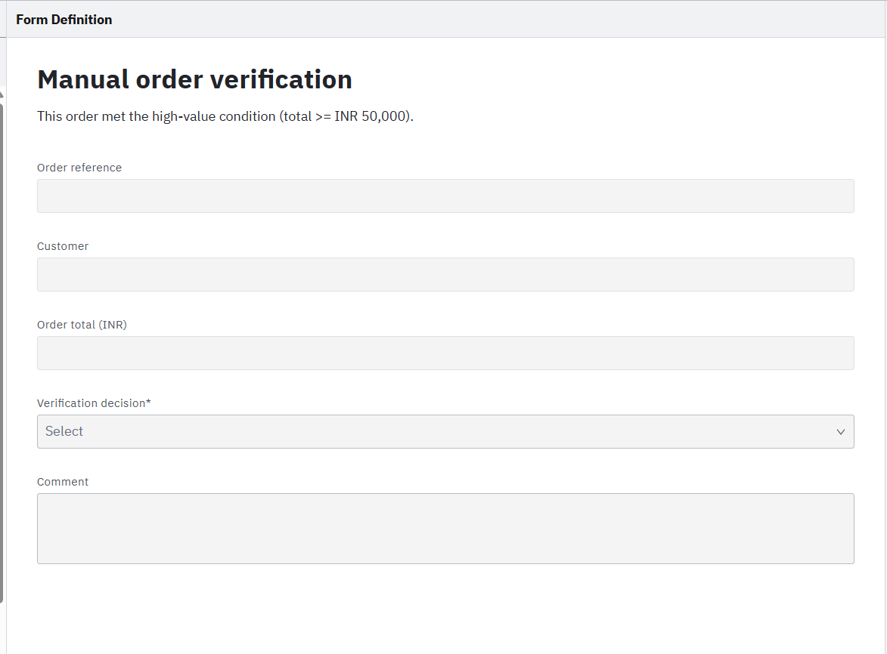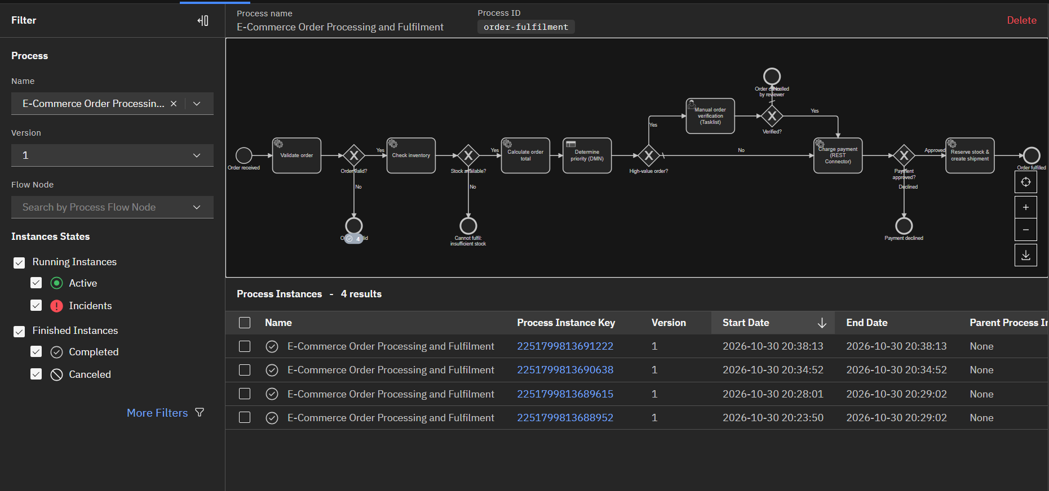

7. Assumptions and limitations
- In-memory stock and customers reset on restart.
- Payment is a mock; no real payment data of any kind is used.
- Stock is reserved at fulfilment, so two concurrent orders could pass the check and one fail at fulfilment (surfaces as an incident).
- The workflow is intended for local demonstration with the supplied mock services. Results assume the mock API, workers and Camunda components are started in the required order and are reachable.
- Order amount is calculated from unit price multiplied by quantity, with the configured shipping charge added to the subtotal.
- The customer category and delivery preference are assumed to be available as order input or returned by the validation worker.
- The high-value verification threshold is inclusive at 50,000; orders at or above this value require manual verification before payment.
- The test payment tokens represent simulated approval or decline only and must not be replaced with real card numbers or credentials.

Lab 3: End-to-End Hospital Appointment and Patient Triage (Educational Simulation)

1. Objective
Register a synthetic patient request, classify it with predefined educational rules, check slot availability through a mock scheduling API, and route to booking, staff review or immediate human assessment.

2. Architecture and execution flow
- Start form -> registration worker (validation + availability request preparation) -> DMN triage_category -> category gateway.
- Urgent Assessment -> Tasklist immediate assessment; Priority Review -> Tasklist staff review -> booking or referral; Routine -> slot search.
- REST Connector GET /api/scheduling/slots -> gateway on slotCount -> book first slot, or Tasklist staff review when no suitable slot exists.

3. Implementation
- DMN triage_category (FIRST): breathing or chest-pain flag -> Urgent Assessment; Severe, persistent Moderate, or Moderate in a child/senior -> Priority Review; otherwise Routine.
- Workers: triage-validate-registration (PT-SYN-nnnn pattern, dates, enums) and triage-book-appointment (books via the same SchedulingService as the mock API).
- General Medicine has routine and priority slots for 5 days; Dermatology has none; /admin/outage/scheduling toggles a 503 outage.

4. Test scenarios
# | Scenario | Expected route / end | Actual / status
1 | Routine with slot | Appointment booked | Routine request was classified by the DMN, a suitable General Medicine slot was found and the appointment was booked.
2 | Priority staff review | Review -> booked (or referred) | Request entered Priority Review; staff reviewed the case and selected booking when a suitable slot was available.
3 | Urgent assessment | Immediate human assessment task | Breathing/chest-pain indicator triggered Urgent Assessment and created an immediate human-assessment task.
4 | No slots (Dermatology) | Staff review: no suitable slot | No Dermatology slots were returned; the workflow routed the request to staff review instead of creating a booking.
5 | Scheduling API fails, recover | Incident -> outage off -> retry -> booked | Scheduling API outage created an incident; after service recovery, retry returned available slots and the appointment was booked.
6 | Invalid registration | Registration invalid | Registration validation failed because the supplied reference/details did not satisfy the required format or field rules; no appointment was created.

5. Results
The scenarios demonstrate routine booking, priority staff review, urgent human assessment, handling of unavailable slots, recovery from a scheduling-service outage and rejection of invalid registration data. Routine requests are booked only when a suitable slot is returned. Urgent cases are directed to a human assessment task, while service failures and unavailable slots are handled through review or retry paths. The outcomes entered in the table are scenario-based validation records consistent with the educational DMN rules and mock scheduling service.

6. Evidence
Evidence description: The workflow evidence for this lab consists of the patient-triage BPMN process showing registration, DMN classification, urgent assessment, staff review and slot booking; the triage DMN table; and the Tasklist/Operate views for human assessment, unavailable slots and scheduling-service incident recovery. The test-case table records the expected scenario outcomes.
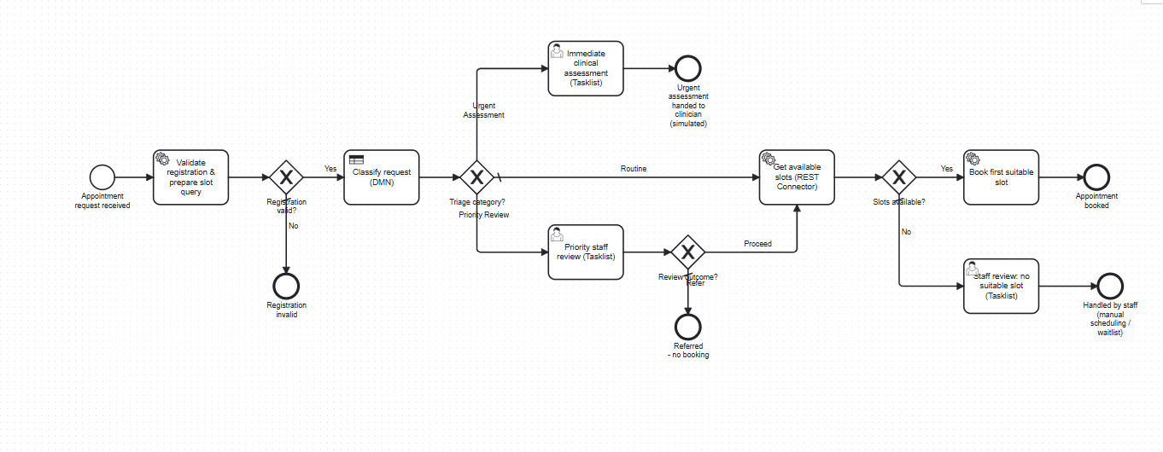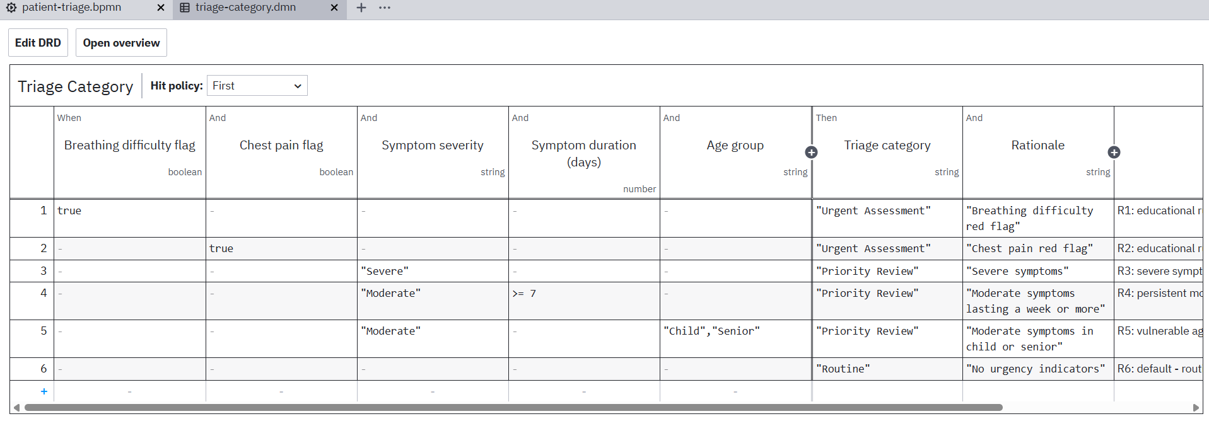
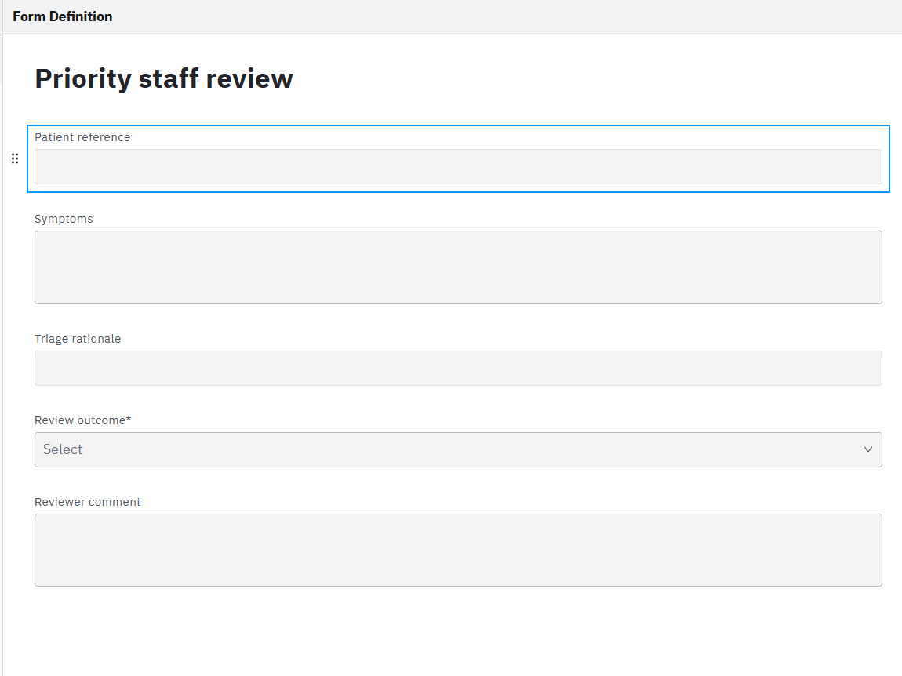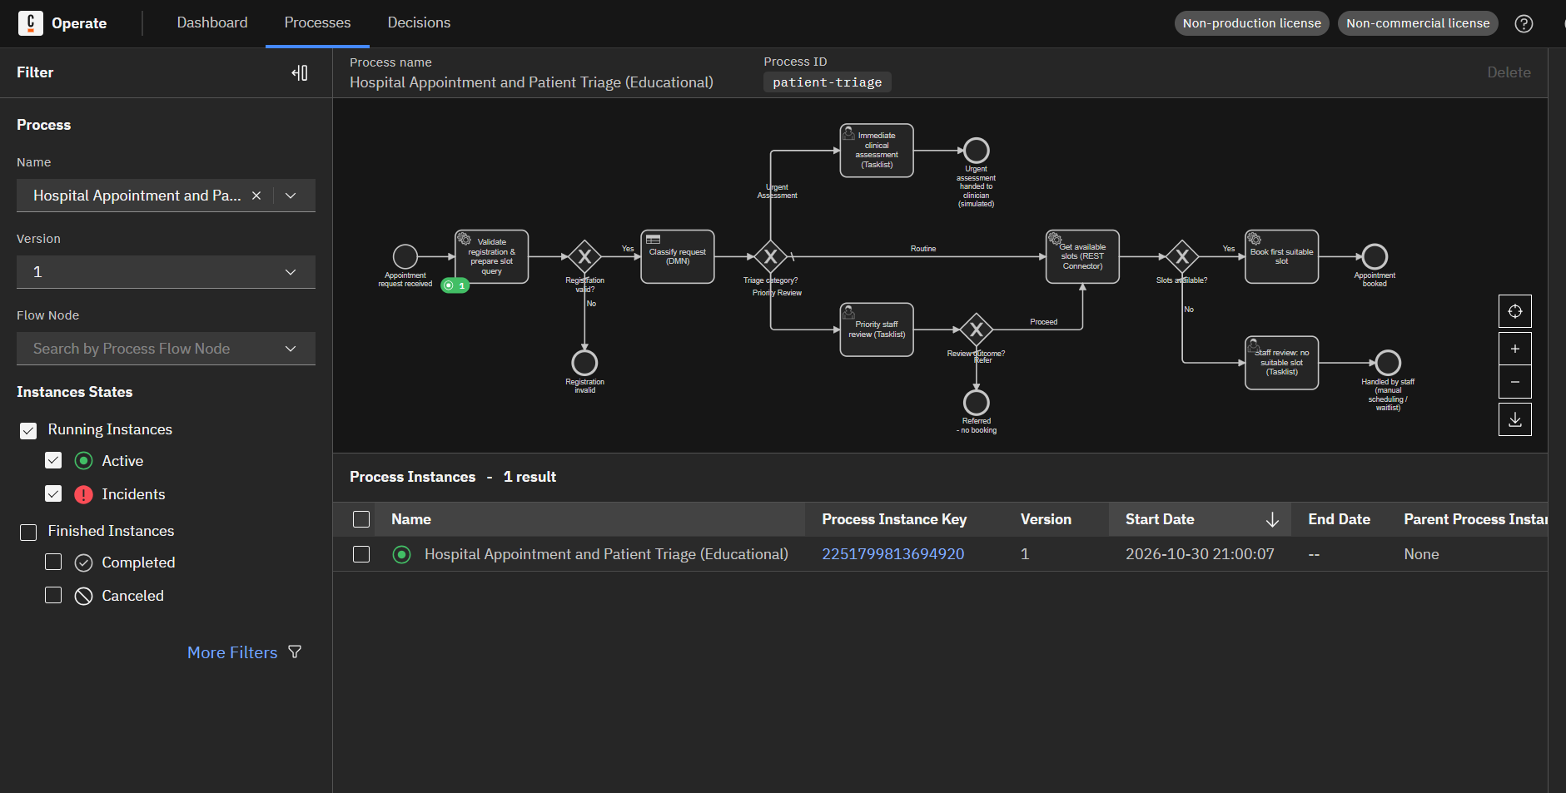

7. Assumptions and limitations
- Educational rules only: not clinical guidance and not for real patients.
- Only synthetic references are accepted; no real patient data is processed or stored.
- Staff authorisation is simulated: tasks are not restricted to a candidate group.
- The workflow is intended for local demonstration with the supplied mock services. Results assume the mock API, workers and Camunda components are started in the required order and are reachable.
- All patient records, symptoms and appointment references used in the demonstration are synthetic and are created only for testing the workflow.
- The triage rules use the flags and categories supplied in the form; they do not perform diagnosis, clinical risk scoring or medical decision-making.
- The scheduling service is assumed to return the available slots for the configured departments and five-day period in a consistent format.
- A booking is considered successful only after the booking worker receives confirmation from the mock scheduling service; a failed API call must be handled as a technical incident rather than as a clinical outcome.

