THE BOMB GAME
Comprehensive Technical Report: Gameplay Mechanics, Enemy Archetypes & Level Architecture
Platform: Unity 6 (6000.4.1f1) | Pipeline: Universal Render Pipeline 2D (URP) | Language: C#
1. Executive Summary & Core Game Concept
The Bomb Game is a polished 2D action-platformer developed in Unity 6 utilizing the Universal Render Pipeline (URP 2D). The player assumes the role of a pirate captain armed with throwable timed bombs navigating dangerous pirate strongholds, multi-tiered cabins, and vertical elevator shafts. The game combines responsive platformer movement physics (coyote time, jump buffering, and zero-drift velocity) with tactical physics-based bomb combat where distinct enemy archetypes react dynamically by kicking, catching, swallowing, or defusing the player's explosives.
Progression is strictly tied to combat mastery: level exit doors remain securely locked until every enemy in the active stage has been eliminated. Once clear, the player must approach the unlocked portal and execute a deliberate keypress [X] to advance to the next level.
2. Core Gameplay Mechanics
2.1 Player Locomotion & Platforming Feel (PlayerMovement.cs)
- Zero-Drift Horizontal Velocity: Horizontal velocity is assigned directly (6.5 m/s) in FixedUpdate, completely eliminating physics skating and slippery landings.
- Vertical Impulse: High-precision jump force (11.5 impulse) mapped exclusively to the Spacebar.
- Coyote Time (0.12s): Jump inputs remain valid for 120 ms after walking off an edge, preventing frustrating missed jumps on tight platforms.
- Jump Buffering (0.12s): Spacebar presses occurring up to 120 ms prior to landing are queued and triggered the instant the player touches ground.
- Dual Ground Verification: Combines Physics2D.OverlapBox with a downward raycast. Crucially filters out 'Enemy' and 'Bomb' colliders so the player cannot accidentally stand on enemies or bombs.
- Procedural Footstep Cadence: Timer-driven (0.32s cadence) audio trigger that plays gravel footsteps with randomized pitch (0.92x - 1.08x) exclusively while grounded and running.
2.2 Bomb Mechanics & Physics Arc (Bomb.cs)
- Parabolic Launch: Throwing initiated via F, J, E, or Left Click. Spawns with horizontal force (7.5) and loft (4.0) plus angular spin.
- Dynamic Fuse System: 3.5-second fuse subdivided into 4 visual phases: Charging (0-72%), Full Pulsing (72-88%), Closing (88-95%), and Disappearance (95-100% just before blast).
- Blast Radius & Knockback: OverlapCircle blast (1.6 unit radius) inflicting 1 damage and 7.0 impulse knockback to all IDamageable entities.
- Interactive Bomb States: Bombs feature complete state machines supporting PickUp, Drop, Throw, Kick, Swallow, and Extinguish routines.
2.3 Health Economy & Zero-Downtime Loop
- Health Budget: 3 maximum heart containers visually displayed on the top-left HUD banner ribbon.
- Contact Damage & Knockback: Physical contact with active enemies deals 1 heart damage and applies directional knockback (7.5 impulse).
- Post-Hit Invulnerability: 1.2 seconds of sprite flickering protects the player from instant chain-hits and trap stunlock.
- Pitfall Boundary: Falling below y = -6.5 (Levels 1-3) or y = -24.0 (Level 4) triggers fall whistle audio and instant demise.
- Instant Respawn: Automatically reloads the current scene after a 0.35s delay with no blocking dialog boxes. Hotkey 'R' provides instantaneous manual restart at any moment.
2.4 Level Exit & Door Interactivity (LevelDoor.cs)
- Locked Door Gate: Continuously queries alive enemies via EnemyAI.GetAliveEnemyCount(). While enemies > 0, the door remains shut.
- Audio-Visual Unlock: When the last enemy falls, the door sprite flips to open, an audio fanfare plays, and a HUD banner alerts the player.
- Tactile [X] Key Progression: The player must physically walk to the door (proximity radius 1.4u) and press 'X' to enter. If pressed while locked or away, an audio buzz and count of remaining enemies is displayed.
3. Enemy AI Archetypes & Reactive Behaviors (EnemyAI.cs)
Each enemy archetype exhibits a signature tactical behavior designed specifically to counter or interact with the player's bombs. All enemies utilize edge-detection and wall-detection raycasts to safely patrol without falling off cliffs unless forced.
Enemy Name | Base HP | Bomb Interaction | Combat Behavior | Elimination Strategy
Bald Pirate | 1 | Kicks bombs away (8.5 force, 0.4 loft) | Standard platform patrol, kicks threats | Drop bombs from high ground or time fuse
Big Guy (Heavy) | 3 | Picks up bomb & hurls it back (9.0 force) | Heavy mini-boss; turns to target player | Requires 3 bomb blasts; hit-and-run spacing
Cucumber | 2 | Blows out wick / extinguishes bomb | Aggressive speed (2.5), chases & bites (1 DMG) | Time bombs so fuse pops before wick blow animation
Captain (Coward) | 1 | Panics & flees from bombs (5.2 speed) | High detection (5.0u); runs away in fear | Corner against walls/ledges or trap patrol path
Whale (Devourer) | Immune (999) | Swallows bombs whole into mouth | Immune to bomb damage; bites player in melee | Puzzle kill: knockback into pits/chasms (v_y <= -6.5)

4. Level Architecture & Environmental Progression
4.1 Main Menu (MainMenu.unity & MainMenuController.cs)
A dedicated standalone menu configured at Build Index 0. Features keyboard-first arcade navigation using UP/DOWN arrow keys or W/S with ENTER/Spacebar to confirm. Options include 'PLAY LEVEL 1', 'LEVEL 2', 'LEVEL 3', 'LEVEL 4', and 'QUIT GAME'. Also supports direct hotkeys 1, 2, 3, 4 for instantaneous developer/player level hopping.
4.2 Level 1: The Interior Hold (Leve1.unity)
- Theme & Ambiance: Warm 16-bit pirate ship interior cabin, wood-paneled walls, chandeliers, decorative tables, chairs, barrels, and ambient 2D point lighting.
- Player Spawn: (-4.55, -2.57) on the lower cabin floor.
- Enemy Population: 2 enemies total. 1x Bald Pirate at (-4.32, 0.73) on the mid-deck; 1x Big Guy at (4.64, 3.79) guarding the upper tier.
- Tactical Objective: Intro combat encounter. Teaches the player how to lob bombs up onto ledges to bypass the Bald Pirate's kick and wear down the Big Guy's 3-HP pool.
- Exit Door: Located on the upper right tier at (6.45, 3.87). Unlocks upon defeating both enemies; press [X] to advance.
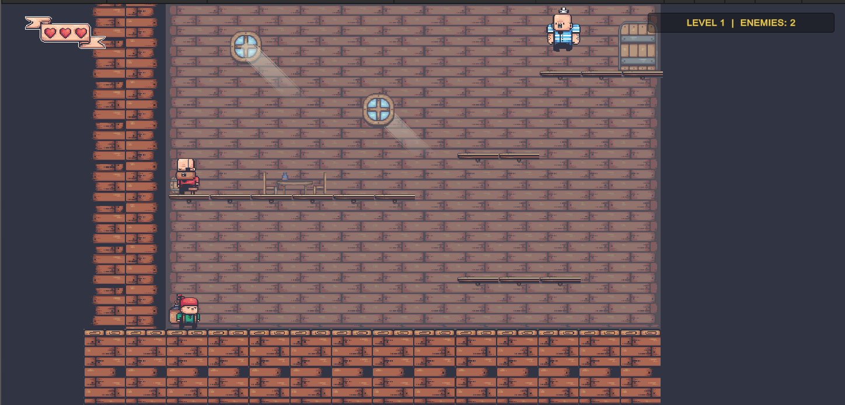
4.3 Level 2: The Upper Quarters (Level2.unity)
- Theme & Ambiance: Multi-tiered fortress with elevated wooden scaffolding, vertical chasm shafts, and hazardous open drops.
- Player Spawn: (-5.58, -5.50) on the bottom left scaffold.
- Enemy Population: 3 enemies total. 1x Bald Pirate at (-4.54, 0.41); 1x Big Guy at (2.30, 0.50); 1x Cucumber at (9.28, -3.50).
- Tactical Challenge: Introduces the Cucumber, which sprints to extinguish lit bombs. Demands precision timing and tactical vertical drops to detonate before enemies react.
- Exit Door: Located at (8.50, -2.40) past the right chasm. Unlocks when all 3 foes are defeated; press [X] to advance.
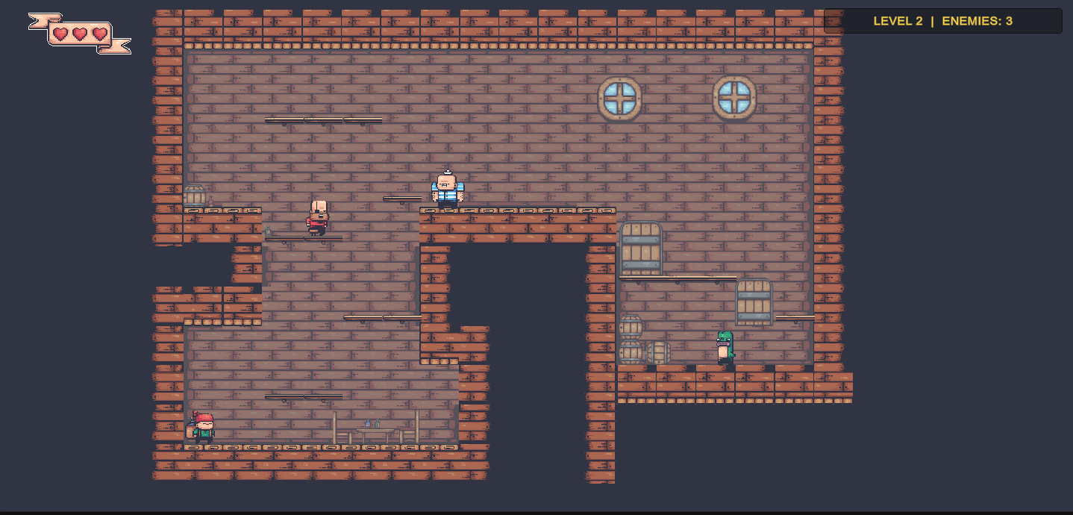
4.4 Level 3: The Moving Gauntlet (Level3.unity & Level3PlatformController.cs)
- Theme & Ambiance: Expansive pirate sky-rigging featuring high chasms and three actively moving Kinematic platforms.
- Player Spawn: (-13.28, -5.45) on the far-left staging deck.
- Dynamic Platforms: Fully automated rider friction (MovingPlatform.cs) using Kinematic Rigidbody2D that carries player and enemies smoothly without jitter:
- * Platform 1 (Left): 3 blocks wide, moves horizontally (X axis) over 2.6 units at speed 2.2.
- * Platform 2 (Bottom-Right): 2 blocks wide, moves vertically (Y axis) over 3.2 units at speed 2.0.
- * Platform 3 (Top-Right): 2 blocks wide, moves horizontally (X axis) over 5.2 units at speed 2.2.
- Enemy Population: 5 enemies total - all 5 archetypes present! 1x Big Guy (-11.05, 0.82), 1x Bald Pirate (-2.16, -2.54), 1x Captain (6.96, -4.40), 1x Cucumber (12.48, 4.79), 1x Whale (15.61, 1.46).
- Stage Progression: The Whale devours all direct bombs; players must use explosion knockback to blast it off the edge to trigger lethal fall damage. Defeating all 5 enemies automatically clears the level and opens the door at (11.50, 4.80) to Level 4.
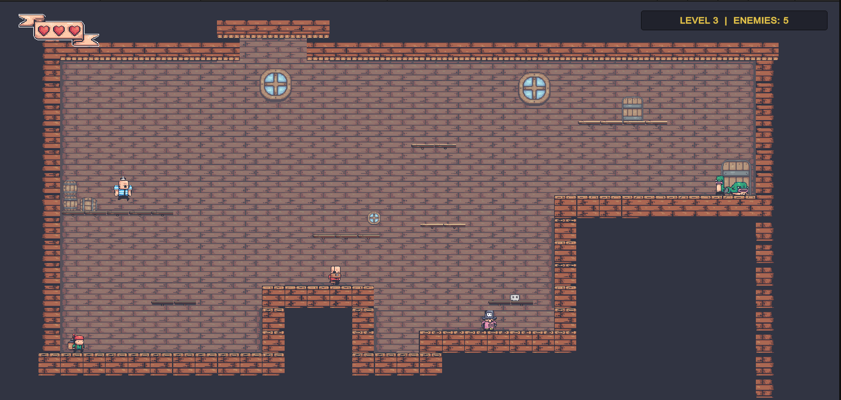
4.5 Level 4: The Deep Fortress (Level4.unity & Level4PlatformController.cs)
- Theme & Ambiance: Massive subterranean fortress citadel with huge vertical relief extending from battlements (y = +15) down to the deep dungeon (y = -19). Fall boundary dynamically lowered to y = -24.0.
- Player Spawn: (-0.54, -15.57) at the bottom floor of the dungeon pit.
- Vertical Elevator Shaft: A specialized 3-block wide platform acting as a high-speed elevator moving vertically across 13.5 units down and up at speed 6.0 (fast) with a 0.25s pause at the upper and lower landings.
- Enemy Population: 4 elite enemies. 1x Big Guy (-10.15, -10.50), 1x Captain (22.33, 0.50), 1x Bald Pirate (-6.64, 14.53), 1x Cucumber (-17.23, 14.66).
- Grand Finale & Victory: Ascend the deep shaft via the moving elevator, clear the garrison, and reach the summit Door at (7.0, 15.0). Pressing [X] triggers the Game Complete Victory fanfare and returns to the Main Menu.
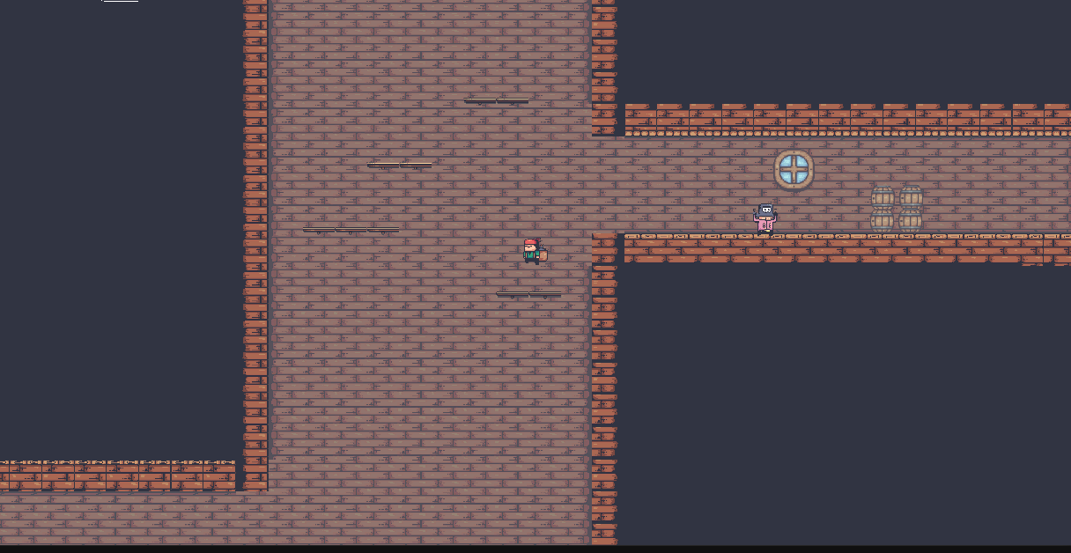
5. Technical Architecture & Engineering Insights
The project demonstrates sound object-oriented architecture and decoupled system design tailored for Unity 2D games:
- Interface-Driven Combat: IDamageable cleanly decouples the bomb explosion blast logic from player and enemy health scripts. Explosions simply query Physics2D.OverlapCircle and call TakeDamage.
- Singleton Management: LevelManager and SoundManager persist across scene loads with DontDestroyOnLoad, preventing audio cut-off and coordinating scene transitions.
- Rider Physics Resolution: Moving platforms manage standing riders using a contact-normal check (normal.y < -0.4f) and translate riders by the exact platform delta, preventing physics slipping.
- Dynamic Stage Gating: LevelDoor automatically counts enemies in the hierarchy via EnemyAI.GetAliveEnemyCount(), ensuring complete decoupling between level design layouts and progression triggers.

