Program Structures and Algorithms
Spring 2025
Project Report

NAMEs: Jinping Zhang, Ojas Misra
NUIDs: 002373254, 002310795
GITHUB LINK: DSAIPG/src/main/java/com/phasmidsoftware/dsaipg/projects/mcts at finalProject · OjasHusky/DSAIPG

~MONTE CARLO TREE SEARCH~


Monte Carlo Tree Search (MCTS) is a powerful decision-making algorithm widely used in artificial intelligence (AI), especially for games and complex scenarios requiring optimal choices under uncertainty. It incrementally builds a search tree by intelligently balancing exploration of new possibilities and exploitation of known promising moves through random simulations. The algorithm consists of four main phases:

1. Selection:
Starting at the root node, MCTS traverses the tree by selecting child nodes according to a policy that balances exploration and exploitation. This is typically done using the Upper Confidence Bound for Trees (UCT) formula, which favors nodes with high win ratios and those less frequently visited, thus guiding the search towards promising yet under-explored moves.

2. Expansion:
Once a leaf node is reached (a node without fully expanded children), the algorithm expands the tree by adding one or more child nodes representing possible next moves, unless the node corresponds to a terminal game state such as a win, loss, or draw.

3. Simulation:
From the newly added node(s), MCTS performs random simulations (also called rollouts or playouts) by playing out the game to completion using random or heuristic moves. The outcomes of these simulations estimate the value or potential success of the node, providing statistical insight into the consequences of moves.

4. Backpropagation:
The results from the simulations are propagated back up the tree, updating the statistics (such as visit counts and win ratios) of all nodes along the path from the simulated node to the root. This feedback refines the value estimates of nodes, improving future selection decisions.

This iterative process allows MCTS to focus computational resources on the most relevant parts of the search space, adapting dynamically as more simulations are performed. It is an anytime algorithm, meaning it can return the best current decision at any point if interrupted, and its performance improves with more computation time.

MCTS has been successfully applied in various domains including classic and modern board games (like Go, Chess, and Shogi), card games (such as Poker), video games, robotics, and planning problems. Its strength lies in handling large, complex, or partially known state spaces where exhaustive search is infeasible.

In summary, MCTS is a heuristic, probabilistic search method that uses selective tree expansion and random simulations to make informed decisions under uncertainty, balancing exploration of new moves and exploitation of known good moves to optimize outcomes effectively.

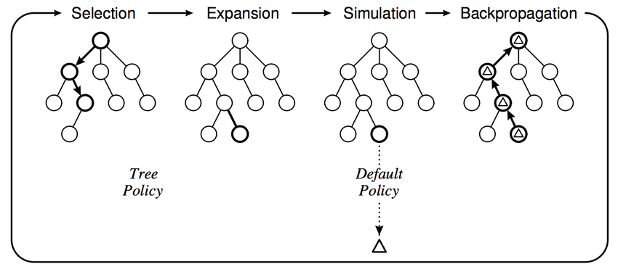
GAME 1

TIC – TAC – TOE



Tic-Tac-Toe is a classic paper-and-pencil game played by two players who alternately mark spaces in a 3x3 grid with either X or O. The objective is to be the first to place three of one’s marks consecutively in a horizontal, vertical, or diagonal row. Tic-Tac-Toe is a solved game, meaning that if both players play optimally, the game will always end in a draw.

Our implementation simulates a two-player Tic-Tac-Toe game where one player is controlled by the computer using the Monte Carlo Tree Search (MCTS) algorithm. This approach allows the CPU to make intelligent decisions by exploring possible future moves and outcomes through simulations.

Steps Involved in CPU Move Selection Using MCTS
The MCTS algorithm operates through four main phases to decide the best move for the CPU player:

1. Selection
The algorithm begins at the root node (representing the current game state) and selects child nodes recursively until it reaches a leaf node. The selection is guided by the Upper Confidence Bound applied to Trees (UCT) formula, which balances exploration of less-visited moves and exploitation of moves with high win rates.
The UCT formula is defined as:

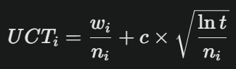
Where:
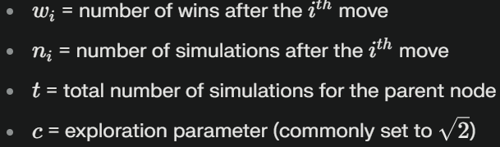
This formula helps select the child node with the highest potential by considering both its success rate and how often it has been explored.

2. Expansion
When the algorithm reaches a leaf node that is not a terminal game state (win, loss, or draw) and cannot select further child nodes using UCT, it expands the tree by generating all possible next game states (i.e., all legal moves from the current position) and appends them as child nodes.

3. Simulation (Rollout)
From one of the newly expanded child nodes, the algorithm performs a randomized simulation or "playout" of the game until it reaches an end state. Moves during simulation are chosen randomly or semi-randomly (known as light playouts), providing an unbiased estimate of the likelihood of winning from that position.

4. Backpropagation (Update)
After the simulation ends, the algorithm evaluates the outcome (win, loss, or draw) and propagates this result back up the tree. For each node visited during the selection phase, it increments the visit count and updates the win count if the simulation resulted in a win for the player associated with that node.

Iterative Process
These four phases—Selection, Expansion, Simulation, and Backpropagation—are repeated for a fixed number of iterations or until computational time runs out. Over many iterations, the algorithm builds a comprehensive search tree, improving the accuracy of its move evaluations.

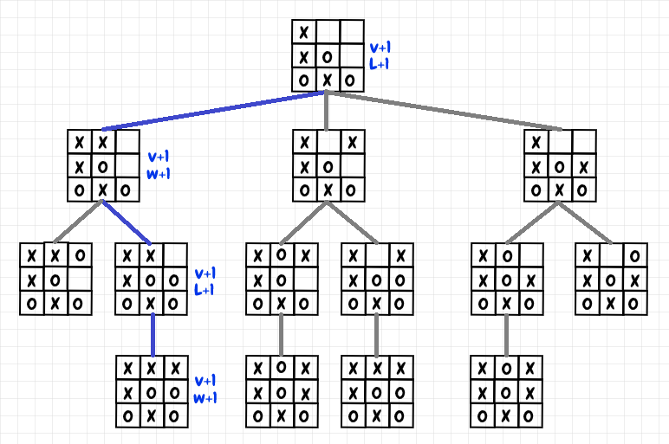

Output Screenshots:
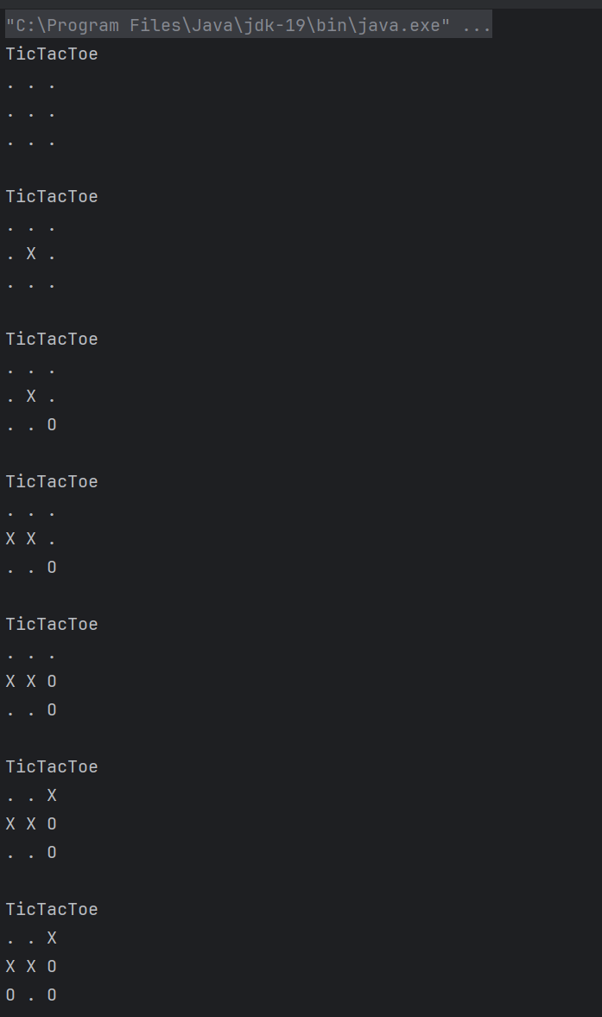
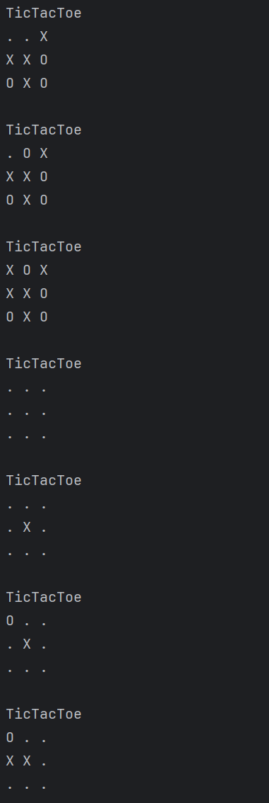
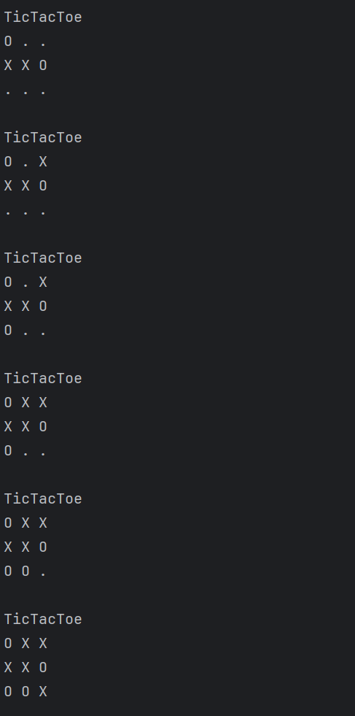
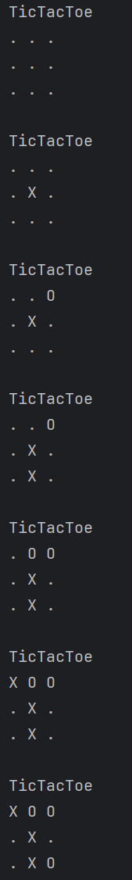
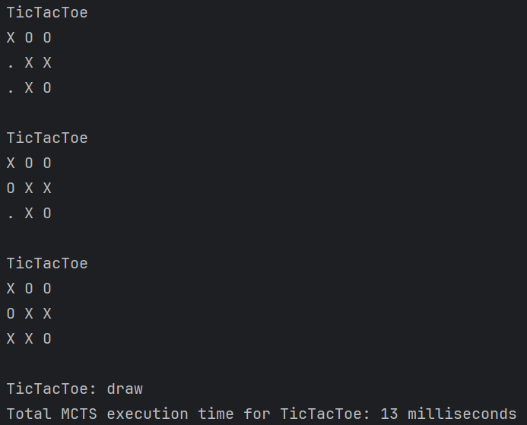
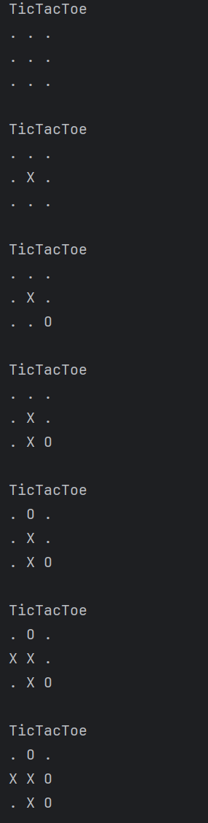
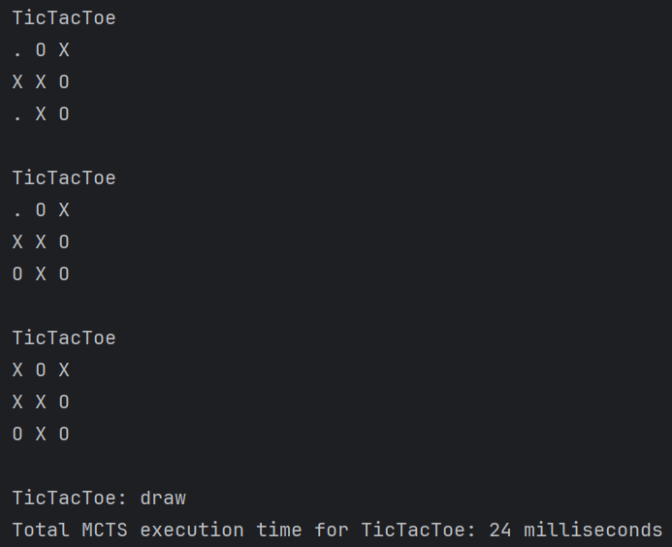

Unit Tests Screenshots:

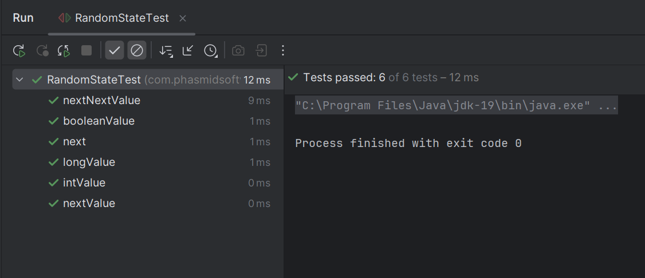

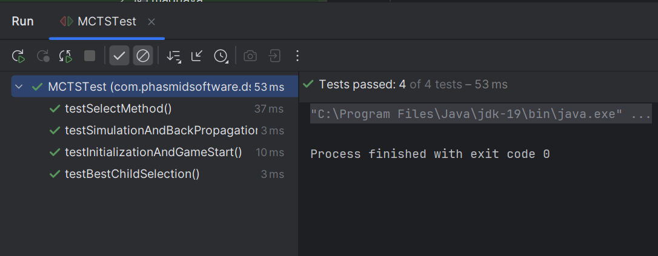

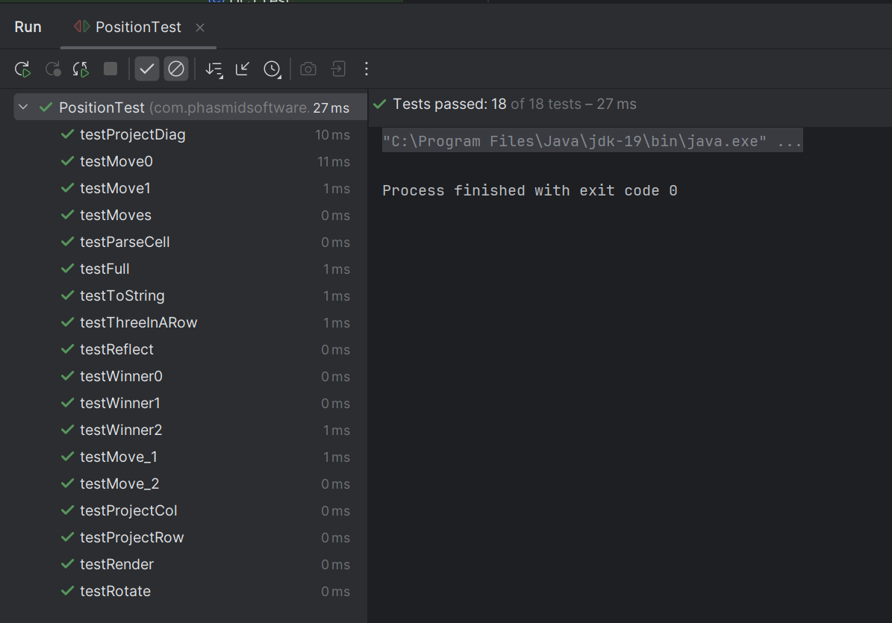

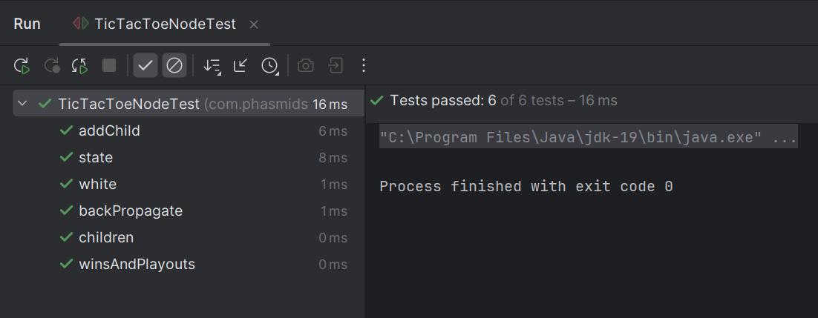

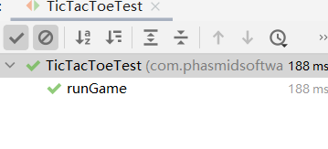

Conclusions:
The table below summarizes the number of victories achieved by X and O and draws and average time taken based on the number of iterations. It's important to note that all time measurements are provided in milliseconds (ms).
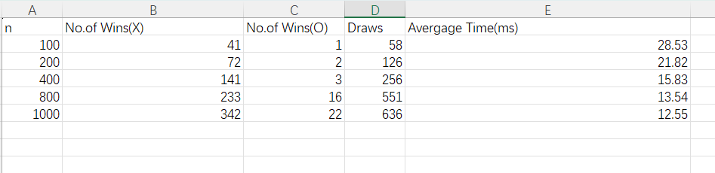

GAME 2

CONNECT-4

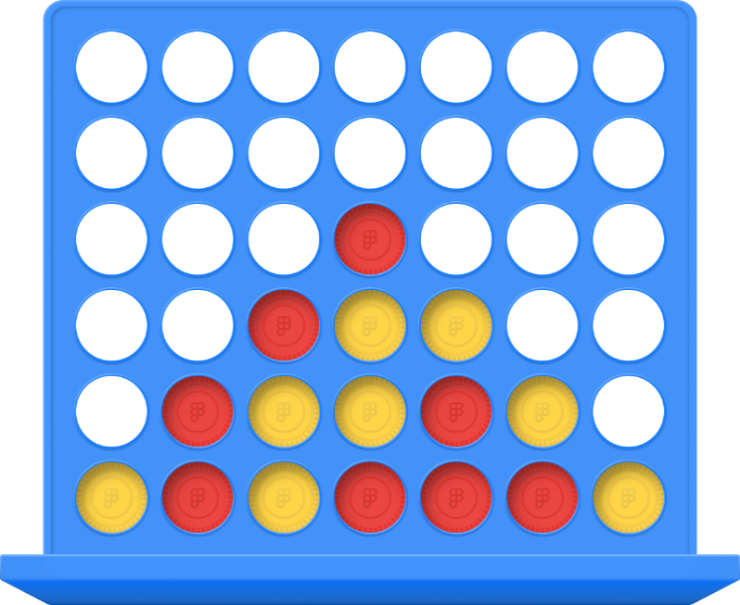

Connect Four is a classic two-player connection game where players select a color or symbol and take turns dropping their tokens into a vertically suspended grid consisting of six rows and seven columns. The tokens fall straight down, occupying the lowest available space within the chosen column. The objective is to be the first player to align four of their tokens consecutively in a horizontal, vertical, or diagonal line.

Game Setup and Play
In our implementation, Connect Four is designed as a two-player game between a human and the computer (CPU). The CPU always begins the game by placing an X token on the board, followed by the human player placing an O token. Players alternate turns until one player achieves four in a row or the board fills up, resulting in a draw.

CPU Move Selection Using Monte Carlo Tree Search (MCTS)
To enable the CPU to make strategic and optimal moves, we employ the Monte Carlo Tree Search (MCTS) algorithm. This algorithm enables the CPU to explore possible future game states and outcomes by simulating many random playouts, balancing exploration of new moves and exploitation of moves known to be strong.

Advantages of Using MCTS in Connect Four
Handling Large Search Space: Connect Four has a significantly larger state space than Tic-Tac-Toe. MCTS efficiently explores this space without exhaustive enumeration, making it suitable for this game.

Balancing Exploration and Exploitation: The UCT formula ensures the CPU does not miss potentially strong moves by balancing between exploring new moves and exploiting well-known moves.

Anytime Algorithm: MCTS can return the best move found so far at any time, allowing flexible computation time based on available resources.

Adaptability: The algorithm adapts dynamically as the game progresses, focusing computational effort on the most relevant parts of the search tree.

Output Screenshots:

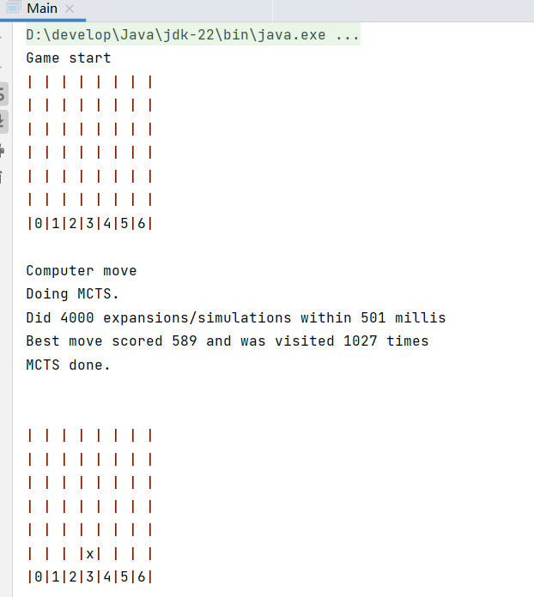

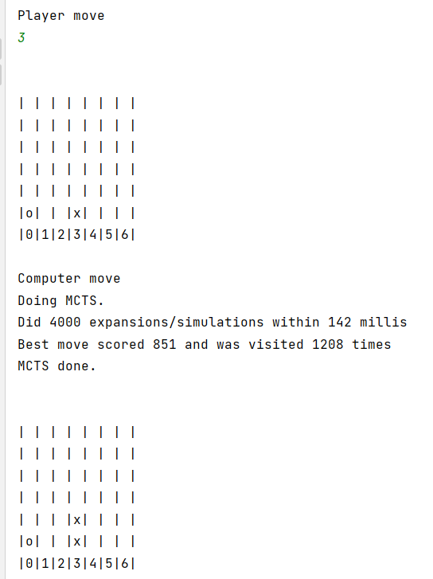

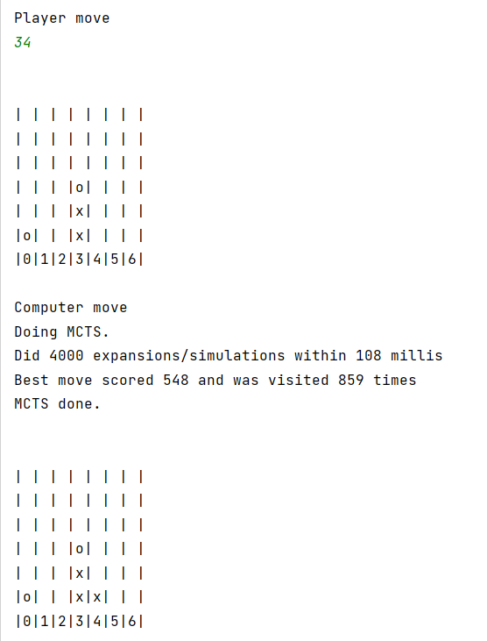

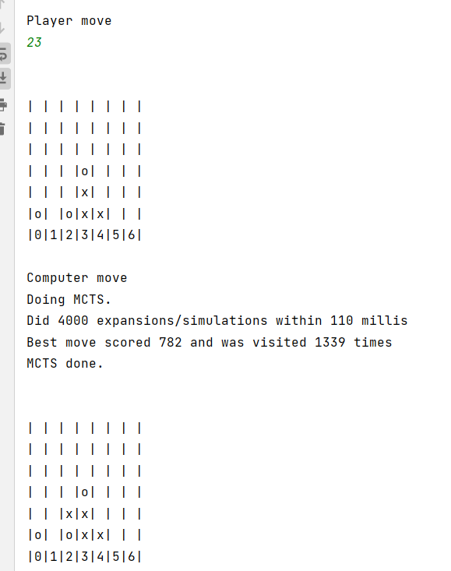

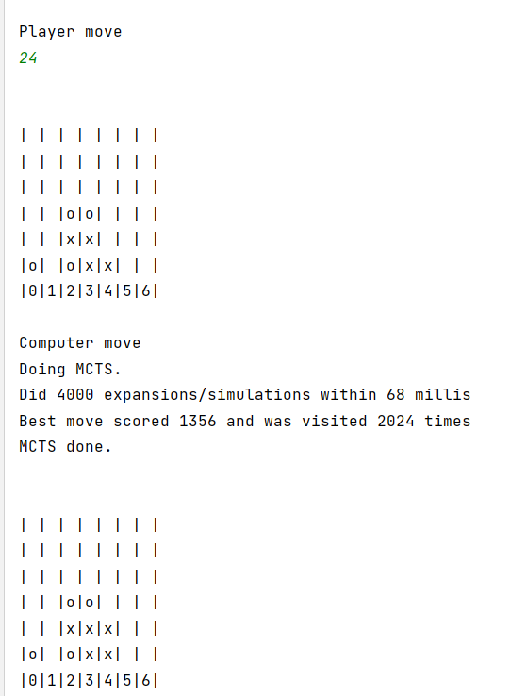

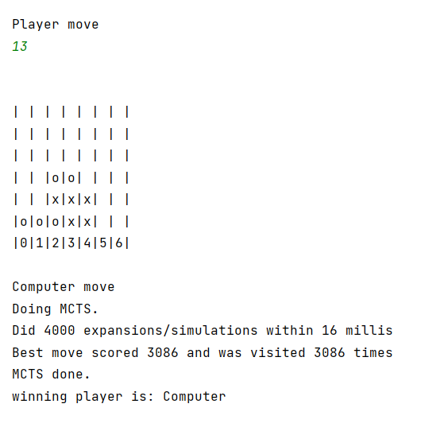
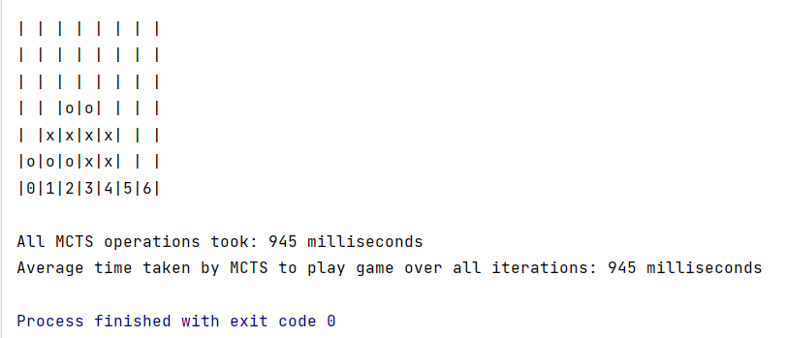

Unit Tests Screenshots:

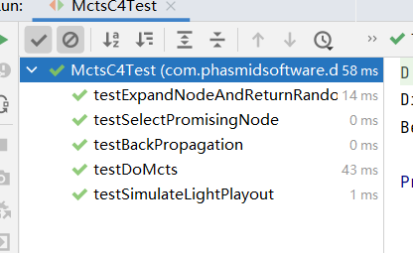
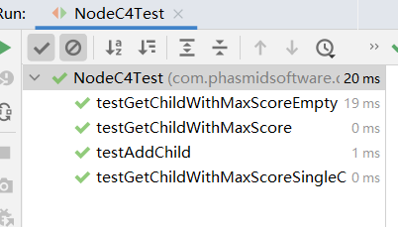

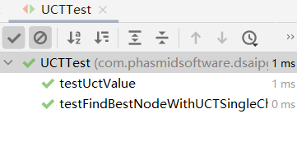

Conclusion:
The graph below demonstrates the time required by the Monte Carlo Tree Search (MCTS) algorithm to evaluate all possible moves to win a Connect-4 game, plotted against the number of iterations. It's important to note that all recorded times are expressed in milliseconds (ms).

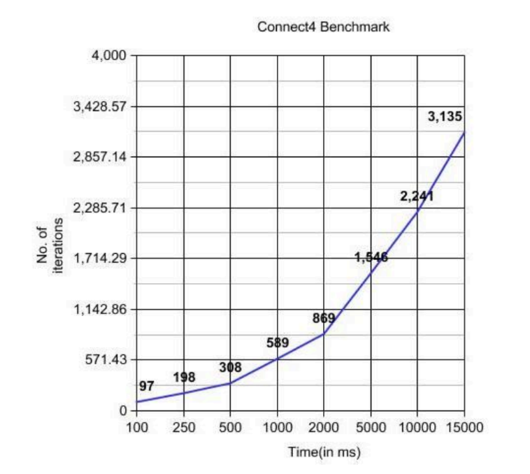

References:

- https://www.researchgate.net/figure/Monte-Carlo-Tree-Search-steps-5_fig2_316451377
- https://www.harrycodes.com/blog/monte-carlo-tree-search
- https://nestedsoftware.com/2019/08/07/tic-tac-toe-with-mcts-2h5k.152104.html
- https://mcts.netlify.app/
- https://medium.com/@shehan_rathnayake/implementation-of-monte-carlo-tree-search-algorithm-for-connect-4-game-89c9ae23858f
- https://en.wikipedia.org/wiki/Monte_Carlo_tree_search
- https://arxiv.org/abs/2103.04931
- https://int8.io/monte-carlo-tree-search-beginners-guide/

