FCFS
#include <stdio.h>

int main() {
int n, i, j;

printf("Enter total number of processes: ");
scanf("%d", &n);

int pid[n], arrival[n], burst[n];
int completion[n], turnaround[n], waiting[n];

for(i = 0; i < n; i++) {
pid[i] = i + 1;
printf("\nProcess %d\n", pid[i]);

printf("Arrival Time: ");
scanf("%d", &arrival[i]);

printf("Burst Time: ");
scanf("%d", &burst[i]);
}

for(i = 0; i < n - 1; i++) {
for(j = i + 1; j < n; j++) {
if(arrival[i] > arrival[j]) {
int temp;

temp = arrival[i];
arrival[i] = arrival[j];
arrival[j] = temp;

temp = burst[i];
burst[i] = burst[j];
burst[j] = temp;

temp = pid[i];
pid[i] = pid[j];
pid[j] = temp;
}
}
}

int current_time = 0;
float totalTAT = 0, totalWT = 0;

for(i = 0; i < n; i++) {

if(current_time < arrival[i]) {
current_time = arrival[i];
}

completion[i] = current_time + burst[i];

turnaround[i] = completion[i] - arrival[i];

waiting[i] = turnaround[i] - burst[i];

current_time = completion[i];

totalTAT += turnaround[i];
totalWT += waiting[i];
}

printf("\nP\tAT\tBT\tCT\tTAT\tWT\n");

for(i = 0; i < n; i++) {
printf("P%d\t%d\t%d\t%d\t%d\t%d\n",
pid[i], arrival[i], burst[i],
completion[i], turnaround[i], waiting[i]);
}

printf("\nAverage Turnaround Time = %.2f", totalTAT / n);
printf("\nAverage Waiting Time = %.2f\n", totalWT / n);

return 0;
}
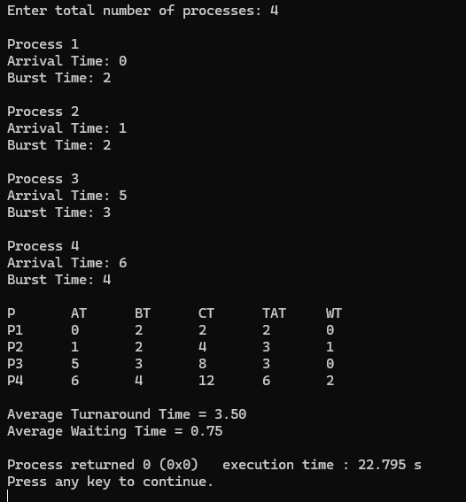
SJF_NonPreemptive
#include <stdio.h>

int main() {
int n, i;

printf("Enter number of processes: ");
scanf("%d", &n);

int pid[n], arrival[n], burst[n], ct[n], tat[n], wt[n], finished[n];

for(i = 0; i < n; i++) {
pid[i] = i + 1;
finished[i] = 0;

printf("\nProcess %d\n", pid[i]);

printf("Arrival Time: ");
scanf("%d", &arrival[i]);

printf("Burst Time: ");
scanf("%d", &burst[i]);
}

int completed = 0, current_time = 0;
float total_tat = 0, total_wt = 0;

while(completed < n) {
int idx = -1;
int min_bt = 9999;

for(i = 0; i < n; i++) {
if(arrival[i] <= current_time && finished[i] == 0) {
if(burst[i] < min_bt) {
min_bt = burst[i];
idx = i;
}
}
}

if(idx != -1) {
ct[idx] = current_time + burst[idx];
tat[idx] = ct[idx] - arrival[idx];
wt[idx] = tat[idx] - burst[idx];

current_time = ct[idx];
finished[idx] = 1;
completed++;

total_tat += tat[idx];
total_wt += wt[idx];
}
else {
current_time++;
}
}

printf("\nSJF Scheduling Result\n");
printf("PID\tAT\tBT\tCT\tTAT\tWT\n");

for(i = 0; i < n; i++) {
printf("P%d\t%d\t%d\t%d\t%d\t%d\n",
pid[i], arrival[i], burst[i], ct[i], tat[i], wt[i]);
}

printf("\nAverage Turnaround Time = %.2f", total_tat/n);
printf("\nAverage Waiting Time = %.2f\n", total_wt/n);

return 0;
}
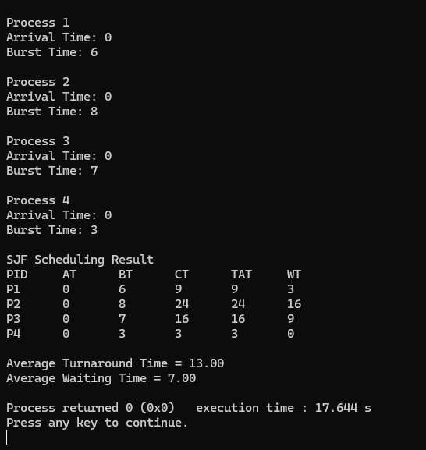

SJF_Preemptive

#include <stdio.h>
#include <limits.h>

int main()
{
int n, i;
int pid[20], arrival[20], burst[20];
int remaining[20], completion[20], turnaround[20], waiting[20];
int finished[20];

int current_time = 0, completed = 0;
float avg_wt = 0, avg_tat = 0;

printf("Enter number of processes: ");
scanf("%d", &n);

for(i = 0; i < n; i++)
{
pid[i] = i + 1;
finished[i] = 0;

printf("\nProcess %d\n", pid[i]);

printf("Arrival Time: ");
scanf("%d", &arrival[i]);

printf("Burst Time: ");
scanf("%d", &burst[i]);

remaining[i] = burst[i];
}

while(completed < n)
{
int shortest = -1;
int min = INT_MAX;

for(i = 0; i < n; i++)
{
if(arrival[i] <= current_time && finished[i] == 0 && remaining[i] < min)
{
min = remaining[i];
shortest = i;
}
}

if(shortest == -1)
{
current_time++;
continue;
}

remaining[shortest]--;
current_time++;

if(remaining[shortest] == 0)
{
finished[shortest] = 1;
completed++;

completion[shortest] = current_time;
turnaround[shortest] = completion[shortest] - arrival[shortest];
waiting[shortest] = turnaround[shortest] - burst[shortest];

avg_wt += waiting[shortest];
avg_tat += turnaround[shortest];
}
}

printf("\nPID\tAT\tBT\tCT\tTAT\tWT\n");

for(i = 0; i < n; i++)
{
printf("%d\t%d\t%d\t%d\t%d\t%d\n",
pid[i], arrival[i], burst[i],
completion[i], turnaround[i], waiting[i]);
}

printf("\nAverage Waiting Time: %.2f", avg_wt/n);
printf("\nAverage Turnaround Time: %.2f\n", avg_tat/n);

return 0;
}
