iQ
ITQAN IQ
BUSINESS FUNCTIONAL SPECIFICATION
Enterprise Strategy Execution and KPI Management Application

Document purpose
Provide a business-readable, testable and production-aware specification of ITQAN IQ, aligned to the revised functional baseline and simplified workflows.

Attribute | Value
Version | 1.3
Status | Draft for business review
Baseline | Revised functional specification reviewed 17 September 2026
Business owner | Strategy Team / Performance Management Office
Primary audience | Business owners, Strategy Team, departments, Product Owner, UX, IT, Data, Security, Audit and delivery teams
Classification | Confidential

Document Control
Item | Details
Purpose | Business functional specification for validation, prioritization, design, implementation planning and acceptance.
Normative language | Shall = mandatory; Should = recommended; May = optional.
Source hierarchy | The revised FUNCTIONAL_SPECIFICATION.md is authoritative for detailed implemented behavior. WORKSPACE_FLOWS.md and WORKFLOWS.md clarify screen ownership and lifecycle.
Current vs production | Prototype behavior and production requirements are explicitly separated.
Revision summary | Rebuilt structure; updated action/recovery distinction; added UAE login; incorporated multi-objective hierarchy, one recovery flow, configurable lists and refined diagrams.

How to Read This Document
Part | Purpose
A. Business Foundation | Why the application exists, scope, outcomes, roles and operating model.
B. Functional Specification | What each module does and the main business requirements.
C. Business Workflows | How users complete strategy, KPI, approval, action and recovery processes.
D. Rules and Information | Calculations, data ownership, status, records, reporting and audit.
E. Production Readiness | Integrations, non-functional requirements, gaps, roadmap and open decisions.
Appendices | Acceptance outcomes, glossary and source traceability.

Contents
Part A. Business Foundation
1. Executive Summary
2. Business Context, Objectives and Scope
3. Stakeholders, Roles and Operating Model
Part B. Functional Specification
4. Application Capability Map
5. Module Requirements
Part C. Business Workflows
6. Strategy and KPI Governance
7. Actual Data and Performance
8. Action and Recovery Plans
9. Approval, Monitoring, Closure and Reopening
Part D. Rules and Information
10. Business Rules and Calculations
11. Information, Reporting and Audit
12. Administration and Lists of Values
Part E. Production Readiness
13. Integrations and Non-Functional Requirements
14. Gaps, Roadmap and Open Decisions
Appendices
A. Acceptance Outcomes
B. Glossary and Source Traceability

Part A. Business Foundation

1. Executive Summary
ITQAN IQ is a governed enterprise workspace that connects strategic goals, objectives, KPI definitions and targets, externally owned actuals, performance assessment, simple action plans, recovery plans, approvals, evidence and executive reporting. The revised baseline separates simple delivery actions from KPI recovery and provides one consistent recovery flow across all entry points.
Core operating principle
The point from which a user starts work determines context only. Shared records, eligibility, validation, approvals, monitoring and closure rules remain consistent across screens.

2. Business Context, Objectives and Scope
Business need | Required response
Fragmented strategy and performance records | Connect goals, objectives, KPIs, plans, approvals and evidence.
Inconsistent KPI definitions | Use a governed KPI registry and versioned target history.
Manual or untrusted actuals | Receive read-only source observations with mapping and provenance.
Corrective work disconnected from performance | Link simple actions to objectives/KPIs and recovery plans to current Amber/Red KPIs.
Duplicate recovery experiences | Use one eligible-KPI chooser and one recovery form from every screen.
Weak accountability | Assign owners, deadlines, evidence, approvals and retained closure snapshots.
Uncontrolled administration | Provide ten structured sections and protected configurable lists.

ID | Business objective | Success indicator
BO-01 | Make strategy-to-outcome relationships visible. | Users navigate goal → objective → KPI → plan.
BO-02 | Govern KPI definitions and targets. | Published values require Department then Strategy approval.
BO-03 | Provide trusted performance assessment. | All views reconcile to approved targets and source actuals.
BO-04 | Enable proportionate corrective action. | Simple actions and recovery plans have distinct purposes and gates.
BO-05 | Make recovery consistent. | Every recovery entry uses the same form and workflow.
BO-06 | Support authorized enterprise search. | AI Insights finds and explains permitted workspace content.
BO-07 | Support controlled configuration. | Lists and defaults are validated, retained and audited.
BO-08 | Prepare for production. | Identity, storage, ingestion, security, accessibility and operations are completed.

2.1 Scope
- UAE-themed login preview and four demo roles
- Strategic goals with multiple child objectives
- KPI registration, amendment, source key and target governance
- Read-only actuals, calculations, Data Flows and Impact & Escalation
- Simple Action Plans for an objective or published KPI
- Recovery Plans for a current published Amber/Red KPI
- Two-stage approvals, delivery evidence, monitoring and closure
- Executive overview, reports, notifications, audit and ten-section Administration

2.2 Current prototype exclusions
- Live UAE PASS or organization authentication
- Backend authorization and shared database
- Live source ingestion and scheduled imports
- Connected generative AI
- External notification delivery
- Document attachment repository and tamper-evident audit
- Dynamic operational reporting calendar and custom workflow designer

3. Stakeholders, Roles and Operating Model
Role | Business responsibility | Scope
Strategy Team | Maintain hierarchy, work across departments and provide final business approval. | All departments
Department Contributor | Register KPIs, propose targets, create plans and deliver approved work. | Assigned department
Department Approver | Perform first-stage review of another person’s submission. | Assigned department
Administrator | Maintain hierarchy, configuration, lists and accounts; no KPI/plan business approval bypass. | All-department read and administration
Source / Data Owner | Provide validated actuals, mapping, corrections and provenance. | Authorized source measures
Executive Sponsor | Review strategic outcomes and critical escalations. | Enterprise
Audit / IT / Security | Assure and operate the production service. | Authorized technical scope

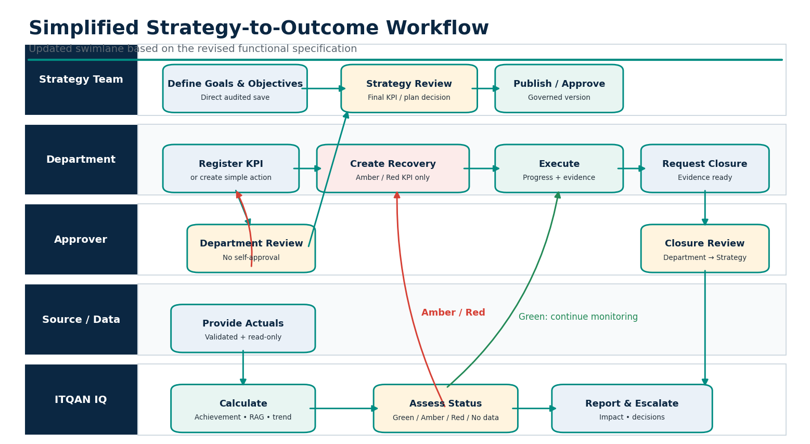

Part B. Functional Specification

4. Application Capability Map
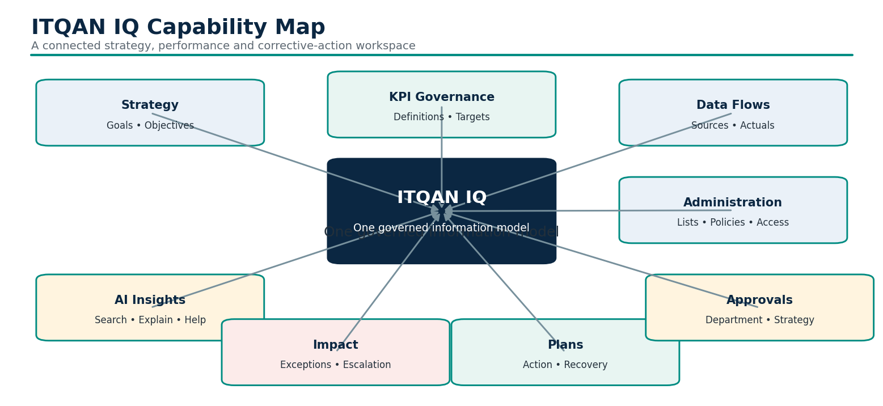

4.1 Connected information model
Relationship
Strategic Goal → one or more Objectives → KPIs and/or direct Action Plans. A Recovery Plan always links to one currently underperforming published KPI. Plans, approval requests, evidence, monitoring and closure snapshots stay connected to their originating records.

5. Module Requirements
Module | Purpose | Primary capability
Login | Enter a demo role or preview organization sign-in. | Four visible roles, department/account selection, English/Arabic, UAE PASS and credentials preview.
Executive Overview | Summarize authorized performance. | Achievement, goal roll-ups, trends and attention items.
Strategy & Objectives | Maintain and explore hierarchy. | Create/edit goals; add multiple objectives; register KPI or direct action from objective.
KPI Registry | Govern definitions and targets. | Register draft; amend name/owner/definition/formula/source key/objective; change target.
Data Flows | Explain actual lineage. | Source, key, KPI, actual, confidence, cadence and read-only results.
AI Insights | Search and explain the workspace. | Goals, objectives, KPIs, plans, sources, requests, audit and app help within scope.
Impact & Escalation | Explain gaps and response. | Needs attention / All KPIs, impact, advisory route, updates, plans and eligible recovery.
Plans & Recovery | Manage corrective work. | All/Action/Recovery tabs; Open/In progress/Closed lanes; Manage plan.
Approvals | Govern KPI and plan changes. | Department then Strategy review, notes, snapshots, version validation.
Administration | Configure shared application settings. | Ten sections, protected lists, defaults, sources, accounts and policies.
Reports & Audit | Share and assure performance. | CSV, print view, department comparison and scoped activity history.

5.1 Login and access
AUTH-01 Show four role cards and filter active demo accounts by role and department.
AUTH-02 Keep demo access visibly separate from disconnected organization credentials and UAE PASS.
AUTH-03 Support English/Arabic before entry; preserve the physical UAE flag orientation in RTL.
AUTH-04 Production shall replace the picker with verified identity and server-side authorization.

5.2 Strategy & Objectives
STR-01 Strategy Team and Administrator shall create strategic goals and child objectives.
STR-02 A goal may be empty during setup and may contain multiple objectives.
STR-03 An objective shall have one parent goal, owner and responsible department.
STR-04 Register KPI from an objective shall preselect it; Create Action shall permit a direct objective task.
STR-05 Hierarchy edits save directly with audit and preserve connected KPI/plan references.

5.3 KPI Registry
KPI-01 Saving registration creates an unpublished draft with no fabricated actuals.
KPI-02 Publication requires Department then Strategy approval.
KPI-03 Published amendments may change name, owner, definition, formula, source metric key and objective.
KPI-04 Source application, department, unit, direction and actual history are not changed through amendment.
KPI-05 Target changes affect the current period only after final approval and preserve history.

5.4 Data, AI and Impact
DAT-01 Data Flows shall show source, metric key, KPI mapping, actual, confidence and expected refresh.
DAT-02 No business-user actual entry or edit action shall exist.
AI-01 AI Insights and top-bar search shall find permitted goals, objectives, KPIs, plans, sources, approvals and audit updates.
AI-02 Current AI is local search/help and shall not be presented as a connected model.
IMP-01 Impact shall default to Needs attention and provide All KPIs for wider context.
IMP-02 Recovery creation shall appear only for current eligible Amber/Red KPIs; action creation may support healthy KPIs or objectives.

5.5 Plans, Approvals and Administration
PLN-01 Plans shall be shown in Open, In progress and Closed lanes with separate Action and Recovery tabs.
APR-01 One pending request, no self-approval, mandatory note and base-version check shall apply.
ADM-01 Administration shall contain Organization, Strategy & Objectives, Lists of Values, Departments, Users & Roles, Performance Rules, Approval Policy, Plan & Recovery Defaults, Notifications and Source Systems.
ADM-02 Configuration shall not write actuals or bypass business approval.

Part C. Business Workflows

6. Strategy and KPI Governance
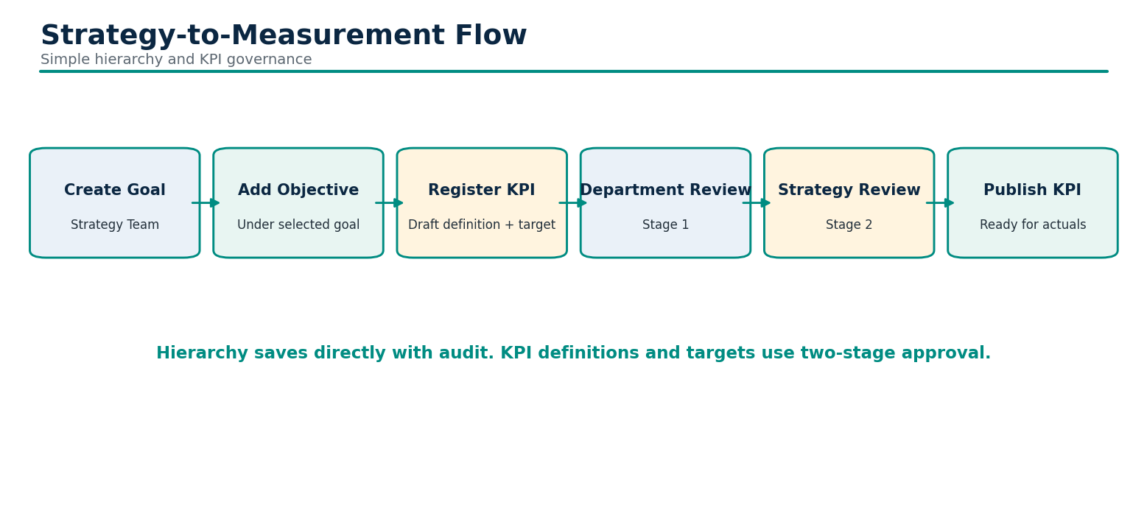
Operation | Save behavior | Approval / effect
Goal or objective | Direct audited save | No KPI/plan approval cycle.
Register KPI | Unpublished Draft | Submit separately; Department then Strategy publishes.
KPI amendment | Approved definition remains active | Final approval applies permitted fields and increments version.
Target change | Approved thresholds remain active | Final approval changes current-period target/Amber only.

7. Actual Data and Performance
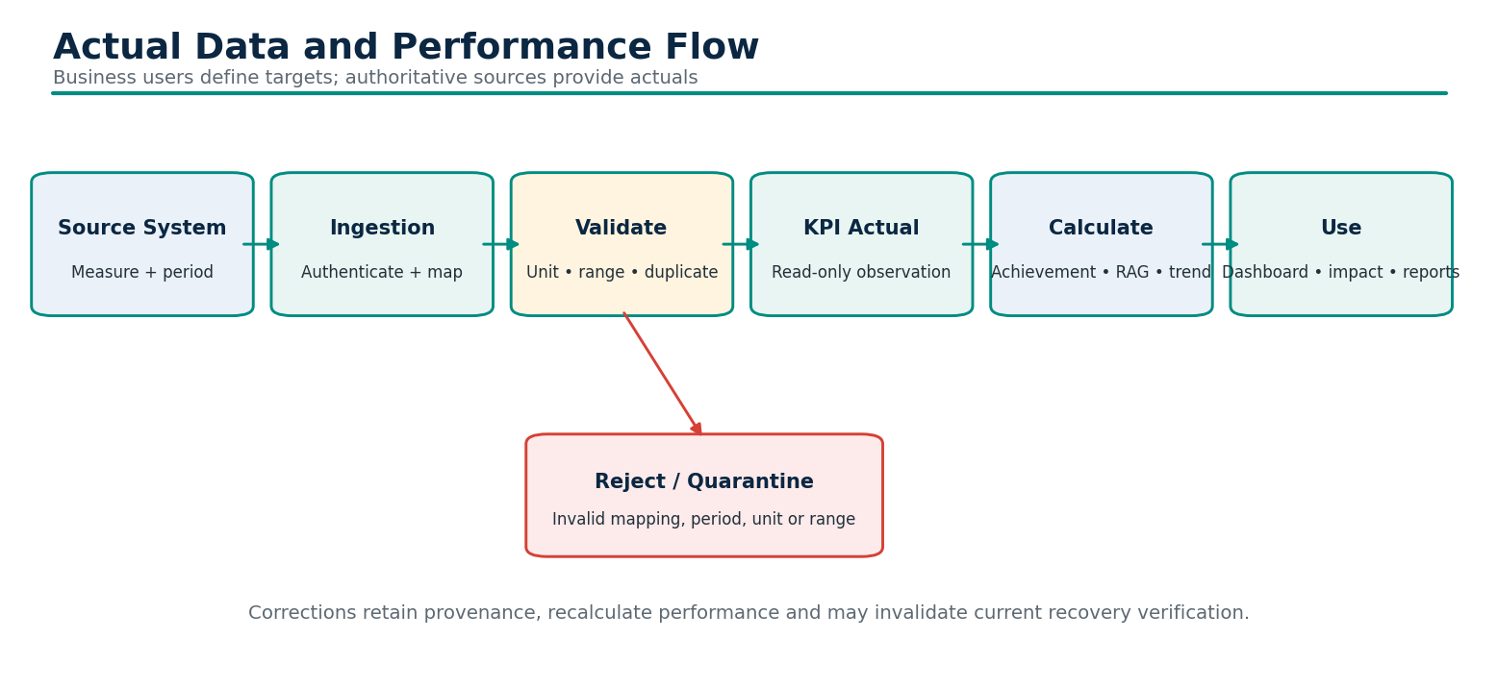

8. Action and Recovery Plans
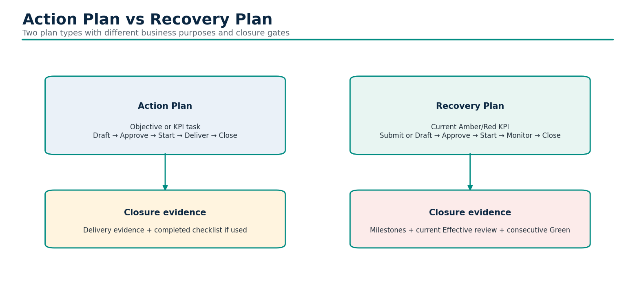

8.1 One recovery creation flow
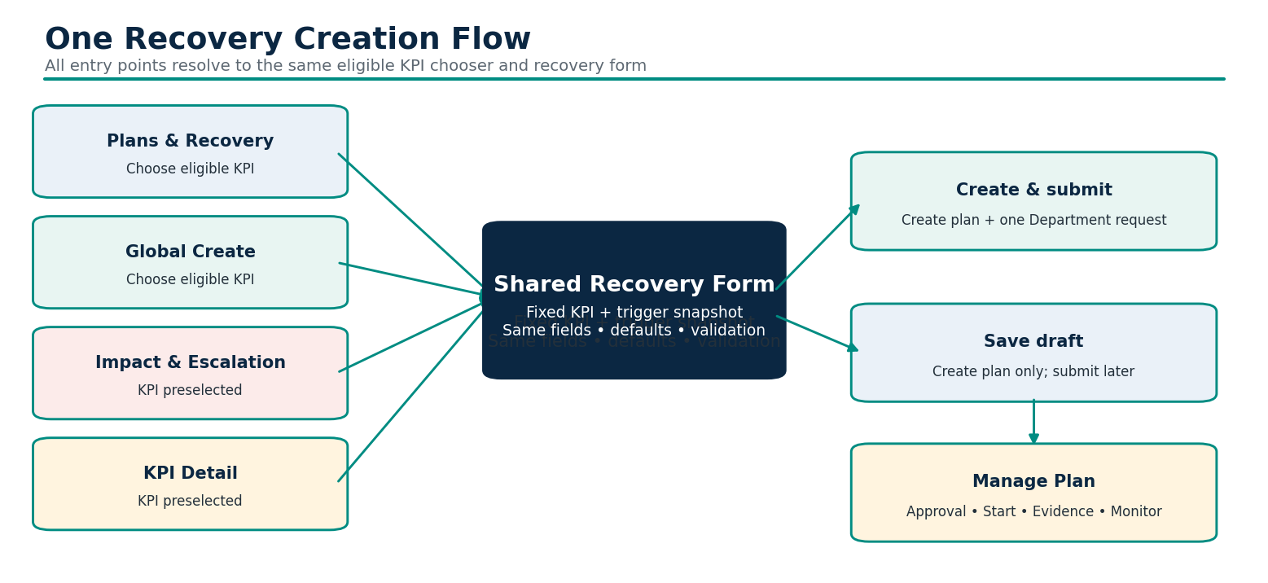
Entry point | KPI selection | Next step
Plans & Recovery | Choose a current eligible KPI. | Shared Recovery Form
Global Create | Choose a current eligible KPI. | Shared Recovery Form
Impact & Escalation | Current underperforming KPI already selected. | Same Recovery Form
KPI Detail | Current underperforming KPI already selected. | Same Recovery Form

Eligibility
Only a current published KPI with an actual classified Amber or Red may initiate Recovery. Healthy, No data, Draft and historical KPI views are not eligible. Existing recoveries remain visible after performance improves.

8.2 Recovery form and submission
Area | Required behavior
Trigger | Fixed KPI with read-only period, actual, target, status and source; preserve creation snapshot.
Defaults | Prefill title, KPI owner, target outcome, configured priority, deadline, review owner and cadence.
Initial detail | Cause, corrective steps and next review; steps initialize the first milestone.
Primary action | Create & submit for approval atomically creates one Open plan and one Department-review request.
Secondary action | Save draft creates the Open plan without a request; complete and submit later.
Manage Plan | Show request stage, lock while pending, then support Start, progress, evidence and monitoring.
Multiple plans | Permitted; eligible-KPI chooser shows existing open recoveries before creation.

9. Approval, Monitoring, Closure and Reopening
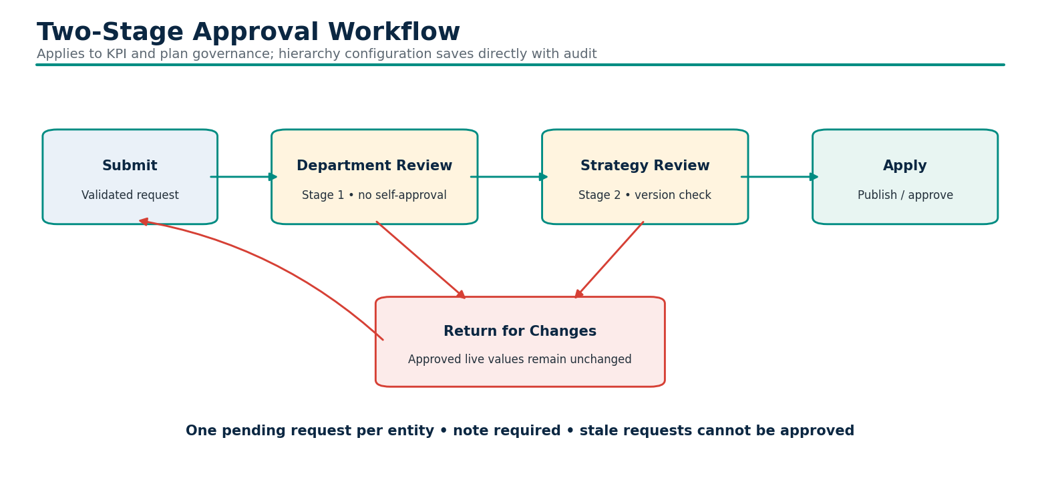
Gate | Action Plan | Recovery Plan
Approved and In progress | Required | Required
Delivery / closure evidence | Required | Required
Checklist / milestones | Complete if action checklist used | All mandatory milestones complete
Corrective detail | Not required | Required
Current Effective review | Not required | Required
Consecutive Green KPI results | Not required | Configured 2–6 periods
Closure review | Department then Strategy | Department then Strategy

MON-01 Monitoring applies only to approved, complete In-progress Recovery Plans with no pending request.
MON-02 An Effective review requires completed evidenced milestones and sustained Green results.
CLS-01 Final closure approval shall revalidate every applicable gate and retain a closure snapshot.
CLS-02 Reopening requires a reason and both approvals; Recovery then requires fresh effectiveness verification.

Part D. Rules and Information

10. Business Rules and Calculations
Area | Rule
Higher is better | Green A ≥ T; Amber B ≤ A < T; Red A < B.
Lower is better | Green A ≤ T; Amber T < A ≤ B; Red A > B.
Achievement | Higher: A/T; Lower: T/A; bounded 0–100%.
Missing data | No data; exclude from numeric averages.
Aggregation | Equal measured KPIs within objective; equal measured objectives within goal; equal measured goals overall.
Escalation | Data gap → KPI owner; repeated Red or weak linked objective → Executive; other Red → Objective owner; Amber → KPI owner.
Recovery | Latest configured N published observations are valid and Green.
History | Retain targets, actual versions, decisions and closure snapshots.
Authorization | Views, direct links, search, exports, notifications, approvals and audit use the same scope.

11. Information, Reporting and Audit
Record | Minimum information
Goal / Objective | Stable identity, parent, names, owner, responsible department.
KPI | Definition, formula, source/key, objective, department, owner, type, direction, unit, target, version and publication.
Observation | KPI, source measure, period, actual, unit, confidence, source version, timestamps and provenance.
Action Plan | Objective/KPI, task, owner, deadline, priority, outcome, notes and optional checklist.
Recovery Plan | Trigger snapshot, cause, corrective steps, criteria, review schedule, milestones and reviews.
Approval Request | Entity, type, snapshots, requester, department, stage, deadlines, decisions and base version.
Closure Snapshot | Plan, evidence, checklist/milestones, monitoring and KPI/threshold evidence as applicable.
Audit | Event, actor, time, department context and affected record.

Output | Minimum content
Executive overview | Overall achievement, goal performance, trends, attention items and plans.
Strategy view | Goals, objectives, owners, KPIs, actions and recovery coverage.
Impact report | Exceptions, severity, advisory route, updates and plan coverage.
Plans board | Open/In progress/Closed, type, owner, due date, approval and progress/review.
Controlled export | Authorized published KPIs with formula-injection protection.
Audit / approval history | Actors, stages, notes, versions, events and snapshots.

12. Administration and Lists of Values
Section | Responsibility
Organization | Name, framework label, language and landing page.
Strategy & Objectives | Create/edit goals and child objectives.
Lists of Values | KPI types; enabled units, priorities, recovery cadence and source refresh cadence.
Departments | Add department/owner and inspect coverage.
Users & Roles | Demo accounts, fixed roles, department and active status.
Performance Rules | Aggregate Green/Amber boundaries.
Approval Policy | Review days and reviewer coverage.
Plan & Recovery Defaults | Green periods, cadence, priority and deadline.
Notifications | Approval, monitoring and performance categories.
Source Systems | Add source, owner/team and expected refresh.

List | Rules
KPI types | Leading/Lagging initially; custom unique values up to 60 characters.
KPI units | Enable %, days, min, count and rate.
Plan priorities | Enable High, Medium and Low.
Recovery review frequency | Enable Weekly, Fortnightly and Monthly.
Source refresh frequency | Enable Daily, Weekly and Monthly.

Protected meanings
At least one value must remain in each configurable list. Existing records retain saved values. Plan types, execution states, approval stages, roles, directions and the monthly reporting calendar remain governed system values, not arbitrary lists.

Part E. Production Readiness

13. Integrations and Non-Functional Requirements
Integration | Production requirement
Identity / UAE PASS | Provider onboarding, verified sessions, callbacks and trusted role/department mapping.
KPI Sources | Authenticated ingestion, mapping, validation, idempotency, correction, freshness and reconciliation.
Workflow persistence | Stable IDs, shared durable database, transactional requests and concurrency protection.
Notifications | Approved recipients, channels, SLAs, retries and delivery tracking.
Connected AI | Scoped retrieval, direct evidence links, retention, security and evaluation.
Evidence / Audit | Durable files, classification, retention, provenance and tamper protection.

Quality area | Requirement
Security | Least privilege, backend authorization, encryption, secrets, secure coding, testing and monitoring.
Availability and resilience | Approved service hours, RTO/RPO, backup, restoration and transaction recovery.
Performance and scale | Agreed response times and supported enterprise volumes.
Accessibility | Keyboard, focus, contrast and screen-reader verification.
Localization | Complete English/Arabic terminology and desktop/mobile LTR/RTL validation.
Auditability | Durable attributable decisions, source corrections and privileged events.
Maintainability | Central calculation/business rules, documentation, regression tests and controlled configuration.

14. Gaps, Roadmap and Open Decisions
Priority | Gap | Required action
Critical | Verified identity and backend authorization | Replace account picker and enforce scope server-side.
Critical | Shared database and transaction model | Implement stable IDs, concurrency, backups and atomic recovery submission.
Critical | Source actual ingestion | Add authenticated mappings, validation, corrections and reconciliation.
Critical | Security and durable audit | Complete threat model, penetration tests, monitoring and retention.
High | Operational calendar | Define financial year, period progression, close/reopen and effective dating.
High | Evidence and notifications | Add repository, classifications, recipients, SLAs and tracking.
High | Arabic and accessibility | Complete translations and human/browser verification.
Medium | Advanced governance and analytics | Decide custom weighting, multi-KPI plans, connected AI and Power BI.

Phase | Focus | Exit outcome
0 | Business confirmation and open decisions | Approved specification and backlog
1 | Identity, authorization, database, audit and CI/CD | Secure multi-user foundation
2 | Hierarchy, KPI governance, approvals and reporting | Governed KPI lifecycle
3 | Source ingestion and lineage | Trusted actuals
4 | Actions, recovery, evidence, monitoring and closure | Closed-loop improvement
5 | Arabic, accessibility, notifications, attachments and DR | Go-live readiness

Decision | Owner
Named owners versus all scoped writers | Strategy Governance
Delegation and unavailable reviewer handling | Strategy / Departments
Calendar, period control and target effective dating | Strategy / Finance
Source authority, correction and freshness | Data Owners
Recovery treatment when targets change | Strategy Governance
Custom weighting and multi-KPI plans | Product / Strategy
Evidence, signatures and retention | Audit / Legal
Hosting, residency, availability and DR | IT / Security
Connected AI and outbound integrations | Architecture / Product

Appendices

Appendix A. Acceptance Outcomes
ID | Outcome
AC-01 | Strategy Team can create a goal, add multiple objectives and retain links through edits.
AC-02 | KPI registration creates a Draft and publishes only after Department then Strategy approval.
AC-03 | Published formula, source-key, definition, owner and objective changes remain proposed until final approval.
AC-04 | Data Flows shows source mapping and read-only actuals; no business-user actual-entry control exists.
AC-05 | Recovery is offered only for a current published Amber/Red KPI with an actual.
AC-06 | Every recovery entry point opens the same form and applies the same defaults, validation and approval lifecycle.
AC-07 | Create & submit creates exactly one plan and one Department-review request; invalid submission creates neither.
AC-08 | Save draft creates no request and can be completed and submitted later.
AC-09 | Action Plans do not require recovery monitoring or consecutive Green results.
AC-10 | Recovery closure requires milestones, current Effective review, consecutive Green results and both approvals.
AC-11 | No self-approval, wrong-stage approval or stale-version approval is accepted.
AC-12 | Plans appear in one board with Action/Recovery tabs and Open/In progress/Closed lanes.
AC-13 | AI search returns only authorized records and does not change business data.
AC-14 | Configurable lists preserve existing values and reject empty lists or disabled active defaults.
AC-15 | Production identity, integration, security, performance, backup, accessibility and penetration gates pass.

Appendix B. Glossary and Source Traceability
Term | Meaning
Action Plan | Simple objective/KPI delivery task with outcome and optional checklist.
Recovery Plan | Corrective response to a current Amber/Red published KPI with monitoring and sustained Green closure gate.
Actual | Read-only source-owned KPI observation.
Trigger snapshot | KPI period, actual, target, status and source retained when Recovery is created.
Approval request | Versioned before/proposed change reviewed by Department then Strategy.
Execution status | Open, In progress or Closed, separate from approval stage.
Recovery verified | Sustained Green readiness indicator, not final closure approval.

Source file | Use in this revision
FUNCTIONAL_SPECIFICATION.md | Authoritative detailed baseline, requirements, UAT and production gaps.
WORKSPACE_FLOWS.md | Screen responsibilities, one recovery flow and configurable lists.
WORKFLOWS.md | Draft/submit behavior, approval, action, recovery, monitoring and closure.
USER_GUIDE.md | End-user paths, button labels and current screen behavior.
CONFIGURATION.md | Ten admin sections, supported values and defaults.
LOGIN.md | UAE login, role selection and disconnected provider behavior.
ARCHITECTURE.md | Connected model, storage, runtime and production boundary.
INTEGRATIONS.md | Identity, actual ingestion, persistence, AI and notification contracts.
DEVELOPMENT.md | 51-test baseline and verification qualification.
README.md | Documentation index and current functional baseline.

Review outcome required
Approve, amend or reject the module responsibilities, simplified workflows, action/recovery distinction and production decisions before detailed solution design or implementation.

