Group Assignment

**Group members:**

**22bcs077 Ojasv Sakhi (Admin)**

**22bcs071 Mirza Nomanbaig**

**22bcs068 Medasani Bharath**

**22bcs080 Parth Abhang**

**22bcs081 Patha Snehith**

**Repo Creation:**

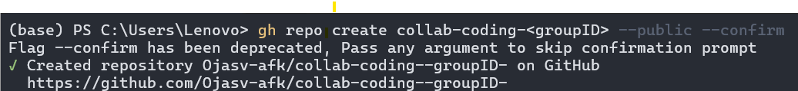

**Adding Collaborators:**

**Adding repo url to link with cli:**



**Adding Readme.md and Contribute.md:**

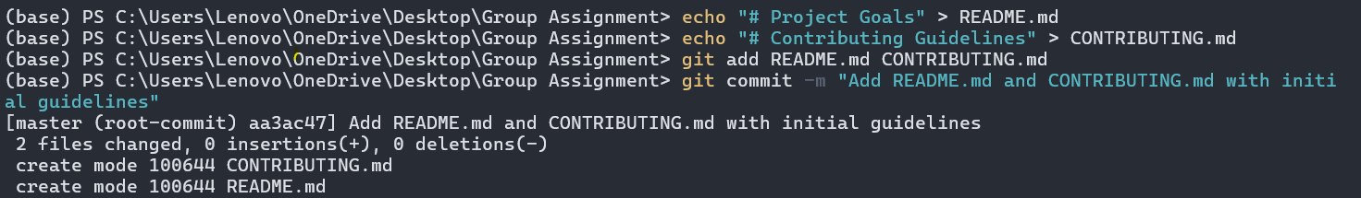

**Pushing Readme and Contribute in main branch:**

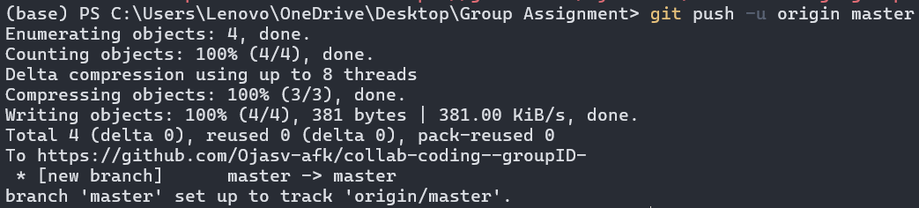

**Adding a Starter main.py file:**

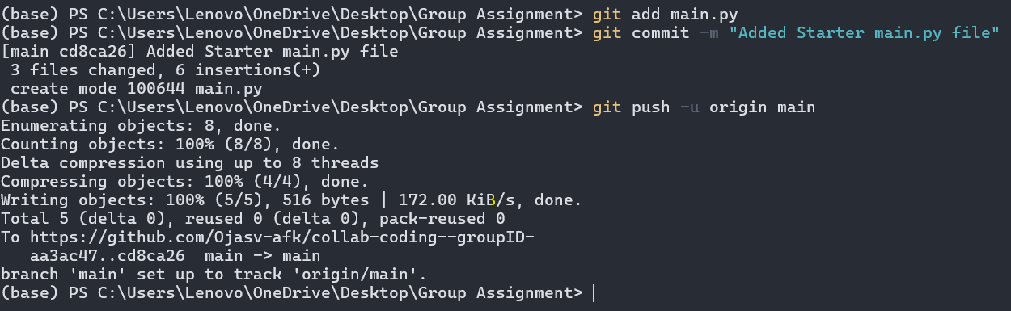

**Creating a separate branch for GCD function:**



**Modifying main.py and adding test_GCD.py in 22bcs077 branch:**

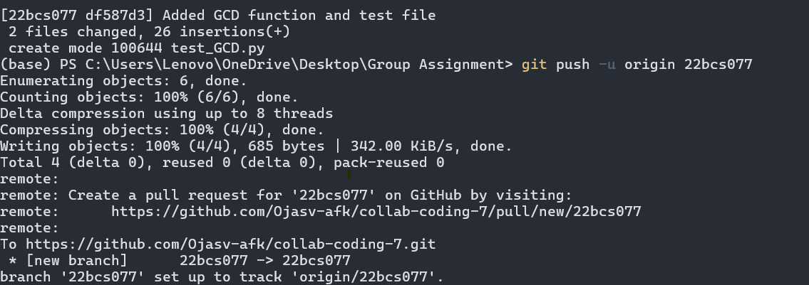

**Opening a Pull request:**

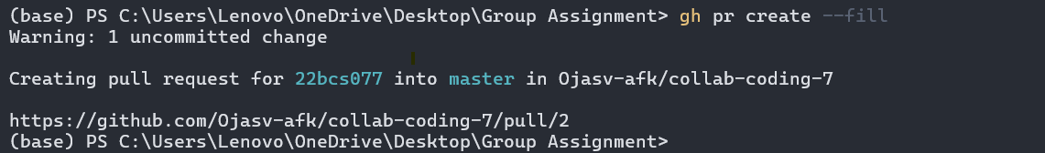

**Pull Request accepted and branch merged successfully:**

