Introduction:

In 2018, the Behavioral Risk Factor Surveillance System (BRFSS) conducted a nationwide cross-sectional study that included every state in the U.S., along with the District of Columbia, Guam, and Puerto Rico. This study primarily seeks to collect a wide range of data related to health risk behaviors, chronic conditions, healthcare access, and the usage of preventive health services from noninstitutionalized adults over the age of 18 through a carefully designed telephone survey approach. This project focuses on exploring the relationship between sexual orientation and mental health, aiming to understand how sexual orientation impacts mental health status and to identify any disparities present among different groups.

Statistical Methods

The statistical approach for this project involved a comprehensive application of descriptive and inferential statistical methods to analyze the Behavioral Risk Factor Surveillance System (BRFSS) dataset. Descriptive statistics were used to summarize and present the data in terms of means, standard deviations, frequencies, and percentages, providing an overview of the central tendencies and distribution of variables across different sexual orientation groups. For inferential analysis, ANOVA and Chi-square tests were employed to examine and compare the mental health outcomes among these groups. This allowed us to ascertain significant differences and determine if variations in mental health metrics were associated with participants' sexual orientation. Additionally, measures of effect size and confidence intervals were calculated to quantify the strength and precision of the observed associations, ensuring that the statistical conclusions drawn from the data were robust and reliable.

Results/Discussion:

**Table 1 Participant Characteristics Stratified by Sexual Orientation**

|  |  |  |  |  |  |
| --- | --- | --- | --- | --- | --- |
| **Characteristic** | **Straight**  **n=99446** | **Lesbian or Gay**  **n=2213** | **Bisexual**  **N=3280** | **Something Else**  **n=1346** | **Test stat, df, pvalue** |
| Sex  Male  Female | **41846(42.08)**  **57600(57.92)** | **1263(57.07)**  **950(42.93)** | **1008(30.73)**  **2272(69.27)** | **545(40.49)**  **801(59.51)** | **Test stat=378.78**  **Df=3**  **P value<0.0001** |
| Race  White, Non-Hispanic  Black, Non-Hispanic  Asian, Non-Hispanic  American Indian/Alaskan Native, Non-Hispanic  Hispanic  Other race, Non-Hispanic | **77195(77.63)**  **9031(9.08)**  **2261(2.27)**  **1618(1.63)**  **5332(5.36)**  **4009(4.03)** | **1664(75.19)**  **172(7.77)**  **42(1.9)**  **29(1.31)**  **174(7.86)**  **132(5.96)** | **2380(72.56)**  **257(7.84)**  **68(2.07)**  **50(1.52)**  **299(9.12)**  **226(6.89)** | **904(67.16)**  **100(7.43)**  **48(3.57)**  **28(2.08)**  **162(12.04)**  **104(7.73)** | **Test stat=379.28**  **Df=15**  **P value<0.0001** |
| Age  18-29  30-39  40-59  60 and older | **10414(10.47)**  **11272(11.33)**  **32784(32.97)**  **44976(45.23)** | **475(21.46)**  **317(14.32)**  **765(34.57)**  **656(29.64)** | **1288(39.27)**  **675(20.58)**  **775(23.63)**  **542(16.52)** | **315(23.40)**  **169(12.56)**  **296(21.99)**  **566(42.05)** | **Test stat=3667.15**  **Df= 9**  **P value<0.0001** |
| Income Category  Less than $50,000  $50,000 or more | 46513(53.73)  40060(46.27) | **1084(53.64)**  **937(46.36)** | **1751(63.10)**  **1024(36.90)** | **786(71)**  **321(29)** | **Test stat=222.50**  **Df=3**  **P value <0.0001** |
| BMI Category  Underweight  Normal weight  Overweight  Obese | 1810(1.82)  28444(28.60)  33017(33.20)  36175(36.38) | **53(2.39)**  **704(31.81)**  **707(31.95)**  **749(33.85)** | 88(2.68)  1086(33.11)  881(26.86)  1225(37.35) | **57(4.23)**  **422(31.35)**  **417(30.98)**  **450(33.43)** | **Test stat=136.99**  **Df=9**  **P value<0.0001** |
| Number of poor mental health days in the past 30 days | 6.87(9.85) | 8.61(10.34) | 11.05(10.86) | 10.23(11.31) | F value=247.69  Df=3,103766  P value <0.0001 |
| Depressive Disorder  Yes  No | **29404(29.57)**  **70042(70.43)** | **943(42.61)**  **1270(57.39)** | **1731(52.77)**  **1549(47.23)** | **592(43.98)**  **754(56.02)** | **Test stat=1069.55**  **Df=3**  **P value<0.0001** |
| Number of poor health days in the past 30 days | 5.39(9.46) | 5.79(9.27) | 6.25(9.21) | 6.90(10.11) | F value=20.19  Df=3, 104620  P value <.0001 |
| General Health  Excellent  Very good  Good  Fair  Poor | **9566(9.62)**  **27696(27.85)**  **32139(32.32)**  **20404(20.52)**  **9641(9.69)** | **236(10.66)**  **624(28.20)**  **745(33.66)**  **445(20.11)**  **163(7.37)** | **295(8.99)**  **930(28.35)**  **1097(33.45)**  **691(21.07)**  **267(8.14)** | **113(8.40)**  **279(20.73)**  **441(32.76)**  **333(24.74)**  **180(13.37)** | **Test stat=84.58**  **Df=12**  **P value<0.0001** |
| Does the participant have a health plan?  Yes  No | **91948(92.46)**  **7498(7.54)** | **2033(91.87)**  **180(8.13)** | **2877(87.71)**  **403(12.29)** | **1174(87.22)**  **172(12.78)** | **Test stat=148.33**  **Df=3**  **P value<0.0001** |
| Smoking Status  Current smoker - smokes every day  Current smoker - smokes some days  Former smoker  Never smoked | **13201(13.27)**  **4943(4.97)**  **29594(29.76)**  **51708(52)** | **402(18.17)**  **156(7.05)**  **632(28.56)**  **1023(46.23)** | **596(18.17)**  **269(8.20)**  **779(23.75)**  **1636(49.88)** | **185(13.74)**  **90(6.69)**  **324(24.07)**  **747(55.50)** | **Test stat=252.53**  **Df=9**  **P value<0.0001** |

2b. The Table 1 demonstrates statistically significant associations between sexual orientation and all the demographic characteristics (p value being <0.05). Specifically, a higher proportion of individuals identifying as lesbian or gay are male (57.07%), whereas the bisexual group contains a higher percentage of females (69.27%). Regarding race, the White, Non-Hispanic category is predominant across all groups but is least represented among bisexuals (72.56%), suggesting greater racial diversity within this group. Age differences are also notable; younger individuals (18-29 years) are disproportionately represented among those identifying as bisexual (39.27%) and 'Something else' (23.40%), indicating that younger adults are more likely to report diverse sexual orientations. Additionally, lower income levels are more prevalent among bisexual and 'Something else' respondents, pointing to potential socioeconomic challenges in these groups. These findings illustrate significant variability in demographic and economic conditions across different sexual orientation categories, highlighting the need for tailored approaches in health and social programs to address these disparities.

**Table 2 Association Between Poor Mental Health Days and Sexual Orientation**

|  |  |  |
| --- | --- | --- |
| **Characteristic** | **Measure of Effect**  **(95% CI)** | **Pvalue** |
| Sexual Orientation  Straight/not gay(ref)  Lesbian/Gay  Bisexual  Something else | 0  1.14(0.72, 1.56)  2.30(1.93,2.67)  2.45(1.88,3.02) | <0.0001  <0.0001  <0.0001 |
| Sex  Male(ref)  Female | 0  1.06(0.93,1.18) | <0.0001 |
| Race  White, Non-Hispanic(ref)  Black, Non-Hispanic  Asian, Non-Hispanic  American Indian/Alaskan Native, Non-Hispanic  Hispanic  Other race, Non-Hispanic | 0  -0.36(-0.58,-0.14)  -1.30(-1.72,-0.87)  1.25(0.76,1.75)  -0.46(-0.74,-0.18)  0.74(0.42,1.05) | <0.0001  <0.0001  <0.0001  <0.0001  <0.0001 |
| Age  18-29(ref)  30-39  40-59  60 and older | 0  -1.03(-1.28,-0.77)  -1.18(-1.40,-0.96)  -3.59(-3.81,-3.37) | <0.0001  <0.0001  <0.0001 |
| Income Category  Less than $50,000(ref)  $50,000 or more | 0  -2.78(-2.91,-2.65) | <0.0001 |
| BMI Category  Underweight  Normal weight(ref)  Overweight  Obese | 1.13(0.65,1.62)  0  0.16(-0.004,0.32)  1.02(0.86,1.18) | <0.0001  <0.0001  <0.0001 |
| Does the participant have a health plan?  Yes  No(ref) | -0.53(-0.77,-0.29)  0 | <0.0001 |
| Smoking Status  Current smoker - smokes every day  Current smoker - smokes some days  Former smoker  Never smoked(ref) | 4.09(3.90,4.29)  3.07(2.78,3.36)  1.12(0.98,1.27)  0 | <0.0001  <0.0001  <0.0001 |

3b The analysis in Table 2 indicates a significant relationship between sexual orientation and the number of poor mental health days, highlighting notable disparities. Specifically, compared to individuals identifying as straight, those identifying as lesbian or gay reported more poor mental health days with an effect size of 1.14 (95% CI: 0.72, 1.56). Bisexual individuals experienced even greater mental health challenges, with an effect size of 2.30 (95% CI: 1.93, 2.67). Those identifying as 'Something else' also reported a substantial increase in poor mental health days, with an effect size of 2.45 (95% CI: 1.88, 3.02). These results, all statistically significant with p-values less than 0.0001, underscore the pressing mental health disparities faced by sexual minorities and underscore the critical need for targeted mental health support and interventions tailored to these groups.

3c 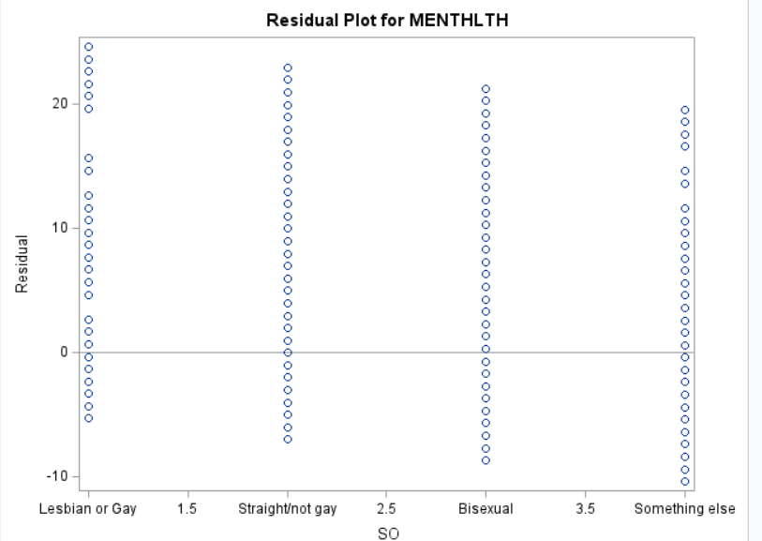

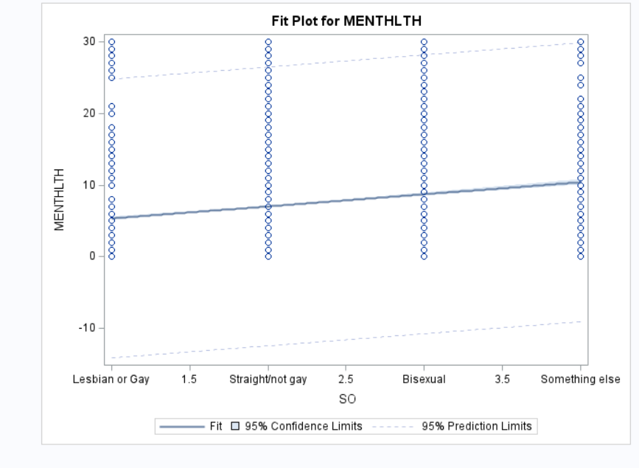

Based on these plots we can conclude that the assumptions for linear regression or normality were not met

**Table 3 Association Between Depressive Disorder and Sexual Orientation**

|  |  |  |
| --- | --- | --- |
| **Characteristic** | **Measure of Effect**  **(95% CI)** | **Pvalue** |
| Sexual Orientation  Straight/not gay(ref)  Lesbian/Gay  Bisexual  Something else | 1  1.80(1.64, 1.98)  2.15(1.98,2.32)  1.74(1.54,1.97) | <0.0001  <0.0001  <0.0001 |
| Sex  Male(ref)  Female | 1  1.78(1.73,1.84) | <0.0001 |
| Race  White, Non-Hispanic(ref)  Black, Non-Hispanic  Asian, Non-Hispanic  American Indian/Alaskan Native, Non-Hispanic  Hispanic  Other race, Non-Hispanic | 1  0.61(0.58,0.64)  0.51(0.45,0.58)  1.05(0.94,1.17)  0.76(0.71,0.82)  0.88(0.82,0.95) | <0.0001  <0.0001  <0.0001  <0.0001  <0.0001 |
| Age  18-29(ref)  30-39  40-59  60 and older | 1  1.02(0.96,1.08)  1.07(1.01,1.12)  0.70(0.67,0.74) | <0.0001  <0.0001  <0.0001 |
| Income Category  Less than $50,000(ref)  $50,000 or more | 1  0.57(0.56,0.59) | <0.0001 |
| BMI Category  Underweight  Normal weight(ref)  Overweight  Obese | 1.07(0.96,1.20)  1  1.15(1.11,1.20)  1.56(1.51,1.62) | <0.0001  <0.0001  <0.0001 |
| Does the participant have a health plan?  Yes  No(ref) | 1.25(1.80,1.32)  1 | <0.0001 |
| Smoking Status  Current smoker - smokes every day  Current smoker - smokes some days  Former smoker  Never smoked(ref) | 2.17(2.08,2.27)  1.95(1.83,2.08)  1.41(1.36,1.45)  1 | <0.0001  <0.0001  <0.0001 |

Summary-

Table 3, presents the complexities of how sexual orientation intersects with the risk of being diagnosed with depression. The data reveals a distinct gradient of risk across sexual orientations—lesbian or gay respondents are 1.8 times more likely to be diagnosed with depression, bisexuals are at a 2.15-fold higher risk, and those identifying as 'Something else' have a 1.74 times higher chance than straight participants. These figures stand out against the backdrop of other demographic factors like sex and race, which also show their own patterns of association with depression diagnoses. The statistics suggest that the tapestry of mental health is woven with diverse threads of identity, each contributing to the overall picture.

4b Table 3 clearly shows that sexual orientation is a significant predictor of depressive disorders, with bisexual individuals at the highest risk, showing an odds ratio (OR) of 2.15 and a confidence interval (CI) of 1.98 to 2.32. Similarly, lesbian or gay individuals have an OR of 1.80 (CI: 1.64, 1.98), and those identifying as 'Something else' have an OR of 1.74 (CI: 1.54, 1.97). These figures indicate a much higher likelihood of depressive diagnoses compared to straight individuals. Gender also plays a crucial role, with females experiencing a higher incidence of depressive disorders, evidenced by an OR of 1.78 (CI: 1.73, 1.84). The data from this table underscores the significant mental health challenges faced by sexual minorities, particularly among bisexual individuals.

**Table 4: Effect of Sexual Orientation Stratified by Age Category**

|  |  |  |  |  |  |
| --- | --- | --- | --- | --- | --- |
| **Outcomes** | **18-29 Years** | **30-39 Years** | **40-59 Years** | **≥60 Years** | **Pvalue\*\*** |
|  | **Effect Measure**  **(95% CI)\*** | **Effect Measure**  **(95% CI)\*** | **Effect Measure**  **(95% CI)\*** | **Effect Measure**  **(95% CI)\*** |
| Poor Mental Health Days  Lesbian/Gay vs. Straight/ not gay  Bisexual vs. Straight/not gay  Something else vs. Straight/not gay | 2.42(1.49,3.35)  3.09(2.46,3.71)  5.41(4.17,6.65) | 0.86(-0.23,1.96)  2.90(2.11,3.69)  2.95(1.38,4.52) | 0.91(0.18,1.65)  1.63(0.89,2.37)  1.21(0.00049,2.41) | 0.77(0.016,1.52)  0.96(0.12,1.81)  1.72(0.87,2.56) | <0.0001 |
| Depressive Disorder  Lesbian/Gay vs. Straight/ not gay  Bisexual vs. Straight/not gay  Something else vs. Straight/not gay | 2.27(1.84,2.80)  2.71(2.34,3.12)  4.03(3.05,5.32) | 1.97(1.54,2.53)  2.22(1.86,2.65)  2.07(1.46,2.93) | 1.76(1.5,2.06)  1.96(1.67,2.29)  1.43(1.11,1.85) | 1.59(1.34,1.90)  1.57(1.03,1.54)  1.26(1.03,1.54) | <0.0001 |

*Adjust for sex, race, income, BMI, whether or not they have a health plan and smoking status.

** P-value for the interaction between term between age category and sexual orientation after adjusting for sex, race, income, BMI, whether or not they have a health plan and smoking status.

Summary-

Table 4 elaborates on the modifying effect of age on the association between sexual orientation and mental health outcomes. The data indicates that younger individuals, especially those identifying as 'Something else,' report significantly more poor mental health days, with this effect diminishing but remaining meaningful in older age categories. The analysis underscores age as a pivotal factor in the interplay between sexual orientation and mental health, suggesting that interventions may need to be tailored to the age-specific needs and experiences of the LGBTQ+ community to effectively address these disparities.

5b Table 4 suggests that age category significantly modifies the relationship between sexual orientation and mental health outcomes, including the number of poor mental health days and the likelihood of being diagnosed with depressive disorders. The interaction between age and sexual orientation is statistically significant, indicating that the impact of sexual orientation on mental health varies by age. For example, individuals aged 18-29 who identify as 'Something else' report the highest increase in poor mental health days (Effect Measure: 5.41, CI: 4.17-6.65) compared to their straight peers. Similarly, in this age group, bisexuals show a notably higher risk of depressive disorders (Effect Measure: 2.71, CI: 2.34-3.12). These findings highlight the importance of considering age when evaluating the effects of sexual orientation on mental health, as younger sexual minorities appear particularly vulnerable and may benefit from targeted mental health support.

Appendix-

libname extern "C:\Users\Lenovo\OneDrive\Documents\Core Courses\BS 723\temp";

**proc** **format**;

value sof **1**="Lesbian or Gay" **2**="Straight/not gay" **3**="Bisexual" **4**="Something else";

value sexf **1**="Male" **2**="Female";

value racef **1**="White" **2**="Black" **3**="Asian" **4**="American Indian/Alaskan Native" **5**="Hispanic" **6**="Other";

value agecatf **1**="18-29" **2**="30-39" **3**="40-59" **4**="60 or older";

value incomecatf **1**="Atleast $50,000" **0**="Less than $50,000";

value bmicatf **1**="Underweight" **2**="Normal weight" **3**="Overweight" **4**="Obese";

value ynf **1**="Yes" **2**="No";

value genhlthf **1**="Excellent" **2**="Very Good" **3**="Good" **4**="Fair" **5**="Poor";

value so_dichotf **1**="Straight/not gay" **0**="Not Straight";

value smokerf **1**="Current smoker - smokes daily" **2**="Current smoker- smokes some days" **3**="Former smoker" **4**="Nonsmoker";

**run**;

**data** brfss;

set extern.brfss18;

*recode don't know/refused to respond;

if so in (**7**,**9**) then so=**.**;

if sex1 in (**7**,**9**) then sex1=**.**;

if income2 in (**77**,**99**) then income2=**.**;

if menthlth in (**77**,**99**) then menthlth=**.**;

if addepev2 in (**7**,**9**) then addepev2=**.**;

if poorhlth in (**77**,**99**) then poorhlth=**.**;

if genhlth in (**7**,**9**) then genlth=**.**;

if hlthpln1 in (**7**,**9**) then hlthpln1=**.**;

*create agecatvar;

if age in (**1**,**2**) then agecat=**1**;

if age in (**3**,**4**) then agecat=**2**;

if age in (**5**,**6**,**7**,**8**) then agecat=**3**;

if age ge **9** then agecat=**4**;

*create incomecat var;

if income2 = **.** then incomecat = **.**;

else if income2 le **6** then incomecat=**0**;

else if income2 in (**7**,**8**) then incomecat=**1**;

*recode none for menthlth and poorhlth variables;

if menthlth=**88** then menthlth=**0**;

if poorhlth=**88** then poorhlth=**0**;

*label variables;

label addepev2 = "Diagnosed with depression";

*format variables;

format so sof. sex1 sexf. race racef. agecat agecatf. incomecat incomecatf. bmicat bmicatf. genhlth genhlthf.

so_dichot so_dichotf. smoker smokerf. addepev2 hlthpln1 ynf.;

if so=**.** or sex1=**.** or addepev2=**.** or hlthpln1=**.** then delete;

**run**;

**proc** **means** data=brfss;

class so;

var MENTHLTH POORHLTH;

**run**;

**proc** **anova** data=brfss plots (maxpoints=none);

class so;

model MENTHLTH POORHLTH = so;

**run**;

**proc** **freq** data= brfss;

tables so*(sex1 race agecat incomecat bmicat addepev2 genhlth hlthpln1 smoker) / chisq;

**run**;

**proc** **glm** data=brfss;

class so(ref='Straight/not gay') sex1(ref='Male') Race(ref='White') agecat(ref='18-29') incomecat(ref='Less than $50,000 ') bmicat(ref='Normal weight') hlthpln1(ref='No') smoker(ref='Nonsmoker');

model MENTHLTH = so sex1 race agecat incomecat bmicat hlthpln1 smoker/solution clparm;

**run**;**quit**;

**proc** **glm** data=brfss plots(maxpoints=none)=(diagnostic residuals);

model MENTHLTH = so;

**run**;

**proc** **logistic** data=brfss descending;

class so(ref='Straight/not gay') sex1(ref='Male') Race(ref='White') agecat(ref='18-29') incomecat(ref='Less than $50,000 ') bmicat(ref='Normal weight') hlthpln1(ref='No') smoker(ref='Nonsmoker')/param=ref;

model addepev2(event="Yes")=so sex1 race agecat incomecat bmicat hlthpln1 smoker;

**run**;

**data** brfss;

**proc** **sort** data=brfss;

by agecat;

**run**;

**proc** **glm** data=brfss descending;

class so(ref='Straight/not gay') sex1(ref='Male') Race(ref='White')incomecat(ref='Less than $50,000 ') bmicat(ref='Normal weight') hlthpln1(ref='No') smoker(ref='Nonsmoker');

model menthlth=so sex1 race agecat incomecat bmicat hlthpln1 smoker/solution clparm;

by agecat;

**run**;

**proc** **glm** data=brfss descending;

class so(ref='Straight/not gay') sex1(ref='Male') Race(ref='White')incomecat(ref='Less than $50,000 ') bmicat(ref='Normal weight') hlthpln1(ref='No') smoker(ref='Nonsmoker');

model menthlth=so sex1 race incomecat bmicat hlthpln1 smoker/solution clparm;

**run**;

**proc** **sort** data=brfss;

by agecat;

**run**;

**proc** **logistic** data = brfss;

class so(ref='Straight/not gay') sex1(ref='Male') Race(ref='White')incomecat(ref='Less than $50,000 ') bmicat(ref='Normal weight') hlthpln1(ref='No') smoker(ref='Nonsmoker');

model addepev2 (event='yes')=so sex1 race agecat incomecat bmicat hlthpln1 smoker;

by agecat;

**run**;

**proc** **logistic** data=brfss;

class so(ref='Straight/not gay') sex1(ref='Male') Race(ref='White')incomecat(ref='Less than $50,000 ') bmicat(ref='Normal weight') hlthpln1(ref='No') smoker(ref='Nonsmoker');

model addepev2 (event='yes')=so sex1 race incomecat bmicat hlthpln1 smoker;

**run**;