

**Khadi Mart: E-commerce website**

**CS38**

**Guided by: Submitted by:**

**Dr. Ajay Kumar Yadav Lavanya Bhargava-2116209 Mimansha Sharma-2116222**

**Ojasvi Shankhdhaar-2116241**

**Class- B. Tech CSE section B**

# Chapter 1 SRS

TABLE OF CONTENTS

1. Introduction……………………………………………...……1
   1. Purpose ………………………………………………….… 1
   2. Scope…………………………………………………….… 1
   3. Definitions, Acronyms and Abbreviations……………….... 2
   4. Overview…………………………………………………... 2
2. General Description.................................................................3
   1. Product Perspective……………………………………. …. 3
      1. Product Function …………………………………........... 3
      2. Hardware Interface…………………………………......... 3
      3. Software Interface…………………………………............4
      4. Communication Interface……………………….........…....4
   2. User Characteristics……………………………………….…4
   3. General Constraints……………………………………….....4
   4. Technologies used………………………………………...... 5
3. Specific Requirements..............................................................6
   1. Functional Requirements…………………………………... 6
   2. Non-Functional Requirements ……………………….......….8
      1. AVAILABILITY……………………………………............8
      2. SECURITY……………………………………….........…...8
      3. RELIABILITY……….……………………….......………...8
      4. PORTABILITY…………………………………........……. 8
      5. MAINTAINABILITY………………………………........... 8

## 1. Introduction

### 1.1 Purpose

The purpose of this Software Requirements Specification (SRS) is to provide a comprehensive description of the functional and non-functional requirements for the development of the KhadiMart e-commerce website. This document is intended for:

Development Team: The SRS guides the development team in building the KhadiMart website by detailing what the system must do, ensuring alignment with stakeholders' expectations.

Project Managers: Project managers use the SRS to plan the development process, allocate resources, and monitor project progress.

Client/Stakeholders: The SRS serves as a reference for the client and other stakeholders to understand the project's scope, objectives, and constraints.

### 1.2 Scope

1. Software Product: The software product to be produced is the "KhadiMart" e-commerce website, a digital platform for buying and selling Khadi products.
2. What It Will Do:

Provide a user-friendly website for customers to browse, search for, and purchase Khadi products.

Allow users to register, log in, and manage their profiles.

Support secure payment processing.

Offer features similar to major e-commerce platforms like Amazon, such as product reviews, recommendations, and administrative tools for product and order management.

1. Application: The KhadiMart website is intended to provide a convenient and secure online marketplace for Khadi products. Its objectives include promoting Khadi and enabling sellers to reach a wider audience.
2. Consistency: This scope aligns with similar statements in higher-level specifications if they exist, such as the project proposal.

### 1.3 Definitions, Acronyms, and Abbreviations

Khadi: Hand spun and handwoven fabric made from natural fibres, such as cotton or silk.

SRS: Software Requirements Specification.

E-commerce: Electronic commerce, the buying and selling of goods and services over the internet.

UI: User Interface.

UX: User Experience.

API: Application Programming Interface.

HTTPS: Hypertext Transfer Protocol Secure.

CMS: Content Management System.

GDPR: General Data Protection Regulation.

COPPA: Children's Online Privacy Protection Act.

### 1.4 Overview

1. SRS Contents: The SRS contains detailed information about the functional and non-functional requirements for the KhadiMart e-commerce website.
2. Organization: The SRS is organized into sections, including an introduction, general description, specific requirements, and appendices. Stakeholders are encouraged to refer to the sections most relevant to their roles and interests. For example, potential users should focus on Section 2 (General Description), while developers should concentrate on Section 3 (Specific Requirements).
3. Table of Contents: The table of contents provides an easy reference to locate specific information within the document.

This introduction serves as a high-level summary, directing readers to the sections of the document most pertinent to their roles and interests, without reiterating the entire SRS.

## 2. The Overall Description

### 2.1 Product Perspective

The KhadiMart e-commerce website is a self-contained and independent system designed to provide a platform for the buying and selling of Khadi products. It operates as a standalone e-commerce marketplace, and its functionality does not rely on or interact with any external systems. The system is illustrated as a black box, and internal system architecture details will be presented in design documentation.

#### 2.1.1 Product Function

The KhadiMart e-commerce website will perform the following key functions:

User Registration and Authentication: Users can register for an account, log in, and manage their profiles, enhancing the overall user experience.

Product Catalogue: Display a comprehensive catalogue of Khadi products with details, images, and prices for customers to explore and purchase.

Search and Filter: Enable users to search for products and apply filters, streamlining product discovery.

Shopping Cart: Allow users to add products to their shopping cart, review the cart, and proceed to checkout.

Order Management: Provide users with the ability to view their order history, track current orders, and request returns or cancellations.

Payment Processing: Facilitate secure payment transactions through integration with a payment gateway.

User Reviews and Ratings: Permit registered users to leave reviews and ratings for products, enhancing transparency and trust in the system.

Seller Dashboard: Empower sellers to manage their product listings, inventory, and order details.

Administrator Dashboard: Enable administrators to manage user accounts, product listings, and mediate disputes.

#### 2.1.2 Hardware Interfaces

The KhadiMart e-commerce website has no direct hardware interfaces, as it operates in a web-based environment. It relies on the capabilities and resources provided by the underlying web servers and user devices. The system will support various devices, including desktops, laptops, tablets, and smartphones.

#### 2.1.3 Software Interfaces

The KhadiMart website interfaces with the following external software products and services:

MySQL: The system interacts with the MySQL database for storing and retrieving product data, user information, and order details.

Payment Gateway: Integration with a third-party payment gateway service (e.g., Stripe, PayPal) for secure payment processing.

#### 2.1.4 Communications Interfaces

The KhadiMart e-commerce website employs secure communication protocols, including HTTPS (Hypertext Transfer Protocol Secure), for interactions between the user's device and the web server. Communication within the system and with external payment gateways is managed through secure API interfaces.

### 2.2 User Characteristics

The intended users of the KhadiMart website include a diverse set of individuals with varying characteristics:

Shoppers: These users may have different levels of technical expertise but are comfortable with online shopping and have basic digital literacy.

Sellers: Sellers are expected to have some technical expertise related to product management and inventory control.

Administrators: Administrators should be proficient in managing user accounts, resolving disputes, and maintaining the system.

The characteristics of these users will influence aspects such as user interface design and overall user experience.

### 2.3 Constraints

Several constraints and considerations will shape the design and functionality of the KhadiMart website:

Regulatory Policies: The system must comply with relevant e-commerce and data protection regulations, such as GDPR, in the regions it operates.

Security and Safety: Robust security measures must be in place to protect user data, including encryption and safeguards against common web application vulnerabilities.

Auditing: The system may require auditing and logging functions for security and compliance purposes.

Reliability: The system should be reliable, with minimal downtime or system failures.

Criticality: Ensuring the reliability of the payment processing and data integrity is critical for user trust and financial transactions.

### 2.4 Technologies Used

Frontend:

HTML, CSS, JavaScript, and Bootstrap are used for building the user interface and client-side functionality.

Backend:

Java is used as the programming language for the server-side logic.

JDBC (Java Database Connectivity) is used for connecting to the MySQL database.

JSP (Java Server Pages) is used for dynamically generating web pages on the server.

Servlets are used for handling HTTP requests and managing application flow.

Database:

MySQL is used as the relational database management system to store and retrieve data, including product data, user information, and order details.

## 3. Specific Requirements

This section provides detailed software requirements, enabling designers to create the system and testers to verify that it meets these requirements. All requirements are presented in a clear and structured manner and conform to good SRS practices. Each requirement is uniquely identified for traceability and is stated in a testable format.

### 3.1 Functional Requirements

Functional requirements define the fundamental actions that the software must perform. They encompass input processing, response generation, and validation checks. Functional requirements are denoted by "The system shall..."

3.1.1 User Registration and Authentication

The system shall allow users to register for an account by providing a valid email address and password.

The system shall validate the uniqueness of email addresses during the registration process.

The system shall provide a secure password storage mechanism.

The system shall allow registered users to log in using their email and password.

The system shall offer the option for users to log in using their social media accounts (e.g., Google, Facebook).

3.1.2 Product Catalogue

The system shall display a product catalogue with the following information:

product name, description, price, and images.

The system shall categorize products for easy navigation.

The system shall allow administrators to add, edit, and remove product categories.

3.1.3 Search and Filter

The system shall enable users to search for products by keywords, product names, or categories.

The system shall provide filter options, allowing users to refine search results by price range, category, and seller ratings.

3.1.4 Shopping Cart

The system shall allow users to add products to their shopping cart.

The system shall enable users to view and edit the items in their shopping cart before proceeding to checkout.

3.1.5 Order Management

The system shall provide users with a history of their previous orders.

The system shall allow users to track the status of their current orders, including estimated delivery dates.

The system shall allow users to initiate return requests or order cancellations.

3.1.6 Payment Processing

The system shall integrate with a secure payment gateway for processing payments.

The system shall support multiple payment methods, including credit/debit cards and digital wallets.

3.1.7 User Reviews and Ratings

The system shall allow registered users to submit product reviews and ratings.

The system shall calculate and display the average rating for each product based on user reviews.

3.1.8 Seller Dashboard

The system shall provide a dashboard for sellers to manage their product listings.

The system shall enable sellers to maintain product inventory and stock levels.

3.1.9 Administrator Dashboard

The system shall offer an administrative dashboard for managing user accounts.

The system shall allow administrators to resolve disputes between users.

### 3.2 Non-Functional Requirements (Software System Attributes)

3.2.1 AVAILABILITY

The availability of the KhadiMart website is dependent on the client's internet connection.

The website shall be accessible at all times for users with valid accounts.

Users without accounts may access the homepage but will have limited access to the system.

3.2.2 SECURITY

The system shall employ an authorization mechanism to prevent unauthorized access.

Different user roles (e.g., customers, sellers, administrators) shall have distinct levels of authorization.

3.2.3 RELIABILITY

The system shall maintain a backup file to prevent data loss in the event of a system crash.

3.2.4 PORTABILITY

The system is developed using ASP.Net, ensuring portability for web-based applications.

3.2.5 MAINTAINABILITY

The KhadiMart website shall follow a modular structure to facilitate maintenance.

# Chapter 2 SDS

TABLE OF CONTENTS

1. Introduction
   1. Purpose ………………………………………………….…11

Scope……………………………………………………….......11

* 1. Terms, Definitions, Acronyms and Abbreviations……........11
  2. Overview of Document …….……………………………...11

1. System Architectural Design...................................................12
   1. High Level Design Overview……………………………... 12
   2. Detailed Description of Components...................................14
      1. Data Flow Diagram ………………………………….......14
      2. Structure Chart………………………………………. ......21
2. Data Design..............................................................................41
   1. Database Description………………………………….........41
3. User Interface Design...............................................................49

4.1 Screen images........................................................................49

5. TYPES OF TESTS (With Implementation) ............................ 56

6.References…………………………………………………… 58

## 1. Introduction

### 1.1 Purpose

The purpose of this SDS is to provide a detailed description of the system's architecture and functionality for the design and development teams. This document serves as a blueprint for building the Khadi Mart e-commerce platform.

### 1.2 Scope

Software Product: The software product to be produced is the "Khadi Mart" ecommerce platform.

Functionality: Khadi Mart will provide an online marketplace for buying and selling khadi products, facilitating user-friendly product discovery and secure transactions.

Application: This software aims to create an efficient platform for khadi enthusiasts, artisans, and shoppers, promoting khadi products and supporting online sales.

Benefits and Goals: The platform's primary objectives include promoting khadi products, enhancing the reach of artisans, providing a secure shopping experience, and contributing to the growth of the khadi industry.

### 1.3 Definitions, Acronyms, and Abbreviations

Khadi Mart: The e-commerce platform.

User: Individuals interacting with the Khadi Mart platform, including buyers, sellers, and visitors.

Artisan: Users who create and sell khadi products on the platform.

### 1.4 Overview

This SDS document describes the detailed design and architecture of the Khadi Mart e-commerce platform.

It is organized into sections that cover different aspects of the system's design.

The following sections detail the system's architecture, user interfaces, database structure, security measures, and more.

2. System Architectural Design

### 2.1 High-level Design Overview

Khadi mart is designed as a modern and efficient online shopping platform, bringing together several key components to provide a seamless and secure shopping experience for users.

Front-End Components:

HTML/CSS/JavaScript: The front end leverages these technologies to create the website's structure, styling, and interactivity.

Bootstrap: Bootstrap is used for responsive design, ensuring a consistent and userfriendly interface across various devices.

Web Servers:

Java and Servlets are used in the web servers to handle HTTP requests, process user inputs, and serve dynamic content to users. They serve as the gateway for user interactions.

Back-End Components:

Java/Servlets/JSP: The back-end servers, implemented in Java, Servlets, and Java Server Pages (JSP), manage server-side logic. They handle user authentication, order processing, and the rendering of dynamic web pages.

Database:

MySQL: The database servers store and manage essential data, including product details, user accounts, and order history. Java, through JDBC, interacts with the database for data retrieval and updates.

Payment Gateway:

A third-party payment gateway securely processes online payments, ensuring the safety and convenience of online transactions.

This high-level system architecture diagram demonstrates the core components of Khadi mart, showing how they interact to deliver a seamless shopping experience to users:

q

Payment Gateway

INTERNET

Database Servers

)

MySQL

(

Back

-

End Servers

)

Java

(

Web Servers

Java, JDBC

)

(

User

Front

-

End Servers

HTML, CSS

(

JavaScript)

### 2.2) Detailed Description of Components

#### 2.2.1 Data flow diagram (DFD)

Level 0 DFD

The context level data flow diagram (DFD) describes the whole system. The 0 level DFD describe the all-user module who operate the system. Below data flow diagram of online shopping site shows the two users can operate the system Admin and Member user.

|  |  |  |  |
| --- | --- | --- | --- |
| |  | | --- | | [AAdmin](https://meeraacademy.com/wp-content/uploads/2016/09/olevel.jpg) | | |  | | --- | | [User](https://meeraacademy.com/wp-content/uploads/2016/09/olevel.jpg) | |

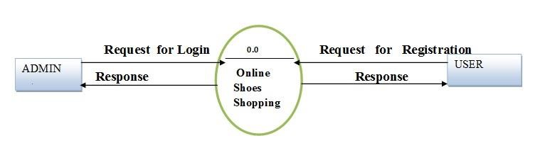

Level 1 Admin Side DFD

The admin side DFD describe the functionality of Admin, Admin is an owner of the website. Admin can first add category of item and then add items by category wise and admin can manage order and payment detail.

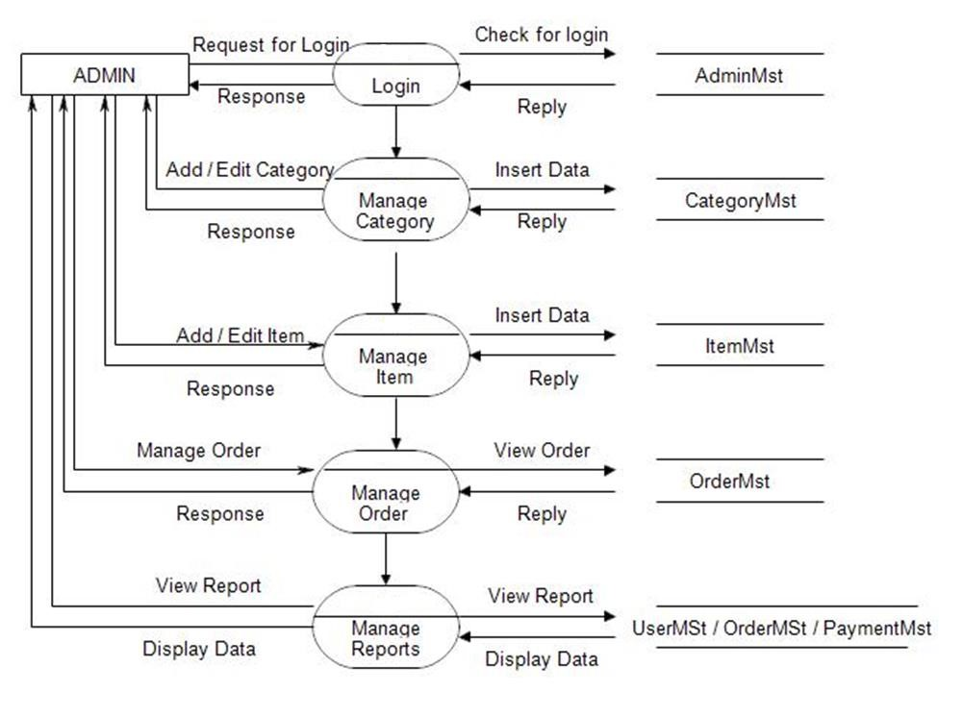

Level 2 admin side DFD

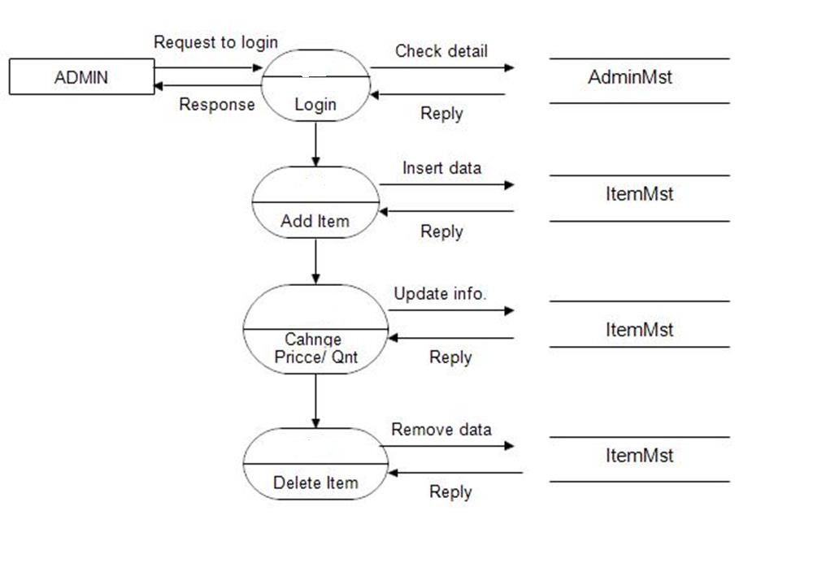

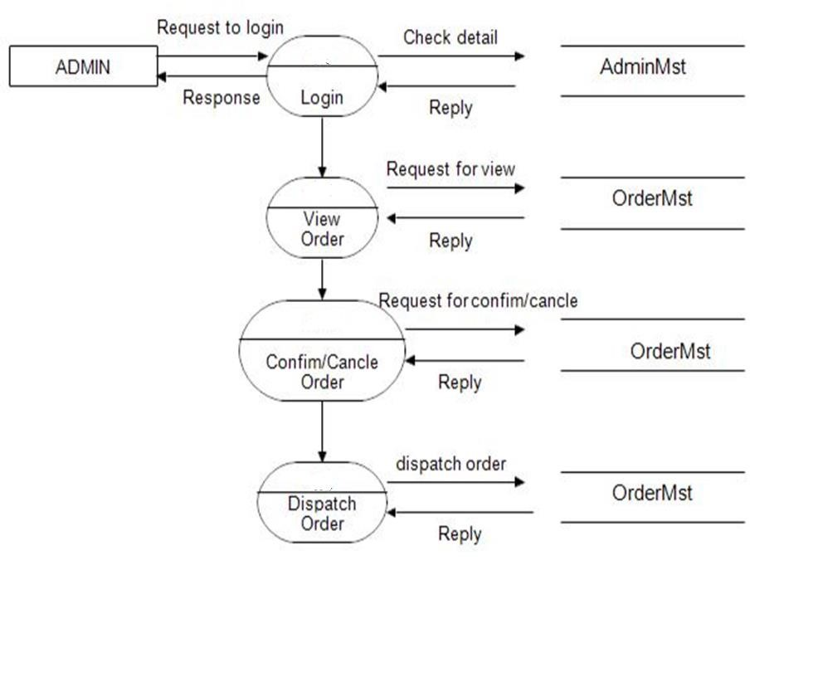

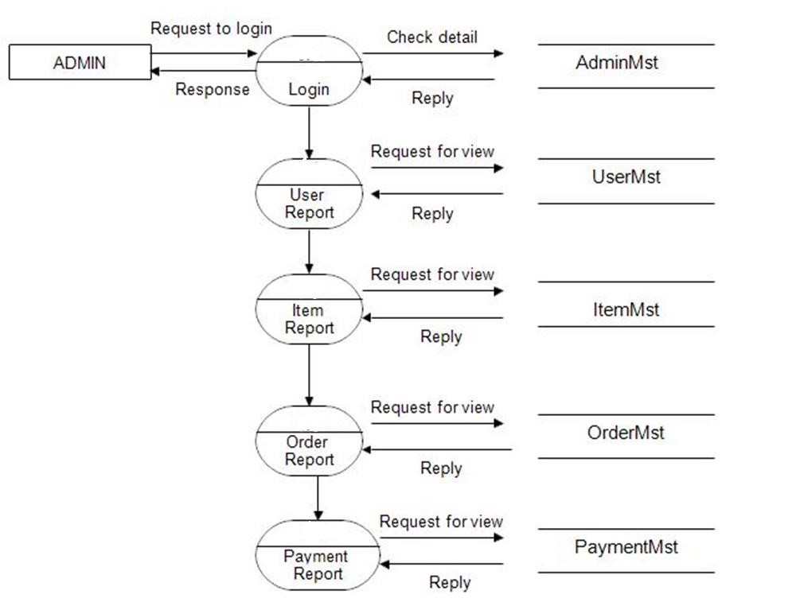

Level 1 user side DFD

The user is all people who operate or visit our website. User is a customer of a website. User can first select product to buy, user must have to register in our system to purchase any item from our website. After registering, user can login to site and buy item by making online payment through any bank debit card or credit card.

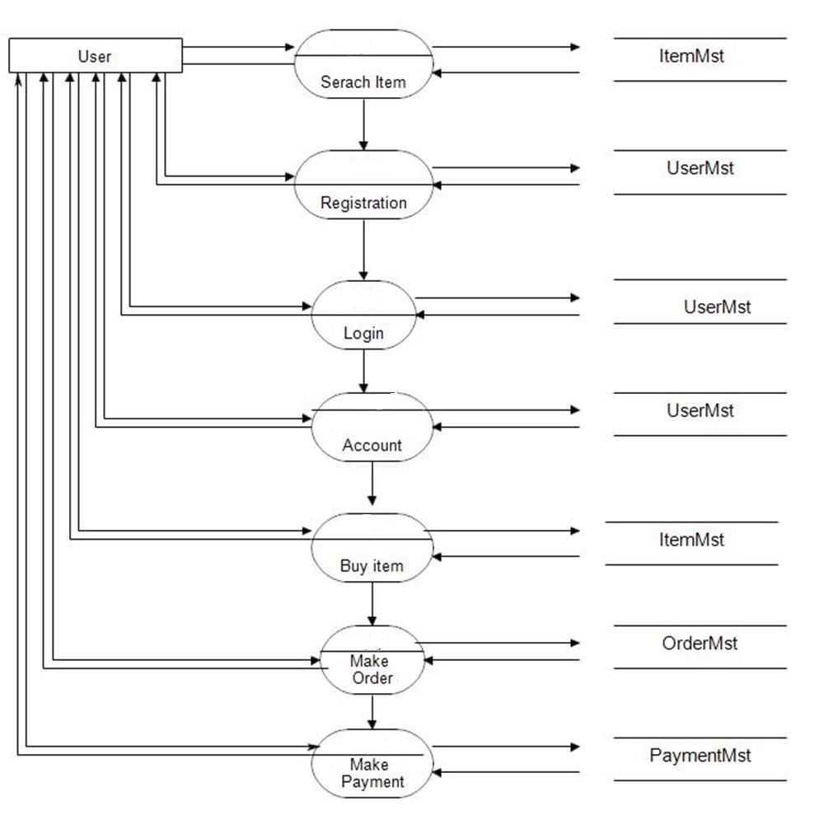

Level 2 user side DFD

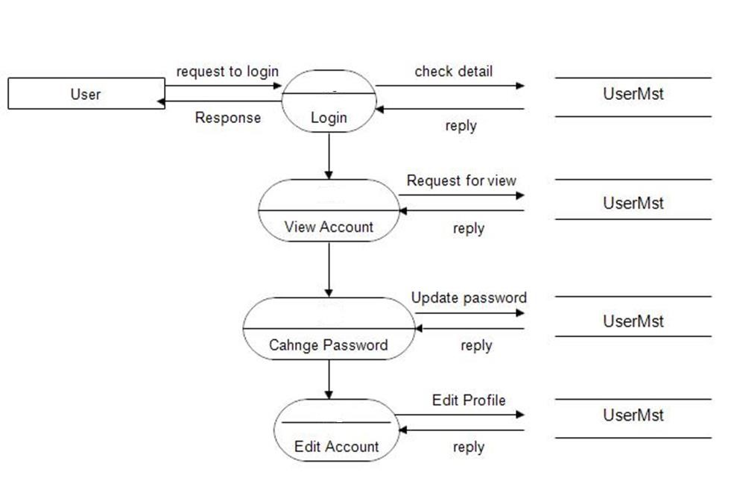

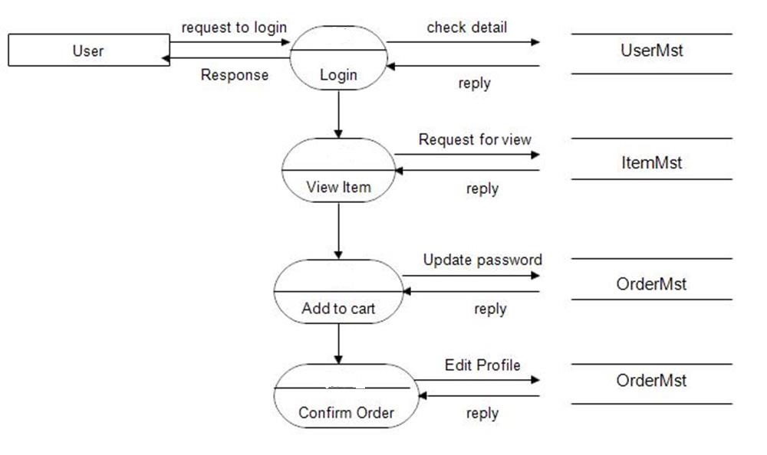

#### 2.2.2 Structure chart

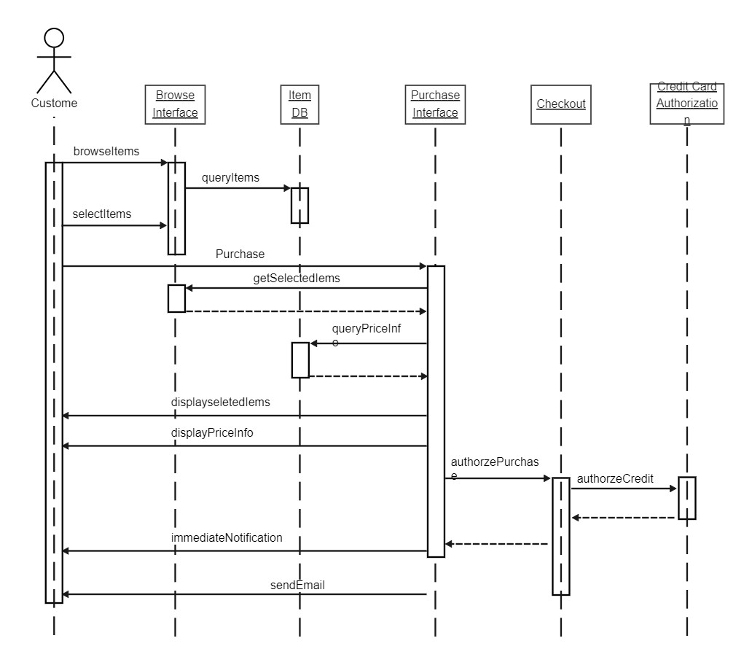

2.2.3 Use Case Diagram

### 1. Actors

Admin: Admin is responsible for website management, which includes user authentication, category management, item management, and order management.

User: Users are customers who interact with the website to register, view items, make orders, make payments, and change their passwords.

### 2. Use Cases

Admin Operations:

1.Admin Login: Admin logs in to access the admin dashboard.

2.Add Category: Admin can add new product categories to the website.

3.Manage Items: Admin can manage product items, including adding, editing, and removing items.

4.Manage Orders: Admin can view and manage customer orders, including order details and status updates.

User Operations:

1.User Registration: Users can create accounts on the Khadimart website.

2.View Items: Users can browse and view product items.

3.Make an Order: Users can select items, add them to the shopping cart, and place orders.

4.Make a Payment: Users can proceed to make payments for their orders.

5.Change Password: Users can change their account passwords.

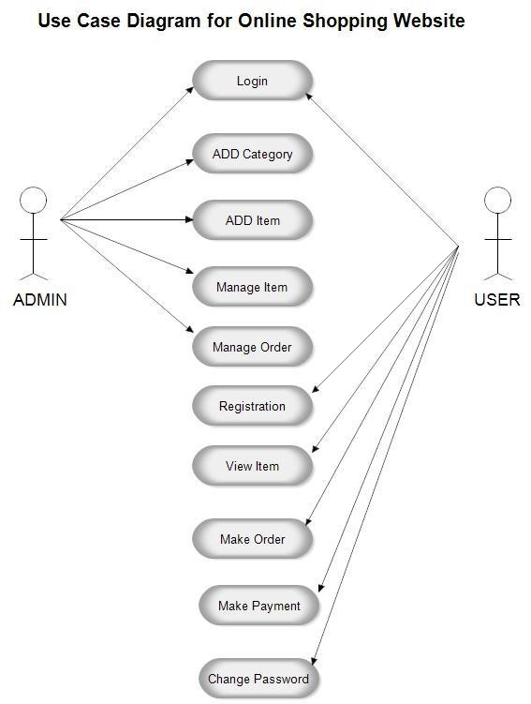

**Login**

**AD**

**D**

**Category**

**Manage Item**

**Manage**

**Order**

**Registration**

**ADD Item**

**Make**

**Payment**

**Make Order**

**View Item**

**Change Password**

2.2.3 Entity Relationship Diagram

An Entity-Relationship (ER) diagram for an online shopping website represents the various entities, their attributes, and the relationships between them. Here's a description of the key components of an ER diagram for an online shopping website: Entities:

1. Supplier: Sid (primary key), number, name, address
2. Online shop: name, address, shop
3. Customer: Cid (primary key), name, email, number, password
4. Courier: coid (primary key), name, address, phone
5. Orders: oid (primary key), pid, coid, orderdate, quantity, dileverystatus, Cid

Relationships:

a. customer-Order Relationship:

A customer can place multiple orders, but each order is placed by a single customer. This is a one-to-many relationship.

customer (1) ----< Orders (Many)

1. Order-Product Relationship:

An order can contain multiple products, and a product can be a part of multiple orders (many-to-many).

Orders (Many) ----< OrderDetails (Many) >---- Products (Many)

1. Product-Category Relationship:

Products belong to specific categories, and a category can have multiple products (many-to-many).

Products (Many) ----< Belongs to (Many) >---- Categories (Many)

1. Order-Payment Relationship:

An order is associated with one payment, but a payment can be linked to multiple orders (one-to-many). Orders (1) ----< Payment (Many) Attributes:

a. OrderDetails:

Attributes: OrderDetailID (Primary Key), Quantity, Subtotal, etc.

This table represents the details of each product in an order.

This ER diagram captures the essential components of an online shopping website, including users, products, categories, orders, and payments, as well as the relationships between them. It provides a foundation for designing the database schema and implementing the functionality of the website.

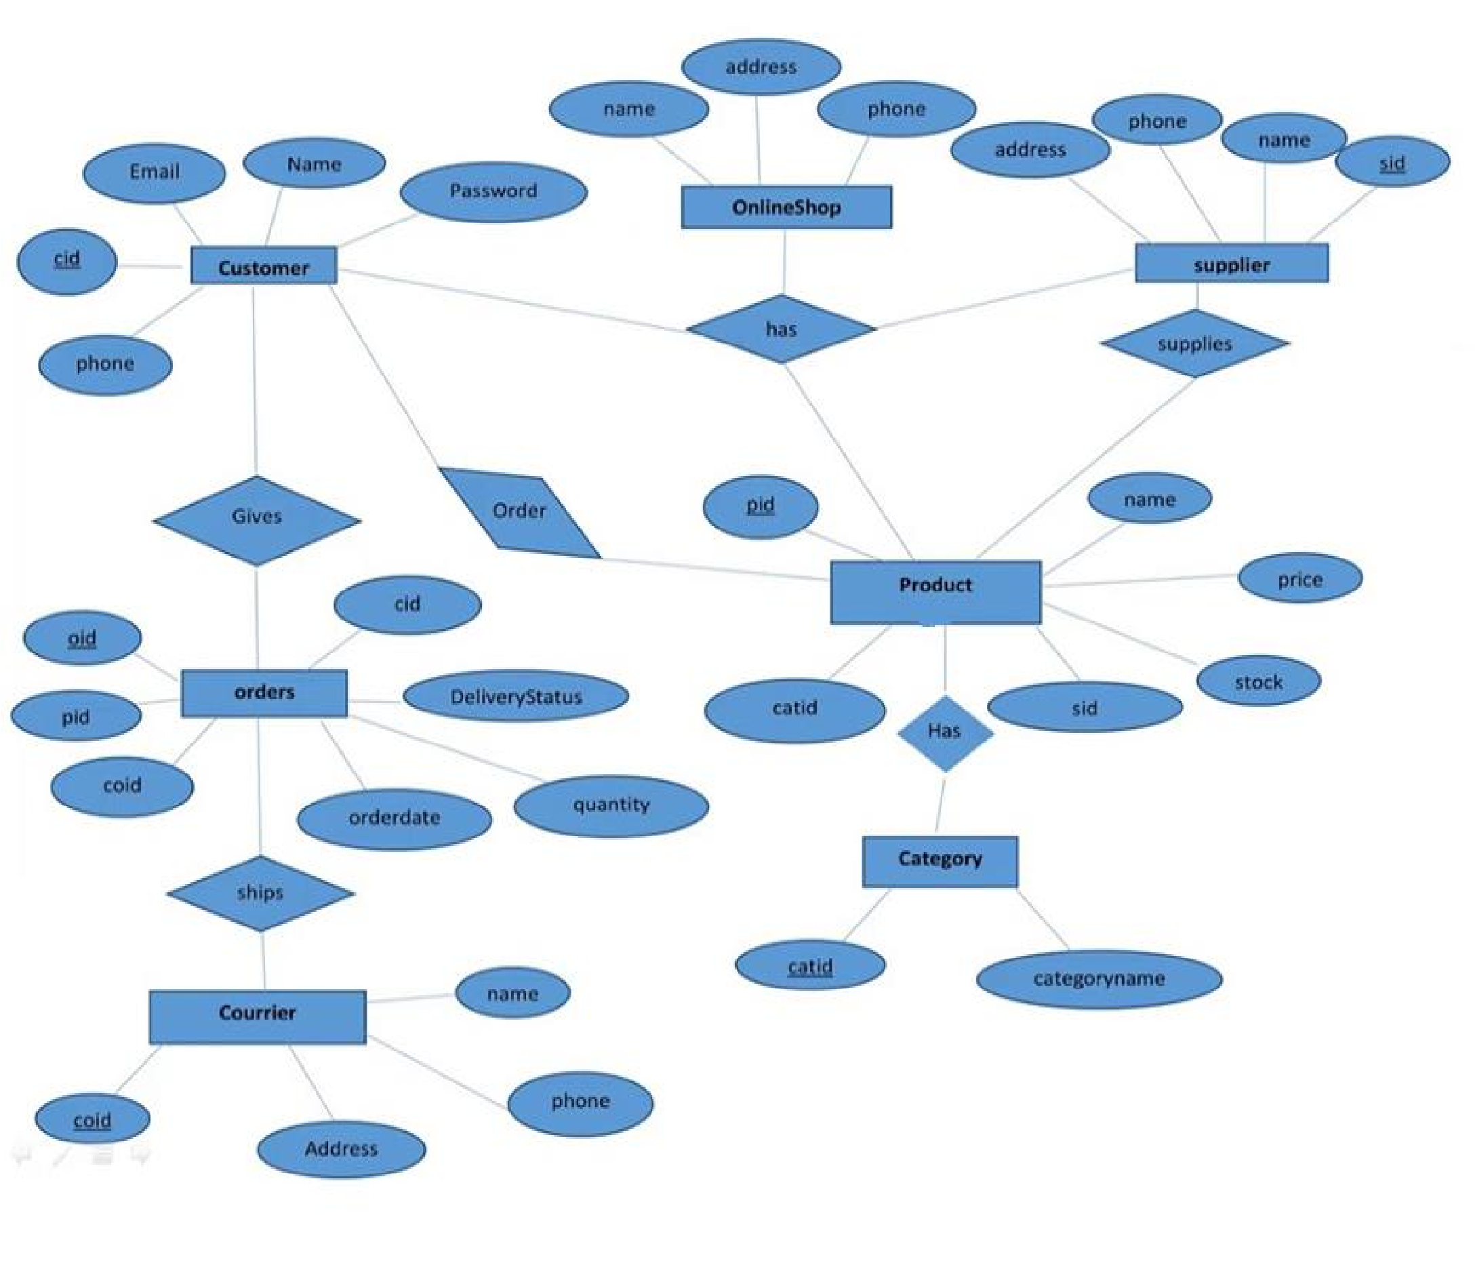

#### 2.2.4. Class Diagram

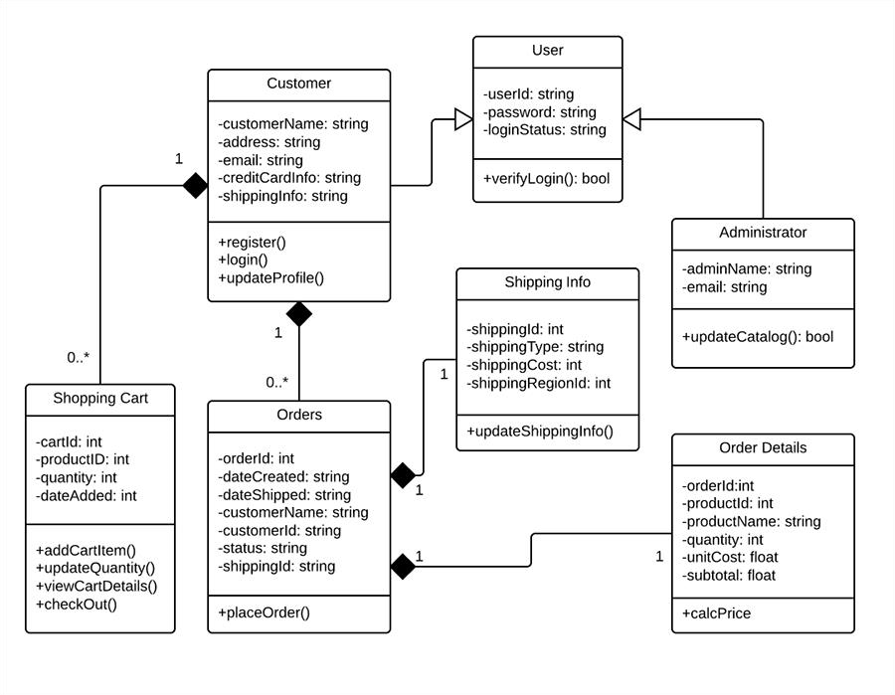

#### 2.2.5 Activity Diagram

-

+

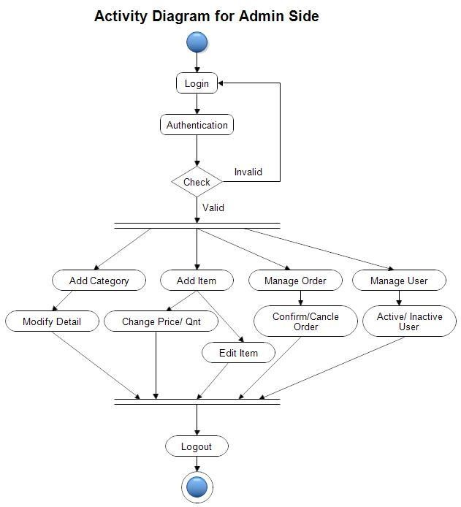

This activity diagram illustrates the sequence of activities that an administrator can perform on the Khadi e-commerce website's admin panel. It starts with the login process and branches into different tasks based on the outcome of the authentication process.

**Description:**

1.Login: The activity begins with the "Login" action, where the administrator enters their credentials (username and password) and initiates the login process.

2.Authentication: After the login action, the system performs authentication to verify the administrator's identity.

If authentication is successful, the process proceeds to the "Authentication Successful" decision point. If authentication fails, the process loops back to the "Login" action.

Authentication Successful:

When the administrator is successfully authenticated, they can access various admin-side operations.

1. Manage Categories: The admin can choose to "Add Category" or "Modify

Category."

1. Add Item: The admin can add new items to the e-commerce platform.
2. Manage Orders: The admin can "Manage Orders" to process, update, or
3. Manage Users: The admin can "Manage Users," which may involve actions like account suspension, modification, or reviewing user data.
4. Modify Data: The admin can make modifications to the website's data, which could include updating product details, categories, or other information.

3. Logout: The admin can choose to "Logout" to end the admin session.

After logging out, the process ends.

Invalid Authentication:

If authentication fails, the process returns to the "Login" action, allowing the administrator to make another login attempt.

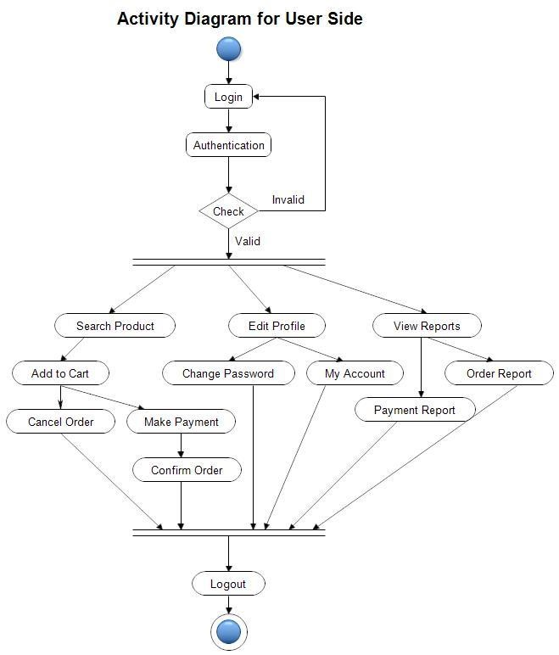

This activity diagram illustrates the sequence of activities that a user can perform on the Khadi e-commerce website. It starts with the login process and branches into different tasks based on the outcome of the authentication process.

**Description:**

1.Login: The activity begins with the "Login" action, where the user enters their credentials (username and password) and initiates the login process.

2.Authentication: After the login action, the system performs authentication to verify the user's identity.

If authentication is successful, the process proceeds to the "Authentication Successful" decision point. If authentication fails, the process loops back to the "Login" action.

Authentication Successful: When the user is successfully authenticated, they can access various user-side operations.

a. Search Product: The user can search for products on the e-commerce platform.

After searching for a product, the process proceeds to the "Add to Cart" action.

Add to Cart: The user can add products to their shopping cart.

After adding to the cart, the process offers two options:

"Cancel Order": The user can choose to cancel the order from the cart.

"Make Payment": The user can proceed to make a payment.

Cancel Order: The user can cancel an order from the shopping cart.

After cancelling the order, the process returns to the "Add to Cart" action.

Make Payment: The user can initiate a payment for the selected products.

After making the payment, the process proceeds to the "Confirm Order" action.

Confirm Order: The user can confirm their order, which includes the final review of the purchase.

After confirming the order, the process proceeds to the "Logout" action.

1. Edit Profile: The user can choose to "Edit Profile," which includes options like changing their password or managing their account.

After editing the profile, the process proceeds to the "Logout" action.

Change Password: The user can change their password to enhance account security.

After changing the password, the process returns to the "Edit Profile" action.

My Account: The user can manage their account settings, preferences, and personal information.

After managing the account, the process returns to the "Edit Profile" action.

1. View Reports: user can view various reports related to their orders and payments.

After viewing reports, the process offers two options:

"Payment Report": The user can view payment-related reports.

"Order Report": The user can view order-related reports.

Payment Report: The user can review reports related to their payments.

After reviewing payment reports, the process proceeds to the "Logout" action.

Order Report: The user can review reports related to their orders.

After reviewing order reports, the process proceeds to the "Logout" action.

3.Logout: The user can choose to "Logout" to end their session.

After logging out, the process ends.

4.Invalid Authentication: If authentication fails, the process returns to the "Login" action, allowing the user to make another login attempt.

#### 2.2.6 STRUCTURE CHART

**Login ok**

**Account**

**Information**

**Login Details Logout**

**Search button criteria**

**Page Navigation**

**Home Home**

**Return Return Product**

**Product**

**Product Info**

**Product in shopping**

**Cart Info**

**Approved**

**Payment Info**



**Login**



**Verification**



**Payment**



**Search Item**



**Shopping Cart**



**Generate**

**Receipt**



**Process**

**Transaction**



**Product**

**Details**



**Browse**

**Product**



**User**

**Home**

This sequence chart outlines the primary interactions and activities for users on the Khadi e-commerce website, from login to the purchase process.

Description**:**

1.Login Sequence: Users initiate the login process by providing their credentials.

The system verifies the user's credentials for authentication.

2.User Home Sequence: Upon successful authentication, users are directed to the "User Home" page.

From here, they have several options for actions.

3.Search Item Sequence:

Users can "Search Item" using the website's search functionality.

This action leads to a list of search results.

4.Browse Product Sequence: Users can "Browse Product" to explore product listings, categories, and details.

The user can select a specific product for further details.

5.Product Details Sequence: Users can view detailed information about a selected product.

From this page, they have the option to proceed to "Shopping" or go back.

6.Shopping Sequence: Users can add the selected product to their shopping cart for purchase.

After adding items to the cart, users proceed to the "Payment" step.

7.Payment Sequence: Users initiate the payment process for the items in their shopping cart.

The payment process involves several steps, including payment details and confirmation.

8.Process Transaction Sequence: The system processes the user's payment transaction.

This may involve interacting with payment gateways and ensuring the transaction is secure.

9.Generate Receipt Sequence: After a successful transaction, the system generates a receipt for the user.

The receipt includes details of the transaction, which can be viewed and saved.

This sequence chart focuses on the key steps involved in the user's journey through your e-commerce website, from logging in to exploring products, making a purchase, and generating a transaction receipt. It highlights the core user interactions and activities that take place during their visit to the website.

### Component and Interface Diagram

User: Represents the end-users of the website.

Web Browser: The user's web browser that interacts with the frontend component.

Frontend Component: This encompasses the user interface of the website and includes various sub-components like Product Catalog, Cart Component, User Account, Product Detail, Reviews, and Ratings.

Product Catalogue: Displays a list of available products.

Cart Component: Manages the user's shopping cart.

User Account: Allows users to manage their account information and order history.

Product Detail: Displays detailed information about a specific product.

Reviews Component: Allows users to read and write product reviews.

Ratings Component: Provides product ratings and user ratings.

Backend Component: Responsible for server-side operations, including handling API requests and business logic.

API Server: Manages incoming requests from the frontend and communicates with various services.

Product Service: Manages product-related operations and interacts with the product database.

User Service: Handles user-related operations and interacts with the user database.

Order Service: Manages order-related operations and interacts with the order database.

Database: Stores product, user, and order data.

Payment Gateway: Interfaces with the payment service to process payments.

Payment Service: Communicates with the payment processor to handle transactions.

Logging Service: Logs system and user activities for analysis and troubleshooting.

Shipping Service: Manages shipping-related operations, including selecting a shipping carrier.

Carrier Service: Interfaces with various shipping carriers to handle the physical delivery of products.

Carriers: Represents multiple shipping carriers that deliver products



Web



browser



User



Frontend com

ponent



Product



details



Produ

ct



services



User



account



Car

t



component



Product



catalogue

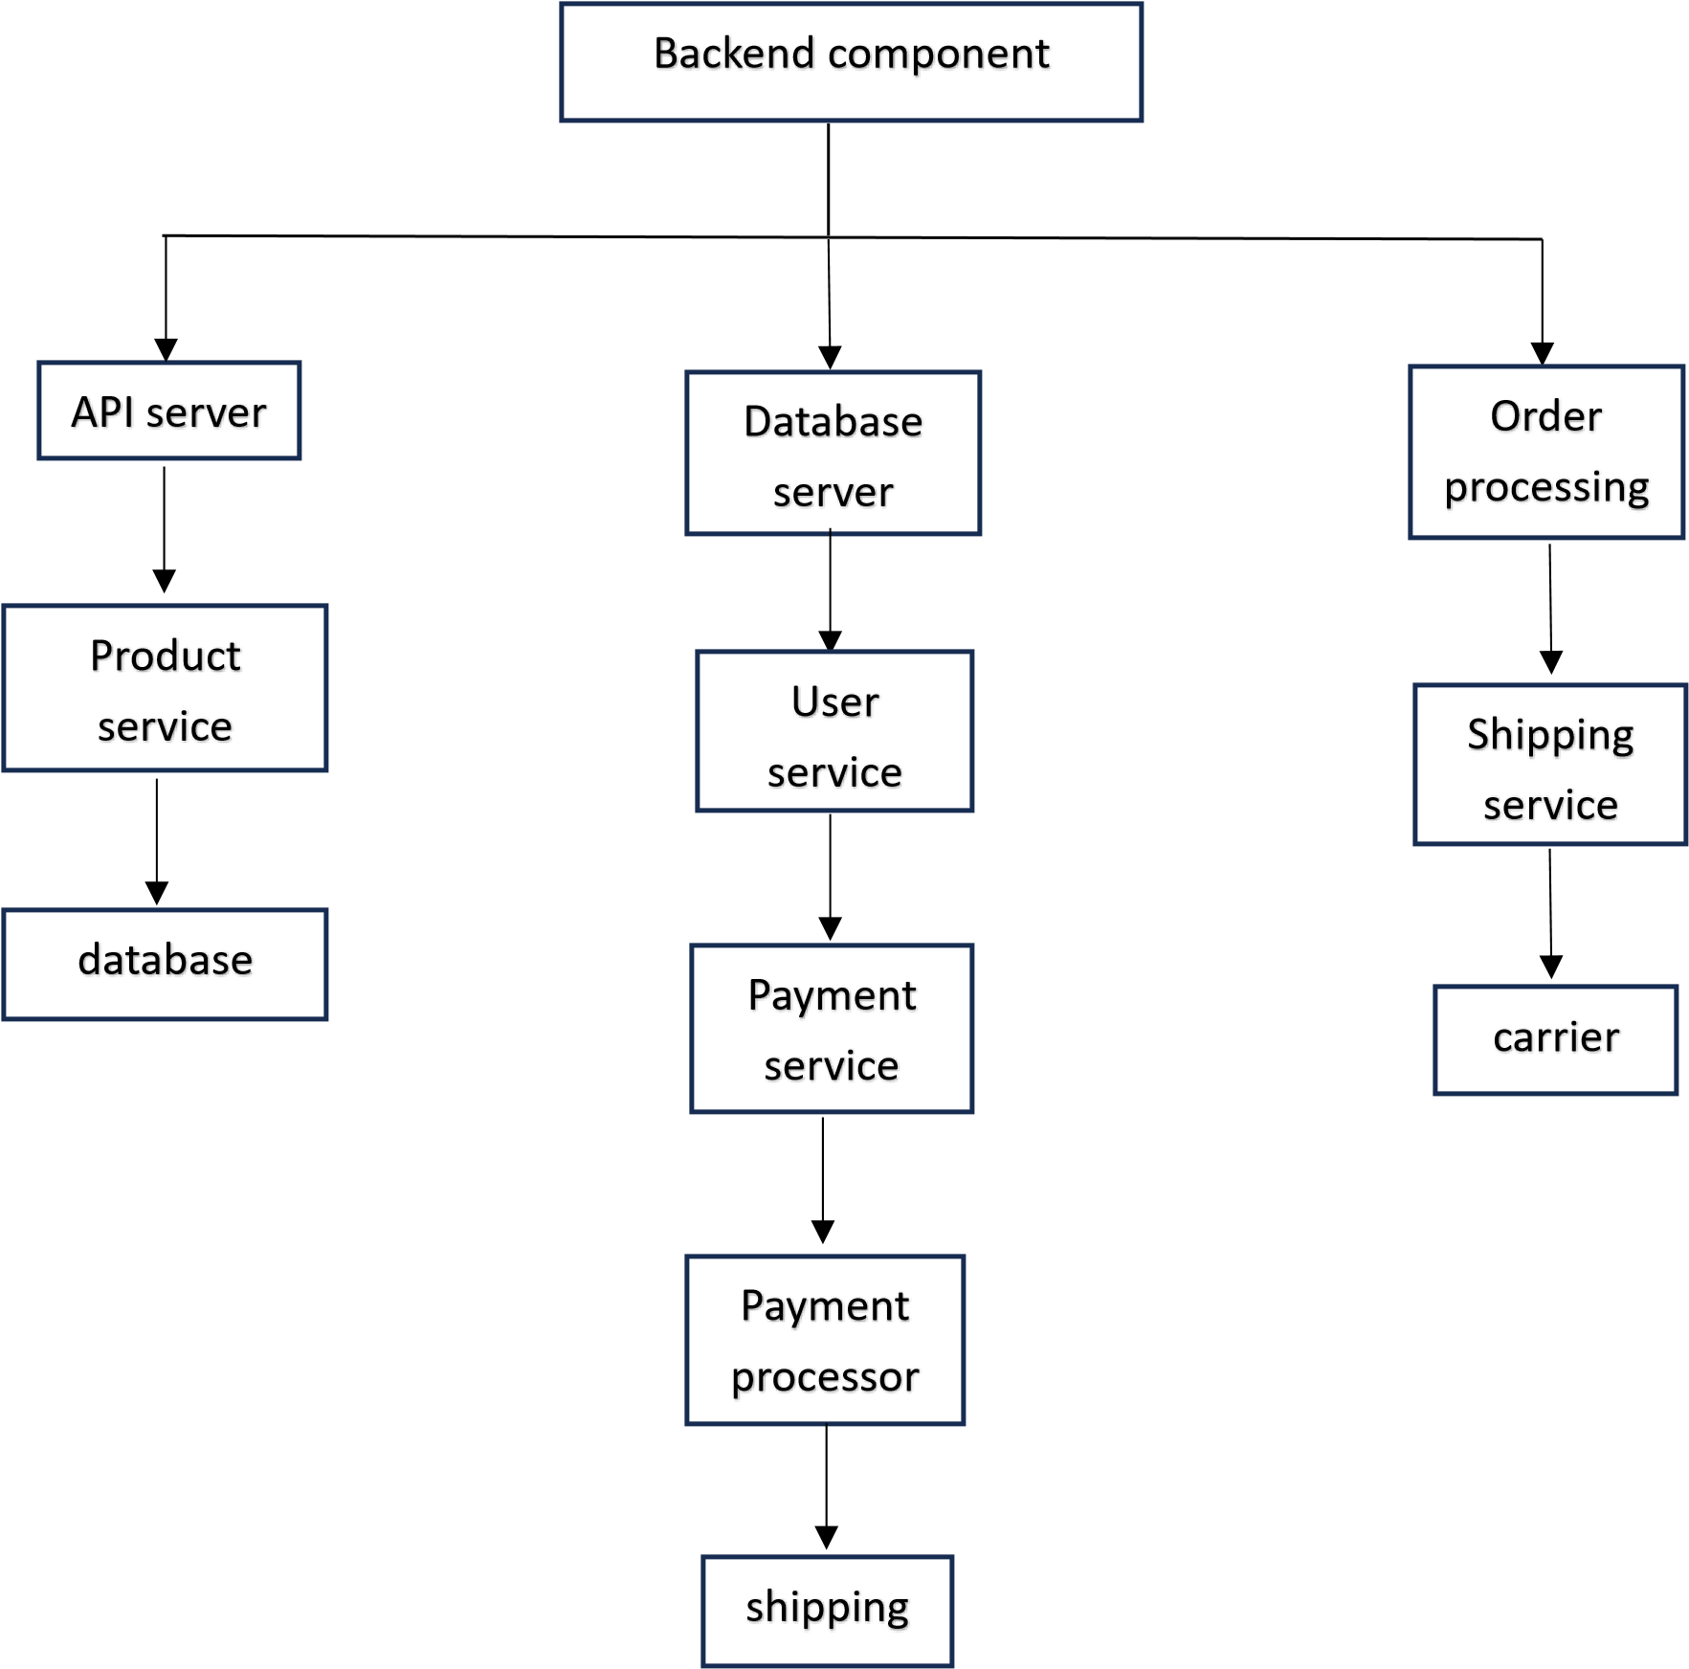

### Component and processing detail

1. Add to Cart Functionality:

Algorithmic Description:

The user clicks the "Add to Cart" button on a product page.

The frontend sends a request to the API server with the product details and the user's session information.

The API server routes the request to the Product Service component.

The Product Service validates the request, checks product availability, and retrieves the product's price and details from the database.

The Product Service calculates the total price for the user's cart and updates the user's cart data in the database.

The API server responds to the frontend with a success message or an error message.

**2. Checkout Process:**

**Algorithmic Description:**

The user clicks the "Checkout" button in the cart.

The frontend sends a request to the API server with the user's cart contents, shipping information, and payment details.

The API server routes the request to the Order Service component.

The Order Service validates the request and checks product availability in the user's cart.

The Order Service creates a new order record and stores it in the database, marking products as "reserved."

The Order Service communicates with the Payment Gateway to process the payment.

The Payment Gateway interacts with the Payment Service to complete the transaction.

If the payment is successful, the Order Service confirms the order and sends a confirmation email to the user.

If the payment fails, the Order Service cancels the order and informs the user.

The Order Service communicates with the Shipping Service to initiate the shipping process.

The Shipping Service selects an appropriate carrier for the order and arranges for product shipment.

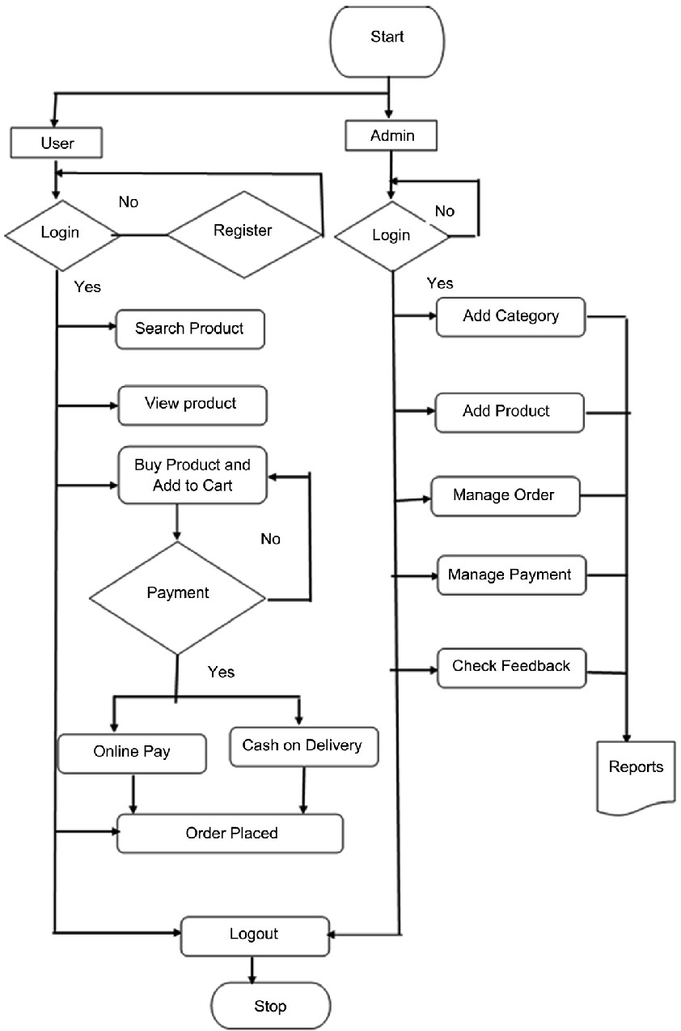

**3. Structure and relationships**

### 3.1 Data Design

Data Structures:

Internal Data Structures:

Supplier Data Structure:

Description: This structure holds information about product suppliers, including their ID, number, name, and address.

Fields:

SID (Supplier ID)

Number

Name

Address

Online Shop Data Structure:

Description: Represents information about online shops, including their name, address, and shop details.

Fields:

Name

Address

Shop

Customer Data Structure:

Description: Stores customer information, including their ID, name, email, number, and password.

Fields:

CID (Customer ID)

Name

Email

Number

Password

Courier Data Structure:

Description: Represents courier services, including their ID, name, address, and phone number.

Fields:

COID (Courier ID)

Name

Address

Phone

Global Data Structures:

Product Data Structure:

Description: Contains details about products, such as their ID, name, description, price, and stock quantity.

Fields:

Product ID

Name

Description

Price

Stock Quantity

Order Data Structure:

Description: Represents order details, including order ID, product ID, courier ID, order date, quantity, delivery status, and customer ID.

Fields:

OID (Order ID)

PID (Product ID)

COID (Courier ID)

Order Date

Quantity

Delivery Status

CID (Customer ID) Temporary Data Structures:

OrderDetails Data Structure:

Description: A temporary data structure that stores information about individual products within an order, including order detail ID, quantity, subtotal, and other related attributes.

These data structures capture the essential information for the entities from the ER diagram. The internal data structures represent details about suppliers, online shops, customers, and couriers. The global data structures include products and orders, which are central to the functionality of the system. The temporary data structure, OrderDetails, is used to manage the product details within an order temporarily.

These structures are interconnected based on the relationships described in the ER diagram. Further details on their interactions and dependencies can be provided through system documentation, code comments, or system architecture diagrams.

3.2 Database Description:

Entities:

1. Supplier**:**

Purpose: Stores information about product suppliers.

Fields:

SID (Primary Key)

Number

Name

Address

Data Types and Constraints: SID: Integer, Auto-increment, Not Null

Number, Name, Address: Text

1. Online Shop:

Purpose: Represents online shops.

Fields:

Name Address

Shop

Data Types and Constraints:

Name, Address, Shop: Text

1. Customer:

Purpose: Stores information about customers.

Fields:

CID (Primary Key)

Name

Email

Number

Password

Data Types and Constraints:

CID: Integer, Auto-increment, Not Null

Name, Email, Number, Password: Text

1. Courier:

Purpose: Represents courier services used for deliveries.

Fields:

COID (Primary Key)

Name

Address

Phone

Data Types and Constraints:

COID: Integer, Auto-increment, Not Null

Name, Address, Phone: Text

1. Order:

Purpose: Records orders placed by customers.

Fields:

OID (Primary Key)

PID

COID

Order Date

Quantity

Delivery Status

CID

Data Types and Constraints:

OID: Integer, Auto-increment, Not Null

PID: Integer, Foreign Key (referencing Products)

COID: Integer, Foreign Key (referencing Courier)

Order Date: Date, Not Null

Quantity: Integer, Not Null

Delivery Status: Text

CID: Integer, Foreign Key (referencing Customer) Relationships:

1. Customer-Order Relationship:

Description: A customer can place multiple orders, but each order is placed by a single customer. This is a one-to-many relationship.

Relationship:

Customer (1) ----< Orders (Many)

1. Order-Product Relationship:

Description: An order can contain multiple products, and a product can be a part of multiple orders (many-to-many).

Relationship:

Orders (Many) ----< OrderDetails (Many) >---- Products (Many)

1. Product-Category Relationship:

Description: Products belong to specific categories, and a category can have multiple products (many-to-many).

Relationship:

Products (Many) ----< Belongs to (Many) >---- Categories (Many)

1. Order-Payment Relationship**:**

Description: An order is associated with one payment, but a payment can be linked to multiple orders (one-to-many).

Relationship:

Orders (1) ----< Payment (Many)

Attributes:

OrderDetails:

Purpose: Stores details of each product in an order.

Fields:

Order Detail ID (Primary Key)

Quantity

Subtotal

Other attributes as needed

Data Types and Constraints:

Order Detail ID: Integer, Auto-increment, Not Null

Quantity: Integer, Not Null Subtotal: Decimal

Other attributes as required

This database structure, based on the ER diagram, provides the foundation for storing data related to customers, suppliers, products, orders, and payments on your online shopping website. Depending on your specific requirements, you may need to further refine and expand this structure, and implement integrity constraints such as primary keys, foreign keys, and data types to ensure data accuracy and consistency.

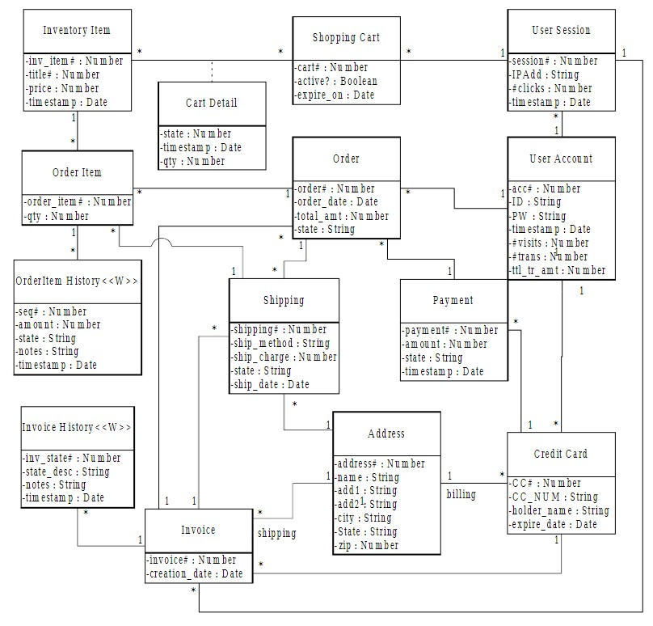

## 4 User Interface Design

### 4.1 Screen images

1. Home Page:

The Home Page is the landing page of the "Khadimart" website.

It provides a visually appealing and user-friendly interface.

Features prominently displayed khadi products, login register and categories.

Users can browse and search for products, view featured items, and access various sections of the website.

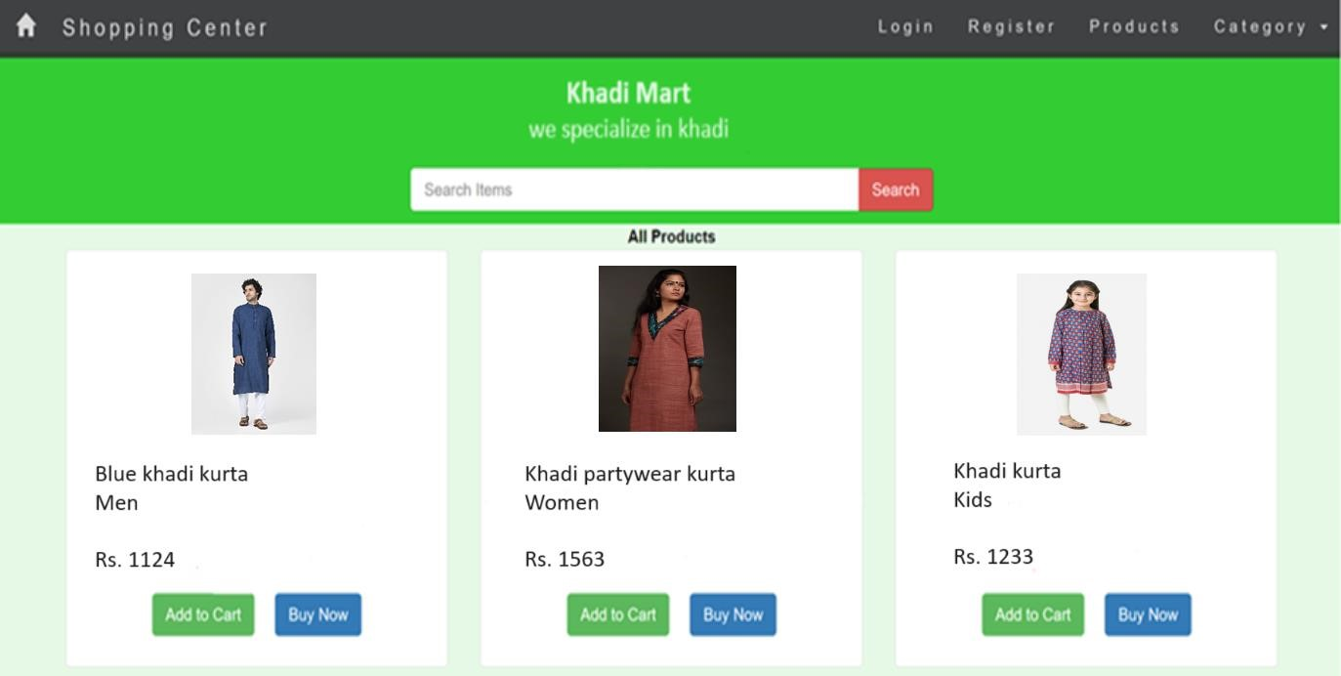

1. Login page

The Login Page allows registered users to log in to their accounts.

Users enter their credentials (email/username and password) to access their accounts.

Provides password recovery options and user-friendly error handling.

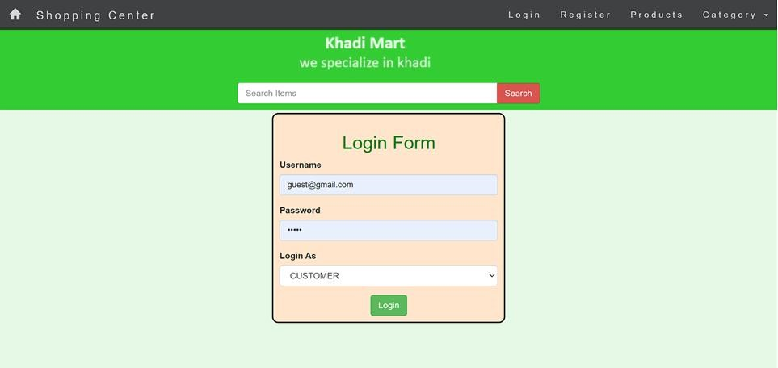

3.Registration Form:

The Registration Form is for new users to create accounts.

It collects essential information such as name, email, password, and contact details.

May include options to sign up using social media accounts for convenience.

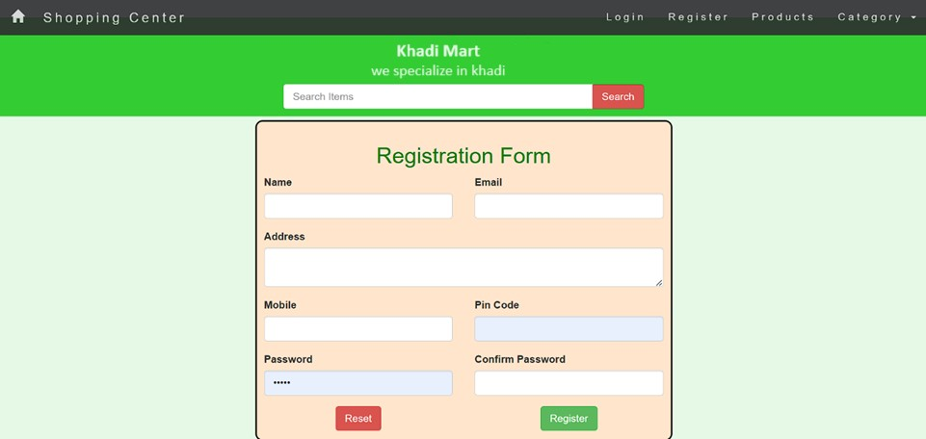

4.User Profile:

The User Profile page allows registered users to manage their account details.

Users can update their personal information, change passwords, and view order history.

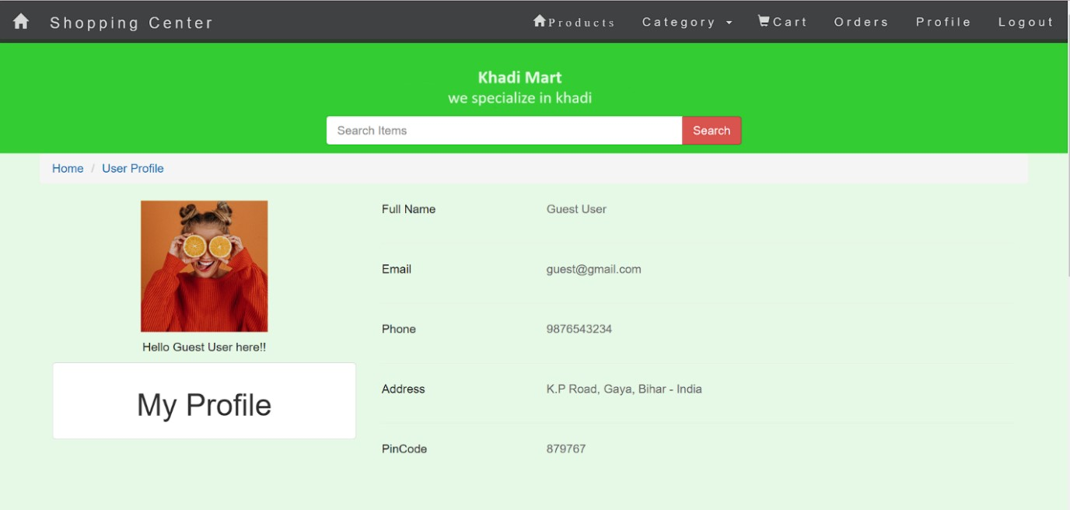

5.Admin Home:

The Admin Home page is a dashboard for administrators or staff responsible for managing the website.

Admins can access tools and features for product management, user management, order processing, and analytics.

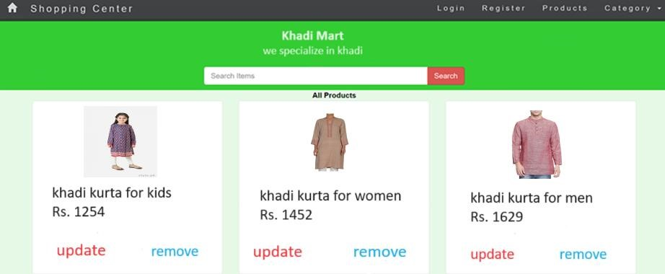

6.Cart Items:

The Cart Items page displays the items added to a user's shopping cart.

Users can review, update, or remove items in their cart.

Shows the total price, and allows users to proceed to checkout.

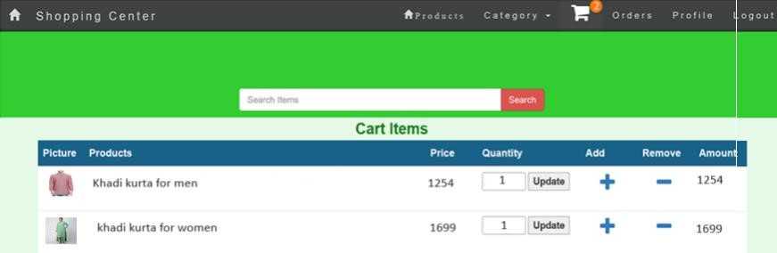

7.Credit Card Payment

The Credit Card Payment Page is a crucial step in the checkout process for users making a purchase on the "Khadimart" website.

Users are directed to this page after reviewing their cart and proceeding to checkout.

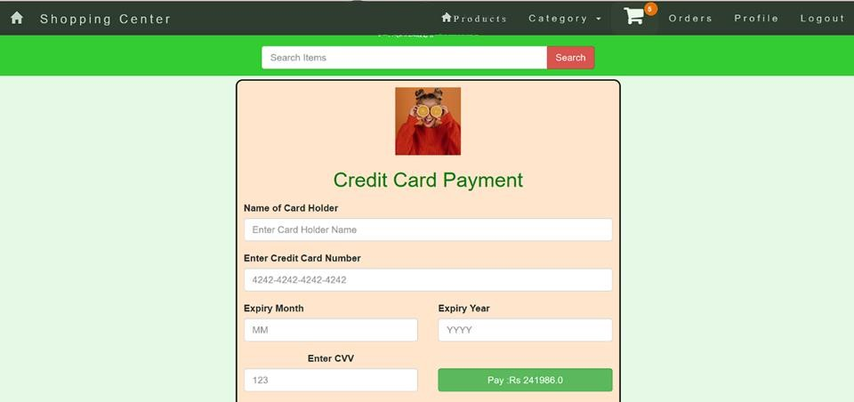

8.Stock Items:

The Stock Items page is an interface for administrators to manage the inventory of khadi products.

Admins can view the current stock, update product details (e.g., price, description), and add new items to the inventory.

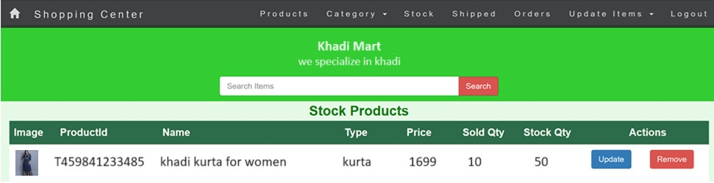

9. Shipped Items:

The Shipped Items page displays orders that have been successfully shipped.

Users can track their shipments and access tracking information.

Provides estimated delivery dates and shipping status updates.

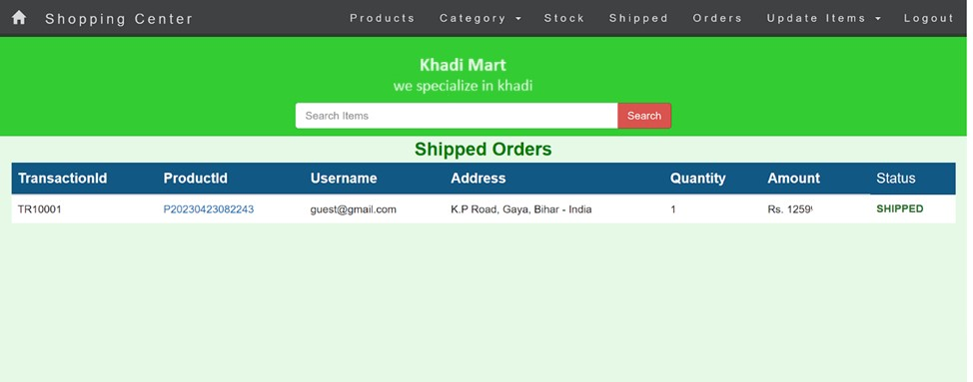

10.Add Product to Stock:

This functionality is part of the admin interface and allows administrators to add new khadi products to the stock.

Admins can input product details, upload images, set pricing, and specify availability.

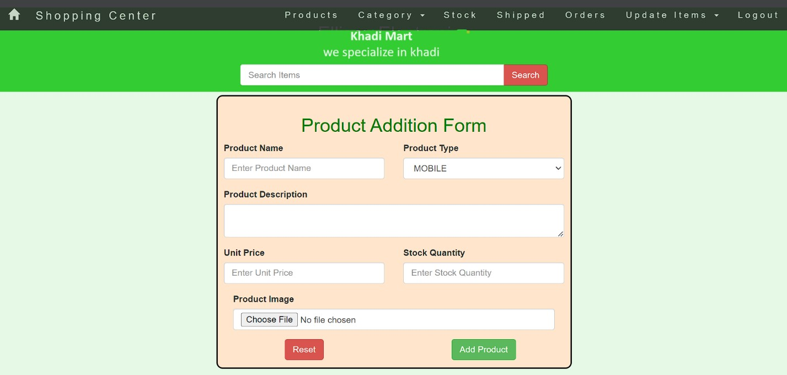

11.Remove Product from Stock:

Also available in the admin interface, this function allows administrators to remove products from the stock.

Admins can select products to be removed, specify reasons (e.g., out of stock, discontinued), and update the stock status.

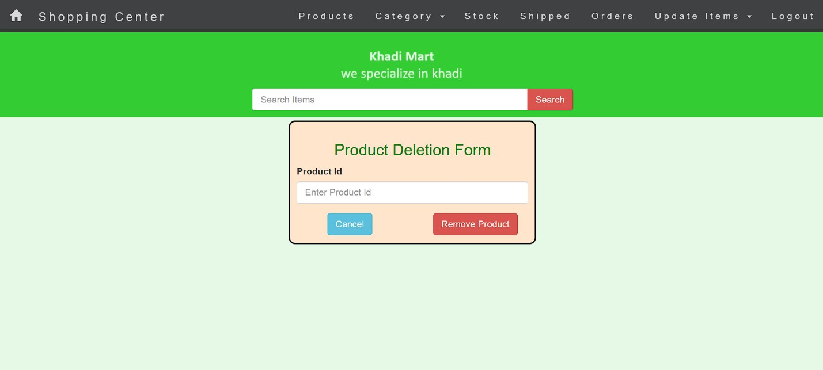

12. Sample Email for order placed

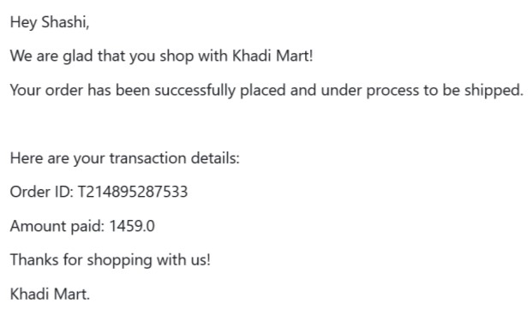

### 5. Types of Tests

1. Unit Tests:

Description: Unit tests are the foundation of the testing pyramid. They are designed to validate that small, isolated piece of code, such as functions or methods, work as expected.

Implementation: Developers write unit tests to validate specific functions, classes, or modules. They use testing frameworks compatible with your programming language, like JUnit for Java, or Mocha for JavaScript. These tests are typically executed on a developer's local machine or a continuous integration (CI) server.

1. System Tests:

Description: System tests are high-level tests that focus on the entire application or system. They ensure that the application functions correctly as a whole, including user interfaces, business logic, and database interactions.

Implementation: System tests simulate real user interactions with the Khadi Mart website. This can include navigating through the website, adding products to the cart, checking out, and more. Tools like Selenium or Cypress are used to automate these tests. They are crucial for ensuring the website's overall functionality.

1. Integration or Regression Tests:

Description: Integration tests check the interactions between different components, while regression tests ensure that new code changes do not introduce new issues or break existing functionality.

Implementation: Integration tests can be automated using tools like Postman (for API testing) or custom scripts that validate data flow between components. Continuous integration and continuous deployment (CI/CD) pipelines are commonly used to run these tests automatically whenever code changes are made, ensuring that new features or fixes don't introduce regressions.

1. Stress Tests:

Description: Stress tests evaluate how the Khadi Mart website performs under extreme conditions, such as heavy user loads or high traffic.

Implementation: Stress testing should ideally be conducted in an environment that matches the target hosting environment, including hardware and configuration. Tools like Apache JMeter or Locust allow you to simulate a large number of concurrent users or requests. This type of testing is critical to identifying performance bottlenecks and ensuring that the system can handle peak loads without issues.

1. Acceptance Tests:

Description: Acceptance tests are user-focused tests that ensure the system meets business requirements and is ready for deployment.

Implementation: Write acceptance tests based on user stories and acceptance criteria. Behaviour-driven development (BDD) tools like Cucumber allow you to define tests in plain language that both technical and non-technical stakeholders can understand. These tests can be executed in the same environment as stress tests and can help validate that the system meets business expectations.

1. Staging for SDS Report:

Description: The staging environment is a replica of the production environment where final testing is conducted before deployment. Preparing the Software Design Specification (SDS) report is essential for documentation.

Implementation: In the staging environment, you should re-run various tests, including unit, integration, and acceptance tests, to ensure that the system is ready for production. Once the tests are successfully completed, you can create the SDS report, documenting the architecture, design, and testing outcomes. The SDS report is crucial for understanding and maintaining your system.

These testing phases, when executed properly, help identify and resolve issues at various stages of development, ensuring that your Khadi Mart shopping website is robust, reliable, and aligns with the desired specifications and requirements. It's essential to have a well-structured testing strategy in place, and documenting the results, especially in the SDS report, helps in ensuring transparency and traceability throughout the development and deployment process.

6.References:

<https://opus.govst.edu/cgi/viewcontent.cgi?article=1079&context=capstones>

[https://creately.com/diagram/example/hzvi5flu/er-diagram-for-online-shoppingsystem](https://creately.com/diagram/example/hzvi5flu/er-diagram-for-online-shopping-system) <https://www.slideshare.net/rabartkurrey/se-dfdr-ep><https://www.lucidchart.com/pages/uml-component-diagram><https://www.geeksforgeeks.org/types-software-testing/>