PROJECT REPORT
CardioVision
AI-ML Coronary Digital Twin
Vessel-level cardiovascular risk prediction, explanation and 3D visualization
Name | Ojaswi Srivastava
Roll No. | 2024008979
Serial No. | 14
Course | Machine Learning
Submitted to | Dr. Himadri B.G.S Bhuyan
Project context | Machine Learning Project
October 2026
For educational and decision-support purposes only. Not a clinical diagnosis.

Abstract
Cardiovascular disease remains a leading cause of death worldwide, and most risk tools return only a number that does not show where in the heart the problem lies. CardioVision is an interactive “digital twin” of the coronary arteries. From 55 demographic, clinical-examination, ECG, laboratory and echocardiographic measurements it predicts overall coronary artery disease (CAD) and the stenosis risk of the three main arteries (LAD, LCX and RCA), explains every prediction with SHAP, and renders the result on a 3D heart whose arteries glow and carry animated blood flow in proportion to the predicted risk.
The models are trained on the 303-patient Z-Alizadeh Sani dataset with all label-leaking columns removed. On a held-out test set of 61 patients they reach a ROC-AUC of 0.88 for CAD and 0.72 to 0.79 for the individual arteries. Beyond accuracy, the system adds calibrated probabilities, a logically coherent CAD risk, conformal uncertainty, a leakage audit, a data-modality ablation and a decision-curve analysis, so that the limits of the model are visible instead of hidden. CardioVision is an educational decision-support prototype, not a diagnostic device.
Keywords: coronary artery disease, explainable AI, SHAP, calibration, conformal prediction, 3D visualization, digital twin.

Contents
Abstract.................................................................................................1
1. Motivation............................................................................................3
2. Objectives............................................................................................4
3. Dataset and Problem Formulation.......................................................................5
4. Workflow..............................................................................................6
4.1 Overview.............................................................................................6
4.2 Data preparation.....................................................................................6
4.3 Model selection and validation.......................................................................6
4.4 Calibration, coherent risk and uncertainty...........................................................7
4.5 Explainability.......................................................................................7
4.6 3D visualization pipeline............................................................................7
4.7 Application architecture.............................................................................8
5. Implementation and Code...............................................................................9
6. Demonstration.........................................................................................10
6.1 The anatomical journey...............................................................................10
6.2 Entering a patient and reading the result............................................................10
6.3 Inspecting one artery................................................................................11
6.4 Why did the AI say that?.............................................................................12
6.5 Low risk versus high risk............................................................................12
6.6 Risk simulation......................................................................................13
6.7 Trust panel, report and disclaimer...................................................................14
7. Results...............................................................................................15
7.1 Predictive performance...............................................................................15
7.2 Leakage audit........................................................................................16
7.3 Which data modalities matter?........................................................................16
7.4 Coherence, calibration and uncertainty...............................................................16
7.5 Is the model clinically useful? Decision-curve analysis..............................................17
7.6 Discussion...........................................................................................17
8. Limitations and Future Work...........................................................................18
9. Conclusion............................................................................................19
References...............................................................................................20
Appendix A: How to run...................................................................................21

1. Motivation
Cardiovascular disease is one of the biggest causes of death in the world. Statistical models can already produce a risk percentage, but a raw number gives clinicians and patients very little intuition about where and why the risk arises. Coronary artery disease is, in the end, a spatial problem: plaque narrows specific arteries that supply specific parts of the heart muscle.
This project was built for the Multimodal AI Hackathon 2026 (IIT Mandi, Track A) and addresses three gaps that we observed in typical risk-prediction demos:
- A number hides the where. A single probability does not tell which artery is most at risk. We predict each of the three main arteries separately and show them on an anatomical model.
- Black boxes are hard to trust. In medicine a prediction is only useful if its reasons can be questioned. Every prediction is therefore explained feature by feature.
- Small data demands honesty. With only 303 patients it is easy to over-claim. We remove target leakage, validate with repeated cross-validation, calibrate the probabilities, report confidence intervals and flag predictions the model is unsure about.
The result is meant as a teaching and decision-support tool: it shows how clinical measurements, machine learning and 3D anatomy can be combined into a single interactive experience.

2. Objectives
The overall objective is to turn clinical measurements into a risk picture that a clinician can see, question and trust. This is broken down into the following specific objectives:
- Train classification models that predict overall CAD status and the stenosis status of the LAD, LCX and RCA from demographic, examination, ECG, laboratory and echocardiographic features.
- Exclude LAD, LCX, RCA and Cath from the model inputs to prevent target leakage, and prove that this matters.
- Evaluate with accuracy, precision, recall, F1-score and ROC-AUC, using a validation method that is robust for a small dataset.
- Explain every prediction with SHAP and show the patient’s own measurements next to their contribution.
- Render an interactive 3D human torso and heart whose coronary arteries change colour, glow and blood-flow speed according to the predicted probabilities, with rotate, zoom and artery selection.
- Provide a clinical-dashboard experience (new-patient test form, risk simulation, printable report) and a visible safety disclaimer.
- Keep the system lightweight enough to run in a normal browser without a dedicated GPU, and extensible without a redesign.

3. Dataset and Problem Formulation
We use the Extension of Z-Alizadeh Sani Dataset from the UCI Machine Learning Repository (dataset id 411), which is also available on Kaggle. It contains 303 patient records collected at a single centre. Each record has 55 input features from four modalities and four target labels.
Modality | Examples of features
Demographic and history | age, weight, BMI, sex, diabetes, hypertension, smoking, family history
Symptoms and examination | blood pressure, pulse rate, typical chest pain, dyspnea, murmurs, oedema
ECG | ST elevation, ST depression, T inversion, LVH, Q wave, bundle branch block
Laboratory and echo | fasting glucose, lipids (LDL, HDL, TG), creatinine, ESR, ejection fraction, region with RWMA
Table 1: Data modalities and example features.
CAD in this dataset means at least 50% narrowing of one or more of the major coronary vessels. The targets and their prevalence in the full dataset are:
Target | Meaning | Positive cases
CAD | Overall coronary artery disease | 71.3%
LAD | Left Anterior Descending: supplies the front of the heart | 58.4%
LCX | Left Circumflex: supplies the side and back | 39.3%
RCA | Right Coronary Artery: supplies the right side and bottom | 37.6%
Table 2: Prediction targets and their prevalence.
Target leakage. The dataset also contains the columns LAD, LCX, RCA and Cath, which are the answers themselves. Following the problem statement, they are removed from the inputs of every model. Section 7 shows how misleading the results would be otherwise.
What the model does not do. The features, including the echocardiographic finding “region with RWMA”, are not anatomical coordinates and do not give a lesion map. CardioVision therefore predicts vessel-level risk statistically and then visualizes it on the corresponding artery. It never claims to have found a blockage at an exact location.

4. Workflow

4.1 Overview
The system has two halves that meet in a small web API. The machine-learning half turns a patient record into calibrated, explained, uncertainty-aware risks. The visualization half turns those risks into a living 3D heart.
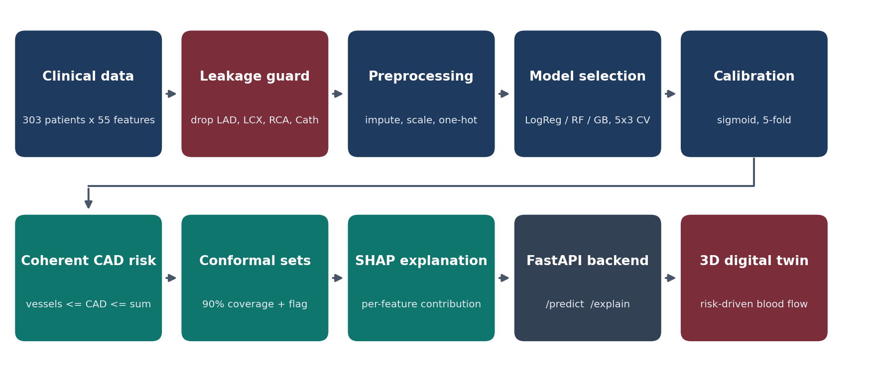
Figure 1: End-to-end workflow of CardioVision.

4.2 Data preparation
The 303 records are split once into a training set (242 patients, 80%) and an untouched test set (61 patients, 20%), stratified on CAD with a fixed random seed. Numeric features are median-imputed and standardized; categorical features are most-frequent-imputed and one-hot encoded. All preprocessing is inside a scikit-learn pipeline, so it is fitted on training folds only.
leak = ves + [c for c in df.columns if c.lower() in ("cath", "cad")]
X = df.drop(columns=leak)
tr, te = train_test_split(np.arange(len(X)), test_size=0.2, stratify=Y.CAD, random_state=SEED)

4.3 Model selection and validation
For each of the four targets we compare three model families: Logistic Regression, Random Forest and Gradient Boosting. The winner is chosen by repeated stratified 5-fold cross-validation (3 repeats) on the training set, using ROC-AUC. Different targets may choose different models: Gradient Boosting was chosen for CAD and Random Forest for LAD, LCX and RCA.
def candidates(X):
mk = lambda est: Pipeline([("p", prep(X)), ("m", est)])
return {"logreg": mk(LogisticRegression(C=0.5, max_iter=3000, class_weight="balanced")),
"rf": mk(RandomForestClassifier(400, min_samples_leaf=2, class_weight="balanced_subsample", random_state=SEED, n_jobs=-1)),
"hgb": mk(HistGradientBoostingClassifier(max_depth=3, learning_rate=0.05, max_iter=150, random_state=SEED))}

4.4 Calibration, coherent risk and uncertainty
Calibration. The probabilities shown to the user must mean what they say, so each chosen model is wrapped in a sigmoid calibrator (5-fold) and the calibration curve is checked on out-of-fold predictions.
Coherent CAD risk. By definition, a patient has CAD if at least one vessel is stenotic. The CAD probability must therefore be at least the largest vessel probability and at most their sum. The raw CAD model violated this for 6.6% of the test patients; the coherence step projects the probability into the valid range.
Conformal uncertainty. Using split-conformal prediction on out-of-fold scores, each prediction receives a set of plausible outcomes with a 90% coverage target. If the set contains both outcomes the prediction is labelled uncertain, and the artery in the 3D view pulses to show it. A screening threshold (the highest threshold that keeps recall at or above 0.85) is also stored for each target.
def conformal_q(y, p, alpha=ALPHA):
s = np.where(y == 1, 1 - p, p) # nonconformity = 1 - prob of the true class
k = min(np.ceil((len(s) + 1) * (1 - alpha)) / len(s), 1.0)
return float(np.quantile(s, k, method="higher"))

def conf_report(y, p, q):
in_set = np.where(y == 1, 1 - p <= q, p <= q)
both = (1 - p <= q) & (p <= q)
none = (1 - p > q) & (p > q)
return {"q": q, "coverage": float(in_set.mean()), "uncertain_rate": float(both.mean()), "abstain_rate": float(none.mean())}

def coherent(p_cad, P):
"""CAD <=> at least one vessel stenotic, so max(P_vessel) <= P(CAD) <= min(1, sum P_vessel)."""
return np.minimum(np.maximum(p_cad, P.max(1)), np.minimum(1.0, P.sum(1)))

4.5 Explainability
SHAP values are computed with a permutation explainer directly on the raw clinical features, so each contribution belongs to one understandable measurement (for example “Typical Chest Pain = 1: +10.3 percentage points”). The dashboard shows the patient’s value beside each contribution, plus totals by modality (demographic, symptoms, ECG, laboratory and echo).

4.6 3D visualization pipeline
- Anatomy. The coronary arteries come from BodyParts3D (35 separate OBJ parts, merged into named LAD, LCX and RCA groups; left main stem and posterior interventricular artery are kept neutral because they depend on coronary dominance). A realistic heart shell and a human body base mesh were decimated and re-oriented. The heart shell was shrink-wrapped onto the arteries so that the vessels sit on its surface. The ribcage and lungs are procedural.
- Blood flow that follows the artery. For every artery vertex we pre-compute the geodesic distance from the aortic root along the mesh. A fragment shader moves bright “packets” along this distance, so the flow follows the real branching geometry.
- Risk drives the look. Risk controls flow speed (about 40 times faster at high risk), packet density, glow and colour heat, plus a heartbeat-like pulse for high risk. Artery identity colours are fixed: LAD amber, LCX violet, RCA cyan.
- Territories. The heart shell is softly tinted by the approximate supply area of each artery (geometric proximity), scaled by that artery’s predicted risk. This is explicitly not a lesion map.
- Interaction. Rotate, zoom, pan, an XYZ gizmo that snaps the view, a heart-size slider, layer toggles and click-to-focus on an artery.

4.7 Application architecture
A FastAPI backend loads the trained artefacts and exposes three endpoints: /api/meta (feature schema, examples, metrics), /api/predict (calibrated, coherent probabilities with uncertainty status and out-of-range warnings) and /api/explain (SHAP). The front end is a single HTML page using three.js, served by the same process. The feature form, sliders and explanations are generated from the stored schema, so new clinical features or models need no redesign.

5. Implementation and Code
The complete source code is organised as follows.
File | Purpose
train.py | Leakage guard, preprocessing, model selection by repeated CV, calibration, coherence, conformal sets, test metrics; saves model and metrics
analyze_extra.py | Modality ablation and decision-curve analysis
app.py | FastAPI backend: /api/meta, /api/predict, /api/explain; serves the dashboard
static/index.html | Dashboard and three.js 3D scene: shaders, intro animation, form, simulation, report
tools/make_flow.py, make_territory.py | Bake artery flow distances and heart territory weights
static/*.glb | Coronary tree, heart shell and body meshes
run.bat / run.sh | One-command setup and launch
Table 3: Project files and their purpose.
Prediction endpoint. The backend returns, for every target, the calibrated probability, the conformal status and whether the screening threshold is exceeded. It also warns when an input lies outside the range seen in training.
@app.post("/api/predict")
def predict(r: Req):
X = one(r.features)
p = {t: float(B["models"][t].predict_proba(X)[0, 1]) for t in T}
vp = np.array([p[v] for v in V])
p["CAD"] = float(np.clip(p["CAD"], vp.max(), min(1.0, vp.sum()))) # CAD <=> any vessel stenotic
out = {}
for t in T:
k = "CAD_coh" if t == "CAD" else t
s = [c for c, pc in ((0, 1 - p[t]), (1, p[t])) if 1 - pc <= B["conformal_q"][k]]
status = "uncertain" if len(s) == 2 else "abstain" if not s else "elevated" if s == [1] else "not elevated"
out[t] = {"p": p[t], "status": status, "above_screen_threshold": p[t] >= B["thresholds"][k]}
out["warnings"] = [{"f": c, "value": float(r.features[c]), "min": SPEC[c]["min"], "max": SPEC[c]["max"]}
for c in F if c in NUM and c in r.features and not SPEC[c]["min"] <= float(r.features[c]) <= SPEC[c]["max"]][:5]
return out

Risk-driven blood flow (GLSL excerpt). The fragment shader converts the predicted risk into speed, packet density and glow:
float k = smoothstep(0., 1., uRisk); // predicted risk -> 0..1 intensity
float sp = mix(.08, 3.2, k*k); // flow speed (about 40x range)
float fr = mix(1.1, 4.2, k); // packet density
float ph = fract(vF*fr - uTime*sp); // vF = distance along the artery
float band= smoothstep(0., .06, ph) * (1. - smoothstep(.06, mix(.5,.18,k), ph));
float gl = mix(.1, 2.4, k*k) * beat; // glow, pulsing at high risk
col += mix(uBase, uHot, k*.7) * gl * (band*1.6 + rim*.45);

Technology stack. Python (scikit-learn, pandas, SHAP, FastAPI), JavaScript (three.js, WebGL), GLSL shaders; meshes in glTF. The system runs on a normal laptop CPU/integrated GPU.

6. Demonstration
This section walks through a typical session. All figures are screenshots of the running application.

6.1 The anatomical journey
When the application opens, the camera dives from the whole body, through the skin and ribcage, to the heart; the coronary arteries light up and the AI analysis is initialized.
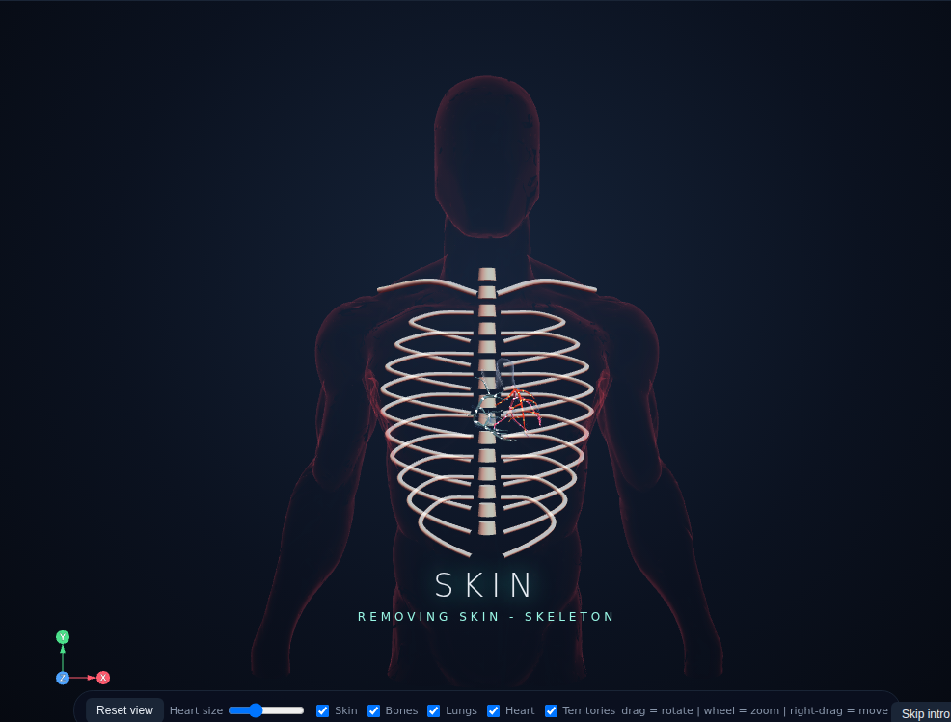 | 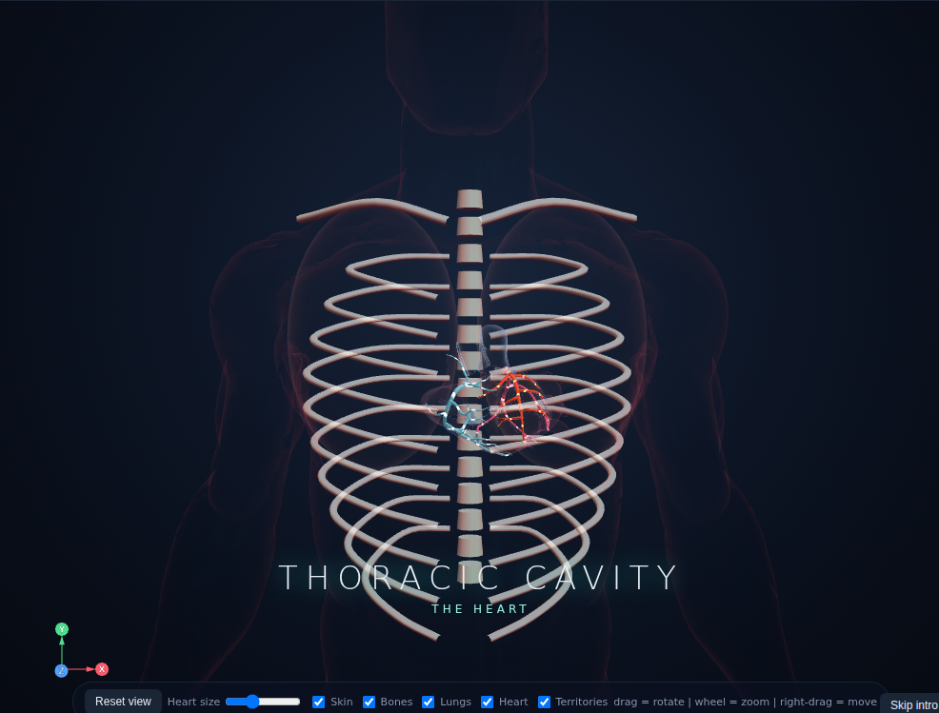 | 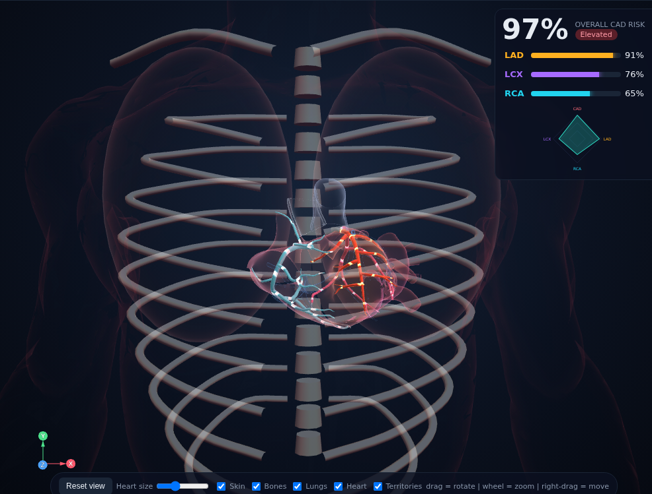
Figure 2: The cinematic introduction: body, skeleton, then heart and coronary arteries.

6.2 Entering a patient and reading the result
The “Test for new patients” card holds all 55 features, grouped by modality, with Low-, Medium- and High-risk examples (the active example is highlighted). After ANALYZE PATIENT the overall CAD risk and the three vessel risks appear next to the 3D heart. A risk fingerprint summarizes the four probabilities, and a banner appears if any input is outside the range the model was trained on.
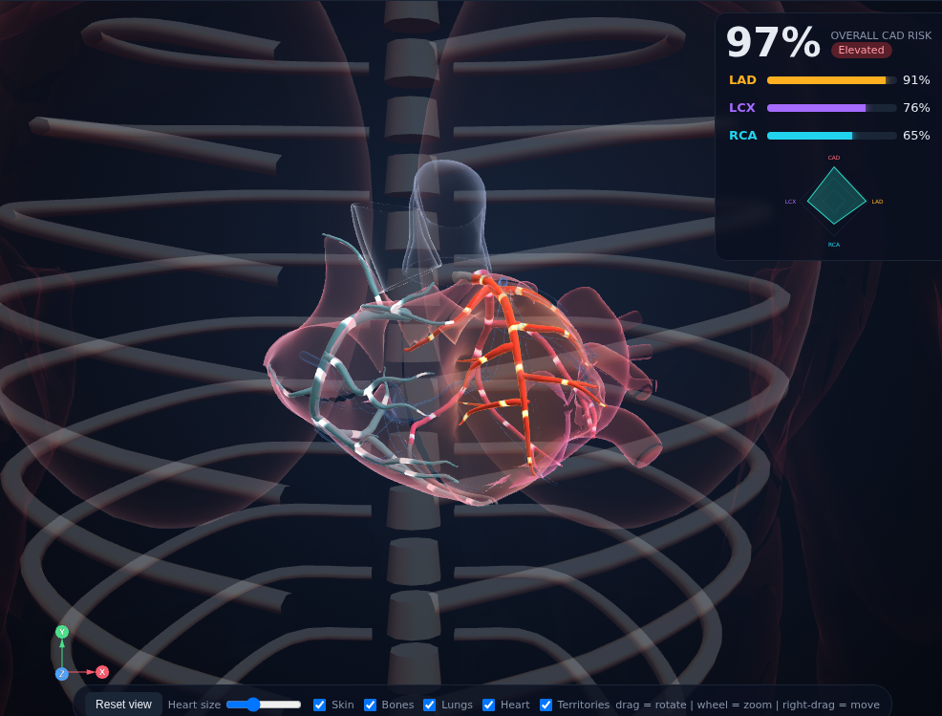
Figure 3: High-risk example. Arteries are colour-coded by vessel (LAD amber, LCX violet, RCA cyan); flow speed, glow and heat show the predicted risk.
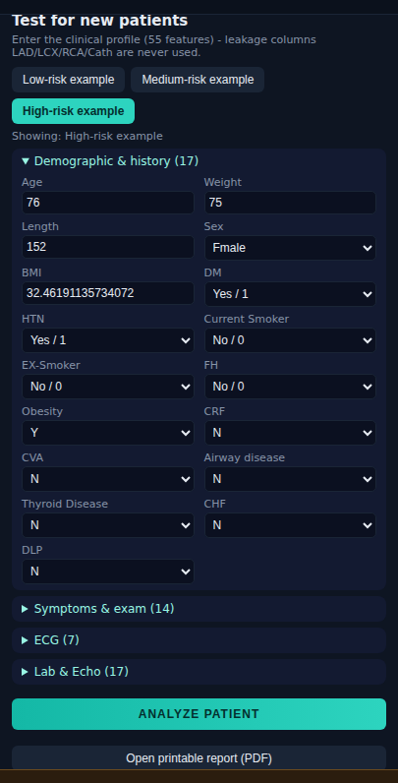
Figure 4: The new-patient form (first group shown).

6.3 Inspecting one artery
Clicking an artery (or its row in the risk panel) makes the camera fly to it and dims the others. The other two arteries stay visible so that their relative risk is still readable.
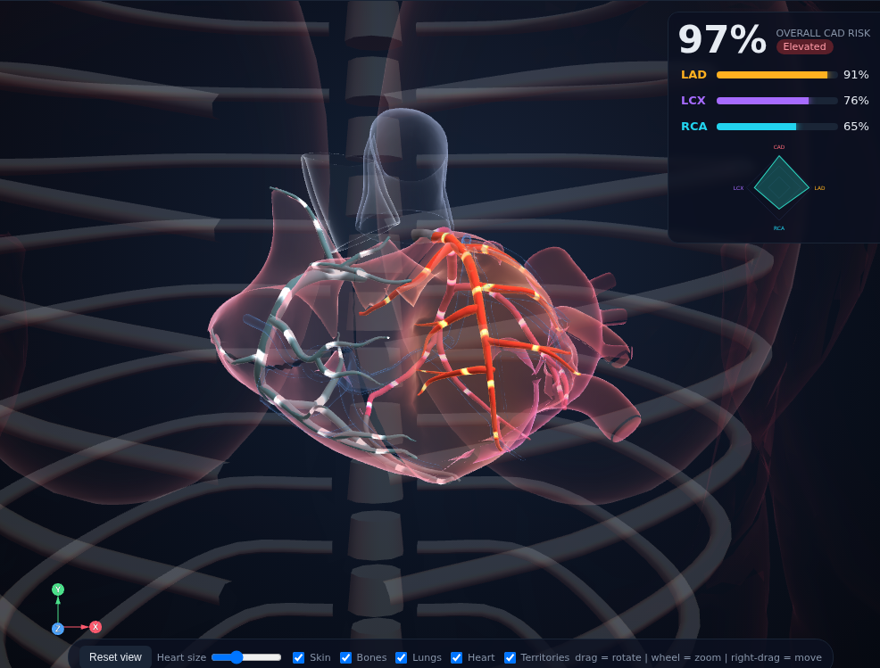
Figure 5: Focus on the LAD for the high-risk example.

6.4 Why did the AI say that?
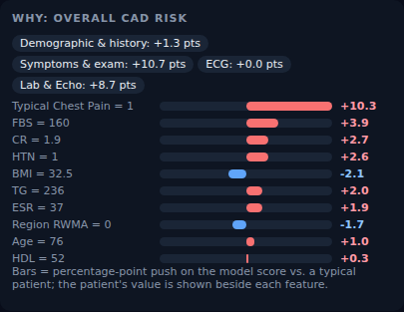
Figure 6: SHAP explanation for overall CAD risk: each bar is the push of one feature in percentage points, with the patient’s value beside it and totals by modality on top.

6.5 Low risk versus high risk
Loading the Low-risk example makes the same arteries calmer: slower and dimmer flow, no heat, and a lower CAD risk.
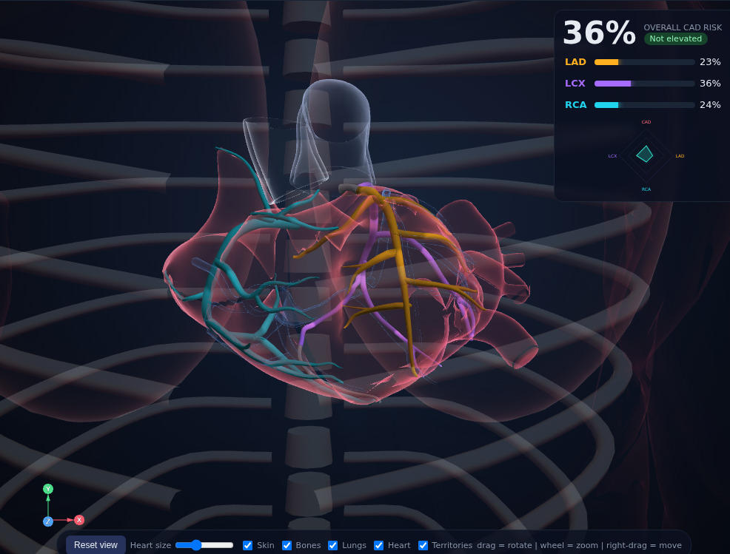
Figure 7: Low-risk example (overall CAD risk 36%).

6.6 Risk simulation
The simulation card lets the user move modifiable measurements (blood pressure, glucose, lipids, weight) and press SIMULATE. A before/after table shows the model’s response and the 3D heart updates. This is an educational what-if about the model, not a prediction that changing a value will reduce a real patient’s risk, and not treatment advice.
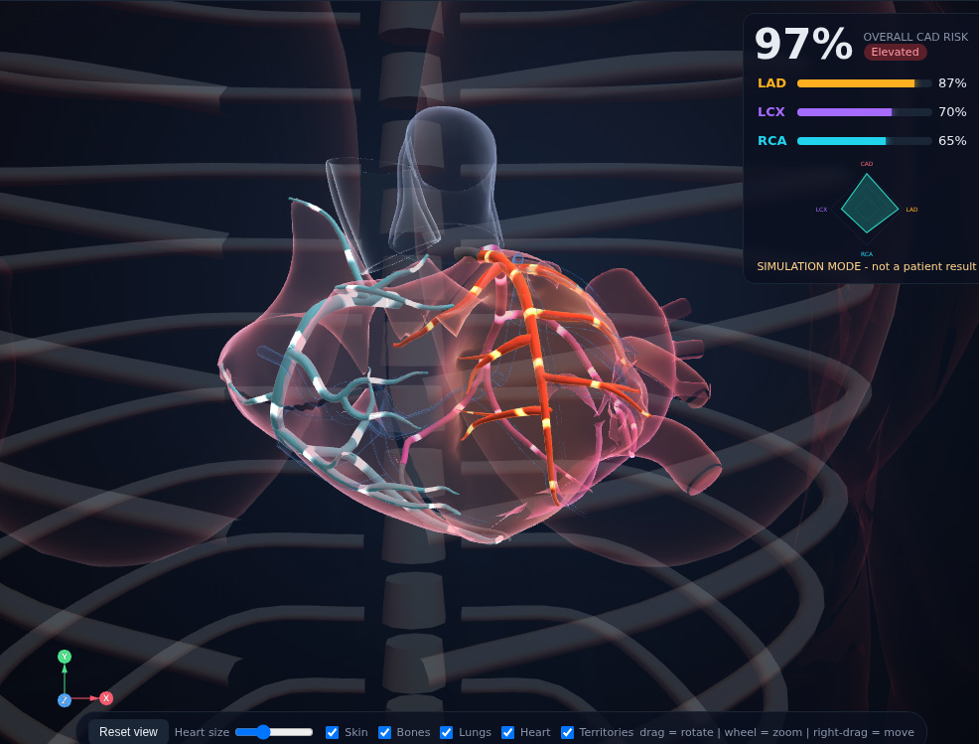
Figure 8: The 3D view in simulation mode after lowering blood pressure and LDL.

6.7 Trust panel, report and disclaimer
A trust panel reports the held-out test metrics, the leakage audit, the modality ablation, a decision curve and a calibration plot. The “Open printable report” button creates a one-page report (risk table, 3D snapshot, main factors, patient inputs and the disclaimer) that can be saved as PDF. A clear safety disclaimer is permanently visible at the bottom of the screen.

7. Results

7.1 Predictive performance
Table 4 shows the results on the held-out test set (61 patients) at the default threshold of 0.5. CAD is predicted well. Vessel-level prediction is harder: with 303 patients and clinical features that are only indirectly related to individual arteries, ROC-AUC is between 0.72 and 0.79.
Target | Accuracy | Precision | Recall | F1 | ROC-AUC [95% CI] | Brier
CAD | 0.84 | 0.82 | 0.98 | 0.89 | 0.88 [0.78, 0.96] | 0.132
LAD | 0.67 | 0.67 | 0.82 | 0.74 | 0.79 [0.67, 0.89] | 0.186
LCX | 0.70 | 0.72 | 0.50 | 0.59 | 0.72 [0.59, 0.85] | 0.214
RCA | 0.67 | 0.50 | 0.35 | 0.41 | 0.75 [0.63, 0.88] | 0.191
Table 4: Test-set metrics (threshold 0.5). Brier score: lower is better.
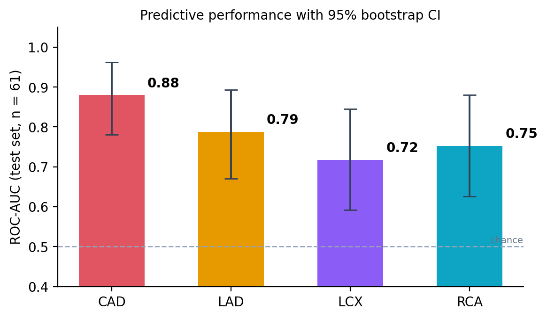
Figure 10: Test ROC-AUC with 95% bootstrap confidence intervals.
Screening thresholds. At a threshold of 0.5, recall for LCX and RCA is low. Choosing, for each target, the highest threshold that keeps recall at or above 0.85 on out-of-fold data raises the test recall to 0.86 (CAD), 0.79 (LAD), 0.81 (LCX) and 0.90 (RCA), at the price of lower precision (0.88, 0.69, 0.51 and 0.45).
Model selection. Cross-validated ROC-AUC on the training set (5-fold, 3 repeats) for the three model families:
Target | Logistic Regression | Random Forest | Gradient Boosting | Chosen
CAD | 0.923 | 0.924 | 0.925 | Gradient Boosting
LAD | 0.820 | 0.857 | 0.828 | Random Forest
LCX | 0.662 | 0.749 | 0.724 | Random Forest
RCA | 0.697 | 0.701 | 0.672 | Random Forest
Table 5: Cross-validated ROC-AUC of the candidate models.

7.2 Leakage audit
If the vessel labels were left in as input features, the cross-validated CAD ROC-AUC would be 0.99, an artefact, compared with the honest 0.92 after removing them. This is why the problem statement requires removing LAD, LCX, RCA and Cath.
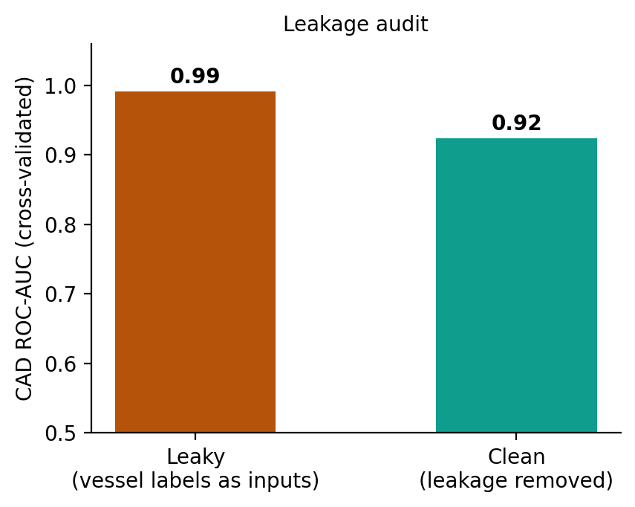
Figure 11: Leakage audit for CAD.

7.3 Which data modalities matter?
Adding modalities one at a time shows that each contributes. For CAD, the cross-validated ROC-AUC rises from 0.75 (demographics and history only) to 0.87 (adding symptoms and examination), 0.88 (ECG) and 0.92 (laboratory and echo). The benefit is smaller for LCX and RCA, which are the hardest targets.
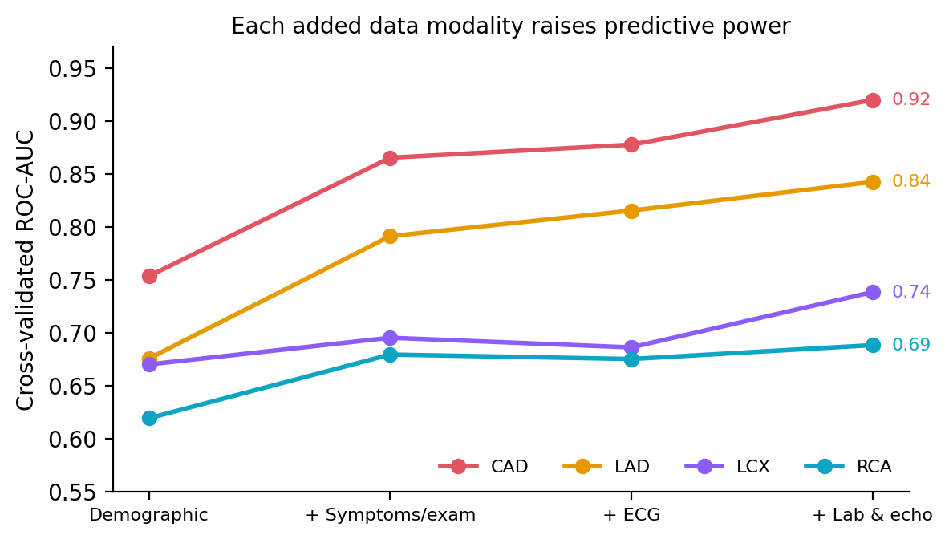
Figure 12: Cross-validated ROC-AUC as data modalities are added (echo findings are grouped with laboratory data).

7.4 Coherence, calibration and uncertainty
- Coherence. The raw CAD model assigned a lower probability than at least one vessel for 6.6% of test patients. After the coherence step this cannot happen, with essentially unchanged quality (ROC-AUC 0.876 to 0.880, Brier 0.131 to 0.132).
- Calibration. The out-of-fold reliability curve follows the diagonal closely for CAD, so a displayed 70% risk corresponds to about 70% observed frequency in this dataset.
- Uncertainty. The 90% conformal sets achieved test coverage of 0.87 (CAD), 0.92 (LAD), 0.87 (LCX) and 0.97 (RCA). The model labels 13% of CAD predictions as uncertain, but 48% to 62% of vessel predictions, an honest reflection of how hard vessel-level prediction is on this data.

7.5 Is the model clinically useful? Decision-curve analysis
The decision curve compares the net benefit of flagging patients above a risk threshold against flagging everyone. Because 70% of the patients have CAD, flagging everyone is a strong baseline at low thresholds, where the model is only equal to it. At higher thresholds the model is clearly better (for example, net benefit 0.54 versus 0.41 at a threshold of 0.5, and 0.44 versus 0.16 at 0.65). With only 61 test patients this curve is indicative, not conclusive.
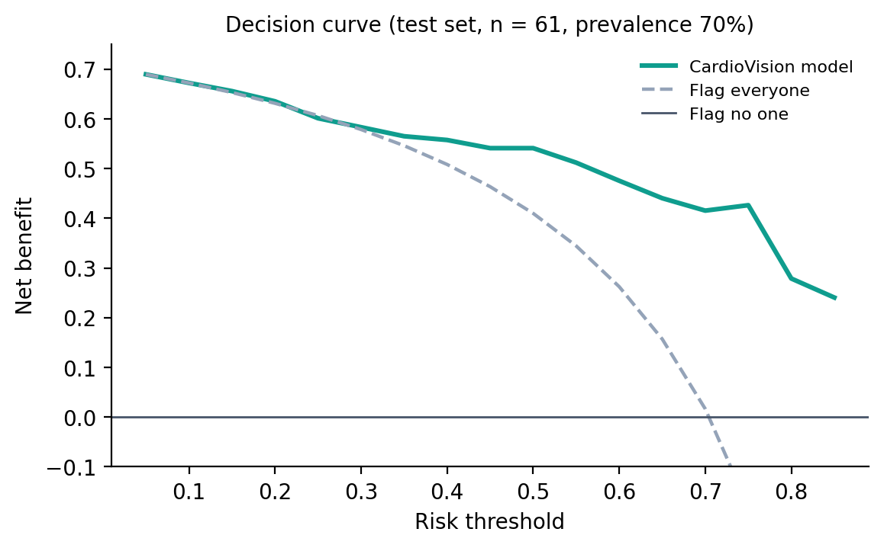
Figure 13: Decision curve on the test set.

7.6 Discussion
The results show a clear pattern: overall CAD can be predicted from routine clinical data with good accuracy, and every modality helps, whereas predicting which individual artery is narrowed is much harder and remains modest. Rather than hiding this, CardioVision surfaces it through confidence intervals, uncertainty flags and the trust panel. This honesty is a deliberate design goal.

8. Limitations and Future Work
Limitations
- Only 303 patients from a single centre; no external validation. The 61-patient test set gives wide confidence intervals.
- Vessel-level ROC-AUC is modest (0.72 to 0.79) and LCX and RCA recall at the default threshold is low.
- The coronary tree, heart shell and body come from different sources and are fitted approximately; the ribcage is procedural. The assignment of artery parts to LAD, LCX and RCA follows anatomical part names and has not been reviewed by a clinician.
- Artery territories on the heart are geometric approximations, not a clinically derived myocardial supply map.
- The what-if simulation reflects the model’s sensitivity, not causal effects of treatment.
Future work
- Validate on data from other hospitals and add more patients.
- Add imaging (for example CT angiography) as an additional modality, which is the natural next step for a multimodal system.
- Have the anatomy mapping and territories reviewed by a cardiologist.
- Evaluate prospectively before any clinical use; this prototype is for education and decision support only.

9. Conclusion
CardioVision shows how clinical measurements, machine learning and 3D anatomy can be combined into a single interactive tool. It predicts overall CAD and the risk of each main coronary artery from 55 features, explains each prediction, says when it is unsure, and presents the outcome on a 3D heart where blood flow speed, glow and heat follow the predicted risk. Overall CAD is predicted well (ROC-AUC 0.88), while vessel-level prediction (0.72 to 0.79) is limited by the size of the dataset, a limitation the system reports openly. The leakage audit, modality ablation, calibration, conformal uncertainty and decision-curve analysis give a reviewer the evidence needed to judge the results for themselves.
Safety statement. Predictions are for decision support and educational purposes only and are not a substitute for formal diagnostic imaging or professional medical evaluation.

References
- UCI Machine Learning Repository. Extention of Z-Alizadeh Sani Dataset (dataset id 411). https://archive.ics.uci.edu/dataset/411
- Alizadehsani, R. et al. Z-Alizadeh Sani coronary artery disease dataset, UCI Machine Learning Repository.
- Pedregosa, F. et al. Scikit-learn: Machine Learning in Python. Journal of Machine Learning Research 12, 2825-2830 (2011).
- Lundberg, S. M. and Lee, S.-I. A Unified Approach to Interpreting Model Predictions. Advances in Neural Information Processing Systems 30 (2017).
- Vovk, V., Gammerman, A. and Shafer, G. Algorithmic Learning in a Random World. Springer (2005).
- Vickers, A. J. and Elkin, E. B. Decision curve analysis: a novel method for evaluating prediction models. Medical Decision Making 26, 565-574 (2006).
- Mitsuhashi, N. et al. BodyParts3D: 3D structure database for anatomical concepts. Nucleic Acids Research 37, D782-D785 (2009). Licensed CC BY-SA 2.1 Japan.
- three.js, JavaScript 3D library. https://threejs.org
- Body base mesh “Anatomy Study 2.0” and heart mesh “Realistic human heart”: credit the original authors and licences listed on their source pages.

Appendix A: How to run
On Windows, download the project zip, then paste the following into the command prompt (cmd). The script finds or installs Python, creates a private environment, installs the packages, starts the server and opens the browser at http://localhost:7860.
cd "%USERPROFILE%\Downloads" && tar -xf cardiovision.zip && cd cardiovision && run.bat

To retrain the models: python train.py --data "<dataset>.xlsx", then python analyze_extra.py --data "<dataset>.xlsx".

