CRM Application to Manage the Services offered by an Institution

Description :
A CRM application to manage the services offered by an institution like EduConsultPro Institute is a comprehensive solution designed to streamline and enhance the management of admissions, student inquiries, and expert consulting services. As the institute grows and attracts more prospective students, the need for an efficient system becomes paramount. This CRM integrates various processes, enabling the institution to automate application submissions, manage student inquiries, and handle consulting requests all within a single platform. By capturing detailed information about prospective students and automating key tasks such as follow-up communications and status tracking, the CRM ensures a seamless and responsive experience for both students and staff. Additionally, it supports the management of consulting services and immigration cases, providing a centralized, organized approach that enhances operational efficiency and improves the overall quality of service. This tailored CRM solution ultimately allows EduConsultPro Institute to focus on delivering an exceptional educational experience while maintaining high standards of professionalism and care in every interaction.

Tasks

Task-1: Creating Objects from Spreadsheet

1. Creating Objects from Spreadsheet
1. Create the Course Object

1. Access Object Manager:
○. Navigate to Setup in Salesforce and search for Object Manager.
○. Select Create Object from Spreadsheet.

2. Upload Spreadsheet:
○. Download the provided Course spreadsheet.
○. Upload the file in Salesforce and map the fields from the spreadsheetto Salesforce fields.
○. Complete the upload to create the Course object.

2. Create Additional Objects
1. Repeat the steps in 1.1 for each of the following objects:
1. ○. Consultant (using Consultant spreadsheet)
○. Student (using Student spreadsheet)
○. Appointment (using Appointment spreadsheet)

2. Creating Relationships Among Objects
1. Create Lookups Between Appointment and Other Objects

1. Appointment to Student:
○. In Object Manager, select Appointment.
○. Navigate to Fields & Relationships and click New
. ○. Choose Lookup Relationship and select Student as the related object.
○. Save the relationship.

2. Appointment to Consultant:
○. Repeat the process to create a lookup relationship between Appointment and Consultant.

2. Create the Registration Object and Its Relationships
1. Create Registration Object:
○. Follow the object creation process using the Registration spreadsheet or manually create it in Object Manager.
2. Create Lookups:
○. Create lookup relationships between Registration and Student to link course registrations.
○. Additionally, create a lookup between Student and Case objects to manage student queries.

3. Create Tabs for Objects

1. Create Object Tabs:
● Go to Setup and search for Tabs.
● Create tabs for each of the following objects:
○ Course
○ Consultant
○ Student
○ Appointment
○ Registration
4. Configure the Case Object
1.
1. Modify Case Fields
1. Edit Type Field:
○. In Object Manager, select Case.
○. Navigate to Fields & Relationships and find the Type field.
○. Add the following values:
■. Immigration
■. Visa Application

2. Edit Status Field:
○. Locate the Status field.
○. Add the following values:
■. Open
■. In-progress

2. Create a Lightning App
1. Setup EduConsultPro App

1. App Manager:
○. In Setup, search for App Manager.
○. Click on New Lightning App.

2. App Configuration:
○. Name the app EduConsultPro and follow the prompts to proceed (Next, Next, Next). ○. Add the following items to the app:
○. Home
○. Students
○. Courses
○. Consultants
○. Appointments
○. Registrations
○. Cases

3. Assign Profiles:
○. From the available profiles, select System Administrator.
○. Click Save & Finish to complete the app creation.

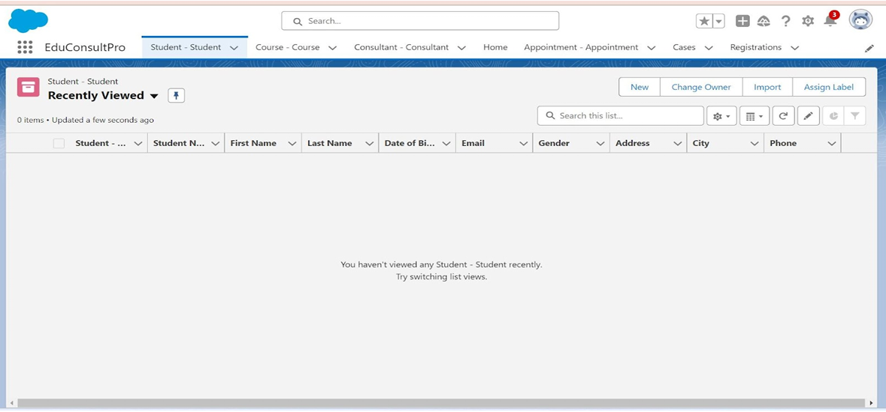

Task-2 : Create a ScreenFlow for Student Admission Application process.

1. Create a New ScreenFlow

1. Access Flow Builder:
○. In Setup, enter Flow Builder in the Quick Find box.
○. Click on New Flow and select ScreenFlow.
○. Click Create to start building the flow.

2. Add Student Info Screen Element

1. Add Screen Element:
○. Drag a Screen element onto the canvas.
○. In the Screen Properties pane, label it as Student Info.

2. Create and Configure StudentRecordRes Resource:
○. Click on Fields in the screen element.
○. Select Create New Resource and choose Record (StudentRecordRes).
○. Map this resource to the Student object to automatically pull in all fields from the Student object.

3. Add Fields to the Screen:
○. Drag the necessary fields (e.g., Name, Email, Phone, Address) from StudentRecordRes onto the screen to collect student information.
● Click Done to save the screen.

3. Create Student Record Using Create Element

1. Add Create Records Element:
○. Drag a Create Records element onto the canvas after the Student Info screen.
○. Label it as Create Student Record.

2. Configure the Create Element:
○. Under How many records to create, select One.
○. Under How to Set the Record Fields, select Use all values from a record.
○. Choose StudentRecordRes as the record variable to create the student record.
○. Click Done to save the element.
2. Add Course Selection Screen
1. Add Screen Element:

○. Drag another Screen element onto the canvas after the Create Student Record element.
● Label it as Course Screen.
2. Add Picklist Component:
○. Drag a Picklist component from the left panel to the screen.
○. Label it as Select Course.
○. For choices, add:
■. IELTS
■. GRE
■. GMAT
■. Duolingo
■. TOEFL
○. Each choice automatically creates a variable with the respective name.
○. Click Done to save the screen.
3. Add Decision Element for Course Selection
1. Add Decision Element:
○. Drag a Decision element onto the canvas after the Course Screen.
○. Label it as Selecting Course.
2. Configure Outcomes:
○. For each course (IELTS, GRE, GMAT, Duolingo, TOEFL), create an outcome: ○. Outcome Label: For example, "Selected IELTS"
○. Resource: Select_Course (the variable created by the picklist)
○. Operator: Equals
○. Value: IELTS (or the respective course)
○. Repeat for all courses and click Done.

4. Add Get Record Element for Each Course
1. Add Get Records Element:
○. Add a Get Records element under the path for each course.
○. Label it as Get IELTS Rec (or the respective course).
2. Configure Get Record Element:
○. Object: Course
○. Condition Requirements: All Conditions are Met (AND) ●
● Field: Course Name
● Operator: Equals
● Value: {!Select_Course}
● Repeat for GRE, GMAT, TOEFL, Duolingo.
● Click Done.

2. Create Registration Record Using Create Records Element
1. Add Create Records Element:
○. After each Get Records element, add a Create Records element.
○. Label it as Create IELTS Registration Rec (or the respective course).
2. Configure Create Record Element:
○. Object: Registration
○. How many records to create: One
○. How to Set the Record Fields: Use separate resources and literal values.
○. Field: Course_Name c
○. Value: {!Get_IELTS_Rec.Id}
○. Field: Student_Name c
○. Value: {!StudentRecordRes.Id}
○. Repeat for GRE, GMAT, TOEFL, Duolingo.
○. Click Done.

3. Create Email Text Template Variables :
1. Create Email Body Template:
○. Click on the toolbox toggle in the left corner and select New Resource.
○. Choose Text Template as the resource type.
○. Label it as StuRegistrationEmailTextTempBody.
○. Select View as Plain Text and insert the text.
○. Click Done.
2. Create Email Subject Template:
○. Repeat the process to create an email subject template.
○. Label it as StuRegistrationEmailTextTempSub and enter the desired subject text.
○. Click Done.

4. Add Action Element to Send Email
1. Add Send Email Action:
○. Add an Action element after each Create Records element.
○. Label it as Send Email to Student.
2. Configure the Action:
○. Body: {!StuRegistrationEmailTextTempBody}
○. Recipient Address List: {!StudentRecordRes.Email c}
○. Subject: {!StuRegistrationEmailTextTempSub}
○. Click Done.
2. Add Success Screen
1. Add Final Screen Element:
○. Drag a Screen element after the Send Email to Student action.
○. Label it as Success Screen.
2. Add Display Text Component:
○. Add a Display Text component from the left panel.
○. Label it as SuccessMessage.
3. Configure Success Message:
○. Paste the content in the Resource picker box
○. Click Done.
3. Save and Activate the Flow
1. Save the Flow:
○. Click Save and name the flow EduConsultPro Student Flow.
2. Click Activate to make the flow available for use.

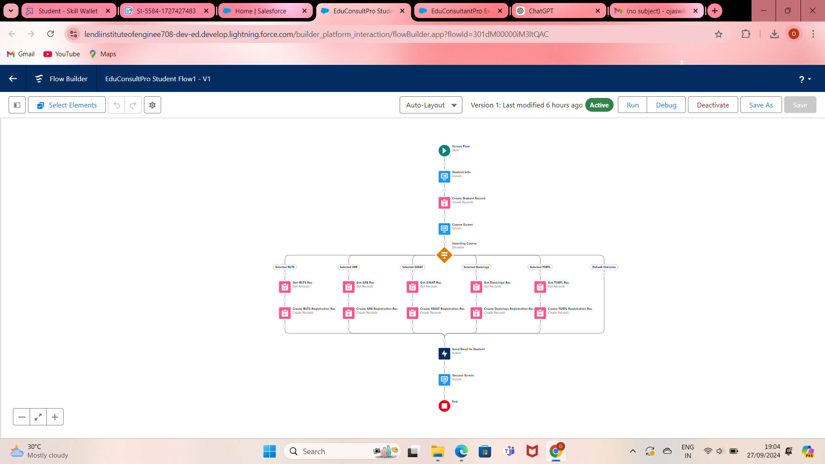

Task-3: Creating a New User in Salesforce
1. Create a User with a Standard Platform User Profile
1. Access User Setup:
● Navigate to Setup in Salesforce.
● Go to Administration → Users → Users.
● Click on New User.
● 2. Create User:
○. Last Name: Enter "Consultant."
○. License: Select Salesforce Platform.
○. Profile: Select Standard Platform User.
○. Fill in all mandatory fields, including:
■. First Name
■. Email
■. Username
■. Alias
○. Click Save to create the user.
2. Configure the User Settings
1. Edit User Settings:
● Return to Setup → Administration → Users.
● Find the newly created user "Consultant" and click Edit next to their name.
2. Configure Approver Settings:
○. Scroll down to the bottom of the page to Approver Settings.
○. In the Manager field, select "Consultant."
3. Click Save to apply the changes.

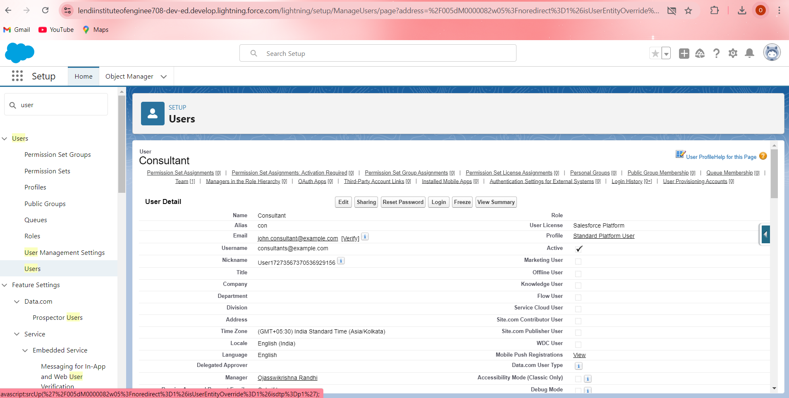

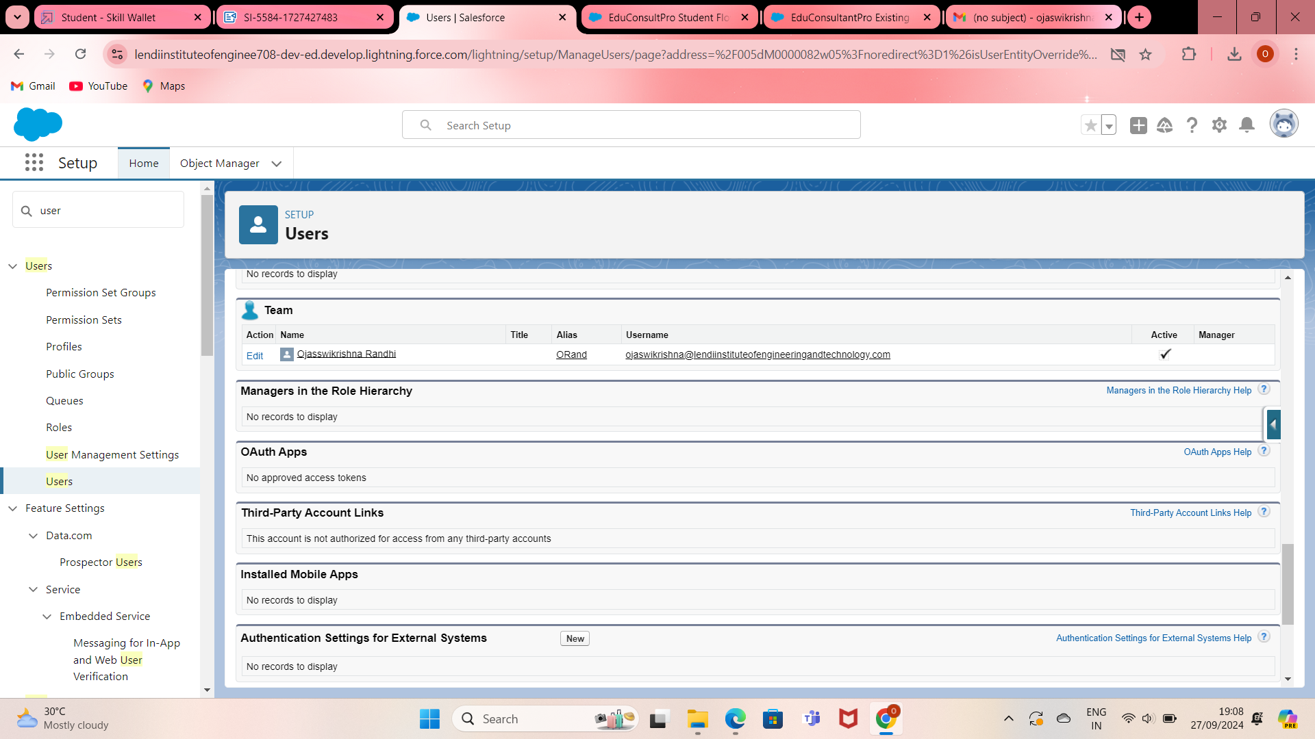

Task-4: Creating an Approval Process for the Property Object
1. Create an Email Template
1. Access Lightning Email Templates:
● From Setup, enter "Templates" in the Quick Find box.
● Select Lightning Email Templates and toggle it on.
2. Create a New Folder for Email Templates:
○. Go to App Launcher and search for Email Templates.
○. Create a new folder with your desired name.
3. Create a New Email Template:
● Within the folder you just created, click to create a new email template.
● Enter the following details:
○ Folder: Select the folder you created.
○ HTML Value: Use the provided text below and save the template as "Submission "Submission Template".
4. Create Additional Email Templates:
● Create two more email templates following the same process for Approval and Rejection of requests.
2. Create an Approval Process for Appointment Object:
1. Access Approval Processes:
● From Setup, enter "Approval" in the Quick Find box.
● Select Approval Processes.
2. Create a New Approval Process:
● Under Manage Approval Processes For, select Appointment.
● Click Create New Approval Process → Use Jump Start Wizard.
3. Configure the Approval Process:
○. Process Name: Enter "Appointment Approval".
○. Select Approver: Choose Manager for the option "Automatically assign an approver using a standard or custom hierarchy field."
○. Click Next.
○. Under Next Automated Approver Determined By, select Manager.
○. Record Editability Properties: Choose "Administrators OR the currently assigned approver can edit records during the approval process."
○. Save the approval process.
4. Add Initial Submission Actions:
● Click View Approval Process Detail Page.
● Under Initial Submission Actions, click Add New → Field Update.
● Configure it with the following values:
○ Name: Submitted
○ Field to Update: Appointment: Status
○ A Specific Value: Pending
5. Add Email Alert:
● Click Add New → Email Alert.
● Configure it with the following values:
○ Description: Submission Email Alert
○ Unique Name: Auto Populates ○ Email Template: Submission Template ○ Recipient Type: Select your Name
6. Repeat for Final Approval and Rejection Actions:
○. Repeat Steps 4 and 5 for Final Approval and Final Rejection actions, using the corresponding email templates

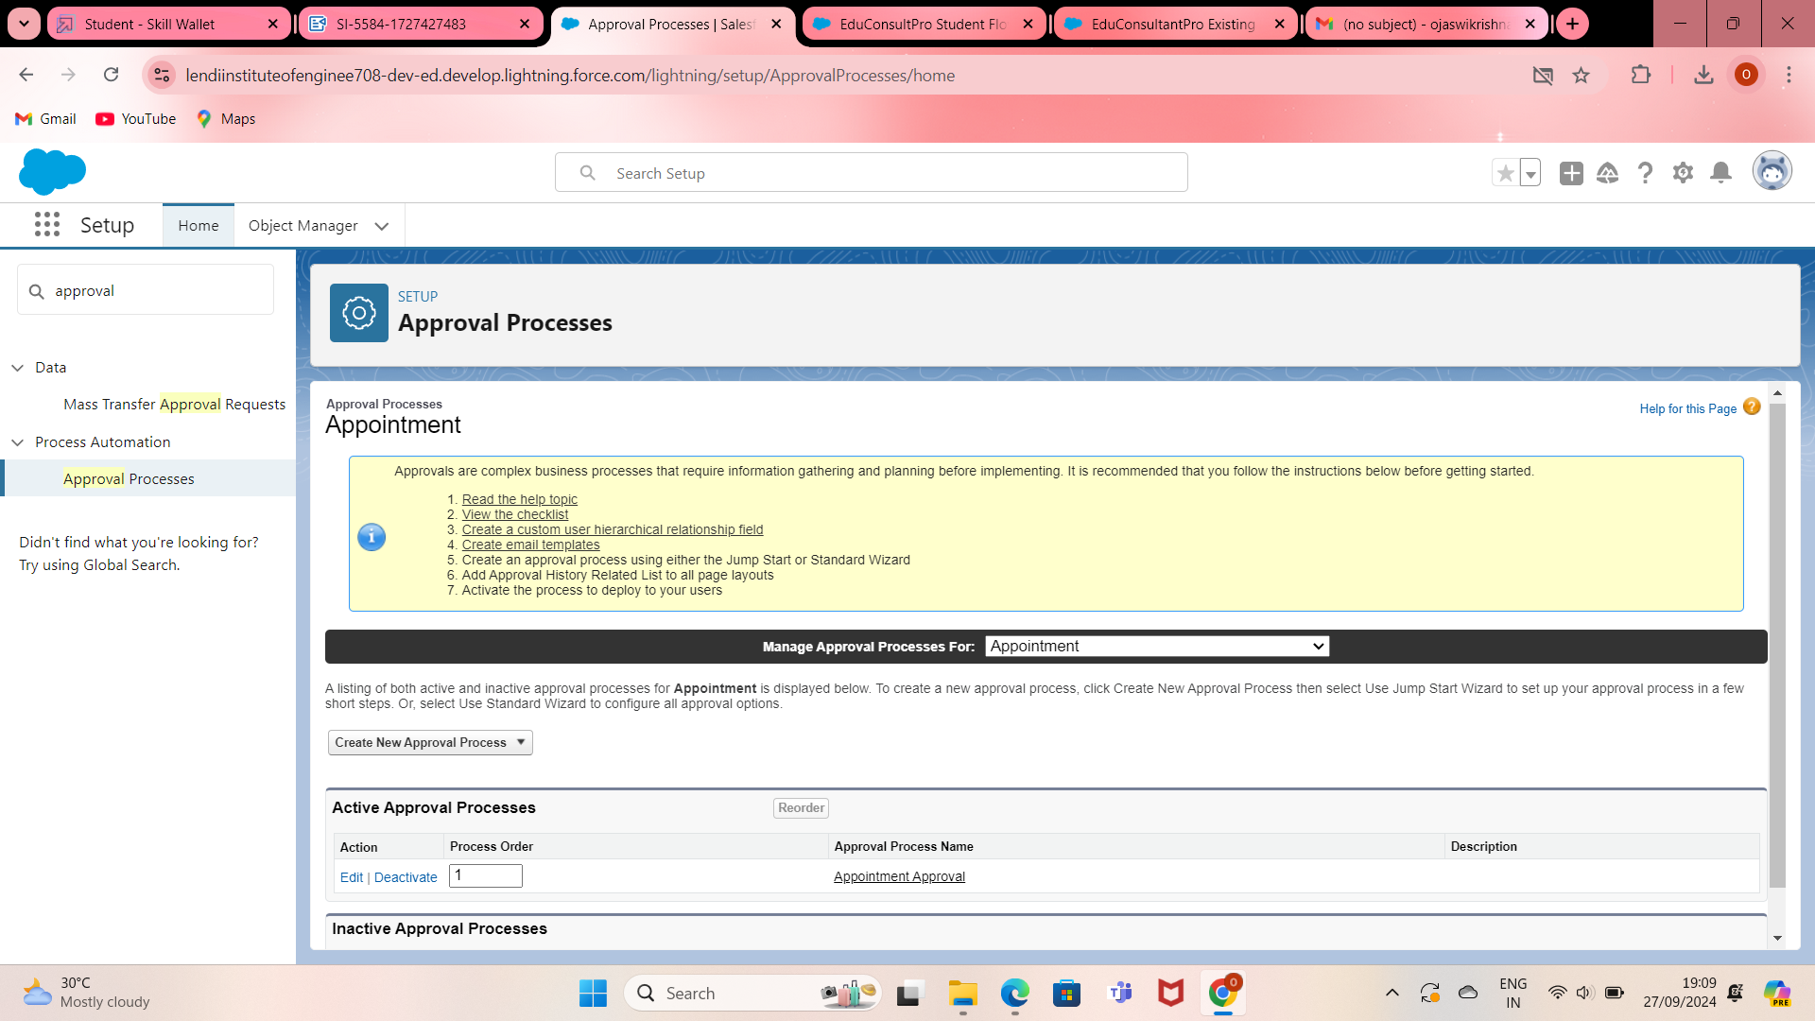

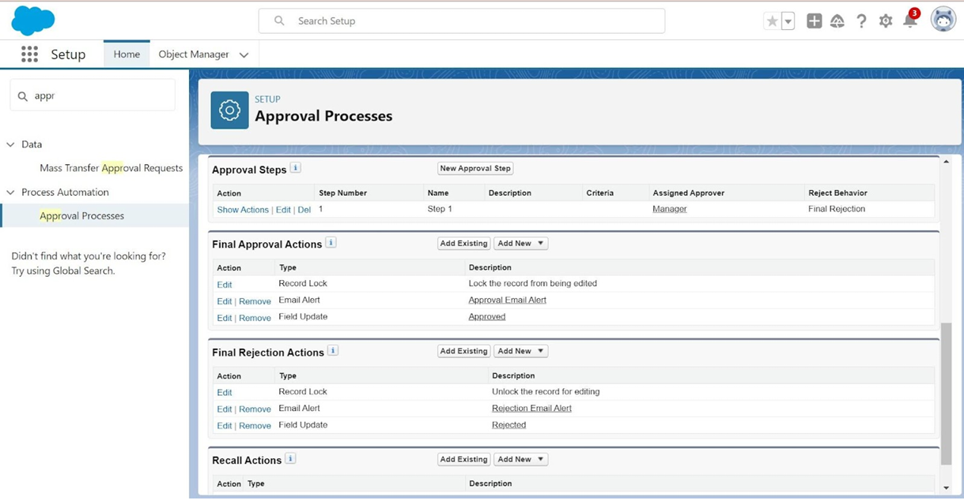

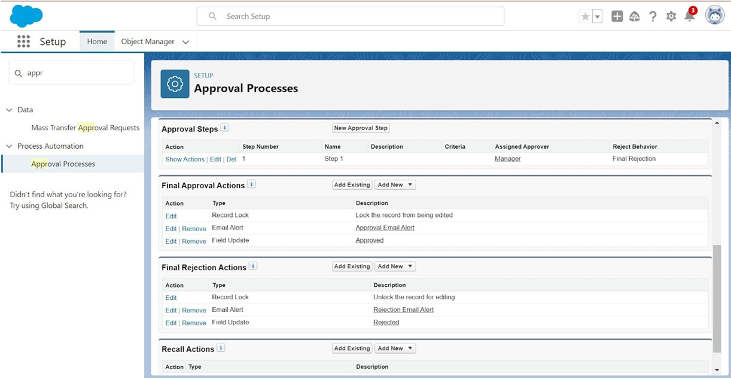

Task-5: Create a Record-Triggered Flow
1. Configure the Start Element
1. Access Flows:
● From Setup, enter Flows in the Quick Find box.
● Select Flows.
2. Create a New Flow:
● Click New Flow.
● Select Record-Triggered Flow.
● Click Create to open the Configure Start window.
3. Configure Start:
○. Object: Select Appointment.
○. Trigger the Flow When: Select A record is created.
2. Add an Action Element
1. Add Action Element:
● After the Start Element, click to add an Action element.
● Select the Submit for approval action.
● Label the Action: Name it Approval SubFlow.
2. Set the RecordId:
○. Set the RecordId to “{!$Record.Id}”.
3. Save and Activate the Flow
1. Save the Flow:
● Label: Name the flow "EduConsultPro Approval Flow".
● Click Save.
2. Activate the Flow:
○. Click on Activate to make the flow live.

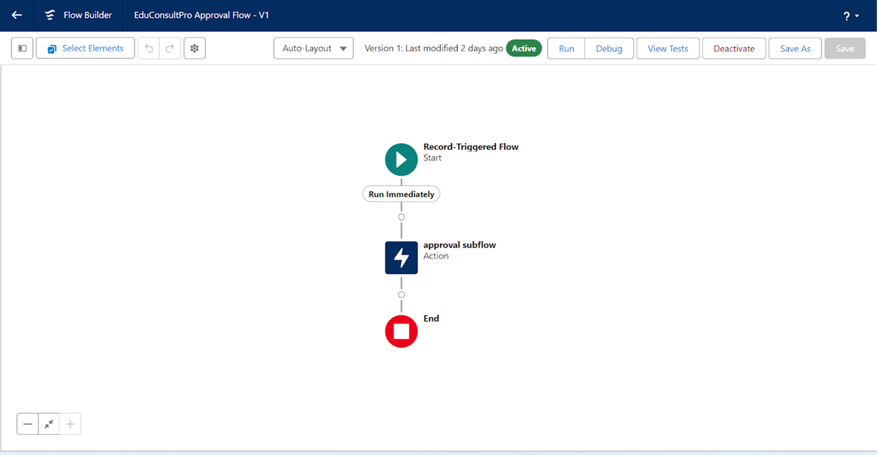

Task-6: Create a Screen Flow for Existing Students to Book an Appointment
1. Add Screen Element
1. Access Flow Builder:
● From Setup, enter Flow Builder in the Quick Find box.
● Select New Flow → Screen Flow.
2. Add a Screen Element:
● Add a Screen element.
● In the Screen Properties pane, for Label, enter "Get Student Info".
● Add two Text components from the left panel:
○ 1st Text Component Label: Enter Student Name
○ 2nd Text Component Label: Enter Student Email
● Click Done.
2. Add GET Record Element
1. Add a GET Record Element
● Add a GET Record element after the Decision element, label it as "Get Rec".
● Select Object: Student
Condition Requirements: All Conditions are Met (AND)
○ Field: Student Name
■ Operator: Equals
■ Value: {!Enter_Student_Name}
● Field: Email c
○ Operator: Equals
○ Value: {!Enter_Student_Email}
1. Add Decision Element
1. Add a Decision Element:
● Add a Decision element after the Select Display Student Details element, label it as "Appointment or Case".
● Outcome Label: Appointment
○ Condition:
■ Resource: {!How_may_I_Help_you}
■ Operator: Equals
■ Value: {!Book_an_Appointment}
● Click the + icon and repeat step
2 for the Case options.
● Click Done.
2. Add Screen Element for Appointment Booking
1. Add a Screen Element:
● Add a Screen element after the Decision element on the Appointment path, label it as "Appointment Booking Screen".
● Click on Fields, select the record variable input, and create a new Resource (AppointmentRecordRes) to display all the fields in the Appointment object
● Drag the necessary fields to the screen to collect student information.
● Click Done.
3. Add GET Record Element for Consultant
1. Add a GET Record Element:
● Add a GET Record element after the Decision element, under the Appointment path, and label it as "Get Consultant Rec".
● Select Object: Consultant
● Condition Requirements: All Conditions are Met (AND)
○ Field: Name
■ Operator: Equals
■ Value: {!AppointmentRecordRes.Consultant_Name c}
4. Create Appointment Record using Create Records Element
1. Add a Create Records Element:
● Add a Create element after the Get Consultant Rec element, label it as "Create Appointment".
● How many records to create: One
● How to set the record fields: Use separate resources and literal values.
● Select Object: Appointment
○ Field: Appointment_DateTime c
■ Value: {!AppointmentRecordRes.Appointment_DateTime c}
○ Field: Consultant c
■ Value: {!Get_Consultant_Rec.Id}
○ Field: Notes c
■ Value: {!AppointmentRecordRes.Notes c}
○ Field: PurposeTopic c
■ Value: {!AppointmentRecordRes.PurposeTopic c}
○ Field: Student_Name c
■ Value: {!Get_Rec.Id}
1. Add Confirmation Screen Element
1. Add a Screen Element:
● Add a Screen element after the Send Email to Student Action element, label it as "Confirmation Screen".
● From the left panel, drag the Display Text component to the main panel, label it as "Appointment_Confirmation".
● Add the data in the Resource picker box
● Click Done.
2. Add SubFlow Element
1. Add a SubFlow Element:
● Add a SubFlow element after the Decision element, on the Case path.
● Search and select Create a Case.
● Label it as "Create Student Case".
3. Save and Activate the Flow 1
. Save the Flow:
● Label: Name the flow "EduConsultantPro Existing Student Flow".
● Click Save.
2. Activate the Flow:
○. Click Activate to make the flow live

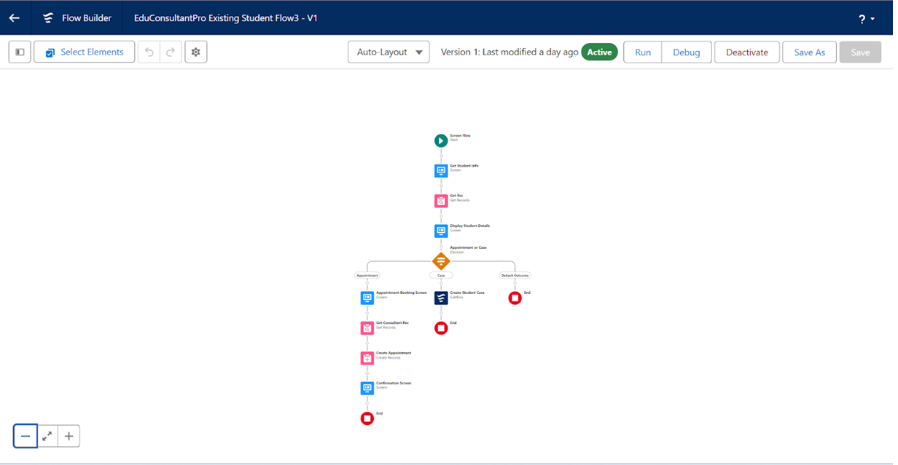
Task-7: Create a Screen Flow to Combine All Flows

1. Add Welcome Screen Element

1. Add a Screen Element:
● Add a Screen element.

● Label: Enter "Welcome Screen".

2. Configure Display Text:
● From the left side panel, search for the Display Text component and drag it to the main panel.
● Label: Enter "SuccessMessage".
● Resource Picker Box Content: Add the content
● Click Done.

2. Add Existing or New Student Confirmation Screen

1. Add a Screen Element:

● Add a Screen element after the Welcome Screen element.
● Label: Enter "Existing or New Student Confirmation Screen".

2. Add Radio Button Component:
● From the left side panel, add a Radio Buttons component.
● Label: Enter "Are you an Existing Student".
● Click Add Choice:
○ Type: Enter" Yes "and click Create Yes Choice.
○ Repeat for "No" choice.
● Click Done.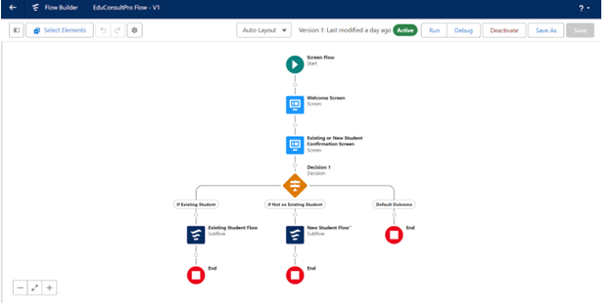

1. Activate the Lightning App Page

1. Activate the Page:

● Click Activate.
2. Assign Page to Apps and Profiles:
● Click App and Profile.
● Click Assign to Apps and Profiles.

3. Configure App Assignment:
○. Select App: Choose the Sales app.
○. Click Next.
4. Configure Profile Assignment:
● Scroll down the list of profiles and select System Administrator.
● Click Next.
5. Review and Save
: ● Review the assignment details.
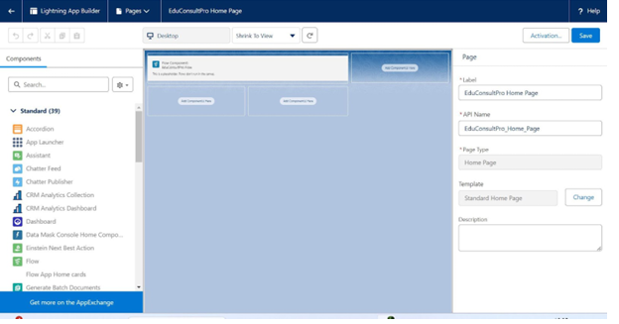 ● Click Save.

