Visvesvaraya Technological University

BelgaVI-590014


A DBMS Mini-Project Report
On

“Online Event Sharing Portal”

Submitted in partial fulfillment of the requirements for the 5th semester of Bachelor of Engineering in Computer Science and Engineering
of Visvesvaraya Technological University, Belgavi

Submitted by:

ADITH KUMAR 1RN16CS004
OJASWIN MUJOO 1RN16CS064

Under the Guidance of:

Mrs. Mamtha Jajur Mr. Sanjay
Assistant Professor Assistant Professor
Dept. of CSE Dept. of CSE


Department of Computer Science and Engineering
RNS Institute of Technology
Channasandra, Dr.Vishnuvardhan Road, Bengaluru-560 098
2017-2018

RNS Institute of Technology
Channasandra, Dr. Vishnuvardhan Road,
Bengaluru-560 098

Department of Computer Science & Engineering

CERTIFICATE
Certified that the DBMS mini-project work entitled “Online Event Management Portal” has been successfully carried out by Adith Kumar bearing USN 1RN16CS004 and Ojaswin Mujoo bearing USN 1RN16CS064 , bonafide students of RNS Institute of Technology, in partial fulfillment of the requirements for the 5th semester Bachelor of Engineering in Computer Science and Engineering of Visvesvaraya Technological University, Belgavi during academic year 2018-2019. It is certified that all corrections/suggestions indicated for Internal Assessment have been incorporated in the report. The project report has been approved as it satisfies the mini-project requirements of DBMS lab of 5th semester BE in CSE.

Mrs. Mamtha Jajur Mr. Sanjay Dr. G. T. Raju
Assistant Professor Assistant Professor Prof. and Head
Dept. of CSE Dept. of CSE Dept of CSE

External Viva:
Name of the Examiners Signature with Date
1.
2.

ACKNOWLEDGEMENTS

Any achievement, be it scholastic or otherwise does not depend solely on the individual efforts but on the guidance, encouragement and cooperation of intellectuals, elders and friends. A number of personalities, in their own capacities have helped me in carrying out this project work. I would like to take this opportunity to thank them all.

I would like to thank Dr. H N Shivashankar, Director, RNSIT, Bengaluru, for his moral support towards completing my project.

I am grateful to Dr. M K Venkatesha, Principal, RNSIT, Bengaluru, for his support towards completing my mini-project.

I would like to thank Dr. G T Raju, Dean of Engg., Prof & Head , Department of Computer Science & Engineering, RNSIT, Bengaluru, for his valuable suggestions and expert advice.

I deeply express my sincere gratitude to Mrs. Mamtha Jajur and Mr. Sanjay, Asst Professors, Department of CSE, RNSIT, Bengaluru, for their able guidance, regular source of encouragement and assistance throughout this project.

I would like to thank all the teaching and non-teaching staff of Department of Computer Science & Engineering RNSIT, Bengaluru for their constant support and encouragement.

Date : ADITH KUMAR 1RN16CS064

Place : Bengaluru OJASWIN MUJOO 1RN16CS064

ABSTRACT

The project developed provides a centralized database for event sharing and management system. The online event hosting system gives event planners and organisers the ability to increase sales and expand their business by giving them a platform to share their events and attract more customers. This mini-project looks at the faced by event organisers to advertise their events. In existing system there are few problems: a) There is no way for the event organisers to advertise their events or parties except word of mouth which is not a reliable way of publicizing. b) Often people miss the opportunity to attend various events they would have otherwise enjoyed due to the lack of a proper platform for them to discover new things happening around them.

In this system, the details about the events based on the location along with the details of the organiser and the event description is stored, so that any data can be retrieved easily. The system alerts the customer when any fields are left empty during sign up. The system also allows deletion or modification of events.

Online ordering system that we are proposing here, aims to provide a platform for organisers to share their events and people to discover new events based on their interests and location. System presents an interactive and up-to-date menu with all available options in an easy to use manner. Users can view detailed description of events. Organizers can make an account to add new events and manage their existing events

This mini-project has been implemented using HTML, CSS, Javascript and Angular as front-end tools and Javascript running in a Node.js environment and SQL as back-end tools.
CONTENTS
6

9

14

17

28

Chapter No. TitlePage No

1. Introduction
1.1 Database technologies
1.2. Characteristics of database approach
1.3. Applications of DBMS
1.4. Problem description/ statement
2. Requirements Analysis
2.1 Hardware Requirements
2.2 Software Requirements
2.3 Functional Requirements
2.3.1 Major Entities
2.3.2 End User Requirements
2.3.3 HTML, CSS, Bootstrap
2.3.4 PHP
2.3.5 Apache Server
2.3.6 MySQL
3. Database Design
3.1 Entities, Attributes and Relationships
3.2 Identify major entities/Attributes and relationships
3.3 ER Schema
3.4 Relational Schema
4. Implementation
4.1 Database connectivity
4.2 Pseudo code For Major Functionalities
5. Results, snapshots and discussions
34

6. Conclusion and Future Enhancements
35
7. Bibliography

CHAPTER 1

INTRODUCTION

  - DATABASE TECHNOLOGIES

The essential feature of database technology is that it provides an internal representation (model) of the external world of interest. Examples are the representation of a particular date/time/flight/aircraft in airline reservation or of item code/item description/quantity on hand/reorder level/reorder quantity in a stock control system.
The technology involved is concerned primarily with maintaining the internal representation consistent with external reality; this involves the results of extensive R&D over the past 30 years in areas such as user requirements analysis, data modelling, process modelling, data integrity, concurrency, transactions, file organisation, indexing, rollback and recovery, persistent programming, object-orientation, logic programming, deductive database systems, active database systems... and in all these (and other) areas there remains much to be done.

The essential point is that database technology is a CORE TECHNOLOGY with links to:

- Information management / processing
- Data analysis / statistics
- Data visualization / presentation
- Multimedia and hypermedia
- Office and document systems
- Business processes, workflow, CSCW (computer-supported cooperative work)

Relational DBMS is the modern base technology for many business applications. It offers flexibility and easy-to-use tools at the expense of ultimate performance. More recently relational systems have started to extend their facilities in the directions of information retrieval, object-orientation and deductive/active systems leading to the so-called 'Extended Relational Systems'.

Information Retrieval Systems started with handling library catalogues and extended to full free-text utilizing inverted index technology with a lexicon or thesaurus. Modern systems utilize some KBS (knowledge-based systems) techniques to improve retrieval.

Object-Oriented DBMS started for engineering applications where objects are complex, have versions and need to be treated as a complete entity. OODBMSs share many of the OOPL features such as identity, inheritance, late binding, overloading and overriding. OODBMSs have found favour in engineering and office systems but have not yet been successful in traditional application areas.

Deductive / Active DBMS have emerged over the last 20 years and combine logic programming technology with database technology. This allows the database itself to react to external events and to maintain dynamically its integrity with respect to the real world.

  - CHARACTERISTICS OF DATABASE APPROACH
Traditionally, data was organized in file formats. DBMS was a new concept then, and all the research was done to make it overcome the deficiencies in traditional style of data management. A modern DBMS has the following characteristics −
- Real-world entity − A modern DBMS is more realistic and uses real-world entities to design its architecture. It uses the behavior and attributes too. For example, a school database may use students as an entity and their age as an attribute.
- Relation-based tables − DBMS allows entities and relations among them to form tables. A user can understand the architecture of a database just by looking at the table names.
- Isolation of data and application − A database system is entirely different than its data. A database is an active entity, whereas data is said to be passive, on which the database works and organizes. DBMS also stores metadata, which is data about data, to ease its own process.
- Less redundancy − DBMS follows the rules of normalization, which splits a relation when any of its attributes is having redundancy in values. Normalization is a mathematically rich and scientific process that reduces data redundancy.
- Consistency − Consistency is a state where every relation in a database remains consistent. There exist methods and techniques, which can detect attempt of leaving database in inconsistent state. A DBMS can provide greater consistency as compared to earlier forms of data storing applications like file-processing systems.
- Query Language − DBMS is equipped with query language, which makes it more efficient to retrieve and manipulate data. A user can apply as many and as different filtering options as required to retrieve a set of data. Traditionally it was not possible where file-processing system was used.
- ACID Properties − DBMS follows the concepts of Atomicity, Consistency, Isolation, and Durability (normally shortened as ACID). These concepts are applied on transactions, which manipulate data in a database. ACID properties help the database stay healthy in multi-transactional environments and in case of failure.
- Multiuser and Concurrent Access − DBMS supports multi-user environment and allows them to access and manipulate data in parallel. Though there are restrictions on transactions when users attempt to handle the same data item, but users are always unaware of them.
- Multiple views − DBMS offers multiple views for different users. A user who is in the Sales department will have a different view of database than a person working in the Production department. This feature enables the users to have a concentrate view of the database according to their requirements.
- Security − Features like multiple views offer security to some extent where users are unable to access data of other users and departments. DBMS offers methods to impose constraints while entering data into the database and retrieving the same at a later stage. DBMS offers many different levels of security features, which enables multiple users to have different views with different features. For example, a user in the Sales department cannot see the data that belongs to the Purchase department. Additionally, it can also be managed how much data of the Sales department should be displayed to the user. Since a DBMS is not saved on the disk as traditional file systems, it is very hard for miscreants to break the code.

  - APPLICATIONS OF DBMS

Applications where we use Database Management Systems are:
- Telecom: There is a database to keeps track of the information regarding calls made, network usage, customer details etc. Without the database systems it is hard to maintain that huge amount of data that keeps updating every millisecond.

- Industry: Where it is a manufacturing unit, warehouse or distribution centre, each one needs a database to keep the records of ins and outs. For example distribution centre should keep a track of the product units that supplied into the centre as well as the products that got delivered out from the distribution centre on each day; this is where DBMS comes into picture.

- Banking System: For storing customer info, tracking day to day credit and debit transactions, generating bank statements etc. All this work has been done with the help of Database management systems.

- Education sector: Database systems are frequently used in schools and colleges to store and retrieve the data regarding student details, staff details, course details, exam details, payroll data, attendance details, fees details etc. There is a hell lot amount of inter-related data that needs to be stored and retrieved in an efficient manner.

- Online shopping: You must be aware of the online shopping websites such as Amazon, Flipkart etc. These sites store the product information, your addresses and preferences, credit details and provide you the relevant list of products based on your query. All this involves a Database management system.
1.4 PROBLEM DESCIPTION/ STATEMENT

It is known that, in today’s market, it is extremely difficult for new small scale organisers and institutions to spread the word about their events or functions. In fast paced time of today, when everyone is squeezed for time, the majority of people don’t bother to seek out new events by themselves. This has led to a demand for a platform for organisers to host and advertise their events. Online Event Hosting Portal that we are proposing here, greatly enables both, organizers to gain exposure and the general user to inform themselves about the upcoming events around them. System presents an interactive and up-to-date menu with all available options in an easy to use manner. Users can view detailed description of events. Organizers can make an account to add new events and manage their existing events.

CHAPTER 2

REQUIREMENT ANALYSIS

2.1 HARDWARE REQUIREMENTS

The Hardware requirements are very minimal and the program can be run on most of the machines.
Processor | : | 64 bit, 3 GHz minimum per core
Processor Speed | : | 2.4 GHz
RAM | : | 2 GB
Storage Space | : | 40 GB

2.2 SOFTWARE REQUIREMENTS

- Brackets Text Editor: HTML, CSS, Bootstrap, PHP

- Node.js backend server connected to MYSQL database

- Browser that supports HTML and JavaScript

2.3 FUNCTIONAL REQUIREMENTS

2.3.1 Major Entities

- Organiser
- Event
- Location
- General customer

2.3.2 End-User Requirements

- Reduction of time consumption on phone enquiries
- Elimination of requirement for extra phone lines.
- Building a user-friendlyevent management database.
- Providing a platform for organisers to market and promote their events
- Improved service.
- Greater customer satisfaction.

2.3.3.1 HTML

Hypertext Markup Language (HTML) is the standard markup language for creating web pages and web applications. With Cascading Style Sheets (CSS) and JavaScript it forms a triad of cornerstone technologies for the World Wide Web. Web browsers receive HTML documents from a web server or from local storage and render them into multimedia web pages. HTML describes the structure of a web page semantically and originally included cues for the appearance of the document.

HTML elements are the building blocks of HTML pages. With HTML constructs, images and other objects, such as interactive forms, may be embedded into the rendered page. It provides a means to create structured documents by denoting structural semantics for text such as headings, paragraphs, lists, links, quotes and other items. HTML elements are delineated by tags, written using angle brackets. Tags such as <img /> and <input /> introduce content into the page directly. Others such as <p>...</p> surround and provide information about document text and may include other tags as sub-elements. Browsers do not display the HTML tags, but use them to interpret the content of the page.

HTML can embed programs written in a scripting language such as JavaScript which affect the behaviour and content of web pages. Inclusion of CSS defines the look and layout of content.

2.3.3.2 CSS

Cascading Style Sheets (CSS) is a style sheet language used for describing the presentation of a document written in a markup language. Although most often used to set the visual style of web pages and user interfaces written in HTML and XHTML, the language can be applied to any XML document, including plain XML, SVG and XUL, and is applicable to rendering in speech, or on other media. Along with HTML and JavaScript, CSS is a cornerstone technology used by most websites to create visually engaging webpages, user interfaces for web applications, and user interfaces for many mobile applications.

CSS is designed primarily to enable the separation of presentation and content, including aspects such as the layout, colors, and fonts. This separation can improve content accessibility, provide more flexibility and control in the specification of presentation characteristics, enable multiple HTML pages to share formatting by specifying the relevant CSS in a separate .css file, and reduce complexity and repetition in the structural content.

2.3.3.3 BOOTSTRAP

Bootstrap is a free and open-source front-end web framework for designing websites and web applications. It contains HTML and CSS based design templates for typography, form, buttons, navigation and other interface components, as well as option JavaScript extensions. Unlike many web frameworks, it concerns itself with front-end development only.

Bootstrap is modular and consists of a series of “Less Stylesheets” that implement the various components of the toolkit. These stylesheets are generally compiled into a bundle and included in web pages, but individual components can be included or removed. Bootstrap provides a number of configuration variables that control things such as color and padding of various components.

2.3.4 Node.js

Node.js is an open-source, cross-platform JavaScript run-time environment that executes JavaScript code outside of a browser. Typically, JavaScript is used primarily for client-side scripting, in which scripts written in JavaScript are embedded in a webpage's HTML and run client-side by a JavaScript engine in the user's web browser. Node.js was originally written by Ryan Dahl in 2009,[ about thirteen years after the introduction of the first server-side JavaScript environment

Node.js allows the creation of Web servers and networking tools using JavaScript and a collection of "modules" that handle various core functionality. Modules are provided for file system I/O, networking (DNS, HTTP, TCP, TLS/SSL, or UDP), binary data (buffers), cryptography functions, data streams, and other core functions. Node.js's modules use an API designed to reduce the complexity of writing server applications.
Though initially the module system was based on commonjs module pattern, the recent introduction of modules in the ECMAScript specification has shifted the direction of using ECMAScript Modules in Node.js by default instead
Node.js is primarily used to build network programs such as Web servers.The biggest difference between Node.js and PHP is that most functions in PHP block until completion (commands execute only after previous commands finish), while Node.js functions are non-blocking (commands execute concurrently or even in parallel, and use callbacks to signal completion or failure).

Node.js brings event-driven programming to web servers, enabling development of fast web servers in JavaScript.Developers can create highly scalable servers without using threading, by using a simplified model of event-driven programming that uses callbacks to signal the completion of a task. Node.js connects the ease of a scripting language (JavaScript) with the power of Unix network programming.
Node.js was built on the Google V8 JavaScript engine since it was open-sourced under the BSD license. It is extremely fast and proficient with internet fundamentals such as HTTP, DNS, TCP. Also, JavaScript was a well-known language, making Node.js immediately accessible to the entire web development community.

2.3.5 MySQL

MySQL is a Relational Database Management System (RDBMS). MySQL server can manage many databases at the same time. In fact, many people might have different databases managed by a single MySQL server. Each database consists of a structure to hold the data and the data itself. A data-base can exist without data, only a structure, be totally empty, twiddling its thumbs and waiting for data to be stored in it.

Data in a database is stored in one or more tables. You must create the data-base and the tables before you can add any data to the database. First you create the empty database. Then you add empty tables to the database. Database tables are organized like other tables that you’re used in rows and columns. Each row represents an entity in the database, such as a customer, a book, or a project. Each column contains an item of information about the entity, such as a customer name, a book name, or a project start date. The place where a particular row and column intersect, the individual cell of the table, is called a field. Tables in databases can be related. Often a row in one table is related to several rows in another table. For instance, you might have a database containing data about books you own. You would have a book table and an author table. One row in the author table might contain information about the author of several books in the book table. When tables are related, you include a column in one table to hold data that matches data in the column of another table.

MySQL, the most popular Open Source SQL database management system, is developed, distributed, and supported by MySQL AB. MySQL AB is a commercial company, founded by the MySQL developers. It is a second generation Open Source company that unites Open Source values and methodology with a successful business model.

- MySQL is a database management system. A database is a structured collection of data. It may be anything from a simple shopping list to a picture gallery or the vast amounts of information in a corporate network. To add, access, and process data stored in a computer database, you need a database management system such as MySQL Server. Since computers are very good at handling large amounts of data, database management systems play a central role in computing, as standalone utilities, or as parts of other applications.

- MySQL is a relational database management system. A relational database stores data in separate tables rather than putting all the data in one big storeroom. This adds speed and flexibility. The SQL part of “MySQL” stands for “Structured Query Language.” SQL is the most common standardized language used to access databases and is defined by the ANSI/ISO SQL Standard. The SQL standard has been evolving since 1986 and several versions exist. “SQL-92” refers to the standard released in 1992, “SQL:1999” refers to the standard released in 1999, and“SQL:2003” refers to the current version of the standard. We use the phrase “the SQLstandard” to mean the current version of the SQL Standard at any time.

- MySQL software is Open Source. Open Source means that it is possible for anyone to use and modify the software. Anybody can download the MySQL software from the Internet and use it without paying anything. If you wish, you may study the source code and change it to suit your needs. The MySQL software uses the GPL (GNU General Public License), to define what you may and may not do with the software in different situations. The MySQL Database Server is very fast, reliable, and easy to use.

MySQL Server was originally developed to handle large databases much faster than existing solutions and has been successfully used in highly demanding production environments for several years. Although under constant development, MySQL Server today offers a rich and useful set of functions. Its connectivity, speed, and security make MySQL Server highly suited for accessing databases on the Internet.

- MySQL Server works in client/server or embedded systems. The MySQL Database Software is a client/server system that consists of a multi-threaded SQL server that supports different back ends, several different client programs and libraries, administrative tools, and a wide range of application programming interfaces (APIs).

CHAPTER 3

DATABASE DESIGN

3.1 Entities, Attributes and Relationships

- Eventlist : eid, ename, venue, cid, edate, oid
- Eventdisc : eid, disc, ename, venue, imglink
- Category : cid, cname
- Location : eid, city
- Organiser : oid, oname, ophone, oemail

3.2 Identify major entities, attributes and relationships

- Eventlist:
In the system, an event is the basic entity that can be registered by the organisers. The details about the event are stored in the Eventlist.

- Eventdisc:
This contains the full details about the event including the event images and a short description..

- Location
The location entity gives the list of cities each event is taking place in.

- Category:
The category entity gives the list of categories each event belongs to.

- Organiser:
The organisers entity gives the details of the organisers who have hosted their events on the site. Theis provides a list containing details like the organiser’s id, phone and email.

3.3 ER DIAGRAM

name
id
email
phone
city
zip
customer
order_items
restaurant
menu
orders
chooses
places
order
select
items
contains
id
price
id
total
id
id
name
address
city
ratings
name
price

Fig 3.1: ER Diagram

3.2 SCHEME

eventlist

eid | email | password | firstname | lastname | phone | address | city | zip

restaurant

id | name | address | city | ratings

menu

id | name | price | restaurant_id

order_items

id | customer_id | menu_id | price

orders

id | customer_id | total

Fig 3.2: Relational Schema

CHAPTER 4

IMPLEMENTATION

4.1 Database Connectivity

- . Node.js provides a ‘mysql’ library that can be downloaded through the node package manager(npm).

- . Import mysql package into node.js using:

- . Connect to the mysql database using:

var con = mysql.createConnection({
host: "localhost",
user: "root",
password: "shivin",
database: "eventman"
});

- Perform SQL operations
Example:-
con.query(`SELECT eid,e.ename,e.venue,e.edate FROM eventlist e WHERE e.cid='${req.params.categoryId}'`, function(err, rows, fields) {
if (err)
console.log(err);
else {
res.send(JSON.stringify(rows));
res.end();
}
})
4.2 Pseudo Code For Major Functionalities

    - Table Creation

- Customer

CREATE TABLE `customer`
( `id` int(11) NOT NULL, `email` varchar(30),
`password` varchar(20), `firstname` varchar(20),
`lastname` varchar(20), `phone` varchar(20),
`address` varchar(75), `city` varchar(10),
`zip` int(6));

ALTER TABLE `customer`
ADD PRIMARY KEY (`id`);

- Menu

CREATE TABLE `menu`
( `id` int(11) NOT NULL, `name` varchar(30) ,
`price` int(10), `restaurant_id` int(11));

ALTER TABLE `menu` ADD PRIMARY KEY (`id`);
ALTER TABLE `menu` ADD FOREIGN KEY (`restaurant_id`) REFERENCES `restaurant` (`id`);

- Restaurant

CREATE TABLE `restaurant` (
`id` int(11) NOT NULL, `name` varchar(30),
`address` varchar(30), `city` varchar(30), `ratings` varchar(5) );

ALTER TABLE `restaurant` ADD PRIMARY KEY (`id`);

d) Order_Items

CREATE TABLE `order_items` (
`id` int(11) NOT NULL, `customer_id` int(11),
`menu_id` int(11), `price` int(11) );

ALTER TABLE `order_items` ADD PRIMARY KEY (`id`);
ALTER TABLE `order_items`
ADD FOREIGN KEY (`customer_id`) REFERENCES `customer` (`id`) ON UPDATE CASCADE,
ADD FOREIGN KEY (`menu_id`) REFERENCES `menu` (`id`) ON UPDATE CASCADE;

e) Orders

CREATE TABLE `orders` (
`id` int(11) NOT NULL, `customer_id` int(11),
`total` int(11) );

ALTER TABLE `orders` ADD PRIMARY KEY (`id`);
ALTER TABLE `orders` ADD FOREIGN KEY
(`customer_id`) REFERENCES `customer` (`id`) ON UPDATE CASCADE;

4.2.2 Populated Tables
- Eventlist
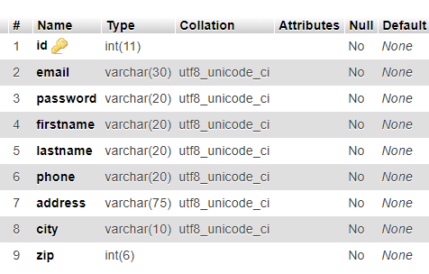

- Eventdisc
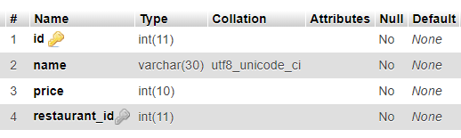

- Location
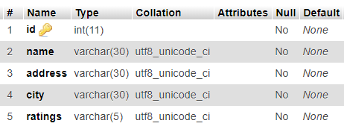
- Category
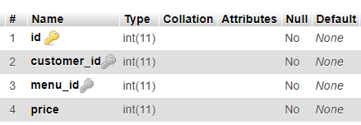

- Organiser
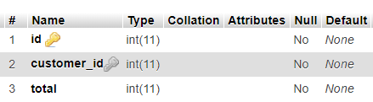

4.3 Backend Code

var mysql = require('mysql');
const express = require("express");
const cors = require("cors");
const app = express();
var bodyParser = require('body-parser');
- ImportsConnecting to MYSQL
var con = mysql.createConnection({
host: "localhost",
user: "root",
password: "shivin",
database: "eventman"
});

con.connect(function(err) {
if (err)
console.log(err);
else {
console.log('success');
}
});
- Serving the static files generated by Angular
app.use(express.static("enetv2"));

- RESTful API

- GET: Events by date
app.get('/api/event', function(req, res) {
con.query(`SELECT eid,ename,venue,edate from eventlist order by edate`, function(err, rows, fields) {
if (err)
console.log(err);
else {
res.send(JSON.stringify(rows));
res.end();
}
});
})
- GET: Getting events details by id
app.get('/api/event/:eventId', function(req, res) {
con.query(`SELECT e.eid,e.ename,e.venue,e.edate,ed.disc,c.cname FROM (eventlist e JOIN eventdisc ed ON e.eid=ed.eid) JOIN category c on e.cid=c.cid WHERE e.eid = ${req.params.eventId}`, function(err, rows, fields) {
if (err)
console.log(err);
else {
res.send(JSON.stringify(rows));
res.end();
}
});
})
- GET: Getting events by city
app.get('/api/event/city/:city', function(req, res) {

con.query(`SELECT e.eid,e.ename,e.venue, e.edate FROM eventlist AS e,location AS l WHERE e.eid=l.eid AND l.city='${req.params.city}'`, function(err, rows, fields) {
if (err)
console.log(err);
else {
res.send(JSON.stringify(rows));
res.end();
// res.render('one',{data:rows[0]})
}
})
})
- GET: Getting events by categor
app.get('/api/event/category/:categoryId', function(req, res) {
con.query(`SELECT eid,e.ename,e.venue,e.edate from eventlist e where e.cid='${req.params.categoryId}'`, function(err, rows, fields) {
if (err)
console.log(err);
else {
res.send(JSON.stringify(rows));
res.end();
}
})
})
DELETE: Delete an event
app.delete('/api/edit/delete/:eventId', function(req, res) {
con.query(`DELETE from eventlist WHERE eid=${req.params.eventId}`, function(err, rows, fields) {
if (err)
console.log(err);
else {
console.log(`deleted ${req.params.eventId}`);
res.end();
}
});
})
- POST: Adding an event
app.post('/api/edit/add', bodyParser(), function(req, res) {

console.log(req.body);
let date = req.body.edate.split("-");
date = new Date(date[0], date[1] - 1, date[2]);

con.query(`insert into eventlist(ename,venue,cid,edate,oid) values(?,?,?,?,?)`, [req.body.ename, req.body.venue, req.body.cid, date, req.body.oid]);

con.query(`select eid from eventlist where ename="${req.body.ename}" AND edate="${req.body.edate}"`, function(err, rows, fields){
if (err)
console.log(err);
else {

con.query(`insert into location values(?,?)`, [rows[0].eid, req.body.city]);

con.query(`insert into eventdisc(eid,disc,ename,venue) values(?,?,?,?)`, [rows[0].eid, req.body.disc, req.body.ename, req.body.venue]);

}
});
});

- PUT: Modifying existing event’s details
app.put('/api/edit/modify/:eventId', bodyParser(), function(req, res) {

con.query(`UPDATE eventlist SET ename="${req.body.ename}",
venue="${req.body.venue}",
cid="${req.body.cid}",
edate="${req.body.edate}",
oid="${req.body.oid}"
WHERE eid = "${req.body.eid}"`);

con.query(`UPDATE location SET city="${req.body.city}" WHERE eid = "${req.body.eid}"`);

con.query(`UPDATE eventdisc SET eid="${req.body.eid}",disc="${req.body.disc}",ename="${req.body.eid}",venue="${req.body.eid}" WHERE eid = "${req.body.eid}"`);

});

CHAPTER 5

RESULTS, SNAPSHOTS AND DISCUSSIONS

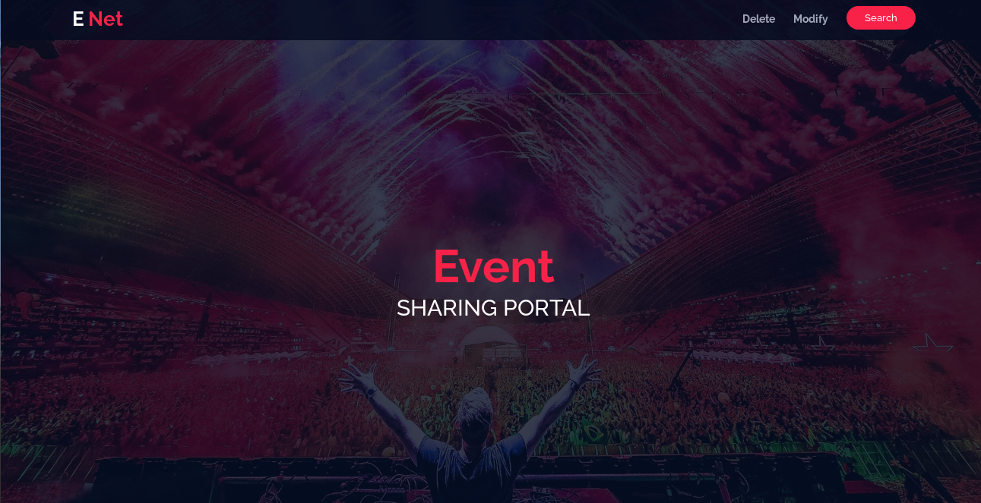

Fig 7.1: Home Page

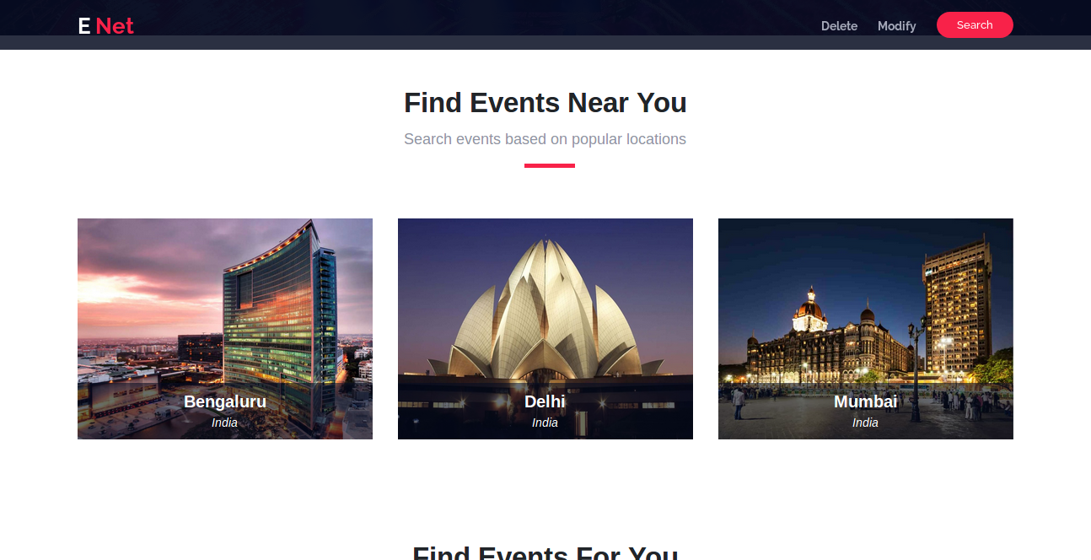

Fig 7.2: Searching events based on city

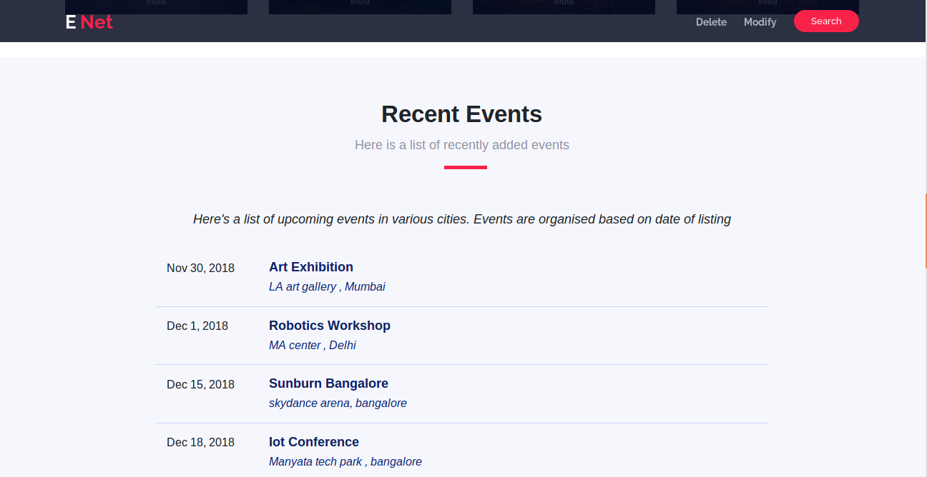

Fig 7.3: Recent event list fetched by date

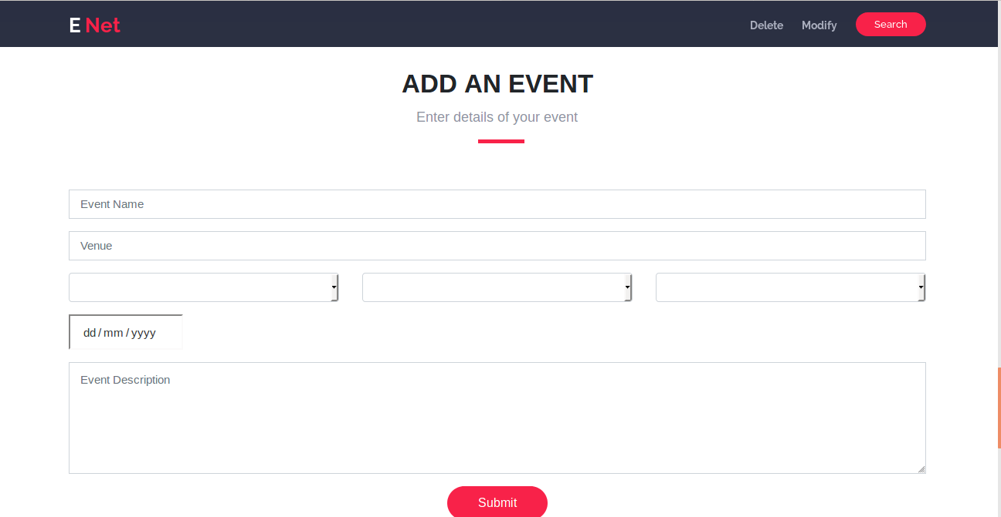

Fig 7.4: Adding an event

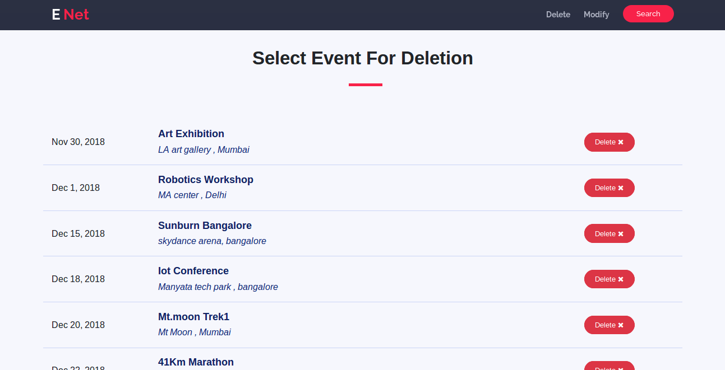

Fig 7.5: Deleting an event

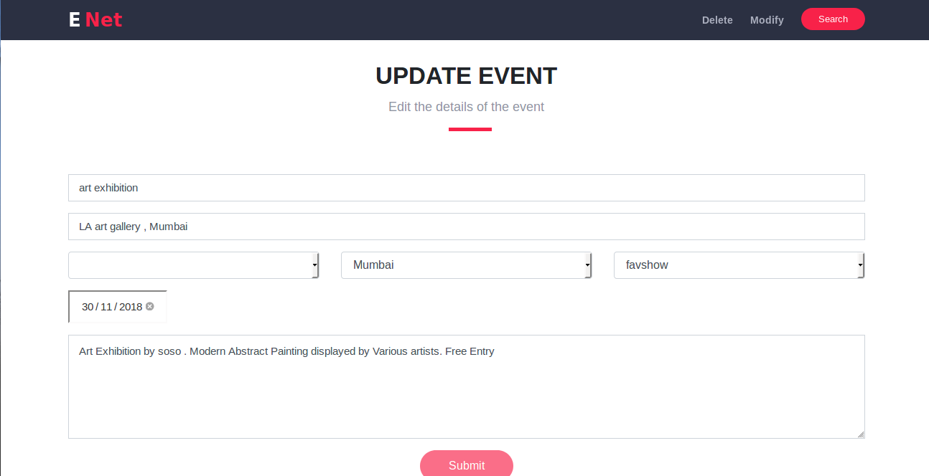

Fig 7.6: Updating an event

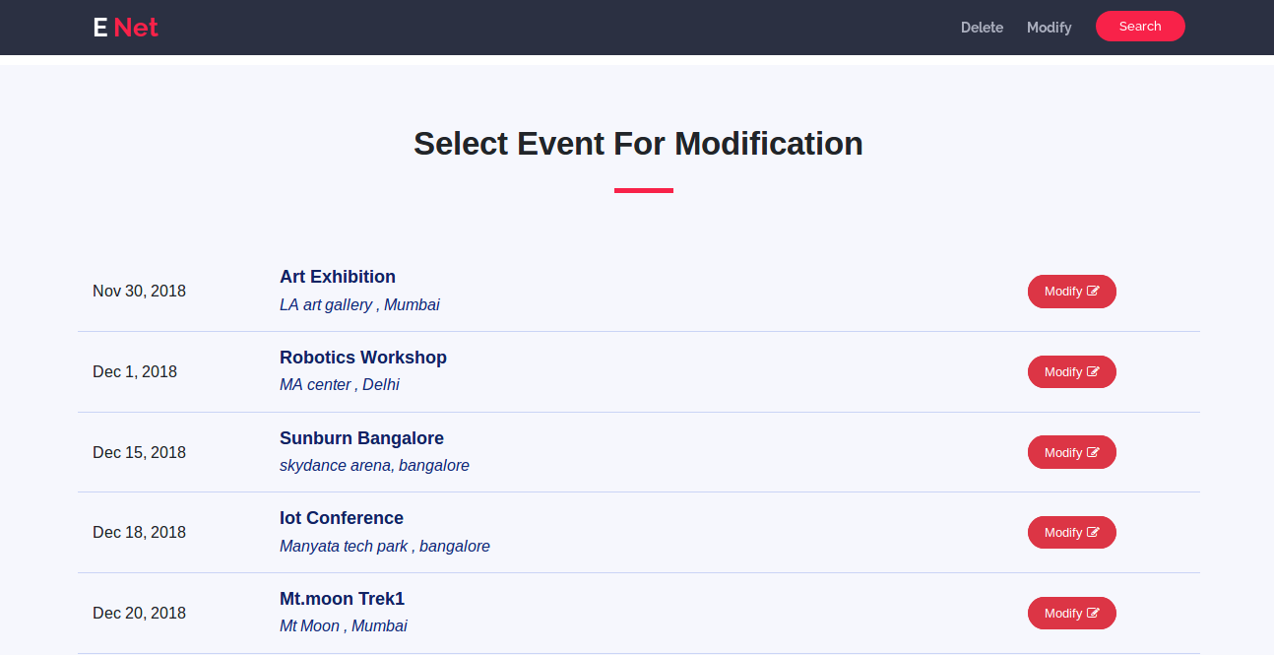

Fig 7.7: Event modification page

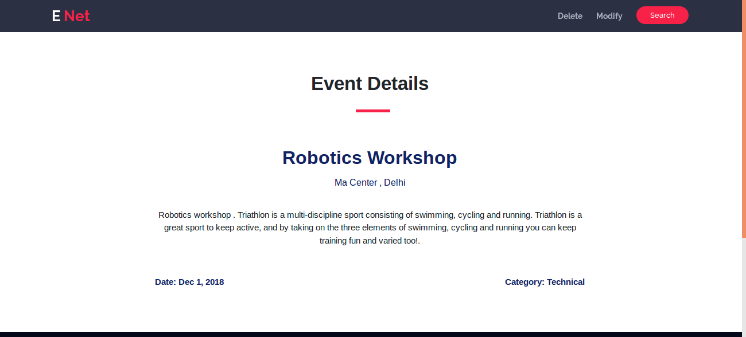

Fig 7.8: Details of an event

CHAPTER 8

CONCLUSION AND
FUTURE ENHANCEMENT

I started the project with no prior experience in web development, and ended up learning HTML, CSS along with frameworks like Bootstrap, and Javascript with frameworks like Angular and Node.js various other tools and concepts relevant to web development like in browser debugging and network visualising tools and concepts like CRUD applications and REST. The project developed is a simple, interactive web application which is extremely user-friendly. It has an open source code and can be altered for future enhancement.
The project developed provides a centralised database for online event hosting portal. The event details are stored effectively in a relational databse for easy access. The system allows users to add and delete events. It also supports modifications of events and provides sorting by city or category facilities.
A lot of enhancements can be made to this project. The immediate feature we plan to implement is a secure login system to allow users to login and register and manage their own events. We plan to make visual improvements including adding additional data and image support. A search by name feature can also be added to the website
If given a chance, I’d further improve this project by adding additional features like having a separate login page for organisers, so they can change data in the database regarding the events they are hosting.

CHAPTER 9

BIBLIOGRAPHY

- Template made by bootstrapmade.com

Fundamentals of Database Systems (6th Edition) by Ramez Elmasri and Shamkant Navathe
- SQL: https://www.w3schools.com/sql/
- Eloquent JavaScript by Marijm Haverbeke

Beginning Node.js by Basarat Syed
- Angular official documentation: https://angular.io/docs
- Wikipedia: http://www.wikipedia.com
- StackOverflow: http://stackoverflow.com

