1. **Course Information**

|  |  |  |  |  |
| --- | --- | --- | --- | --- |
| **Course Code:** | LIT 11 | **LEC Units** | 3 | **Course Description:** |
| **Course Title:** | **Literature of the World** | **LAB Units:** | 0 | A study of works of world literature from Antiquity, the Middle Ages, the Renaissance, and the Contemporary. The course emphasizes the study and consideration of the literary, cultural, and human significance of selected great works of the Western and non-Western literary traditions. An important goal is to promote an understanding of the works in their cultural/historical contexts and of the enduring human values which unite the different literary traditions. |
| **Pre-requisite(s):** | None | **LEC Hours:** | 54 |
| **Co-requisite(s):** | None | **LAB Hours:** | 0 |

1. **Institutional Statements of Vision, Mission, Core Values and Graduate Outcomes**

|  |  |  |  |
| --- | --- | --- | --- |
| **UC Vision** | **UC Mission** | **UC Core Values** | **UC Graduate Outcomes** |
| Democratize quality education. Be the visionary and industry leader. Give hope and transform lives. | University of Cebu offers affordable and quality education responsive to the demands of local and international communities. University of Cebu commits itself to:  (M1) serve as an active catalyst in providing efficient and effective delivery of educational services;  (M2) pursue excellence in instruction, research and community services towards social and economic development as well as environmental sustainability;  (M3) acquire, disseminate and utilize appropriate technology to enhance the university’s educational service; and,  (M4) foster an organizational culture that nurtures employee productivity and engagement | These are the core values that the University of Cebu upholds:  **Innovation** "Be the visionary and the industry leader."  **Camaraderie** "Living in the spirit of harmony and approachability."  **Alignment** "All activities are geared towards core values and priorities." Respect "Always a professional, mindful of God, university, the community and self."  **Excellence** "To be great at whatever it is we do and go for the best." | University of Cebu graduates is (a):  (G5.2.1) Life-long Learner Demonstrate skills and competencies in one’s educational level and field of discipline towards lifelong learning (IG1, IG2, IG3 & IG4)  (GA2) Effective Communicator Exhibit proficiency in listening, speaking, writing, reading and viewing (IG1 & IG4)  (GA3) Socially Accountable and Responsible Demonstrate social accountability and ethical responsibility towards the community and the environment (IG2 & IG6)  (GA4) Team Player Exhibit proactive and collaborative attributes in a diverse society (IG2)  (GA5) Technically Competent Utilize appropriate technology (IG5 & IG7)  (GA6) Ethically Responsible Manifest ethical behavior in diverse situations (IG2) |

1. **UC Graduate Attributes**

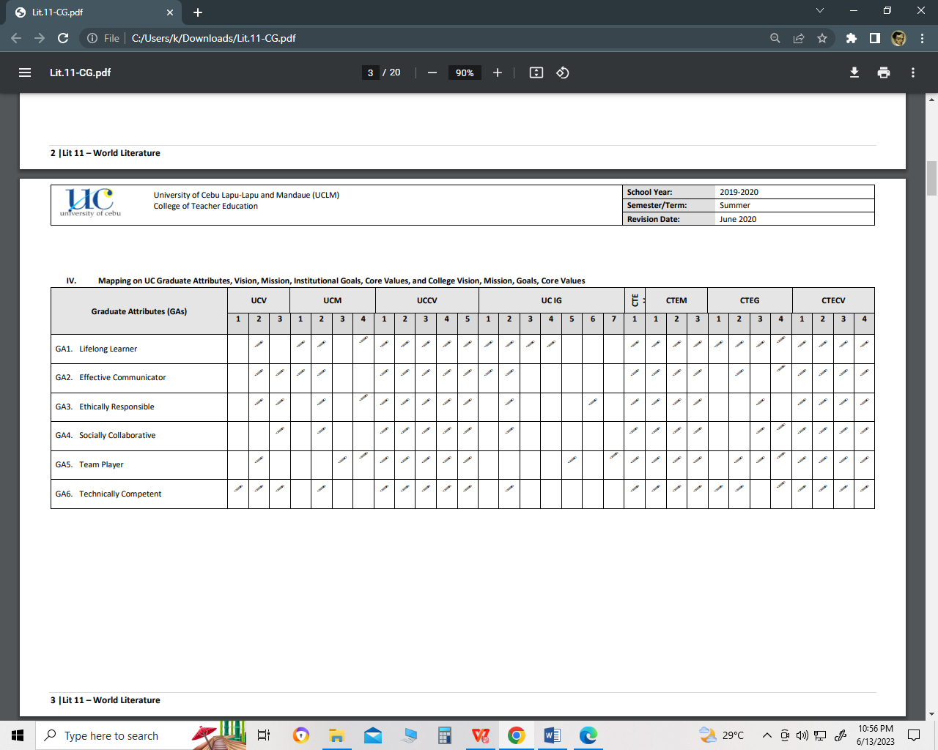

1. **GA-CILO Activation Mapping**

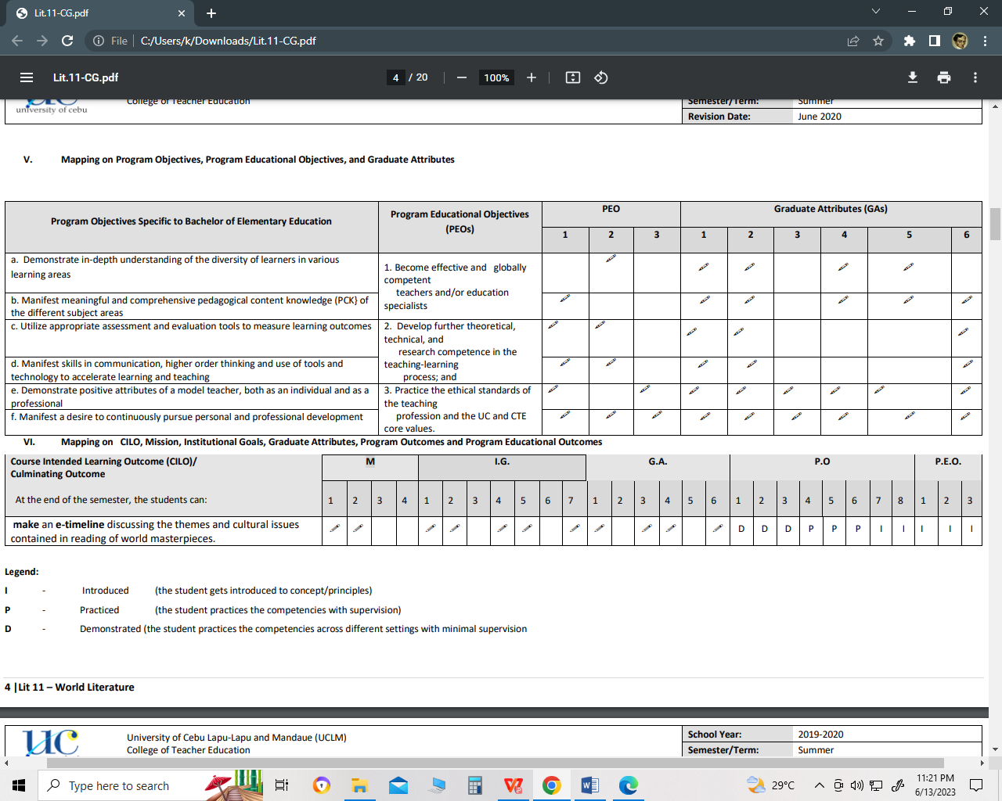

1. **Course Outputs / Summative Assessment Tasks (SATs) (appropriate rubrics may be shown below or in separate page)**



1. **Teaching and Learning Plan**

|  |  |  |  |  |  |  |
| --- | --- | --- | --- | --- | --- | --- |
| **CILO#** | **Specific Intended Learning Outcomes (SILOs)**  At the end of the unit/lesson, the student will be able to: | **Topics** | **Teaching &Learning Activities (TLAs)** | **Formative Assessment Tasks (FATs)** | **Learning Resources / References** | **Time Frame** |
| **1.Craft a literary analysis using appropriate literary approaches, with focused discussion on application to real life situations** | Identify different reading approaches;  Analyze different literary texts through different contexts using different critical reading strategies   State the relevance of analyzing text in decision making in life | *Classification of Literature*  *Reading*  *Approaches*  *Parts of Literary Analysis* | Synchronous:  Journal Analysis: The students will craft a journal literary analysis and use different critical approaches in analyzing different contexts and relevancies of the “Divine Comedy” (by Dante Alighieri) in real life decision making.   See attached rubric from References | Asynchronous:  Reflective essay: Create a literary analysis of the story “ Divine Comedy” by Dante Alighieri using Historical Criticism Approach. See attached rubric | [**https://drive.google.com/file/d/114y0hgAuPLHUbhLckMDJXdjqLKPCVpJl/view?usp=sharing**](https://drive.google.com/file/d/114y0hgAuPLHUbhLckMDJXdjqLKPCVpJl/view?usp=sharing) | 3 Hours  3 Hours  3 Hours |
| **2. Evaluate the themes of the literary works during the ancient times, and integrate themes appropriately in present time scenarios.** | Analyze literary piece in the ancient times using historical and cultural content  Evaluate the themes of literary pieces during the ancient times  Appreciate the value of literature in the olden times | *Introduction to World Literature*  *The Epic of Gilgamesh*  *The Iliad and The Odyssey*  *Mahabharata* | Asynchronous:  Reflective essay: Students will write a reflective essay which evaluates and appreciates the themes of ancient literary works, as well as, apply historical and cultural context in contextualizing personal relevant experiences.  Synchronous:  Evaluate the theme of the story “Iliad and Odyssey” and create an artistic output in the form of Poem, Song, Vlog, Spoken Poetry etc. showing your interpretation of the theme.  Criteria:  Creativity – 10pts  Relevance – 20pts | Asynchronous:  Interactive Quizlet using Menti.com: Using the Menti.com, the students will answer a 10 item test about the introduction of world literature.  Synchronous:  Visual presentation: Students will demonstrate their learning by creating a poster showing their analyzed themes coming from ancient literary works. | Menti.com | 3 Hours  6 Hours  3 Hours  3 Hours |
| **3. Assemble an e-timeline composing the common themes of literary piece during the Middle Ages; and formulate one dominant theme which could be applicable in a particular event at present.** | Analyze literary piece in the Middle Ages using historical and cultural context;  Create an e-timeline depicting the common themes of selected literary works in the middle ages; and  Compare and contrast the themes of literary works in the middle ages to contemporary literature. | *The Parliament of Birds and*  *The Canterbury Tales*  *The Decameron*  *The Tale of Genji* | Asynchronous:  Make an e-timeline depicting the common themes of literary pieces during the middle- ages.  Criteria:  Accuracy – 20pts  Presentation of the theme – 10pts  Synchronous:  eTimeline Creative Report: Students create an e-Timeline which assembles common themes coming from the Middle Ages writings and formulate dominant themes out of these which can be applied in a particular event/situation/context in the present. | Asynchronous:  Create a story grammar of the story “The Canterbury Tales”.  Synchronous:  Exit Ticket One-Minute Reflection: Students will share their one-minute reflection(orally/written) about historical and cultural context analysis on “Iliad and Odyssey”. This serves as their exit ticket before they can leave the Synchronous class. |  | 2hours  2 hours  2hours  2hours |
| **4. Produce an infographic output depicting the common themes of literary pieces during the Renaissance, and generate insights from one dominant theme and compare/contrast with current events.** | Determine the characteristics of literature during Renaissance period;  Analyze literary piece in the Renaissance using historical and cultural context;  Appreciate the contributions of Renaissance literary writers. | *Gargantua*  Hamlet  *The Prince* | Asynchronous:  Podcast (Group): Students will be grouped into three. Each group will choose five literary writings in the Renaissance period  which will be relevant to their assigned topic. The topics include:  Group 1 - characteristics of dominant themes;  Group 2 - historical and cultural context relevance; and,  Group 3 - the impact of Renaissance literary writers' contribution in the world.  Synchronous  H-Bone Technique  Illustrate the characters’ strengths, weaknesses and similarities of the story “Hamlet”. | Asynchronous:  Design an infographic showing the common literary themes during the Renaissance period.  Criteria:  Design – 5pts  Representation – 20pts  Clarity – 10pts  Synchronous:  Visual presentation: Students will design an infographics which depicts the common theme of Renaissance period literary writings |  | 2hours  2hours  2hours |
| **5. Create a reflective essay discussing the common themes of literary pieces emerging in the modern times; and highlight significant human values learned from each literary piece through oral interaction.** | Synthesize the themes of literary pieces during the modern times;  Write a reflective essay based on the common themes of the emerging literary works in the modern times.  Deepen one’s appreciation and understanding of literature as a means of achieving intercultural communication. | *The Eye of Darkness*  *The Year of the Flood* | Asynchronous:  Make a e-portfolio with reflective discussions showing the common themes of literary work during the modern times  Choice of documentation – 10pts  Portfolio Presentation - 10pts  Personal Reflection – 20pts  Synchronous:  eClass Got Talent (Group): Students will work in groups to showcase different interpretations/ways (Poem, Drama, Dance, Song, Vlog, Spoken Poetry etc.) in synthesizing the themes and in deepening their appreciation and understanding of Modern literature.  or —----------------------------  Walkin Gallery: The class will make a gallery museum of the World of Literature. Students are assigned to different groups with assigned literary periods. With their assigned periods, they will create a gallery simulation which shows and explains the significance of its period as well as emphasizing themes on each literary piece being chosen. They will then write a Reflective Essay discussing the themes and cultural issues learned from the Gallery. | Asynchronous:  Quiz using Kahoot  Synchronous:  Blog: Students will write a short blog highlighting significant human values on common themes of the emerging literary works in the modern times. |  | 3 hours  3 hours |
|  |  |  |  |  |  |  |

1. **Textbook(s) and References**

|  |  |
| --- | --- |
| **Textbook (APA Format):** | **References (APA Format including citations):** |
| To be posted soon | To be posted soon |  |  |

1. **Other Information (Classroom Rules and Policies/ Teacher Information, etc.)**

|  |  |
| --- | --- |
| 1. **ATTENDANCE IS CRUCIAL TO THIS COURSE**   Present an excuse letter signed by the dean of the college with supporting documents such as: doctor’s certificate, etc.   1. **LATECOMERS RECEIVE PARTIAL ABSENCES**   If you are absent, you are still responsible for knowing the material and for turning in any assignments for that day. I recommend that you exchange phone numbers with several classmates so that you can keep up.   1. **ACADEMIC INTEGRITY**   You can read our policies on Academic Integrity & Academic Freedom in Pathfinder. You should have already completed the on-line Academic Integrity/Plagiarism tutorial and submitted your on-line acknowledge form, if you haven’t, please do so now at http://library.lclark.edu/reference/plagiarism/index.htm Consult with me about questions.   1. **INTELLECTUAL HONESTY**   Everyone shall avoid cheating or reduplication of work. All work shall include proper citations whenever necessary.   1. **GRADING SYSTEM**   **Class Standing: 70%**  Quiz - Number of Submitted Formative Tasks - 40%  Seatwork/Assignment - Number of hours of Synchronous Attendance 40%  Oral - Synchronous Session with the FS teachers -20%  **Major Exam - 30%**  Summative Tasks   1. **COURSE REQUIREMENTS**   Portfolio, Activities, assessments, and shall preferably attend every meetings or video calls,   1. **SUBMISSION POLICIES**   Make sure to submit on time all requirements as indicated in the course guide.All requirements shall be submitted 3 days after the last meeting of the semester.Preferably do the online tasks as announced and turn them in on time too.Submitted documents should have Name, Date, Module No. , and Activity title (if group activity: Group No., Names of the Members who help in accomplishing the task, Date, Module No., and Activity title)  **…** | Prepared by:  Miss Gina Ompad, Ma. Ed. -ELT  [gompad@uc.edu.ph](mailto:gompad@uc.edu.ph)  Mr. RomelAtabay, MST  [ratabay@uc.edu.ph](mailto:ratabay@uc.edu.ph)  Mr. Omar James CarayoMa. Ed & MAESL  [ojcarayo@uc.edu.ph](mailto:ojcarayo@uc.edu.ph) |