LAB 1 & 2
OPEOLUWA HEZEKIAH OJE
8917862
INFO8491
Prof. Shahid Ismail
Feb 6th, 2024

Table of Contents
Preparation 3
Description 3
Observation 3
Reflection 3
Part 1 3
Building the Topology 3
Screenshots 4
Part 2 4
Configuring the Topology 4
Screenshots 5
Part 3 8
Configuring the Privileged Mode Password 8
Screenshots 8
Part 4 11
Enforcing login 11
Screenshots 11
Part 5 14
Configuring Secure shell 14
Screenshots 14
Part 6 21
Configuring Ip addresses 21
Screenshots 21
Part 7 30
Connecting using SSH 30
Screenshots 30
Lab 2 37
Part 7 37
Configuring Static Routes 37
Preparation 37
Observation 37
Reflection 37
Screenshots 38

Preparation
- Current version of Packet tracer
- Four PC PT Objects
- Two Cisco 2960 Layer 2 Switches
- One Cisco 2811 Router
- One PT Server
- One PT Laptop

Description
The expected goal and result is to ensure the end devices can communicate to all network devices both on their network and outside their network.

Observation
In this lab I was able to configure the network devices to display a motd, I was also enable to enforce login with a password on all network devices on the topology. I also configured a secure shell to ensure login from the workstations/PCs vis ssh.

Reflection
The overall aim and goal is this lab is to increase the level of security on our networks. The enabling password in the privilege mode and enforcing login serves as a form of user authentication and authorization into our network devices.

Part 1

Building the Topology

Screenshots
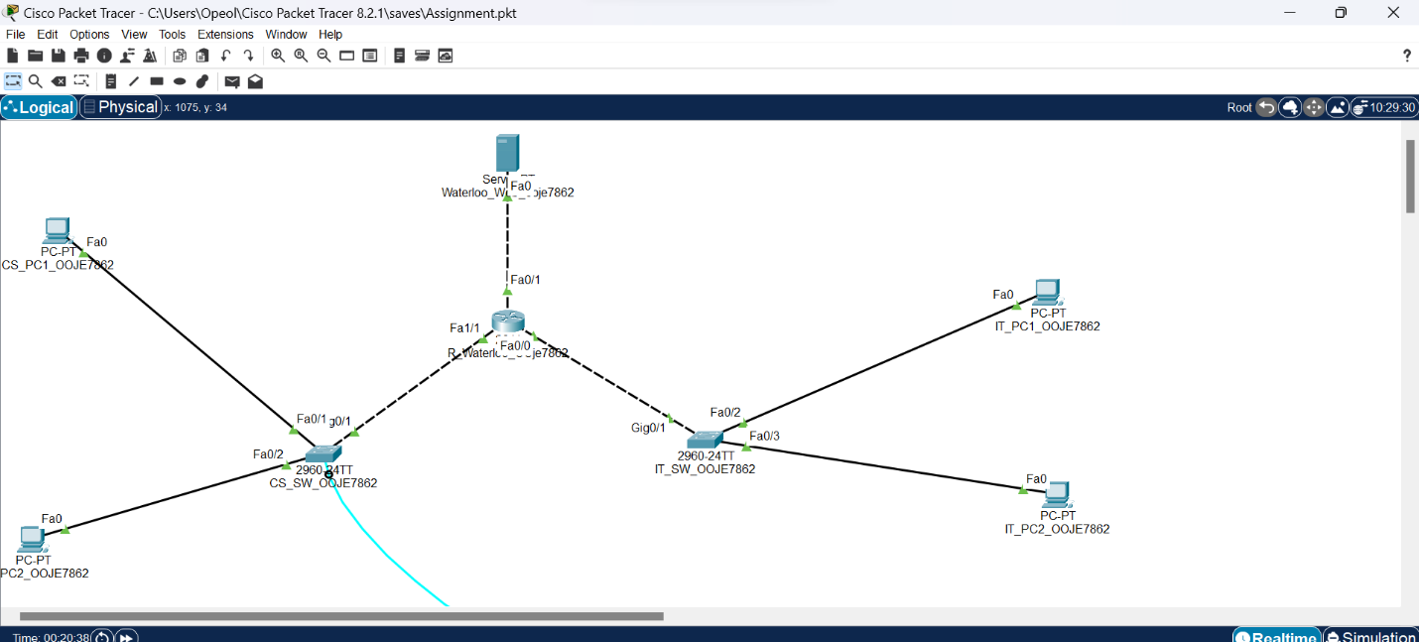
Figure 1 Building of the Topology

Part 2

Configuring the Topology

Screenshots
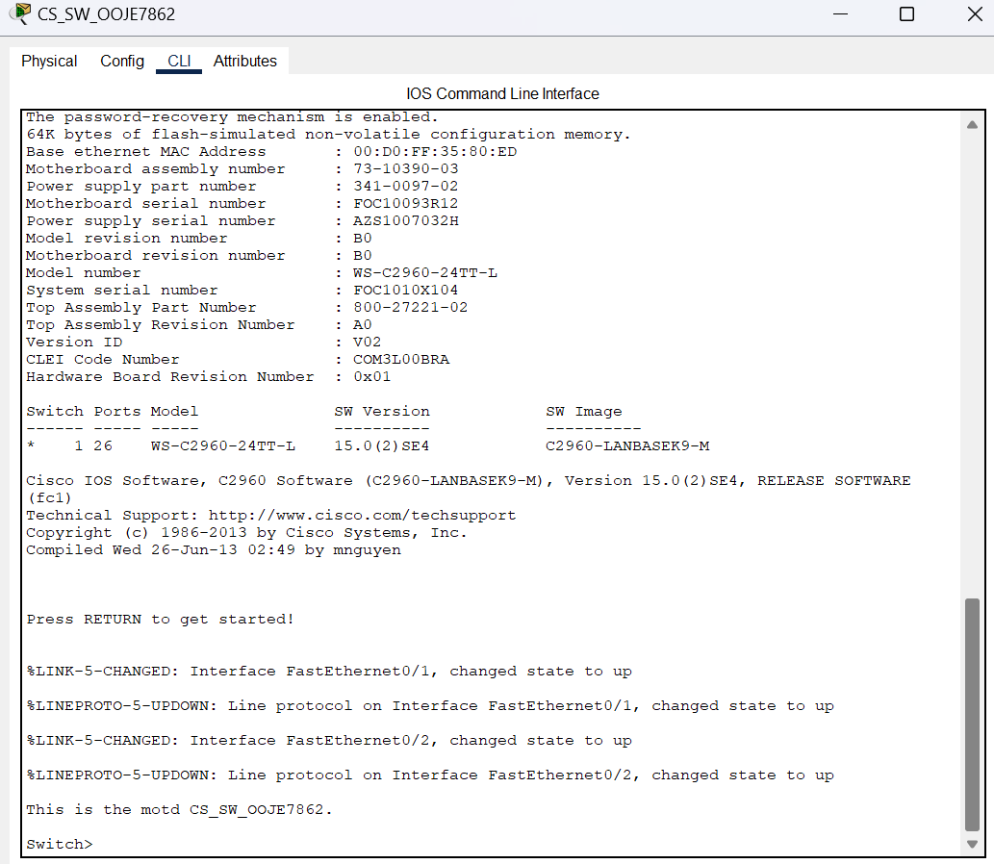
Figure 2.1 Switch 1 showing MOTD

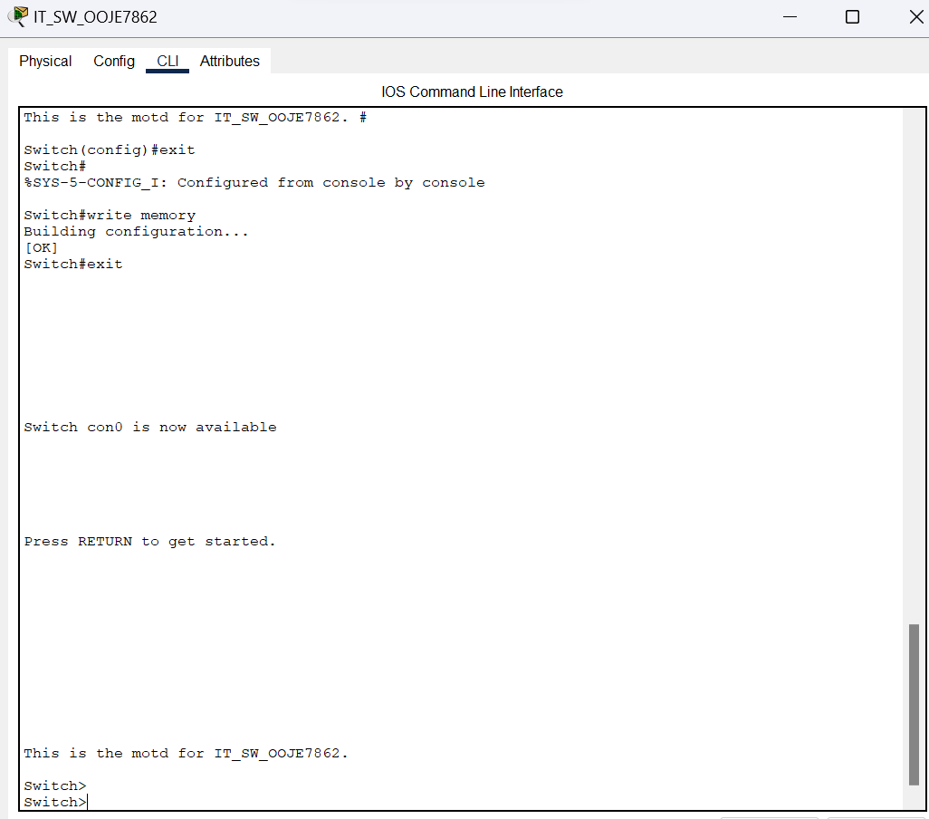
Figure 2.2 Switch 2 showing the motd

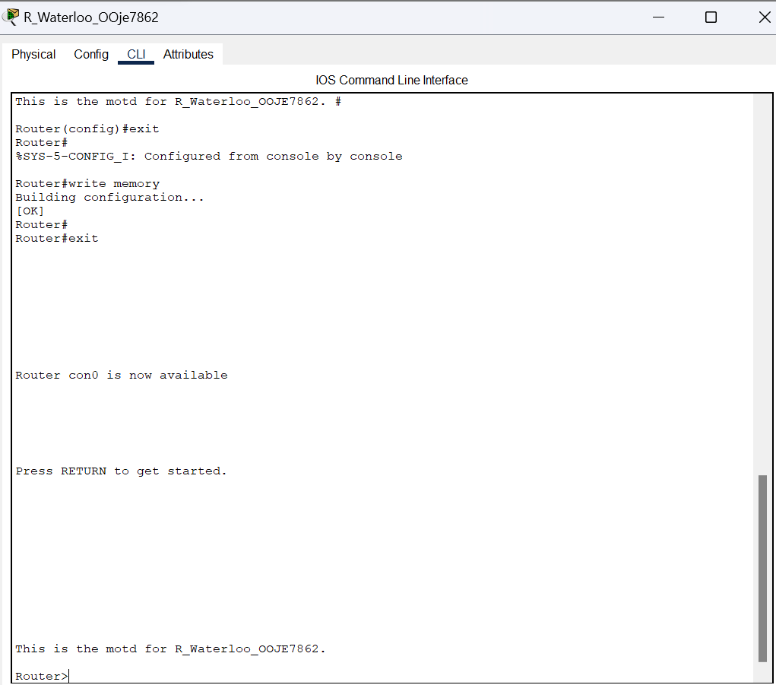
Figure2.3 Router showing the motd

Part 3

Configuring the Privileged Mode Password

Screenshots
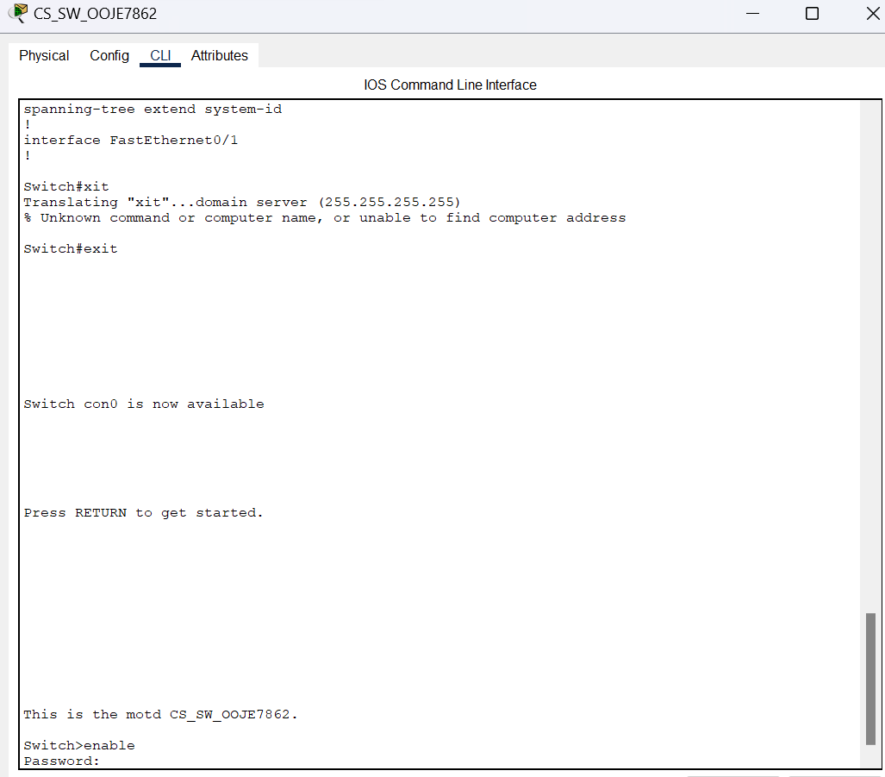
Figure 3.1 Privileged mode password enabled on switch 1
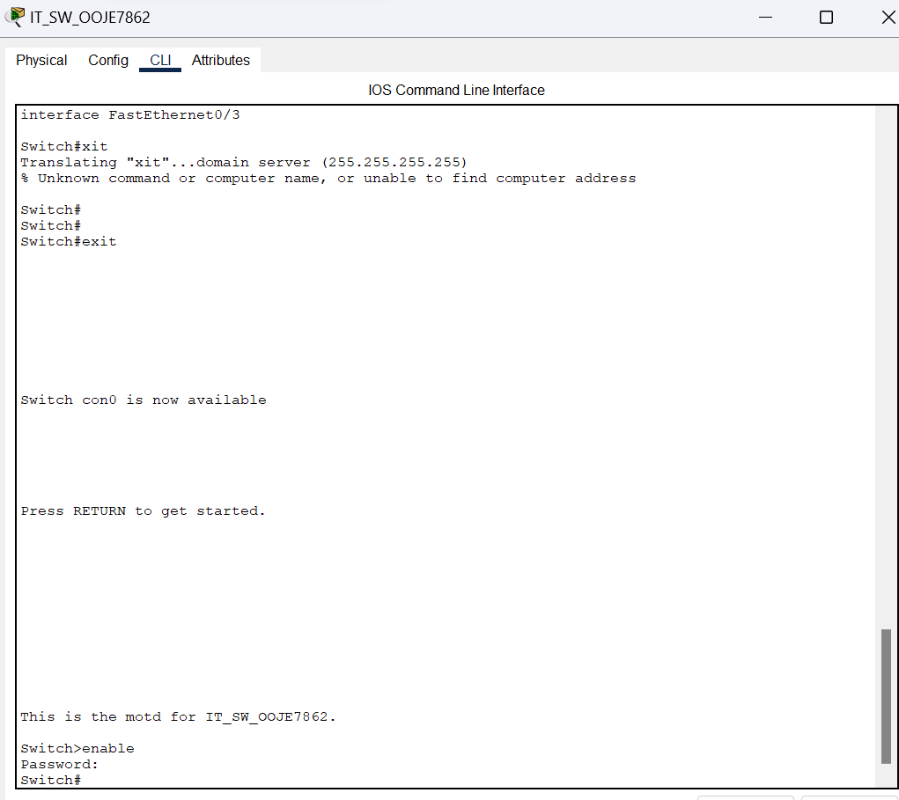
Figure 3.2 Privileged mode password enabled on switch 2
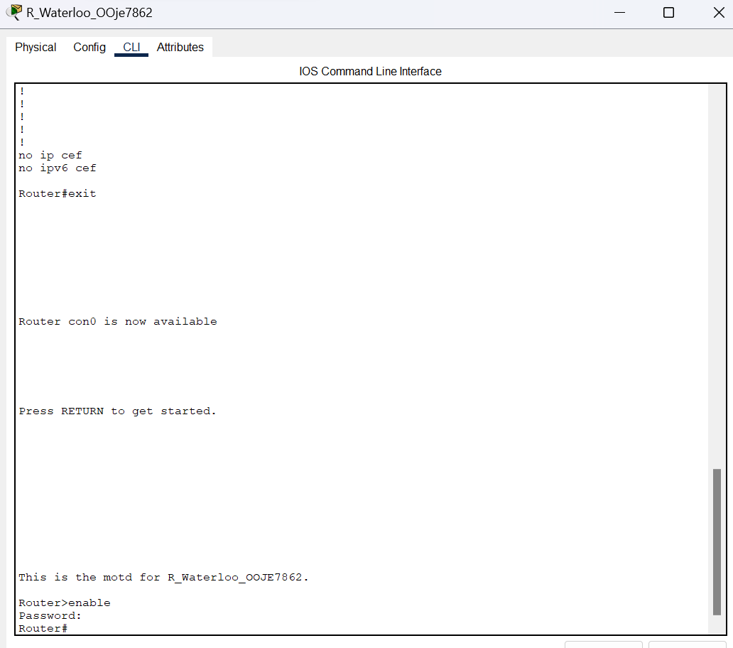
Figure 3.3 Privileged mode password enabled on router

Part 4

Enforcing login

Screenshots
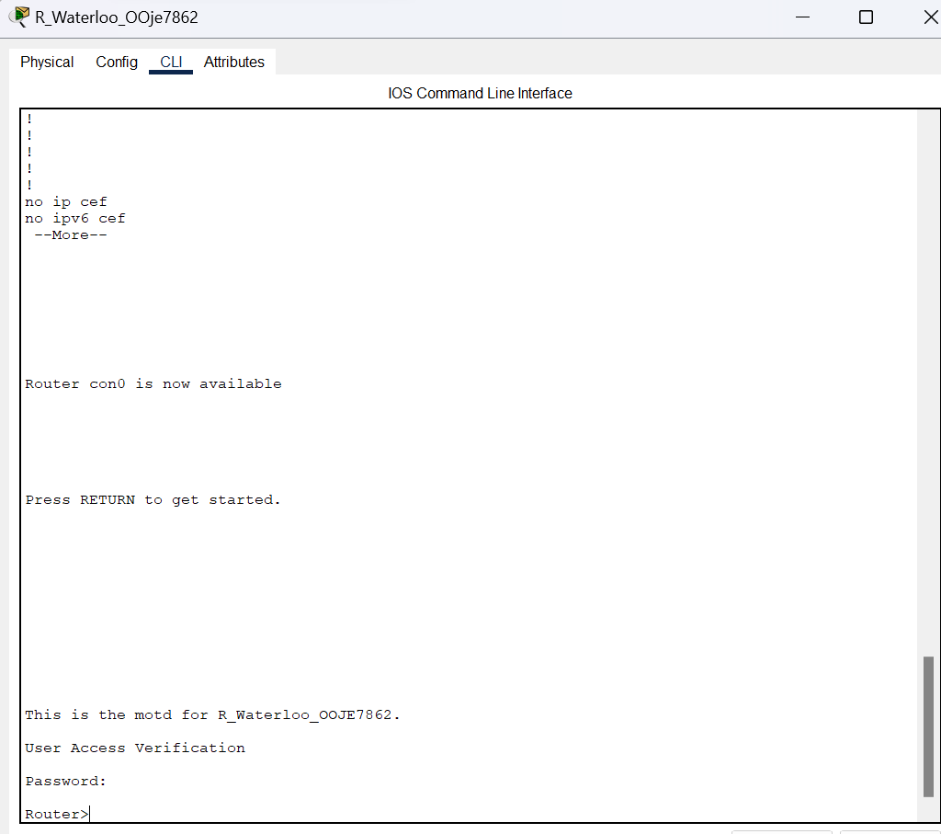
Figure 4.1 Password Enforced on router
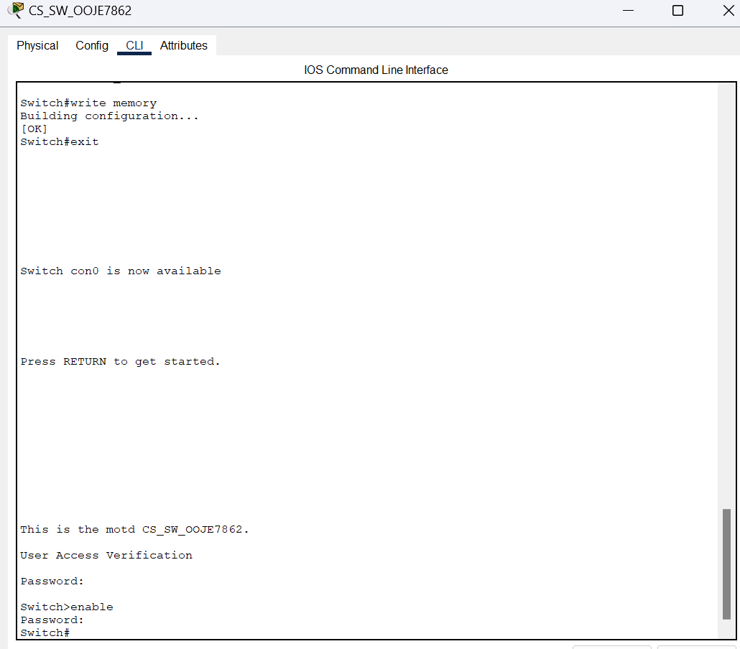
Figure 4.2 Password enforced on switch 1

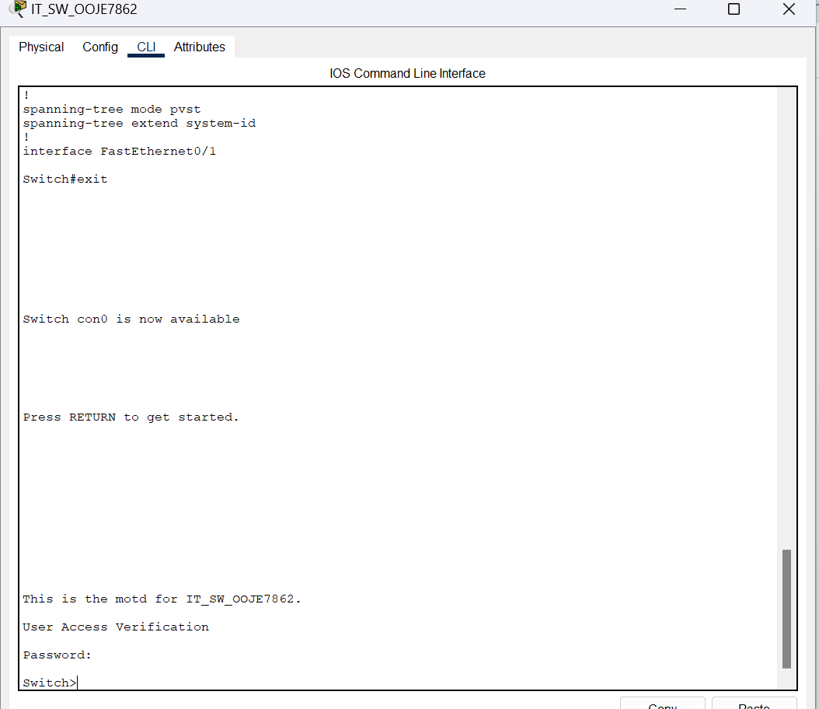
Figure 4.3 Password enforced on switch 2

Part 5

Configuring Secure shell

Screenshots
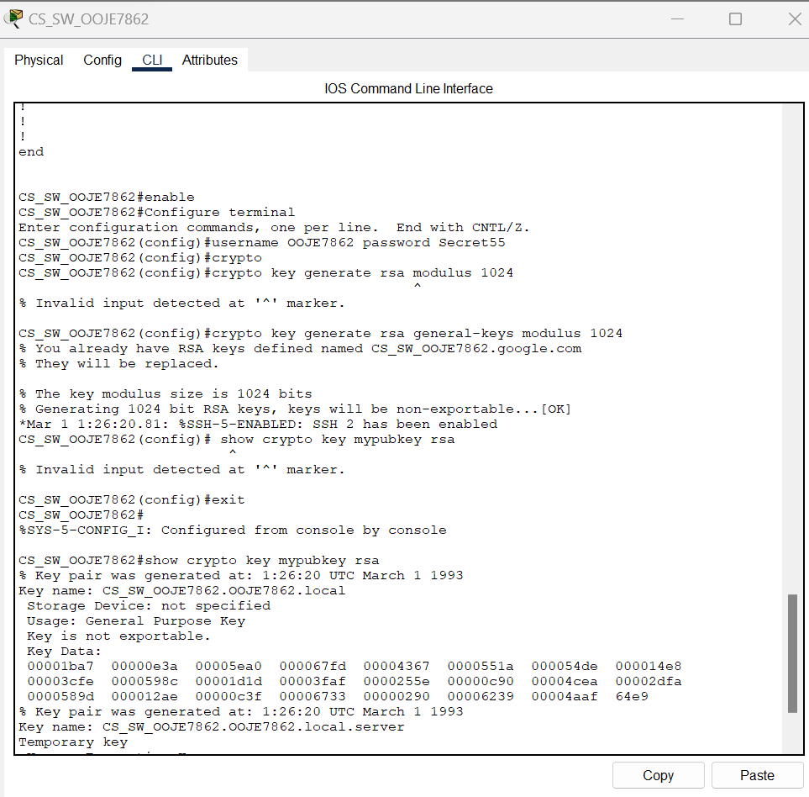
Figure 5.1 Configuring secure shell on switch 1

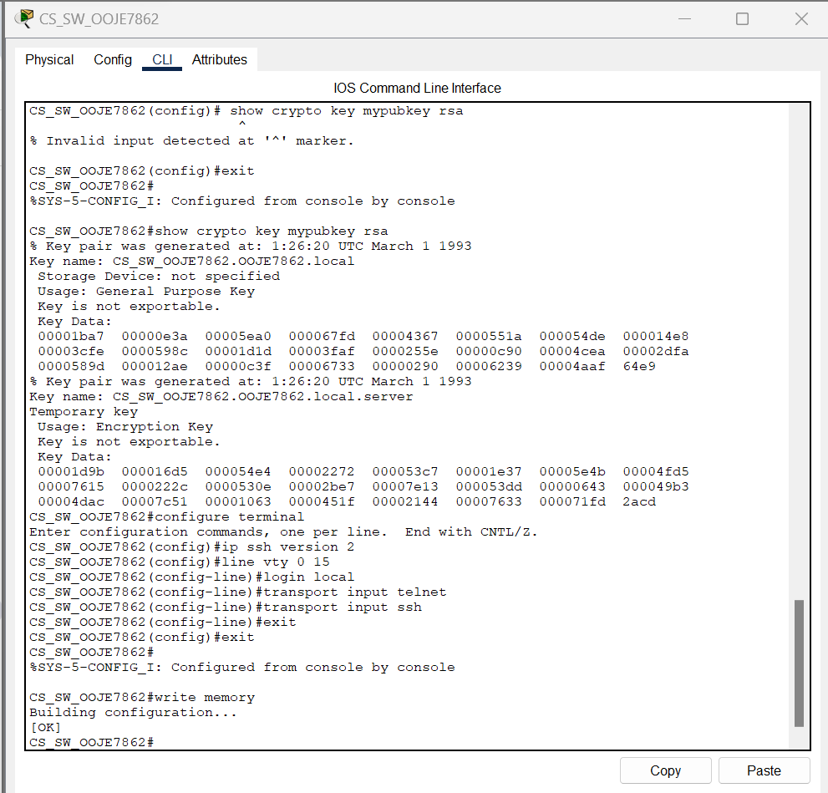
Figure 5.2 Configuring secure shell on switch 1 (2)

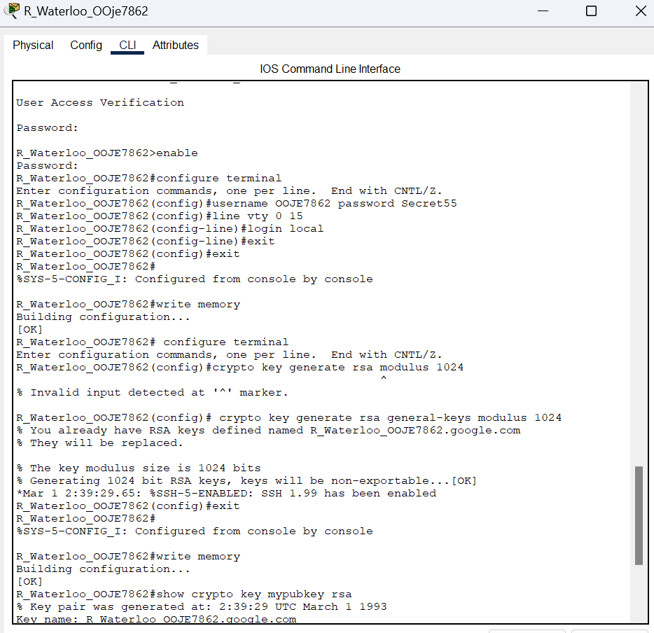
Figure 5.3 Configuring secure on router (1)

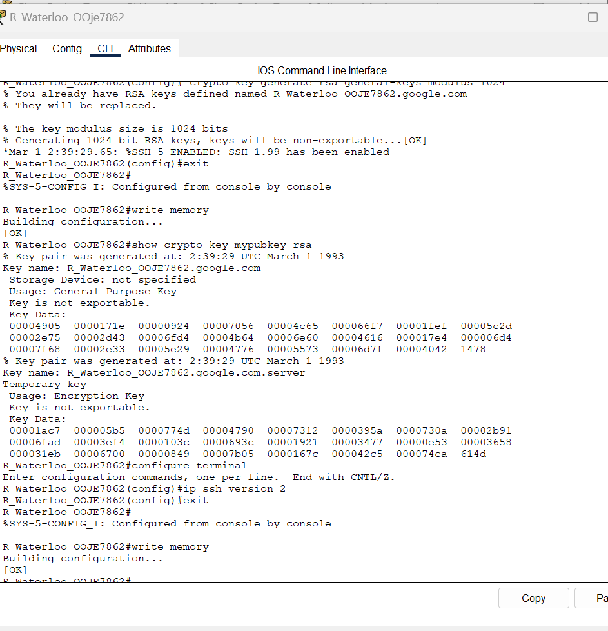
Figure 5.4 Configuring a secure shell on the router (2)
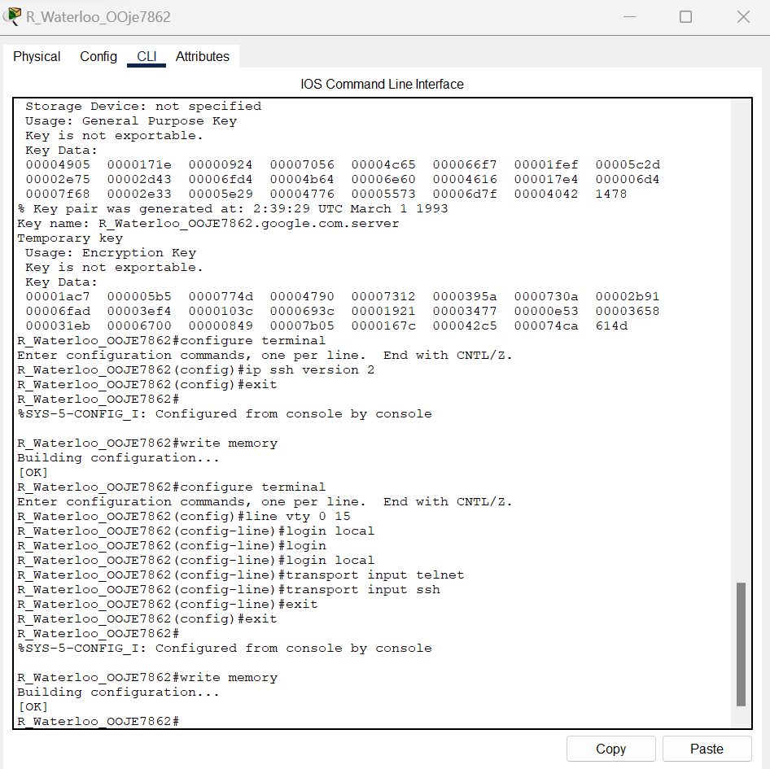
Figure 5.5 Configuring a secure shell on router(3)

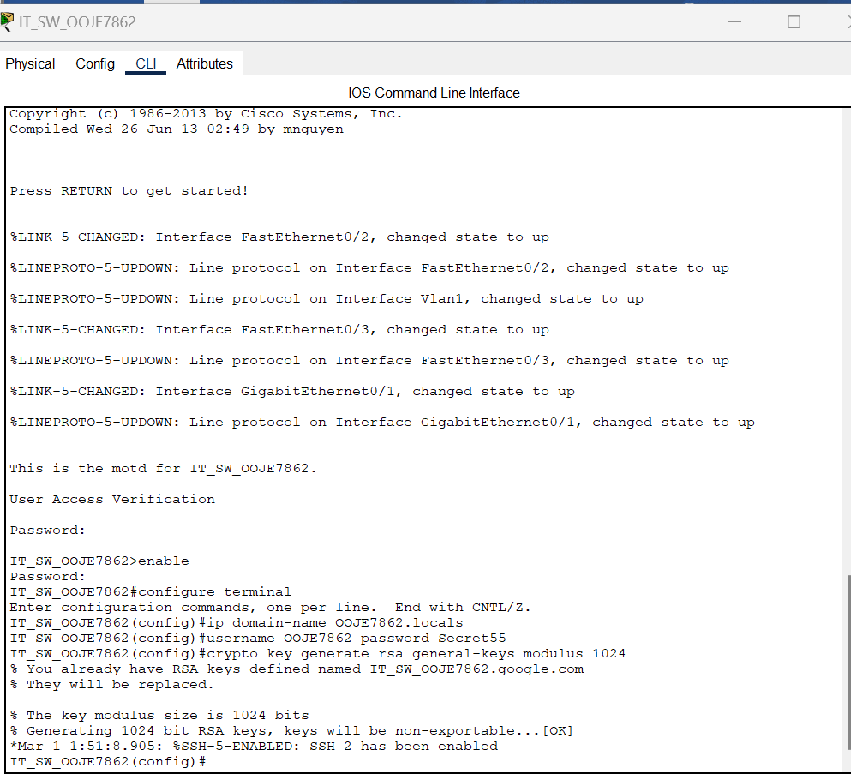
Figure 5.6 Configuring secure shell in switch 2(1)

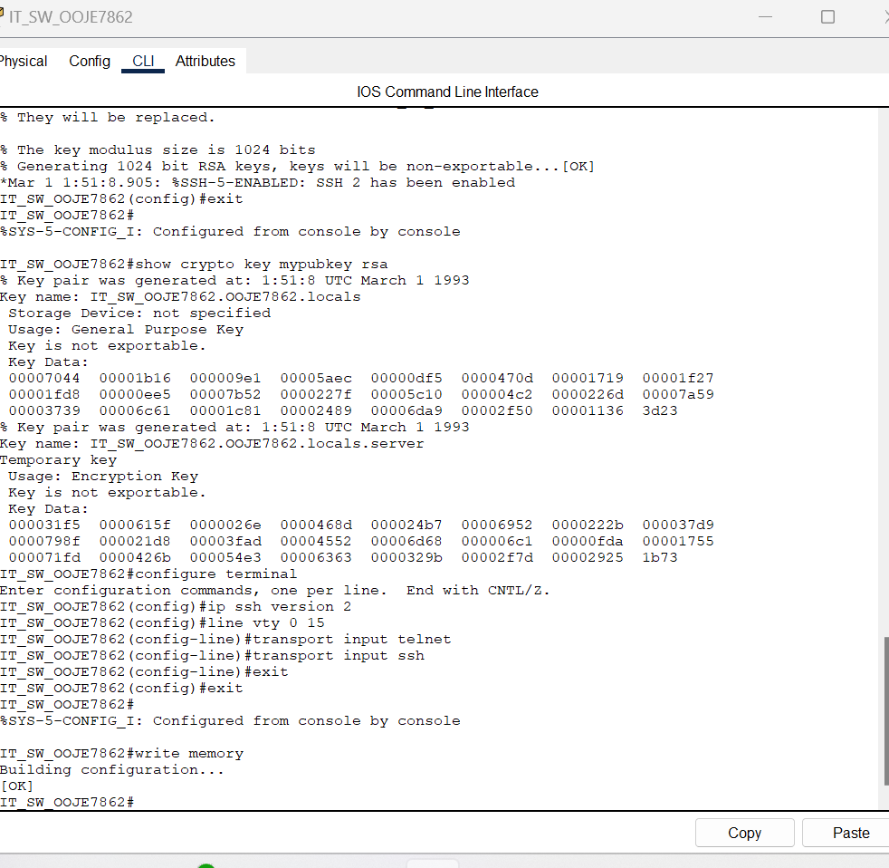
Figure 5.7 Configuring Secure shell in switch 2(2)

Part 6

Configuring Ip addresses

Screenshots
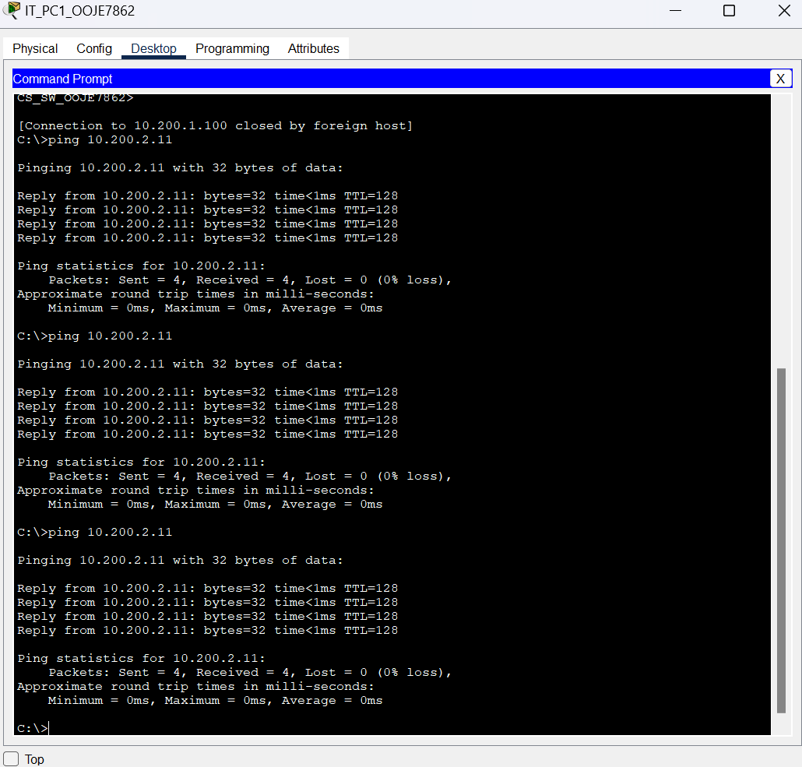
Figure 6.1 Three pings to IT_PC2 from IT_Pc1
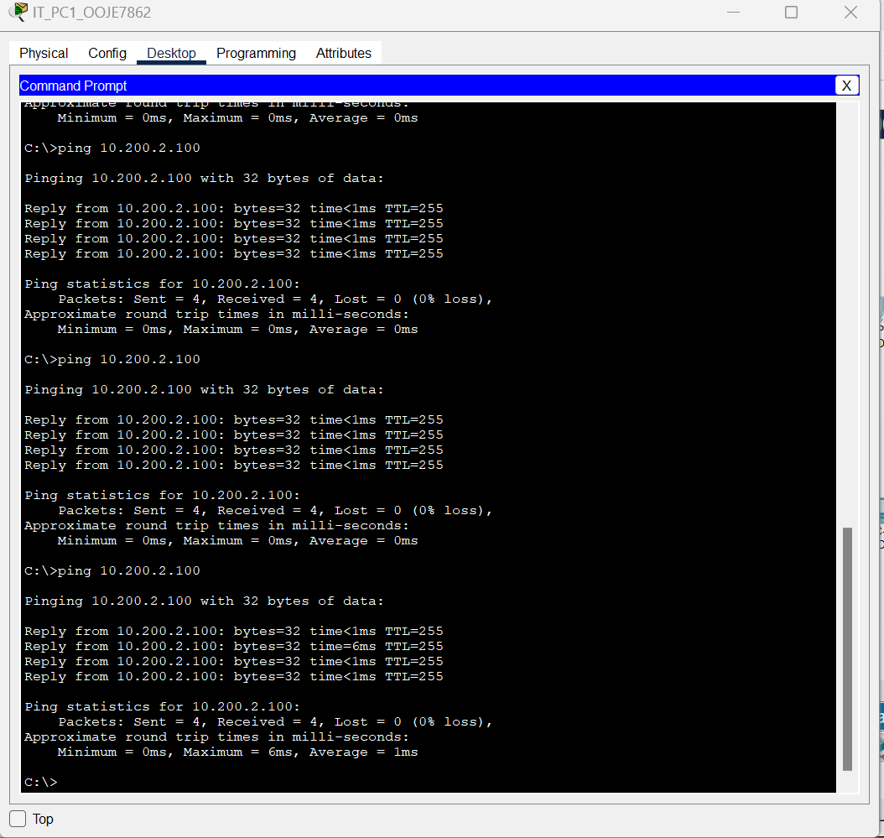
Figure 6.2 Successful ping to IT switch

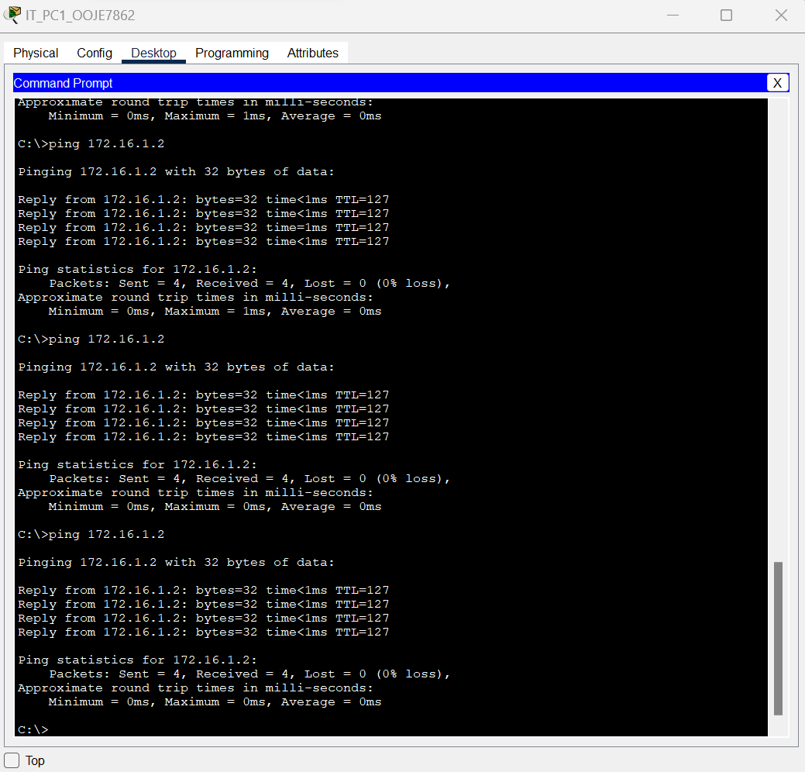
Figure 6.3 Server ping

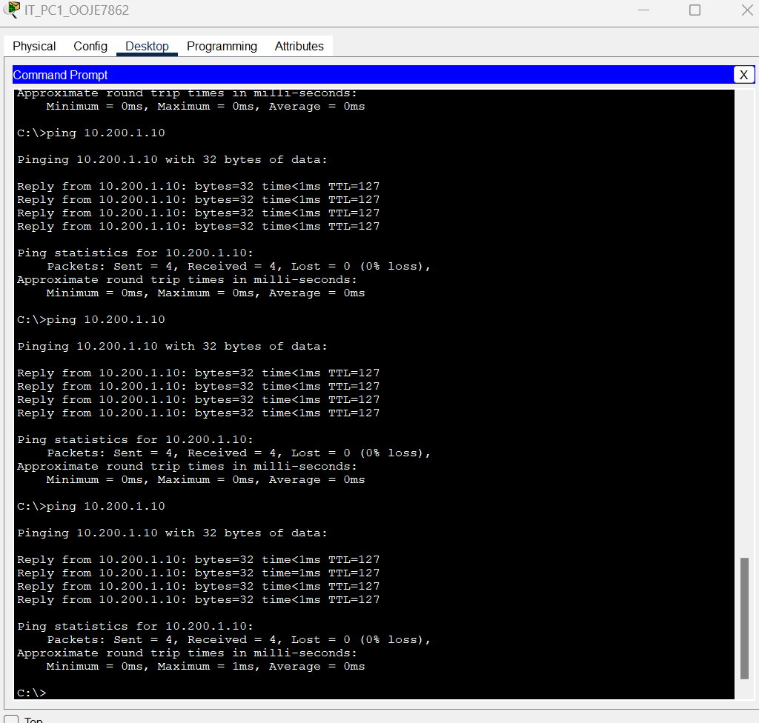
Figure 6.4 CS_PC1 ping from IT_PC1

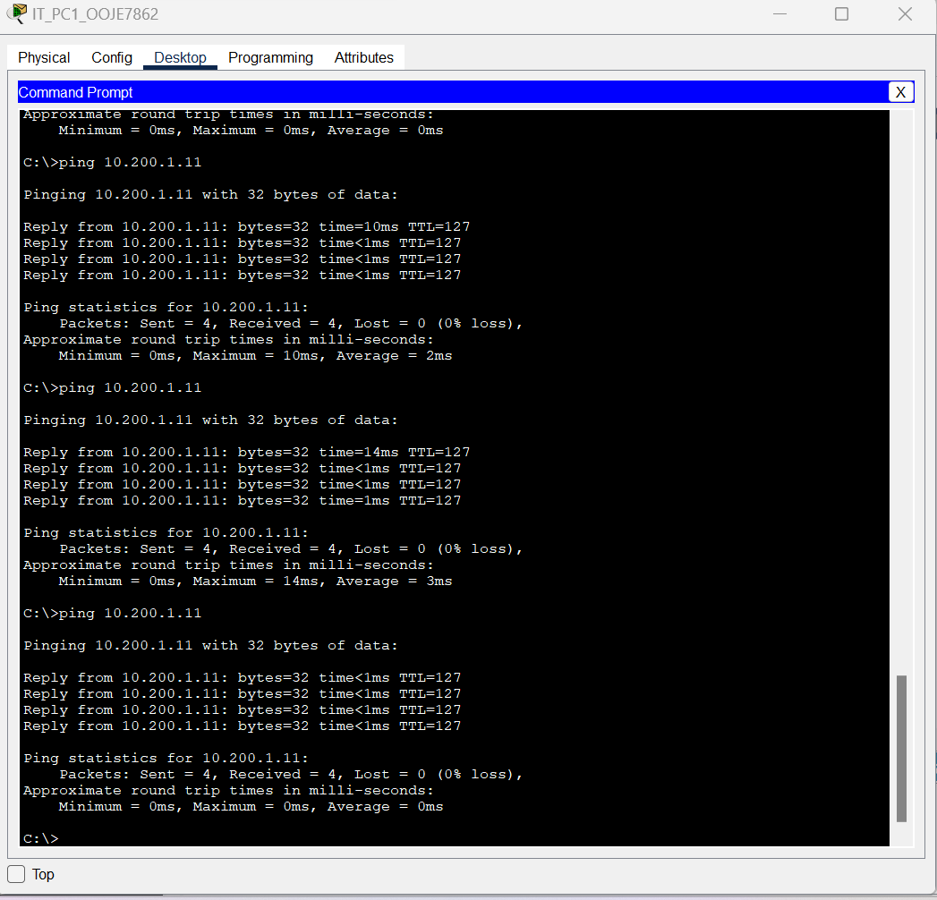
Figure 6.5 CS_PC2 ping from IT_PC1

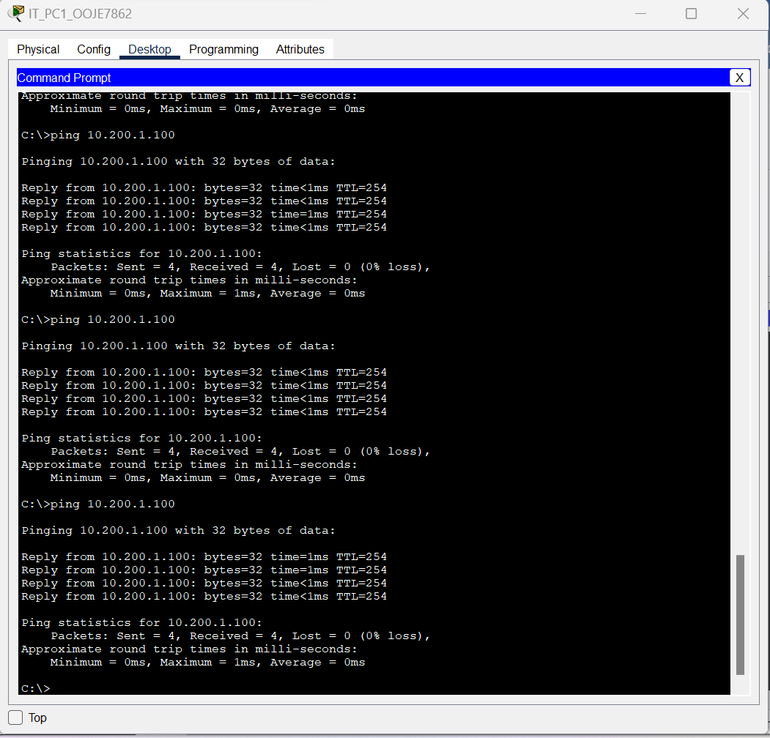
Figure 6.6 Cs switch ping from IT_PC1

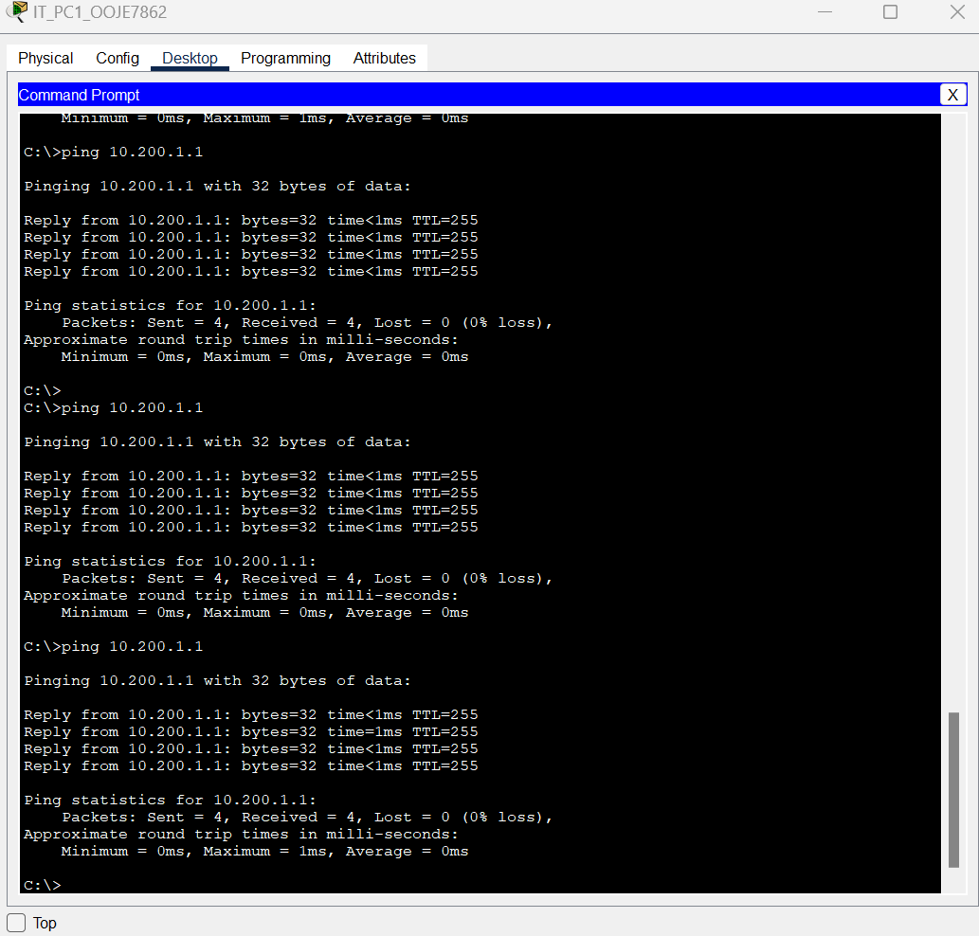
Figure 6.7 Router ping

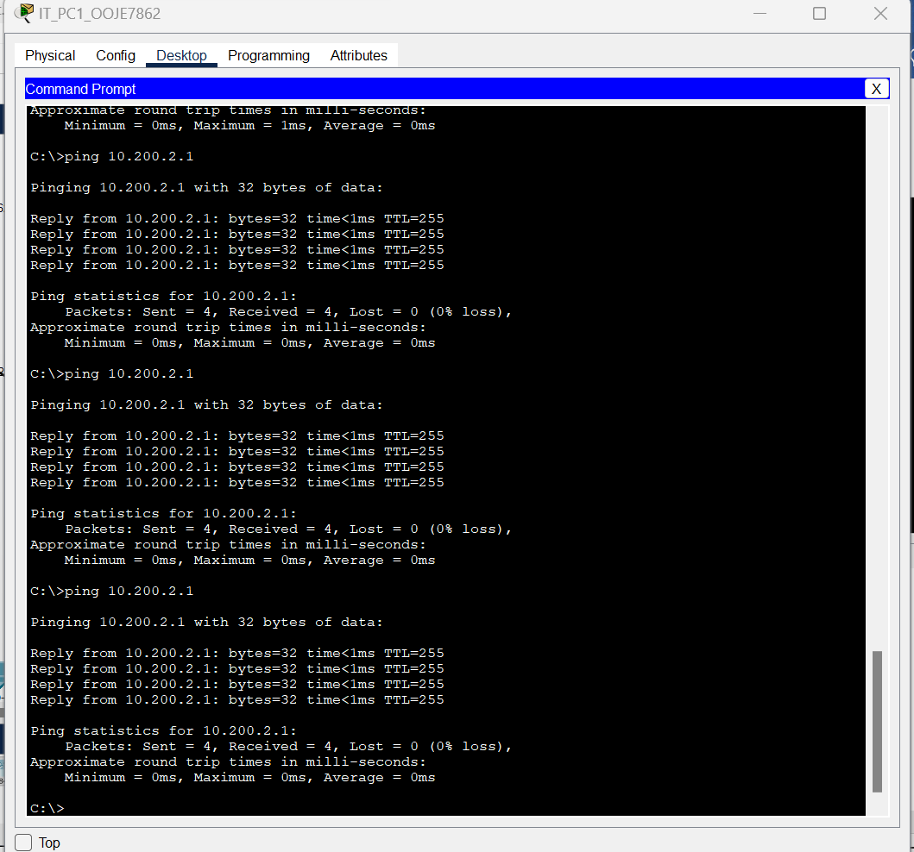
Figure 6.8 router ping

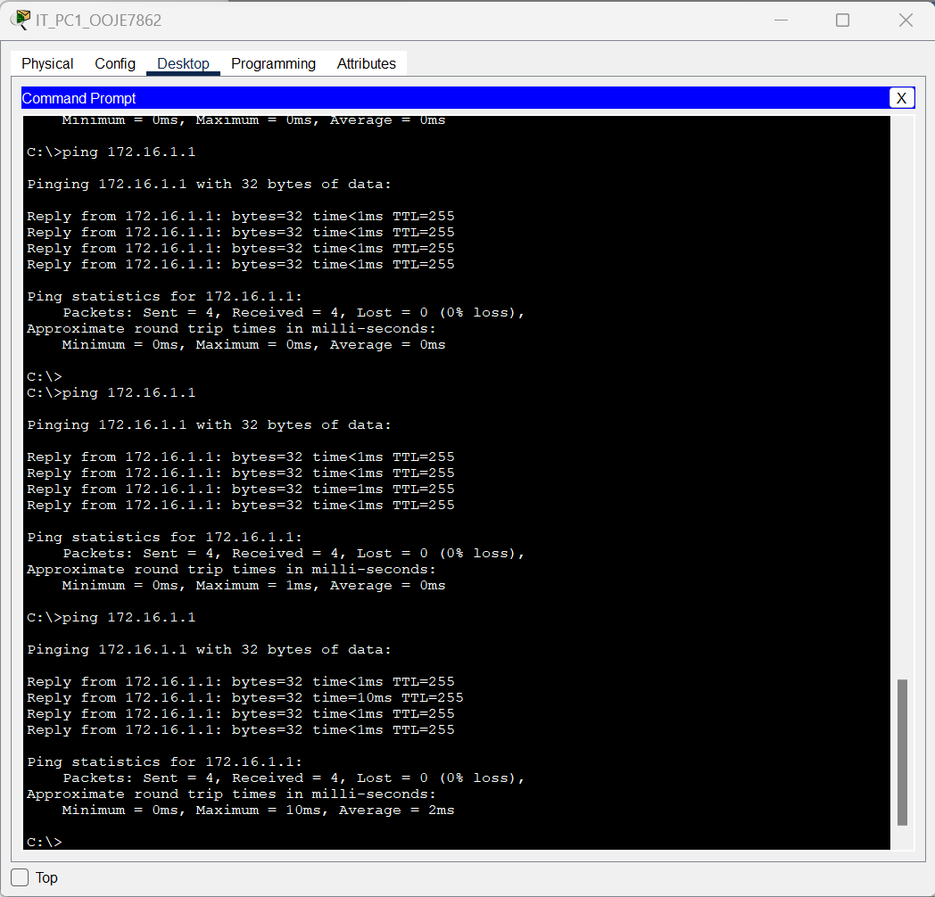
Figure 6.9 router ping

Part 7

Connecting using SSH

Screenshots
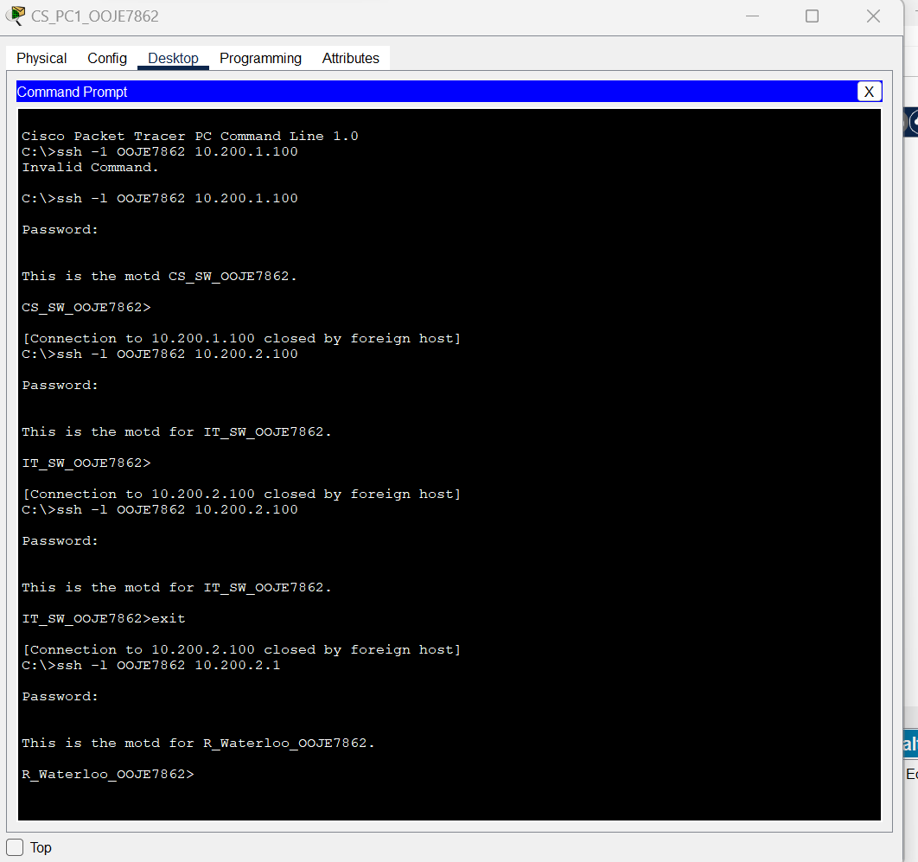
Figure7.1 PC1 connects to IT switch and router via ssh

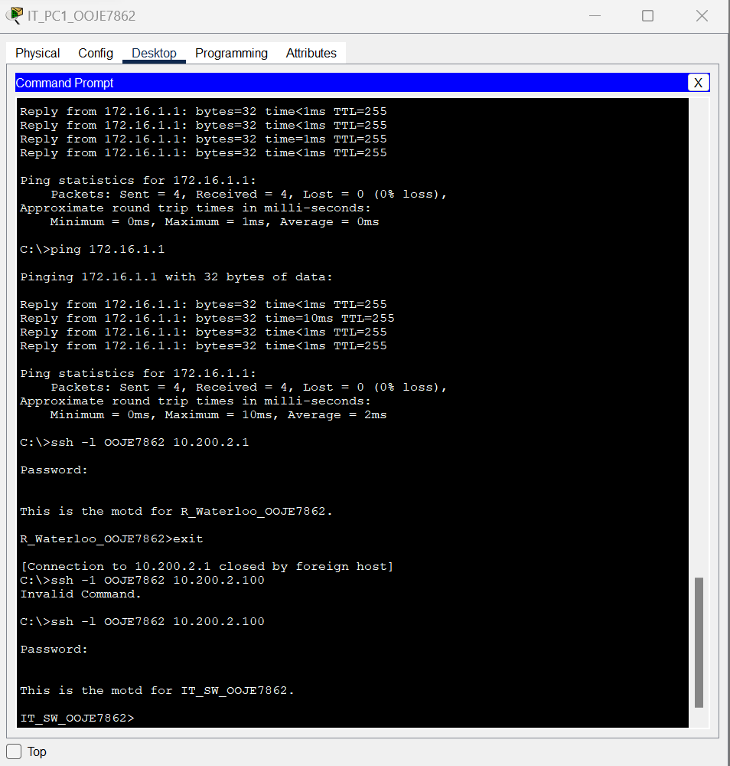
Figure7.2 IT pc1 connects to router and IT switch via ssh

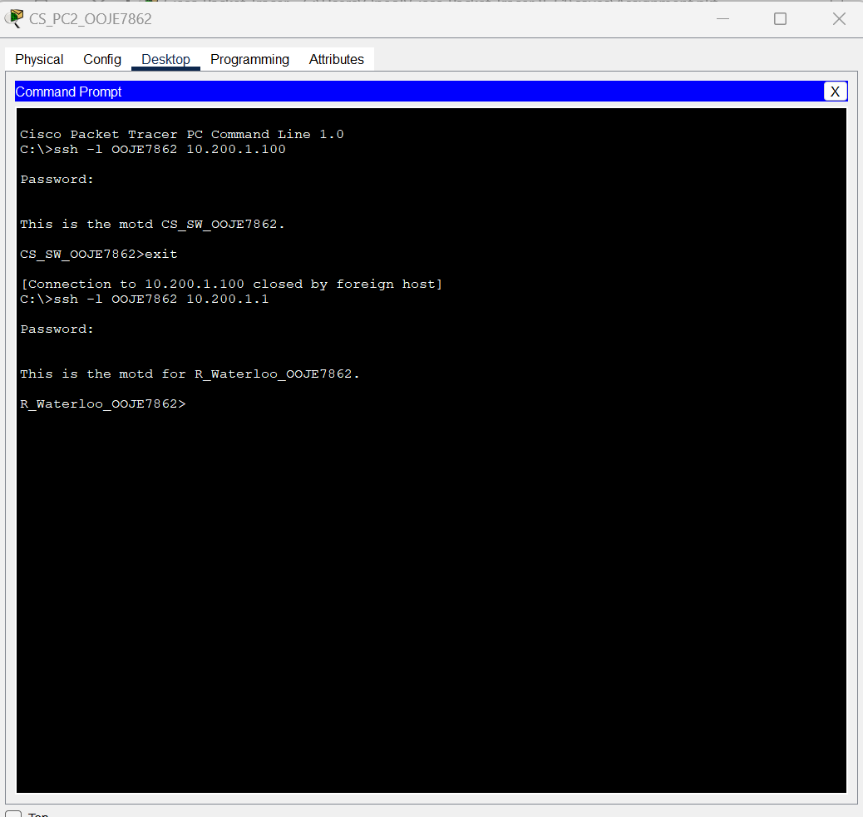
Figure7.3 CS_PC2 connects to Cs_Switch and router

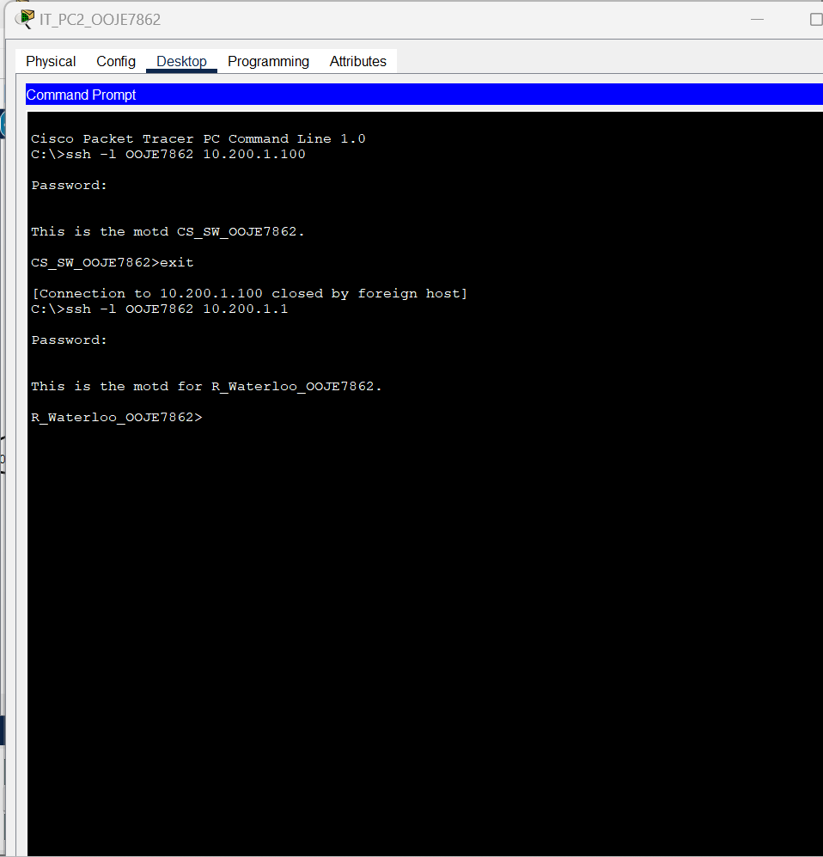
Figure7.4 T_PC2 connects to CS_switch and router via ssh

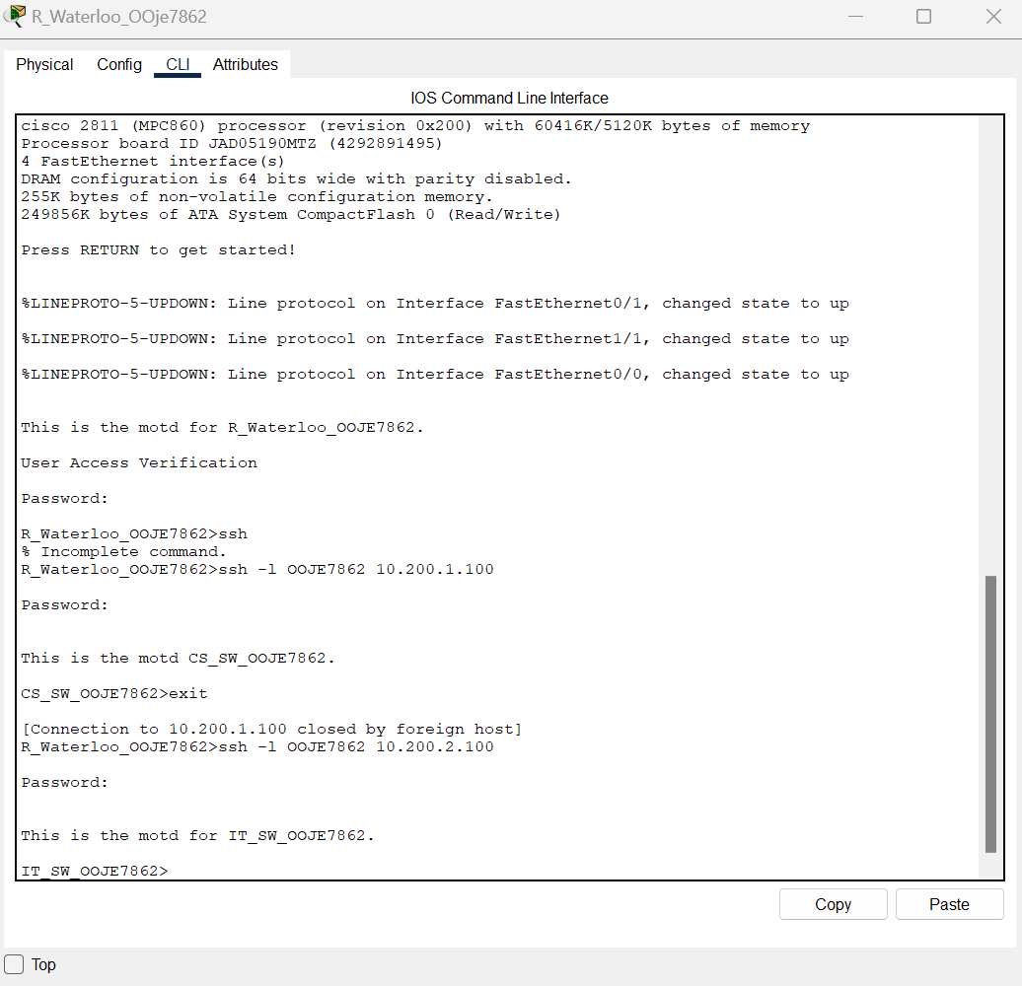
Figure7.5 Router connects to both switches
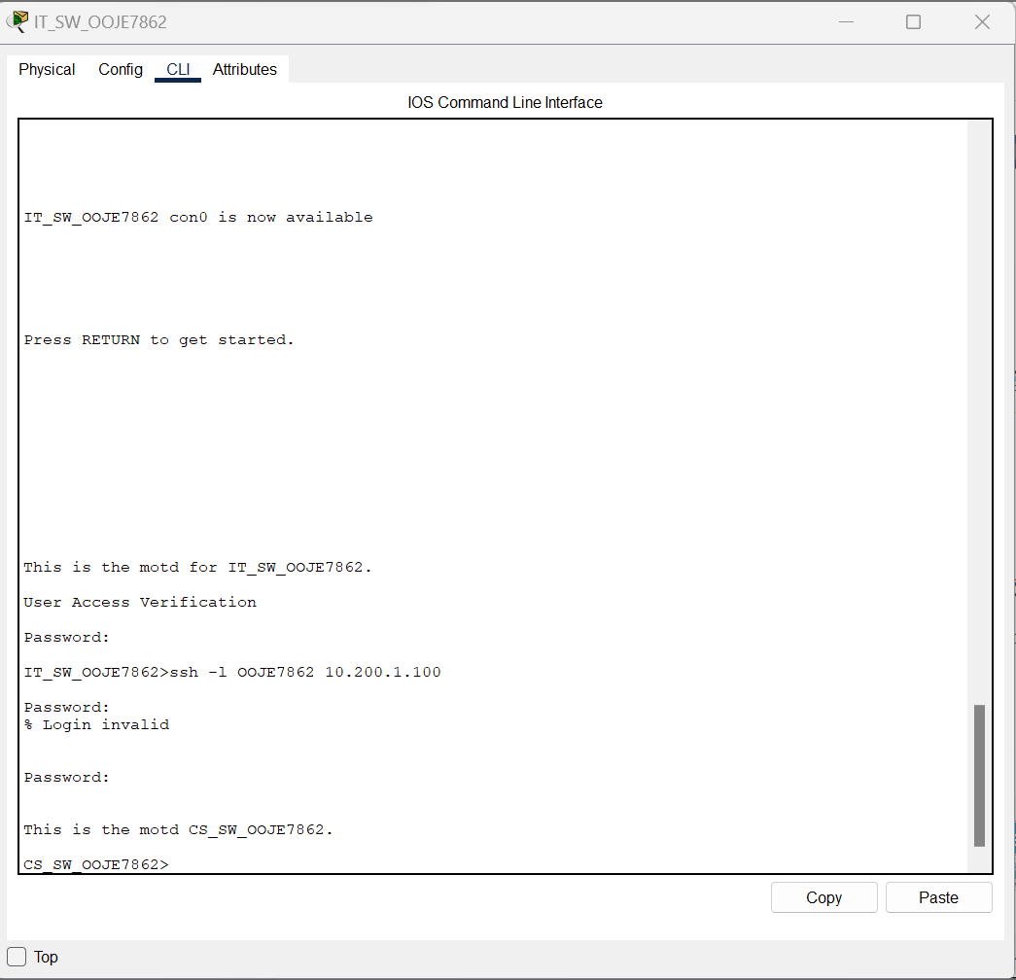
Figure7.6 IT_switch connects to Cs_switch via ssh

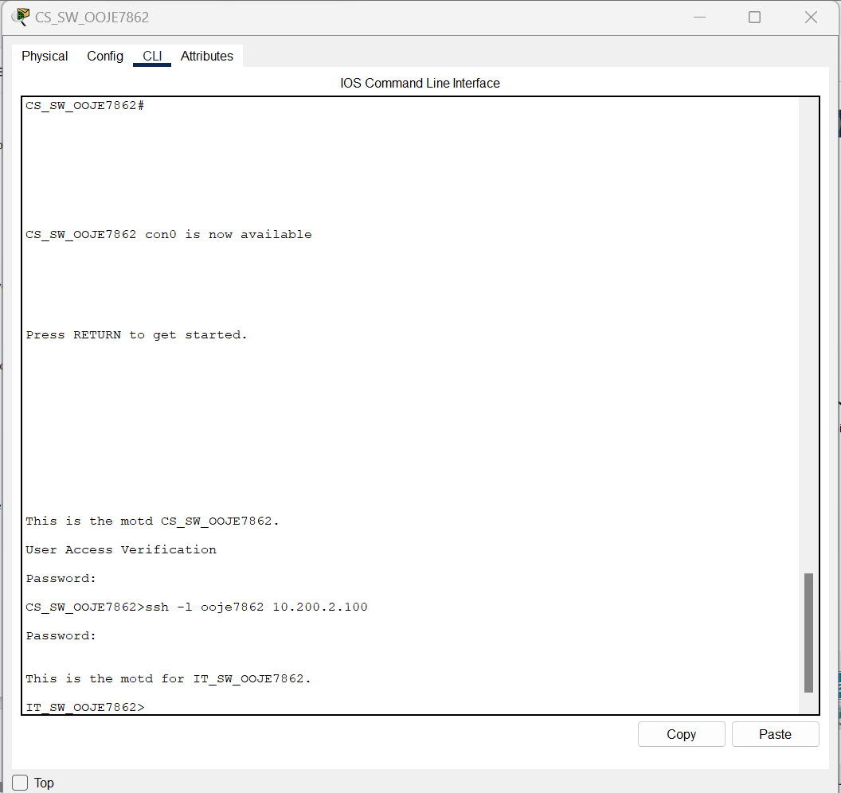
Figure7.7 CS_switch connects to IT_switch via sshss

Lab 2

Part 7

Configuring Static Routes

Preparation
- 1 x Cisco 2960 Switch
- 1 x Cisco 3750 Switch
- 2 x Cisco 2811 Router
- 2 x PC PT Objects
- 1 x PT Server (web services enabled) •
- 1 x PT Laptop

Observation
- During the course of this lab, I realized that security of our network is the main goal. I went as far as enforcing login on all the network devices in the topology. Also, secure shell was configured so as to tighten our network security.

Reflection
- In this I was able to learn how the stub and spoke network system works. I learnt that the only network topologies that frequently use stub routing are hub-and-spoke networks. A remote device/workstation (the spoke) that is connected to one or more distribution devices (the hub) is connected to one or more end (stub) networks in a hub-and-spoke network. The essence of the lab was to ensure communication between the spoke and the stub network.

Screenshots
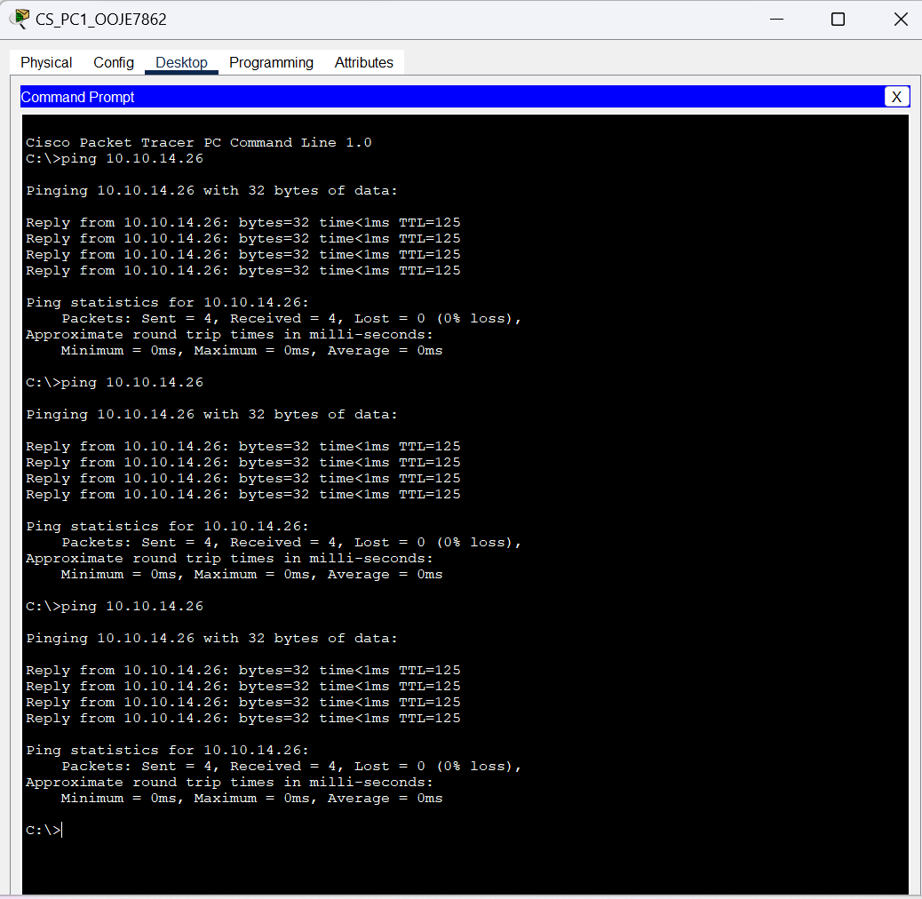
Figure 7.1Ping to server from workstation 1

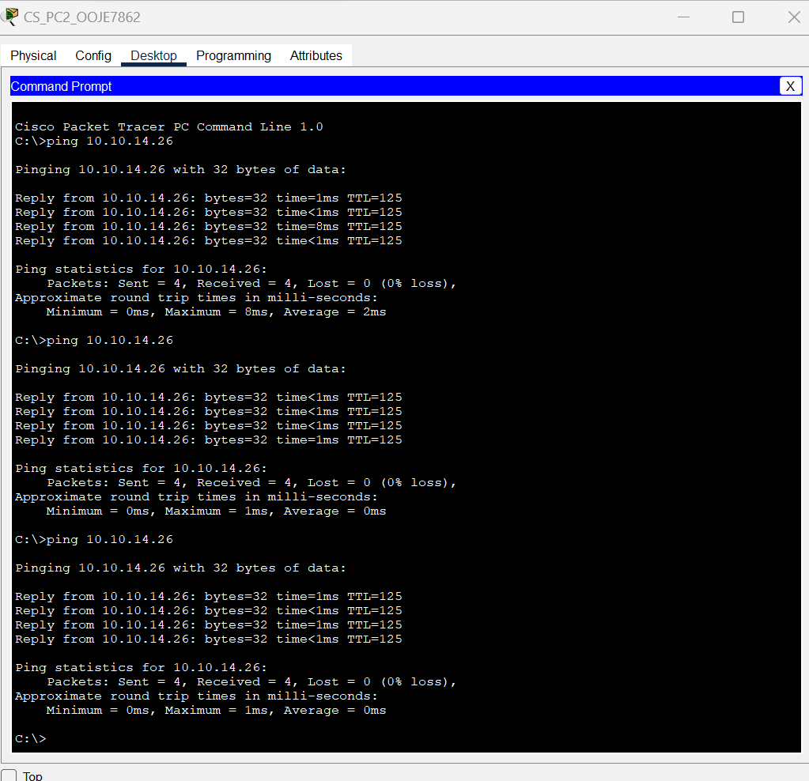
Figure 7.2 ping to server from workstation 2

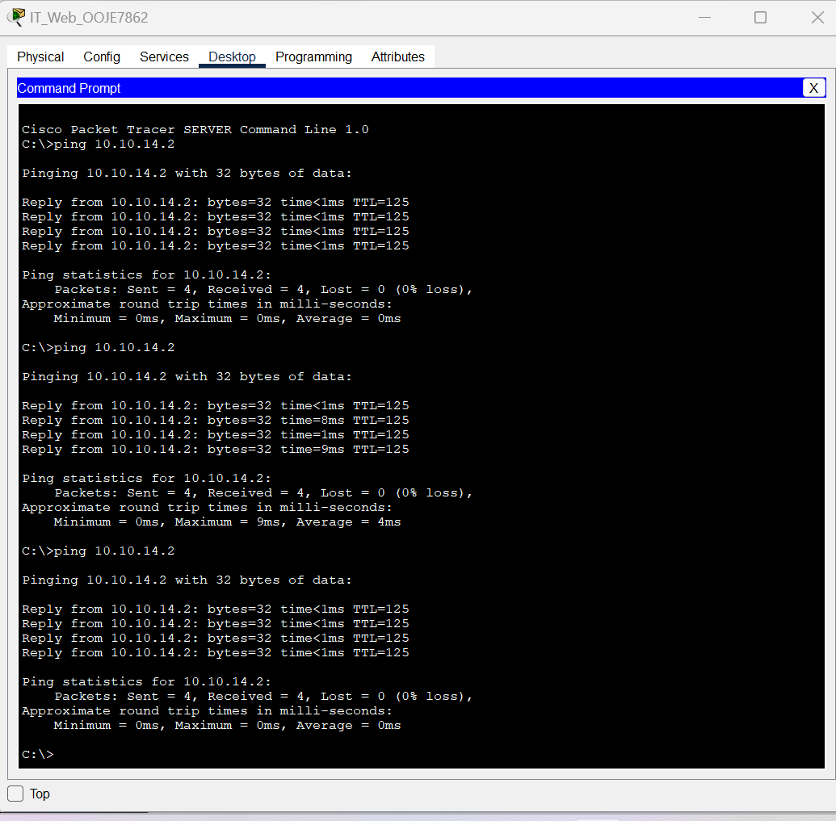
Figure7.3 Server ping workstation 1

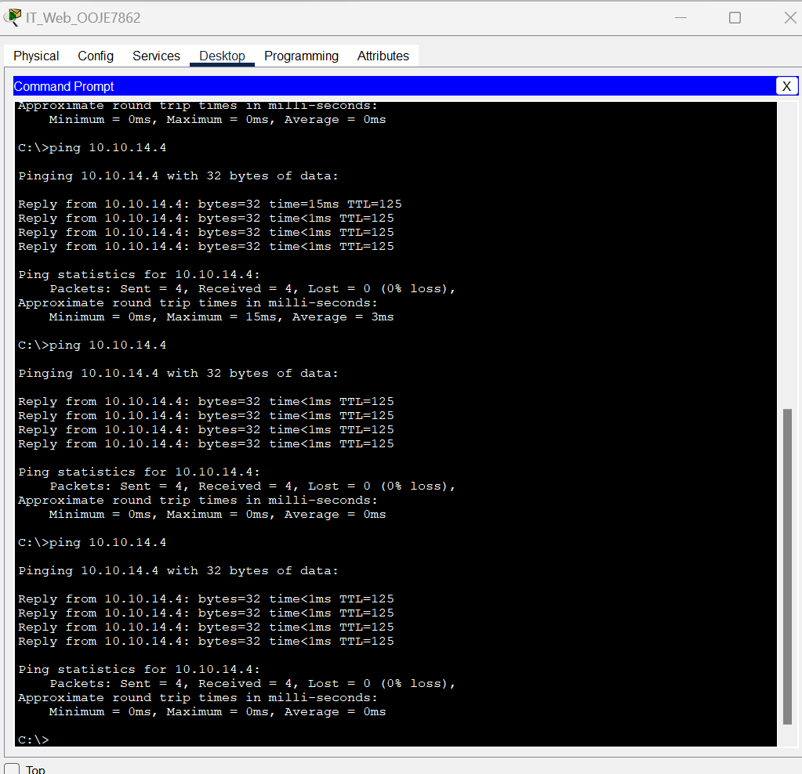
Figure 7.4 Server ping workstation 2

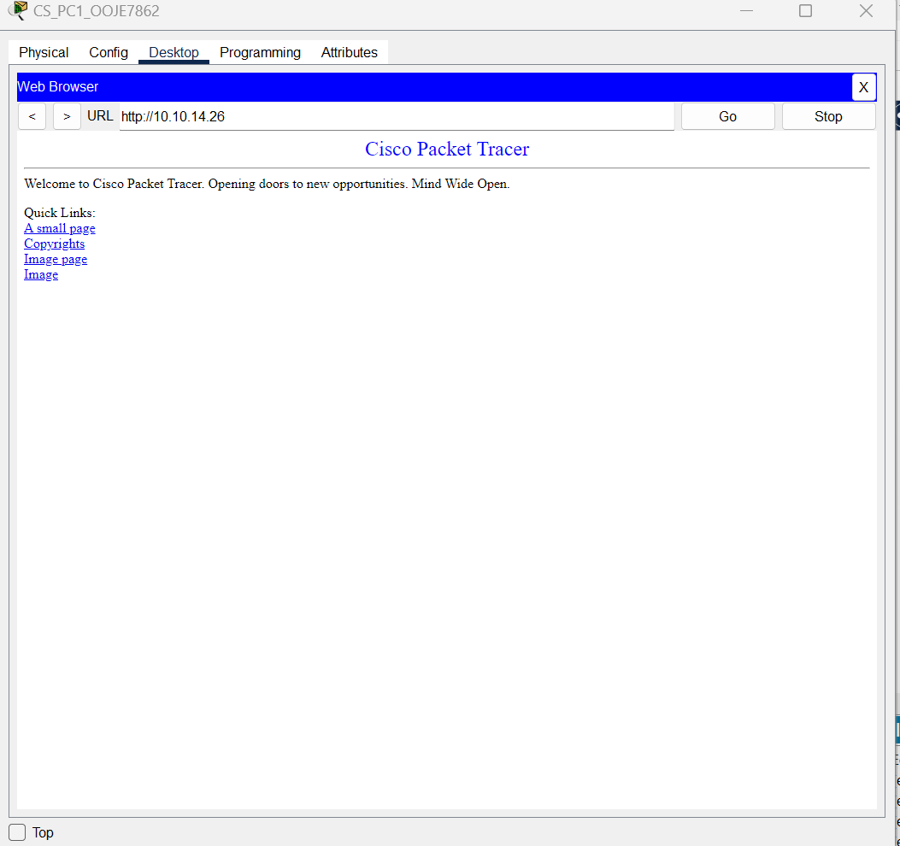
Figure 7.5 workstation 1 accessing custom website on server object

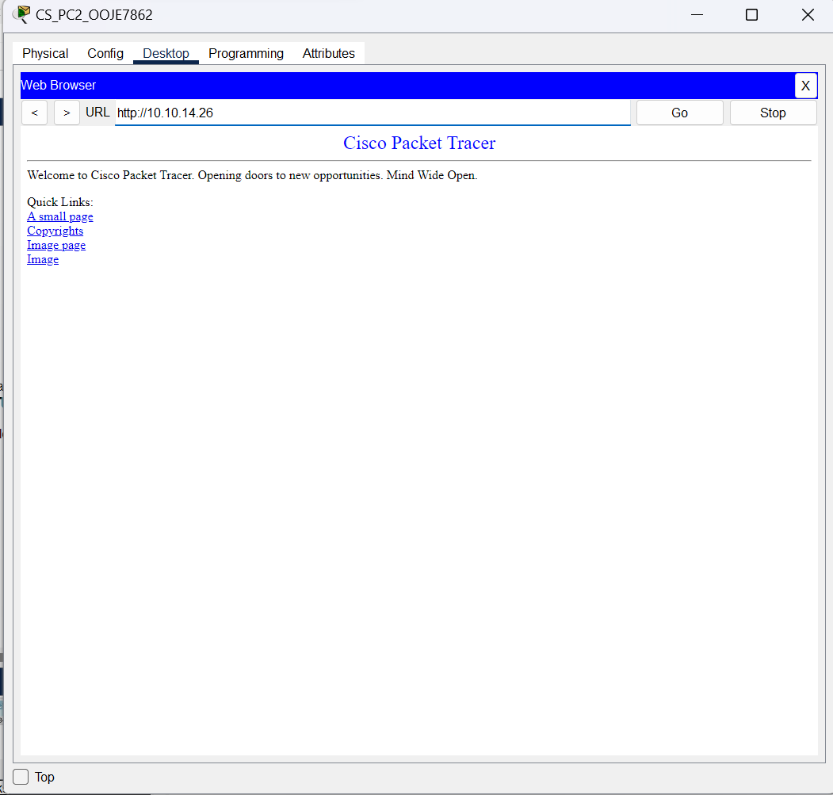
Figure 7.5 workstation 2 accessing custom website on server object

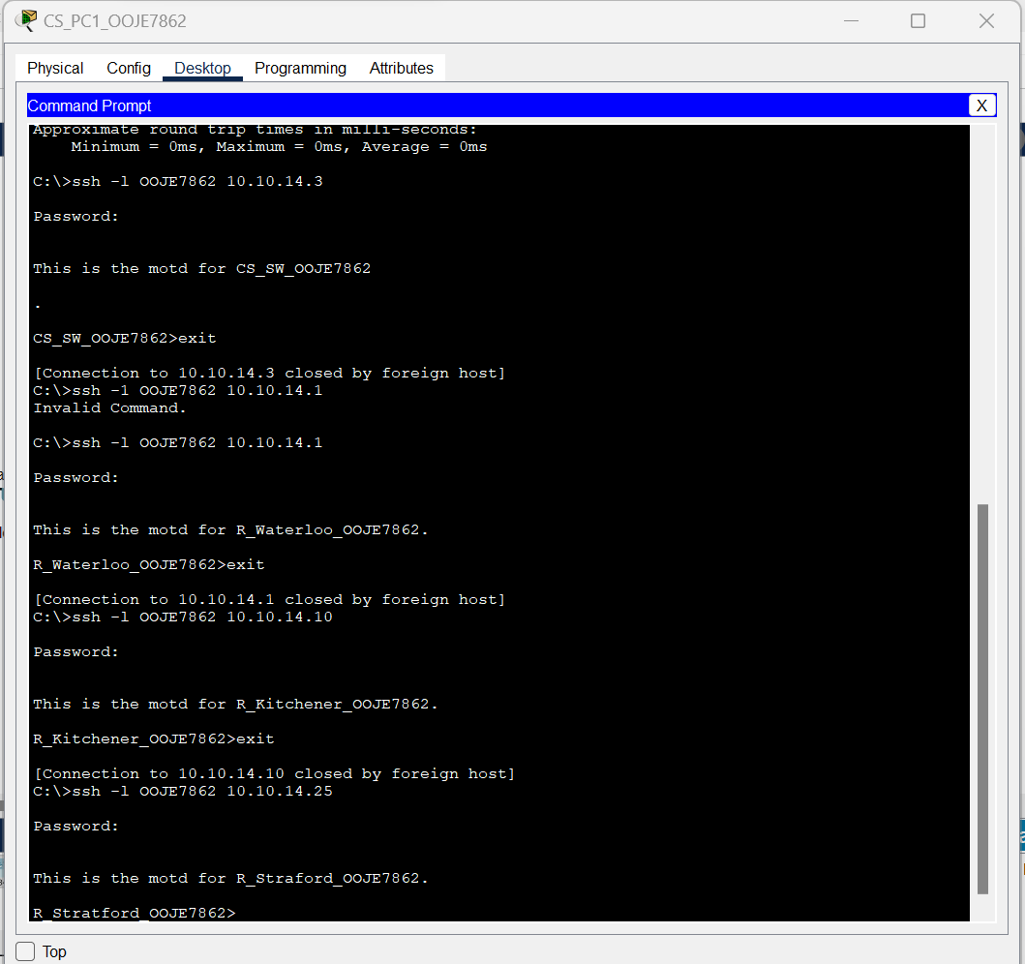
Figure 7.6 Pc1 connects to all network using ssh

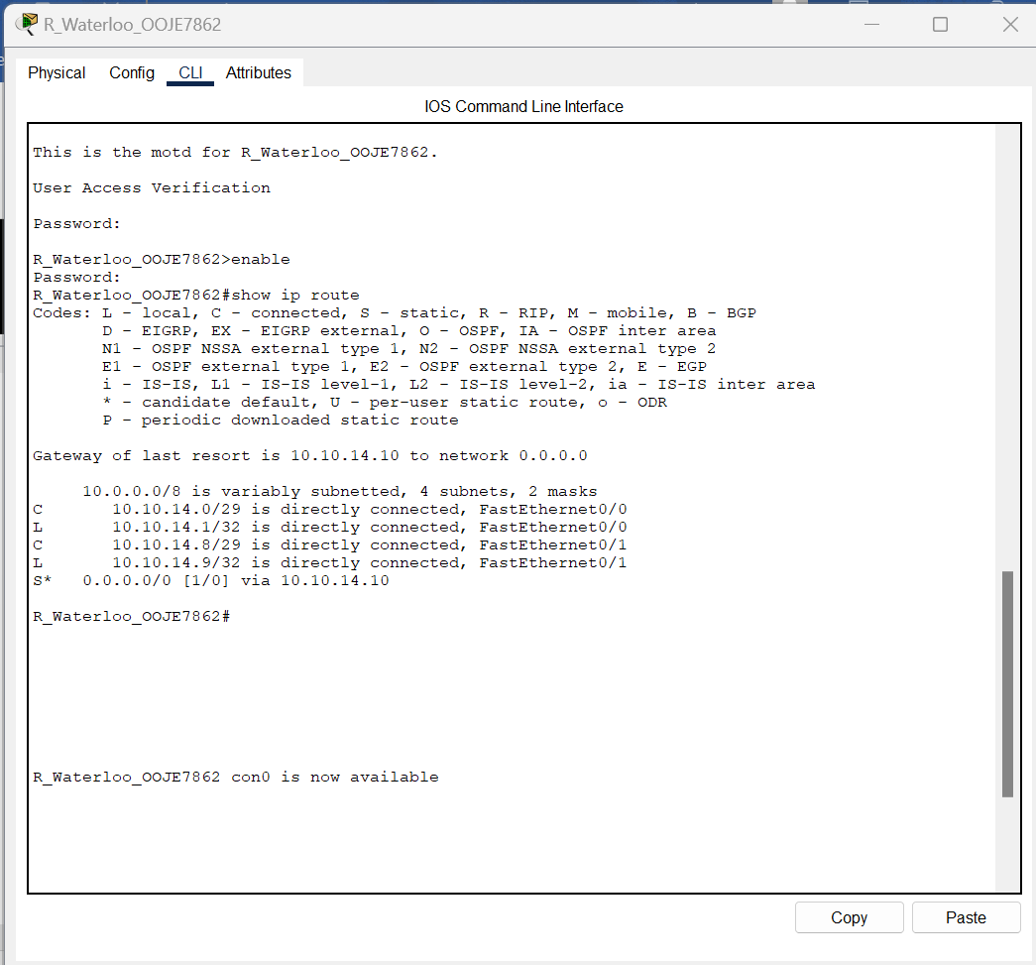
Figure 7.7 Router showing routing table

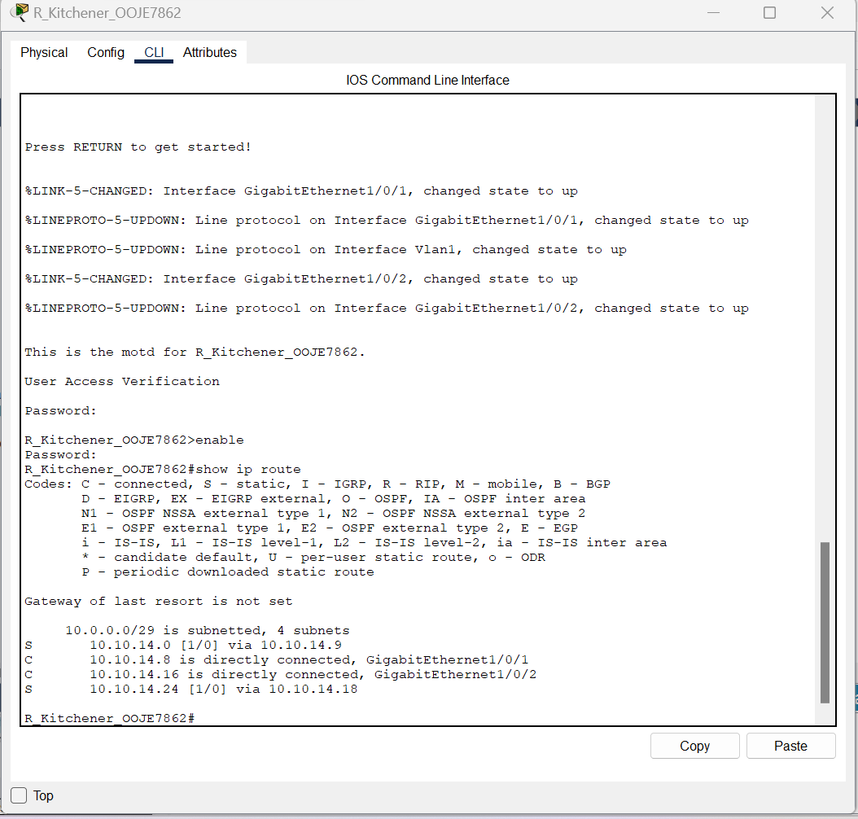
Figure 7.8 Kitchener router showing routing table

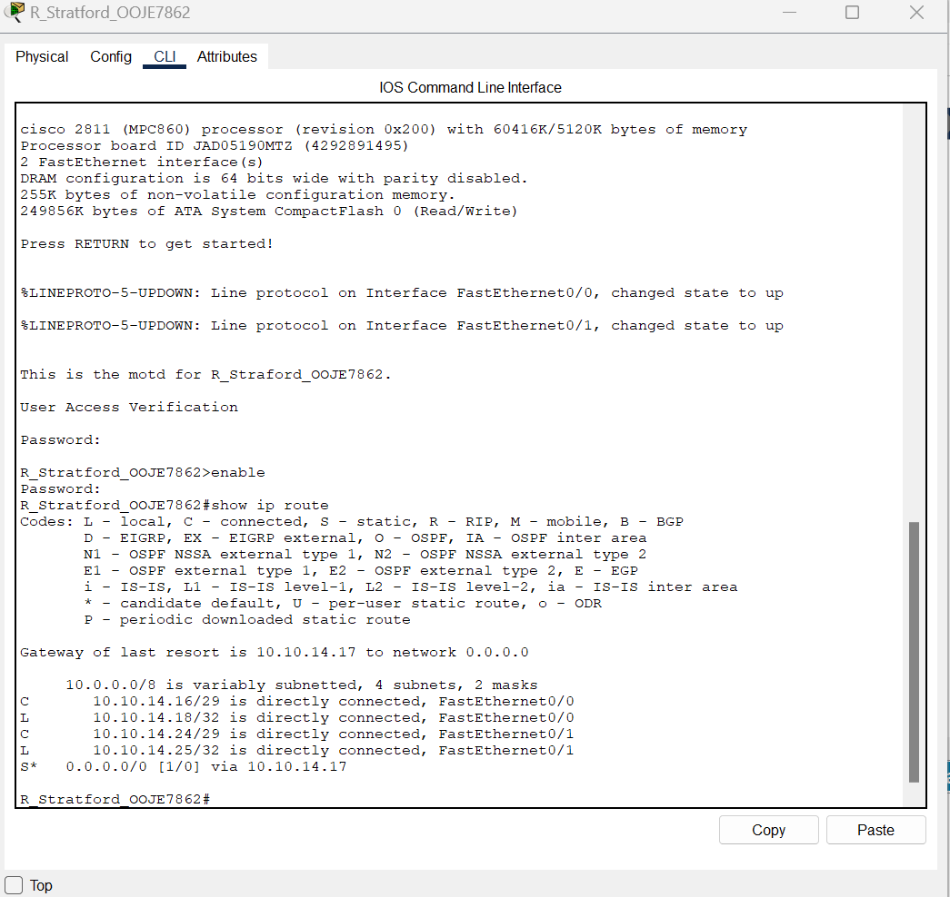
Figure 7.9 Router Stratford showing routing table

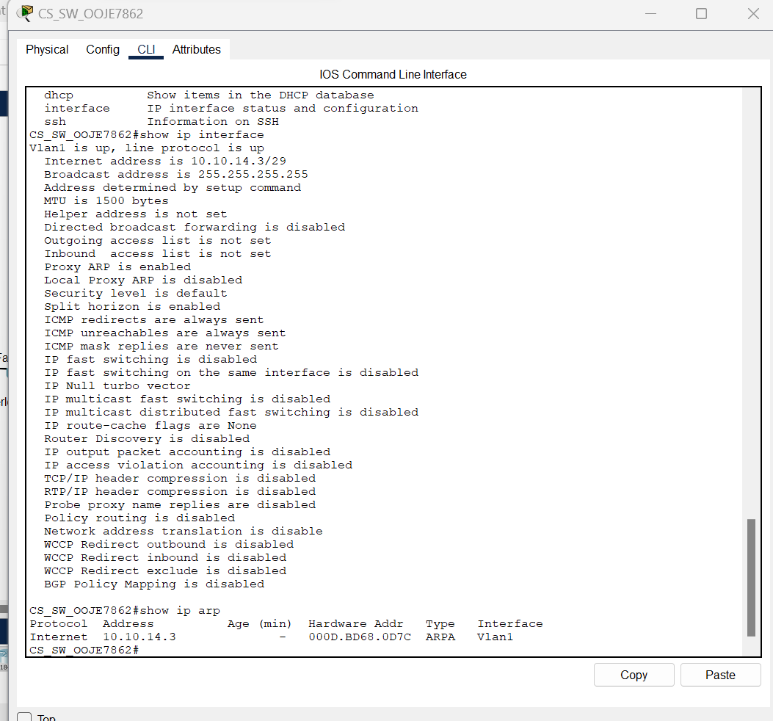
Figure 7.10 Switch showing routing table

