EIGRP ROUTING
OPEOLUWA HEZEKIAH OJE
8917862
INFO8491
Prof. Shahid Ismail
March 2nd, 2024

Table of Contents
Preparation 3
Description 3
Observation 3
Reflection 3
Part 1 4
Building and Configuring the Topology 4
Screenshots 4
Part 2 5
Configuring and Test Routing using RIP 5
Screenshots 5
Preparation 26
Description 26
Observation 26
Reflection 26
Part 3 28
Configure and Test EIGRP Authentication Using MD5 28
Screenshots 28

Preparation
- Current version of Packet tracer
- Six PC PT Objects
- Six Cisco 2960 Layer 2 Switches
- Six Cisco 2811 Router

Description
The expected goal is to ensure the end devices can communicate to all network devices both on their network and outside their network by implementing the EIGRP routing protocol.

Observation
In this lab I was able to configure and implement EIGRP routing protocol on the network topology.

Reflection
The overall aim of this lab is to ensure the exchange of routing information among the routers in the topology. In this lab, I learnt how one or more device on a network can communicate with other devices outside of their network with the implementation of EIGRP.

Part 1

Building and Configuring the Topology

Screenshots
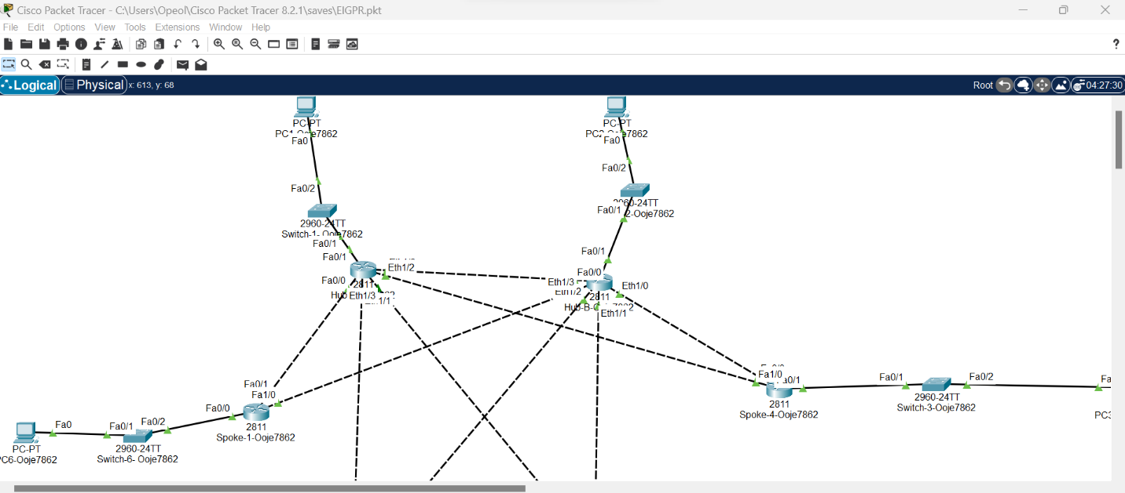
Figure 1 Building of the Topology

Part 2

Configuring and Test Routing using RIP

Screenshots
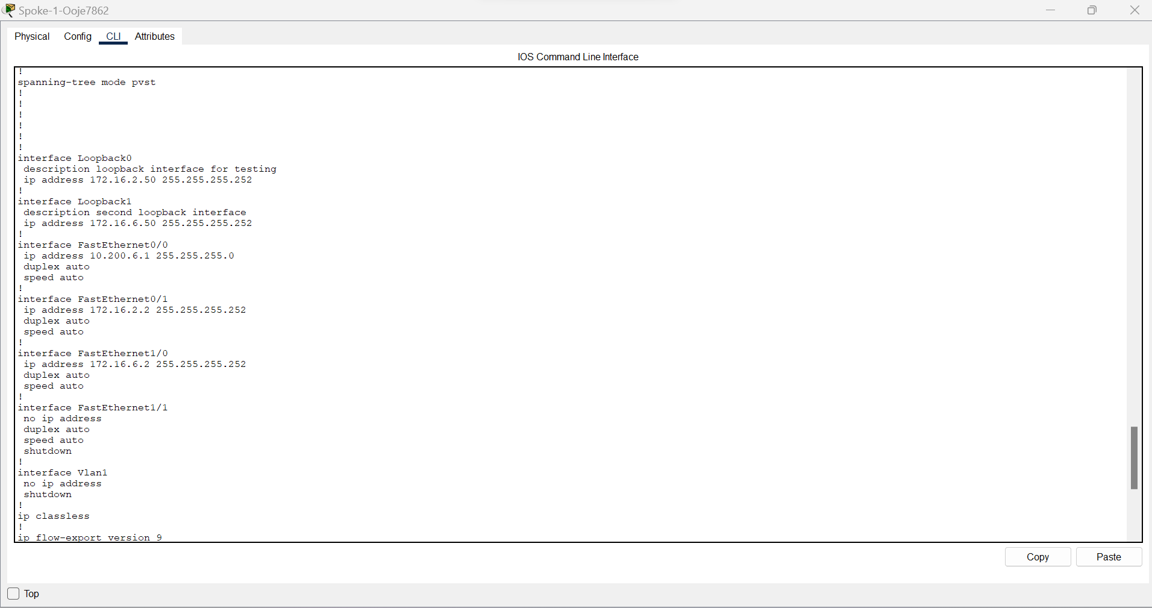
Figure 2.1 Loopback Configuration for spoke 1
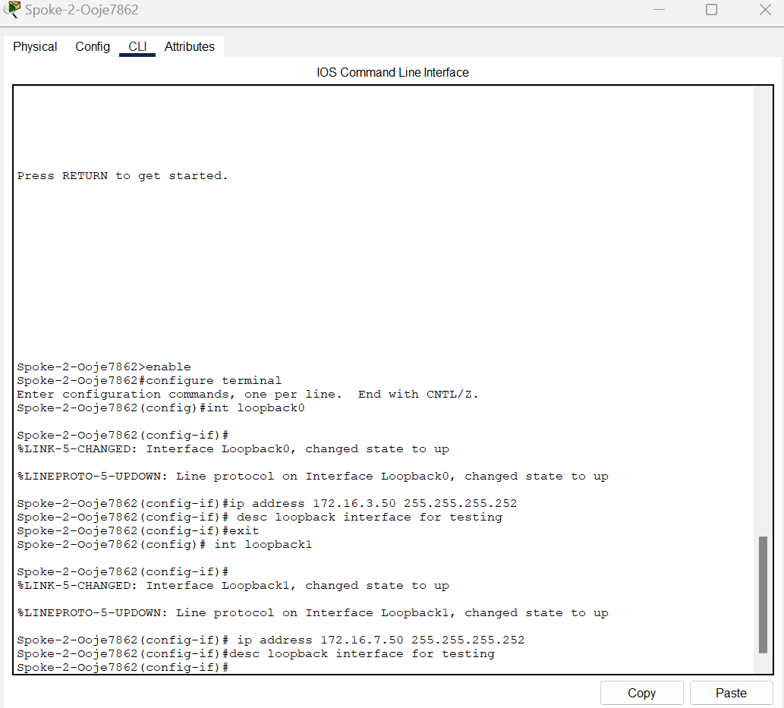
Figure 2.2 Loopback Configuration for Spoke 2
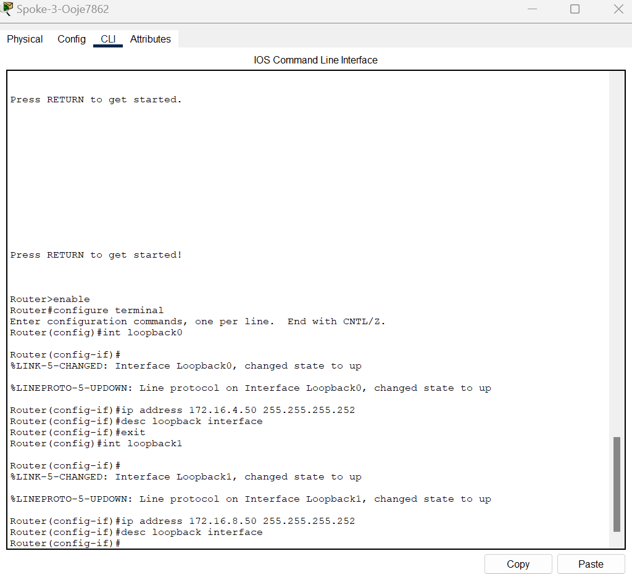
Figure 2.3 Loopback Configuration for Spoke 3
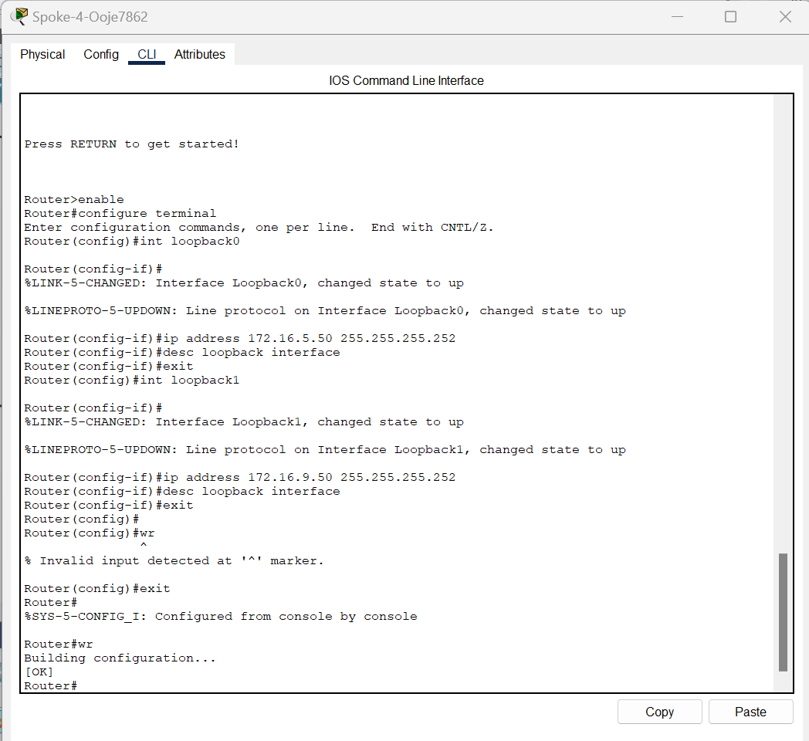
Figure 2.4 Loopback Configuration for Spoke 4

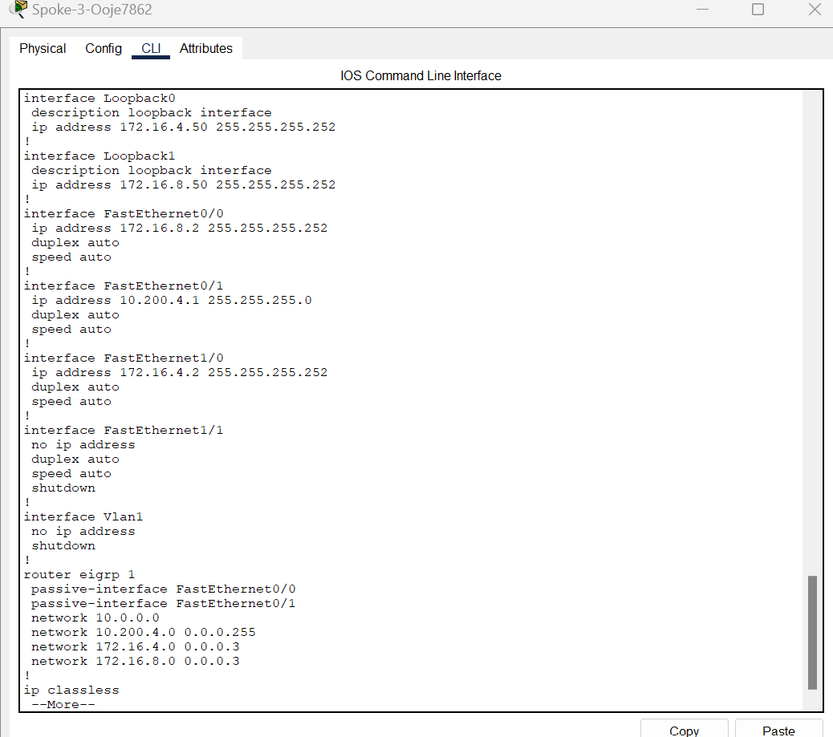
Figure 2.5 Passive interface configuration on Spoke 3
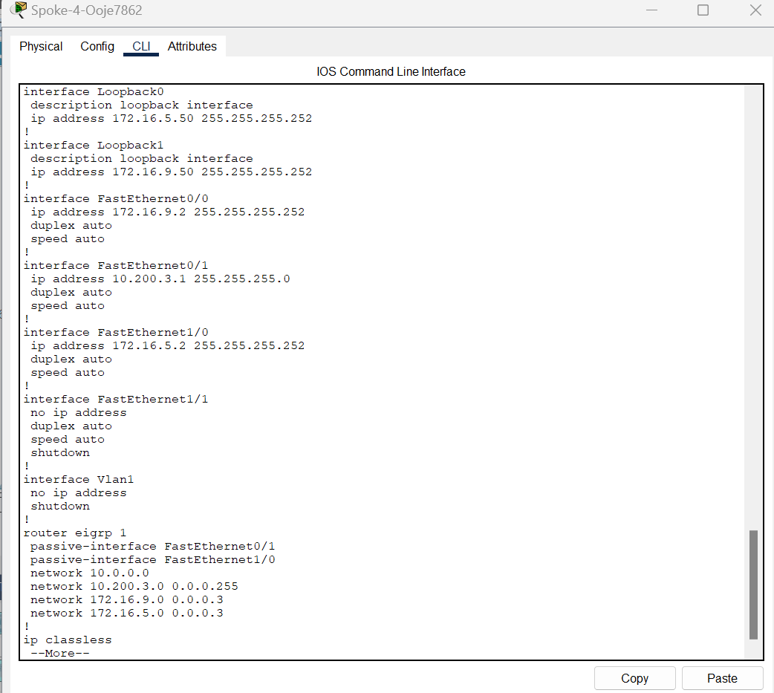
Figure 2.6 Passive interface configuration on Spoke 4

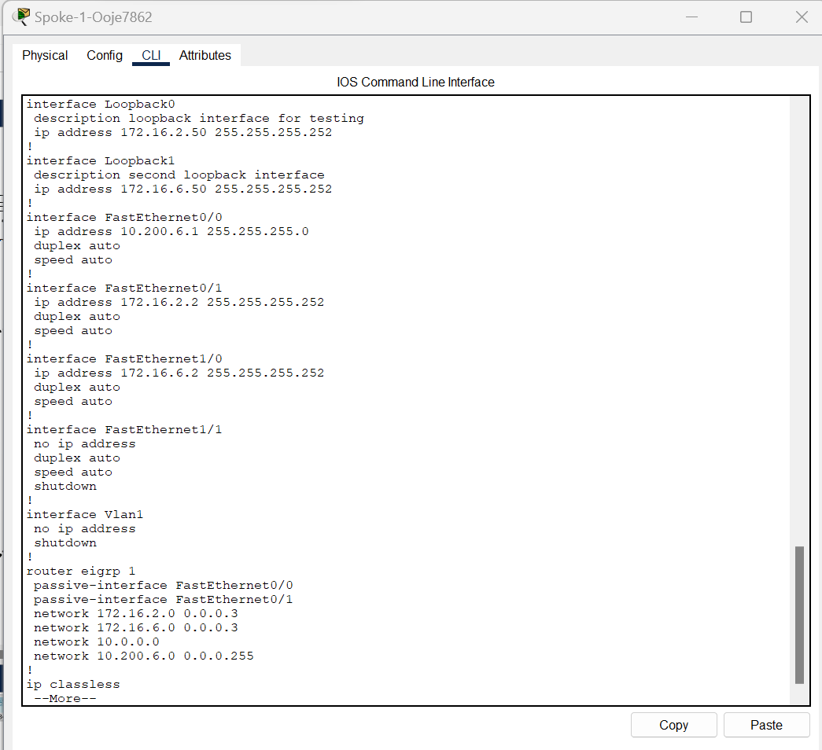
Figure 2.7 Configuration of Passive Interface on Spoke 1

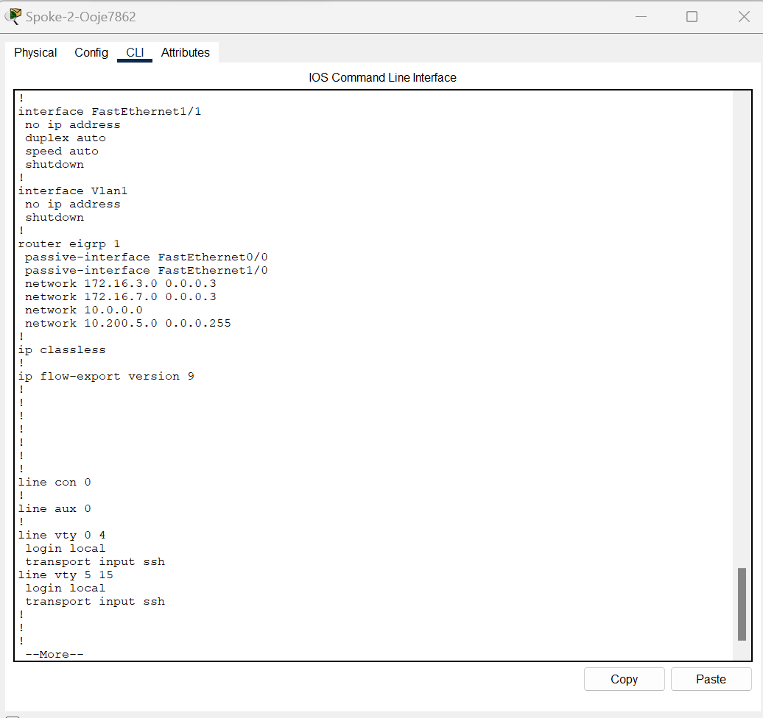
Figure 2.8 Configuration of Passive Interface on Spoke 2

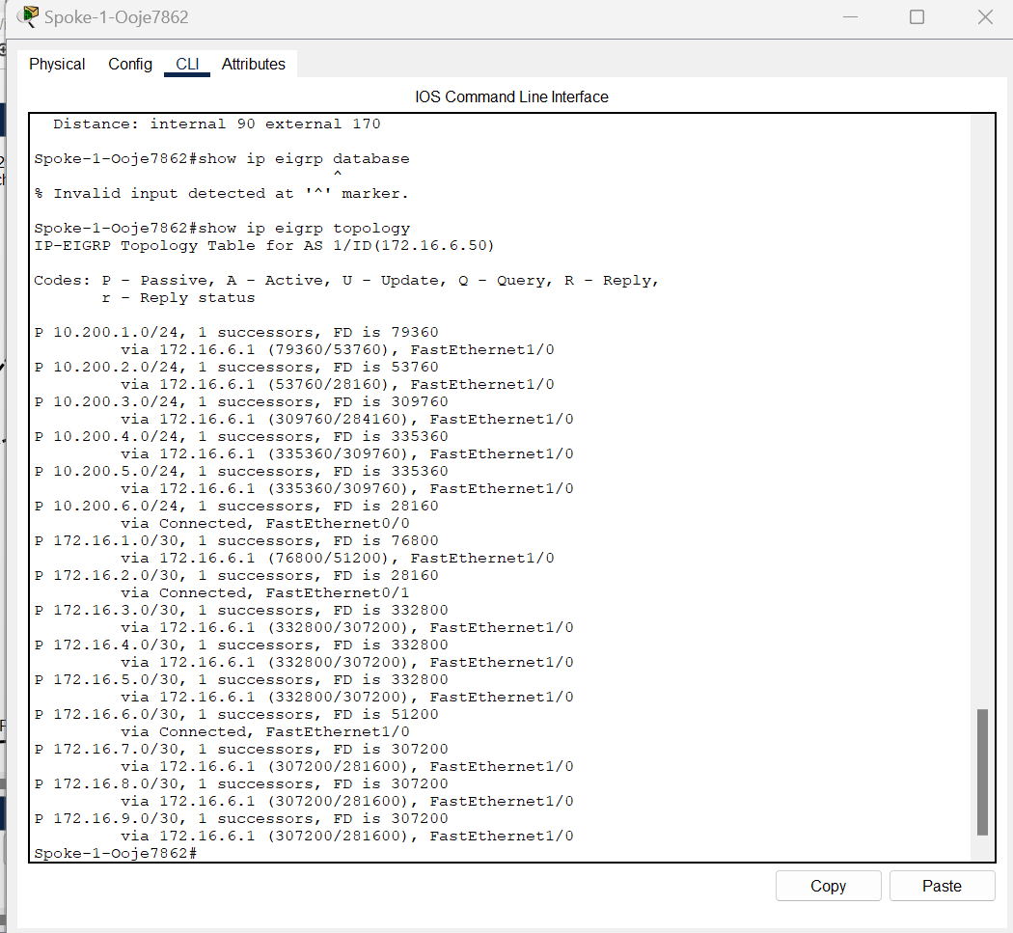
Figure 2.9 Spoke 1 IP database

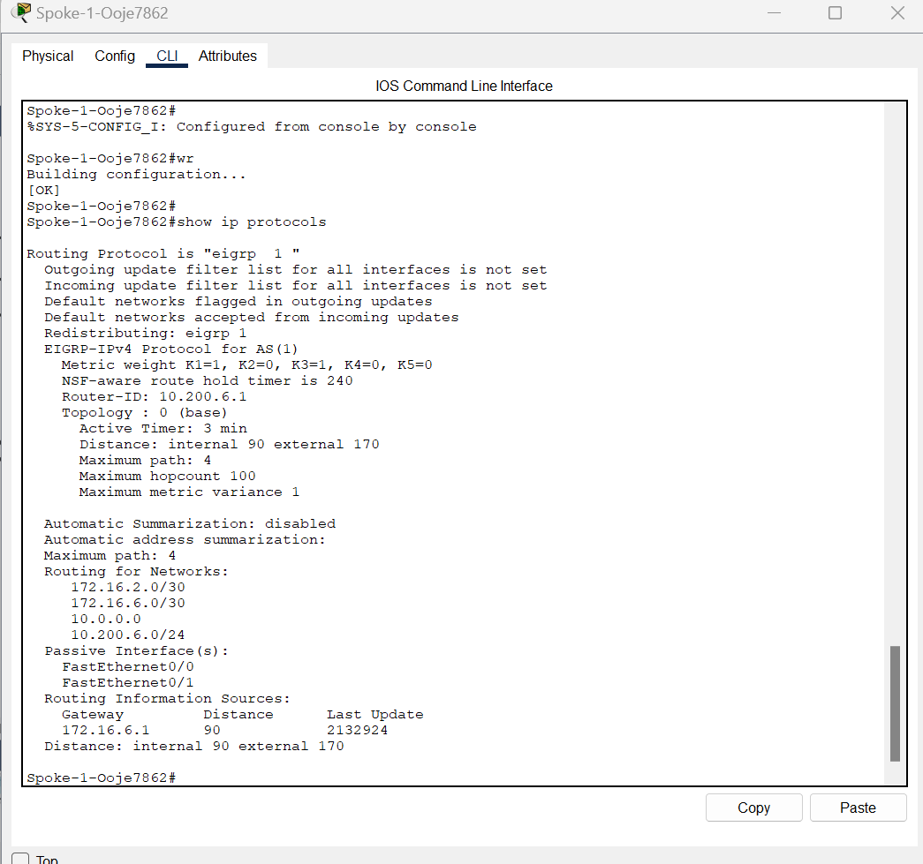
Figure 2.10 Spoke 1 showing Ip protocols and Information

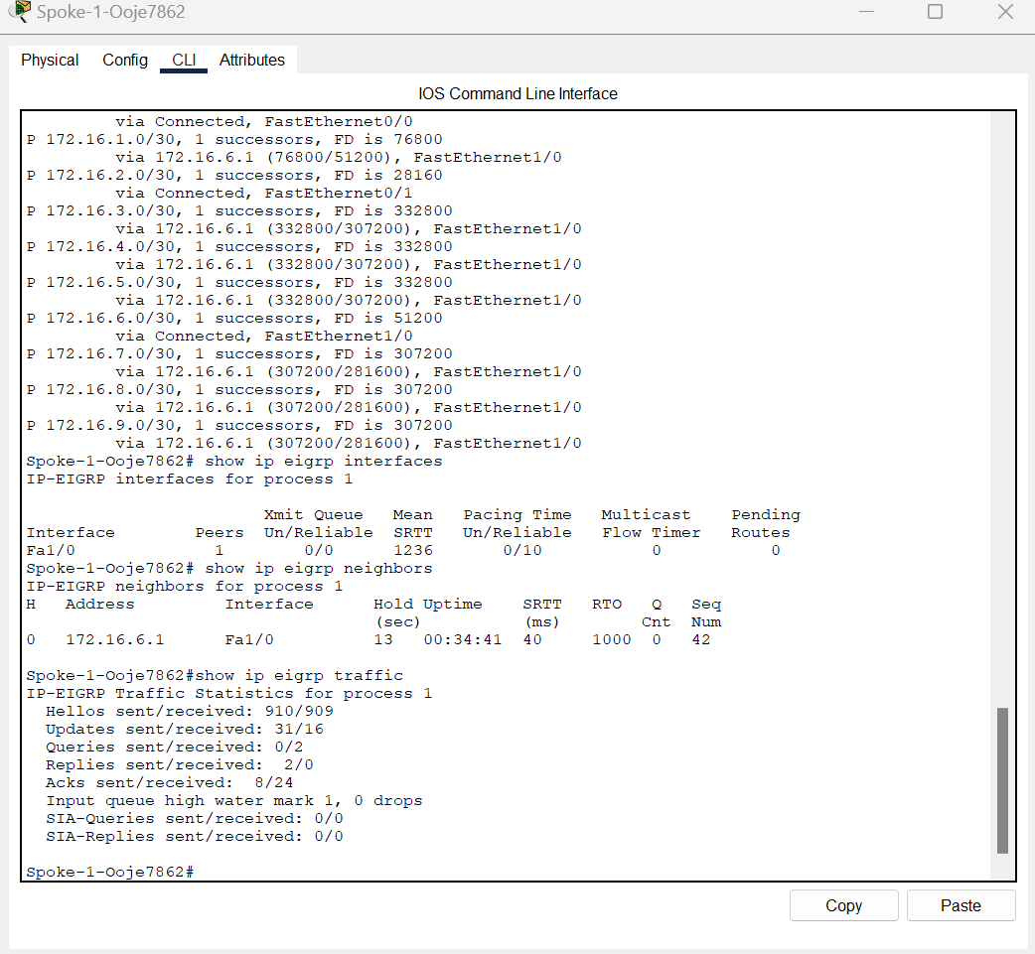
Figure 2.11 Spoke 1 showing Ip traffic, topology and traffic

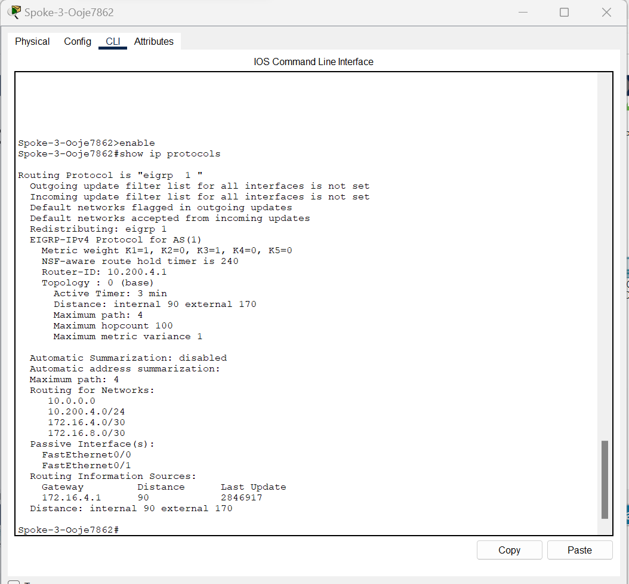
Figure 2.12 Spoke 3 showing Ip protocols

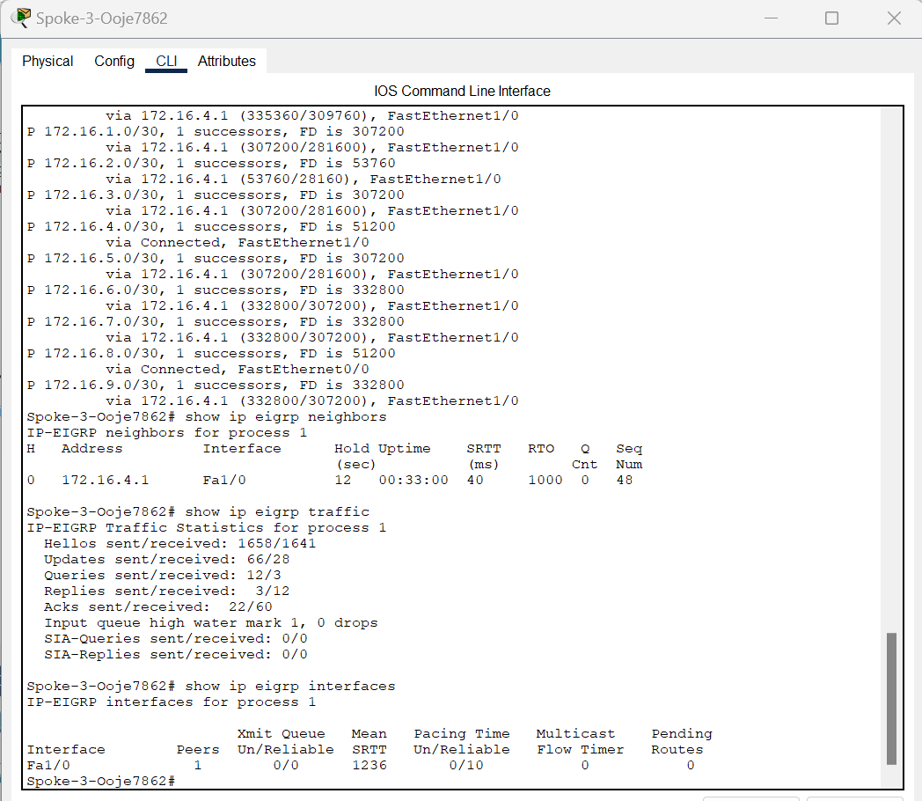
Figure 2.13 Spoke 3 showing Ip topology, traffic and Information.

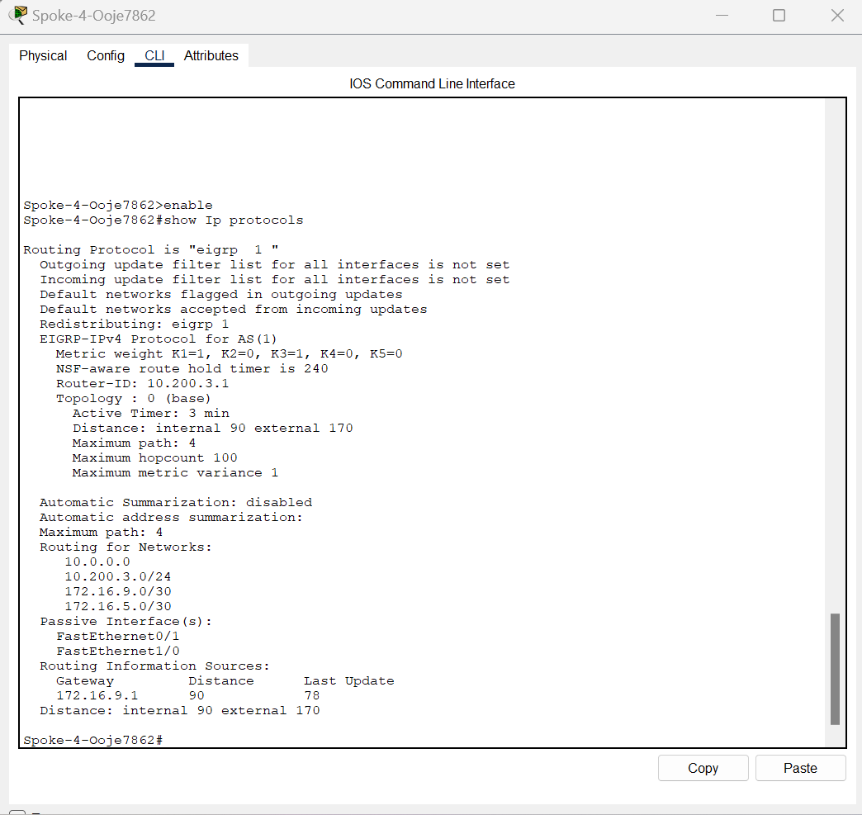
Figure 2.14 Spoke 4 showing Ip protocols

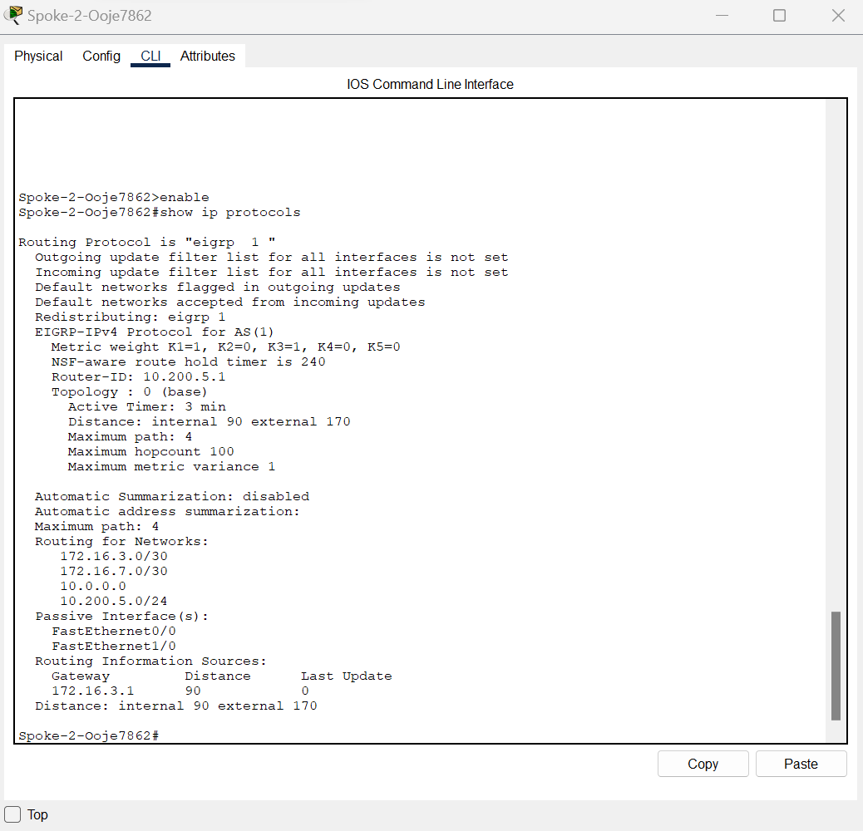
Figure 2.15 Spoke 2 showing IP protocols.

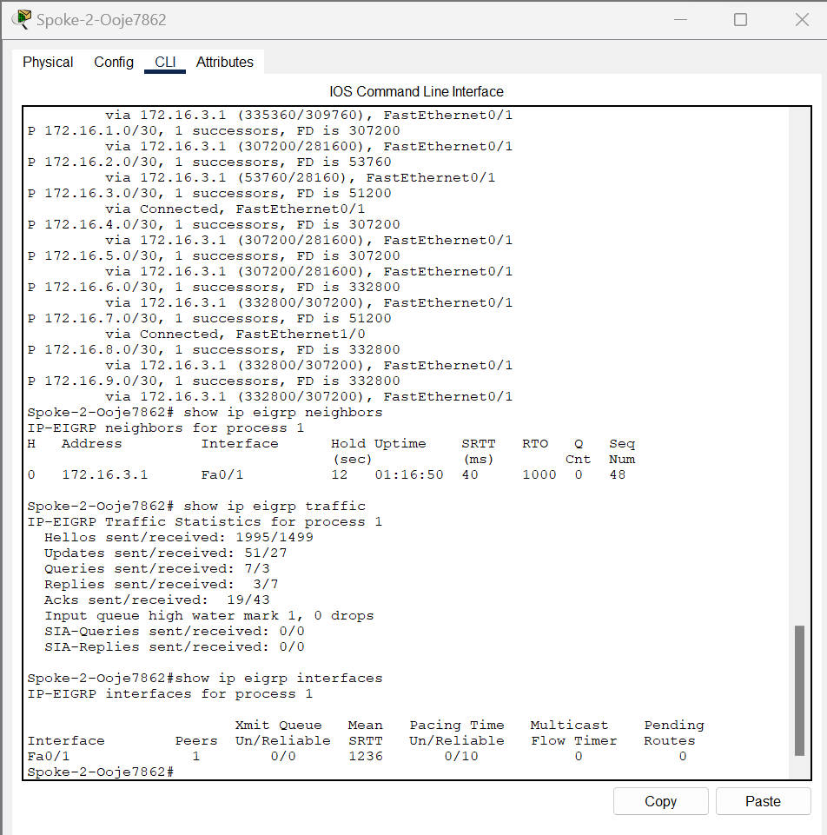
Figure 2.16 Spoke 2 showing IP topology, traffic, interfaces and neighbor.

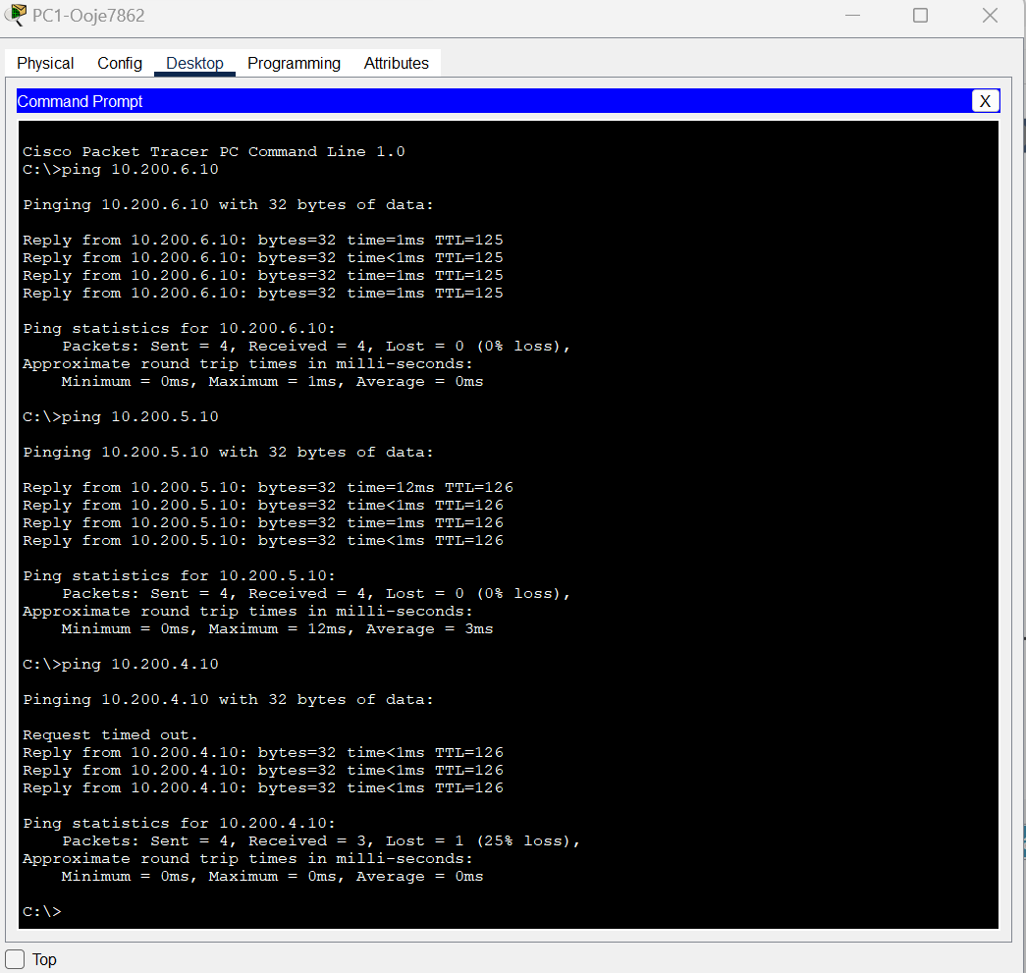
Figure2.17 PC1 ping PC6, PC5 and PC4
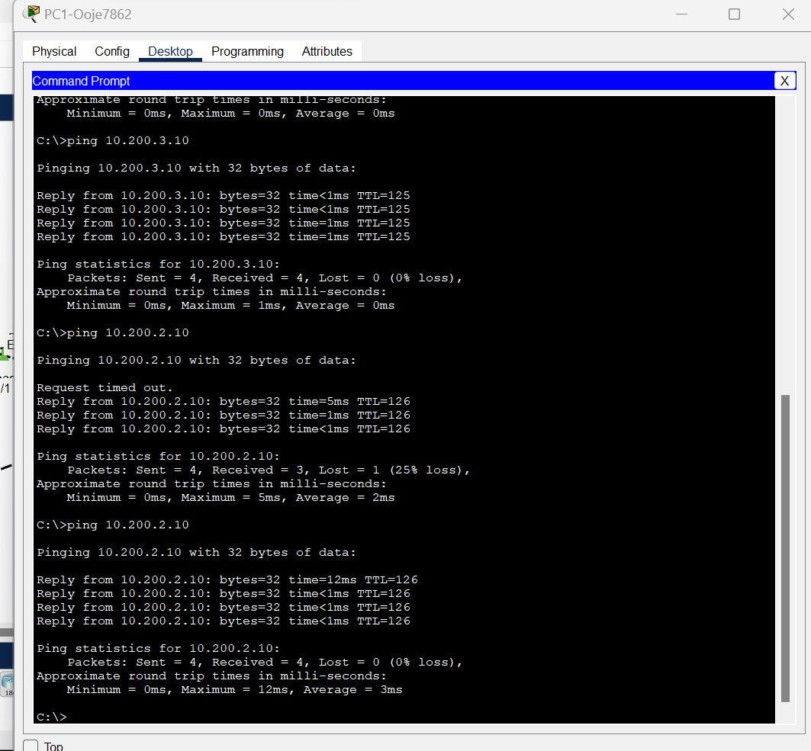
Figure2.18 PC1 ping PC3 and PC2
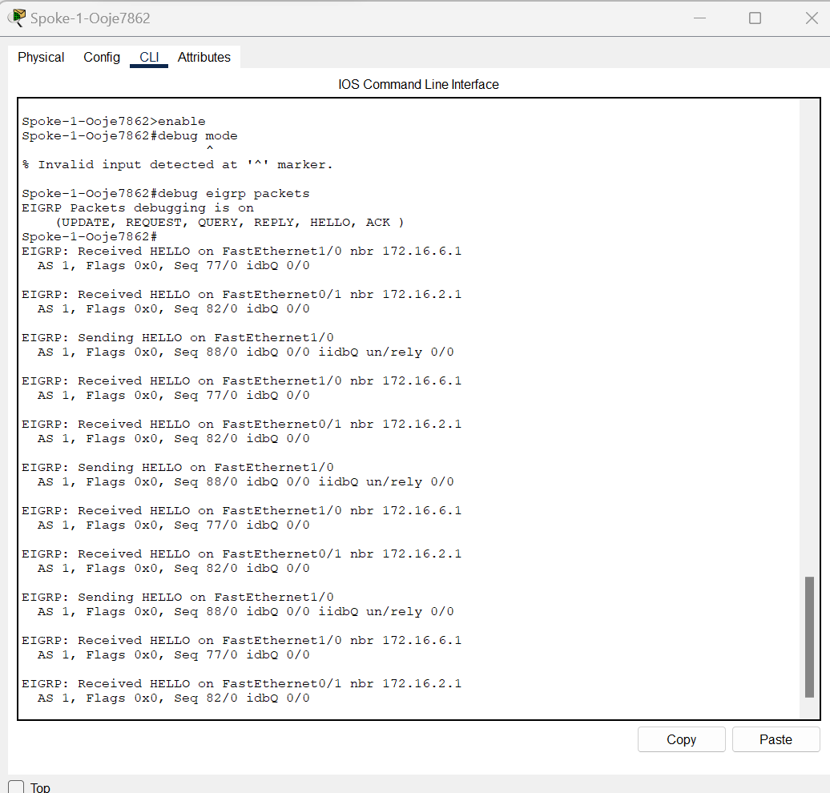
Figure 2.19 EIGRP events on spoke 1 using debug mode

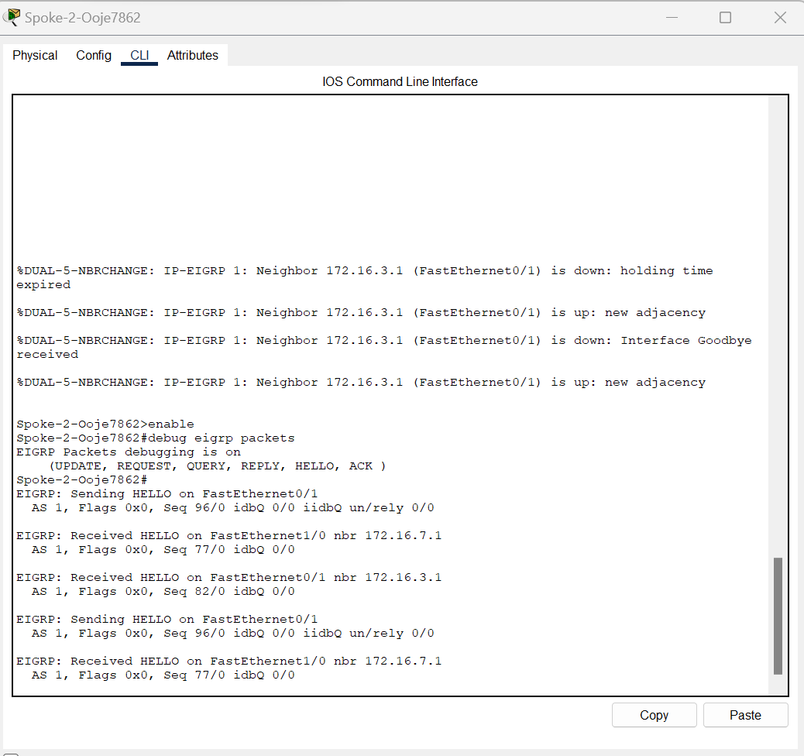
Figure 2.20 EIGRP Events on spoke 2 using debug mode

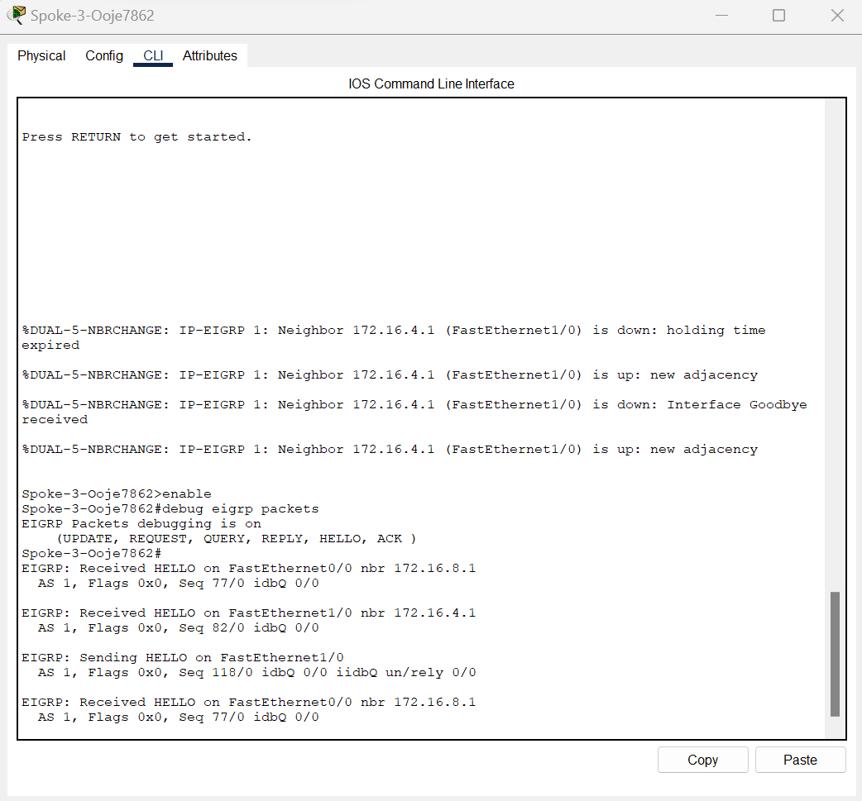
Figure 2.21 EIGRP events showing on spoke 3 using the debug mode

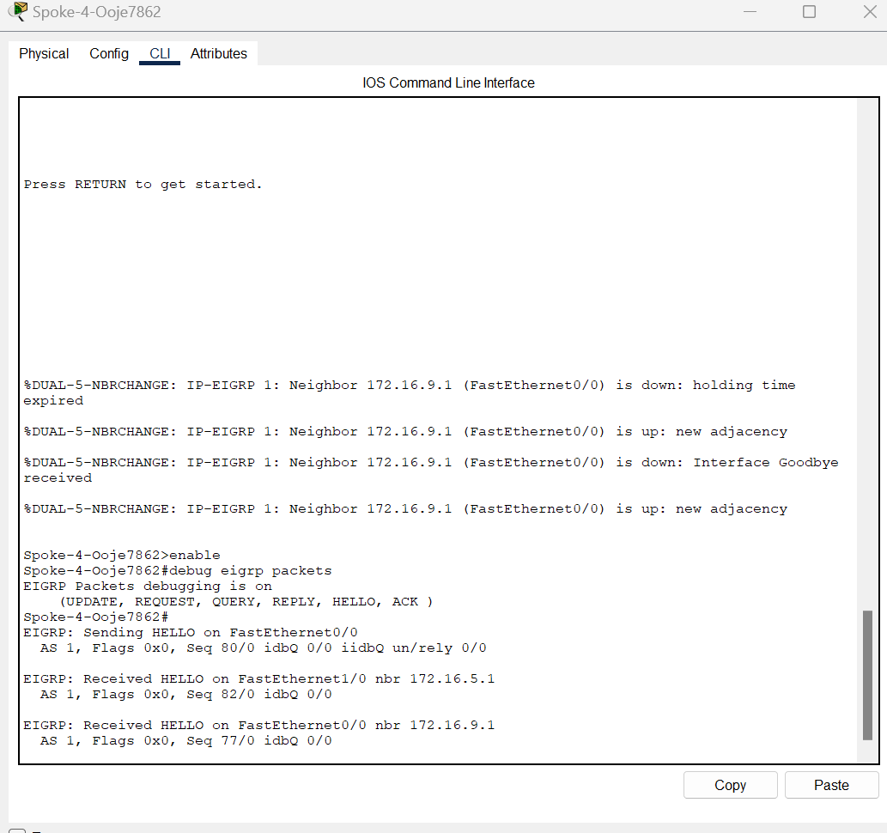
Figure 2.22 EIGRP events on spoke 4 using the debug mode

Preparation
- Current version of Packet tracer
- Six PC PT Objects
- Six Cisco 2960 Layer 2 Switches
- Six Cisco 2811 Router

Description
The expected goal of this lab is to configure an EIGRP Authentication using MD5.

Observation
In this lab I was able to configure an EIGRP Authentication using MD5, I created a keychain which uses MD5 and then configured md5 authentication on the EIGRP routers.

Reflection
The overall aim of this lab is to ensure the exchange of routing information among the routers in the topology. In this lab, I learnt how one or more device on a network can communicate with other devices outside of their network.

EIGRP Merits Vs OSPF
- Ease of Configuration as compared to OSPF.
- EIGRP is often appreciated for being easier to configure than OSPF and not operating with the concept of areas. With a much simpler configuration model, EIGRP can be set up and troubleshot many times easier than Open Shortest Path First.
- Fast Convergence: EIGRP, on the other hand, is one of the fastest to converge. The protocol adjusts in time with changes in the topology and in so doing helps to reduce downtime for network operation, thereby ensuring the environment is stable.
- Low Bandwidth Utilization: Since it sends incremental updates on change across the network, thus reducing remaining network traffic, the efficiency of bandwidth is highly conserved.

Part 3

Configure and Test EIGRP Authentication Using MD5

Screenshots
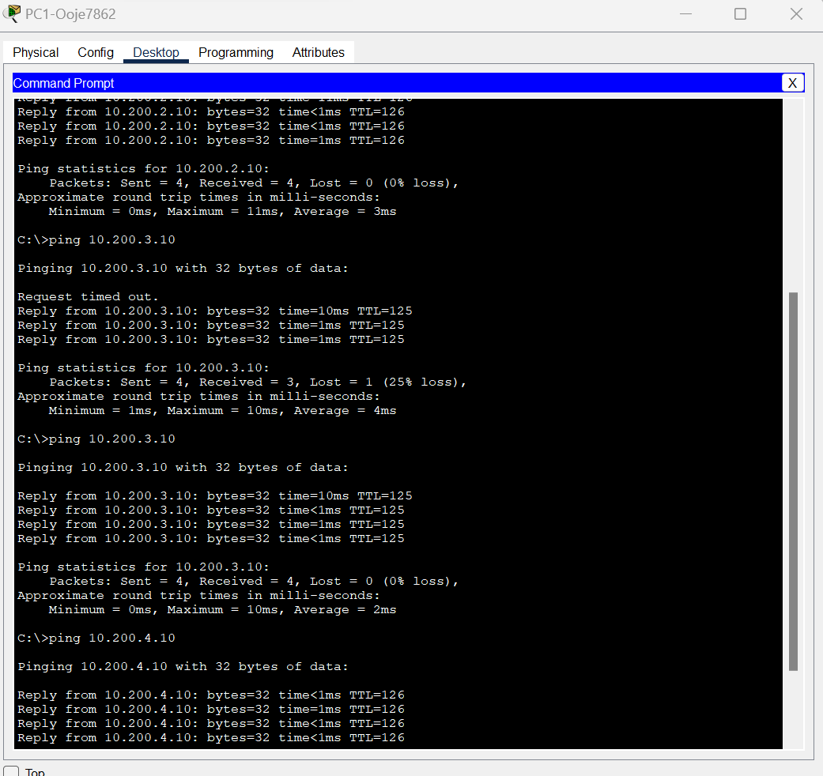
Figure 3.1 PC1 pinged PC2, PC3 and PC4 successfully after MD5 authentication
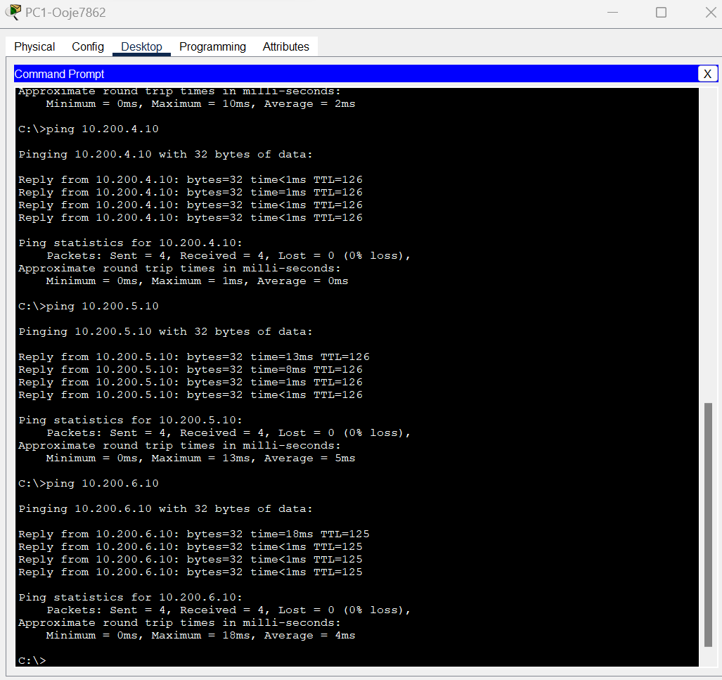
Figure 3.2 Ping successful from PC1 to PC5 and PC6 after MD5 authentication.

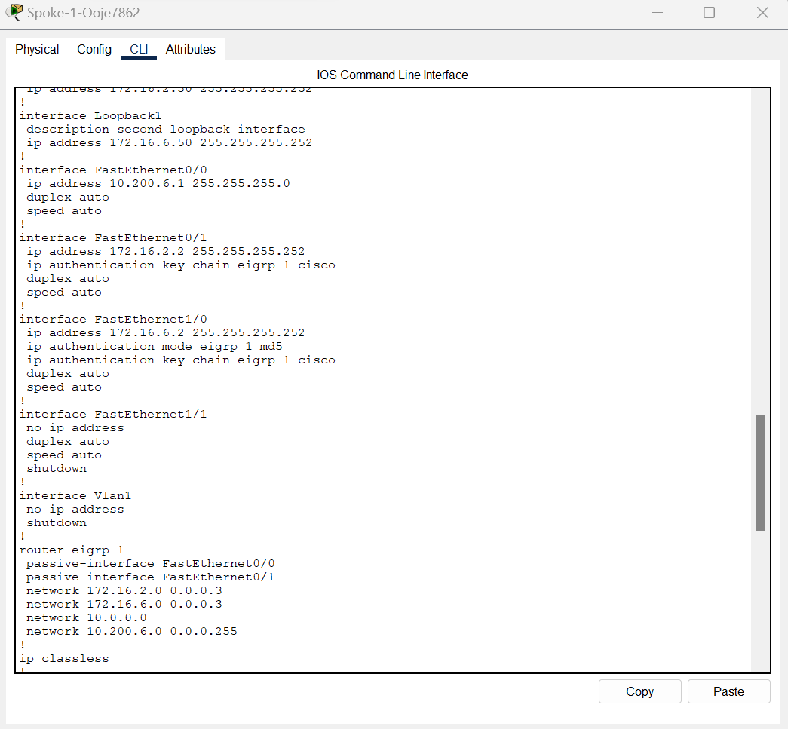

Figure 3.3 Spoke 1 md5 configuration

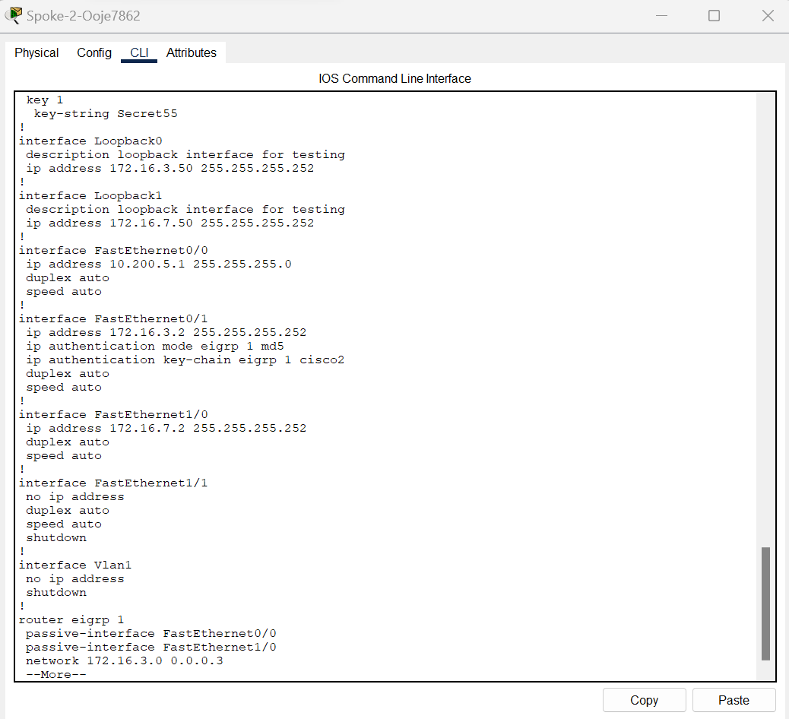
Figure 3.4 Spoke 2 md5 configuration

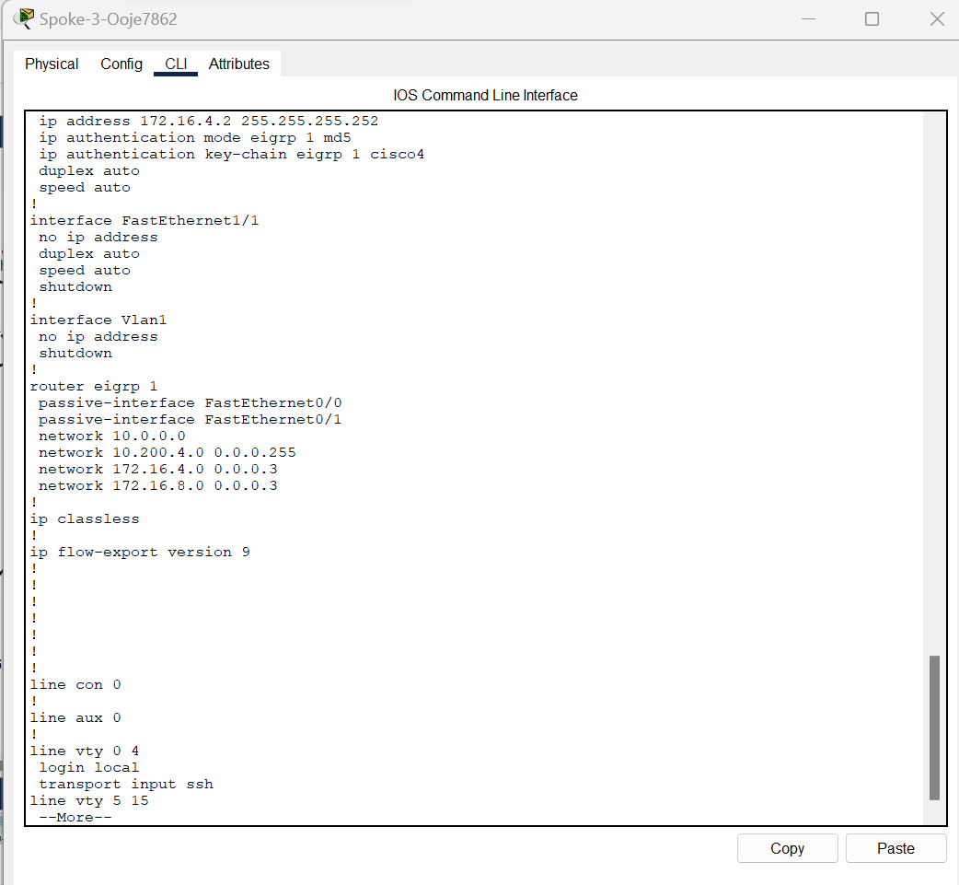
Figure 3.5 Spoke 3 md5 configuration.

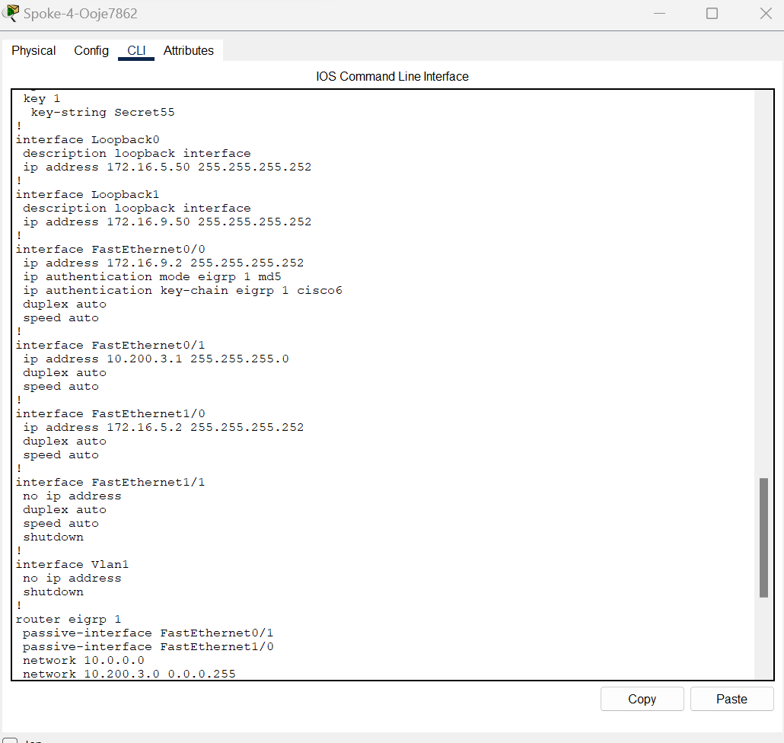
Figure 3.6 Spoke 4 md5 configuration

