RIP & OSPF ROUTING
OPEOLUWA HEZEKIAH OJE
8917862
INFO8491
Prof. Shahid Ismail
March 2nd, 2024

Table of Contents
Preparation 2
Description 2
Observation 3
Reflection 3
Part 1 3
Building and Configuring the Topology 3
Screenshots 4
Part 2 4
Configuring and Test Routing using RIP 4
Screenshots 5
Preparation 16
Description 16
Observation 16
Reflection 16
Part 3 17
Configure and Test Routing using OSPF 17
Screenshots 17

Preparation
- Current version of Packet tracer
- Two PC PT Objects
- One Cisco 2960 Layer 2 Switches
- Three Cisco 2811 Router
- Two PT Server

Description
The expected goal and result is to ensure the end devices can communicate to all network devices both on their network and outside their network by implementing the RIP routing protocol.

Observation
In this lab I was able to configure and implement RIP routing protocol on the network topology.

Reflection
The overall aim of this lab is to ensure the exchange of routing information among the routers in the topology. In this lab, I learnt how one or more device on a network can communicate with other devices outside of their network.

Routing is one of the major aspects of network management. Selection of routing protocol used in accordance with the conditions is marked. The drawbacks and some of the benefits for RIP (Routing Information Protocol) and static routing is all together at totally different stage. Here, it will be discussed about some of the things said to be good for using RIP routing rather than static routing for a few cases:

Below are the reasons why I would choose RIP routing over static routing.
- Dynamic Updates: RIP Routing, this works in consonance with dynamic routing protocols and modifies the routing table in an avalanche scenario of changes in the network topology. This very nature assures that routers become in line with network changes without applying a manual adjustment of changes. Static routing means the routing in which all the routes are manually added in the routing table; they are never learned dynamically. So, in case of any change in the network topology, the routing table will have to be changed, so this routing is not best suited to dynamic scenarios.
- Ease of Implementation: Implementation of RIP is normally easy and fast, especially in medium-sized networks. Routing information is learned and shared automatically, reducing the boom on organization administration.

Part 1

Building and Configuring the Topology

Screenshots
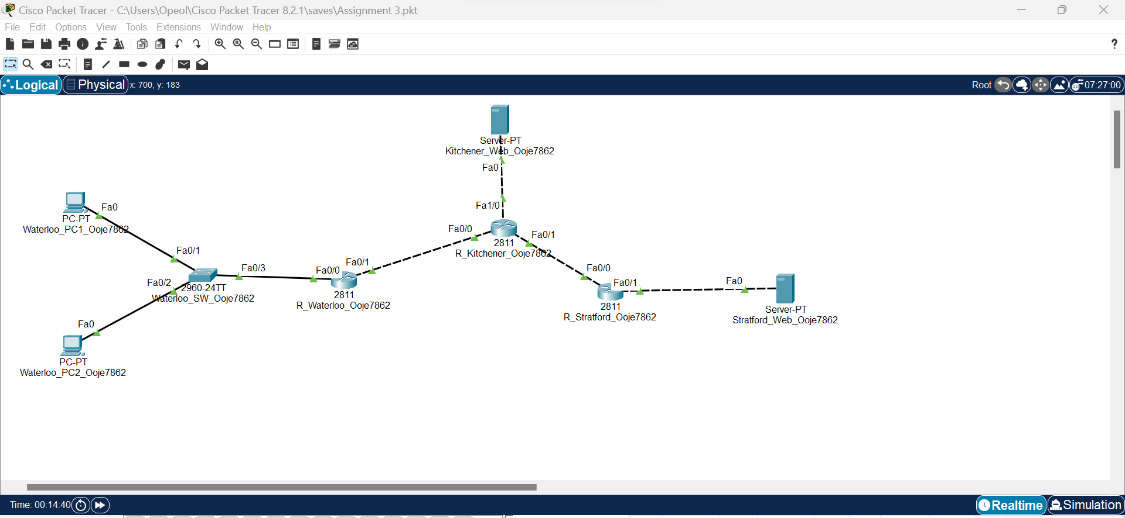
Figure 1 Building of the Topology

Part 2

Configuring and Test Routing using RIP

Screenshots
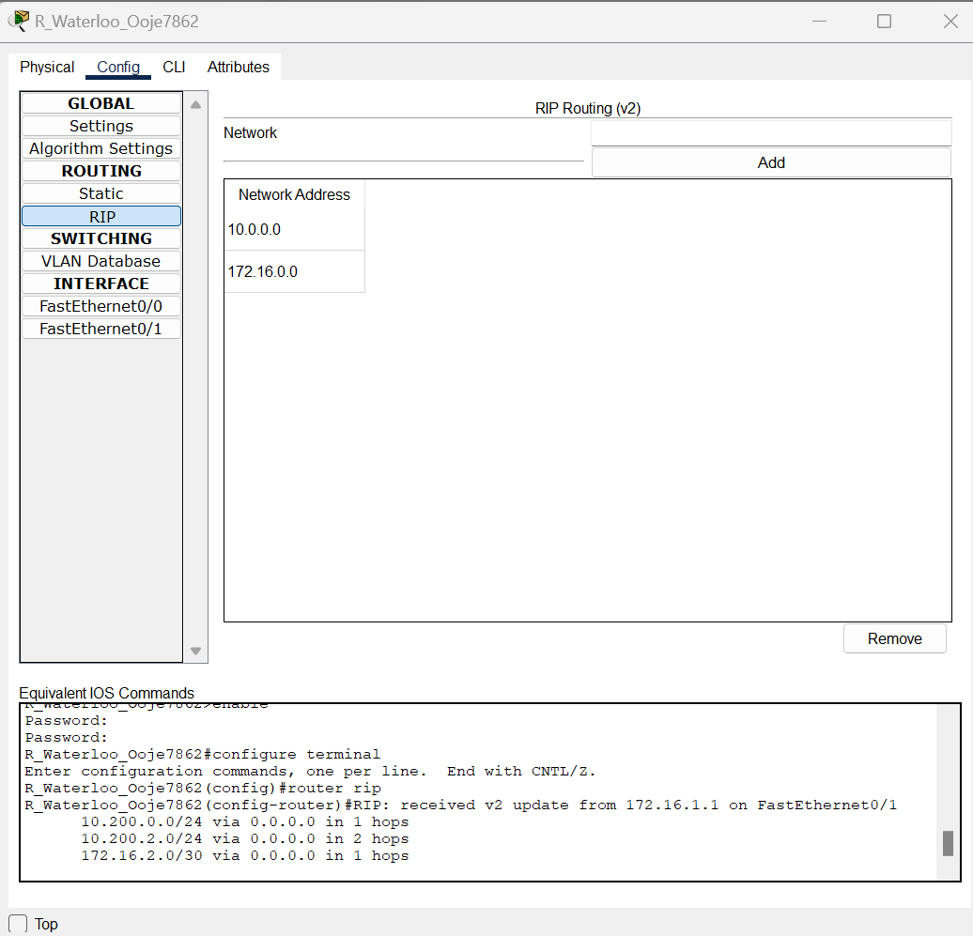
Figure 2.1 RIP version 2 enabled on R Waterloo
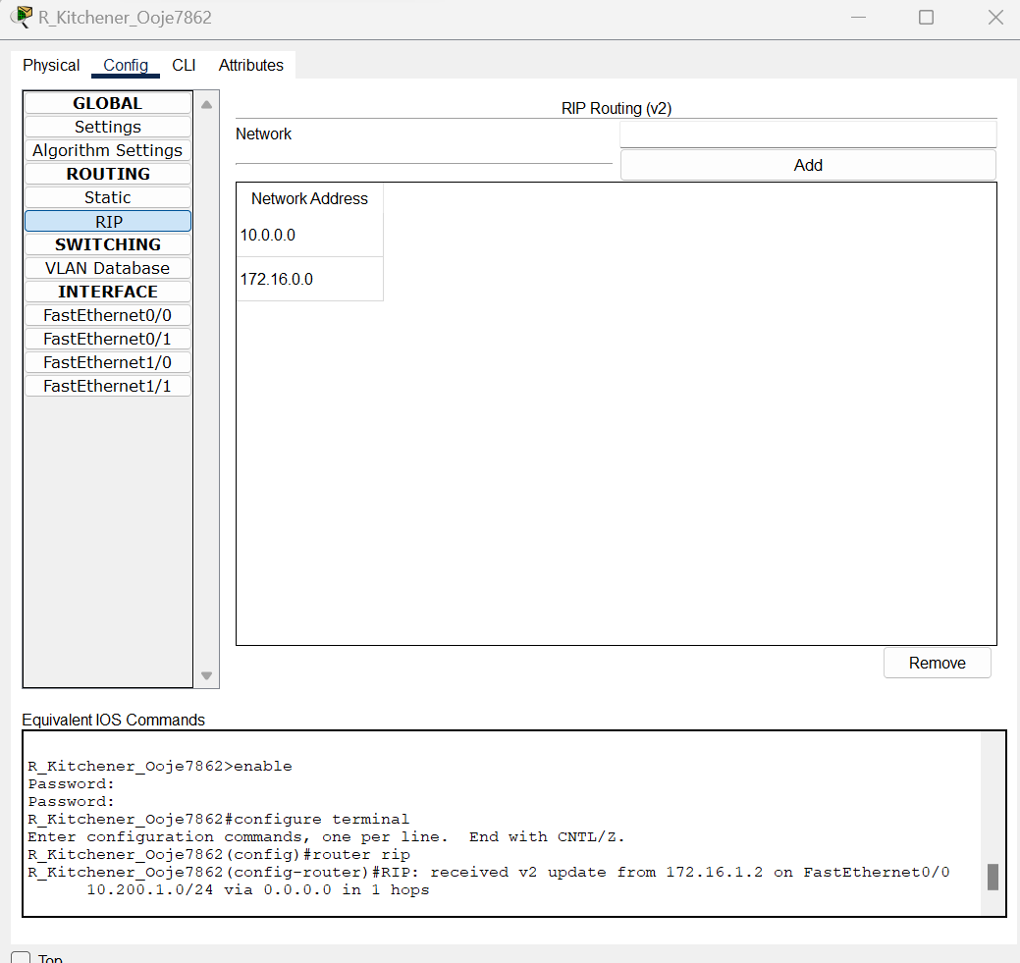
Figure 2.2 RIP version 2 enabled on R kitchener
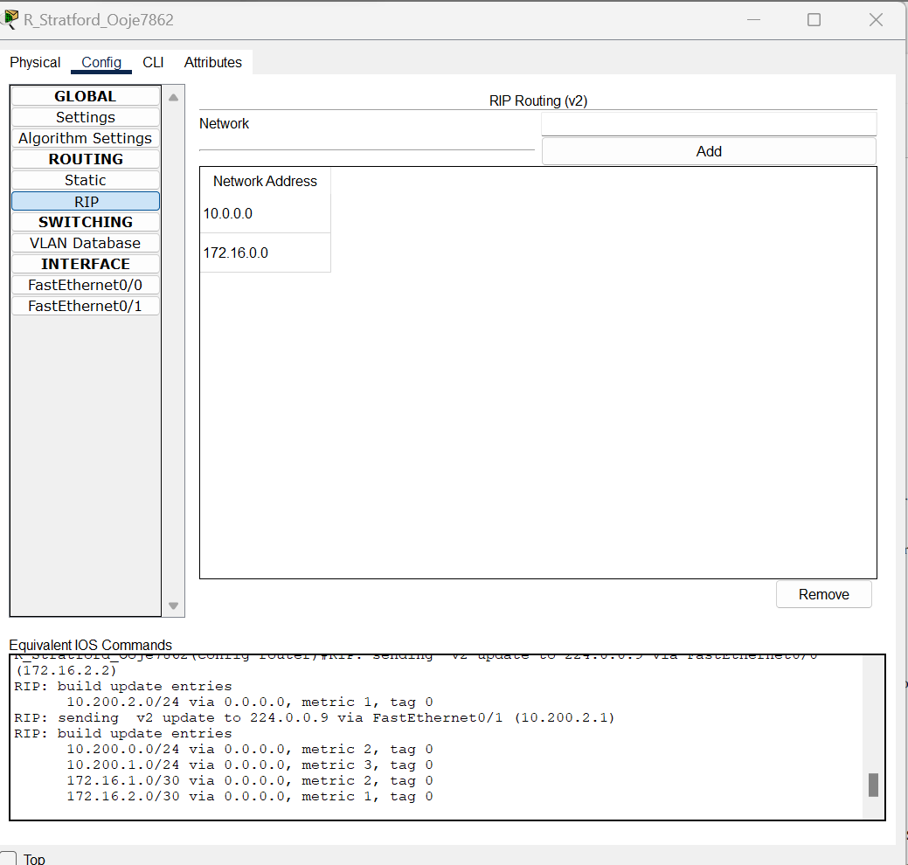
Figure 2.3 RIP version 2 enabled on R Stratford
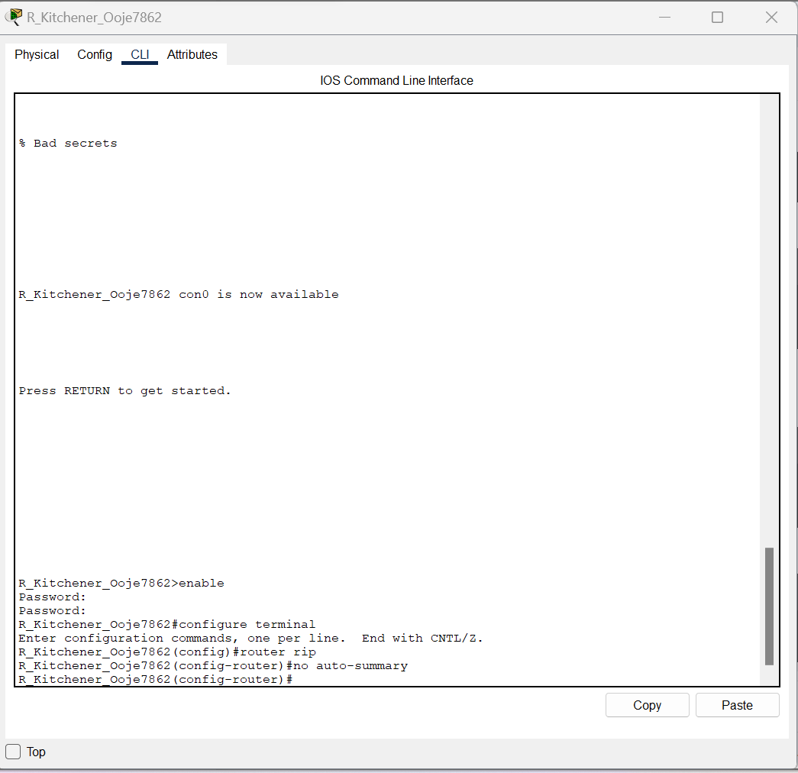
Figure 2.4 No auto summary on R Kitchener

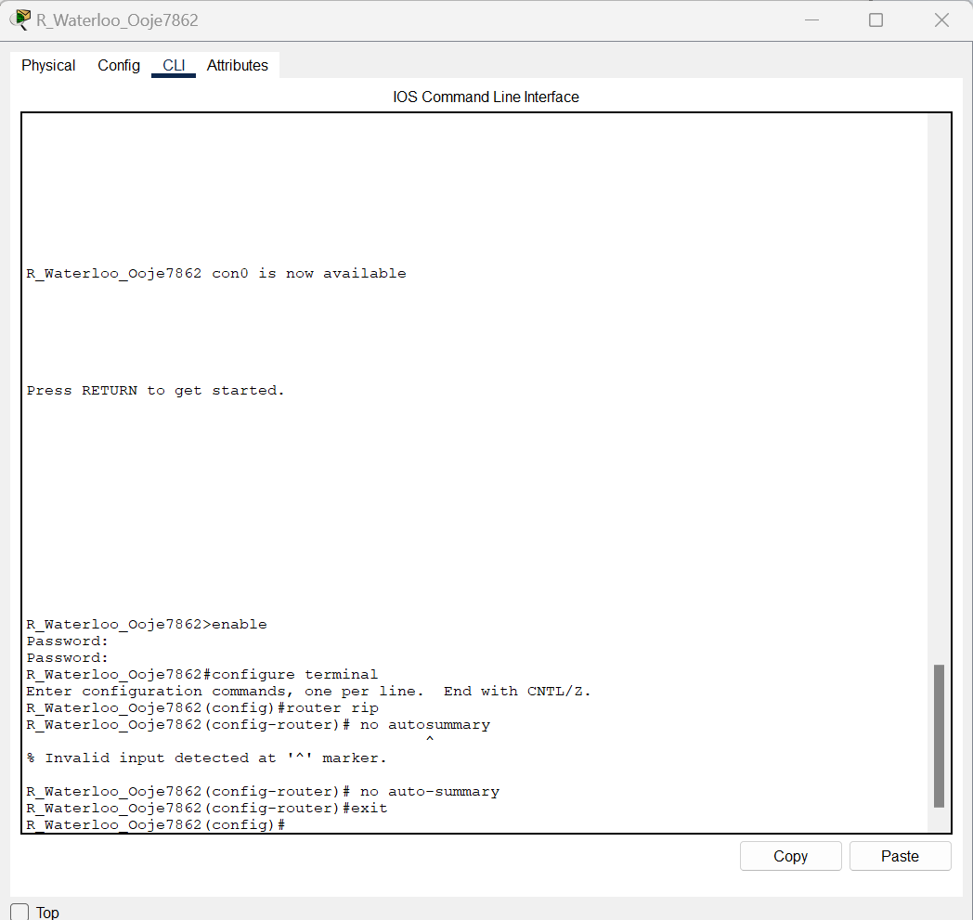
Figure 2.5 No auto summary on R waterloo
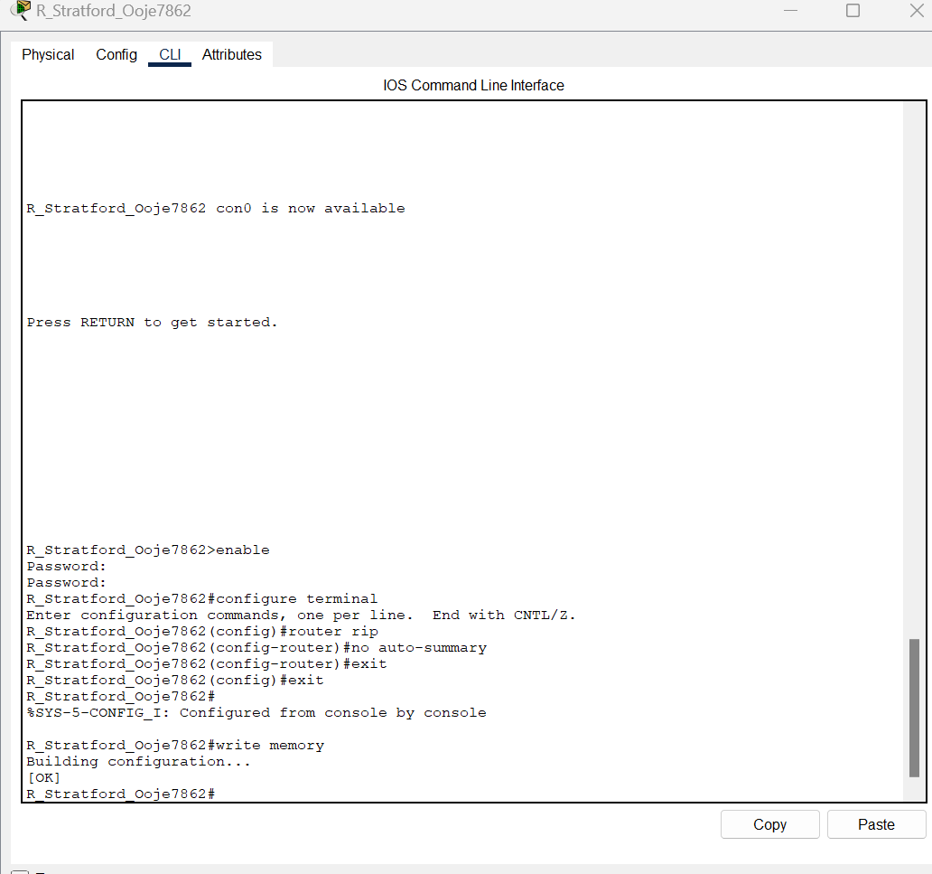
Figure 2.6 no auto summary on R Stratford

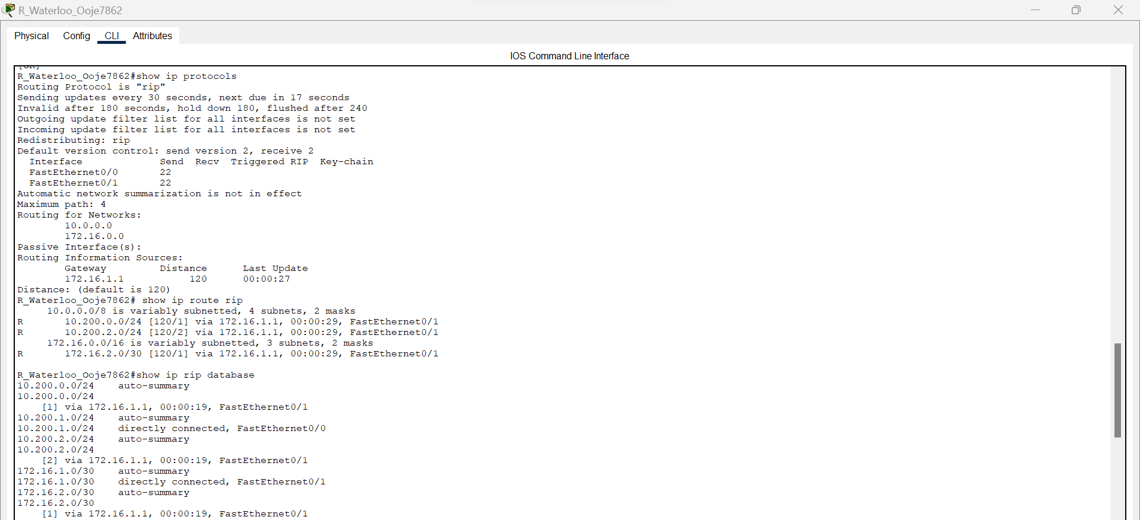
Figure 2.7 R waterloo routing protocols, database and information
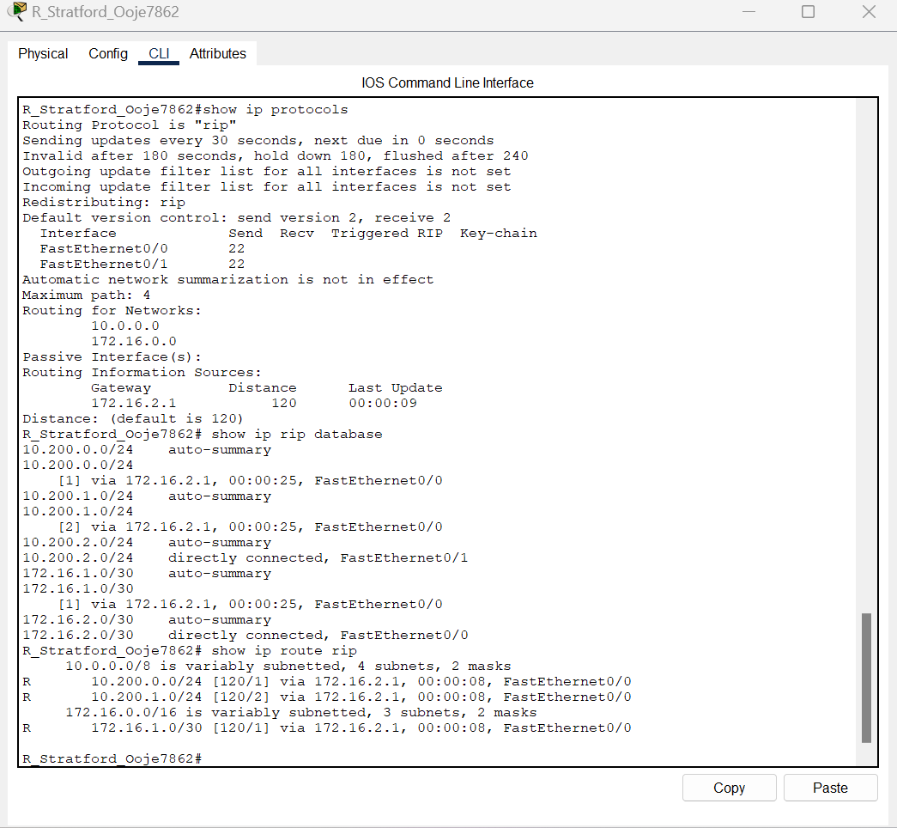
Figure 2.8 R Stratford routing protocols, database and information

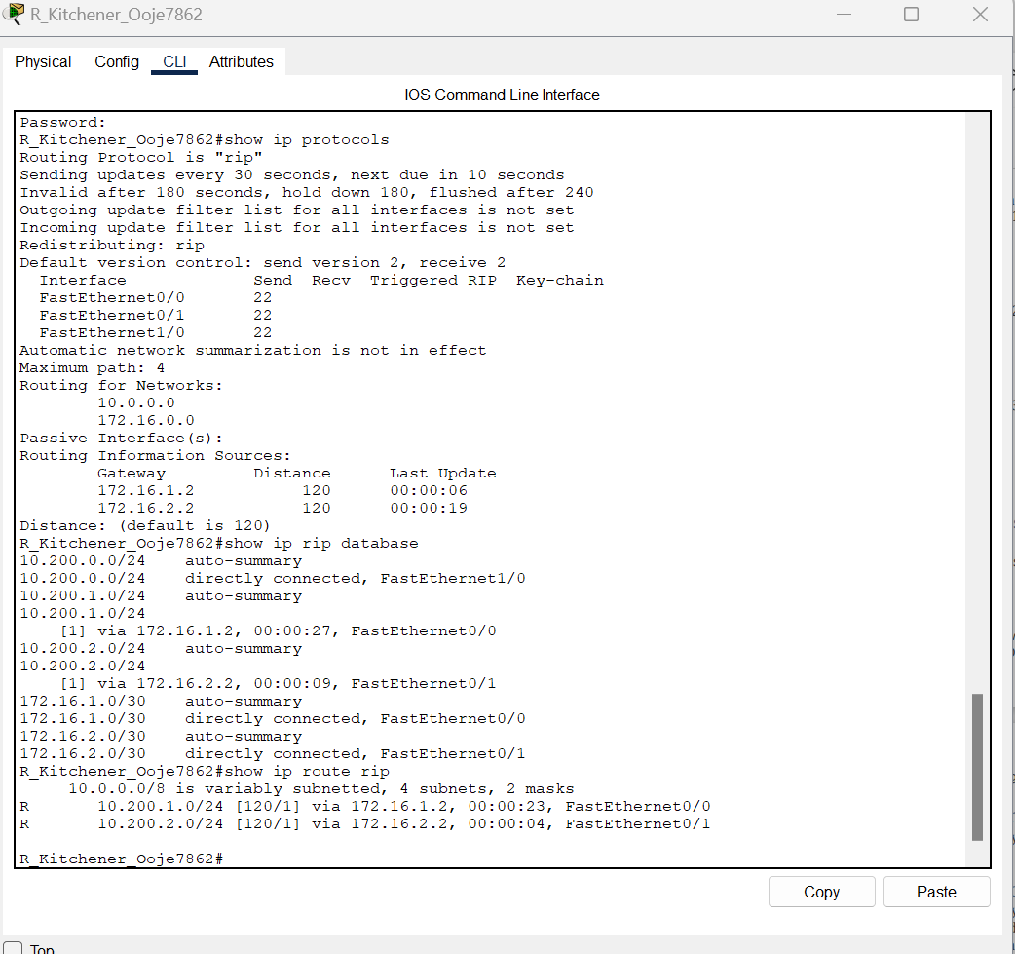
Figure 2.8 IP protocols, database and information on R Kitchener

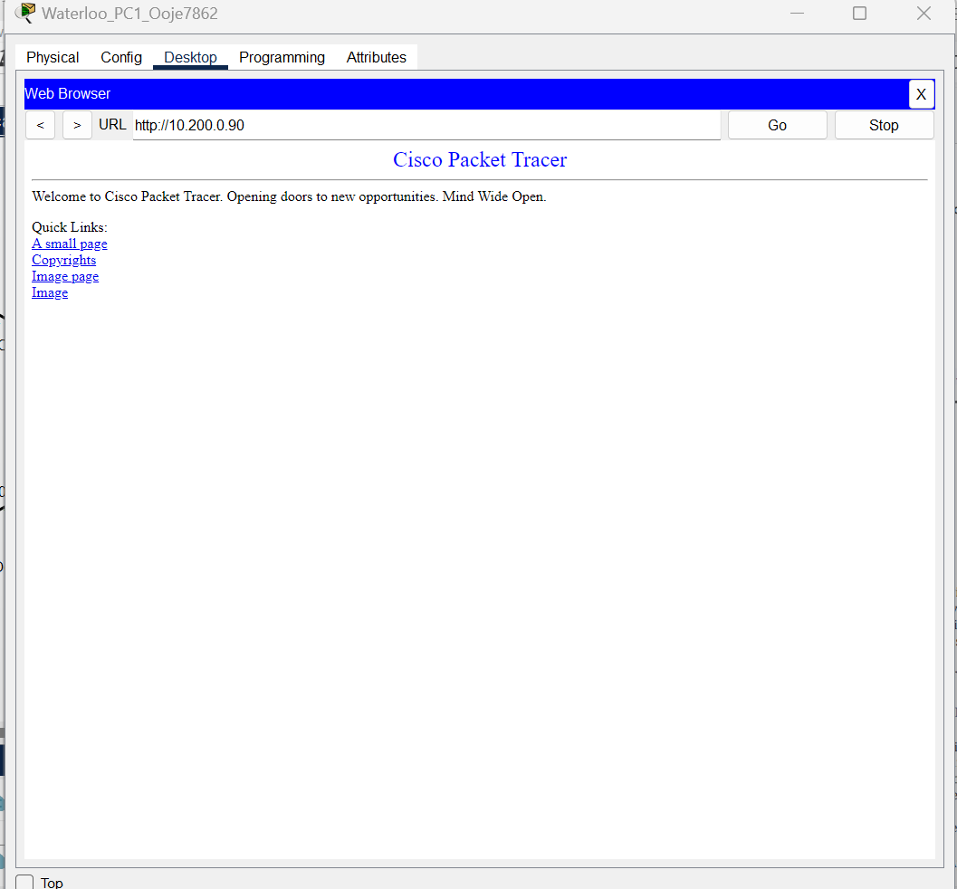
Figure 2.9 Website on Kitchener server reached from waterloo pc 1

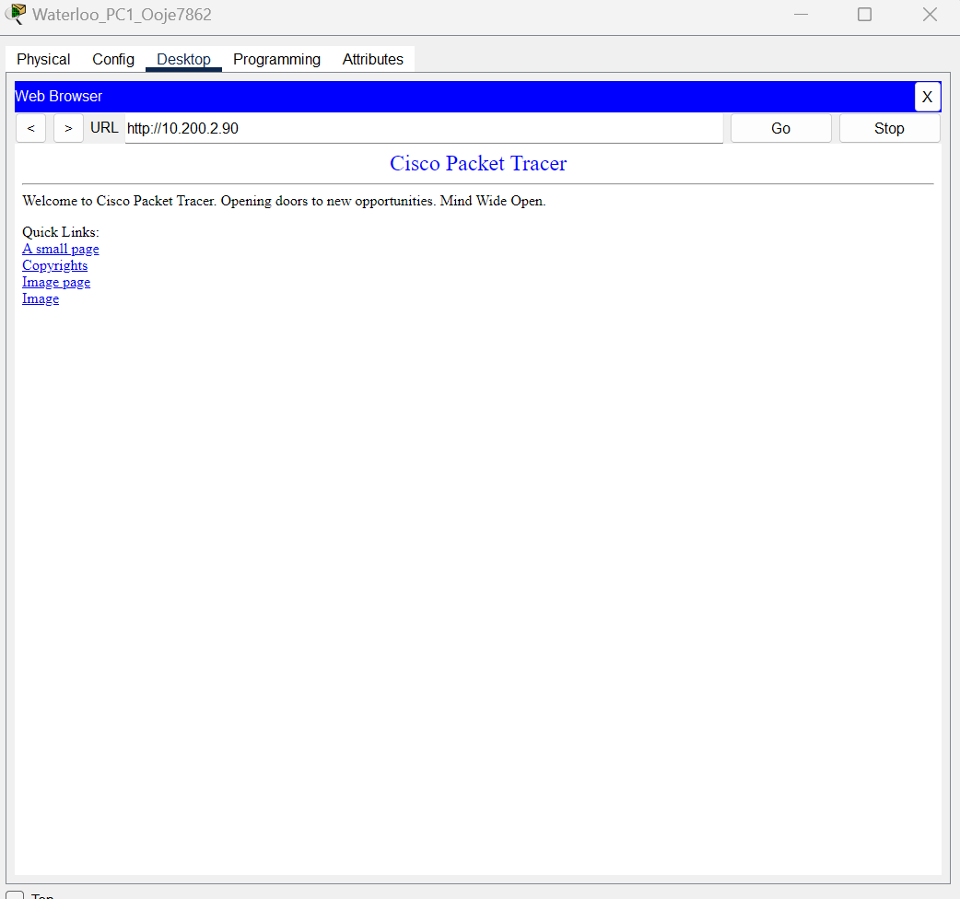
Figure 2.10 Website of server Stratford reached from PC waterloo

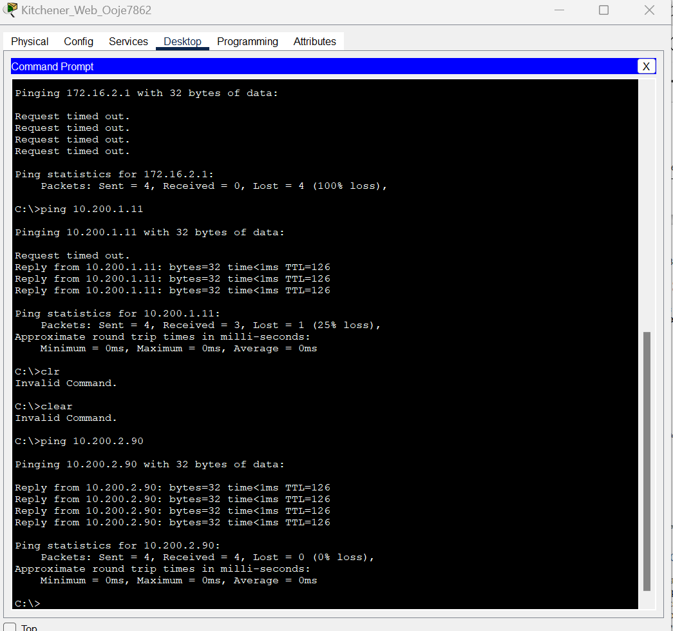
Figure 2.11 Ping for Kitchener sever to PC2 and Stratford server

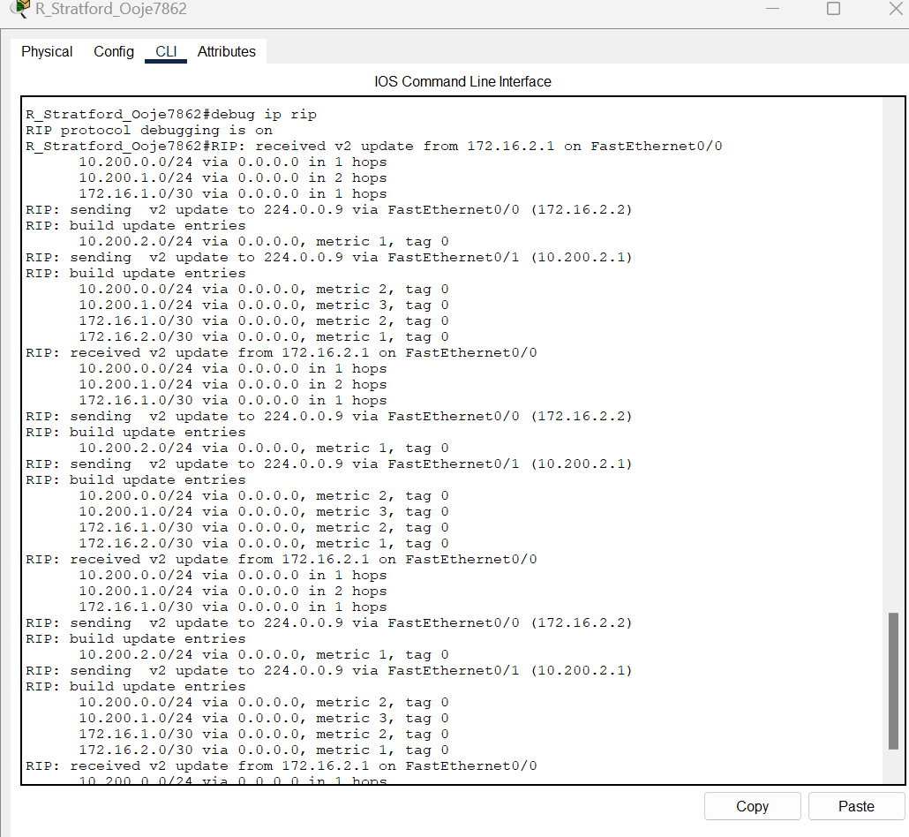
Figure 2.12 Debug mode of R Stratford

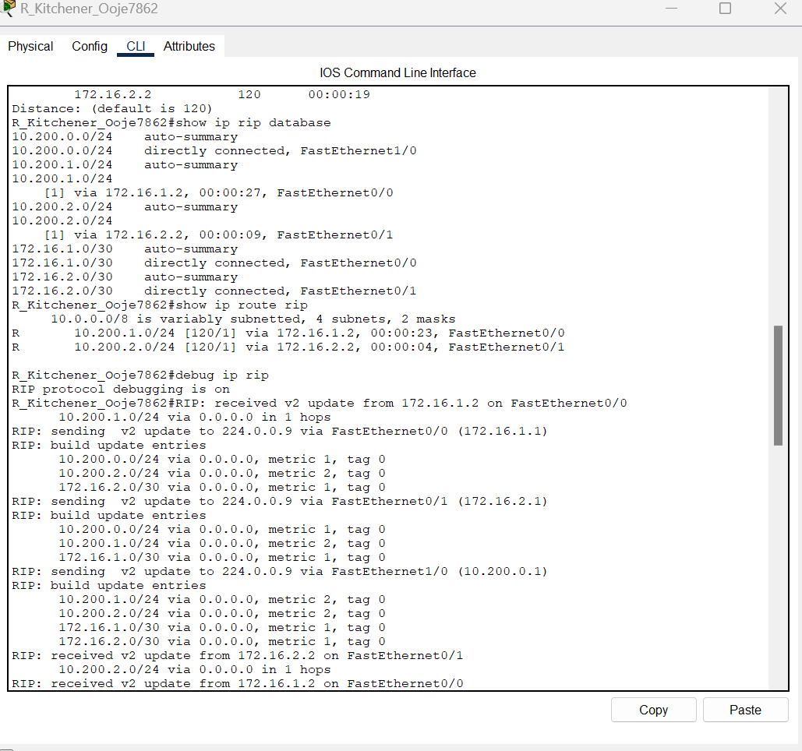
Figure 2.13 Debug mode of R Kitchener

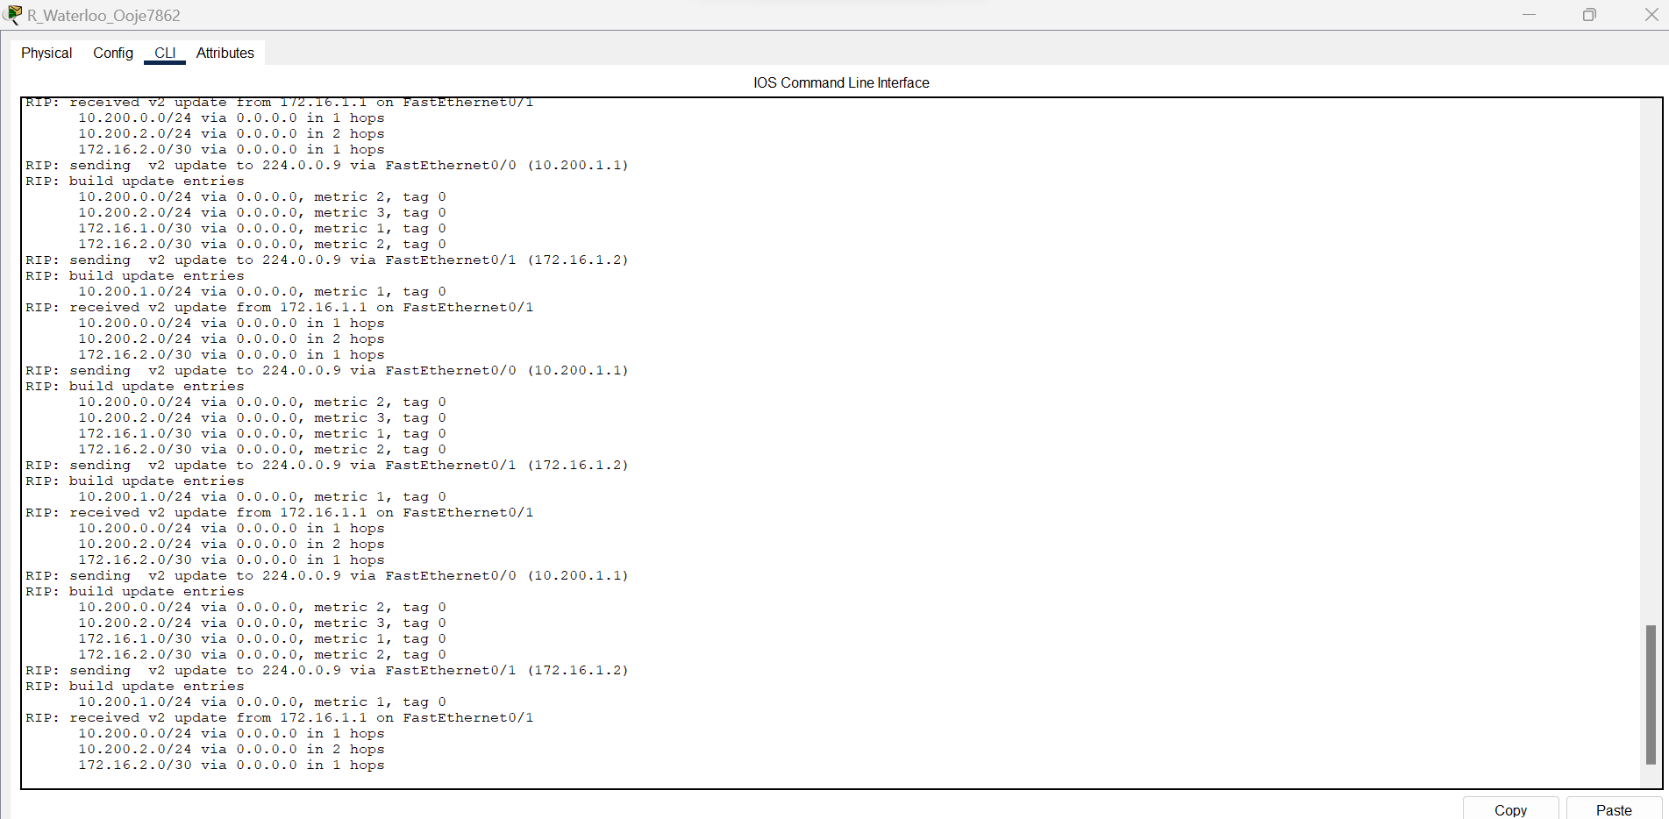
Figure 2.14 Debug mode of R waterloo

Preparation
- Current version of Packet tracer
- Two PC PT Objects
- One Cisco 2960 Layer 2 Switches
- Three Cisco 2811 Router
- Two PT Server

Description
The expected goal is to ensure the end devices can communicate to all network devices both on their network and outside their network by implementing the OSPF (Open shortest path first) routing protocol.

Observation
In this lab I was able to Disable RIP routing protocol on the network topology form the previous lab and implement OSPF routing protocol on the network topology.

Reflection
The overall aim of this lab is to ensure the exchange of routing information among the routers in the topology. In this lab, I learnt how one or more device on a network can communicate with other devices outside of their network.

Actually, selection between RIP or OSPF must be based on realization later on and will be needed in making specific requirements of the decision infrastructure. The real topology in small, stable environments, though, and with relatively rare, can be fine for RIP, while for large and changing, for huge scalability and for fast convergence on the best available path at any given instant, OSPF would provide a much more strong and efficient solution for the routing one.

Part 3

Configure and Test Routing using OSPF

Screenshots
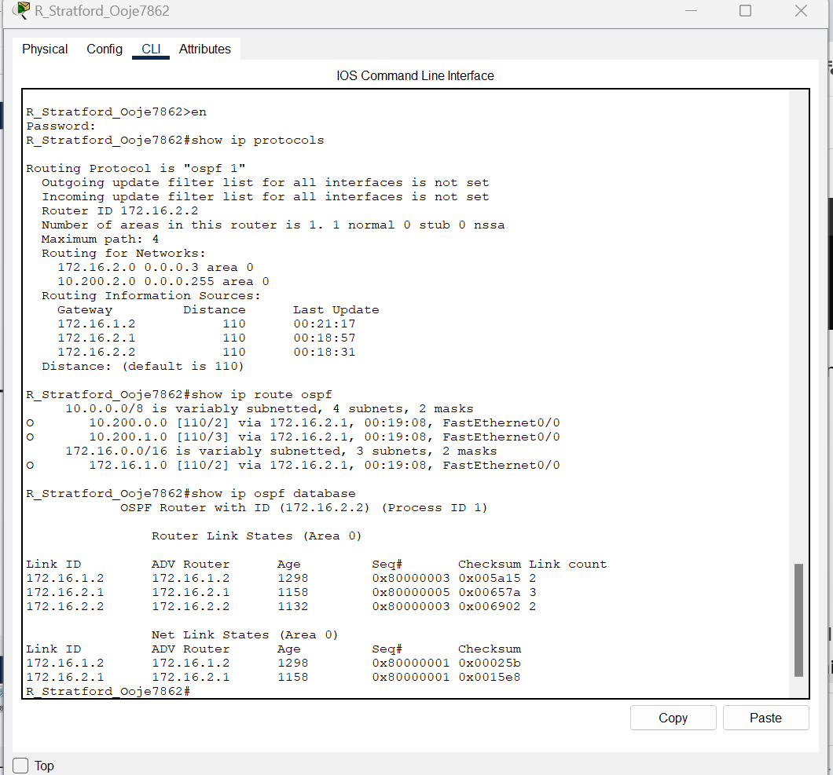
Figure 3.1 R Stratford showing the routing protocols, database and Information
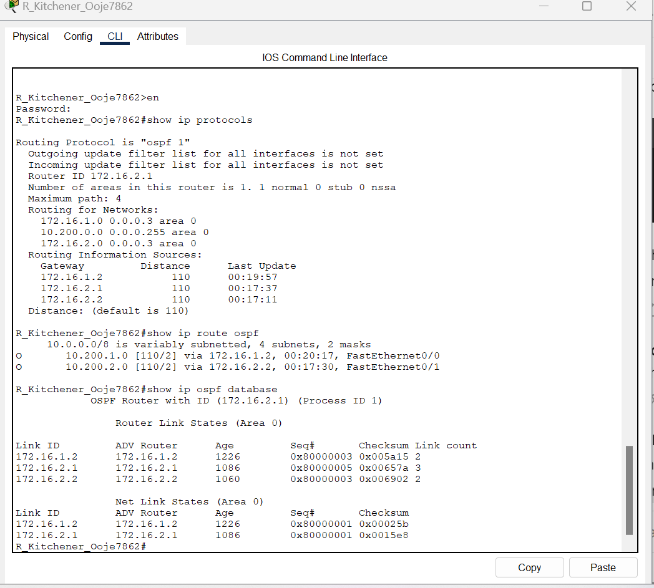
Figure 3.2 R Kitchener showing the routing protocols, information and database

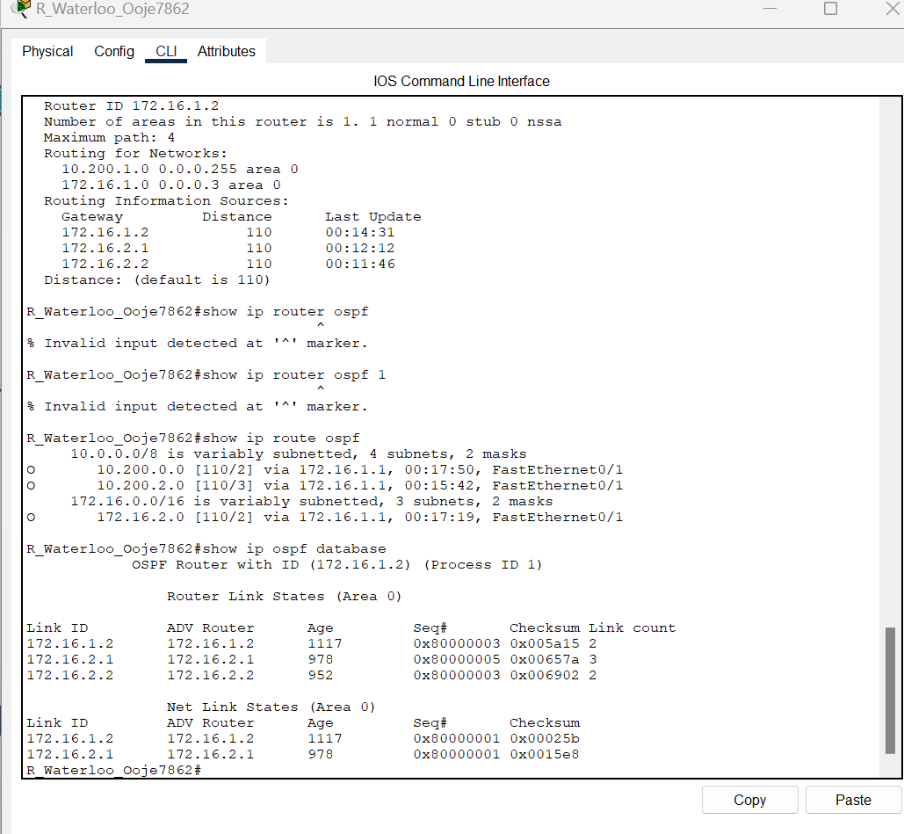
Figure 3.3 R waterloo showing routing protocols, information and Database

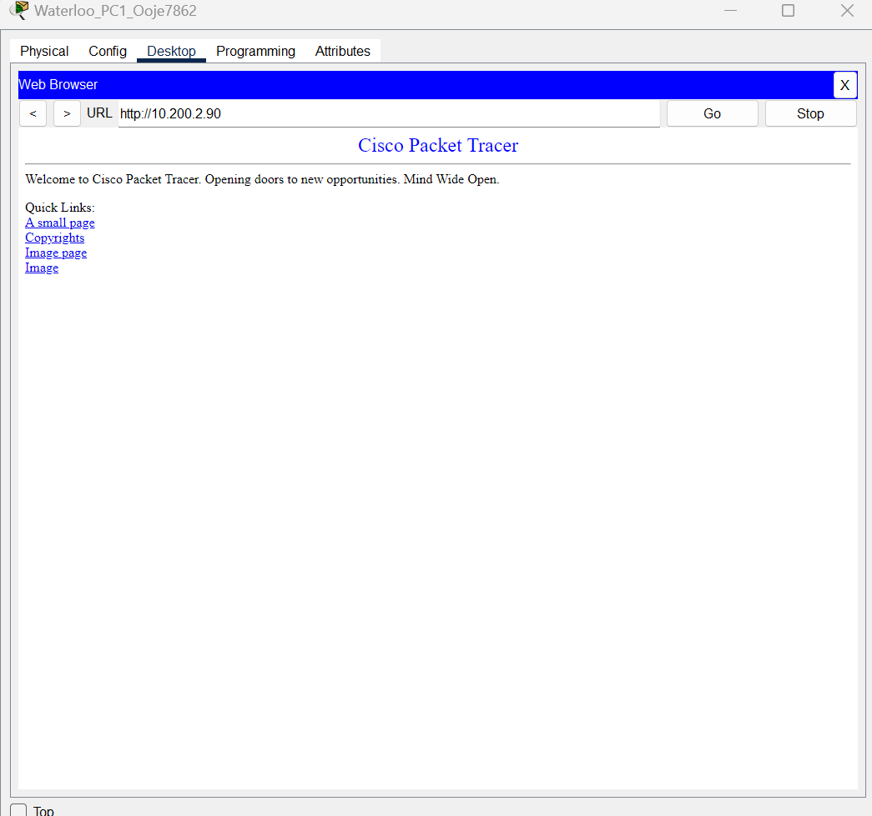
Figure 3.4 Stratford website reached

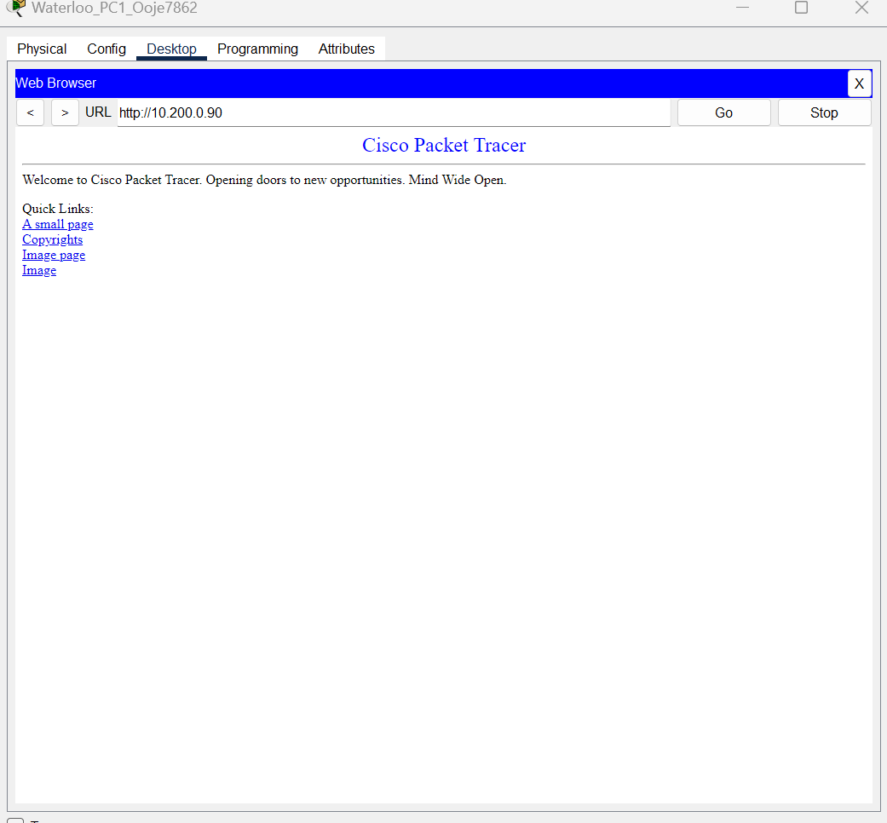
Figure 3.5 Kitchener server reached

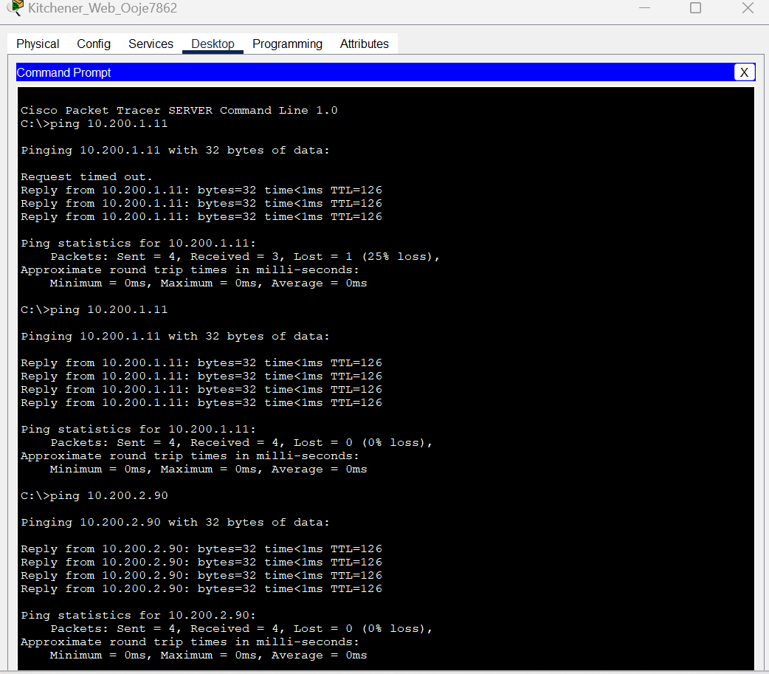
Figure 3.6 Ping successful from Kitchener server to Stratford server and waterloo_PC2

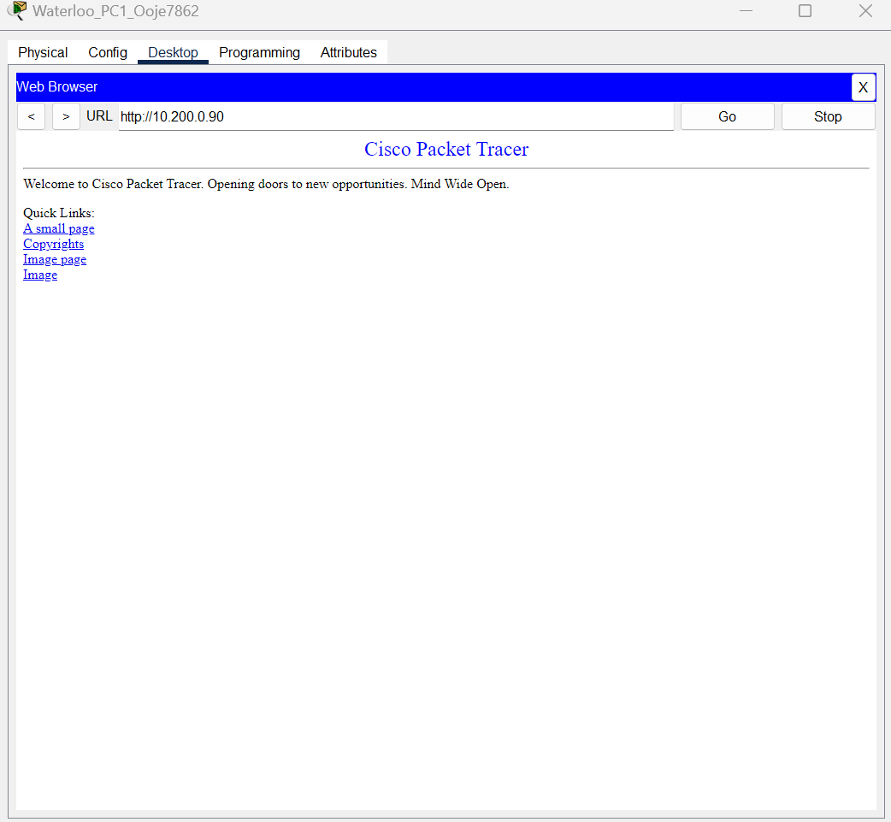
Figure 3.7 Access from PC1 to website of Kitchener server with MD5 authentication


Figure 3.8 Access Stratford website from PC1 after md5 authentication


Figure 6 Kitchener server pinged Stratford server and waterloo PC with MD5 authentication

