Oje Opeoluwa Hezekiah
8917862
Information Technology Network Security
INFO8835-24S-Sec1- Network Security II
Portfolio 1
Prof. Tarooq Mahood
24th May, 2024

Table of Contents
Part 1- Building the Topology 3
Description 3
Screenshots 3
Reflection 8
Task 2 9
Description 9
Task 3 10
Description 10
Observation 11
Reflection 11
Task 4 12
Description 12
Screenshots 12
Observation 13
Reflection 13

Part 1- Building the Topology

Description
In this part of the lab, we are going to build a network technology using our Vsphere environment. In addition to this, we are going to assign the virtual machines we created to different zones using Palo Alto firewall.

Screenshots
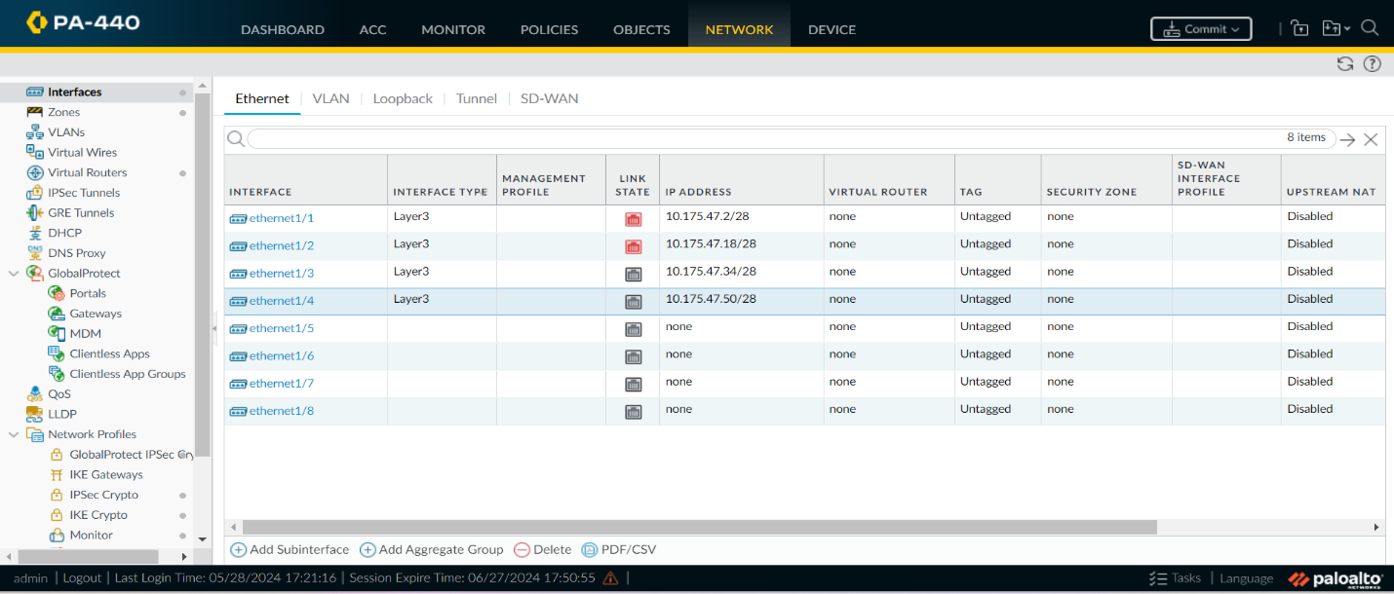
Figure 1 Assigning of Interfaces to the virtual machines
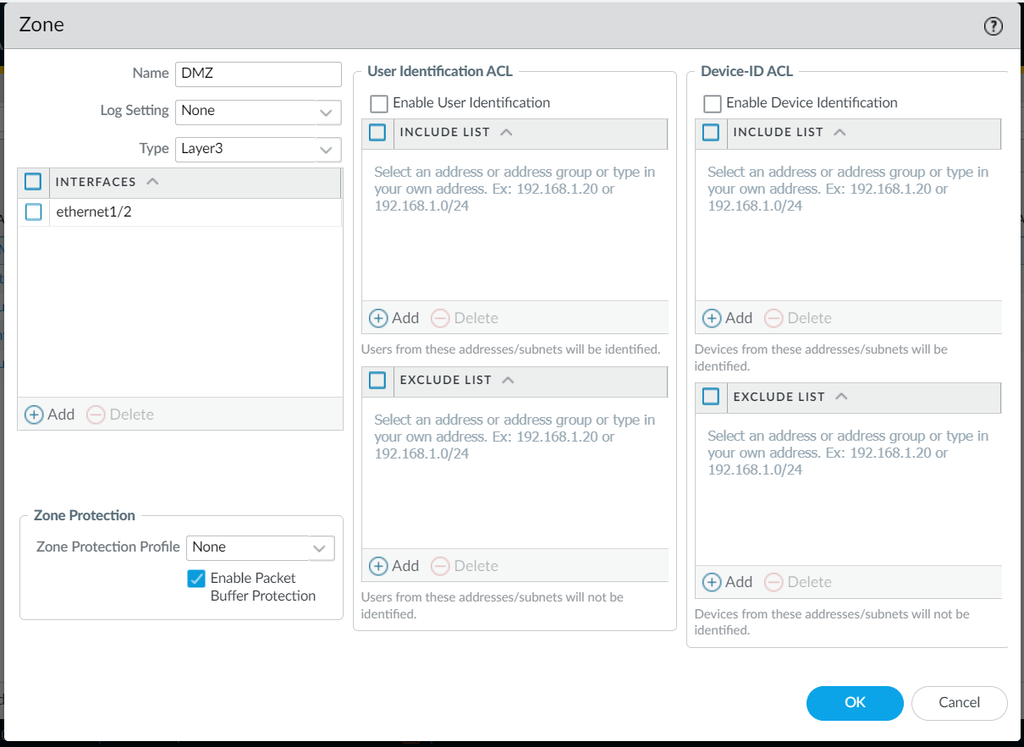
Figure 2 Assigning Zone for Dmz interface
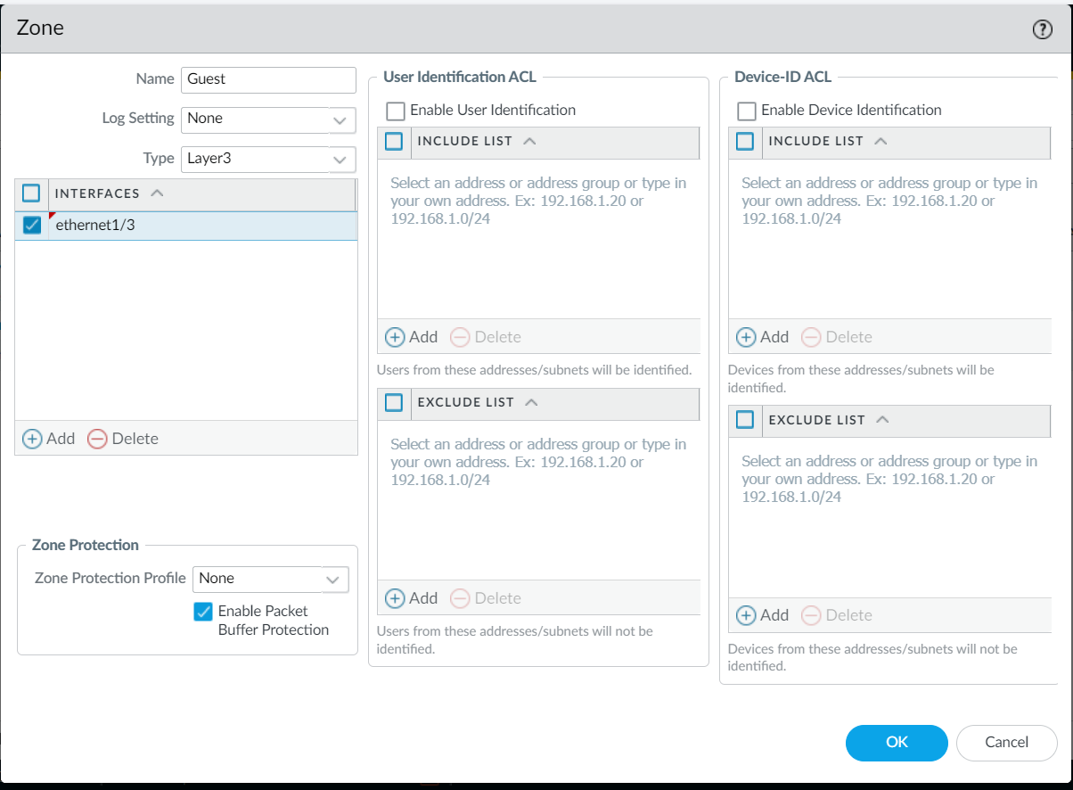
Figure 3 Assigning zone to Guest interface

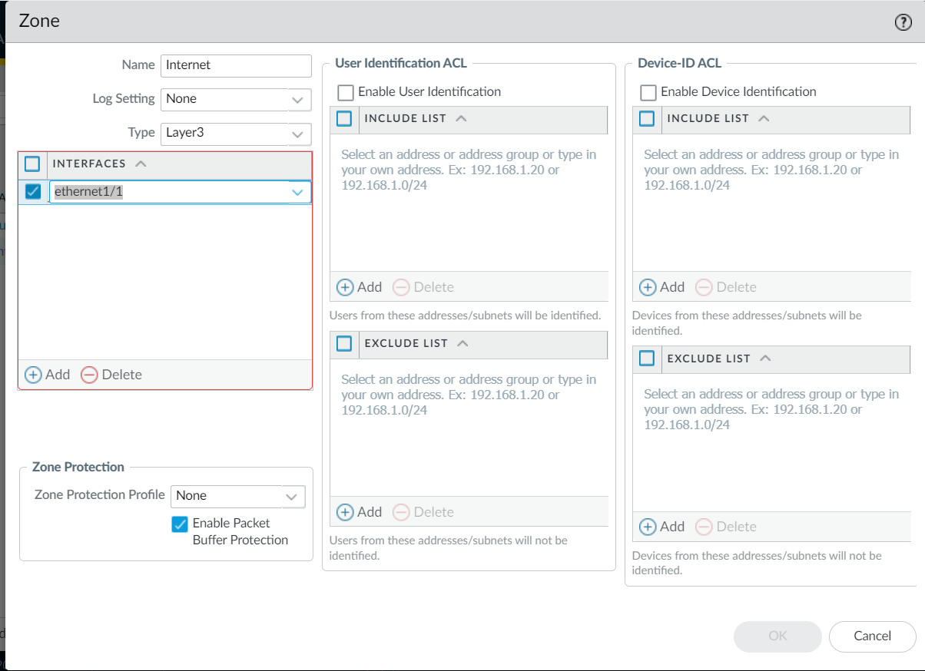
Figure 4 Assigning zone to Internet Interface

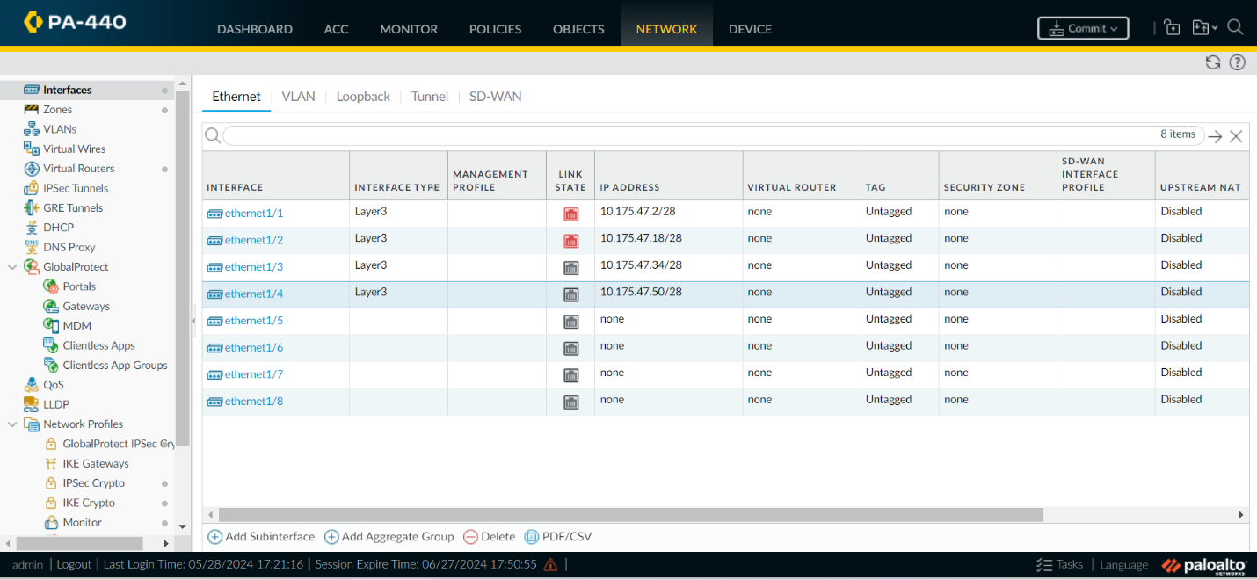
Figure 5 Interfaces created
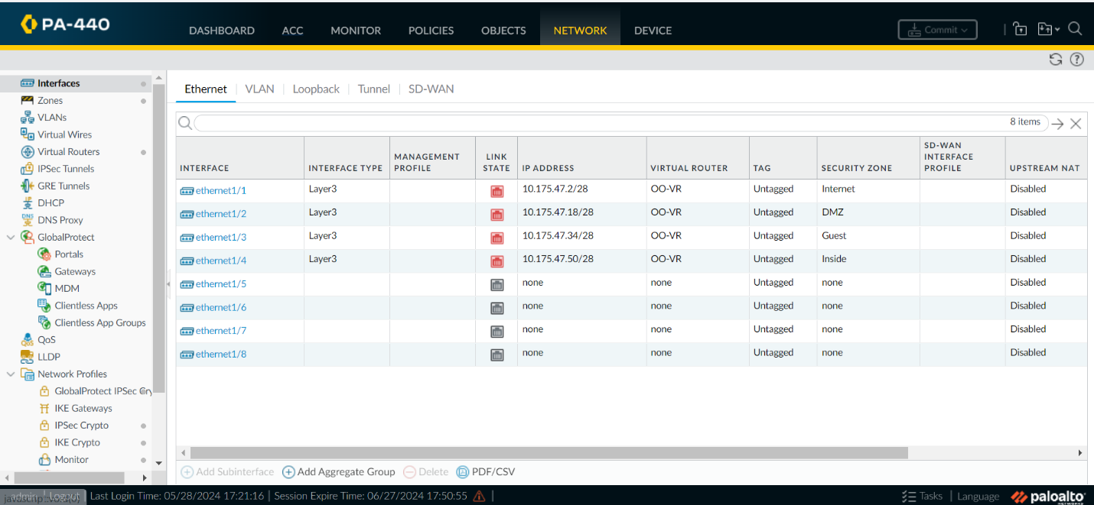
Figure 6 Firewall configured
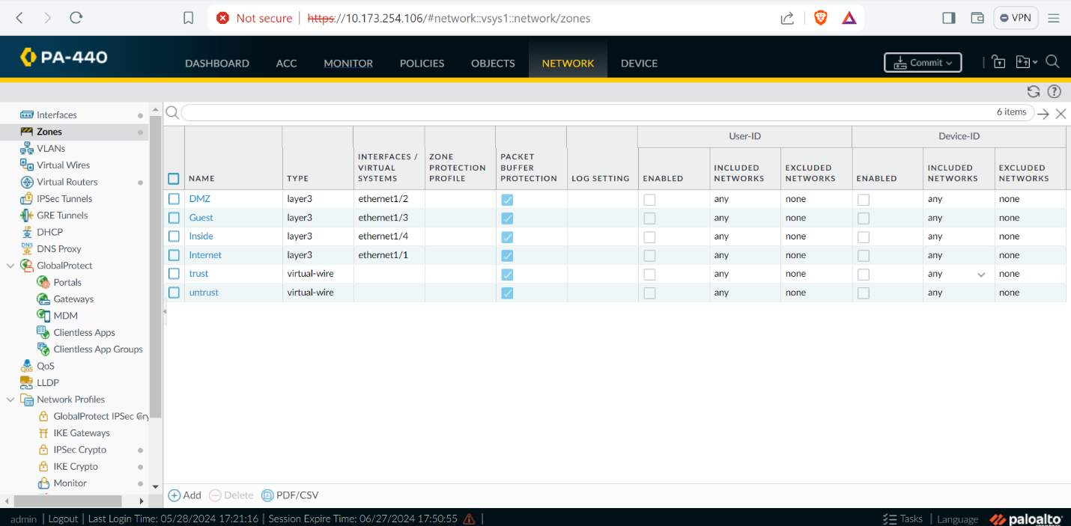
Figure 7 Segmentation based on zones

Observation
- Logged on into Kit088 with the As ip, to access the Palo Alto firewall
- After logging, I loaded base config so as to set the firewall to its default settings.
- Accessed the Palo Alto firewall from web browser using the Ip address (10.173.254.106)
- Created four zones on the firewall named Inside, Internet, DMZ and Guest
- Created and assigned Ip addressed to each interface
- Assigned interface to zones created.
- Created a virtual router and assigned to each network interface created

Reflection
Firewall zones is essential in enhancing and increasing network security by segmentation of networks and controlling traffic between different sites of a network. Firewall ensures the following;

- Enhanced Security- By diving your network into zones, for instance, DMZ, Guest or Internet, one can isolate sensitive areas/sites from the less secure ones, reducing the risk of unauthorized access to the network
- Minimized attack surface- Limited packet or traffic flow between zones helps in minimizing the number of entry points an attacker can exploit, reducing the overall attack surface.
- Increased Performance
- Firewall zones also help in facilitation of Secure Remote Access.

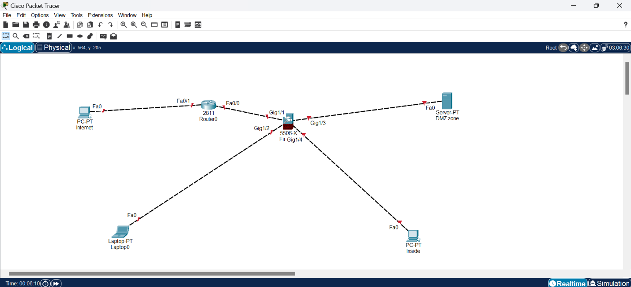
Figure 8 Topology

Task 2

Description
In this lab, I will be building my topology in the Vsphere environment where I will create some virtual machines and configure some Ips on them.

Task 3

Description
In this lab, the aim is to deploy a certificate Authority. A private key will first be generated to generate a Certificate Authority, then a CA will be created using the private key.

Screenshots
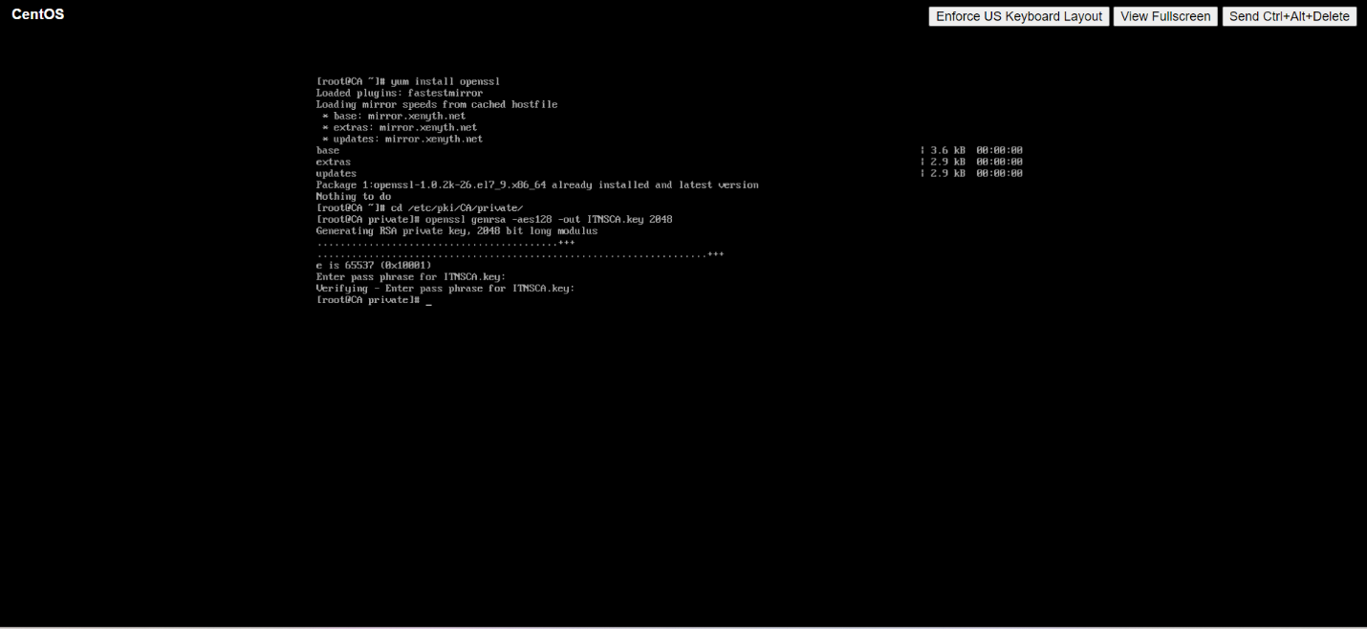
Figure 9 Configuring Certificate Authority
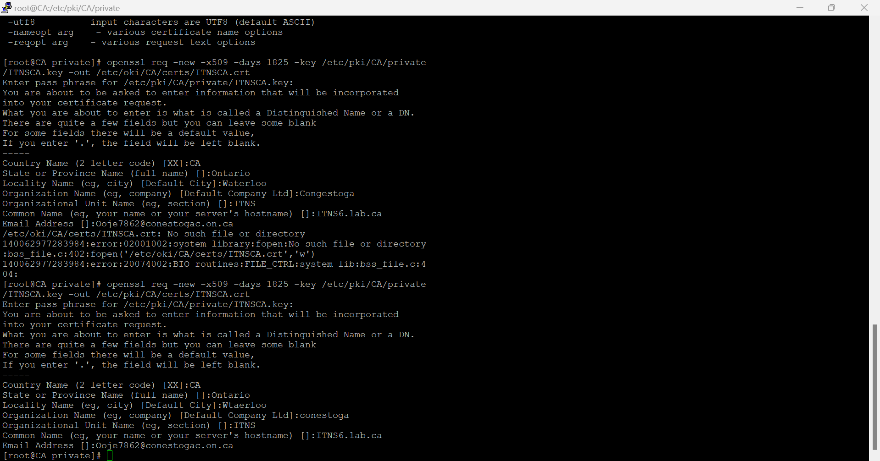
Figure 10 Creation of Certificate Authority key

Observation
- Generated a private key so as to generate Certificate Authority
- Created a Certificate Authority using the private key created
- After this process the CA is now ready to sign client certificate.
While trying to create the CA key, I encountered an error using the command that was provided, ITNSCA.cert was the initial option in the command given to be used but it was giving an error saying “can’t access or open this folder”. My solution to this problem was simply changing the .cert to .crt.

Reflection
Certificate Authority is a trusted entity/organization that issues digital certificates. These certificates are used to verify the identity of entities like websites, devices or even individuals and establish secure and encrypted communications over networks. Components of Ca includes, Name, contact, organization, public key, certificate issue and expiry date and more.

Architecture of a Certificate Authority
- Root certificate Authority
- Intermediate certificate Authority
- Registration Authority
- Certificate Database

There are different types of Certificate Authorities, for instance, we have public ca, private and enterprise certificate authorities. In this lab, I created a private ca as it is issued for personal and internal use.

Task 4

Description
In this lab, the certificate generated will now be signed using the certificate authority server.

Screenshots
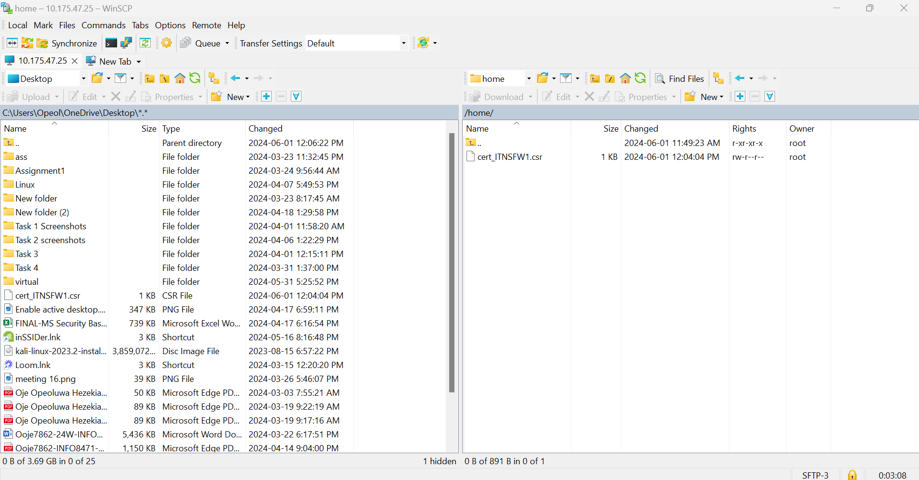
Figure 11 csr document moved from my local Pc to the CA server using WinSCP
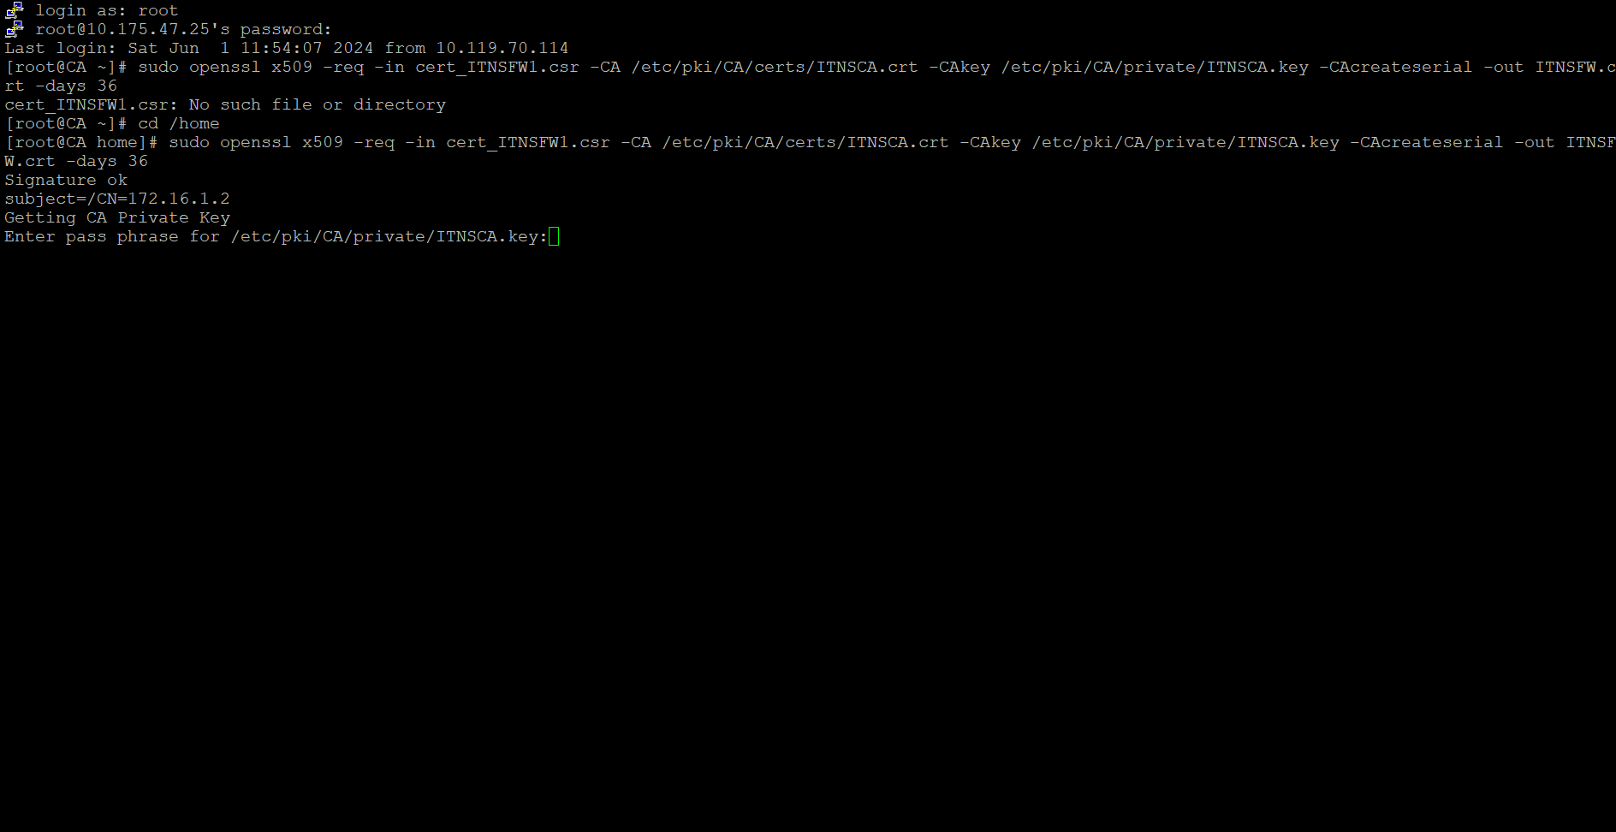
Figure 12 CSR signed
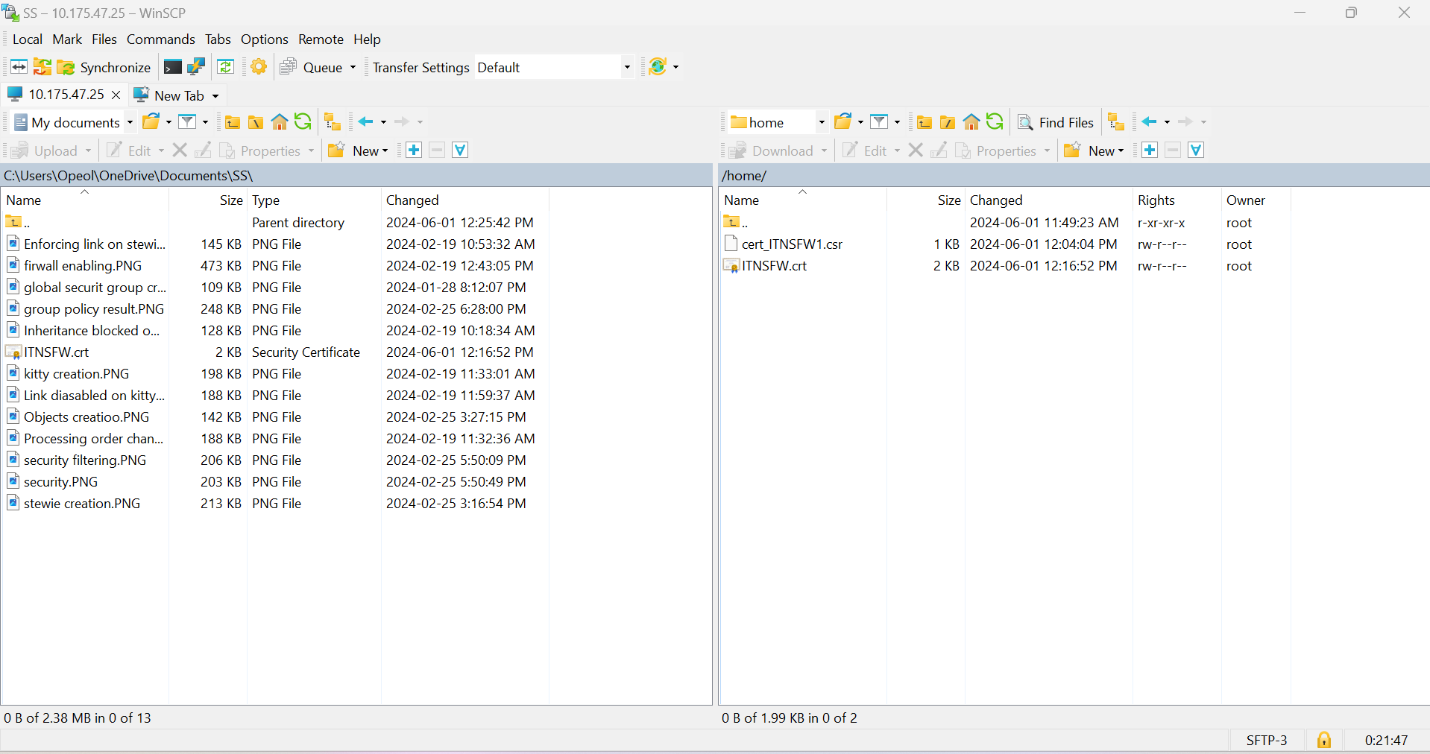
Figure 13 Certificate key gotten

Observation
- Copied the Csr generated from firewall Palo Alto
- Moved the csr to the CA using WinSCP Application
- After signature I got a file with a file extension of .crt
During this task, I first found it difficult transferring the csr filed downloaded from the portal to my CA server, I tried using scp in my command line but it wasn’t responding. I solved this problem by downloading the WinSCP application for easy file transfer from my local pc to the CA server and vice-versa.

Reflection
A Certificate Signing Request and the certificate key are crucial procedures in the process of obtaining and using SSL/TLS certificates for securing communications over a network. CSR and certificate key are very crucial as it helps in validation of users, encryption and decryption of sensitive information. Certificate key also helps in achieving authentication and confidentiality. In network communication, it is used for SSL/TLS handshake.

A public key is a key that can be shared openly and widely. It is paired with a private key but does not need to be kept confidential while A private key is a secret key known only to the owner or the entity responsible for the key pair. It must be kept confidential and secure. Gaining an understanding of how asymmetric cryptography functions to protect data integrity, facilitate secure communication, and verify identities in digital settings requires an understanding of the distinctions between private and public keys.

