Solutions:

1. NFA:

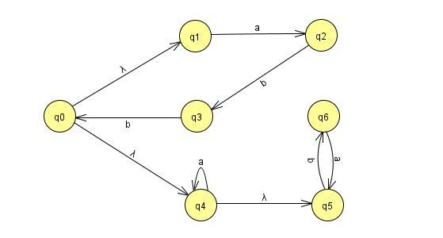

STATE TABLE

|  |  |  |
| --- | --- | --- |
| States | a | b |
| → S{q0, q1,q4, q5}* | A{ q2, q4, q5} | B{q6} |
| A{q2, q4, q5}* | C{q4, q5} | D{q3, q6} |
| B{q6} | E{q5} | - |
| C{q4, q5} | C{q4, a5} | B{q6} |
| D{q3, q6} | E{q5} | F{q1} |
| E{q5}* | - | B{q6} |
| F{q1}* | G{q2} | - |
| G{q2} | - | H{q3} |
| H{q3} | - | F{q1} |

RESULTING DFA:

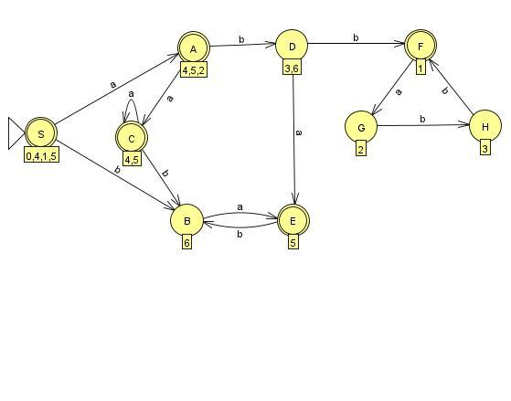

1. Number of states needed = 15(including initial state)

Resulting DFA:

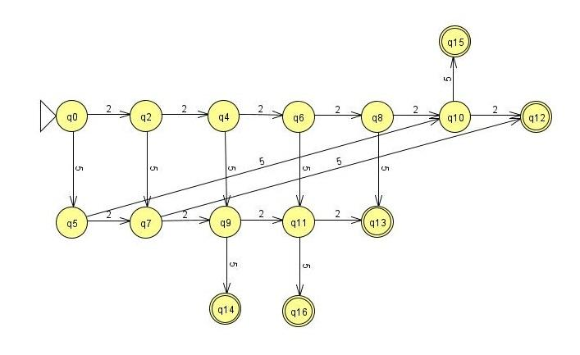

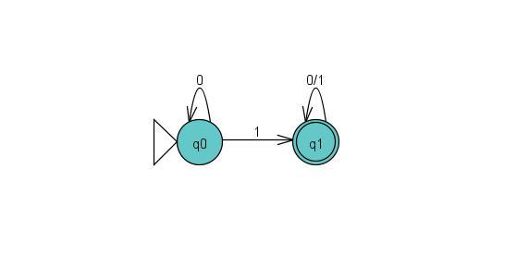

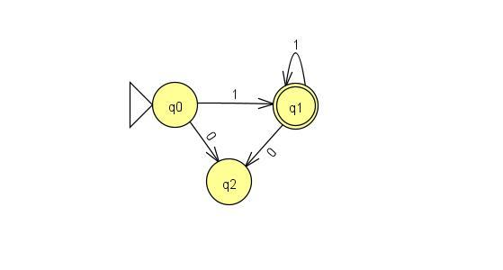

1. A
2. A
3. A

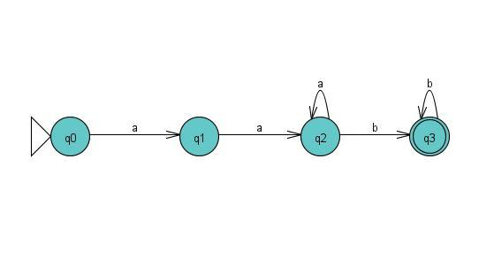

|  |  |  |  |
| --- | --- | --- | --- |
| q1 | x |  |  |
| q2 | x | x |  |
| q3* | x | x | x |
| States | q0 | q1 | q2 |

* q0(a) → q1 q1(a) → q2 q1(a) → q2 q2(a) → q2

q0(b) → - q1(b) → - q1(b) → - q2(b) → q3

* q0(a) → q1 q2(a) → q2 q0(b) → - q2(b) → q3

Thus since no two states are indistinguishable, the DFA is minimal.

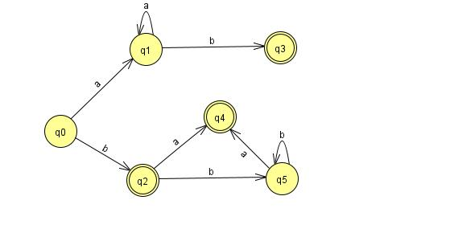

|  |  |  |  |  |  |
| --- | --- | --- | --- | --- | --- |
| q1 | X |  |  |  |  |
| q2* | X | X |  |  |  |
| q3* | X | X | X |  |  |
| q4* | X | X | X | X |  |
| q5 | X | X | X | X | X |
| States | q0 | q1 | q2* | q3* | q4* |

* q0(a) → q1 q1(a) → q1 q0(a) → q1 q5(a) → q4

q0(b) → q2 q1(b) → q3 q0(b) → q2 q5(b) → q5

* q1(a) → q1 q5(a) → q4 q1(b) → q3 q5(b) → q5

Thus since no two states are indistinguishable, the DFA is minimal.

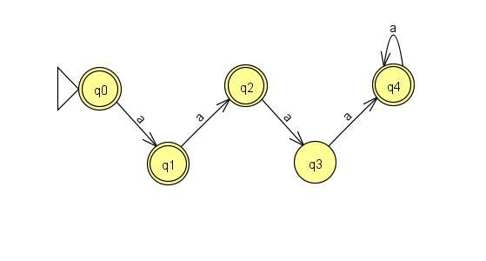

|  |  |  |  |  |
| --- | --- | --- | --- | --- |
| q1* | X |  |  |  |
| q2* | X | X |  |  |
| q3 | X | X | X |  |
| q4* | X | X | X | X |
| States | q0* | q1* | q2* | q3 |

Thus since no two states are indistinguishable, the DFA is minimal.

1. A
2. A
3. a