**SETUP PROCESS TO RUN KIJIJI AUTOBOT SCRAPPER**

**STEP 1:** Install Visual Studio code:

* Go to <https://code.visualstudio.com/download> to download extension
* Under the windows icon look for user installer and select either 64bit, 32bit or ARM button to download.

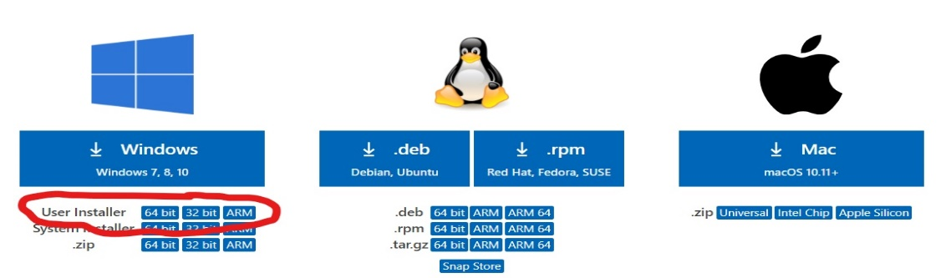

* Alternatively, you can run the 64bit installer already downloaded in the setup folder of this app, the file name is vscode64 (path: KIJIJI-AUTOBOT-V2.5/setup/)
* Follow this video exactly to install it <https://youtu.be/MlIzFUI1QGA?t=52> (you do not need to watch the full video start the current time set by the URL and stop at 1:54 time of the video)

**STEP 2:** Open Kijiji folder with VScode

* If VScode is installed properly right click on Kijiji folder, you should see open with code option, select it.
* Press CTRL + ` to open terminal or go to view and select terminal
* In the terminal type **cd setup/**
* And then run the command **python setup.py** in the terminal
* Check Log folder and open any file that starts with the name setup in the VScode
* See if the last line of the file reads **Setup Module: Environment Setup Completed**
* If so then setup is complete
* In terminal type **cd ../src/**
* And then run **python main.py in terminal**
* Application should start running