

laboratory practice I

Lab Journal



NAME :- OJUS P. JAISWAL

YEAR & DIV :- TE A

ROLL NO. :- TACO19108

SEAT NO. :- S191094290

**Index**

|  |  |  |  |
| --- | --- | --- | --- |
| Sr. No. |  | Title of the Experiment | Page No. |
| **Part I: Systems Programming and Operating System** | | | |
| **Group A** | | | |
| 1 | A1 | Design suitable Data structures and implement Pass-I and Pass-II of a two-pass assembler for pseudo-machine. Implementation should consist of a few instructions from each category and few assembler directives. The output of Pass-I (intermediate code file and symbol table) should be input for Pass-II. | 2-13 |
| 2 | A2 | Design suitable data structures and implement Pass-I and Pass-II of a two-pass macro-processor. The output of Pass-I (MNT, MDT and intermediate code file without any macro definitions) should be input for Pass-II. | 14-23 |
| **Group B** | | | |
| 3 | B2 | Write a program to simulate CPU Scheduling Algorithms: FCFS, SJF (Preemptive), Priority (Non-Preemptive) and Round Robin (Preemptive). | 24-36 |
| 4 | B3 | Write a program to simulate Memory placement strategies – best fit, first fit, next fit and worst fit. | 37-43 |
| **Part II : Elective I (Internet of Things and Embedded Systems)** | | | |
| 5 | C1 | Understanding the connectivity of Raspberry-Pi / Adriano with IR sensor. Write an  application to detect obstacle and notify user using LEDs. |  |
| 6 | C2 | Understanding the connectivity of Raspberry-Pi /Beagle board circuit with temperature sensor. Write an application to read the environment temperature. If temperature crosses a threshold value, generate alerts using LEDs. |  |
| 7 | C3 | Understanding and connectivity of Raspberry-Pi /Beagle board with camera. Write an application to capture and store the image. |  |
| 8 | C4 | Create a small dashboard application to be deployed on cloud. Different publisher devices can publish their information and interested application can subscribe. |  |

**Assignment No. A1**

**Problem Statement :-** Design suitable Data structures and implement Pass-I and Pass-II of a two-pass assembler for pseudo-machine. Implementation should consist of a few instructions from each category and few assembler directives. The output of Pass-I (intermediate code file and symbol table) should be input for Pass-II.

**Solution :-**

Program :

a) Pass-I =>

package A1.A1a;

import java.io.BufferedReader;

import java.io.FileInputStream;

import java.io.FileWriter;

import java.io.InputStreamReader;

import java.io.PrintWriter;

import java.util.ArrayList;

import java.util.Collections;

import java.util.HashMap;

import java.util.Iterator;

import java.util.LinkedHashMap;

import java.util.LinkedList;

import java.util.List;

import java.util.Map;

import java.util.StringTokenizer;

import A1.A1a.LitTuple;

import A1.A1a.SymTuple;

import A1.A1a.Tuple;

class Tuple {

//m_class specifies class of the mnemonic such as IS, DL, or AD

String mnemonic, m_class, opcode;

int length;

Tuple() {}

Tuple(String s1, String s2, String s3, String s4) {

mnemonic = s1;

m_class = s2;

opcode = s3;

length = Integer.parseInt(s4);

}

}

class SymTuple {

String symbol, address;

int length;

SymTuple(String s1, String s2, int i1) {

symbol = s1;

address = s2;

length = i1;

}

}

class LitTuple {

String literal, address;

int length;

LitTuple() {}

LitTuple(String s1, String s2, int i1) {

literal = s1;

address = s2;

length = i1;

}

}

public class Assembler_PassOne_V2{

static int lc,iSymTabPtr=0, iLitTabPtr=0, iPoolTabPtr=0;

static int poolTable[] = new int[10];

static Map<String,Tuple> MOT;

static Map<String,SymTuple> symtable;

static ArrayList<LitTuple> littable;

static Map<String, String> regAddressTable;

static PrintWriter out_pass2;

static PrintWriter out_pass1;

static int line_no;

public static void main(String[] args) throws Exception{

initializeTables();

System.out.println("====== PASS 1 OUTPUT ======\n");

pass1();

}

static void pass1() throws Exception {

BufferedReader input = new BufferedReader(new InputStreamReader(new FileInputStream("src/A1/A1a/input.txt")));

out_pass1 = new PrintWriter(new FileWriter("src/A1/A1a/output_pass1.txt"), true);

PrintWriter out_symtable = new PrintWriter(new FileWriter("src/A1/A1a/symtable.txt"), true);

PrintWriter out_littable = new PrintWriter(new FileWriter("src/A1/A1a/littable.txt"), true);

String s;

//Read from input file one line at a time

lc=0;

while((s = input.readLine()) != null) {

StringTokenizer st = new StringTokenizer(s, " ", false);

//For each line, separate out the tokens

String s_arr[] = new String[st.countTokens()];

for(int i=0 ; i < s_arr.length ; i++) {

s_arr[i] = st.nextToken();

}

if(s_arr.length == 0){

continue;

}

int curIndex = 0;

//Contains a value in the label field

if(s_arr.length == 3){

String label = s_arr[0];

insertIntoSymTab(label,lc+"");

curIndex = 1;

}

String curToken = s_arr[curIndex];

//Get current tuple from opcode Table

Tuple curTuple = MOT.get(curToken);

String intermediateStr="";

//Analyze current token to check class of token (IS, DL, AD)

if(curTuple.m_class.equalsIgnoreCase("IS")){

intermediateStr += lc + " (" + curTuple.m_class + "," + curTuple.opcode + ") ";

lc += curTuple.length;

intermediateStr += processOperands(s_arr[curIndex+1]);

}

else if(curTuple.m_class.equalsIgnoreCase("AD")){

if(curTuple.mnemonic.equalsIgnoreCase("START")){

intermediateStr += lc + " (" + curTuple.m_class + "," + curTuple.opcode + ") ";

lc = Integer.parseInt(s_arr[curIndex+1]);

intermediateStr += "(C," + (s_arr[curIndex+1]) + ") ";

}

else if(curTuple.mnemonic.equalsIgnoreCase("LTORG")){

intermediateStr +=processLTORG();

}

else if(curTuple.mnemonic.equalsIgnoreCase("END")){

intermediateStr += lc + " (" + curTuple.m_class + "," + curTuple.opcode + ") \n";

intermediateStr +=processLTORG();

//break;

}

}

else if(curTuple.m_class.equalsIgnoreCase("DL")){

intermediateStr += lc + " (" + curTuple.m_class + "," + curTuple.opcode + ") ";

if(curTuple.mnemonic.equalsIgnoreCase("DS")){

lc += Integer.parseInt(s_arr[curIndex+1]);

}

else if(curTuple.mnemonic.equalsIgnoreCase("DC")){

lc += curTuple.length;

}

intermediateStr += "(C," + s_arr[curIndex+1] + ") ";

}

//Print the instruction in the intermediate file

System.out.println(intermediateStr);

out_pass1.println(intermediateStr);

//Add the length of the instruction in the location counter

}

//Close intermediate file

out_pass1.flush();

out_pass1.close();

//Print symbol table

System.out.println("====== Symbol Table ======");

SymTuple tuple;

Iterator<SymTuple> it = symtable.values().iterator();

String tableEntry;

while(it.hasNext()){

tuple = it.next();

tableEntry = tuple.symbol + "\t" + tuple.address ;

out_symtable.println(tableEntry);

System.out.println(tableEntry);

}

out_symtable.flush();

out_symtable.close();

//Print literal table

System.out.println("====== Literal Table ======");

LitTuple litTuple;

//Iterator<LitTuple> iterator = littable.values().iterator();

tableEntry = "";

for(int i=0; i<littable.size(); i++){

litTuple = littable.get(i);

tableEntry = litTuple.literal + "\t" + litTuple.address ;

out_littable.println(tableEntry);

System.out.println(tableEntry);

}

out_littable.flush();

out_littable.close();

}

static String processLTORG(){

//Process literal table and assign addresses to every literal in the table

LitTuple litTuple;

String intermediateStr = "";

for(int i=poolTable[iPoolTabPtr-1]; i<littable.size(); i++){

litTuple = littable.get(i);

litTuple.address = lc+"";

intermediateStr += lc + " (DL,02) (C," + litTuple.literal + ") \n";

lc++;

}

//Make a new entry in pool table;

poolTable[iPoolTabPtr] = iLitTabPtr;

iPoolTabPtr++;

return intermediateStr;

}

static String processOperands(String operands){

StringTokenizer st = new StringTokenizer(operands, ",", false);

//Separate out the tokens separated by comma

String s_arr[] = new String[st.countTokens()];

for(int i=0 ; i < s_arr.length ; i++) {

s_arr[i] = st.nextToken();

}

String intermediateStr = "", curToken;

for(int i=0; i <s_arr.length; i++){

curToken = s_arr[i];

if(curToken.startsWith("=")){

//Operand is a literal

//Extract literal from the string

StringTokenizer str = new StringTokenizer(curToken, "'", false);

//Separate out the tokens separated by comma

String tokens[] = new String[str.countTokens()];

for(int j=0 ; j < tokens.length ; j++) {

tokens[j] = str.nextToken();

}

String literal = tokens[1];

insertIntoLitTab(literal,"");

intermediateStr += "(L," + (iLitTabPtr -1) + ")";

}

else if(regAddressTable.containsKey(curToken)){

//Operand is a register name

intermediateStr += "(RG," + regAddressTable.get(curToken) + ") ";

}

else{

//Operand is a symbol

insertIntoSymTab(curToken,"");

intermediateStr += "(S," + (iSymTabPtr -1) + ")";

}

}

return intermediateStr;

}

static void insertIntoSymTab(String symbol, String address){

//Check if the symbol is already present in the symbol table

if(symtable.containsKey(symbol)== true){

//Extract entry from symbol table

SymTuple s = symtable.get(symbol);

//Update its address field

s.address = address;

}

else{

//If symbol is not present in the symbol table, create a new entry

symtable.put(symbol, new SymTuple(symbol, address, 1));

}

iSymTabPtr++;

}

static void insertIntoLitTab(String literal, String address){

//If label is not present in the literal table, create a new entry

littable.add(iLitTabPtr, new LitTuple(literal, address, 1));

iLitTabPtr++;

}

static void initializeTables() throws Exception {

symtable = new LinkedHashMap<>();

littable = new ArrayList<>();

regAddressTable = new HashMap<>();

MOT = new HashMap<>();

String s,mnemonic;

BufferedReader br;

br = new BufferedReader(new InputStreamReader(new FileInputStream("src/A1/A1a/mot.txt")));

while((s = br.readLine()) != null) {

StringTokenizer st = new StringTokenizer(s, " ", false);

mnemonic = st.nextToken();

MOT.put(mnemonic, (new Tuple(mnemonic, st.nextToken(), st.nextToken(), st.nextToken())));

}

br.close();

//Initiallize register address table

regAddressTable.put("AREG", "1");

regAddressTable.put("BREG", "2");

regAddressTable.put("CREG", "3");

regAddressTable.put("DREG", "4");

//Initiallize pool table

poolTable[iPoolTabPtr] = iLitTabPtr;

iPoolTabPtr++;

}

}

b) Pass-II =>

package A1.A1b;

import java.io.BufferedReader;

import java.io.FileInputStream;

import java.io.FileWriter;

import java.io.InputStreamReader;

import java.io.PrintWriter;

import java.util.ArrayList;

import java.util.HashMap;

import java.util.LinkedHashMap;

import java.util.Map;

import java.util.StringTokenizer;

import A1.A1b.Tuple;

import A1.A1b.SymTuple;

import A1.A1b.LitTuple;

class Tuple {

//m_class specifies class of the mnemonic such as IS, DL, or AD

String mnemonic, m_class, opcode;

int length;

Tuple() {}

Tuple(String s1, String s2, String s3, String s4) {

mnemonic = s1;

m_class = s2;

opcode = s3;

length = Integer.parseInt(s4);

}

}

class SymTuple {

String symbol, address, length;

SymTuple(String s1, String s2, String i1) {

symbol = s1;

address = s2;

length = i1;

}

}

class LitTuple {

String literal, address, length;

LitTuple() {}

LitTuple(String s1, String s2, String i1) {

literal = s1;

address = s2;

length = i1;

}

}

public class Assembler_PassTwo {

static int lc,iSymTabPtr=0, iLitTabPtr=0, iPoolTabPtr=0;

static int poolTable[] = new int[10];

static Map<String,Tuple> MOT;

static ArrayList<SymTuple> symtable;

static ArrayList<LitTuple> littable;

static Map<String, String> regAddressTable;

static PrintWriter out_pass2;

static void initiallizeTables() throws Exception{

symtable = new ArrayList<>();

littable = new ArrayList<>();

regAddressTable = new HashMap<>();

//MOT = new HashMap<>();

String s;

BufferedReader br;

br = new BufferedReader(new InputStreamReader(new FileInputStream("src/A1/A1b/symtable.txt")));

while((s = br.readLine()) != null) {

StringTokenizer st = new StringTokenizer(s, "\t", false);

symtable.add(new SymTuple(st.nextToken(), st.nextToken(), ""));

}

br.close();

br = new BufferedReader(new InputStreamReader(new FileInputStream("src/A1/A1b/littable.txt")));

while((s = br.readLine()) != null) {

StringTokenizer st = new StringTokenizer(s, "\t", false);

littable.add(new LitTuple(st.nextToken(), st.nextToken(), ""));

}

br.close();

//Initiallize register address table

regAddressTable.put("AREG", "1");

regAddressTable.put("BREG", "2");

regAddressTable.put("CREG", "3");

regAddressTable.put("DREG", "4");

}

static void pass2() throws Exception{

BufferedReader input = new BufferedReader(new InputStreamReader(new FileInputStream("src/A1/A1b/output_pass1.txt")));

out_pass2 = new PrintWriter(new FileWriter("src/A1/A1b/output_pass2.txt"), true);

String s;

//Read from intermediate file one line at a time

while((s = input.readLine()) != null) {

//Replace all ( and ) characters by a blank string

s=s.replaceAll("(\\()", " ");

s=s.replaceAll("(\\))", " ");

//For each line, separate out the tokens

String ic_tokens[] = tokenizeString(s, " ");

if(ic_tokens == null || ic_tokens.length==0){

continue;

}

String output_str = "";

//Second token contains mnemonic class and opcode

String mnemonic_class = ic_tokens[1];

//Separate the mnemonic and its opcode which are separated by a comma

String m_tokens[] = tokenizeString(mnemonic_class, ",");

//Write the second token as is in the output file

if(m_tokens[0].equalsIgnoreCase("IS")){

//First token is location counter which will be output as it is

output_str += ic_tokens[0] + " ";

//Output the opcode of the instruction

output_str += m_tokens[1] + " ";

String opr_tokens[];

for(int i = 2; i <ic_tokens.length; i++){

opr_tokens = tokenizeString(ic_tokens[i], ",");

if(opr_tokens[0].equalsIgnoreCase("RG")){

output_str += opr_tokens[1] + " ";

}

else if(opr_tokens[0].equalsIgnoreCase("S")){

int index = Integer.parseInt(opr_tokens[1]);

output_str += symtable.get(index).address + " ";

}

else if(opr_tokens[0].equalsIgnoreCase("L")){

int index = Integer.parseInt(opr_tokens[1]);

output_str += littable.get(index).address + " ";

}

}

}

else if(m_tokens[0].equalsIgnoreCase("DL")){

//First token is location counter which will be output as it is

output_str += ic_tokens[0] + " ";

if(m_tokens[1].equalsIgnoreCase("02")){

//Process for operands of mnemonic DC

String opr_tokens[] = tokenizeString(ic_tokens[2], ",");

output_str += "00 00 " + opr_tokens[1] + " ";

}

}

System.out.println(output_str);

out_pass2.println(output_str);

}

}

static String[] tokenizeString(String str, String separator){

StringTokenizer st = new StringTokenizer(str, separator, false);

//Construct an array of the separated tokens

String s_arr[] = new String[st.countTokens()];

for(int i=0 ; i < s_arr.length ; i++) {

s_arr[i] = st.nextToken();

}

return s_arr;

}

public static void main(String[] args) throws Exception {

initiallizeTables();

pass2();

}

}

Output :

a) Pass-I =>

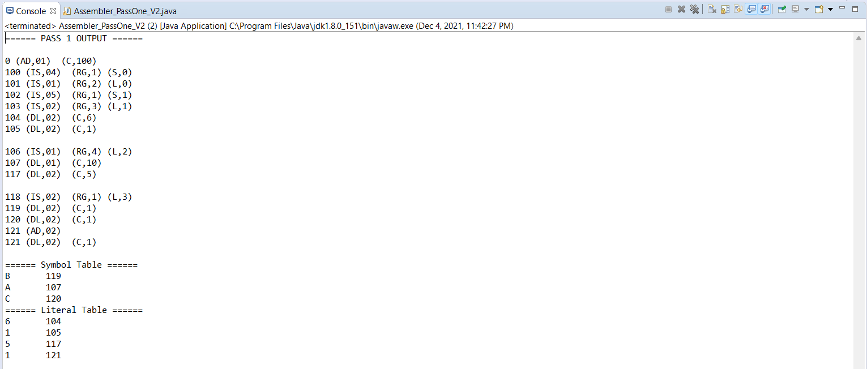

b) Pass-II =>

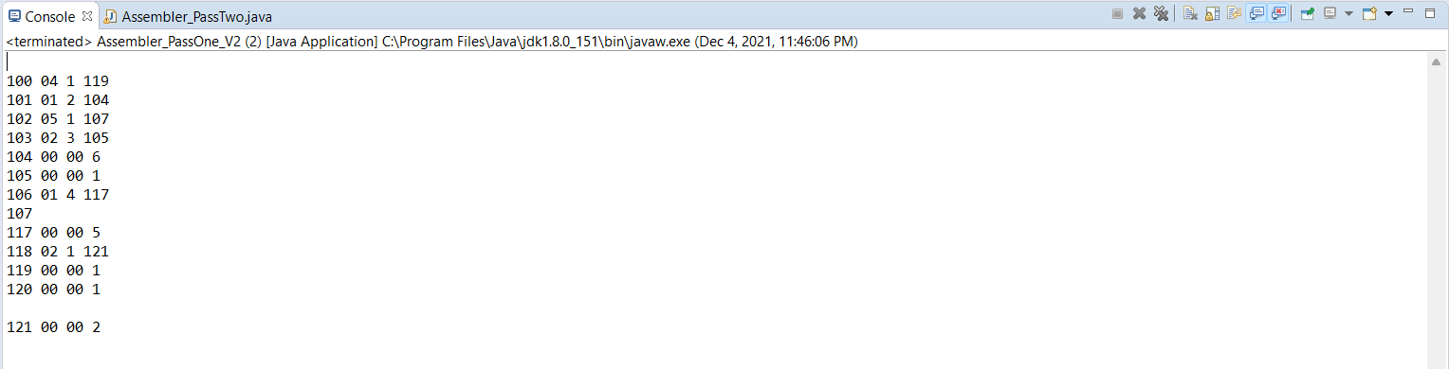

**Assignment No. A2**

**Problem Statement :-** Design suitable data structures and implement Pass-I and Pass-II of a two-pass macro-processor. The output of Pass-I (MNT, MDT and intermediate code file without any macro definitions) should be input for Pass-II.

**Solution :-**

Program :

a) Pass-I =>

package A2.A2a;

import java.io.BufferedReader;

import java.io.FileInputStream;

import java.io.FileWriter;

import java.io.InputStreamReader;

import java.io.PrintWriter;

import java.util.ArrayList;

import java.util.HashMap;

import java.util.Iterator;

import java.util.LinkedHashMap;

import java.util.List;

import java.util.Map;

import java.util.StringTokenizer;

public class MacroProcessor_PassOne {

static List<String> MDT;

static Map<String, String> MNT;

static int mntPtr, mdtPtr;

static Map<String,String> ALA;

public static void main(String[] args) {

try{

pass1();

}catch(Exception ex){

ex.printStackTrace();

}

}

static void pass1() throws Exception {

//Initiallize data structures

MDT = new ArrayList<String>();

MNT = new LinkedHashMap<String, String>();

ALA = new HashMap<String,String>();

mntPtr =0; mdtPtr = 0;

BufferedReader input = new BufferedReader(new InputStreamReader(new FileInputStream("src/A2/A2a/input.txt")));

PrintWriter out_pass1 = new PrintWriter(new FileWriter("src/A2/A2a/output_pass1.txt"), true);

PrintWriter out_mnt = new PrintWriter(new FileWriter("src/A2/A2a/MNT.txt"), true);

PrintWriter out_mdt = new PrintWriter(new FileWriter("src/A2/A2a/MDT.txt"), true);

String s;

boolean processingMacroDefinition = false;

boolean processMacroName = false;

System.out.println("============= Pass 1 Output ==============");

//Read from input file one line at a time

while((s = input.readLine()) != null) {

//For each line, separate out the tokens

String s_arr[] = tokenizeString(s," ");

//Analyze first token to check if it is a macro definition

String curToken = s_arr[0];

if(curToken.equalsIgnoreCase("MACRO")){

processingMacroDefinition = true;

processMacroName = true;

}

else if(processingMacroDefinition == true){

if(curToken.equalsIgnoreCase("MEND")){

MDT.add(mdtPtr++, s);

processingMacroDefinition = false;

continue;

}

//Insert Macro Name into MNT

if(processMacroName == true){

MNT.put(curToken, mdtPtr+"");

mntPtr++;

processMacroName = false;

processArgumentList(s_arr[1]);

MDT.add(mdtPtr,s);

mdtPtr++;

continue;

}

//Convert arguments in the definition into corresponding indexed notation

//ADD &REG,&X == ADD #2,#1

String indexedArgList = processArguments(s_arr[1]);

MDT.add(mdtPtr++, curToken + " " + indexedArgList);

}

else{

//If line is not part of a Macro definition print the line as it is in the output file

System.out.println(s);

out_pass1.println(s);

}

}

input.close();

//Print MNT

System.out.println("============= MNT ==============");

Iterator<String> itMNT = MNT.keySet().iterator();

String key, mntRow, mdtRow;

while(itMNT.hasNext()){

key = (String)itMNT.next();

mntRow = key + " " + MNT.get(key);

System.out.println(mntRow);

out_mnt.println(mntRow);

}

//Print MDT

System.out.println("============= MDT ==============");

for(int i = 0; i < MDT.size(); i++){

mdtRow = i + " " + MDT.get(i);

System.out.println(mdtRow);

out_mdt.println(mdtRow);

}

out_pass1.close();

out_mnt.close();

out_mdt.close();

}

static void processArgumentList(String argList){

StringTokenizer st = new StringTokenizer(argList, ",", false);

//For each macro definition, remove contents of the HashMap

//which are arguments from previous macro definition

ALA.clear();

int argCount = st.countTokens();

//Put all arguments for current macro definition in the HashMap

//with argument as key and argument index as value

String curArg;

for(int i=1 ; i <= argCount ; i++) {

curArg = st.nextToken();

if(curArg.contains("=")){

curArg = curArg.substring(0,curArg.indexOf("="));

}

ALA.put(curArg, "#"+i);

}

}

static String processArguments(String argList){

StringTokenizer st = new StringTokenizer(argList, ",", false);

int argCount = st.countTokens();

String curArg, argIndexed;

for(int i=0 ; i < argCount ; i++) {

curArg = st.nextToken();

argIndexed = ALA.get(curArg);

argList = argList.replaceAll(curArg, argIndexed);

}

return argList;

}

static String[] tokenizeString(String str, String separator){

StringTokenizer st = new StringTokenizer(str, separator, false);

//Construct an array of the separated tokens

String s_arr[] = new String[st.countTokens()];

for(int i=0 ; i < s_arr.length ; i++) {

s_arr[i] = st.nextToken();

}

return s_arr;

}

}

b) Pass-II =>

package A2.A2b;

import java.io.BufferedReader;

import java.io.FileInputStream;

import java.io.FileWriter;

import java.io.InputStreamReader;

import java.io.PrintWriter;

import java.util.ArrayList;

import java.util.LinkedHashMap;

import java.util.List;

import java.util.Map;

import java.util.StringTokenizer;

public class MacroProcessor_PassTwo {

static List<String> MDT;

static Map<String, String> MNT;

static int mntPtr, mdtPtr;

static List<String> formalParams, actualParams;

public static void main(String[] args) {

try{

initiallizeTables();

pass2();

}catch(Exception ex){

ex.printStackTrace();

}

}

static void pass2() throws Exception {

BufferedReader input = new BufferedReader(new InputStreamReader(new FileInputStream("src/A2/A2b/output_pass1.txt")));

PrintWriter out_pass2 = new PrintWriter(new FileWriter("src/A2/A2b/output_pass2.txt"), true);

System.out.println("============= Pass 2 Output ==============");

//Read from input file one line at a time

String s;

while((s = input.readLine()) != null) {

String s_arr[] = tokenizeString(s, " ");

//First token will either be a mnemonic or a macro call

if(MNT.containsKey(s_arr[0])){

//It is a macro call

//Create an array list of formal parameters

String actual_params[] = tokenizeString(s_arr[1], ",");

String param;

actualParams.clear();

for(int i =0; i <actual_params.length; i++){

param = actual_params[i];

if(param.contains("=")){

//If parameter specified a default value, the value will go in the list instead of param name

param = param.substring(param.indexOf("=")+1, param.length());

}

actualParams.add(param);

}

//Expand the macro call

mdtPtr = Integer.parseInt(MNT.get(s_arr[0]));

//Read macro definitaion starting from mdtPtr till MEND

String macroDef;

boolean createParamArray = true;

String def_tokens[] = {}, paramStr = "", printStr;

while(true){

//First line of macro definition is name and arglist

macroDef = MDT.get(mdtPtr);

if(createParamArray == true){

createFormalParamList(macroDef);

createParamArray = false;

}

else{

//Tokenize line of macro definition

def_tokens = tokenizeString(macroDef, " ");

//If the line is MEND, exit loop

if(def_tokens[0].equalsIgnoreCase("MEND")){

break;

}

else{

//Replace formal parameters with actual parameters

paramStr = replaceFormalParams(def_tokens[1]);

}

printStr = "+" + def_tokens[0] + " " + paramStr;

System.out.println(printStr);

out_pass2.println(printStr);

}

mdtPtr++;

}

}

else{

//It is a line of normal assembly code

//Print the line as it is in the output file

System.out.println(s);

out_pass2.println(s);

}

}

input.close();

out_pass2.close();

}

static String replaceFormalParams(String formalParamList){

String returnStr = "";

//Replace # by blank string

formalParamList = formalParamList.replace("#", "");

//Separate formal params

String param_array[] = tokenizeString(formalParamList, ",");

int index;

String actualParam;

//For every parameter in the formal parameter list

for(int i = 0; i < param_array.length; i++){

index = Integer.parseInt(param_array[i]);

if(index <= actualParams.size()){

actualParam = actualParams.get(index-1);

}

else{

actualParam = formalParams.get(index-1);

}

returnStr += actualParam + ",";

}

//Strip last comma

returnStr = returnStr.substring(0,returnStr.length() -1);

return returnStr;

}

static void createFormalParamList(String macroDef){

//By processing macro call generate array of actual parameters

String argList, arg_array[];

String s_arr[] = tokenizeString(macroDef, " ");

//First array element will be macro name and second will be argument list

argList = s_arr[1];

//Separate the arguments in the list

arg_array = tokenizeString(argList, ",");

String param;

formalParams.clear();

for(int i=0; i <arg_array.length; i++){

param = arg_array[i];

if(param.contains("=")){

//If parameter specified a default value, the value will go in the list instead of param name

param = param.substring(param.indexOf("=")+1, param.length());

}

formalParams.add(param);

}

}

static void initiallizeTables() throws Exception{

MDT = new ArrayList<String>();

MNT = new LinkedHashMap<String, String>();

formalParams = new ArrayList<String>();

actualParams = new ArrayList<String>();

//Read contents of MNT.txt and create internal data structure

BufferedReader br;

String s;

br = new BufferedReader(new InputStreamReader(new FileInputStream("src/A2/A2b/MNT.txt")));

while((s = br.readLine()) != null) {

StringTokenizer st = new StringTokenizer(s, " ", false);

MNT.put(st.nextToken(), st.nextToken());

}

br.close();

//Read contents of MDT.txt and create internal data structure

br = new BufferedReader(new InputStreamReader(new FileInputStream("src/A2/A2b/MDT.txt")));

while((s = br.readLine()) != null) {

//For each line, separate out the tokens

String s_arr[] = tokenizeString(s," ");

if(s_arr.length == 0){

continue;

}

int index = Integer.parseInt(s_arr[0]);

if(s_arr.length == 2){

MDT.add(index, s_arr[1]);

}

else if(s_arr.length == 3){

MDT.add(index, s_arr[1] + " " + s_arr[2]);

}

}

br.close();

}

static String[] tokenizeString(String str, String separator){

StringTokenizer st = new StringTokenizer(str, separator, false);

//Construct an array of the separated tokens

String s_arr[] = new String[st.countTokens()];

for(int i=0 ; i < s_arr.length ; i++) {

s_arr[i] = st.nextToken();

}

return s_arr;

}

}

Output :

a) Pass-I =>

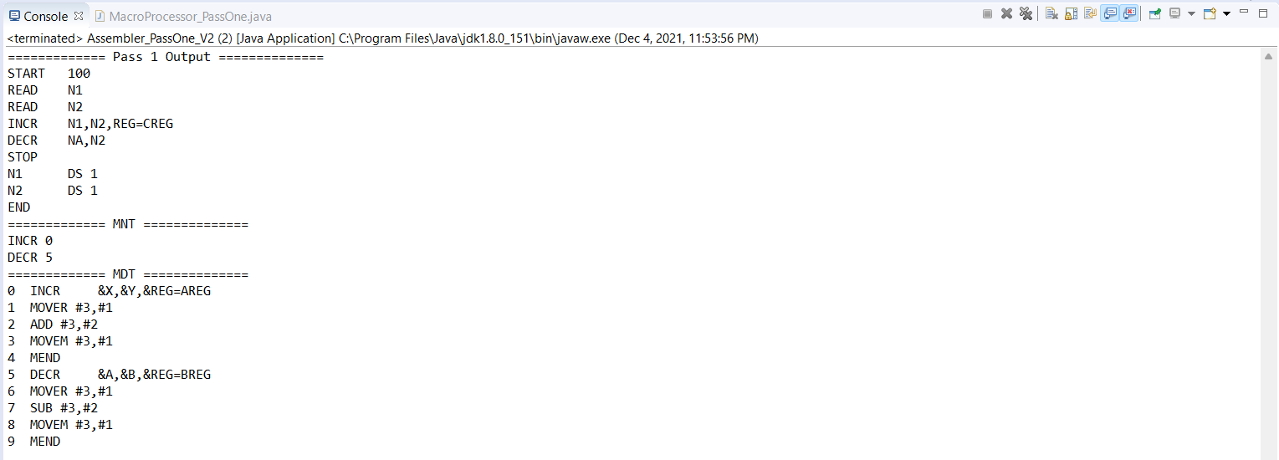

b) Pass-II =>

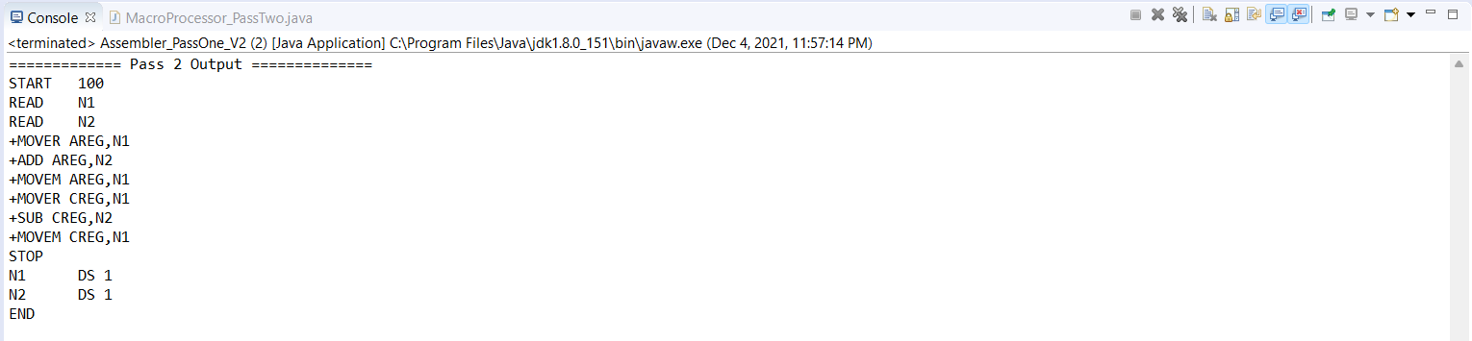

**Assignment No. B2**

**Problem Statement :-** Write a program to simulate CPU Scheduling Algorithms: FCFS, SJF (Preemptive), Priority (Non-Preemptive) and Round Robin (Preemptive).

**Solution :-**

Program :

a) FCFS =>

/* FCFS */

package B2;

import java.io.*;

import java.util.Scanner;

public class FCFS

{

public static void main(String args[])

{

int i,no_p,burst_time[],TT[],WT[];

float avg_wait=0,avg_TT=0;

burst_time=new int[50];

TT=new int[50];

WT=new int[50];

WT[0]=0;

Scanner s=new Scanner(System.in);

System.out.println("Enter the number of process: ");

no_p=s.nextInt();

System.out.println("\nEnter Burst Time for processes:");

for(i=0;i<no_p;i++)

{

System.out.print("\tP"+(i+1)+": ");

burst_time[i]=s.nextInt();

}

for(i=1;i<no_p;i++)

{

WT[i]=WT[i-1]+burst_time[i-1];

avg_wait+=WT[i];

}

avg_wait/=no_p;

for(i=0;i<no_p;i++)

{

TT[i]=WT[i]+burst_time[i];

avg_TT+=TT[i];

}

avg_TT/=no_p;

System.out.println("\n****************************************************************");

System.out.println("\tProcesses:");

System.out.println("****************************************************************");

System.out.println(" Process\tBurst Time\tWaiting Time\tTurn Around Time");

for(i=0;i<no_p;i++)

{

System.out.println("\tP"+(i+1)+"\t "+burst_time[i]+"\t\t "+WT[i]+"\t\t "+TT[i]);

}

System.out.println("\n----------------------------------------------------------------");

System.out.println("\nAverage waiting time : "+avg_wait);

System.out.println("\nAverage Turn Around time : "+avg_TT+"\n");

}

}

b) SJF (Preemptive) =>

/* SJF (Preemptive) */

package B2;

import java.util.*;

public class SJF {

public static void main (String args[])

{

Scanner sc=new Scanner(System.in);

System.out.println ("enter no of process:");

int n= sc.nextInt();

int pid[] = new int[n]; // it takes pid of process

int at[] = new int[n]; // at means arrival time

int bt[] = new int[n]; // bt means burst time

int ct[] = new int[n]; // ct means complete time

int ta[] = new int[n];// ta means turn around time

int wt[] = new int[n]; // wt means waiting time

int f[] = new int[n]; // f means it is flag it checks process is completed or not

int k[]= new int[n]; // it is also stores brust time

int i, st=0, tot=0;

float avgwt=0, avgta=0;

for (i=0;i<n;i++)

{

pid[i]= i+1;

System.out.println ("enter process " +(i+1)+ " arrival time:");

at[i]= sc.nextInt();

System.out.println("enter process " +(i+1)+ " burst time:");

bt[i]= sc.nextInt();

k[i]= bt[i];

f[i]= 0;

}

while(true){

int min=99,c=n;

if (tot==n)

break;

for ( i=0;i<n;i++)

{

if ((at[i]<=st) && (f[i]==0) && (bt[i]<min))

{

min=bt[i];

c=i;

}

}

if (c==n)

st++;

else

{

bt[c]--;

st++;

if (bt[c]==0)

{

ct[c]= st;

f[c]=1;

tot++;

}

}

}

for(i=0;i<n;i++)

{

ta[i] = ct[i] - at[i];

wt[i] = ta[i] - k[i];

avgwt+= wt[i];

avgta+= ta[i];

}

System.out.println("pid arrival burst complete turn waiting");

for(i=0;i<n;i++)

{

System.out.println(pid[i] +"\t"+ at[i]+"\t"+ k[i] +"\t"+ ct[i] +"\t"+ ta[i] +"\t"+ wt[i]);

}

System.out.println("\naverage tat is "+ (float)(avgta/n));

System.out.println("average wt is "+ (float)(avgwt/n));

sc.close();

}

}

c) Priority (Non-Preemptive) =>

/* Priority (Non-Preemptive) */

package B2;

import java.util.Scanner;

public class Priority

{

int burstTime[];

int priority[];

int arrivalTime[];

String[] processId;

int numberOfProcess;

void getProcessData(Scanner input)

{

System.out.print("Enter the number of Process for Scheduling : ");

int inputNumberOfProcess = input.nextInt();

numberOfProcess = inputNumberOfProcess;

burstTime = new int[numberOfProcess];

priority = new int[numberOfProcess];

arrivalTime = new int[numberOfProcess];

processId = new String[numberOfProcess];

String st = "P";

for (int i = 0; i < numberOfProcess; i++)

{

processId[i] = st.concat(Integer.toString(i));

System.out.print("Enter the burst time for Process - " + (i) + " : ");

burstTime[i] = input.nextInt();

System.out.print("Enter the arrival time for Process - " + (i) + " : ");

arrivalTime[i] = input.nextInt();

System.out.print("Enter the priority for Process - " + (i) + " : ");

priority[i] = input.nextInt();

}

}

void sortAccordingArrivalTimeAndPriority(int[] at, int[] bt, int[] prt, String[] pid)

{

int temp;

String stemp;

for (int i = 0; i < numberOfProcess; i++)

{

for (int j = 0; j < numberOfProcess - i - 1; j++)

{

if (at[j] > at[j + 1])

{

//swapping arrival time

temp = at[j];

at[j] = at[j + 1];

at[j + 1] = temp;

//swapping burst time

temp = bt[j];

bt[j] = bt[j + 1];

bt[j + 1] = temp;

//swapping priority

temp = prt[j];

prt[j] = prt[j + 1];

prt[j + 1] = temp;

//swapping process identity

stemp = pid[j];

pid[j] = pid[j + 1];

pid[j + 1] = stemp;

}

//sorting according to priority when arrival timings are same

if (at[j] == at[j + 1])

{

if (prt[j] > prt[j + 1])

{

//swapping arrival time

temp = at[j];

at[j] = at[j + 1];

at[j + 1] = temp;

//swapping burst time

temp = bt[j];

bt[j] = bt[j + 1];

bt[j + 1] = temp;

//swapping priority

temp = prt[j];

prt[j] = prt[j + 1];

prt[j + 1] = temp;

//swapping process identity

stemp = pid[j];

pid[j] = pid[j + 1];

pid[j + 1] = stemp;

}

}

}

}

}

void priorityNonPreemptiveAlgorithm()

{

int finishTime[] = new int[numberOfProcess];

int bt[] = burstTime.clone();

int at[] = arrivalTime.clone();

int prt[] = priority.clone();

String pid[] = processId.clone();

int waitingTime[] = new int[numberOfProcess];

int turnAroundTime[] = new int[numberOfProcess];

sortAccordingArrivalTimeAndPriority(at, bt, prt, pid);

//calculating waiting & turn-around time for each process

finishTime[0] = at[0] + bt[0];

turnAroundTime[0] = finishTime[0] - at[0];

waitingTime[0] = turnAroundTime[0] - bt[0];

for (int i = 1; i < numberOfProcess; i++)

{

finishTime[i] = bt[i] + finishTime[i - 1];

turnAroundTime[i] = finishTime[i] - at[i];

waitingTime[i] = turnAroundTime[i] - bt[i];

}

float sum = 0;

for (int n : waitingTime)

{

sum += n;

}

float averageWaitingTime = sum / numberOfProcess;

sum = 0;

for (int n : turnAroundTime)

{

sum += n;

}

float averageTurnAroundTime = sum / numberOfProcess;

//print on console the order of processes along with their finish time & turn around time

System.out.println("Priority Scheduling Algorithm : ");

System.out.format("%20s%20s%20s%20s%20s%20s%20s\n", "ProcessId", "BurstTime", "ArrivalTime", "Priority", "FinishTime", "WaitingTime", "TurnAroundTime");

for (int i = 0; i < numberOfProcess; i++) {

System.out.format("%20s%20d%20d%20d%20d%20d%20d\n", pid[i], bt[i], at[i], prt[i], finishTime[i], waitingTime[i], turnAroundTime[i]);

}

System.out.format("%100s%20f%20f\n", "Average", averageWaitingTime, averageTurnAroundTime);

}

public static void main(String[] args)

{

Scanner input = new Scanner(System.in);

Priority obj = new Priority();

obj.getProcessData(input);

obj.priorityNonPreemptiveAlgorithm();

}

}

d) Round Robin (Preemptive) =>

/* Round Robin (Preemptive) */

package B2;

import java.util.*;

public class RoundRobin{

private static Scanner inp = new Scanner(System.in);

//Driver Code

public static void main(String[] args){

int n,tq, timer = 0, maxProccessIndex = 0;

float avgWait = 0, avgTT = 0;

System.out.print("\nEnter the time quanta : ");

tq = inp.nextInt();

System.out.print("\nEnter the number of processess : ");

n = inp.nextInt();

int arrival[] = new int[n];

int burst[] = new int[n];

int wait[] = new int[n];

int turn[] = new int[n];

int queue[] = new int[n];

int temp_burst[] = new int[n];

boolean complete[] = new boolean[n];

System.out.print("\nEnter the arrival time of the processess : ");

for(int i = 0; i < n; i++)

arrival[i] = inp.nextInt();

System.out.print("\nEnter the burst time of the processess : ");

for(int i = 0; i < n; i++){

burst[i] = inp.nextInt();

temp_burst[i] = burst[i];

}

for(int i = 0; i < n; i++){ //Initializing the queue and complete array

complete[i] = false;

queue[i] = 0;

}

while(timer < arrival[0]) //Incrementing Timer until the first process arrives

timer++;

queue[0] = 1;

while(true){

boolean flag = true;

for(int i = 0; i < n; i++){

if(temp_burst[i] != 0){

flag = false;

break;

}

}

if(flag)

break;

for(int i = 0; (i < n) && (queue[i] != 0); i++){

int ctr = 0;

while((ctr < tq) && (temp_burst[queue[0]-1] > 0)){

temp_burst[queue[0]-1] -= 1;

timer += 1;

ctr++;

//Updating the ready queue until all the processes arrive

checkNewArrival(timer, arrival, n, maxProccessIndex, queue);

}

if((temp_burst[queue[0]-1] == 0) && (complete[queue[0]-1] == false)){

turn[queue[0]-1] = timer; //turn currently stores exit times

complete[queue[0]-1] = true;

}

//checks whether or not CPU is idle

boolean idle = true;

if(queue[n-1] == 0){

for(int k = 0; k < n && queue[k] != 0; k++){

if(complete[queue[k]-1] == false){

idle = false;

}

}

}

else

idle = false;

if(idle){

timer++;

checkNewArrival(timer, arrival, n, maxProccessIndex, queue);

}

//Maintaining the entries of processes after each preemption in the ready Queue

queueMaintainence(queue,n);

}

}

for(int i = 0; i < n; i++){

turn[i] = turn[i] - arrival[i];

wait[i] = turn[i] - burst[i];

}

System.out.print("\nProgram No.\tArrival Time\tBurst Time\tWait Time\tTurnAround Time"

+ "\n");

for(int i = 0; i < n; i++){

System.out.print(i+1+"\t\t"+arrival[i]+"\t\t"+burst[i]

+"\t\t"+wait[i]+"\t\t"+turn[i]+ "\n");

}

for(int i =0; i< n; i++){

avgWait += wait[i];

avgTT += turn[i];

}

System.out.print("\nAverage wait time : "+(avgWait/n)

+"\nAverage Turn Around Time : "+(avgTT/n));

}

public static void queueUpdation(int queue[],int timer,int arrival[],int n, int maxProccessIndex){

int zeroIndex = -1;

for(int i = 0; i < n; i++){

if(queue[i] == 0){

zeroIndex = i;

break;

}

}

if(zeroIndex == -1)

return;

queue[zeroIndex] = maxProccessIndex + 1;

}

public static void checkNewArrival(int timer, int arrival[], int n, int maxProccessIndex,int queue[]){

if(timer <= arrival[n-1]){

boolean newArrival = false;

for(int j = (maxProccessIndex+1); j < n; j++){

if(arrival[j] <= timer){

if(maxProccessIndex < j){

maxProccessIndex = j;

newArrival = true;

}

}

}

if(newArrival) //adds the index of the arriving process(if any)

queueUpdation(queue,timer,arrival,n, maxProccessIndex);

}

}

public static void queueMaintainence(int queue[], int n){

for(int i = 0; (i < n-1) && (queue[i+1] != 0) ; i++){

int temp = queue[i];

queue[i] = queue[i+1];

queue[i+1] = temp;

}

}

}

Output :

a) FCFS =>

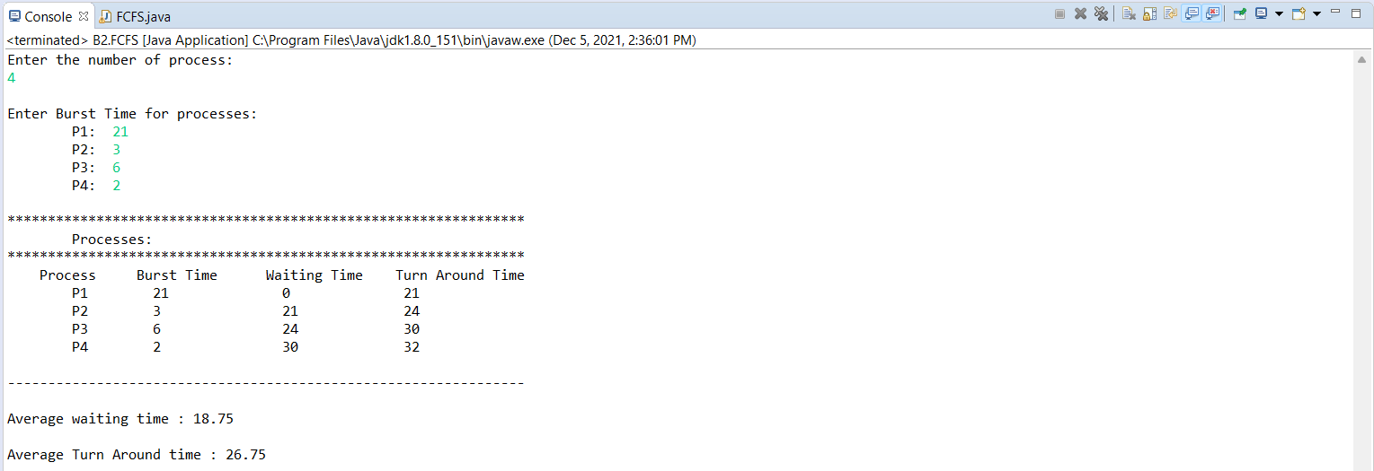

b) SJF (Preemptive) =>

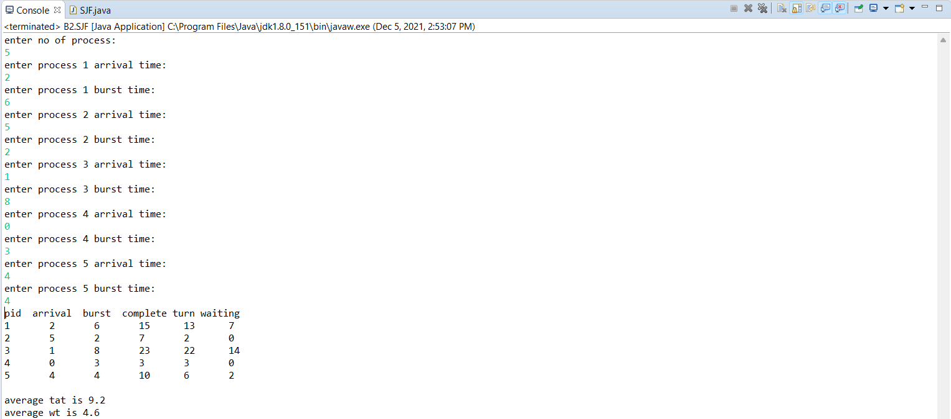

c) Priority (Non-Preemptive) =>

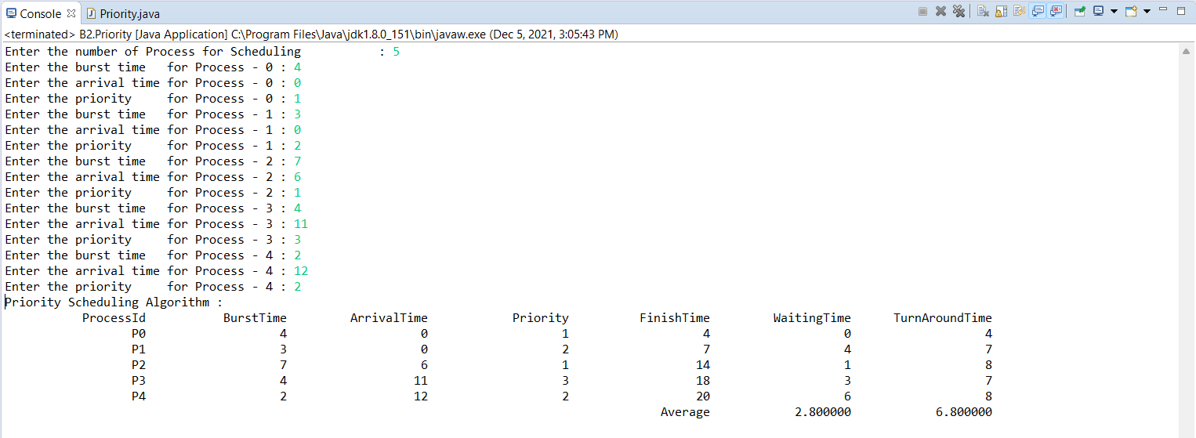

d) Round Robin (Preemptive) =>

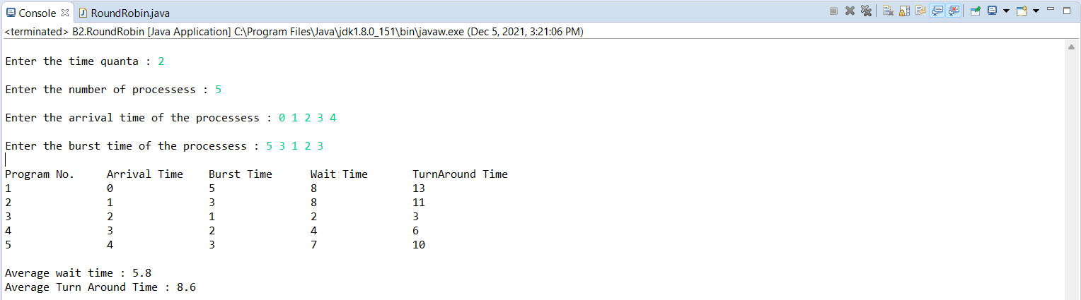

**Assignment No. B3**

**Problem Statement :-** Write a program to simulate Memory placement strategies – best fit, first fit, next fit and worst fit.

**Solution :-**

Program :

/* Memory Placement Strategies */

package B3;

import java.util.Arrays;

class First

{

// Method to allocate memory to

// blocks as per First fit algorithm

static void firstFit(int blockSize[], int m,

int processSize[], int n)

{

// Stores block id of the

// block allocated to a process

int allocation[] = new int[n];

// Initially no block is assigned to any process

for (int i = 0; i < allocation.length; i++)

allocation[i] = -1;

// pick each process and find suitable blocks

// according to its size ad assign to it

for (int i = 0; i < n; i++)

{

for (int j = 0; j < m; j++)

{

if (blockSize[j] >= processSize[i])

{

// allocate block j to p[i] process

allocation[i] = j;

// Reduce available memory in this block.

blockSize[j] -= processSize[i];

break;

}

}

}

System.out.println("\nProcess No.\tProcess Size\tBlock no.");

for (int i = 0; i < n; i++)

{

System.out.print(" " + (i+1) + "\t\t" +

processSize[i] + "\t\t");

if (allocation[i] != -1)

System.out.print(allocation[i] + 1);

else

System.out.print("Not Allocated");

System.out.println();

}

}

static void bestFit(int blockSize[], int m, int processSize[],

int n)

{

// Stores block id of the block allocated to a

// process

int allocation[] = new int[n];

// Initially no block is assigned to any process

for (int i = 0; i < allocation.length; i++)

allocation[i] = -1;

// pick each process and find suitable blocks

// according to its size ad assign to it

for (int i=0; i<n; i++)

{

// Find the best fit block for current process

int bestIdx = -1;

for (int j=0; j<m; j++)

{

if (blockSize[j] >= processSize[i])

{

if (bestIdx == -1)

bestIdx = j;

else if (blockSize[bestIdx] > blockSize[j])

bestIdx = j;

}

}

// If we could find a block for current process

if (bestIdx != -1)

{

// allocate block j to p[i] process

allocation[i] = bestIdx;

// Reduce available memory in this block.

blockSize[bestIdx] -= processSize[i];

}

}

System.out.println("\nProcess No.\tProcess Size\tBlock no.");

for (int i = 0; i < n; i++)

{

System.out.print(" " + (i+1) + "\t\t" + processSize[i] + "\t\t");

if (allocation[i] != -1)

System.out.print(allocation[i] + 1);

else

System.out.print("Not Allocated");

System.out.println();

}

}

static void worstFit(int blockSize[], int m, int processSize[],

int n)

{

// Stores block id of the block allocated to a

// process

int allocation[] = new int[n];

// Initially no block is assigned to any process

for (int i = 0; i < allocation.length; i++)

allocation[i] = -1;

// pick each process and find suitable blocks

// according to its size ad assign to it

for (int i=0; i<n; i++)

{

// Find the best fit block for current process

int wstIdx = -1;

for (int j=0; j<m; j++)

{

if (blockSize[j] >= processSize[i])

{

if (wstIdx == -1)

wstIdx = j;

else if (blockSize[wstIdx] < blockSize[j])

wstIdx = j;

}

}

// If we could find a block for current process

if (wstIdx != -1)

{

// allocate block j to p[i] process

allocation[i] = wstIdx;

// Reduce available memory in this block.

blockSize[wstIdx] -= processSize[i];

}

}

System.out.println("\nProcess No.\tProcess Size\tBlock no.");

for (int i = 0; i < n; i++)

{

System.out.print(" " + (i+1) + "\t\t" + processSize[i] + "\t\t");

if (allocation[i] != -1)

System.out.print(allocation[i] + 1);

else

System.out.print("Not Allocated");

System.out.println();

}

}

static void NextFit(int blockSize1[], int m1, int processSize1[], int n1) {

// Stores block id of the block allocated to a

// process

int allocation[] = new int[n1], j = 0;

// Initially no block is assigned to any process

Arrays.fill(allocation, -1);

// pick each process and find suitable blocks

// according to its size ad assign to it

for (int i = 0; i < n1; i++) {

// Do not start from beginning

int count = 0;

while (j < m1) {

count++; //makes sure that for every process we traverse through entire array maximum once only.This avoids the problem of going into infinite loop if memory is not available

if (blockSize1[j] >= processSize1[i]) {

// allocate block j to p[i] process

allocation[i] = j;

// Reduce available memory in this block.

blockSize1[j] -= processSize1[i];

break;

}

// mod m will help in traversing the blocks from

// starting block after we reach the end.

j = (j + 1) % m1;

}

}

System.out.print("\nProcess No.\tProcess Size\tBlock no.\n");

for (int i = 0; i < n1; i++) {

System.out.print( i + 1 + "\t\t" + processSize1[i]

+ "\t\t");

if (allocation[i] != -1) {

System.out.print(allocation[i] + 1);

} else {

System.out.print("Not Allocated");

}

System.out.println("");

}

}

// Driver Code

public static void main(String[] args)

{

System.out.println("....First Fit....");

int blockSize[] = {100, 500, 200, 300, 600};

int processSize[] = {212, 417, 112, 426};

int m = blockSize.length;

int n = processSize.length;

firstFit(blockSize, m, processSize, n);

System.out.println(" ");

System.out.println("....Best Fit....");

bestFit(blockSize, m, processSize, n);

System.out.println(" ");

System.out.println("....Worst Fit....");

worstFit(blockSize, m, processSize, n);

System.out.println(" ");

System.out.println("....Next Fit....");

int blockSize1[] = {5, 10, 20};

int processSize1[] = {10, 20, 5};

int m1 = blockSize1.length;

int n1 = processSize1.length;

NextFit(blockSize1, m1, processSize1, n1);

}

}

Output :

