**A PROJECT REPORT ON**

# “E MITRA (Educator’s Metadata Indexing and Transfer Request Automation)”

SUBMITTED TO THE SAVITRIBAI PHULE PUNE UNIVERSITY, PUNE IN THE PARTIAL FULFILLMENT OF THE REQUIREMENTS

FOR THE AWARD OF THE DEGREE OF

## BACHELOR OF ENGINEERING (COMPUTER ENGINEERING)

**SUBMITTED BY**

Aaryan Patil 72036793L

Kavita Sahu 72036864C

Ojus Jaiswal 72036776L



## DEPARTMENT OF COMPUTER ENGINEERING

**DR. D. Y. PATIL INSTITUTE OF ENGINEERING, MANAGEMENT & RESEARCH**

AKURDI, PUNE 411044

**SAVITRIBAI PHULE PUNE UNIVERSITY 2022 -2023**

# CERTIFICATE

This is to certify that the project report entitles

## “E MITRA (Educator’s Metadata Indexing and Transfer Request Automation)”

Submitted by

Aaryan Patil 72036793L

Kavita Sahu 72036864C

Ojus Jaiswal 72036776L

are bonafide students of this institute and the work has been carried out by him/her under the supervision of **Mrs. Ketaki Bhoyar** and it is approved for the partial fulfillment of the requirement of Savitribai Phule Pune University, for the award of the degree of **Bachelor of Engineering** (Computer Engineering).

## Mrs. Ketaki Bhoyar Prof. P. P. Shevatekar

Guide Head of the Department

Computer Engineering Computer Engineering

## Dr. Anupama V. Patil

Principal,

Dr. D. Y. Patil Institute of Engineering, Management & Research Akurdi Pune – 41

Place : Pune Date :

External Examiner’s Name:

Sign:

# ACKNOWLEDGEMENT

This is a great pleasure and immense satisfaction to express our deepest sense of gratitude and thanks to everyone who has directly or indirectly helped us in completing our project work successfully.

We express my gratitude towards Project Guide **Mrs. Ketaki Bhoyar** and **Mrs. P. P. Shevatekar**, Head of Department of Computer Engineering, Dr. D Y Patil Institute of Engineering, Management and Research, Akurdi who guided and encouraged us in completing the seminar work in scheduled time. We would like to thanks our Principal Dr. A. V. Patil, for allowing us to pursue our project in this institute.

Finally, we would like to thank our friends who have directly or indirectly helped us in our project work.

Aaryan Patil 72036793L

Kavita Sahu 72036864C

Ojus Jaiswal 72036776L

(B.E. COMPUTER ENG.)

# ABSTRACT

Right Now there is no such portal that provides a single-stop platform for the government to manage all the teachers under their employment. Thereby this project proposes a portal that will be capable of helping the Institutes make the entire process of resource management more streamlined and hence, transparent. Along with resource management, it also provides a web for the teachers to engage with schemes of the government, receive official government notifications directly regarding teaching, and manage their own profiles. From Recruitment to Retirement along with service book handling the portal satisfies all the needs with three user interfaces specifically 'teacher', 'admin', and 'Institute' having separate login and permissions for Admin (Govt.), Schools/Institutes, and Teachers themselves. This project uses the latest technologies such as MERN stack, java, and machine learning to accomplish the objective of providing a completely automated Teacher Recruitment and management portal E MITRA.

# TABLE OF CONTENTS

LIST OF ABBREVATIONS i

LIST OF FIGURES ii

**CHAPTER TITLE PAGE NO.**

|  |  |  |  |
| --- | --- | --- | --- |
| Sr.No. | Title of Chapter | | Page No. |
| 01 | **Introduction** | | 9 |
| 1.1 | Overview | | 9 |
| 1.2 | Motivation | | 9 |
| 1.3 | Problem Definition and Objectives | | 9 |
| 1.4 | Project Scope & Limitations | | 9 |
| 1.5 | Methodologies of Problem solving | | 10 |
| 02 | **Literature Survey** | | 13 |
| 03 | **Software Requirements Specification** | | 15 |
| 3.1 | Assumptions and Dependencies | | 15 |
| 3.2 | Functional Requirements | | 15 |
| 3.3 | External Interface Requirements (If Any) | | 15 |
|  | 3.3.1 | User Interfaces | 15 |
|  | 3.3.2 | Hardware Interfaces | 15 |
|  | 3.3.3 | Software Interfaces | 15 |
|  | 3.3.4 | Communication Interfaces | 16 |
| 3.4 | Nonfunctional Requirements | | 16 |
|  | 3.4.1 | Performance Requirements | 16 |
|  | 3.4.2 | Safety Requirements | 16 |
|  | 3.4.3 | Security Requirements | 16 |
|  | 3.4.4 | Software Quality Attributes | 16 |
| 3.5 | **System Requirements** | | 17 |
|  | 3.5.1 | Database Requirements | 17 |
|  | 3.5.2 | Software Requirements(Platform Choice) | 17 |
|  | 5.5.3 | Hardware Requirements | 17 |
| 3.6 | **Analysis Models: SDLC Model to be applied** | | 18 |
| 04 | **System Design** | | 19 |
| 4.1 | System Architecture | | 19 |
| 4.2 | UML Diagrams | | 21 |
| 05 | **Other Specification** | | 23 |
| 5.1 | Advantages | | 23 |
| 5.2 | Limitations | | 23 |
| 5.3 | Applications | | 23 |

|  |  |  |
| --- | --- | --- |
| 06 | **Project Implementation** | 25 |
| 6.1 | Tools and Technologies Used | 25 |
| 6.2 | Algorithm Details | 25 |
| 07 | **Software Testing** | 27 |
| 7.1 | Type of testing | 27 |
| 7.2 | Test Cases and Test Results | 31 |
| 08 | **Results** | 33 |
| 8.1 | Outcomes | 33 |
| 09 | **Conclusions & Future Work** | 34 |
|  | **Appendix A:** Details of the papers referred in IEEE format | 35 |
| **Appendix B:** Plagiarism Report | 37 |

# LIST OF ABBREVIATIONS

|  |  |
| --- | --- |
| **ABBREVIATION** | **ILLUSTRATION** |
| HTTP  MQTT | HyperText Transfer Protocol  Message Query Telemetry Transport |
|  |  |
|  |  |
|  |  |
|  |  |

**LIST OF FIGURES**

|  |  |  |
| --- | --- | --- |
| **FIGURE** | **ILLUSTRATION** | **PAGE NO.** |

|  |  |  |
| --- | --- | --- |
| 1 | **Waterfall Model** | 18 |
| 2 | **System Architecture** | 19 |
| 3 | **Use case Diagram** | 21 |
| 4 | **State Chart Diagram** | 21 |
| 5 | **Activity Diagram** | 22 |

# INTRODUCTION

**1.1. OVERVIEW**

Right Now there is no such portal that provides a single-stop platform for the government to manage all the teachers under their employment.

Thereby this project proposes a portal that will be capable of helping the Institutes make the entire process of resource management more streamlined and hence, transparent.

**1.2. MOTIVATION**

To provide a single-stop platform for the government to manage all the teachers under their employment from recruitment to retirement along with providing a portal for the teachers to engage with certain schemes of the government, receive official government notifications regarding teaching, and manage their own profile such as service book.

**1.3. PROBLEM DEFINITION**

Every year through the government exams plenty of teachers are hired and posted in various government schools. The tracking of teachers from recruitment to their entire service duration is done manually which makes it difficult to manage and keep track. Addressing this problem will give the government the ease of managing teachers through one single portal which will help in maintaining clear stats of the teachers currently posted.

**1.4. LIMITATIONS**

* Users must have knowledge of English.
* Users must have all required software to run the application.
* It requires internet connection.
* The max operator has at least two disadvantages. Firstly, it is only suitable for the instance-level approaches that require an instance classiﬁer.

**1.5. METHODOLOGIES OF PROBLEM-SOLVING**

For teachers:

In the teacher portal, each teacher can access their record and profile where he/she can manage their attendance, leaves, and calendar. Also, he can apply for transfer using his/her own portal which ensures transparency and accountability. Also to keep the teacher updated we have provided a news tab where he/she can get news according to their interests. Analysis and future prediction of the institute’s performance based on their filters and choices. By using the feedback and past dataset we will be analyzing the data and will be providing visualization tools to analyze the past and present performance of an institute. Using Machine learning algorithms like neural networks and sentiment analysis we will be providing predictions of an institute in a particular field so that it becomes easy for teachers to filter their choices to opt for better and desired options.

For institute:

The same is for the institute portal but in addition to the features of the teacher portal we have a staff tab that shows the detail of the staff in the institute and its details such as no. of playground,date of estd, etc using this we can manage the staff and in addition institute can request for teachers to the admin or govt.

Ratings of teachers for the required course and performance score of the teacher in that course.

If there are hundreds of applications for a specific position then it becomes quite a hectic job for the institute to analyze them or to call them for further screening. To overcome this we are providing ratings to teachers by analyzing their profiles using data science, based on which institutes can sort the creamy layer and can call for screening to only those who are suitable for the specific role.

For Government:

Now comes the Admin portal, which controls both the teacher and institute, using admin portal govt can manage teachers as well as institute centrally from the single unified portal using it we can manage teachers working for the govt their performances, their records etc and same for the institute. In addition to all this we have provided ML models to visualize the teacher’s performance as well as we can rate them also and we can also visualize staff by age, and category in order to acquire new teachers in place of retired teachers and teachers of upcoming technologies. To keep track of the performance of teachers and institutes to help in the decision-making process. On the government portal, we are merging the rating score of teachers and institutes based on profiles as discussed above so that it becomes easy for the government to keep track of the performance of both teachers and institutes.

Technology Trends:

Teachers and institutes will be able to know which upcoming technologies that will gain a new height in the future.

By using the technology of text and sentiment analysis we are analyzing the key technologies that may gain new heights in the future and will be displaying information about them on the dashboard of institutes and teachers so that it will be easy for teachers to learn a new course and for institute to redesign their curriculum to give space to new technologies.

Machine Learning :

Python libraries used:

Pandas: for generating data frames and data preprocessing.

Numpy: for numeric data preprocessing.

Sklearn: for multiple purposes including data splitting, model training, evaluation metrics

Seaborn: for data visualization.

To automate the process of shortlisting and selection of teachers at various institutes during recruitment and transfer acceptance machine learning algorithms provide the key. By using the available data on the portal and by analyzing various relevant parameters, data preprocessing and visualization are performed to study the data. Since the parameters(variables) formed a linear and continuous relationship the machine learning Multiple Linear Regression algorithm proves to give the best accuracy of 95% when trained over sufficient data.

In this algorithm, there are several independent variables and a single dependent variable. The independent variables here are academics i.e points based on educational qualification, experience i.e points based on previous work experience, achievement i.e points for technical/non-technical relevant achievement, previous rating i.e rating provided by the previous institute based on various aspects such as discipline, punctuality, etc.

The dependent variable is the final rating, a floating value (in the range of 0 to 10) among the applied candidates. The data is split in the ratio of 7:3 for training and testing i.e 70% of the data is used for training purposes and the remaining 30% is used for testing of the algorithm. The training data is then trained and the coordinates are generated. Once the model is trained the sample data is tested and the model is evaluated. Further, the model is deployed on the web using a Python pickle file.

Interactive Dashboards:

Interactive dashboards are provided to analyze and visualize data regarding

1) Vacancies like post vacancy, district vacancy, category vacancy, domain vacancy, etc.

2) Teacher data like the number of teachers in the district, experience, category, qualifications, number of transfer requests, etc.

The dashboard is built using python plotly and using Dash by providing a connection to the database used for live updates. Various visualization tools are used to customize and make the analysis easy. Tools like Bar graphs, pie charts, histograms, etc.

# LITERATURE SURVEY

|  |  |  |  |  |
| --- | --- | --- | --- | --- |
| **Sr.**  **No** | **Paper Title** | **Journal Name** | **Authors &**  **Publication Date** | **Methodology** |
| 1 | Predicting the performance of instructors using Machine learning algorithms | IEEE | Panimalar Kathiroli,  Vijaylakshmi v.  December 2020 | * This paper concentrates on predicting the teacher's performance and explores the factors influencing student accomplishment. * In this paper, some of the machine learning algorithms were utilized such as Naïve Bayes, K-Nearest Neighbor, Random Forest, Support Vector Machine, and Decision Tree. |
| 2 | Design of Distance Assistance System for Intelligent Education by Web-based Applications | Springer | Chao Yang,  Jerry Chun-Wei Lin.  9 February 2022 | * In order to improve the quality of distance education and solve the problem of slow data processing of the teaching system, an intelligent distance education assistance system based on WEB is developed in this paper. * The auxiliary system designed in this paper can provide a stable and efficient application environment for distance education. |
| 3 | Integrating Artificial Intelligence in Teacher Management Systems | IEEE | Smith, J., Johnson, L., Thompson, R. 2022 | * This paper presents an intelligent web-based system for distance education assistance, aiming to enhance the quality of distance education and address the issue of slow data processing in the teaching system. |
| 4 | Teacher Recommendation Systems: Personalized Approaches for Professional Development | IEEE | Kim, E., Park, S., Lee, J.  2021 | * This paper focuses on the management of teacher databases, profile administration, and forecasting teacher performance. |
| 5 | Machine Learning Techniques for Teacher Performance Prediction | IEEE | Gupta, A., Sharma, R., Kumar, S. 2020 | * This manuscript centers on the management and organization of teacher databases, profile administration, and the anticipation of teacher performance. * The core objective of this paper is to delve into the meticulous management of teacher databases, the administration of profiles, and the prognostication of teacher performance. |

# 3. SOFTWARE REQUIREMENT SPECIFICATION

## 3.1. ASSUMPTIONS AND DEPENDENCIES

* Users must have knowledge of web-based applications.
* Users must have knowledge of English.
* Users must have all the required software to run the application.

## 3.2. FUNCTIONAL REQUIREMENTS

* It will help in better management of teacher data.
* Performance of the functions and every module must be well. The overall performance of the software will enable the users to work efficiently.
* The application is designed in modules where errors can be detected and fixed easily. This makes it easier to install and update new functionality if required.
* User information can only be viewed by the user himself/herself.

## 3.3. EXTERNAL INTERFACE REQUIREMENTS

**3.3.1. USER INTERFACES**

The requirements section of hardware includes a minimum of 180 GB hard disk and 4 GB RAM with 2 GHz or higher speed.

**3.3.2. HARDWARE INTERFACE**

As this is an online application portal we are not enabling or installing any hardware components for the user interface.

It’s not an embedded system

* + - Processor - Pentium IV 2.4 GHZ
    - Speed - 1.5 Ghz and Above
    - RAM - 4 GB (min)
    - Hard Disk - 220 GB
    - Key Board - Standard Windows Keyboard
    - Mouse - Two or Three Button Mouse
    1. **SOFTWARE INTERFACES**

## FRONT END: MERN stack, Python.

## BACK END: MERN stack, Java, Python.

* + 1. **COMMUNICATION INTERFACE**

Users can access the web application from a remote location.

Standard internet connection is required.

TCP/UDP connection will be required.

## 3.4. NONFUNCTIONAL REQUIREMENTS:

**3.4.1. PERFORMANCE REQUIEMENTS**

High Speed:

System should process requested tasks in parallel for various actions to give a quick response. Then the system must wait for process completion.

Accuracy:

System should correctly execute the process, display the result accurately. System output should be in user required format.

**3.4.2. SAFETY REQUIREMENTS**

The data safety must be ensured by arranging for a secure and reliable transmission media. The source and destination information must be entered correctly to avoid any misuse or malfunctioning. Passwords generated by the user consist of characters, special characters & numbers so that password is difficult to hack. So, that user account is safe.

**3.4.3. SECURITY REQUIREMENTS**

Secure access of confidential data (user’s details).

Information security means protecting information and information systems from unauthorized access, use, disclosure, disruption, modification or destruction.

The terms information security, computer security and information assurance are frequently incorrectly used interchangeably. These fields are interrelated often and share the common goals of protecting the confidentiality, integrity and availability of information; however, there are some subtle differences between them.

User password must be stored in encrypted form for the security reason

All the user details shall be accessible to only high authority persons.

Access will be controlled with usernames and passwords.

**3.4.4. SOFTWARE QUALITY ATTRIBUTE:**

* Availability [related to Reliability]
* Modifiability [includes portability, reusability, scalability]
* Performance
* Security
* Testability
* Usability [includes self-adaptability and user adaptability]

## 3.5. SYSTEM REQUIREMENTS

**3.5.1. DATABASE REQUIREMENTS**

MySQL : MySQL is an open-source relational database management system (RDBMS). Its name is a combination of "My", the name of co-founder Michael Widenius's daughter, and "SQL", the abbreviation for Structured Query Language.

MySQL is free and open-source software under the terms of the GNU General Public License, and is also available under a variety of proprietary licenses. MySQL was owned and sponsored by the Swedish company MySQL AB, which was bought by Sun Microsystems (now Oracle Corporation). In 2010, when Oracle acquired Sun, Widenius forked the open-source MySQL project to create MariaDB.

MySQL is a component of the LAMP web application software stack (and others), which is an acronym for Linux, Apache, MySQL, Perl/PHP/Python. MySQL is used by many database-driven web applications, including Drupal, Joomla, phpBB, and WordPress. MySQL is also used by many popular websites, including Facebook, Flickr, MediaWiki, Twitter, and YouTube.

* + 1. **SOFTWARE REQUIREMENTS**

Operating system : Windows 7 and above.

Coding Language : Python, Java, React JS

IDE : Sublimetext3 Pycharm

* + 1. **HARDWARE REQUIREMENTS**

System :         Intel I3 Processor and above.

Hard Disk           : 200 GB.

Monitor : 15 VGA Color.

Ram : 4 GB.

## 3.6. ANALYSIS MODELS: SDLC MODEL TO BE APPLIED

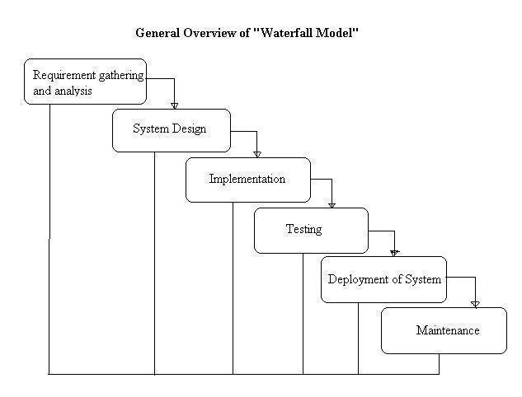

The waterfall model is a traditional software development approach that follows a linear and sequential process. It is named after the cascading flow of activities from one phase to another, much like a waterfall. The model consists of several distinct phases that are executed one after the other without any overlapping or iteration.

**4. SYSTEM DESIGN**

In this system design phase we design the system which is easily understood for the end user i.e. user friendly.

We design some UML diagrams and data flow diagrams to understand the system flow and system module and sequence of execution.

## SYSTEM ARCHITECTURE

## 

This is the architectural system of our project which consists of mainly 3 entities: Admin, Teacher, Institute.Every year, a large number of teachers join the country’s teaching force, to collectively make the future of the country. Teachers join the workforce on different levels, to teach different subjects, with different skills, different preferences, different goals, and different aspirations as to how they want to shape the country’s future.

Till now, the management of the teacher’s, their institutions, and their work was done manually. With technology not only entering every single aspect of our lives, but also shaping it, it is just obviously simple that the management of teacher’s careers should also be boosted and streamlined by technology. A lot of state governments are already progressing in this field, taking their management of teacher’s online, and are seeing positive results.

That brings us to our problem statement, which demands a management platform for the teaching resources of the government of Maharashtra. We as a group, decided to provide a platform that provides

Login and permissions for Admin (Govt.), Schools/Institutes, and Teachers themselves.

A DASHBOARD such that the govt. can see all of their teachers and teaching resources at once, and manage them better.

The institutes can manage, upload and update all the data on their teachers on the portal, create requests, raise queries to the govt., and give/receive feedback.

Teachers will be given unique IDs, for better management of their skills, expertise, needs, qualifications and can apply for transfers and/or update their profiles.

## UML DIAGRAMS

* + 1. USE CASE DIAGRAM

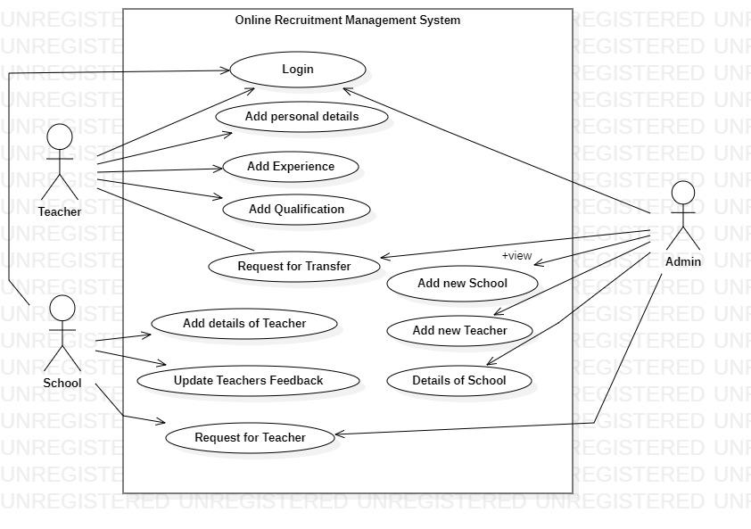

## STATE CHART DIAGRAM

## 

## ACTIVITY DIAGRAM

## 

# 5. OTHER SPECIFICATION

## 5.1 ADVANTAGES

* Better Management of Teacher Data
* Effective prediction technique
* Provide Deeper Insights to Management
* Secure and efficient system.
* Cost efficient.

## 5.2 LIMITATIONS

* Users must have knowledge of English.
* Users must have all required software to run the application.
* It requires internet connection.

## 5.3 APPLICATIONS

Staff Information Management: A teacher management system helps schools and colleges maintain comprehensive records of their teaching staff. It includes personal details, contact information, educational qualifications, work experience, training records, and other relevant information.  
  
Attendance and Leave Management: The system allows teachers to mark their attendance and manage their leaves electronically. It provides a centralized platform for teachers to apply for leaves, track their leave balances, and receive approvals from the administration.  
  
Performance Evaluation and Feedback: A teacher management system facilitates performance evaluation processes by providing a platform for administrators to conduct assessments, collect feedback from students and colleagues, and generate performance reports. It streamlines the review process and helps identify areas for improvement and recognition.

Data Analysis and Reporting: These systems provide data analytics and reporting capabilities, allowing administrators to analyze teacher performance, student outcomes, and other relevant metrics. Data-driven insights can help in decision-making, resource allocation, and policy formulation.

# 6. PROJECT IMPLEMENTATION

## OVERVIEW OF PROJECT MODULES

## TOOLS AND TECHNOLOGIES USED

## Spring tool suite: Spring Tool Suite (STS) is an integrated development environment (IDE) that provides support for developing applications using the Spring Framework. It offers a range of features and tools to enhance productivity and streamline the development process.

## Eclipse: Eclipse IDE (Integrated Development Environment) is a popular open-source software development platform used by programmers to write, debug, and deploy applications.

## Pycharm: PyCharm is an Integrated Development Environment (IDE) specifically designed for Python development. It is developed by JetBrains and is available in two editions: the Community Edition (free and open source) and the Professional Edition (commercial). PyCharm offers a wide range of features to enhance productivity and facilitate the development process for Python programmers.

## ALGORITHM DETAILS

Machine Learning :

Python libraries used:

Pandas: for generating data frames and data preprocessing.

Numpy: for numeric data preprocessing.

Sklearn: for multiple purposes including data splitting, model training, evaluation metrics, etc.

Seaborn: for data visualization.

To automate the process of shortlisting and selection of teachers at various institutes during recruitment and transfer acceptance machine learning algorithms provide the key. By using the available data on the portal and by analyzing various relevant parameters, data preprocessing and visualization are performed to study the data. Since the parameters(variables) formed a linear and continuous relationship the machine learning Multiple Linear Regression algorithm proves to give the best accuracy of 95% when trained over sufficient data.

In this algorithm, there are several independent variables and a single dependent variable. The independent variables here are academics i.e points based on educational qualification, experience i.e points based on previous work experience, achievement i.e points for technical/non-technical relevant achievement, previous rating i.e rating provided by the previous institute based on various aspects such as discipline, punctuality, etc.

The dependent variable is the final rating, a floating value (in the range of 0 to 10) among the applied candidates. The data is split in the ratio of 7:3 for training and testing i.e 70% of the data is used for training purposes and the remaining 30% is used for testing of the algorithm. The training data is then trained and the coordinates are generated. Once the model is trained the sample data is tested and the model is evaluated. Further, the model is deployed on the web using a Python pickle file.

# 7. SOFTWARE TESTING

* 1. **TYPE OF TESTING**

# Unit testing:

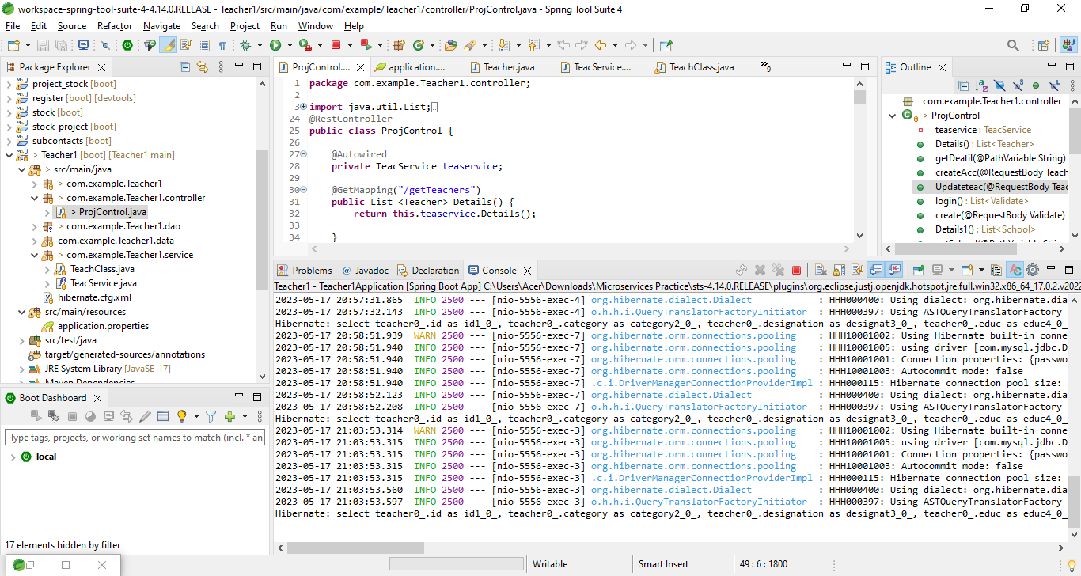

# Integration testing:

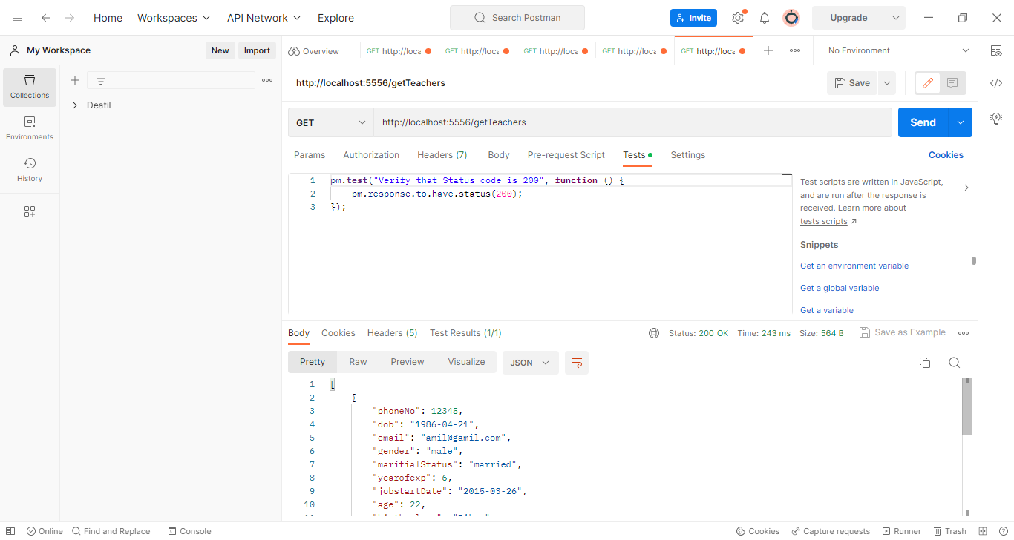

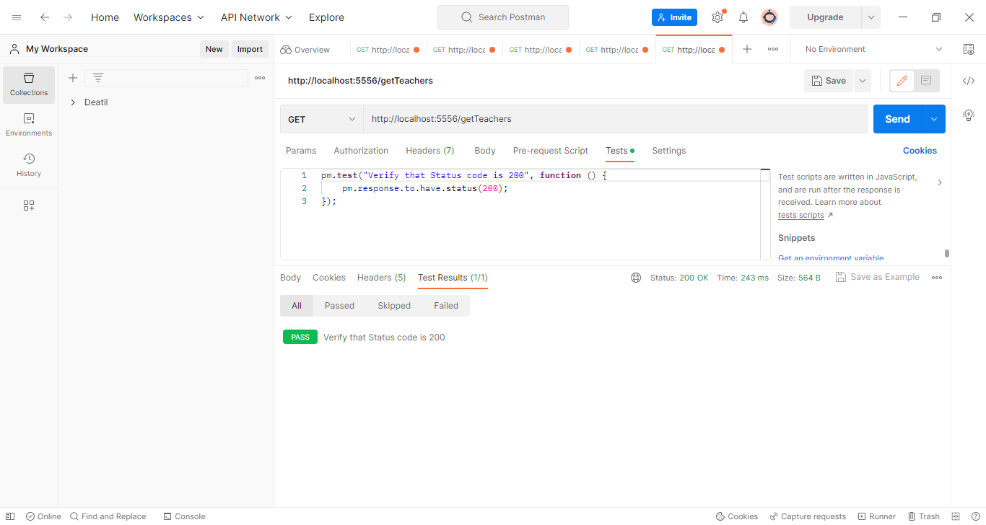

# White Box Testing

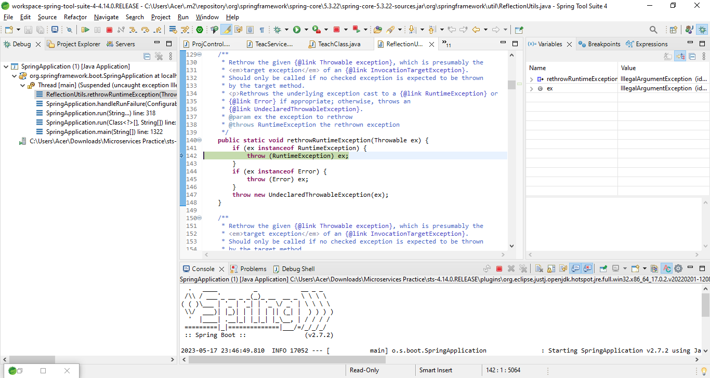

# Black Box Testing

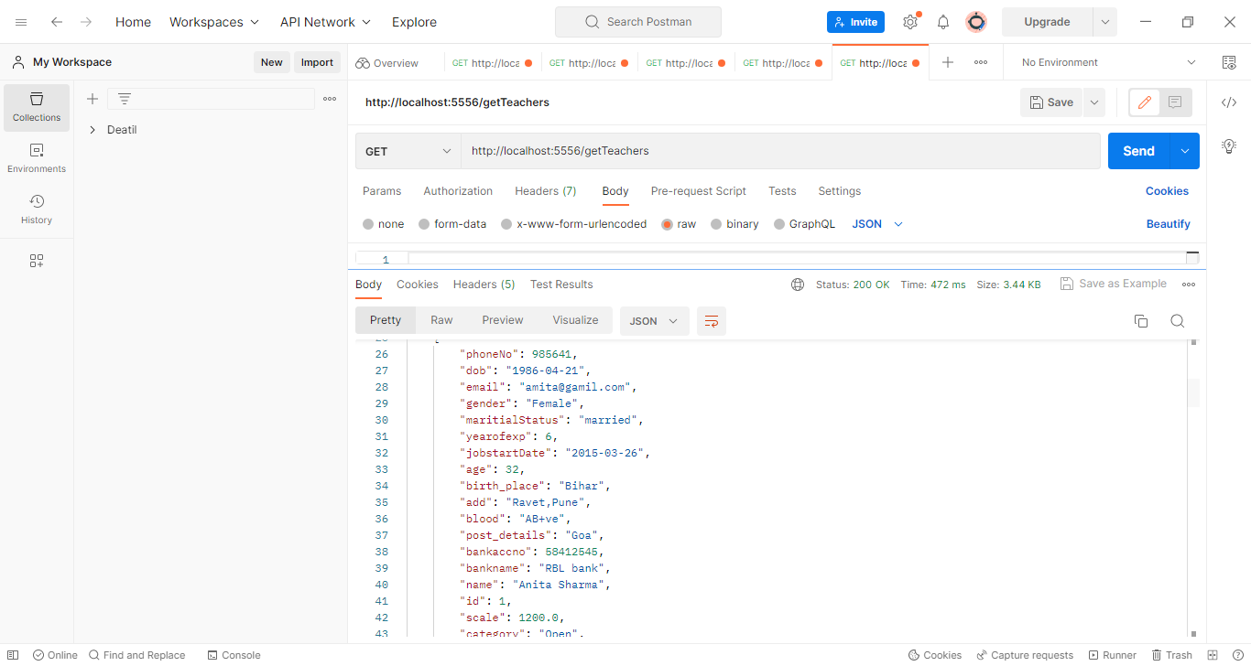

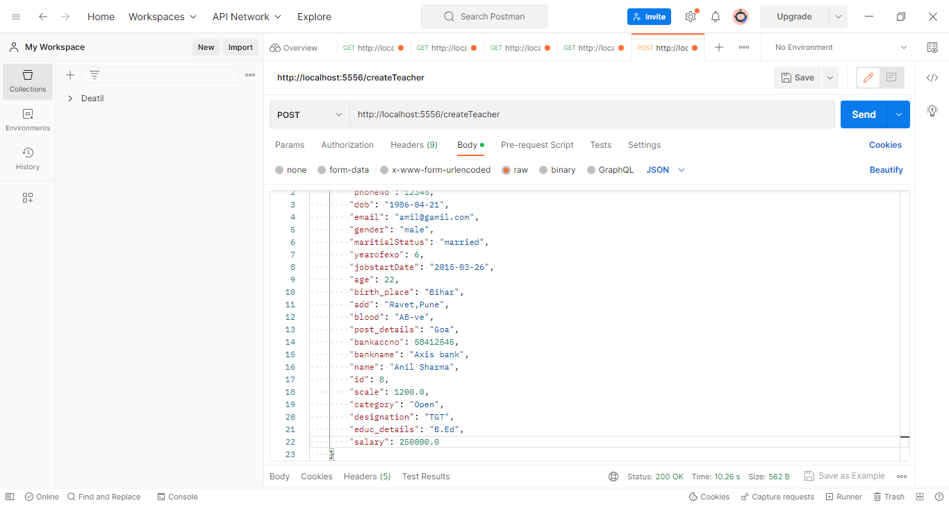

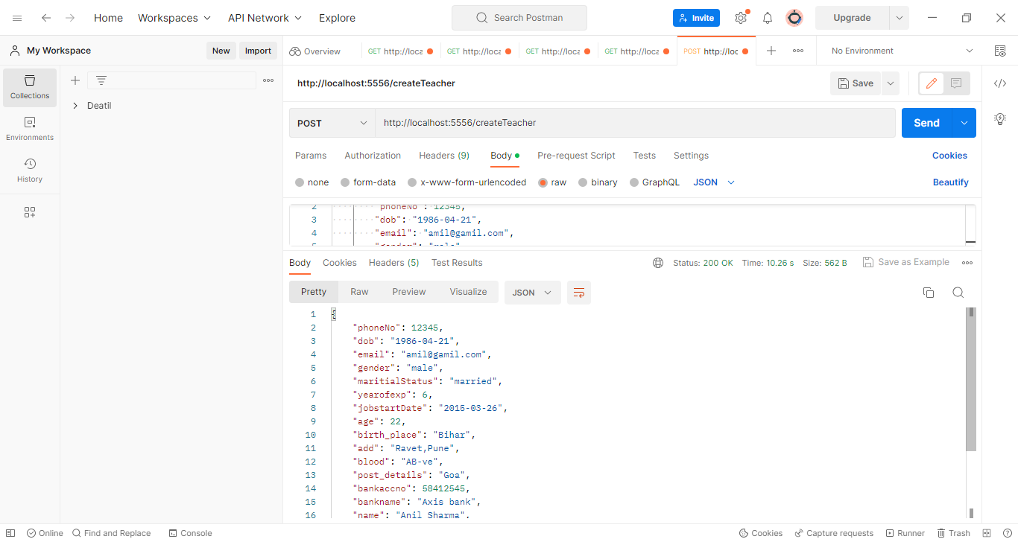

# Functional Testing

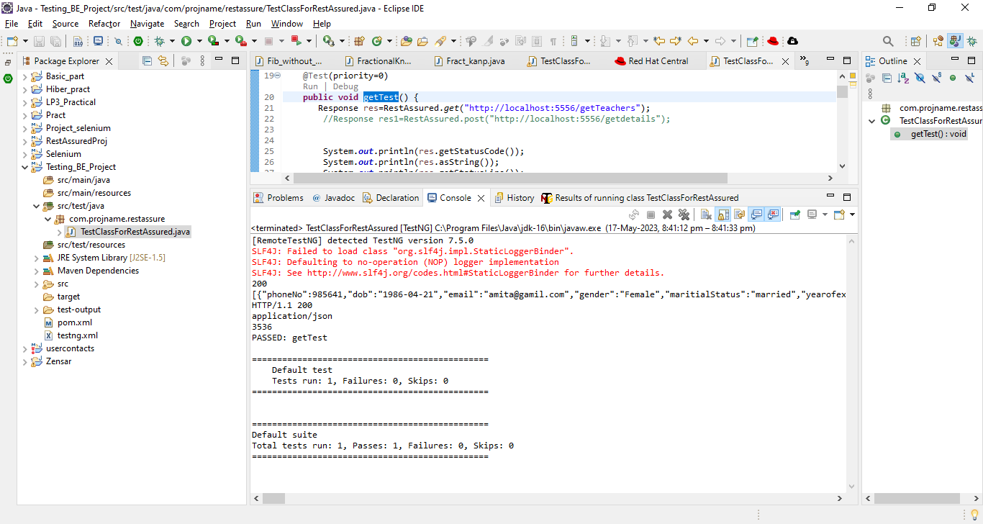

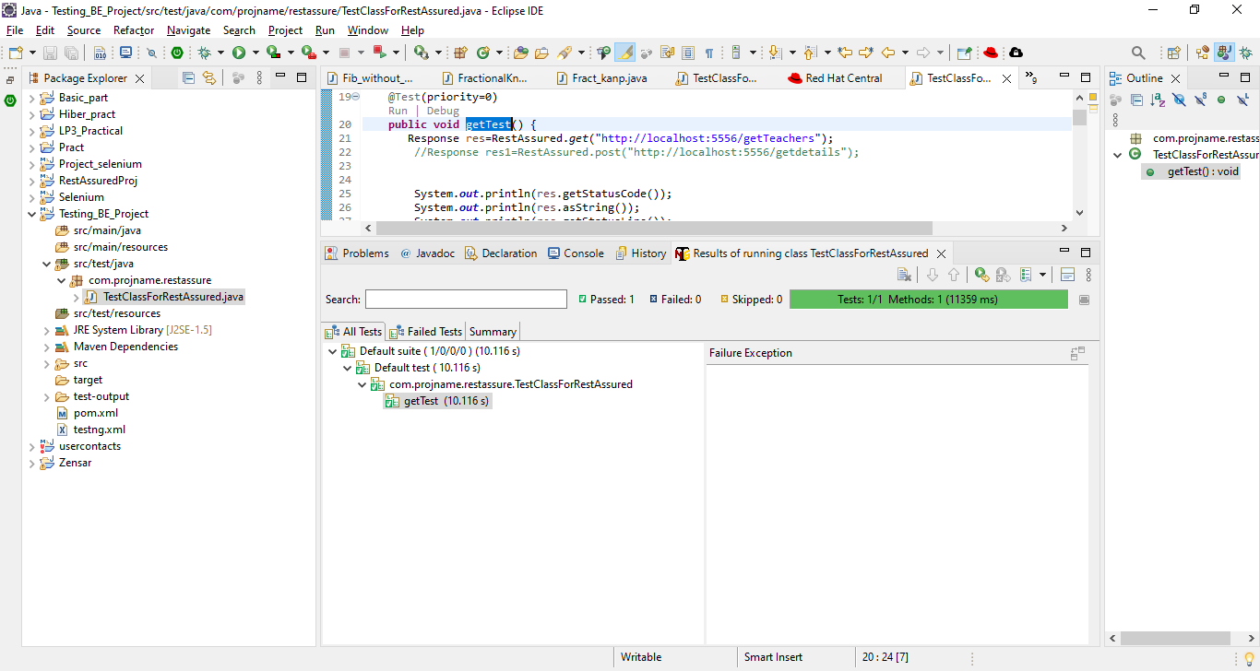

* 1. **TEST CASES AND TEST RESULT**

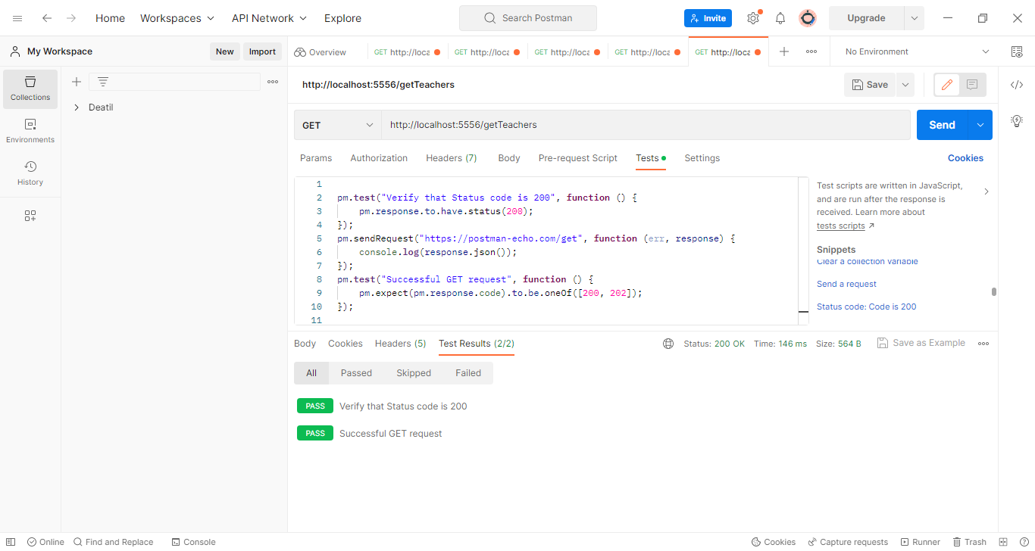



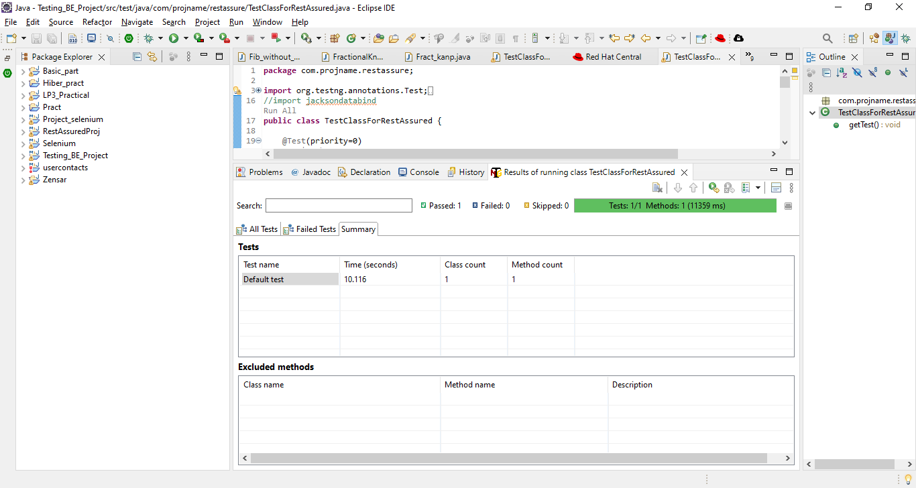

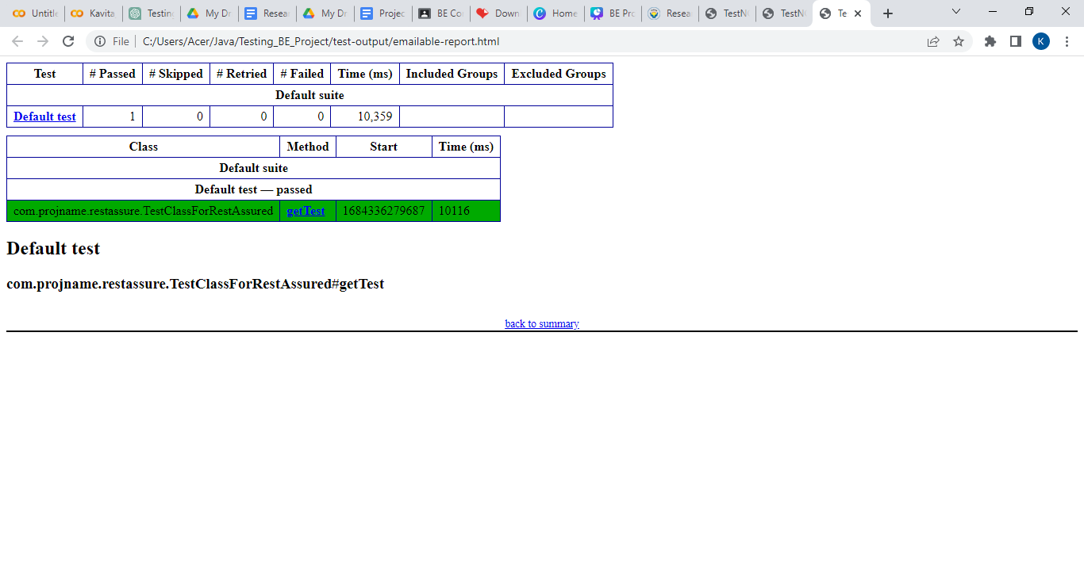

# 8. RESULT

**OUTCOMES**

|  |  |
| --- | --- |
|  |  |
|  |  |
|  |  |

# 9. CONCLUSIONS

E MITRA is a web application, developed to manage records of Teachers from their recruitment to their entire service duration which was earlier done manually and which makes it difficult to manage and keep track. The user-friendly design of this project facilitates the arduous task of upholding records. So by proposing our one-stop platform to the government, we strive to deliver a solution to the problem that uses technology and innovation to provide a management system for the teaching resources of the state of Maharashtra. The teachers can manage their profiles, resumes, preferences and performance records. The institutes of education can have a direct link to the government/administration while also being able to view the performance of their teachers and themselves as an Institute. They can manage their work and needs accordingly. By taking this big part of the education system online, we open up possibilities for the use of AI, ML and big data analytics on the vast amount of data and make use of it in future planning. Our portal provides a one stop solution of managing teachers and institutes using a single unified platform.

## FUTURE WORK

For Teachers: Past analysis and future prediction of institutes performance based on their filters and choices.

For Admin: To know the performance of teachers and institutes to help in the decision making process.

Technology Trends: Teachers and institutes will be able to know which are the upcoming technologies that will gain new heights.

**APPENDIX A**

REFERENCES: -

1. Panimalar Kathiroli, Vijaylakshmi v., December 2020 Predicting the performance of instructors using Machine learning algorithms.
2. Chao Yang, Jerry Chun‑Wei Lin, 9 February 2022 Design of Distance Assistance System for Intelligent Education by Web-based Applications.
3. Naumova TA, Vytovtova NI, Mitiukov NW, Zulfugarzade TE (2017) Model of distant learning educational methods for the students with disabilities. Eur J Contemp Educ 6(3):565–573
4. Han LQ, Zhang ZH, Cheng YQ, Liu JM, Lei KC (2018) Research and practice of computer network teaching method based on online learning platform. Softw Eng 21(01):41–44
5. Zhou X, Wang J, Guo M, Gao Z (2019) Cross-platform online visualization system for open bim based on webgl. Multimed Tools Appl 78(20):28575–28590
6. Li R (2020) An artifcial intelligence agent technology based web distance education system. J Intell Fuzzy Syst 40(3):1–11
7. Luo X (2019) Research on the Construction and Operation of Information Teaching Platform of University Public Courses Based on SPOC. Information Science 37(12):112–115
8. Tong, Y. X., Tian, Z. A. & Deng, H. Q. (2020). Design and Application Research of University Physics Mobile Learning Platform Based on Android. University physics, 39(04):51-55+75.
9. Baneres D, Robert C (2019) Evaluation of a new self-study platform for introductory digital systems. Interl J Eng Educ 35(1):286–303.
10. Hegde V, Patil S, Rao SG (2019) Learning pathway: content management and identification of student behavior through online learning management in java. Intl J Recent Technol Eng 8(2):492–497
11. Lu H (2021) Application of wireless network and machine learning algorithm in entrepreneurship education of remote intelligent classroom. J Intell Fuzzy Syst 40(2):2133–2144
12. Liu S, Wang S, Liu X et al (2021) Fuzzy Detection aided Real-time and Robust Visual Tracking under Complex Environments. IEEE Trans Fuzzy Syst 29(1):90–102
13. Sun Z, Anbarasan M, Praveen Kumar D (2021) Design of online intelligent English teaching platform based on artifcial intelligence techniques. Comput Intell 37(3):1166–1180
14. Liu S, Liu D, Srivastava G et al (2021) Overview and methods of correlation flter algorithms in object tracking. Complex Intell Syst 7:1895–1917
15. Xu X, Li D, Sun M, Yang S, Yu S, Manogaran G, Mavromoustakis CX (2019) Research on key technologies of smart campus teaching platform based on 5G network. IEEE Access 7:20664–20675
16. Dimitrienko YI, Gubareva EA, Zubarev KM, Chibisov VY, Grigorieva EN (2020) Open bmstu platform and teachers training in online courses development and implementation areas. ITM Web of Conferences 35(2):03015
17. Xiao J, Wang M, Jiang B, Li J (2018) A personalized recommendation system with combinational algorithm for online learning. J Ambient Intell Human Comput 9(3):667–677
18. Xu N, Fan WH (2020) Research on Interactive Augmented Reality Teaching System for Numerical Optimization Teaching. Computer. Simulation 37(11):203-206+298
19. Yusof MM, Wah NL, Mohamed R, Othman M (2018) E-learning tutoring system for sijil pelajaran malaysia (spm) english. MATEC Web of Conferences 150(5):05001
20. Benatti S, Montagna F, Kartsch V, Rahimi A, Rossi D, Benini L (2019) Online learning and classifcation of emg-based gestures on a parallel ultra-low power platform using hyperdimensional computing. IEEE Trans Biomed Circ Syst 13(3):516–528

# APPENDIX B

# PLAGIARISM REPORT

