*E MITRA*

*(Educator's Metadata Indexing and Transfer Request Automation)*

*Ketaki Bhoyar,Ojus Jaiswal, Kavita Sahu, Aaryan Patil, Vidhit Khajuria*

*Computer Department,*

*Dr. D.Y. Patil Institute of Engineering, Management and Research, Akurdi*

*ketaki.bhoyar@dypiemr.ac.in*

[*ojusjaiswal2001@gmail.c*](mailto:ojusjaiswal2001@gmail.com)*om*

[*sahukavita497@gmail.com*](mailto:sahukavita497@gmail.com)

[*patilaaryanm@gmail.com*](mailto:patilaaryanm@gmail.com)

[*vidhit82@gmail.com*](mailto:vidhit82@gmail.com)

**Abstract:-**

**Right Now there is no such portal that provides a single-stop platform for the government to manage all the teachers under their employment. Thereby this project proposes a portal that will be capable of helping the Institutes make the entire process of resource management more streamlined and hence, transparent. Along with resource management, it also provides a web for the teachers to engage with schemes of the government, receive official government notifications directly regarding teaching, and manage their own profiles. From Recruitment to Retirement along with service book handling the portal satisfies all the needs with three user interfaces specifically 'teacher', 'admin', and 'Institute' having separate login and permissions for Admin (Govt.), Schools/Institutes, and Teachers themselves. This project uses the latest technologies such as MERN stack, java, and machine learning to accomplish the objective of providing a completely automated Teacher Recruitment and management portal.**

**Keywords*:-* Teacher Management, Machine Learning, Java, MERN stack.**

1. **INTRODUCTION**

The platform would be helpful in keeping track of all the government teachers after their CTET test. It would streamline the process of recruitment which is a very time consuming, repetitive and mundane task, which also includes a huge amount of manual errors and the time required to understand and resolve those errors.

So, to eliminate unnecessary time waste and to make the process of keeping track of teachers' performance efficient and easy, we propose an idea of a common portal for gov. authorities, teachers, schools to provide a centralized digital platform, where all the three entities can communicate easily and effectively.

1. Teachers - can create and then update their profile as per the need and can also request for transfer or raise a complaint easily and can visualize the analytics describing vacancies at various institutes.
2. Schools - can view and update their teachers profile upto some extent to add the performance on the basis of the feedback that teacher has received by the students and also suggest some improvements if required to teachers. If a new subject is introduced in the syllabus, schools can view the interests and achievements of teachers to decide which teacher should be allocated to that subject. They can also raise a request for new teachers, whenever the need arises.
3. Admin - This entity includes the gov. education authority. It can receive transfer-requests from teachers and teacher-requests from schools and then can work on those requests for further processing. It can view the performance stats of schools and teachers to analyze the effect of earlier implemented schemes and to plan some new schemes that can enhance the productivity of the schools and teachers.

In this way, the digitalization of the process can be implemented, which will free teachers and administrators from their burdensome work and allow them to spend more time to focus on their key goals.

**II. LITERATURE WORK**

Existing research has demonstrated the prediction of teacher performance and navigates the factors that impact student performance by Predicting the performance of instructors using Machine learning algorithms. To ameliorate the calibre of remote education and mitigate the issue of tardy data handling within the pedagogical framework, an astute distance learning aid mechanism rooted in the web was also contrived. However, there is still a significant research gap in providing a one stop solution of managing teachers and institutes using a single unified platform. Further research is needed to propose one stop platform to the government, for that we need to deliver a solution to the problem that uses technology and innovation to provide a management system for the teaching resources of the state of Maharashtra.

**III. OVERALL STRUCTURE OF THE SYSTEM**

Design of the functional structure of the system:

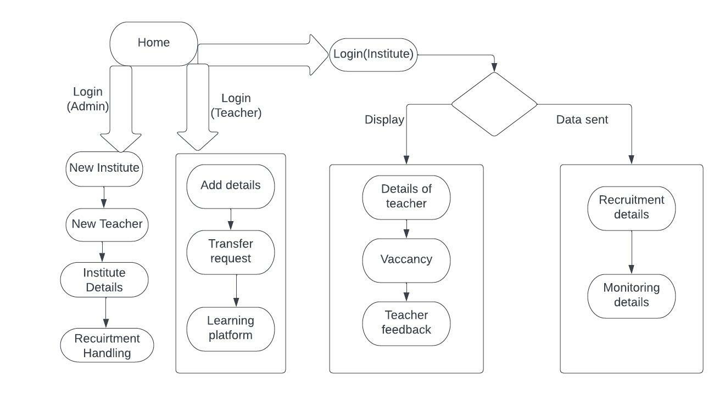

This is the architectural system of our project which consists of mainly 3 entities: Admin, Teacher, and Institute. Every year, a large number of teachers join the country’s teaching force, to collectively make the future of the country. Teachers join the workforce on different levels, to teach different subjects, with different skills, different preferences, different goals, and different aspirations as to how they want to shape the country’s future.Till now, the management of the teacher’s, their institutions, and their work was done manually. With technology not only entering every single aspect of our lives, but also shaping it, it is just obviously simple that the management of teacher’s careers should also be boosted and streamlined by technology. A lot of state governments are already progressing in this field, taking their management of teacher’s online, and are seeing positive results.That brings us to our problem statement, which demands a management platform for the teaching resources of the government of Maharashtra. We as a group, decided to provide a platform that provides -Login and permissions for Admin (Govt.), Schools/Institutes, and Teachers themselves.A DASHBOARD such that the govt. can see all of their teachers and teaching resources at once, and manage them better.The institutes can manage, upload and update all the data on their teachers on the portal, create requests, raise queries to the govt., and give/receive feedback.Teachers will be given unique IDs, for better management of their skills, expertise, needs, qualifications and can apply for transfers and/or update their profiles.

**IV. EXPERIMENTAL ANALYSIS**

We have developed the frontend application using reactjs due to its various advantages .

**For teachers:**

In the teacher portal each teacher can access their record and profile where he/she can manage its attendance ,leaves and calendar. Also, he can apply for transfer using his/her own portal which ensures transparency and accountability. Also to keep the teacher updated we have provided a news tab where he/she can get news according to their interests.Analysis and future prediction of institute’s performance based on their filters and choices.By using the feedback and past dataset we will be analyzing the data and will be providing visualization tools to analyze the past and present performance of an institute. Using Machine learning algorithms like neural networks and sentiment analysis we will be providing predictions of an institute in a particular field so that it becomes easy for teachers to filter their choices to opt for better and desired options.

|  |  |
| --- | --- |
|  |  |

**For institute:**

Same is for the institute portal but in addition to the features of the teacher portal we have staff tab which shows the detail of the staff in the institute and its details such as no. of playground,date of estd, etc using this we can manage the staff and in addition institute can request for teachers to the admin or govt.

Ratings of teachers for the required course and performance score of the teacher in that course.

If there are hundreds of applications for a specific position then it becomes quite a hectic job for the institute to analyze them or to call them for further screening. To overcome this we are providing ratings to teachers by analyzing their profiles using data science, based on which institutes can sort the creamy layer and can call for screening to only those who are suitable for the specific role.

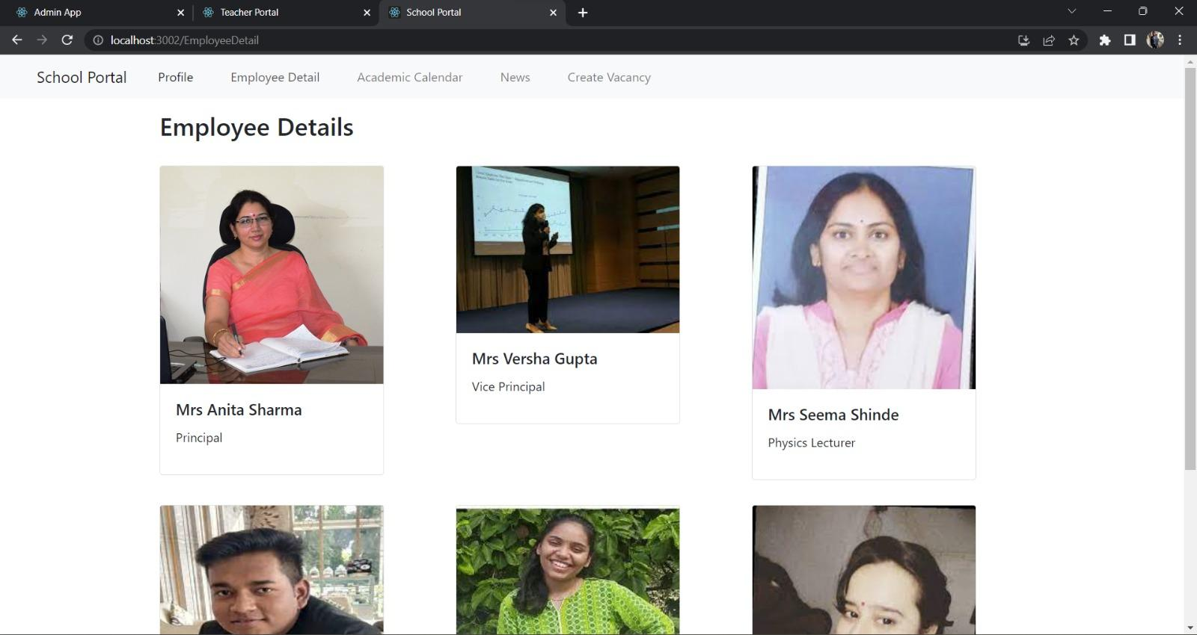

**For Government:**

Now comes the Admin portal ,which controls both the teacher and institute , using admin portal govt can manage teachers as well as institute centrally from the single unified portal using it we can manage teachers working for the govt their performances ,their records etc and same for the institute. In addition to all this we have provided ML models to visualize the teachers performance as well as we can rate them also and we can also visualize staff by age,category in order to acquire new teacher in place of retired teachers and teachers of upcoming technologies.To keep a track of the performance of teachers and institutes to help in the decision-making process.On the government portal, we are merging the rating score of teachers and institutes based on profiles as discussed above so that it becomes easy for the government to keep track of the performance of both teachers and institutes.

**Technology Trends:**

Teachers and institutes will be able to know which are the upcoming technologies that will gain a new height in the future.

By using the technology of text and sentiment analysis we are analyzing the key technologies that may gain new heights in the future and will be displaying information about them on the dashboard of institutes and teachers so that it will be easy for teachers to learn a new course and for institute to redesign their curriculum to give space to new technologies.

**Machine Learning :**

Python libraries used:

Pandas: for generating data frames and data preprocessing.

Numpy: for numeric data preprocessing.

Sklearn: for multiple purposes including data splitting, model training, evaluation metrics, etc.

Seaborn: for data visualization.

To automate the process of shortlisting and selection of teachers at various institutes during recruitment and transfer acceptance machine learning algorithms provide the key. By using the available data on the portal and by analyzing various relevant parameters, data preprocessing and visualization are performed to study the data. Since the parameters(variables) formed a linear and continuous relationship the machine learning Multiple Linear Regression algorithm proves to give the best accuracy of 95% when trained over sufficient data.

In this algorithm, there are several independent variables and a single dependent variable. The independent variables here are academics i.e points based on educational qualification, experience i.e points based on previous work experience, achievement i.e points for technical/non-technical relevant achievement, previous rating i.e rating provided by the previous institute based on various aspects such as discipline, punctuality, etc.

|  |  |
| --- | --- |
|  |  |

The dependent variable is the final rating, a floating value (in the range of 0 to 10) among the applied candidates. The data is split in the ratio of 7:3 for training and testing i.e 70% of the data is used for training purposes and the remaining 30% is used for testing of the algorithm. The training data is then trained and the coordinates are generated. Once the model is trained the sample data is tested and the model is evaluated. Further, the model is deployed on the web using a Python pickle file.

**Interactive Dashboards**:

Interactive dashboards are provided to analyze and visualize data regarding

1) Vacancies like post vacancy, district vacancy, category vacancy, domain vacancy, etc.

2) Teacher data like the number of teachers in the district, experience, category, qualifications, number of transfer requests, etc.

The dashboard is built using python plotly and using Dash by providing a connection to the database used for live updates. Various visualization tools are used to customize and make the analysis easy. Tools like Bar graphs, pie charts, histograms, etc.

|  |  |
| --- | --- |
|  |  |

**Database used**: MySQL database

MySQL is used for the following reasons: MySQL is an open-source database, and it is highly compatible with most operating systems, programming languages, and platforms. It is highly scalable and can handle large amounts of data with ease, offering fault tolerance also MySQL offers a robust security framework that ensures data privacy and protection against unauthorized access.

**V. CONCLUSION**

E MITRA is a web application, developed to manage records of Teachers from their recruitment to their entire service duration which was earlier done manually and which makes it difficult to manage and keep track. The user-friendly design of this project facilitates the arduous task of upholding records. So by proposing our one stop platform to the government, we strive to deliver a solution to the problem that uses technology and innovation to provide a management system for the teaching resources of the state of Maharashtra. The teachers can manage their profiles, resumes, preferences and performance records. The institutes of education can have a direct link to the government/administration while also being able to view the performance of their teachers and themselves as an Institute. They can manage their work and needs accordingly. By taking this big part of the education system online, we open up possibilities for the use of AI, ML and big data analytics on the vast amount of data and make use of it in future planning. Our portal provides a one stop solution of managing teachers and institutes using a single unified platform.

**References*:-***

1. Panimalar Kathiroli, Vijaylakshmi v., December 2020 Predicting the performance of instructors using Machine learning algorithms.
2. Chao Yang, Jerry Chun‑Wei Lin, 9 February 2022 Design of Distance Assistance System for Intelligent Education by Web-based Applications.
3. Naumova TA, Vytovtova NI, Mitiukov NW, Zulfugarzade TE (2017) Model of distant learning educational methods for the students with disabilities. Eur J Contemp Educ 6(3):565–573
4. Han LQ, Zhang ZH, Cheng YQ, Liu JM, Lei KC (2018) Research and practice of computer network teaching method based on online learning platform. Softw Eng 21(01):41–44
5. . Zhou X, Wang J, Guo M, Gao Z (2019) Cross-platform online visualization system for open bim based on webgl. Multimed Tools Appl 78(20):28575–28590
6. Li R (2020) An artifcial intelligence agent technology based web distance education system. J Intell Fuzzy Syst 40(3):1–11
7. Luo X (2019) Research on the Construction and Operation of Information Teaching Platform of University Public Courses Based on SPOC. Information Science 37(12):112–115
8. Tong, Y. X., Tian, Z. A. & Deng, H. Q. (2020). Design and Application Research of University Physics Mobile Learning Platform Based on Android. University physics, 39(04):51-55+75.
9. Baneres D, Robert C (2019) Evaluation of a new self-study platform for introductory digital systems. Interl J Eng Educ 35(1):286–303
10. Hegde V, Patil S, Rao SG (2019) Learning pathway: content management and identifcation of student behavior through online learning management in java. Intl J Recent Technol Eng 8(2):492–497
11. Lu H (2021) Application of wireless network and machine learning algorithm in entrepreneurship education of remote intelligent classroom. J Intell Fuzzy Syst 40(2):2133–2144
12. Liu S, Wang S, Liu X et al (2021) Fuzzy Detection aided Real-time and Robust Visual Tracking under Complex Environments. IEEE Trans Fuzzy Syst 29(1):90–102
13. Sun Z, Anbarasan M, Praveen Kumar D (2021) Design of online intelligent English teaching platform based on artifcial intelligence techniques. Comput Intell 37(3):1166–1180
14. Liu S, Liu D, Srivastava G et al (2021) Overview and methods of correlation flter algorithms in object tracking. Complex Intell Syst 7:1895–1917
15. Xu X, Li D, Sun M, Yang S, Yu S, Manogaran G, Mavromoustakis CX (2019) Research on key technologies of smart campus teaching platform based on 5G network. IEEE Access 7:20664–20675
16. Dimitrienko YI, Gubareva EA, Zubarev KM, Chibisov VY, Grigorieva EN (2020) Open bmstu platform and teachers training in online courses development and implementation areas. ITM Web of Conferences 35(2):03015
17. Xiao J, Wang M, Jiang B, Li J (2018) A personalized recommendation system with combinational algorithm for online learning. J Ambient Intell Human Comput 9(3):667–677
18. Xu N, Fan WH (2020) Research on Interactive Augmented Reality Teaching System for Numerical Optimization Teaching. Computer. Simulation 37(11):203-206+298
19. Yusof MM, Wah NL, Mohamed R, Othman M (2018) E-learning tutoring system for sijil pelajaran malaysia (spm) english. MATEC Web of Conferences 150(5):05001
20. Benatti S, Montagna F, Kartsch V, Rahimi A, Rossi D, Benini L (2019) Online learning and classifcation of emg-based gestures on a parallel ultra-low power platform using hyperdimensional computing. IEEE Trans Biomed Circ Syst 13(3):516–528