Event Planning Booking Website

Team members:

1. Okafor Somtochukwu Wisdom.

2. Kelani Doyin Israel.

3. Itua Anthony.

4.

Technologies to Work With:

* HTML & CSS
* Bootstrap
* JavaScript
* PHP
* MySql

Project Description:

We were challenged to create a website for event planners who needed to utilize the internet in getting the job done, in other word simplify the whole process of reaching out to their customers. One of the major issues was to develop an application that simplified receiving payment from customers from like around the world.

Solution:

We divided the project into two major parts;

* Front-end
* Back-end

The Front-end

This is in other words the client side. It consists of the beautiful UI that displays when a website is visited.

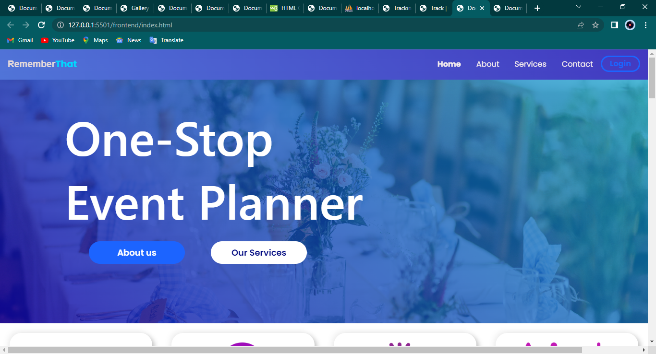

In our case we divided the front-end into about 4 simple pages; the landing page, about us page, service booking page, image gallery, contact us page.

The Landing Page:

This is the first impression a customer would get on visiting the website and so we made this page as beautiful as it can be.

This page of the website gave a brief of every page that exists on the website.

We created the landing page using HTML, CSS & JavaScript.

The About us page describes the subject organization giving every important information to potential customers. This page tells the history, mission and possibly vision and goals

The Back-end

The payment/booking system:

In this version of the web application we have developed a payment system thanks to the flutter-wave/rave payment/checkout API.

The current payment system allows for the customers to book whatever plan it is they want to book by simply selecting the kind of event they want to build