Ejercicios Freecodecamp: OBJETOS

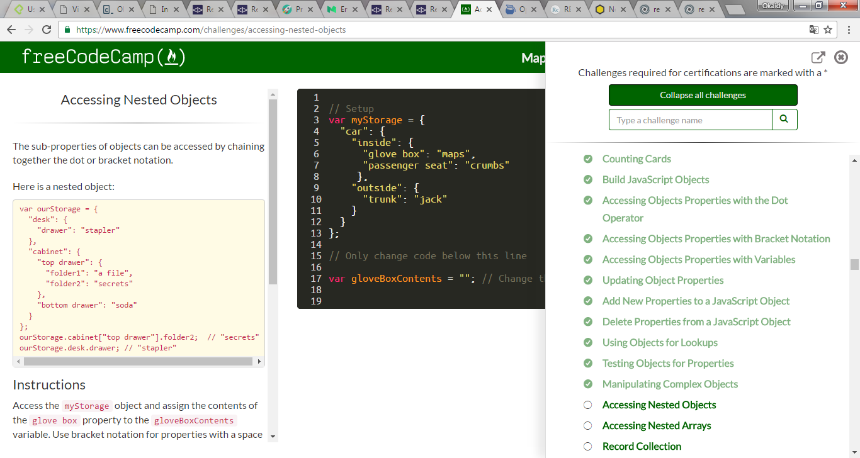

## Ejercicios Freecodecamp: Object Oriented and Functional Programming

