AI Recruiter Assistant Using a
Multi-Agent System

NAME | OMKAR SAWANT
SAPID | 60004230139
ROLL NO | C111
CLASS | C2

Sr No. | Table of Contents
1 | Introduction to Agent Systems
2 | Problem Definition
3 | Objectives and Scope
4 | System Design & Architecture
5 | Development Details
6 | Execution and Screenshots
7 | Deployment Architecture and Proof of Multiple Agents

Introduction to Agent Systems

An AI Agent is an autonomous entity capable of perceiving its operational environment, reasoning over structured and unstructured inputs, and taking actions to achieve a designated objective. While conventional scripts follow static rules and monolithic Large Language Model (LLM) prompts attempt to solve complex problems all at once, an AI agent utilizes focused prompts, bounded memory, and explicit schemas.
In a Multi-Agent System (MAS), multiple specialized agents cooperate to solve complex domains by dividing responsibilities. In the context of technical hiring, evaluating a candidate against a job specification requires three fundamentally distinct tasks:
(1) synthesizing employer requirements,
(2) fact-checking resume statements against those requirements, and
(3) generating probing interview questions.
By assigning each task to an independent agent, the system achieves higher accuracy, eliminates monolithic hallucination, and provides transparent auditability.

Problem Definition

Modern technical hiring is burdened by severe bottlenecks. Recruiters receive hundreds of resumes per job opening. Conventional Applicant Tracking Systems (ATS) rely primarily on naive keyword frequency algorithms.
This leads to two critical failures:
(1) candidates who pad resumes with buzzwords pass automated filters regardless of competence, while
(2) qualified candidates whose resumes describe accomplishments using alternative phrasing are prematurely discarded.
Furthermore, traditional tools do not assist recruiters during the actual interview phase. Recruiters are left without actionable, technically tailored questions to evaluate ambiguous candidate claims. The proposed Multi-Agent System resolves this by delivering evidence-backed analysis and generating 5 targeted interview questions with clear evaluation criteria.

Objectives and Scope

Primary Objectives of the System:
- Implement three distinct, verifiable Python agents (Job Analyzer, Resume Analyzer, and Interview Question Generator).
- Build a dedicated orchestrator module maintaining execution traces and ensuring robust exception recovery.
- Provide dual execution modes: live LLM integration and an offline deterministic fallback engine.
- Develop an intuitive Streamlit web interface with clear evidence displays.
- Enforce strict ethical and responsible-use safeguards: advisory-only output, no automatic accept/reject decisions, and zero demographic profiling.
- Verify all system modules using an automated Pytest test suite.

System Design & Architecture

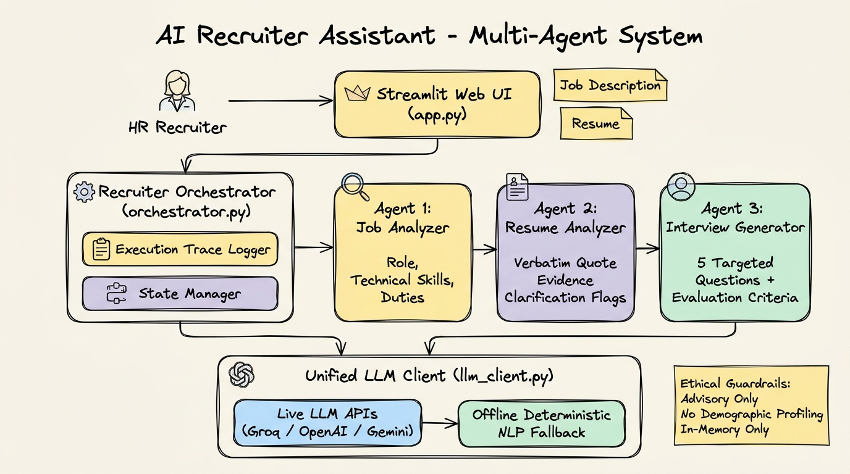

The application follows a modular, pipeline-oriented architecture. The RecruiterOrchestrator manages the sequential flow:
1. Agent 1 (Job Description Analyzer): Ingests the job description text and outputs structured role metadata, required skills, and key responsibilities.
2. Agent 2 (Resume Analyzer): Receives the candidate resume and Agent 1's structured requirements. Extracts verbatim quote evidence for confirmed skills and flags unstated requirements as clarification areas without disqualifying the candidate.
3. Agent 3 (Interview Question Generator): Synthesizes Agent 1's requirements and Agent 2's clarification areas to generate 5 targeted interview questions with explicit evaluation purposes.
4. Orchestrator: Captures per-agent execution times, logs status, and passes aggregated results to the Streamlit UI.

Development Details

The project is structured with strict separation between user interface, orchestration, and agent logic:
- app.py: Streamlit user interface with sidebar configuration and responsible-use badges.
- orchestrator.py: Coordinates the sequential pipeline and captures execution metrics.
- agents/job_analyzer.py: Agent 1 implementation.
- agents/resume_analyzer.py: Agent 2 implementation.
- agents/interview_generator.py: Agent 3 implementation.
- llm_client.py: Zero-dependency HTTP-based caller supporting Groq, OpenAI, and Gemini with auto-fallback.
- tests/test_agents.py: 8 automated unit and integration tests.

6. Execution and Screenshots
The following genuine screenshots were captured during live execution of the web application at http://localhost:8501.

Screenshot 1: Initial Application Interface
Initial Streamlit landing page displaying responsible-use safeguards, multi-agent setup, and input text areas.
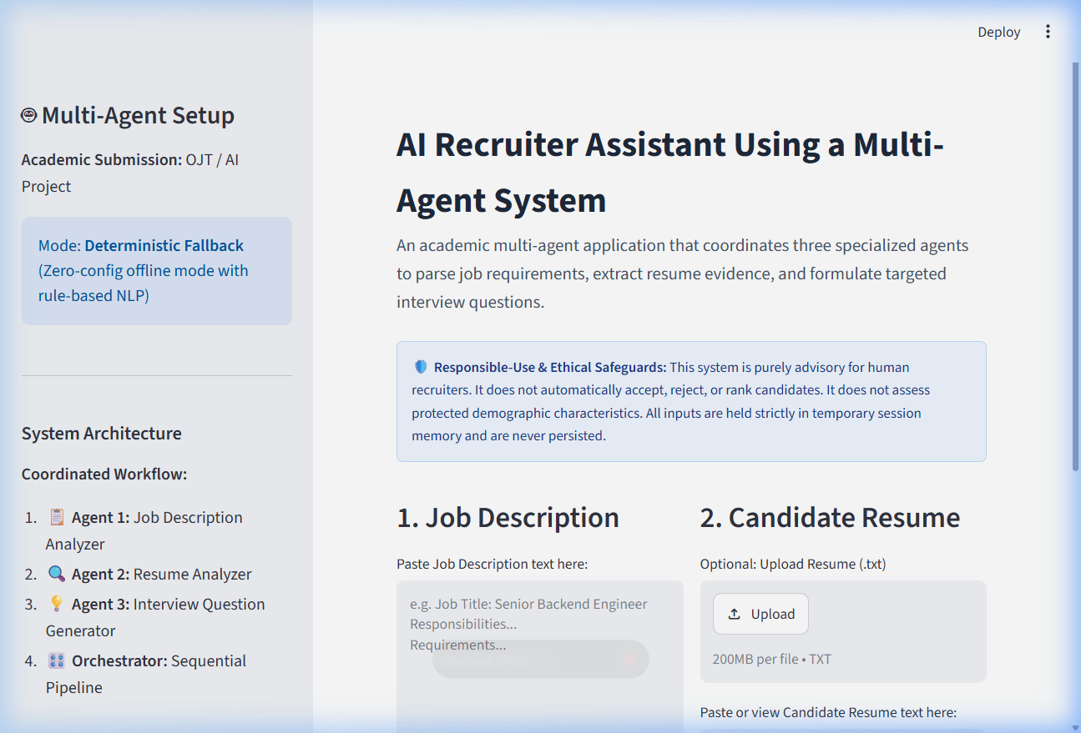
Figure: 01_app_initial.png - Live system execution

Screenshot 2: Sample Inputs Loaded
Synthetic Senior Backend AI Engineer job description and Alex Morgan's resume populated in the application.
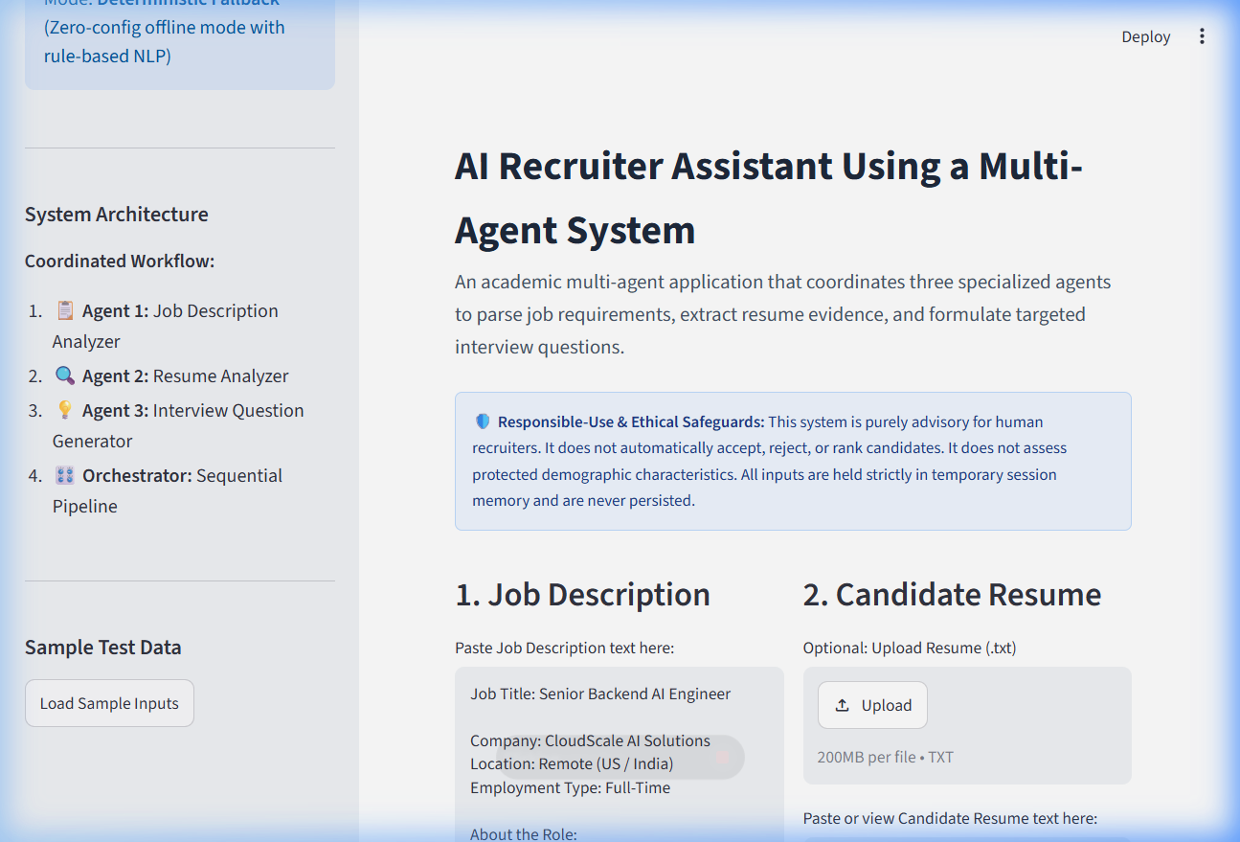
Figure: 02_inputs_loaded.png - Live system execution

Screenshot 3: Multi-Agent Trace & Job Requirements
Live execution trace confirming sequential execution of Steps 1, 2, and 3 alongside Agent 1's extracted requirements.
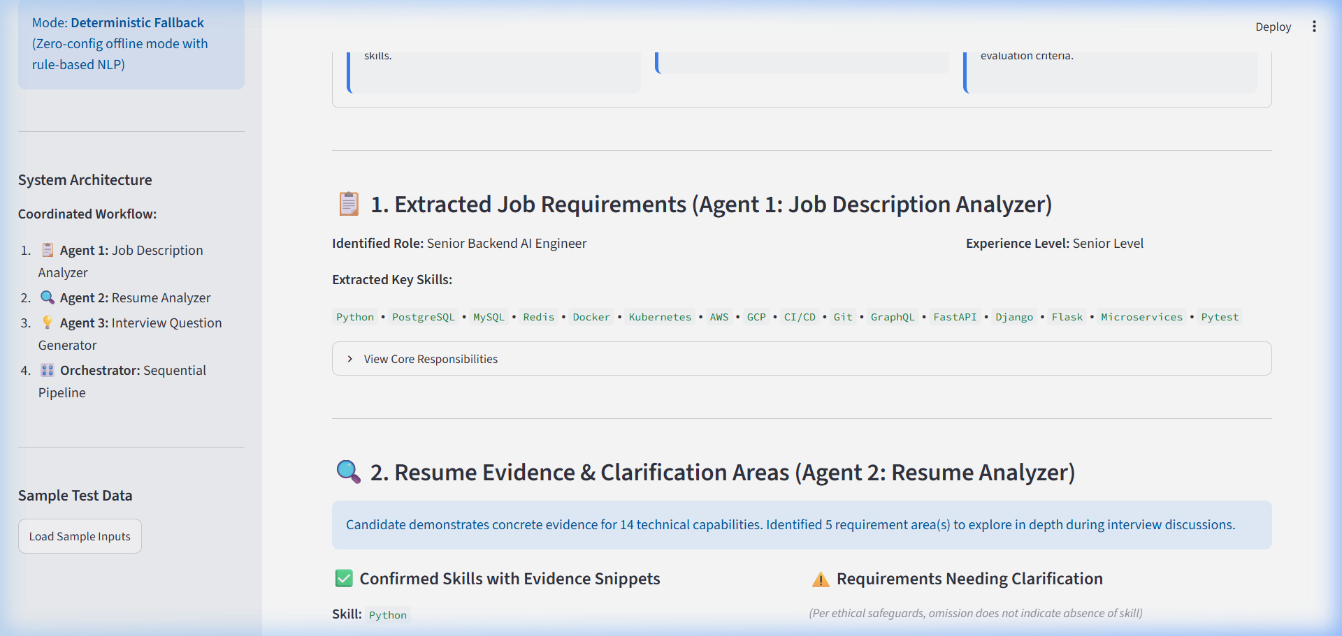
Figure: 03_agent_trace_and_job_requirements.png - Live system execution

Screenshot 4: Resume Evidence Snippets & Clarifications
Agent 2's output displaying confirmed skills with verbatim quote evidence and requirements flagged for recruiter clarification.
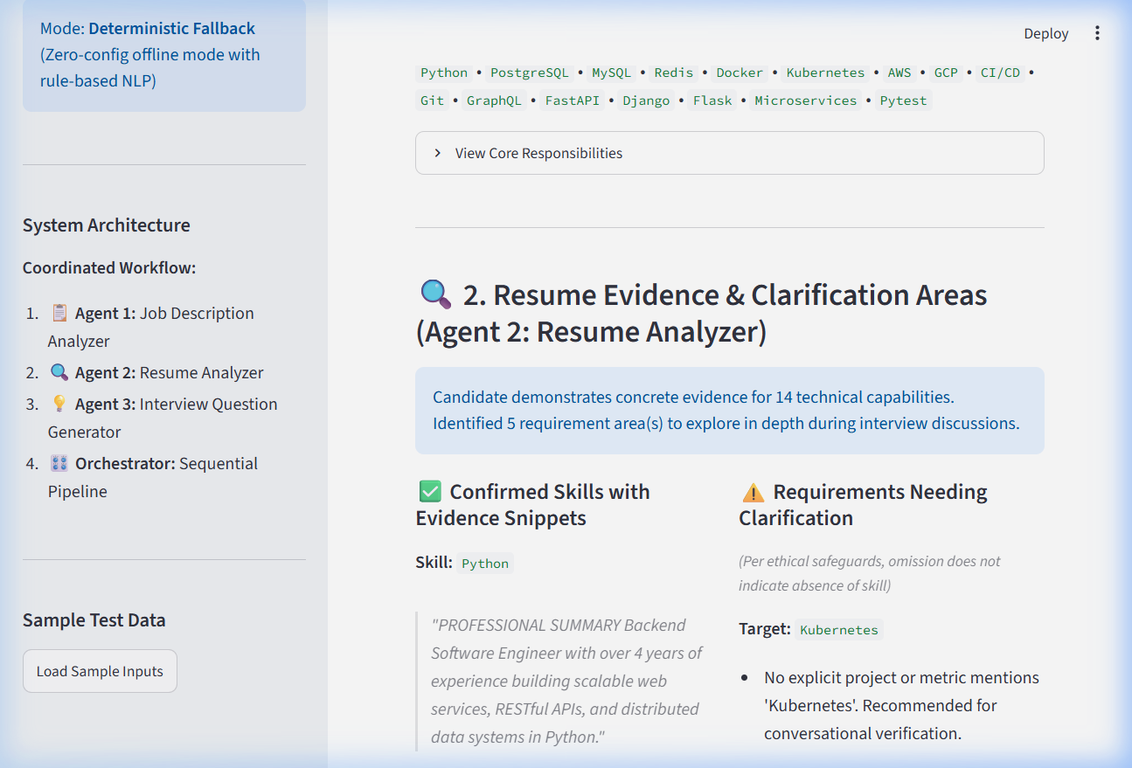
Figure: 04_resume_evidence_and_clarifications.png - Live system execution

Screenshot 5: Targeted Interview Questions
Agent 3's output presenting interview questions paired with specific evaluation purposes.
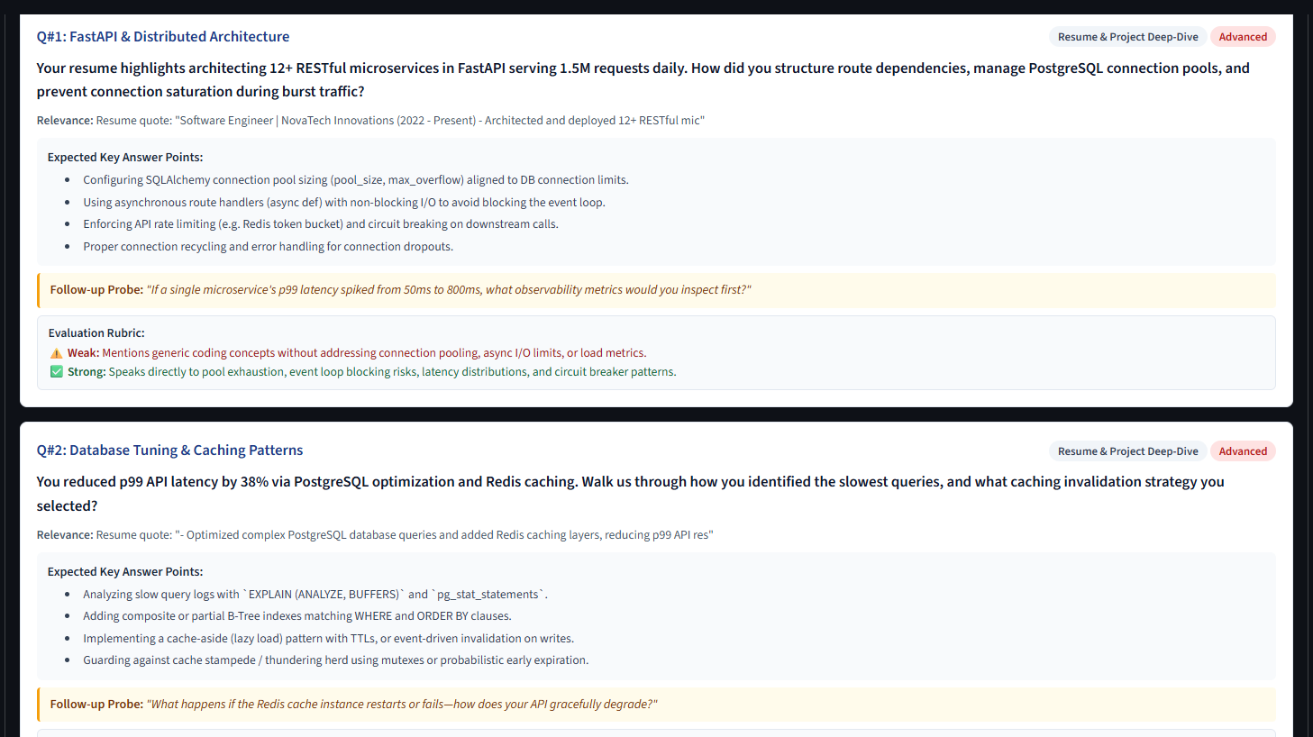
Figure: 05_interview_questions.png - Live system execution

Deployment Architecture and Proof of Multiple Agents

Proof of Multiple Agents:
1. Modular Separation: Each agent is encapsulated in its own class and Python file (job_analyzer.py, resume_analyzer.py, interview_generator.py).
2. Independent Unit Tests: Each agent has dedicated unit tests in tests/test_agents.py that verify functionality in complete isolation.
3. Live Execution Trace: The orchestrator records the independent execution step, duration, and status for each agent during every run.
4. Streamlit Community Cloud Deployment: The project is ready for one-click free hosting on share.streamlit.io by pointing to app.py.

