**COURSE CODE: CSC 401**

**COURSE TITLE**: INTRODUCTION TO DATABASE DESIGN AND MANAGEMENT

**GROUP NAME**: KPMS

**TOPIC**:DATABASE MANAGEMENT SYSTEM FOR THE ORDERING AND DELIVRING SYSTEM OF UNIQUE SNACKS WORLD.

GROUP MEMBER:

* **LAWAL RILIWAN KOLAPO** 140805517
* **OJIMBA OBINNA PASCAL** 140805504
* **SALAMI REMILEKUN SODIQ** 140805516
* **OGUNDEJI ITUNU BISOLA** 140805502

**TABLE OF CONTENT**

**CHAPTER 1 DATABASE ENVIRONMENT OF UNIQUE SNACK WORLD AND DEVELOPMENT PROCESS**

* 1. **INTRODUCTION**
  2. **GOALS**
  3. **ADVANTAGES OF THE DATABASE APPROACH**
  4. **COSTS AND RISK OF DATABASE APPROACH**
  5. **APPROACH**
     1. **SEGMENT OF AN ENTERPRISE DATA MODEL OF UNIQUE SNACK WORLD**
     2. **SEGMENT OF PROJECT DATA MODEL**
  6. **REQUIRED LOGICAL DATA FLOW DIAGRAM**
  7. **DATA DICTIONARY**
  8. **A FULLY DETAILED DATA DICTIONARY**
  9. **ENTITY RELATIONSHIP DIAGRAM(ERD)**

**CHAPTER 2 DEVELOPING A DATABASE APPLOCATION FOR UNIQUE SNACK WORLD**

**2.1 PRELIMINARY DATA MODEL**

**2.2 DATA ATTRIBUTES FOR ENTITIES IN UNIQUE SNACK WORLD**

**2.3 DESIGNING THE DATABASE**

**2.4 USING THE DATABASE**

**CHAPTER 3 DATABASE ANALYSIS**

**3.1 OVERVIEW OF BUSINESS RULE**

**3.2 E-R MODELING OF UNIQUE SNACK WORLD**

**3.3 EER MODELLING OF UNIQUE SNACK WORLD**

**CHAPTER 4 DATABASE DESIGN**

**4.1 NORMALIZATION OF RELATIONS IN UNIQUE SNACK WORLD**

**4.2 MERGING OF RELATIONS IN UNIQUE SNACK WORLD**

**CHAPTER 1**

**DATABASE ENVIROMENT OF UNIQUE SNACK WORLD AND DEVELOPMENT PROCESS**

**1.1 INTRODUCTION**

Unique Snack World is a service providing organization, they deal with food and beverage production and services. They are currently using a file processing method as their approach to information system, this possess a lot of threat because the current system is prone to errors due to program-data dependence, duplication of data, limited data sharing, lengthy development times, excessive program maintenance, amongst others.

It is difficult to store, manipulate, and retrieve large files of data as the establishment grew bigger, and even the competition in the food and beverage industry had intensified, competitors seemed to respond rapidly than Unique Snack World to new business opportunities. Over time, as business applications became more complex, it became evident that the traditional file processing system is outdated and had several shortcomings and limitations. Thus, the system must be replaced with a database processing system

**1.2 GOALS**

Our main objective is to create a database management system for the ordering and delivery system of unique snack world. If this is done it is going to make it easier to store, manipulate and retrieve the system database.

Database management system is a software system that enables the use of database approach, the primary purpose of database management system is to provide a systematic method of creating, updating, storing and retrieving the data stored in a database, it enables data to be shared among multiple applications rather than propagated and stored in new files for every new application

**1.3 Advantages of the Database Approach**

* Program-data independence
* Enforcement of standards
* Improved data quality
* Improved decision support
* Improved data sharing and consistency
* Planned data redundancy
* Improved data accessibility and responsiveness
* Reduced program maintenance

**1.4 Costs and Risks of the Database Approach**

* Need to hire or train new, specialized personnel
* Installation and management cost and complexity
* Conversion costs
* Need for explicit backup and recovery
* Organizational conflict

**1.5 APPROACH**

In the preliminary stage, we will be using an Enterprise model, Enterprise modelling is the abstract representation, description and definition of the structure, processes, information and resources of an identifiable business, government body, or other large organization.

**1.5.1 Segment of an enterprise data model of Unique Snack World**

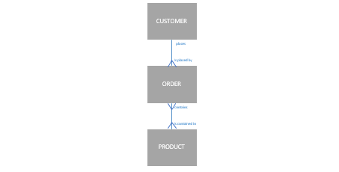

**1.5.2 Segment of project data model.**

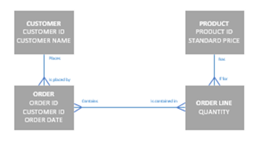

**1.6Required Logical Data Flow Diagram**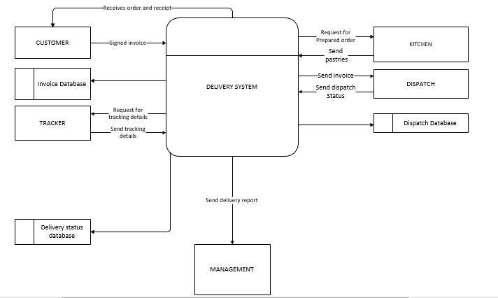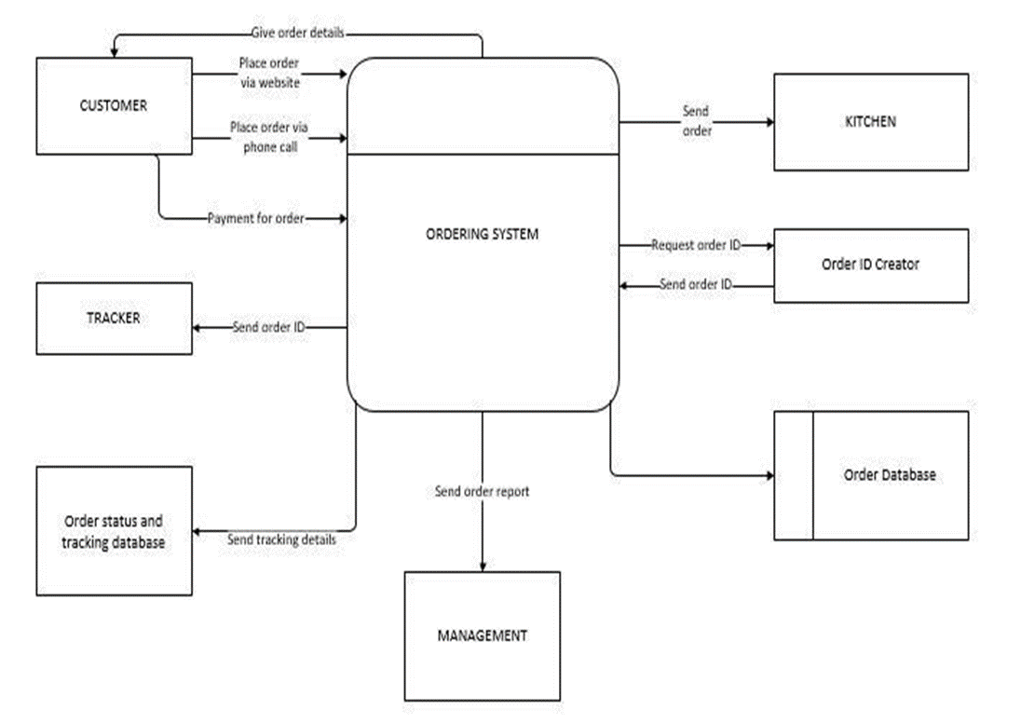

## 1.7Data Dictionary

**Ordering and Delivery System**: This is the process that processes the order and delivery of pastries. In the context diagram, the input are from customer, tracker and kitchen while the output are from all the external entities.

**Customer:** This is an external entity that gets the services of the system by getting his/her goods and his/her receipt.

**Dispatch:** This is an external entity that dispatches the order to the customer’s address

**Kitchen:** This external entity receives the order, processes it and gets the order

**Orders and Delivery Database**: This is the Data Store for the orders where order information are stored and formatted.

**Ordering System:** This is the decomposed process from the ordering and delivery system where this process only takes care of the ordering part of the system

**Delivery System**: This is the decomposed process from the ordering and delivery system where this process only takes care of the delivery part of the system.

**Place Order**: This is the data flow that indicates the customer placing an order for a pastry

**Customer information:** This contain customer information being sent to the dispatch and also introduced into the system by the customers

**Order:** This data flow is meant for the order and contains its information like its ID

**Order Status:** This is the current status of the order which is introduced to the system by tracking.

**1.8 A FULLY DETAILED DATA DICTIONARY**

|  |  |  |  |  |
| --- | --- | --- | --- | --- |
| **Variable Name** | **Variable** | **Variable Type** | **Variable Width** | **Notes** |
| Customer ID | customer_id | Integer | 11 | The Customer ID here is a foreign Key used by other tables to access Customers Details. |
| Customer's First  Name | first_name | VarChar | 70 |  |
| Customer's Middle  Name | middle_name | VarChar | 70 |  |
| Customer's Last  Name | last_name | VarChar | 70 |  |
| Customer's Phone Number | phone_number | numeric | 50 |  |
| Customer's Address | address | TEXT | 1000 | Address to deposit the product to. |
| Customer's Email Address | email_Address | VarChar | 70 |  |
| Customer's Password | password | VarChar | 50 |  |
| Customer's Gender | gender | Integer | 2 | 1 = Male, 2 = Female |
| Time Registered | date_of_registration | DateTime | 50 | 1-31/1-12/1980-2016 |
| Secret Answer | secret_answer | VarChar | 50 | In case the user cannot access his/her email and will like to validate account using another method. |

## 1.9 Entity Relationship Diagram (ERD)

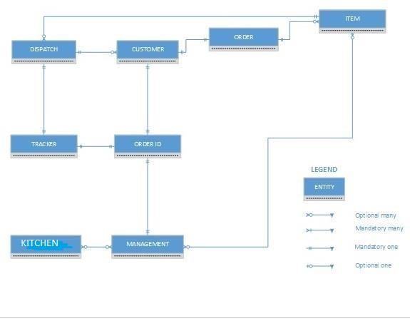

## Database Design (Tables from ERDs)

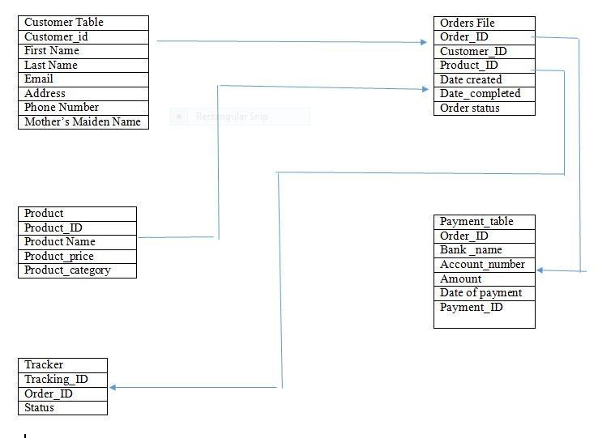

**CHAPTER 2**

**DEVELOPING A DATABASE APPLICATION FOR UNIQUE SNACK WORLD**

**2.1 Preliminary data model**



**2.2 Data attributes for entities in final data model (Unique snack world)**

|  |  |
| --- | --- |
| **Entity type** | **Attributes** |
| Customer | Customer Identifier  Customer Name  Customer Phone No  Customer Address  Customer E-mail  Customer Password  Customer Gender |
| Product | Product Identifier  Product Description  Product Price |
| Order | Order ID  Order Placement Date  Order Fulfillment Date  Ordered Number of Shipment  Order Quantity |
| Tracking | Tracking ID  Order ID  Status  Date of Delivery |
| Invoice | Invoice Number  Order ID  Invoice Date |
| Payment | Invoice Number  Payment Date  Payment Amount |
| Product Line | PL prior year’s sales Goal  PL Current Years Sales Goal |
| Shipment | Shipment Number  Tracking ID  Status  Order ID |

**2.3 Designing the database**

**2.4 USING THE DATABASE**

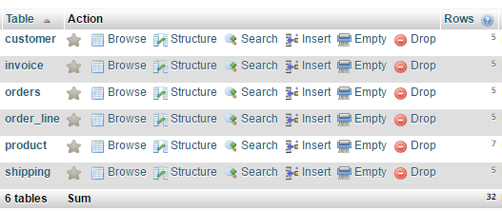

C:\Users\Chisom Anene\AppData\Local\Microsoft\Windows\INetCache\Content.Word\cusq.png

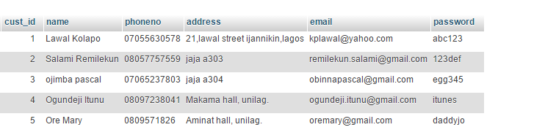

C:\Users\Chisom Anene\AppData\Local\Microsoft\Windows\INetCache\Content.Word\proq.png

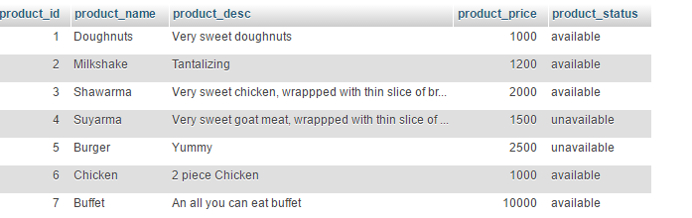

C:\Users\Chisom Anene\AppData\Local\Microsoft\Windows\INetCache\Content.Word\orlq.png

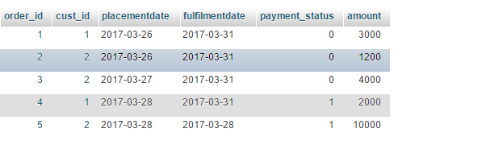

**CHAPTER 3**

**DATABASE ANALYSIS**

**3.1 E-R MODELING UNIQUE SNACK WORLD**

We want to develop a high-level ERD for Unique Snack world, for us to do this we need to explain the business rules with respect to Unique Snack world. The E-R diagram contains several E-R model constructs in it, such as one-to-many, binary, or unary relation.

We need to answer questions like

• Where is a unary relationship, what does it mean, and for what reasons might the cardinalities on it be different in other organizations? • Why Includes a one-to many relationship, and why might this ever be different in some other organization?

• Does it allow for a product to be represented in the database before it is assigned to a product line?

• If there were a different customer contact person for each work station in which a customer did business, where in the data model would we place this person’s name?

• What is the meaning of the Does Business In associative entity, and why does each Does Business In instance should be associated with exactly one work station and one CUSTOMER?

• In what way might Unique Snack World change the way it does business that would cause the Supplies associative entity to eliminated and the relationships around it change?

Each of these questions is included in. From a study of the business processes at Unique Snack World, we have identified the following entity types. An identifier is also suggested for each entity, together with selected important attributes:

• The company sells several different food(snacks) and beverages. These products are grouped into several product items. The identifier for a product is Product ID. We identify the follow/ing additional attributes for product: Product Description, Product name, product status, and Product Price.

• Customers submit orders for products. The identifier for an order is Order ID, and another attribute is Order Date. A customer may submit any number of orders, but need not submit any orders. Each order is submitted by exactly one customer. The identifier for a customer is Customer ID. Other attributes include Customer Name, Customer Address, customer phone number, customer email and customer password.

• A given customer order must request at least one product and only one product per order line item. Any product sold by Unique Snack World may not appear on any order line item or may appear on one or more order line items. An attribute with each order line item is Ordered quantity.



**3.2 EER MODELING UNIQUE SNACK WORLD**

* Why do some customers come to buy directly at pot of sales station.?
* Why do some employees not supervise other employees, and why are they not all supervised by another employee and why do some employees not work in a work center?
* Why is it that some merchant doesn’t supply food items to unique snack world?

The business rules in respect to how unique snack world handles business leads us to this modifications after some modifications.

* There are two types of customers: Online and offline customers. Only offline customers do business in a sales station point. An online customer is associated with making orders online. It is also very much possible for a customer operate on both online and offline.
* Two types of employees exist: Management and staff. Only staff works in the kitchen and sales stations while the whole activities are supervised by the management employees
* Unique snack world keeps track of different merchants, not all supplies food items except those that have contractual agreement with the company.

These business rules have been used to modify the **E-R** diagram into the **EER** diagram

**Rule 1**: Implies that there is a total overlapping specialization of customer into online customer and offline customers.

**Rule 2**: Implies there is a partial, disjoint specialization of employees into management employee and staff employee

**Rule 3**: Means that there is a partial specialization of MERCHANT into SUPPLIER, because only some vendors become suppliers.

**CHAPTER 4**

**DATABASE DESIGN**

**4.1 Normalization of relational data model of Unique Snack World.**

Normalization is the process of decomposing relations with anomalies to produce a smaller, well-structured relations. Normalization helps to minimize data redundancy thereby avoiding anomalies and conserving storage space also makes it easier to maintain data and perform operations like insertion, deletion and updating.

The effect of normalization in relational data model of Unique Snack world will improve representation of the real world and a stronger basis for future growth.

**STEPS IN NORMALIZATION**

1. First normal form: Any multivalued attributes (also called repeating groups) have been removed, so there is a single value (possibly null) at the intersection of each row and column of the table

2. Second normal form: Any partial functional dependencies have been removed (i.e., nonkey attributes are identified by the whole primary key).

3. Third normal form: Any transitive dependencies have been removed (i.e., nonkey attributes are identified by only the primary key).

4. Boyce-Codd normal form: Any remaining anomalies that result from functional dependencies have been removed (because there was more than one possible primary key for the same nonkeys).

5. Fourth normal form: Any multivalued dependencies have been removed.

6. Fifth normal form: Any remaining anomalies have been removed.

**UNIQUE SNACKS WORLD CUSTOMER INVOICE**

**Customer ID**2 **ORDER ID** 2

**Customer Name**REMILEKUN SALAMI **ORDER DATE** 2017-03-26

**Address** A303 JAJA HALL UNILAG

**PRODUCT ID PRODUCT NAME QUANTITY UNIT PRICE EXTENDED PRICE**

2 Milkshake 1 N1,200 N1,200

3 Shawarma 2 N2,000 N4,000

7 Buffet 1 N10,000 N10,000

**TOTAL**  15,200

**STEP 0: REPRESENTING THE INVOICE VIEW IN TABULAR FORM**

**Order Id Order Date Customer Id Customer Name Product Id Product Name Product Price Ordered Qty**

2 2017-03-26 2 Remilekun Salami 2 Milkshake N1,200 1

3 Shawarma N2,000 2

7 Buffet N10,000 1

1 2017-03-26 1 LawalKolapo 1 Doughnuts N1000 3

6 Chicken N1000 2

**STEP 1: CONVERT TO FIRST NORMAL FORM**

**Order Id Order Date Customer Id Customer Name Product Id Product Name Product Price Ordered Qty**

2 2017-03-26 2 Remilekun Salami 2 Milkshake N1,200 1

2 2017-03-26 2 Remilekun Salami 3 Shawarma N2,000 2

2 2017-03-26 2 Remilekun Salami 7 Buffet N10,000 1

1 2017-03-26 1 LawalKolapo 1 Doughnuts N1000 3

1 2017-03-26 1 LawalKolapo 6 Chicken N1000 2

**SELECT THE PRIMARY KEY**

OrderID OrderDate, CustomerID, CustomerName, CustomerAddress

CustomerID CustomerName, CustomerAddress

ProductID ProductName, ProductDescription, ProductPrice

OrderID, ProductID OrderedQuantity

**FUNCTIONAL DEPENDENCY DIAGRAM FOR UNIQUE SNACK WORLD INVOICE**



FULL DEPENDENCIES

**STEP 2: CONVERT TO SECOND NORMAL FORM**

OrderID OrderDate, CustomerID, CustomerName, CustomerAddress

ProductID ProductName, ProductDescription, ProductPrice

**REMOVING PARTIAL DEPENDENCIES**



**STEP 3: CONVERT TO 3NF**



**RELATIONAL SCHEMA FOR INVOICE DATA**



**4.2 Merging relations in Unique snack world relational model**

The importance of merging relations can’t be overemphasized especially when dealing with large projects, the work of several sub teams comes together during logical design so there is often a need to merge relations. Integrating existing databases with new information requirements often leads to the need to integrate different views, New data requirements may arise during the life cycle so there is need to merge any new relations with any new relations with what has already been developed.

There are problems that arises during integration:

Synonyms

This refers to two or more attributes that have different names but same meaning. There are two ways of solving instances like this.

First, is to obtain agreement from the users or business rule, so we choose one of the attribute and eliminate the other.

Second, we need to strike a balance by merging both names to form one.

Example,

EMPLOYEE1(ManagerID, Name)

EMPLOYEE2( StaffID,Name,Address)

After merging we get:

EMPLOYEE( EmployeeID,Name,Address)

Homonyms

An attribute that may have more than one meaning

Example,

CUSTOMER1 ( CustomerID, CustomerName, CustomerAddress)

CUSTOMER2 ( CustomerID, CustomerName, CustomerAddress, CustomerPhoneNo)

After merging we get:

CUSTOMER ( CustomerID, CustomerName, CustomerPermanentAdress,CustomerTemporaryAddress,CustomerphoneNo)

Transitive dependencies

When two 3NF relations are merged to form a single relation, transitive dependencies may result.

Example,

CUSTOMER1 ( CustomerID, CustomerName)

CUSTOMER2 ( CustomerID, address)

After merging we get:

CUSTOMER ( CustomerID,CustomerName,address)

Supertype / subtype relationships

EMPLOYEE ( EmployeeID, skilled, notskilled)

MANAGEMENT EMPLOYEE( EmployeeID, skilled)

STAFF EMPLOYEE( EmployeeID, notskilled)