Name: Oken kumar padhiary RollNo:23MCA033 College: GIET University

Section-A

# 1. Features or Content on Frugal Testing's Website

One of the standout features on Frugal Testing's website is their comprehensive range of testing services. They offer everything from functional and performance testing to more specialized services like AI/ML testing, IoT testing, and Web3 testing. This extensive list highlights their commitment to covering all aspects of software quality assurance, ensuring that clients can rely on them for any type of testing requirement.

Another notable aspect is their agile and DevOps testing methodologies, which reflect their focus on modern, efficient, and continuous testing practices. This shows their dedication to adapting to the latest industry trends and providing clients with up-to-date solutions that enhance delivery and reduce deployment risks.

Frugal Testing's mission and vision statements also caught my attention. Their commitment to being globally admired testing consultants and their goal of delivering highly functional web applications emphasize their dedication to quality and customer satisfaction. Their detailed case studies and testimonials further reinforce their credibility and the real-world impact of their services.

# 2. Impressive Service or Case Study

The case study that stood out to me was their work with a leading FinTech platform, where they provided automation testing to streamline operations. This case study is impressive because it showcases Frugal Testing's ability to handle complex, high-stakes projects in the financial sector, which demands utmost precision and reliability.

Their approach to ensuring the platform's smooth operation through advanced automation techniques demonstrates their expertise in delivering high-quality testing solutions that can handle critical financial transactions and maintain the platform's integrity under varying loads. This not only highlights their technical prowess but also their capability to support and enhance essential services in a highly regulated industry (QA Testing Partner) (QA Testing Partner) (QA Testing Partner).

1. LinkedIn Profile Link: [linkedin.com/in/pritam-pradhan-6b3290276](https://www.linkedin.com/in/pritam-pradhan-6b3290276)

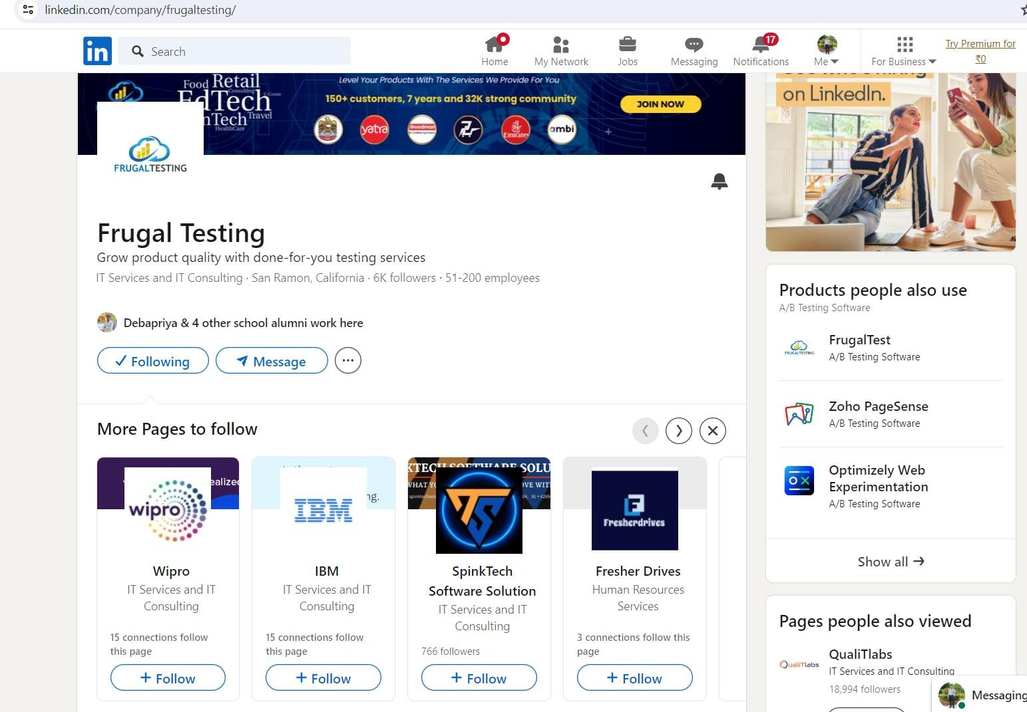

1. My experience with Power BI has been extensive and multifaceted, focusing on creating insightful and interactive data visualizations and reports. I have utilized Power BI to transform raw data into meaningful insights through a variety of projects. Here are some examples:
   1. **Sales Performance Dashboard**: This dashboard tracked key performance indicators (KPIs) such as monthly sales, revenue growth, regional sales distribution, and top- performing products. By using visualizations like bar charts, line graphs, and geographic maps, the dashboard provided a comprehensive view of sales trends and patterns, enabling stakeholders to make data-driven decisions.
   2. **Customer Insights Report**: This report analyzed customer demographics, purchasing behavior, and feedback. It included interactive slicers and filters, allowing users to segment data by age group, location, and product category. The report helped in understanding customer preferences and tailoring marketing strategies accordingly.
   3. **Financial Analysis Dashboard**: This dashboard was designed to monitor financial metrics such as profit margins, expense ratios, and budget vs. actual performance. The use of KPI indicators, treemaps, and waterfall charts facilitated a clear understanding of financial health and operational efficiency.

Key features of Power BI that I find most useful include:

* + - **Interactive Visualizations**: Power BI's ability to create dynamic and interactive charts and graphs makes data exploration intuitive and engaging.
    - **Data Modeling**: The robust data modeling capabilities allow for complex relationships and calculations, providing deeper insights.
    - **Power Query**: This feature enables efficient data transformation and cleansing, ensuring data integrity and consistency.
    - **DAX (Data Analysis Expressions)**: DAX functions enhance data analysis by allowing the creation of custom calculations and aggregations.

Overall, Power BI's comprehensive tools and user-friendly interface make it an invaluable resource for data analysis and visualization.

1. I am very comfortable using Python for data analysis, leveraging its extensive ecosystem of libraries and tools to handle various tasks effectively. For data manipulation, I rely on **Pandas** for efficient data cleaning, transformation, and aggregation, and **NumPy** for numerical operations and handling large datasets.

For data visualization, **Matplotlib** is my foundational tool for creating static and interactive plots, while **Seaborn** builds on Matplotlib to provide attractive statistical graphics, particularly useful for visualizing complex relationships. Additionally, **Plotly** is great for creating interactive visualizations that can be embedded in web applications.

In statistical analysis, I utilize **SciPy** for scientific and technical computing tasks like optimization and statistical tests, and **Statsmodels** for more advanced statistical modeling, including linear and logistic regression, time series analysis, and hypothesis testing.

For machine learning and more complex data analysis tasks, **Scikit-Learn** is indispensable, offering tools for clustering, classification, regression, and preprocessing.

I often integrate these tools in **Jupyter Notebooks** for an interactive and iterative workflow, facilitating exploratory data analysis and making it easy to document and share insights. This combination of libraries and tools allows me to perform comprehensive data analysis efficiently and effectively.

1. Link of Excel file:- https://1drv.ms/x/c/191352df63594efc/Ee1w77J9w3RFlXgFfFwg0PcBuwjOBtRrFn2Y- VeMO333jQ?e=7zXQnp