* Gas Density (at Real Gas Condition)

Gas density at real condition is computed thus:

$$ρ=\frac{2.70Pγ_{g}}{zT}$$

Note that density $ρ$ is in lbm/ft3, T is in degree Rankine and P is in psi.

* Bubble Point Pressure, Pb

Frequently, it is desired to determine bubble point pressure for an undersaturated reservoir, i.e. at what point will the undersaturated reservoir begin to liberate gas. The correlation below is applicable.

$$P_{b}=\left(18×{10}^{y_{g}}\right){\left(\frac{R_{sb}}{γ_{g}}\right)}^{0.83}------------2.32$$

Where $y_{g}=0.00091T_{F}-0.0125{}_{}^{o}{API}----------2.33$

$${}_{}^{o}{API} = \frac{141.5}{γ_{o}}-131.5$$

$$R_{sb} is the solution gas oil ratio at or above bubble point pressure.$$

**Note: TF is temperature in degree Fahrenheit.**

* Solution Gas-Oil Ratio, Rs

The correlation to calculate Rs at pressures below or equal to the bubble point is presented below. There is no need for a correlation to calculate Rs at pressures above bubble point because Rs is constant at pressures above bubble point down to bubble point pressure.

$$R_{s}= γ_{g}{\left(\frac{P}{18×{10}^{y_{g}}}\right)}^{1.204} ------------2.34$$

$$y_{g } is still as defined by equation 2.33$$

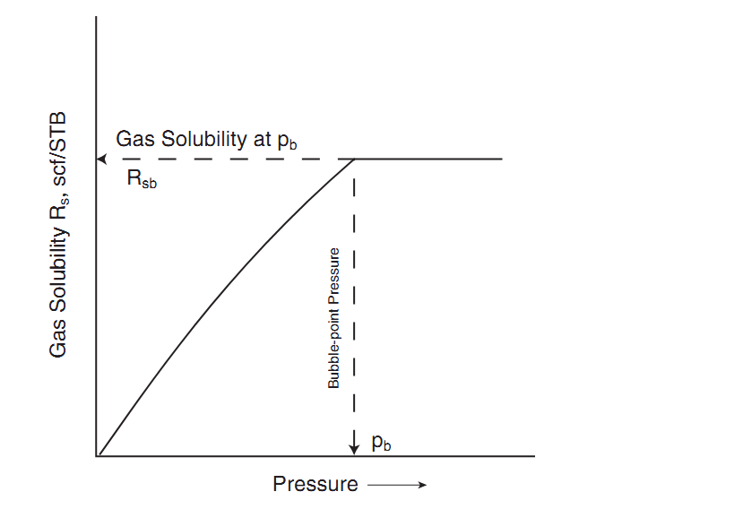

Figure 1: Variation of Rs with Reservoir Pressure.

* Oil Formation Volume Factor, Bo

Recall that the variation of Bo with pressure is divided into two regimes. See Figure 2

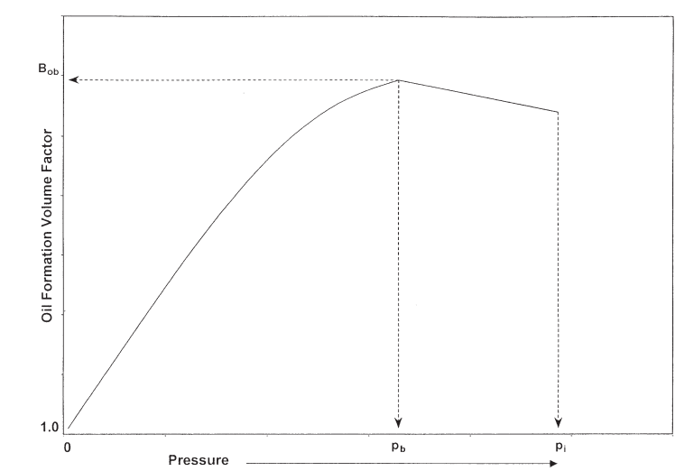.

Figure 1: Variation of Bo with Reservoir Pressure

For pressures below or equal to bubble point, Standing’s correlation for calculating Bo is herein presented:

$$B_{o}=0.9759+0.00012F^{1.2}------------2.35$$

$$Where F= R_{s}{\left(\frac{γ_{g}}{γ_{o}}\right)}^{0.5}+1.25T_{F}------------2.36$$

**Note: TF is temperature in degree Fahrenheit.**

For pressure above bubble point, the analytical equation applicable is given as:

* + Stock Tank Oil Initially In-Place (STOIIP)

The Stock Tank Oil Initially In-Place (STOIIP) is computed thus:

$$N=\frac{7758Ahϕ\left(1-S_{wi}\right)}{B_{oi}}--------------4.5$$

Where:

STOIIP, N = Stock Tank Oil Initially in Place, STB

Area A = Drainage Area of the Reservoir, in Acres

Thickness h = productive oil zone thickness, in ft

Porosity $ϕ$ = formation porosity, in fraction – the fraction of the bulk reservoir made up of pore spaces.

Saturation Swi = initial water saturation, in fraction

Boi = Oil Formation Volume Factor at initial reservoir pressure, RB/STB.

7758 = conversion factor