DIGITAL FORENSIC EXAMINATIO N REPORT

Case Title: | Examination of cartel.img
Module: | Digital Forensics and Incident Response
Examiner: | Okirie Chukwumeniem Faith
Date of Report: | 3 August 2026
Subject Evidence: | cartel.img (Forensic Image)

Objective
This examination aimed to systematically identify, preserve, and recover digital evidence from the provided forensic image 'cartel.img'. The process was executed using industry-standard forensic tools on a SIFT Workstation, ensuring the original image remained unaltered and the chain of custody was respected.

Tools and Methodology
The following tools were utilized during the examination phase:
SIFT Workstation (Forensic Environment)
The Sleuth Kit (ﬂs, icat, istat, mmls, img_stat) PhotoRec 7.1 & Foremost (Data Carving)
LibreOﬃce Writer Linux Terminal Utilities

Evidence Integrity & Veriﬁcation
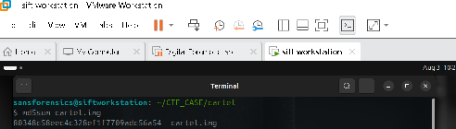
Initial veriﬁcation was conducted by calculating the MD5 and SHA-256 hash values of the source image to establish a baseline for integrity.
Figure 1: MD5 Hash Veriﬁcation (Value: 80348c58eec4c328ef1f7709adc56a54)
Figure 2: SHA- 256 Hash Veriﬁcation

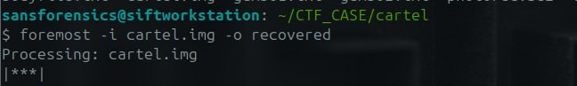
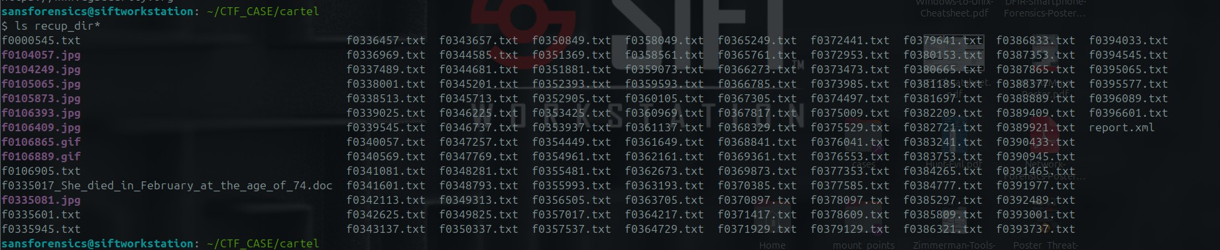
Preliminary Analysis (Triage)
5.2 Foremost Recovery

Figure 6: Redundant recovery using Foremost for cross- veriﬁcation.
5.2 Foremost Recovery
The image was analyzed using Sleuth Kit tools to determine ﬁle system architecture and partition layout.
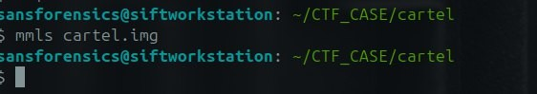
Figure 3: MMLS Partition Analysis (Identifying FAT16 File System)
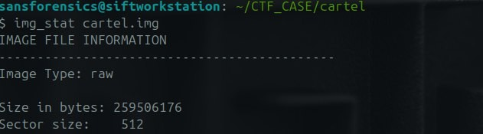
Figure 4: Image Metadata Summary

Data Recovery (Carving)
Multiple data carving techniques were employed to recover deleted ﬁles from the unallocated space of the image.

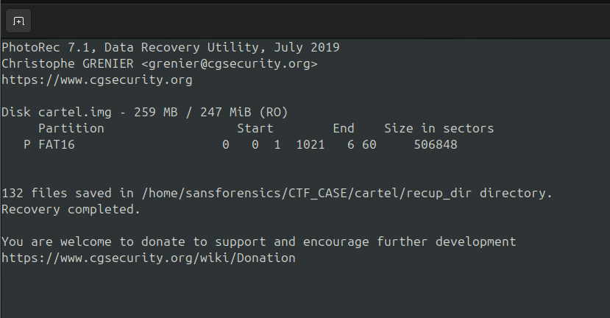
PhotoRec Recovery
Figure 5: Recovery complete; 132 ﬁles identiﬁed and extracted.

Detailed Artifact Analysis

Microsoft Word Document
A signiﬁcant deleted document was recovered and analyzed for metadata and content.
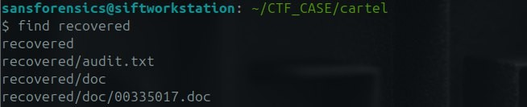
Figure 7: Metadata analysis revealing author 'NOWAY MAN' and content summary.
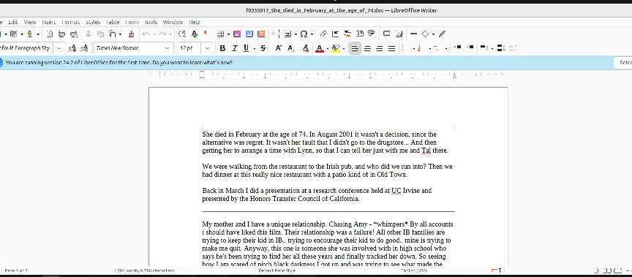
Figure 8: Visual veriﬁcation of the recovered Word document content.

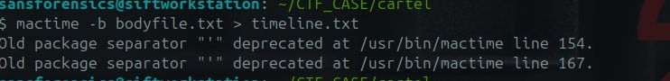
Text Artifacts (Gumbo Recipes)
Figure 9: istat analysis for GUMBO 1.TXT showing directory entry details.
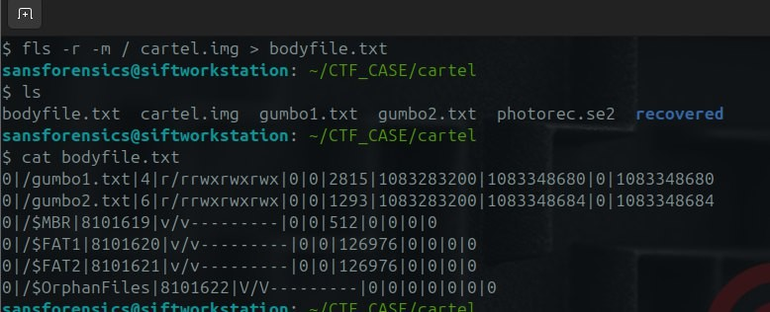
Figure 10: Tail of recovered text content.

Image Artifacts

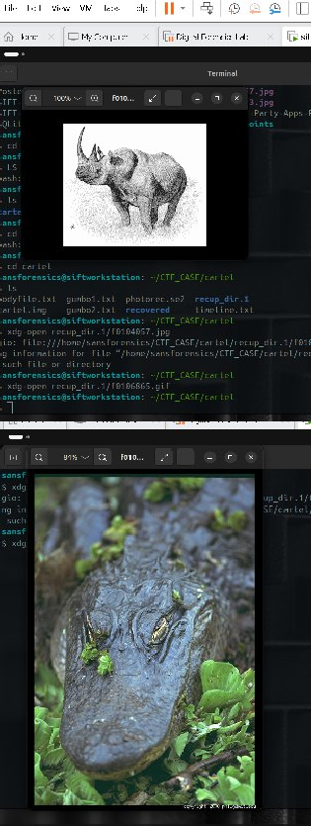
Figure 11: Recovered multimedia assets (Rhino and Alligator ﬁles).

Timeline Reconstruction
A system timeline was generated to visualize ﬁle activity. Key events were noted on April 30, 2004.
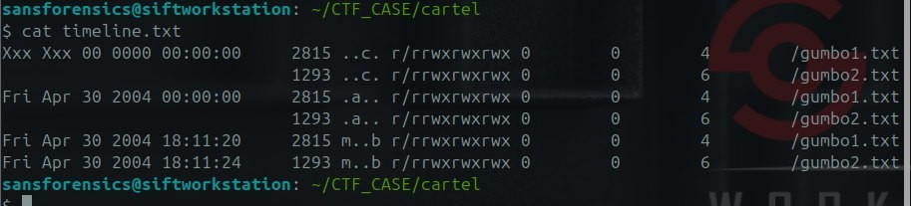
Figure 12: Detailed chronological log of ﬁle modiﬁcations and access.

Findings & Conclusion
Evidence Integrity: Conﬁrmed via MD5/SHA- 256 hash comparison.

File System: FAT16 structure identiﬁed.
Data Recovery: 132 ﬁles recovered including DOC, JPG, and TXT formats.
Refutation: The suspect's claim of only 'personal photos' is falsiﬁed by the recovery of a 1,022- word document.
Active Usage: Timeline analysis proves signiﬁcant data activity occurred on April 30, 2004.
Conclusion: The forensic examination of 'cartel.img' was successful. The recovery of diverse ﬁle types and the analysis of their metadata provide clear evidence of data manipulation and storage beyond the suspect's verbal admissions.

5.3 Manual File Extraction (icat)
Figure 7: Extracting Shrimp and Tasso Gumbo recipe (Inode 4).
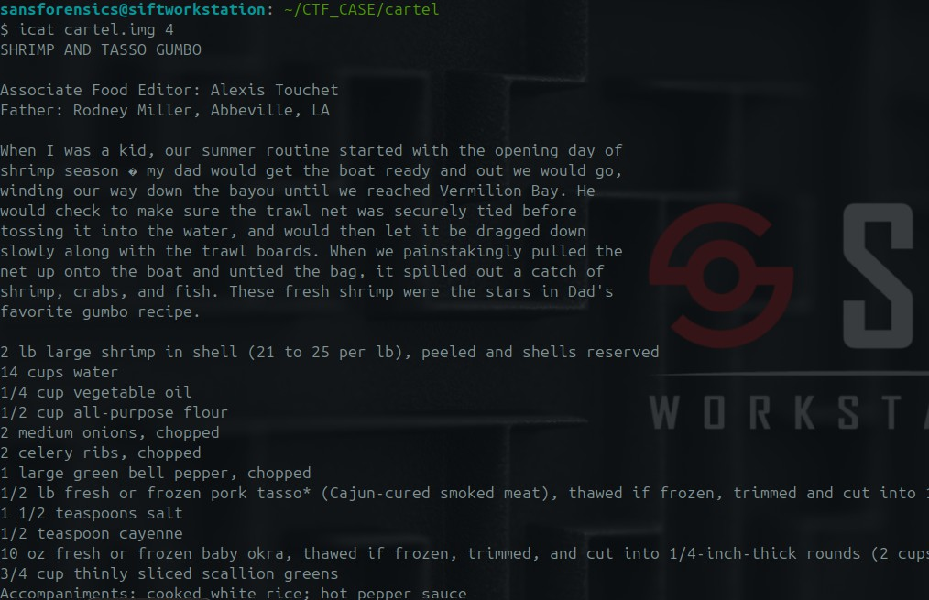

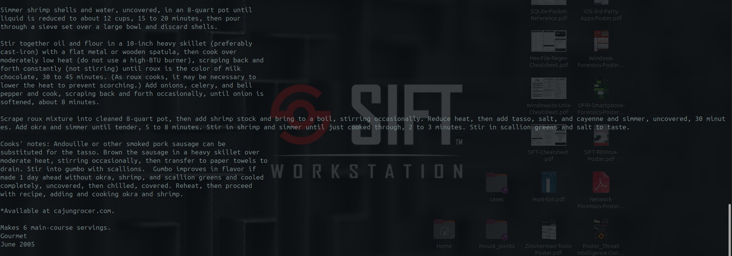

Figure 8: Extracting Shrimp and Andouille Sausage Gumbo recipe (Inode 6).
