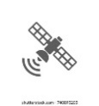

Spatiotemporal Phase

*In-Situ* Automated *IoT* Phase

GEE L8 OLI + MODIS_Aqua

Start

Raw Data Acquisition



IoT Gateway

Raw Img. Collections

cccclkmlmlmlmlcmllCcmkclmCollectiooinson

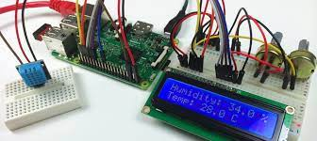 Secure Connection via

**security shell (ssh)**

Study Area Delineation

Raster pre-processing

- Radiometric corrections

- Surface Reflectance­­­ BOA



GPS

Image Filtering

Upload *in-situ* data to microcontroller

NO

Above Surface Temp

Lake Surface Temp.

Spatio-temporal Image Fusion

In-Situ Data **>** Temp. Threshold

Chl-a & Cyanotoxins Detected

Image Analysis



 Initiate an alert text SMS

Nov

Oct

Dec

Sep

Aug

July

June

Cha-a Spatiotemporal Maps,

Spatio-Temporal Monitor Data acq., Processing

LoRa Radio Comm; data

Sensors and MCU acq, Unit test

In-Situ IoT system

Model Selection, Accuracy and Efficacy Testing

ML Predictive System